

**Cambridge International**

**AS and A Level Physics (9702)**

Practical booklet 10

Determination of specific heat capacity using a cooling curve

**Introduction**

Practical work is an essential part of science. Scientists use evidence gained from prior observations and experiments to build models and theories. Their predictions are tested with practical work to check that they are consistent with the behaviour of the real world. Learners who are well trained and experienced in practical skills will be more confident in their own abilities. The skills developed through practical work provide a good foundation for those wishing to pursue science further, as well as for those entering employment or a non-science career.

The science syllabuses address practical skills that contribute to the overall understanding of scientific methodology. Learners should be able to:

1. plan experiments and investigations
2. collect, record and present observations, measurements and estimates
3. analyse and interpret data to reach conclusions
4. evaluate methods and quality of data, and suggest improvements.

The practical skills established at AS Level are extended further in the full A Level. Learners will need to have practised basic skills from the AS Level experiments before using these skills to tackle the more demanding A Level exercises. Although A Level practical skills are assessed by a timetabled written paper, the best preparation for this paper is through extensive hands-on experience in the laboratory.

The example experiments suggested here can form the basis of a well-structured scheme of practical work for the teaching of AS and A Level science. The experiments have been carefully selected to reinforce theory and to develop learners’ practical skills. The syllabus, scheme of work and past papers also provide a useful guide to the type of practical skills that learners might be expected to develop further. About 20% of teaching time should be allocated to practical work (not including the time spent observing teacher demonstrations), so this set of experiments provides only the starting point for a much more extensive scheme of practical work.

© Cambridge International Examinations 2014

**Practical 10 – Guidance for teachers**

**Determination of specific heat capacity using a cooling curve**

**Aim**

To use theory from electricity and heat and apply a cooling correction.

**Outcomes**

Syllabus sections 1.2e, 2.1a, 12.1b

**Skills included in the practical**

|  |  |
| --- | --- |
| **A Level skills** | **How learners develop the skills** |
| Planning | Plan an experiment |

This practical provides an opportunity to build on essential skills introduced at AS Level.

|  |  |
| --- | --- |
| **AS Level skills** | **How learners develop the skills** |
| MMO collection | Measure mass using a balance  Measure temperature using a thermometer |
| MMO values |
| MMO quality of data |
| PDO table | Collect and record data in a table |
| PDO recording |
| PDO graph | Draw a graph  Draw a tangent to a curve to find a rate of change |

**Theory**

When some water in a beaker is heated up the graph of temperature against time is not a straight line. This is because the greater the temperature difference between the water and the surroundings, the greater the rate of loss of heat to the surroundings.

When the heating stops the graph is not a straight line because the rate of cooling decreases as the temperature of the water approaches room temperature.

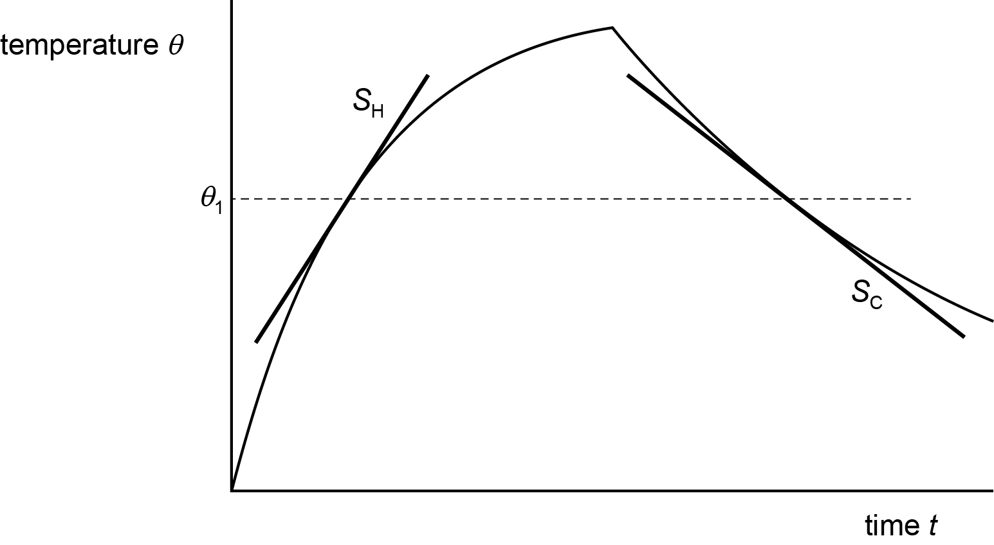

At a particular temperature *θ*1,the rate of temperature increase *S*H is the gradient of the curve at *θ*1 as the water is increasing in temperature, and the rate of temperature decrease *S*C is the positive gradient of the curve at *θ*1 where the water is decreasing in temperature.

If the water is heated electrically then *VI* = (*M*W*C*W + *M*G*C*G) (*S*H + *S*C)

where:

|  |  |
| --- | --- |
| *V* = voltmeter reading | *C*W = specific heat capacity of water |
| *I* = ammeter reading | *C*G = specific heat capacity of glass |
| *M*W = mass of water | *M*G = mass of glass |

**Method**

* Learners set up the circuit shown below.

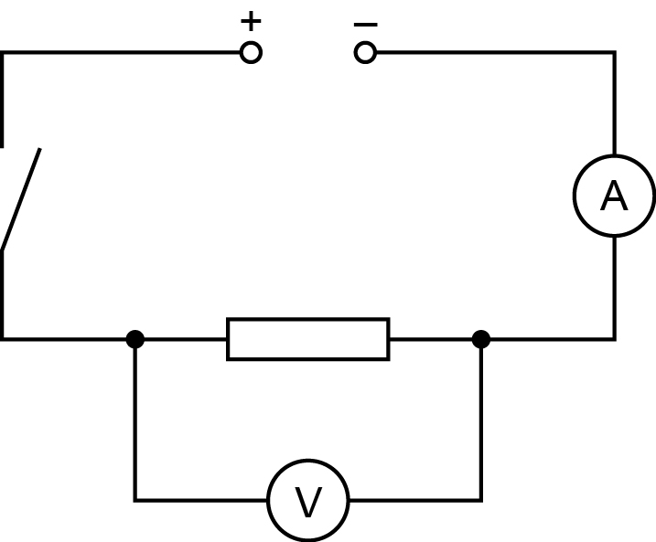

* They record the mass of the beaker and add 75 cm3 of water to it, then record the mass of the beaker plus water and calculate the mass of water. They also record the temperature of the water in the beaker.
* Learners place the resistor in the water, close the switch and start the stopwatch, recording values of time *t* and temperature ** until the temperature has risen by 15°C.
* When the temperature has risen by 15°C they open the switch and continue to take readings until the temperature has dropped to 6°C below the maximum temperature reached.

**Results**

Learners record all of their readings in a table, such as that below.

|  |  |
| --- | --- |
| *t*/s | *θ*/°C |
|  |  |
|  |  |
|  |  |

**Interpretation and evaluation**

Learners draw graphs of the results. At a temperature 4°C *below the maximum temperature reached* they draw tangents to both the heating and cooling curves. They then find the gradients of both tangents, *S*H and *S*C.

Learners then determine *C*W from *VI* = (*M*W*C*W + *M*G*C*G) (*S*H + *S*C).

**Planning**

A planning task is also given, in which learners consider an extension to the experiment by using the same apparatus to investigate Newton’s law of cooling.

**Practical 10 – Information for technicians**

**Determination of specific heat capacity using a cooling curve**

**Each learner will require:**

|  |  |
| --- | --- |
| (a) | 12 V d.c. power supply |
| (b) | ammeter with range 0-10A reading to 0.01 A |
| (c) | voltmeter with range 0-20 V |
| (d) | 15 Ω resistor with a wire of length 15 cm soldered to each end. The other end of each wire should be bared |
| (e) | switch |
| (f) | thermometer |
| (g) | 250 ml beaker with markings every 50 ml |
| (h) | measuring cylinder and supply of water at room temperature |
| (i) | stirrer |
| (j) | six connecting wires |
| (k) | two crocodile clips |
| (l) | stopwatch |
| (m) | access to a balance |
| (n) | paper towels |

**Practical 10 – Worksheet**

**Determination of specific heat capacity using a cooling curve**

**Aim**

To use theory from electricity and heat and apply a cooling correction.

**Method**

1. Set up the circuit shown below.



1. Record the mass *M*G of the glass beaker.
2. Add approximately 75 cm3 of water to the beaker (about half way between the 50 and 100 cm3 markings).
3. Record the mass *M*T of the beaker and water and calculate the mass of water *M*W using *M*W = *M*T – *M*G.
4. Record the temperature **R of the water in the beaker.
5. Place the resistor below the surface of the water in the beaker.
6. Close the switch.
7. Start the stopwatch.
8. Record the ammeter reading *I* and the voltmeter reading *V.*
9. Record values of time *t* and temperature ** every minute until the temperature has risen by 15 °C above **R.
10. Open the switch and continue to take readings until the temperature has dropped to 6 °C below the maximum temperature reached.

**Results**

Record all of your readings.

|  |  |
| --- | --- |
| *t*/s | *θ*/°C |
|  |  |
|  |  |

**Interpretation and evaluation**

When the water is heated up the graph of temperature against time is not a straight line because the greater the temperature difference between the water and *θ*R, the greater the rate of loss of heat to the surroundings.

When the water cools the graph is not a straight line because the rate of cooling decreases as the temperature of the water approaches *θ*R.

At a particular temperature *θ*1,the rate of temperature increase *S*H is the gradient of the curve at *θ*1 as the water is increasing in temperature, and the rate of temperature decrease *S*C is the positive gradient of the curve at *θ*1 where the water is decreasing in temperature.

1. Draw a graph of your results.
2. At a temperature *θ*1 where *θ*1 is 4 °C *below the maximum temperature reached,* draw tangents to both the heating and cooling curves.
3. Find the gradients of both tangents, *S*H and *S*C.
4. Determine *C*W from *VI* = (*M*W*C*W + *M*G*C*G) (*S*H + *S*C) where the specific heat capacity of glass *C*G = 840 J/(kg K).

**Planning**

It is suggested that the cooling of hot water is described by the equation

where **H is the initial temperature of the hot water, **R is room temperature, *t* is time and ** is a constant.

Design a laboratory experiment, using the apparatus provided, to test the relationship between ** and *t* and determine a value for ** You should pay particular attention to the experimental procedure, the measurements to be taken, the control of variables, the analysis of the data and any safety precautions to be taken.