

**Cambridge International**

**AS and A Level Physics (9702)**

Practical booklet 11

Making and using a thermocouple

**Introduction**

Practical work is an essential part of science. Scientists use evidence gained from prior observations and experiments to build models and theories. Their predictions are tested with practical work to check that they are consistent with the behaviour of the real world. Learners who are well trained and experienced in practical skills will be more confident in their own abilities. The skills developed through practical work provide a good foundation for those wishing to pursue science further, as well as for those entering employment or a non-science career.

The science syllabuses address practical skills that contribute to the overall understanding of scientific methodology. Learners should be able to:

1. plan experiments and investigations
2. collect, record and present observations, measurements and estimates
3. analyse and interpret data to reach conclusions
4. evaluate methods and quality of data, and suggest improvements.

The practical skills established at AS Level are extended further in the full A Level. Learners will need to have practised basic skills from the AS Level experiments before using these skills to tackle the more demanding A Level exercises. Although A Level practical skills are assessed by a timetabled written paper, the best preparation for this paper is through extensive hands-on experience in the laboratory.

The example experiments suggested here can form the basis of a well-structured scheme of practical work for the teaching of AS and A Level science. The experiments have been carefully selected to reinforce theory and to develop learners’ practical skills. The syllabus, scheme of work and past papers also provide a useful guide to the type of practical skills that learners might be expected to develop further. About 20% of teaching time should be allocated to practical work (not including the time spent observing teacher demonstrations), so this set of experiments provides only the starting point for a much more extensive scheme of practical work.

© Cambridge International Examinations 2014

**Practical 11 – Guidance for teachers**

**Making and using a thermocouple**

**Aim**

To establish a temperature scale and use it to estimate an unknown temperature.

**Outcomes**

Syllabus sections 1.2e, 2.1a, 11.2a

**Skills included in the practical**

|  |  |
| --- | --- |
| **A Level skills** | **How learners develop the skills** |
| Planning | Plan and then carry out an experiment |
| Analysis | Collect and record data in a table |
| Conclusions | Determine and interpret the gradient and *y*-intercept of a graph  Use the results of the experiment to estimate an unknown temperature |

This practical provides an opportunity to build on essential skills introduced at AS Level.

|  |  |
| --- | --- |
| **AS Level skills** | **How learners develop the skills** |
| MMO collection | Measure temperature using a thermometer  Use a voltmeter with an appropriate scale |
| MMO values |
| MMO data |
| ACE limitations | Identify the limitations of the experimental procedure |

**Theory**

The e.m.f. of the thermocouple circuit shown depends on the temperature difference (* – *0) between the two metal junctions.

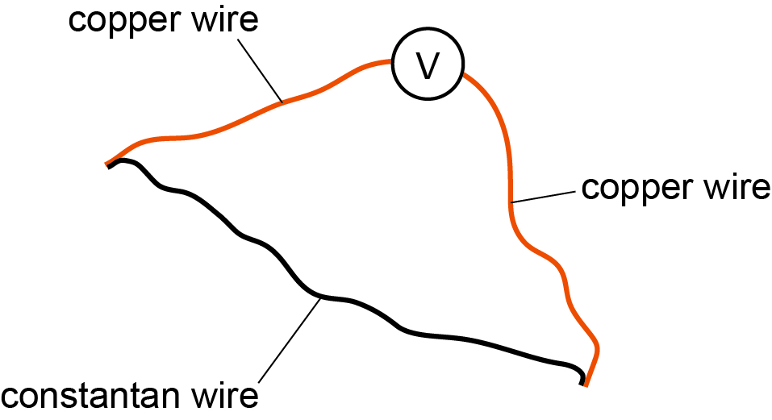

*V* = *a*(* – *0)+ *b* where *a* and *b* are constants

**Method**

Learners are given the circuit diagram and equation above, and should plan and then carry out an experiment to determine the constants *a* and *b* in the equation.

The planning of the experiment should follow the principles assessed in Paper 5, i.e. considering the experimental procedure, the measurements to be taken, the control of variables, the analysis of the data and any safety precautions to be taken.

The expected experimental procedure is:

* Learners construct a thermocouple as shown above.
* Room temperature *θ*0 is measured using the mercury-in-glass thermometer.
* One junction is kept at room temperature while the other is placed in boiling (or very hot) water.
* As the water cools, readings of water temperature *θ* and the voltmeter *V* are recorded.

Learners’ proposed experimental procedures should be checked before they attempt to carry out the experiment, paying particular attention to safety.

**Results**

All water temperature *θ* and voltmeter *V* readings should be recorded.

|  |  |  |
| --- | --- | --- |
| *θ* /°C | *V*/mV | (*θ* – *θ*0)/°C |
|  |  |  |
|  |  |  |
|  |  |  |
|  |  |  |
|  |  |  |
|  |  |  |

**Interpretation and evaluation**

* Using *V* = *a*(*θ* – *θ*0) + *b* the values of *a* and *b* are determined from a graph of *V* against(*θ*– *θ*0).
* The results are used to estimate the temperature of a lit match.
* Learners should be encouraged to question this method of temperature measurement or temperature estimate. Some issues for discussion are:
* the expansion of mercury is not uniform
* the graph should go through (0,0) and not have an intercept. When both junctions are at room temperature the voltmeter reading is zero.

**Practical 11 – Information for technicians**

**Making and using a thermocouple**

**Each learner will require:**

|  |  |
| --- | --- |
| (a) | Liquid-in-glass 0–100 °C thermometer reading to the nearest 1 °C |
| (b) | Digital voltmeter set to 0–200 mV scale reading to the nearest 0.1 mV |
| (c) | One bare 26 swg constantan wire of length 50 cm |
| (d) | Two bare 26 swg copper wires each of length 50 cm  One end of each wire should have a 4 mm plug attached |
| (e) | Beaker |
| (f) | Source of boiling water |
| (g) | Box of matches |

**Practical 11 – Worksheet**

**Making and using a thermocouple**

**Aim**

To establish a temperature scale and use it to estimate an unknown temperature.

**Method**

A thermocouple thermometer can be created by connecting metals of different types. Copper wire and constantan wire are available.

Connect the circuit shown below. The junctions should be formed by twisting the ends of the wire together. The length of each junction should be about 2 cm and it must not be possible to separate the wires by gentle pulling.



The e.m.f. *V* measured by the voltmeter is given by:

*V* = *a*(*θ*– *θ*0) + *b*

where ** and *θ*0 are the temperatures of the two junctions of the thermocouple.

Using the apparatus provided, plan an experiment to test the relationship between *V* and **, and determine values for *a* and *b*.

Check with your teacher that your planned experiment is appropriate, and then carry out the experiment.

**Results**

Draw a table of results with appropriate column headings and use it to record your results.

|  |  |  |
| --- | --- | --- |
|  |  |  |
|  |  |  |
|  |  |  |
|  |  |  |
|  |  |  |
|  |  |  |
|  |  |  |

**Interpretation and evaluation**

1. Determine the values of *a* and *b* from your experiment. This will require plotting a graph.
2. Use your results to estimate the temperature of the flame from a lit match.
3. State two sources of uncertainty.