

**Cambridge International**

**AS and A Level Physics (9702)**

Practical booklet 12

Determination of acceleration of free fall *g* using a V-shaped pendulum

**Introduction**

Practical work is an essential part of science. Scientists use evidence gained from prior observations and experiments to build models and theories. Their predictions are tested with practical work to check that they are consistent with the behaviour of the real world. Learners who are well trained and experienced in practical skills will be more confident in their own abilities. The skills developed through practical work provide a good foundation for those wishing to pursue science further, as well as for those entering employment or a non-science career.

The science syllabuses address practical skills that contribute to the overall understanding of scientific methodology. Learners should be able to:

1. plan experiments and investigations
2. collect, record and present observations, measurements and estimates
3. analyse and interpret data to reach conclusions
4. evaluate methods and quality of data, and suggest improvements.

The practical skills established at AS Level are extended further in the full A Level. Learners will need to have practised basic skills from the AS Level experiments before using these skills to tackle the more demanding A Level exercises. Although A Level practical skills are assessed by a timetabled written paper, the best preparation for this paper is through extensive hands-on experience in the laboratory.

The example experiments suggested here can form the basis of a well-structured scheme of practical work for the teaching of AS and A Level science. The experiments have been carefully selected to reinforce theory and to develop learners’ practical skills. The syllabus, scheme of work and past papers also provide a useful guide to the type of practical skills that learners might be expected to develop further. About 20% of teaching time should be allocated to practical work (not including the time spent observing teacher demonstrations), so this set of experiments provides only the starting point for a much more extensive scheme of practical work.

© Cambridge International Examinations 2014

**Practical 12 – Guidance for teachers**

**Determination of acceleration of free fall *g* using a V-shaped pendulum**

**Aim**

An opportunity to plan an entire experiment given the theory only.

**Outcomes**

Syllabus sections 1.2e, 2.1a, 13.1b

**Skills included in the practical**

|  |  |
| --- | --- |
| **A Level skills** | **How learners develop the skills** |
| Planning | Plan an experiment |

This practical provides an opportunity to build on essential skills introduced at AS Level.

|  |  |
| --- | --- |
| **AS Level skills** | **How learners develop the skills** |
| MMO collection | Measure lengths using a rule  Measure angles using a protractor  Measure time intervals using a stopwatch |
| MMO values |
| MMO quality of data |
| PDO table | Collect and record data in a table |
| PDO recording |
| PDO graph | Draw a graph and determine the gradient and *y*-intercept |
| ACE interpretation | Interpret the gradient and *y*-intercept |

**Method**

Give each learner a copy of one of the theories for a V-shaped pendulum and ask them to plan an experiment to find *g*. The instructions in red are optional.

**Results**

The results tables are optional. More able learners may be able to construct their own tables of results including all required column headings.

**Theory 1**

**Total length of string = *L*.**

**String supported at M and N.**

**Vary 2*θ* and measure *T*.**

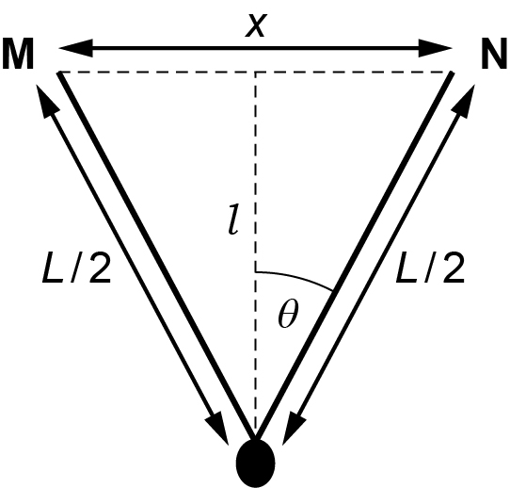

$$\frac{l}{L/2}=\cos{θ}$$

$$l=\frac{L\cos{θ}}{2}$$

Substituting into $T=2π\sqrt{\frac{l}{g}}$ and squaring gives:

$$T^{2}=\frac{2π^{2}L\cos{θ}}{g}$$

Squaring again and using the trigonometric identity sin2** + cos2** = 1:

A graph of *T*4 against sin2** should be a straight line with:

$$A=-\text{gradient}=\frac{4π^{4}L^{2}}{g^{2}}$$

$$B=A=\text{y-intercept}=\frac{4π^{4}L^{2}}{g^{2}}$$

**Theory 2**

**Total length of string = *L*.**

**String supported at M and N.**

**Vary *x* and measure *T*.**

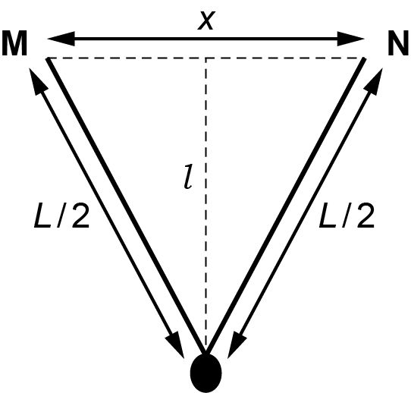

$T=2π\sqrt{\frac{l}{g}}$ raised to the power 4 gives:

$$T^{4}=16π^{4}{\left(\frac{l}{g}\right)}^{2}$$

Using Pythagoras’s Theorem: *l*2 = (*L*/2)2 – (*x*/2)2

therefore

A graph of *T*4 against *x*2 should be a straight line with:

$$C=-\text{gradient}=\frac{4π^{4}}{g^{2}}$$

$$D=\text{y-intercept}=\frac{4π^{4}L^{2}}{g^{2}}$$

Also:

$\sqrt{\frac{D}{C}}=L$

**Theory 3**

**Total length of string = *L*.**

**String supported at M and N but is continuous.**

**Vary *x* and measure *y* and *T*.**

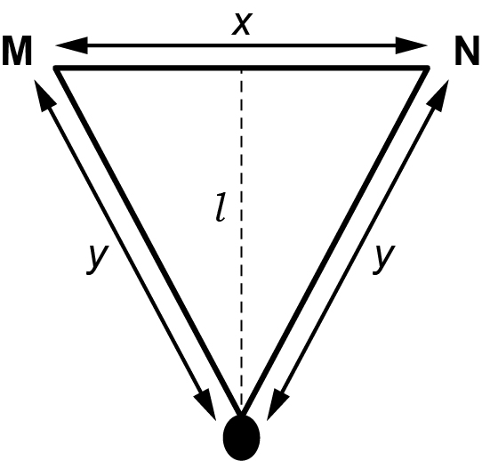

$T=2π\sqrt{\frac{l}{g}}$ raised to the power 4 gives:

$$T^{4}=16π^{4}{\left(\frac{l}{g}\right)}^{2}$$

Length of string = *y* + *y* + *x* = 2*y* + *x* = *L*

By Pythagorus:

$$l^{2}=y^{2}-{\left(\frac{x}{2}\right)}^{2}$$

so

$$T^{4}=16π^{4}{\left(\frac{l}{g}\right)}^{2}=\frac{4π^{4}}{g^{2}}\left(4y^{2}-x^{2}\right)$$

$$4y^{2}-x^{2}=\left(2y-x\right)\left(2y+x\right)=\left(2y-x\right)L$$

Therefore:

$$T^{4}=\frac{4π^{4}}{g^{2}}\left(4y^{2}-x^{2}\right)=\frac{4π^{4}\left(2y-x\right)L}{g^{2}}$$

$$T^{4}=\frac{8π^{4}Ly}{g^{2}}-\frac{4π^{4}Lx}{g^{2}}$$

$$\frac{T^{4}}{x}=\frac{8π^{4}L}{g^{2}}∙\frac{y}{x}-\frac{4π^{4}L}{g^{2}}$$

$$\frac{T^{4}}{x}=E∙\frac{y}{x}-F$$

A graph of *T*4/*x* against *y*/*x* should be a straight line with

$$E=\text{gradient}=\frac{8π^{4}L}{g^{2}}$$

$$F=-\text{y-intercept}=\frac{4π^{4}L}{g^{2}}$$

**Theory 1 results table**

*L* = ………………m

|  |  |  |  |
| --- | --- | --- | --- |
| Time for 10 cycles | | | |
| *θ*/° | sin *θ* | sin2 *θ* | *t*1/s | *t*2/s | *t*average/s | *T*/s | | *T*4/s4 |
|  |  |  |  |  |  |  | |  |
|  |  |  |  |  |  |  | |  |
|  |  |  |  |  |  |  | |  |
|  |  |  |  |  |  |  | |  |
|  |  |  |  |  |  |  | |  |
|  |  |  |  |  |  |  | |  |

**Theory 2 results table**

*L* = ………………m

|  |  |  |
| --- | --- | --- |
| Time for 10 cycles | | |
| *x*/m | x2/m2 | *t*1/s | *t*2/s | *t*average/s | *T*/s | *T*4/s4 |
|  |  |  |  |  |  |  |
|  |  |  |  |  |  |  |
|  |  |  |  |  |  |  |
|  |  |  |  |  |  |  |
|  |  |  |  |  |  |  |
|  |  |  |  |  |  |  |

**Theory 3 results table**

*L* = ……………..m

|  |  |  |
| --- | --- | --- |
| Time for 10 cycles | | |
| *x*/m | *y*/m | *y*/*x* | *t*1/s | *t*2/s | *t*average/s | *T*/s | *T*4/s4 | (*T*4/*x*)/  s4m–1 |
|  |  |  |  |  |  |  |  |  |
|  |  |  |  |  |  |  |  |  |
|  |  |  |  |  |  |  |  |  |
|  |  |  |  |  |  |  |  |  |
|  |  |  |  |  |  |  |  |  |
|  |  |  |  |  |  |  |  |  |

**Practical 12 – Information for technicians**

**Determination of acceleration of free fall *g* using a V-shaped pendulum**

**Each learner will require:**

|  |  |
| --- | --- |
| (a) | two stands |
| (b) | two bosses |
| (c) | two clamps |
| (d) | pendulum bob |
| (e) | string of length 1 m |
| (f) | stopwatch |
| (g) | metre rule |
| (h) | protractor |

**Practical 12 – Worksheet**

**Determination of acceleration of free fall *g* using a V-shaped pendulum**

**Aim**

An opportunity to plan an entire experiment given the theory only.

**Method**

You have been given the theory for a V-shaped pendulum. Plan an experiment to determine *g* by:

* measuring *L*
* drawing up a table for your results
* recording your results in the table
* drawing an appropriate graph
* using the values of the gradient and *y*-intercept