***Platform Rotation Angle Example***

*Longitudinal Axis*

*North*

*Arbitrary Platform Orientation*

*Platform Aligned to North-East-Down*

*East*

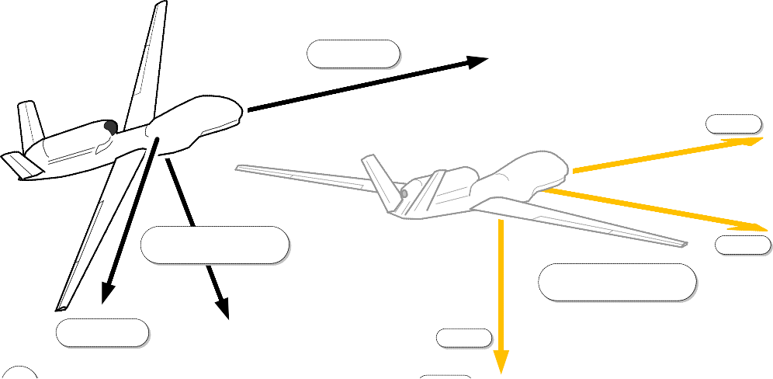

*Transverse Axis*

*Down*