商品期货套利策略实证-产业链-螺纹钢

螺纹钢期货价格=1.6*铁矿石期货价格+0.5*焦炭期货价格+其他成本
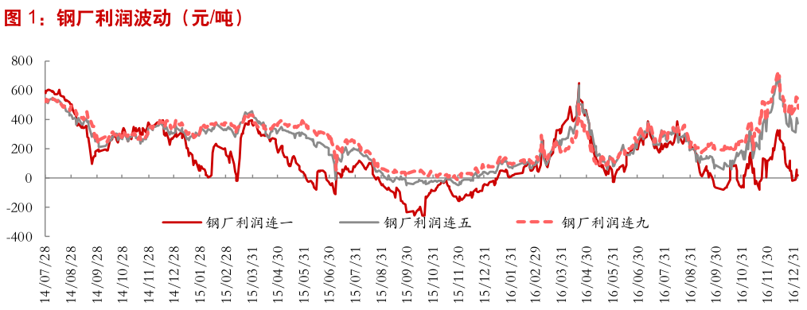

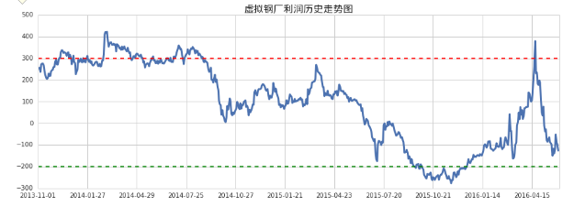
https://bbs.pinggu.org/forum.php?mod=viewthread&tid=4959799
https://uqer.io/v3/community/share/5833aa0f228e5ba297a91aeb

