A-r-15
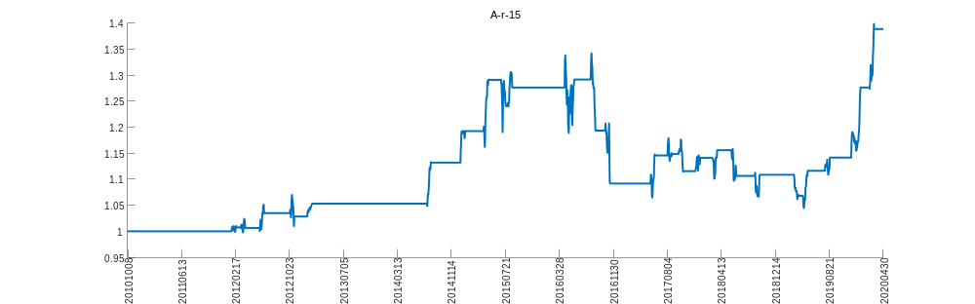
AG-r-15
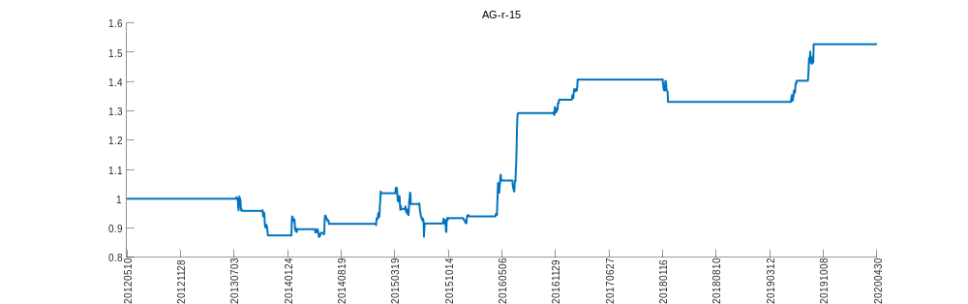
AL-r-15
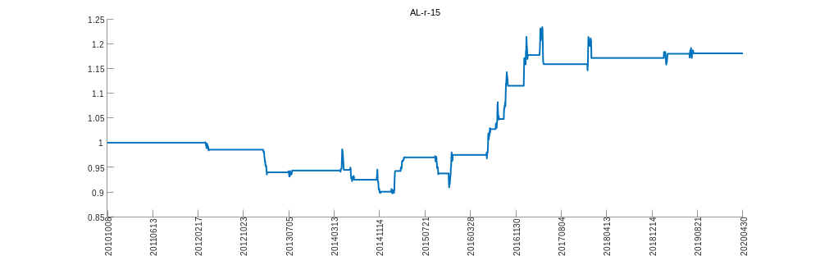
AU-r-15
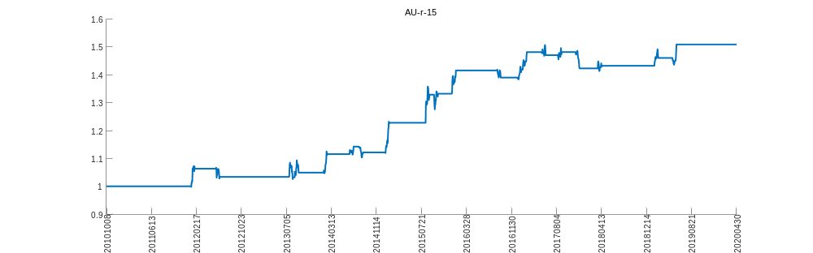
B-r-15
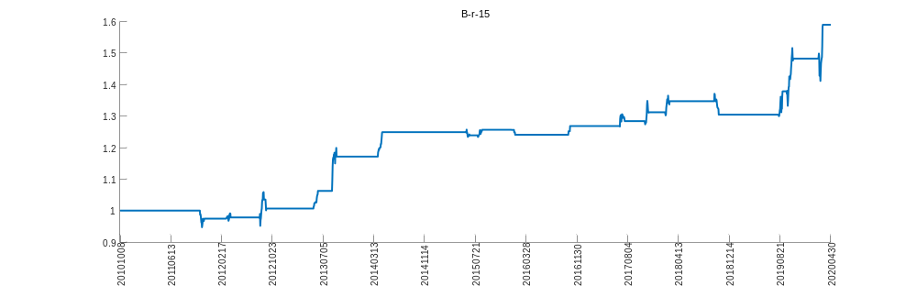
BB-r-15
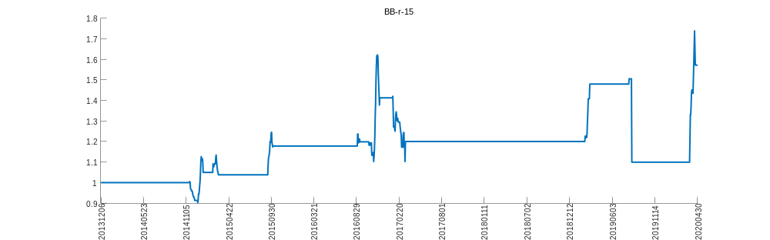
BU-r-15
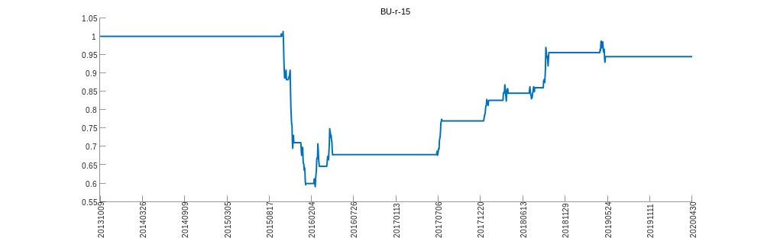
C-r-15
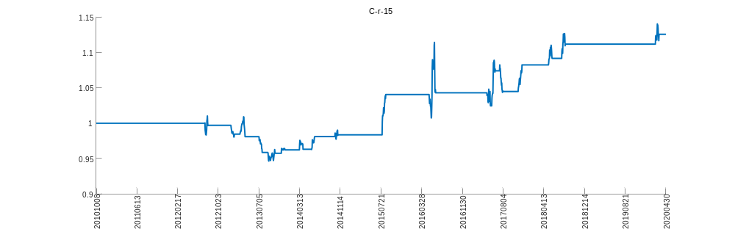
CF-r-15
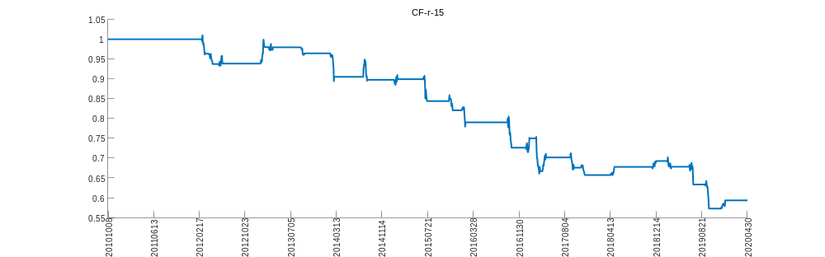
CS-r-15
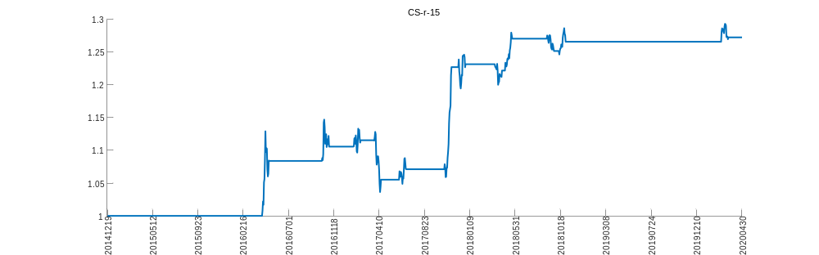
CU-r-15
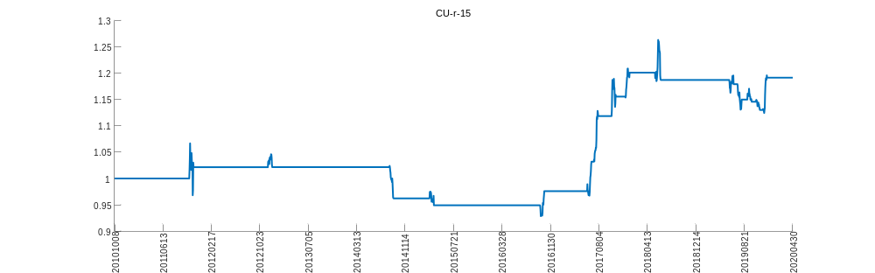
FB-r-15
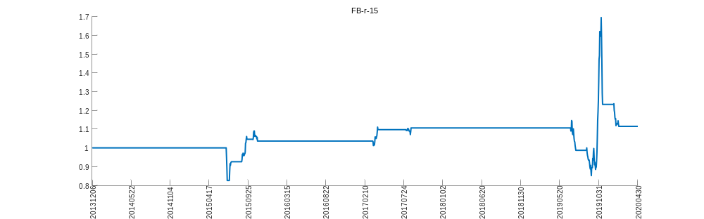
FG-r-15
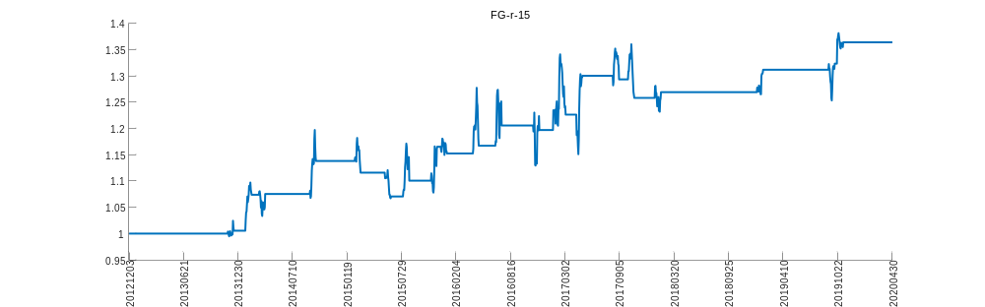
FU-r-15
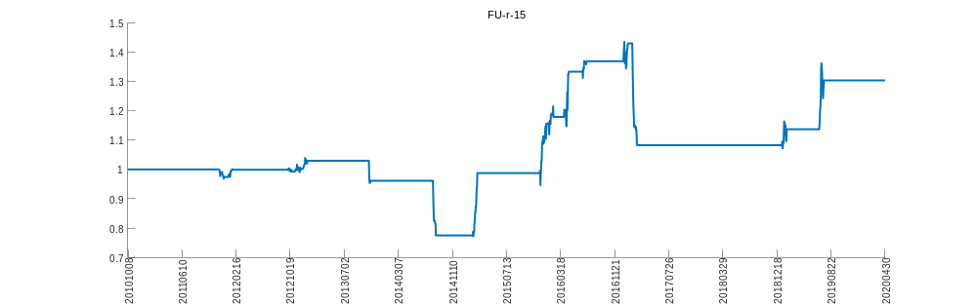
HC-r-15
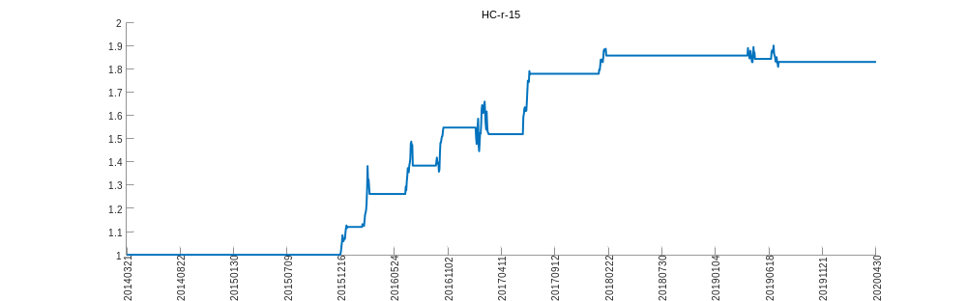
I-r-15
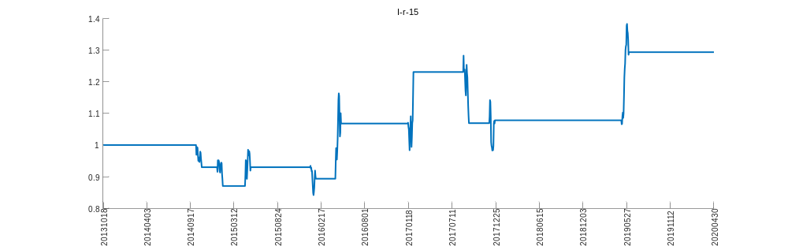
IC-r-15
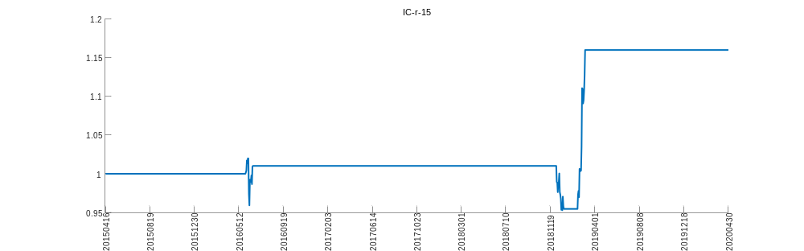
IF-r-15
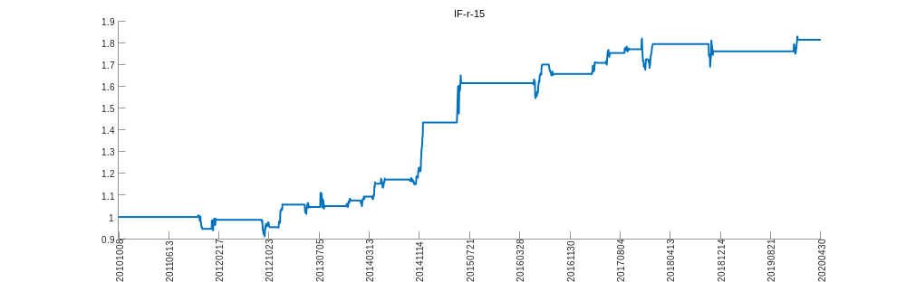
IH-r-15
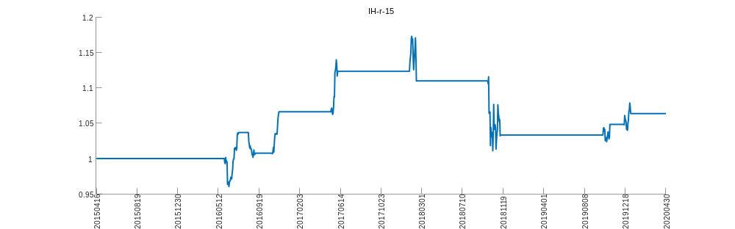
J-r-15
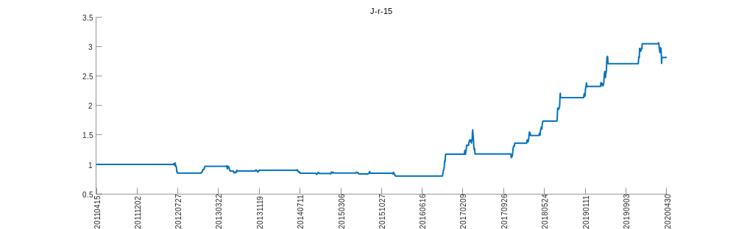
JD-r-15
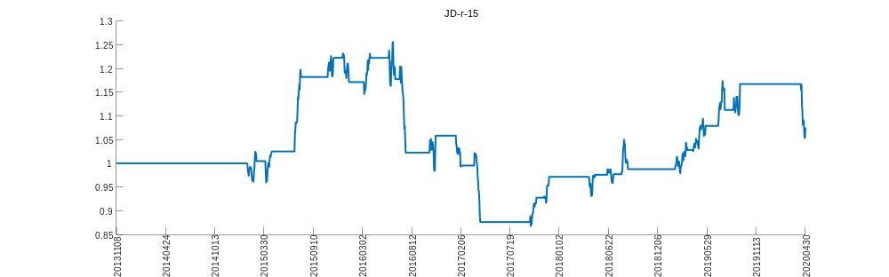
JM-r-15
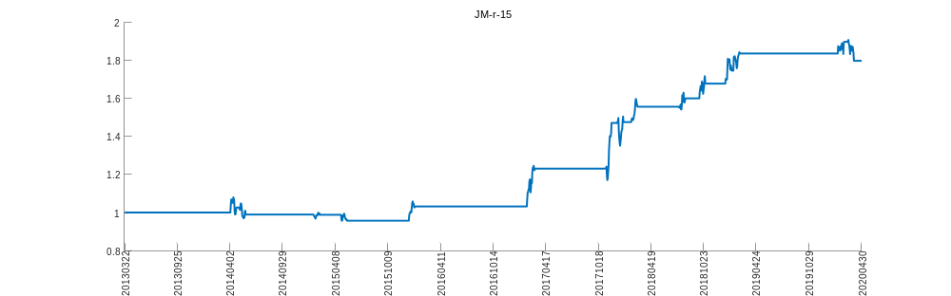
L-r-15
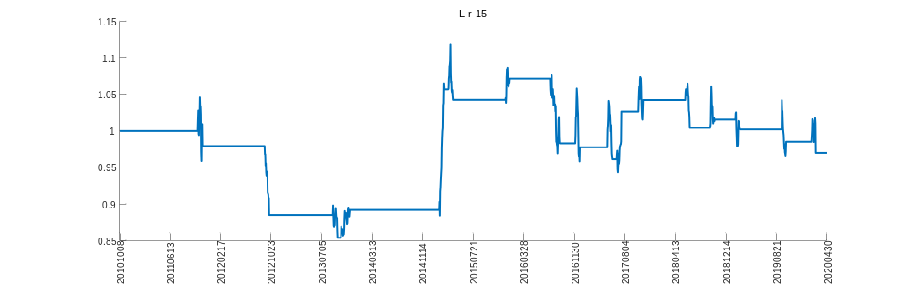
M-r-15
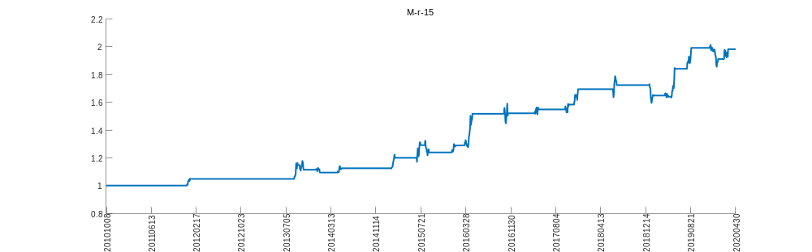
MA-r-15
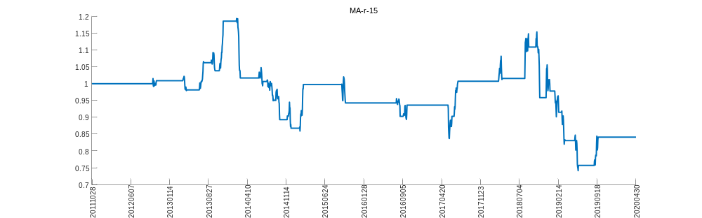
NI-r-15
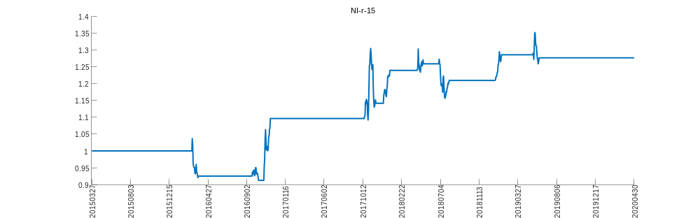
OI-r-15
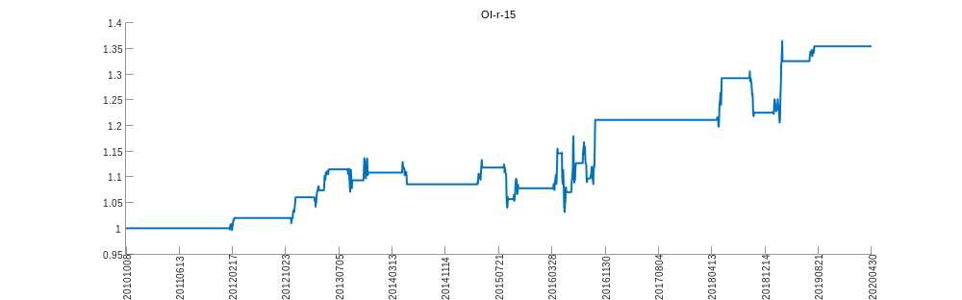
P-r-15
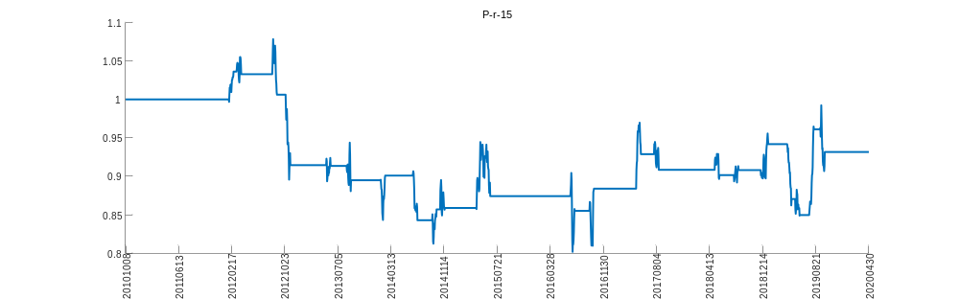
PB-r-15
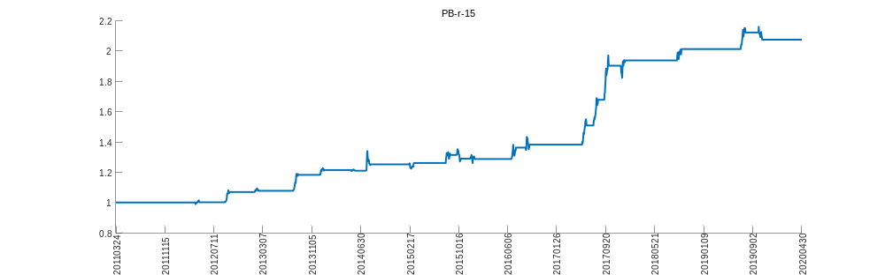
PM-r-15
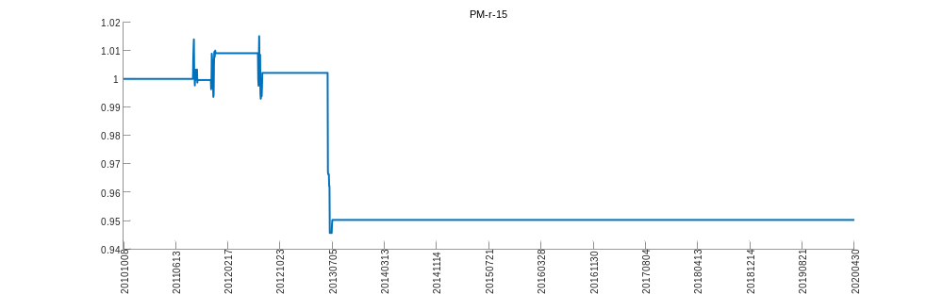
PP-r-15
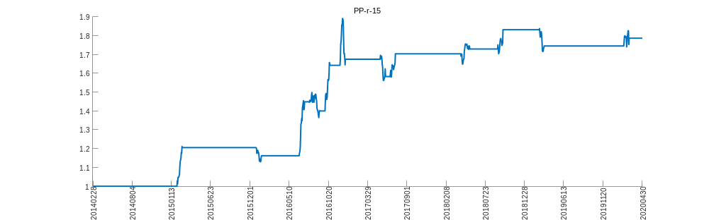
RB-r-15
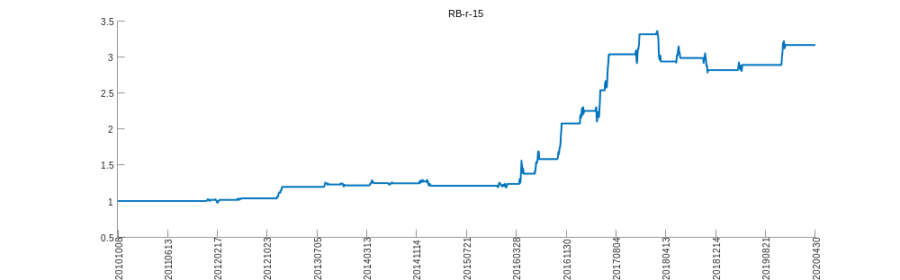
RI-r-15
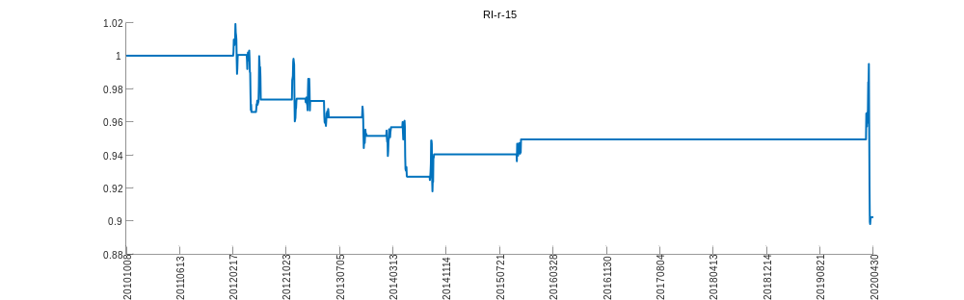
RM-r-15
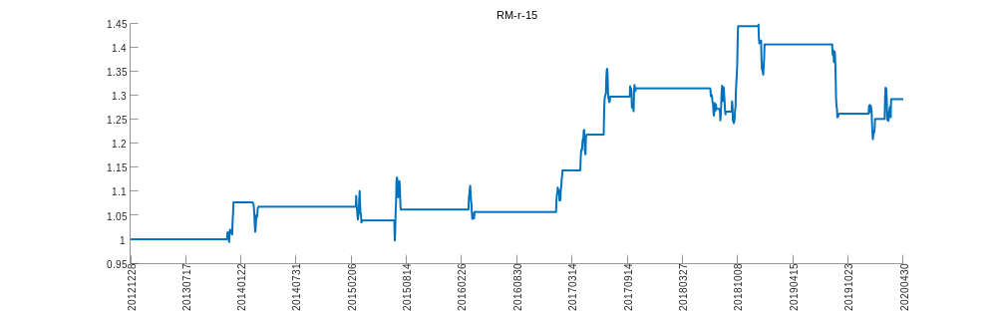
RS-r-15
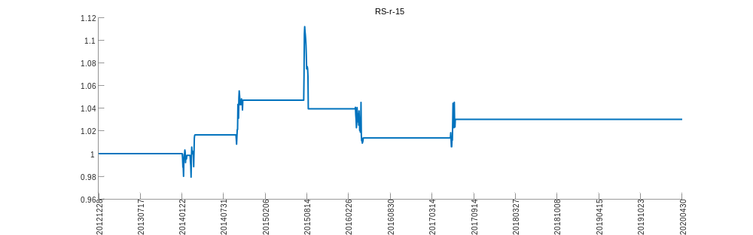
RU-r-15
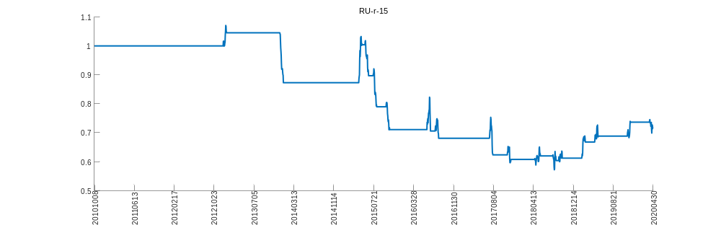
SM-r-15
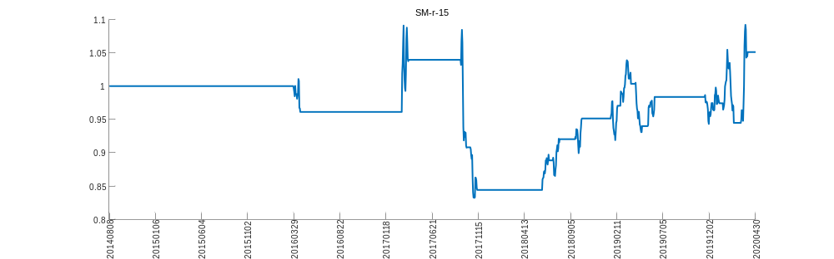
SN-r-15
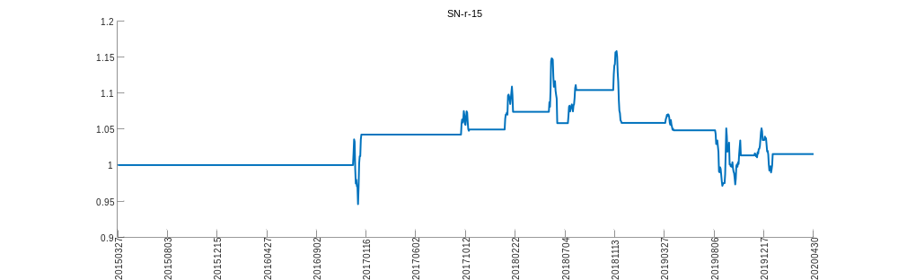
SR-r-15
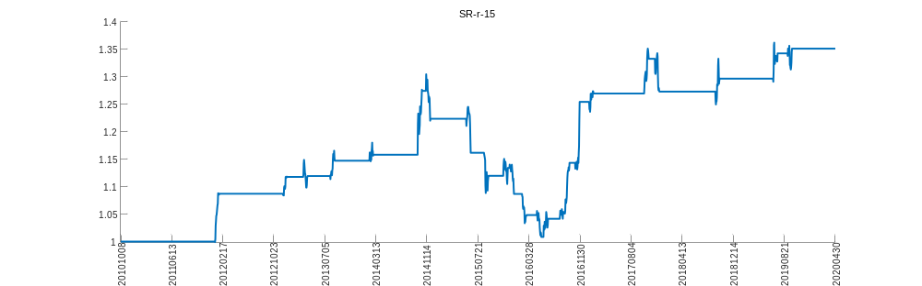
T-r-15
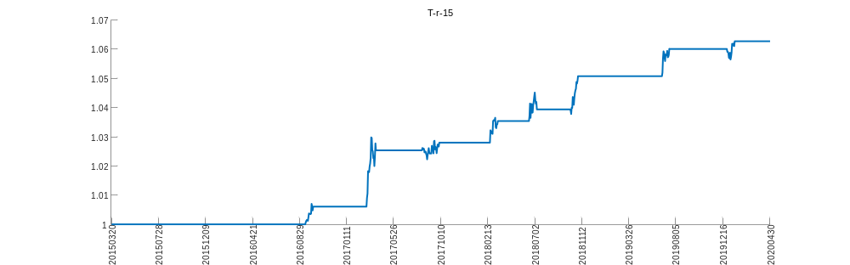
TA-r-15
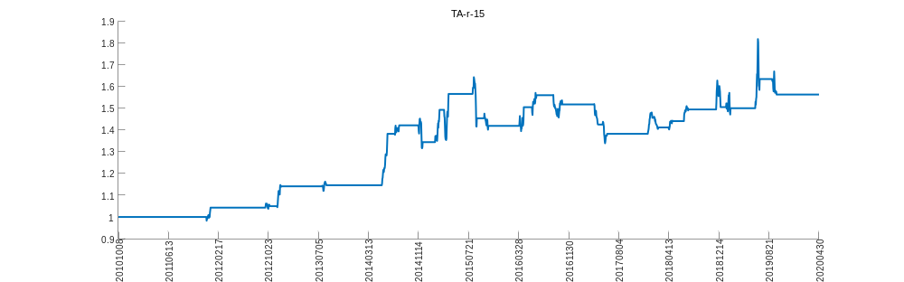
TF-r-15
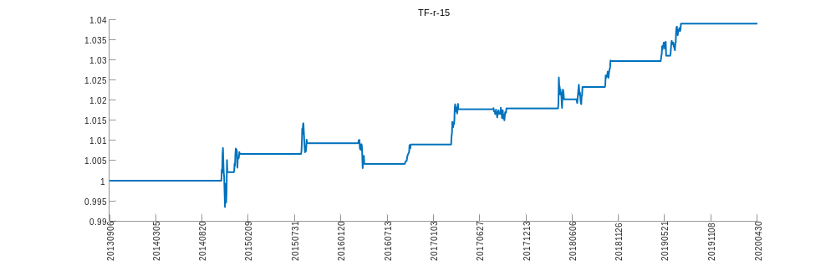
V-r-15
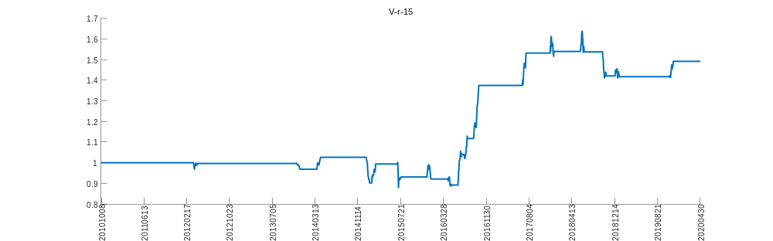
WH-r-15
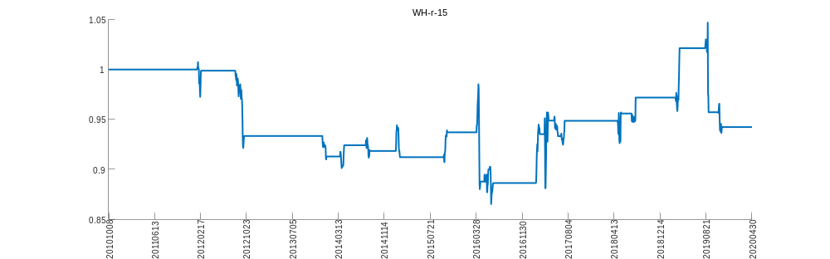
WR-r-15
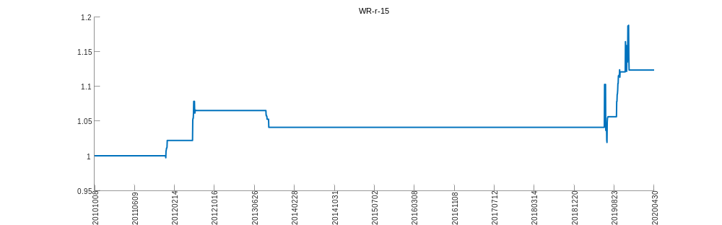
Y-r-15
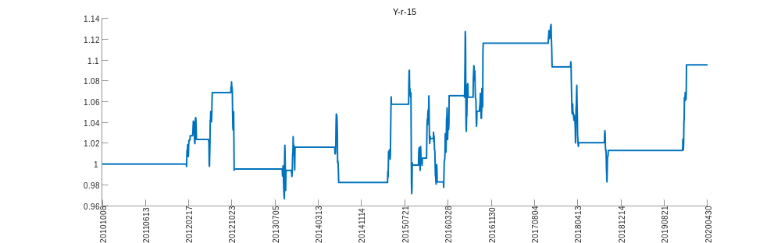
ZC-r-15
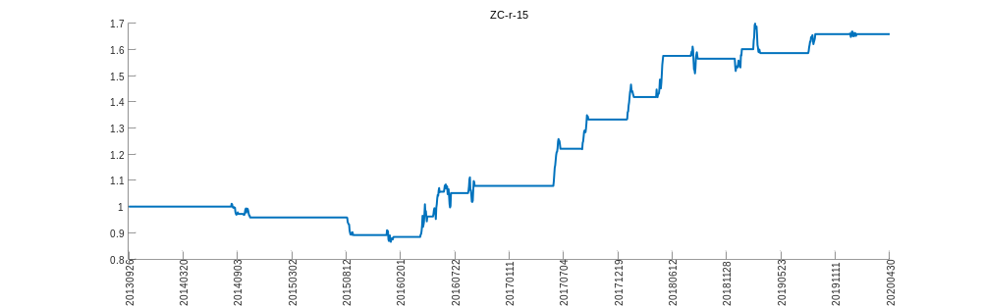
ZN-r-15
