AUDCAD-r-15
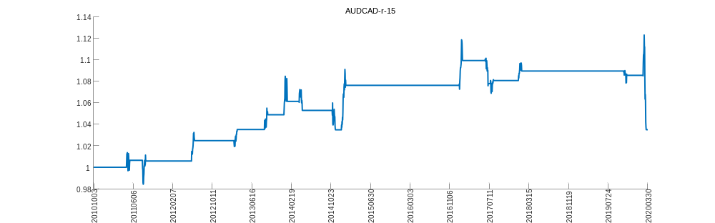
AUDCHF-r-15
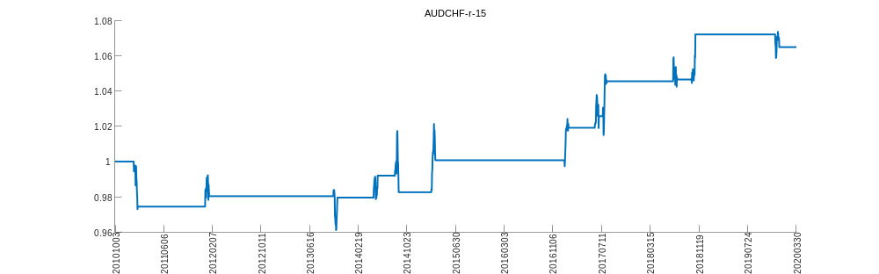
AUDJPY-r-15
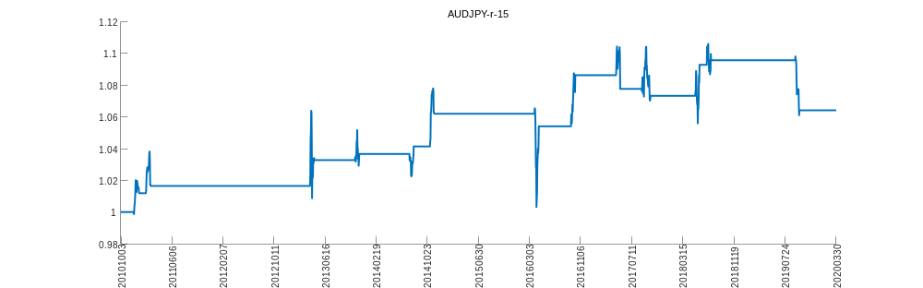
AUDNZD-r-15
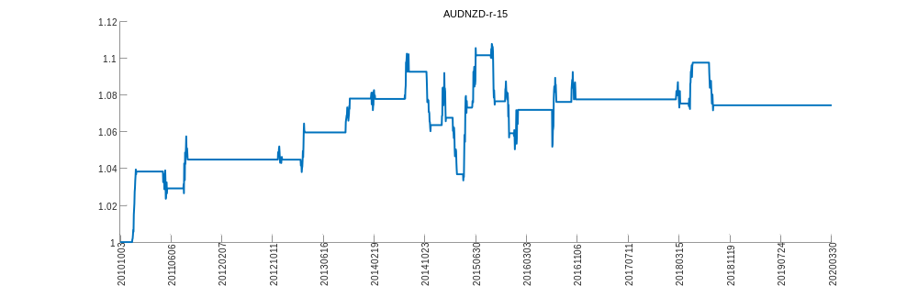
AUDUSD-r-15
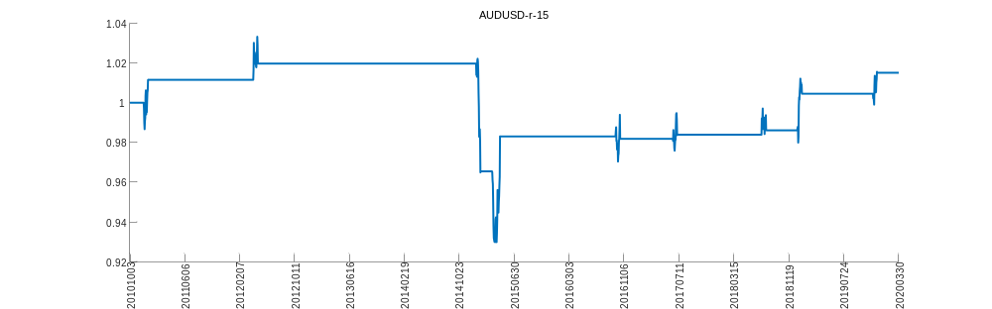
CADCHF-r-15
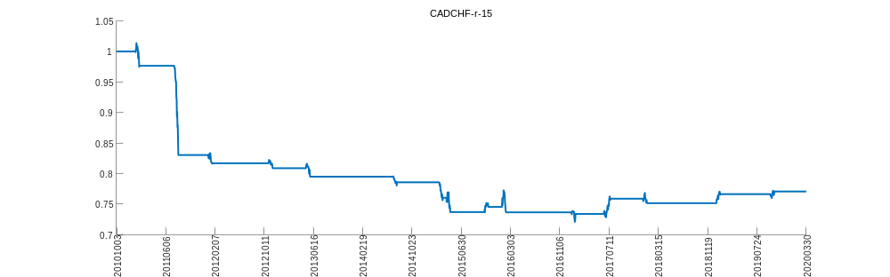
CADJPY-r-15
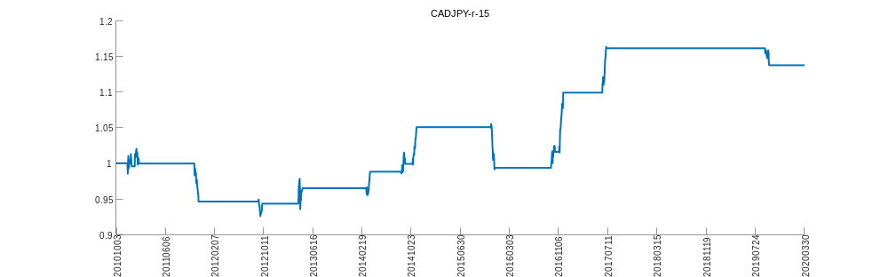
CHFJPY-r-15
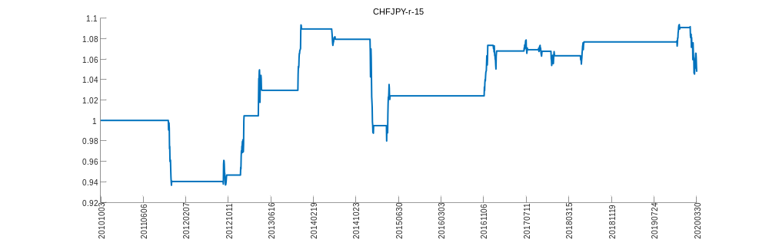
EURAUD-r-15
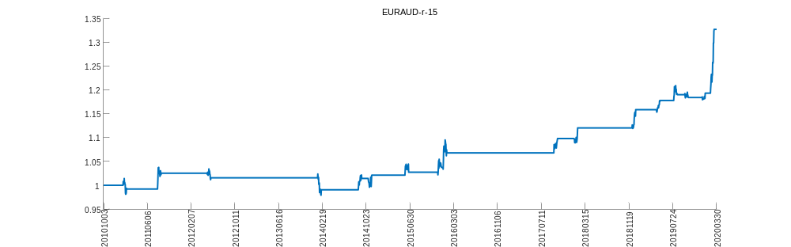
EURCAD-r-15
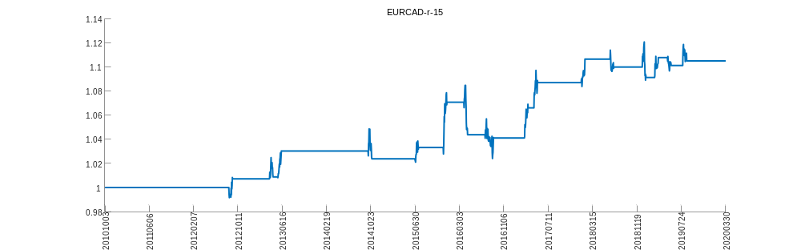
EURCHF-r-15
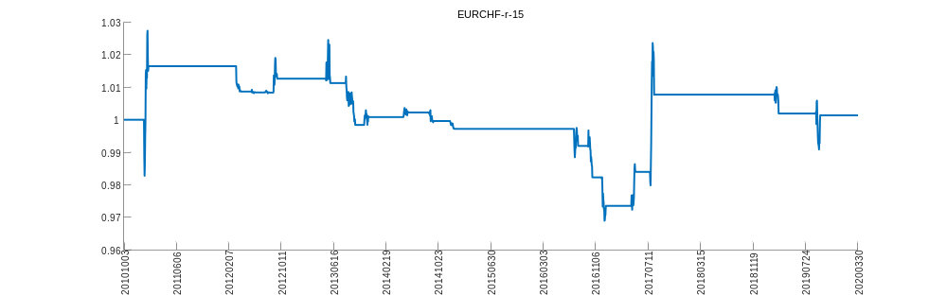
EURGBP-r-15
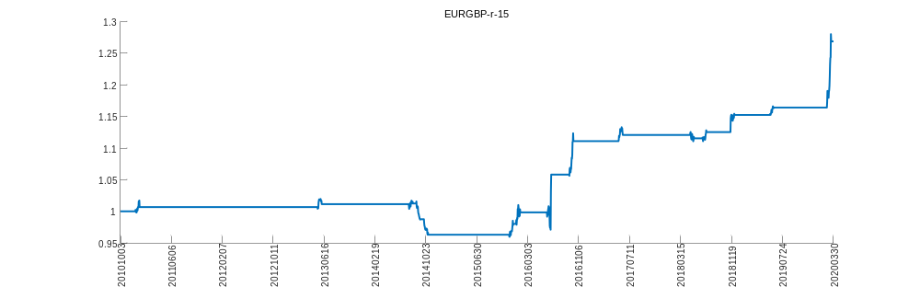
EURJPY-r-15
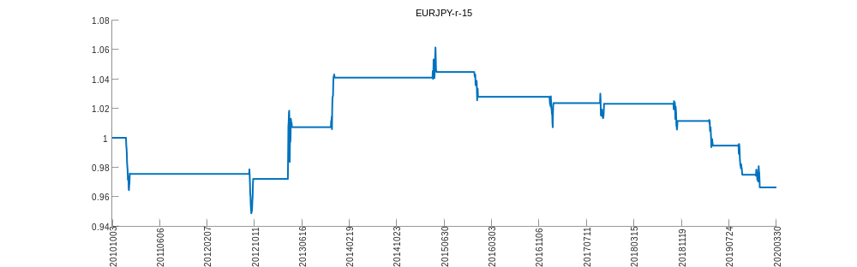
EURNOK-r-15
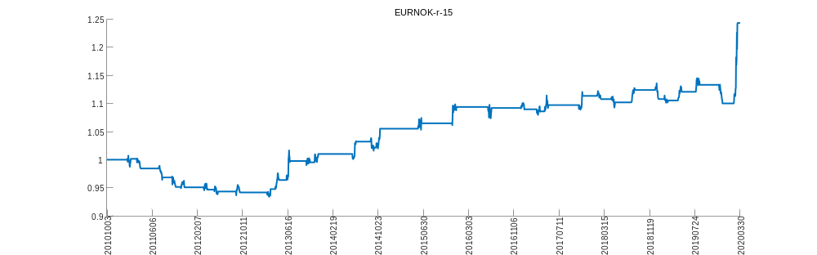
EURNZD-r-15
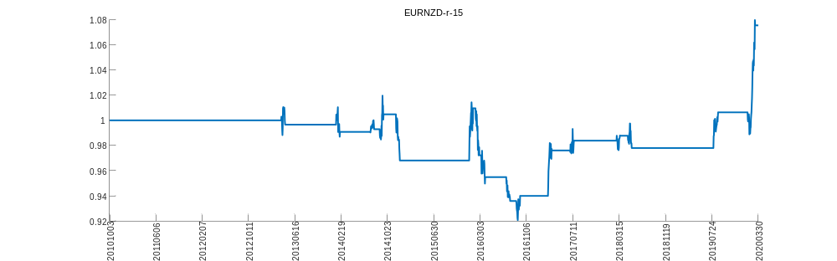
EURUSD-r-15
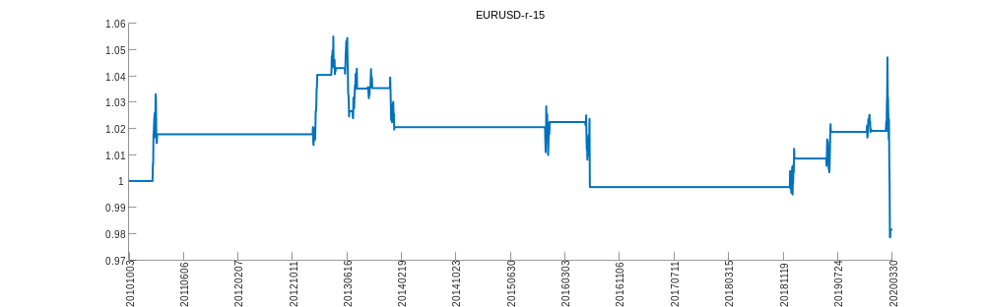
GBPAUD-r-15
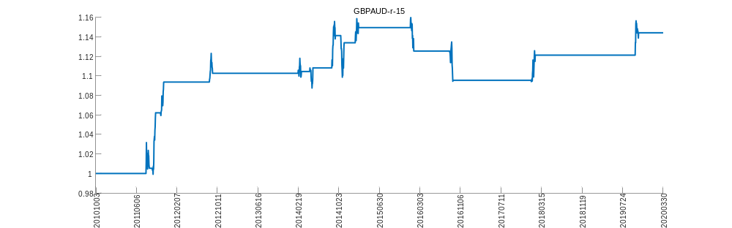
GBPCAD-r-15
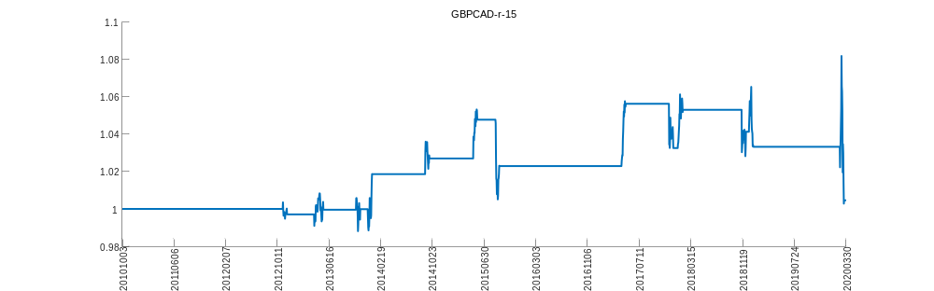
GBPCHF-r-15
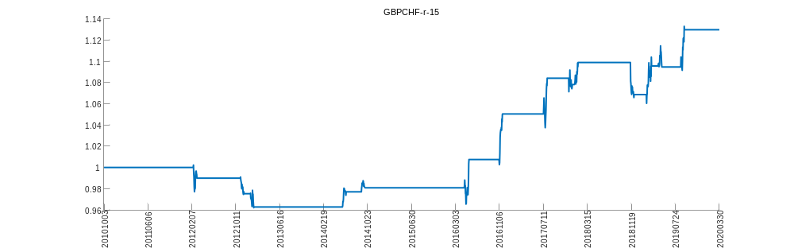
GBPJPY-r-15
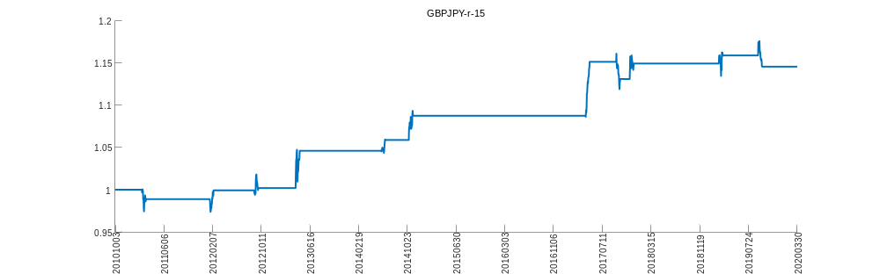
GBPNZD-r-15
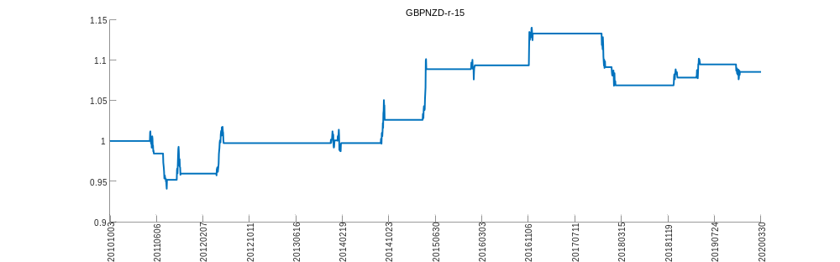
GBPUSD-r-15
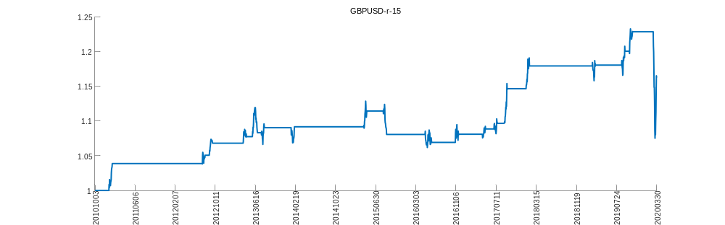
NZDCAD-r-15
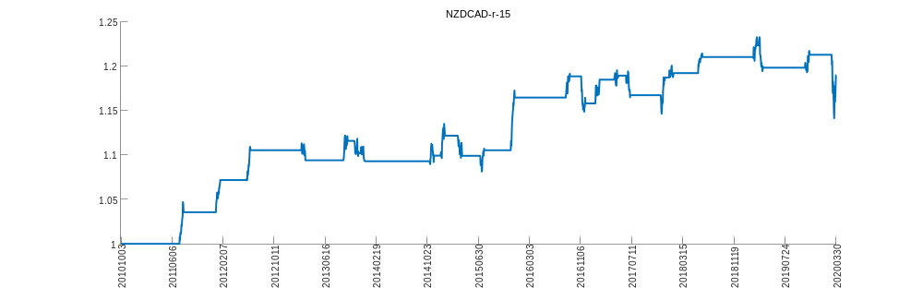
NZDCHF-r-15
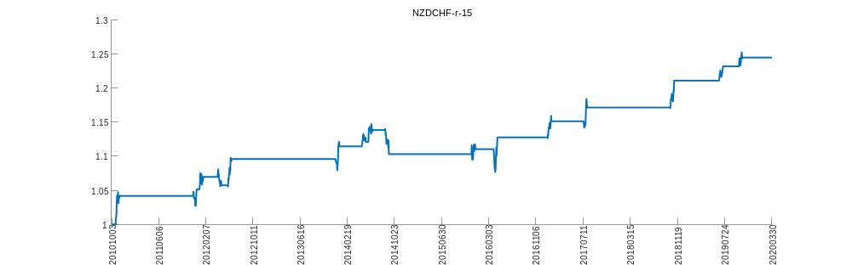
NZDJPY-r-15
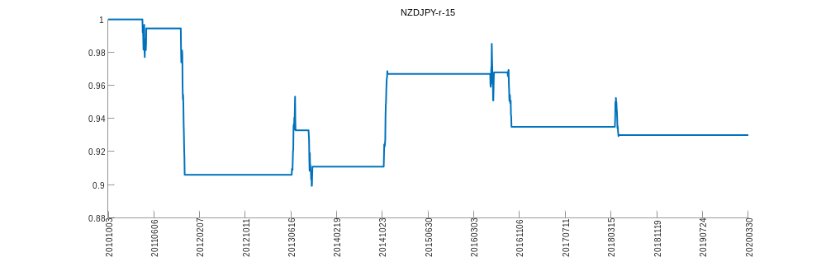
NZDUSD-r-15
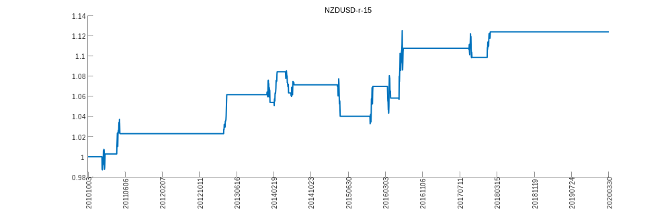
USDCAD-r-15
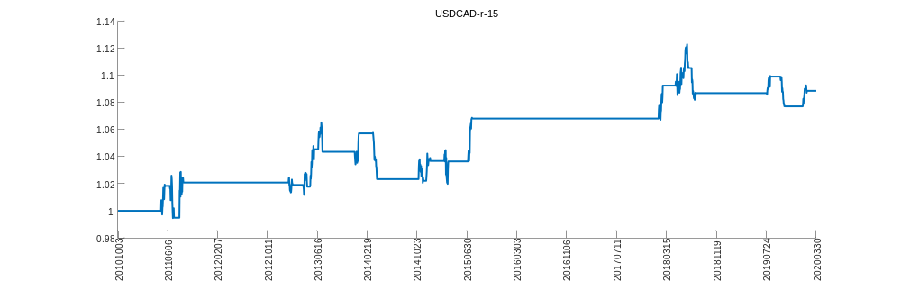
USDCHF-r-15
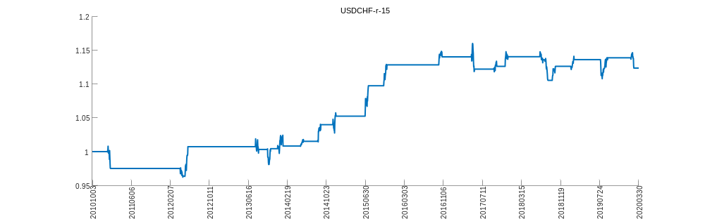
USDJPY-r-15
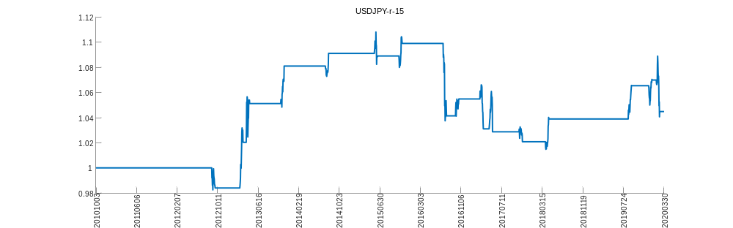
USDSGD-r-15
