验证结果20190702
1 短期收益观察
构建了每日分钟数据数据库，按文献说明统计每支股票每日第一次触发阈值（大于0.01），记录随后10分钟内不同持有时间的累积收益，结果见下表：
上涨异动信号：
上涨阈值 | 名称 | 1分钟 | 2分钟 | 3分钟 | 4分钟 | 5分钟 | 6分钟 | 7分钟 | 8分钟 | 9分钟 | 10分钟
1.00% | 收益率平均值 | 0.03% | -0.04% | -0.09% | -0.10% | -0.10% | -0.08% | -0.06% | -0.06% | -0.06% | -0.07%
 | 收益率中位值 | 0.00% | -0.14% | -0.20% | -0.23% | -0.23% | -0.22% | -0.21% | -0.22% | -0.23% | -0.25%
 | 样本胜率 | 42.76% | 36.90% | 35.28% | 35.51% | 36.38% | 37.69% | 38.67% | 39.14% | 39.15% | 39.04%
 | 样本数量 | 699024 | 697876 | 697176 | 694522 | 692894 | 691464 | 690191 | 688939 | 687703 | 686354
2.00% | 收益率平均值 | -0.16% | -0.32% | -0.39% | -0.42% | -0.44% | -0.44% | -0.42% | -0.40% | -0.40% | -0.40%
 | 收益率中位值 | -0.13% | -0.43% | -0.53% | -0.58% | -0.58% | -0.57% | -0.56% | -0.56% | -0.59% | -0.61%
 | 样本胜率 | 38.28% | 32.20% | 31.53% | 31.64% | 32.27% | 33.37% | 34.36% | 35.13% | 35.30% | 35.03%
 | 样本数量 | 60435 | 60341 | 60286 | 59925 | 59754 | 59633 | 59546 | 59442 | 59352 | 59236
3.00% | 收益率平均值 | -0.50% | -0.73% | -0.82% | -0.87% | -0.91% | -0.94% | -0.93% | -0.90% | -0.89% | -0.88%
 | 收益率中位值 | -0.43% | -0.85% | -0.97% | -1.03% | -1.07% | -1.07% | -1.05% | -1.07% | -1.08% | -1.09%
 | 样本胜率 | 32.71% | 26.65% | 26.57% | 26.41% | 26.84% | 27.21% | 28.46% | 29.61% | 30.07% | 30.17%
 | 样本数量 | 13825 | 13800 | 13783 | 13687 | 13643 | 13619 | 13593 | 13571 | 13548 | 13515
4.00% | 收益率平均值 | -0.87% | -1.16% | -1.29% | -1.34% | -1.40% | -1.46% | -1.47% | -1.44% | -1.43% | -1.40%
 | 收益率中位值 | -0.80% | -1.27% | -1.39% | -1.53% | -1.60% | -1.57% | -1.58% | -1.58% | -1.60% | -1.62%
 | 样本胜率 | 29.11% | 22.57% | 21.85% | 22.09% | 22.63% | 22.09% | 23.27% | 25.27% | 25.88% | 26.29%
 | 样本数量 | 4782 | 4772 | 4765 | 4726 | 4710 | 4699 | 4689 | 4677 | 4672 | 4655
5.00% | 收益率平均值 | -1.21% | -1.58% | -1.77% | -1.82% | -1.86% | -1.91% | -1.97% | -1.96% | -1.96% | -1.92%
 | 收益率中位值 | -1.13% | -1.68% | -1.87% | -1.98% | -2.01% | -2.03% | -2.11% | -2.12% | -2.13% | -2.08%
 | 样本胜率 | 26.61% | 18.95% | 18.38% | 18.38% | 18.91% | 18.25% | 19.09% | 20.18% | 21.77% | 22.27%
 | 样本数量 | 2165 | 2158 | 2154 | 2138 | 2131 | 2126 | 2122 | 2116 | 2113 | 2106

下跌异动信号：
下跌阈值 | 名称 | 1分钟 | 2分钟 | 3分钟 | 4分钟 | 5分钟 | 6分钟 | 7分钟 | 8分钟 | 9分钟 | 10分钟
-1.00% | 收益率平均值 | 0.12% | 0.24% | 0.32% | 0.36% | 0.36% | 0.34% | 0.31% | 0.29% | 0.29% | 0.30%
 | 收益率中位值 | 0.08% | 0.30% | 0.40% | 0.43% | 0.42% | 0.40% | 0.38% | 0.37% | 0.37% | 0.38%
 | 样本胜率 | 52.88% | 63.32% | 66.81% | 67.51% | 66.93% | 65.51% | 64.00% | 62.93% | 62.42% | 62.21%
 | 样本数量 | 514985 | 514688 | 514344 | 513463 | 512534 | 511624 | 510723 | 509793 | 508897 | 508090
-2.00% | 收益率平均值 | 0.36% | 0.60% | 0.69% | 0.72% | 0.71% | 0.68% | 0.65% | 0.62% | 0.61% | 0.63%
 | 收益率中位值 | 0.28% | 0.70% | 0.79% | 0.82% | 0.80% | 0.78% | 0.75% | 0.73% | 0.73% | 0.74%
 | 样本胜率 | 57.83% | 66.90% | 69.18% | 69.14% | 68.58% | 67.22% | 65.93% | 65.09% | 64.63% | 64.61%
 | 样本数量 | 39307 | 39277 | 39247 | 39202 | 39142 | 39070 | 39031 | 38994 | 38951 | 38911
-3.00% | 收益率平均值 | 0.78% | 1.09% | 1.18% | 1.19% | 1.19% | 1.16% | 1.12% | 1.09% | 1.09% | 1.12%
 | 收益率中位值 | 0.64% | 1.15% | 1.26% | 1.26% | 1.21% | 1.21% | 1.18% | 1.12% | 1.13% | 1.13%
 | 样本胜率 | 62.61% | 70.98% | 72.47% | 72.07% | 71.59% | 70.20% | 68.61% | 68.07% | 67.56% | 68.02%
 | 样本数量 | 8452 | 8446 | 8439 | 8426 | 8415 | 8403 | 8391 | 8384 | 8372 | 8364
-4.00% | 收益率平均值 | 1.35% | 1.67% | 1.74% | 1.69% | 1.68% | 1.68% | 1.64% | 1.63% | 1.62% | 1.68%
 | 收益率中位值 | 1.19% | 1.65% | 1.83% | 1.71% | 1.66% | 1.63% | 1.59% | 1.60% | 1.59% | 1.66%
 | 样本胜率 | 67.92% | 74.89% | 75.98% | 74.77% | 74.45% | 74.20% | 72.18% | 71.68% | 71.79% | 72.00%
 | 样本数量 | 2790 | 2788 | 2785 | 2778 | 2775 | 2767 | 2761 | 2758 | 2751 | 2750
-5.00% | 收益率平均值 | 2.02% | 2.39% | 2.43% | 2.33% | 2.33% | 2.31% | 2.32% | 2.34% | 2.35% | 2.37%
 | 收益率中位值 | 1.75% | 2.26% | 2.35% | 2.22% | 2.26% | 2.18% | 2.17% | 2.21% | 2.20% | 2.20%
 | 样本胜率 | 73.15% | 79.46% | 79.89% | 77.75% | 78.09% | 77.32% | 75.73% | 75.41% | 75.46% | 74.91%
 | 样本数量 | 1106 | 1105 | 1104 | 1101 | 1100 | 1098 | 1092 | 1090 | 1088 | 1088

2 结果对比：
验证结果
（1）上涨异动
文献结果
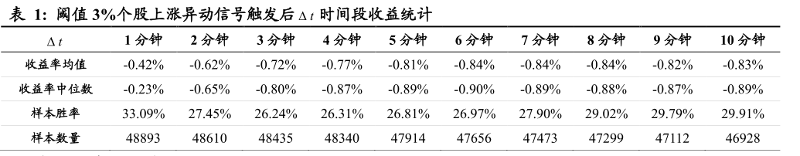
结论：
整体趋势一致，数据无法完全对应上。
原因是我们的样本数量只有文献的1/3～1/4。
猜测根本原因是我们的做法和文献实际做法不同。
文献原文描述是：
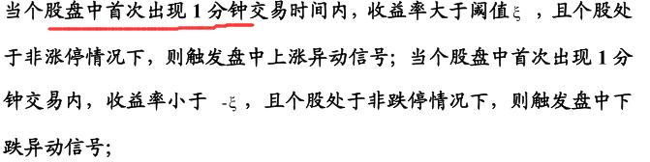
我们按照文献说明执行的时候，个股只统计了当日的第一个信号。从文献结果看，很有可能是作者统计了个股当日所有的信号，这样信号比我们的多。已经走上搜集所有信号的程序，计算时间比较长，计算完毕后再统计结果。

（2）下跌异动
验证结果
文献结果：
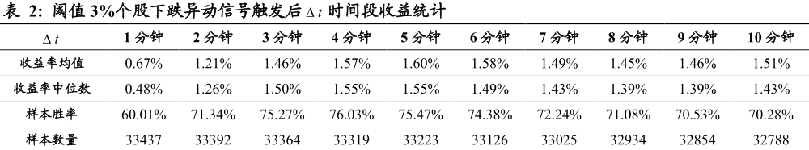
趋势图：
验证结果：
除了数值不能完全对应，趋势是一致的；

3 不同阈值对5分钟时间间隔收益的影响
（1）上涨异动验证结果：
时间间隔 | 名称 | 1% | 2% | 3% | 4% | 5%
5分钟 | 收益率平均值 | -0.10% | -0.44% | -0.91% | -1.40% | -1.86%
 | 收益率中位值 | -0.23% | -0.58% | -1.07% | -1.60% | -2.01%
 | 样本胜率 | 36.38% | 32.27% | 26.84% | 22.63% | 18.91%
 | 样本数量 | 692894 | 59754 | 13643 | 4710 | 2131
文献结果
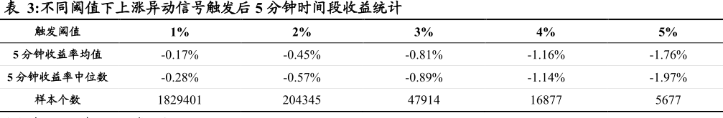
下跌异动验证结果：
时间间隔 | 名称 | -1% | -2% | -3% | -4% | -5%
5分钟 | 收益率平均值 | 0.36% | 0.71% | 1.19% | 1.68% | 2.33%
 | 收益率中位值 | 0.42% | 0.80% | 1.21% | 1.66% | 2.26%
 | 样本胜率 | 66.93% | 68.58% | 71.59% | 74.45% | 78.09%
 | 样本数量 | 512534 | 39142 | 8415 | 2775 | 1100
文献结果：
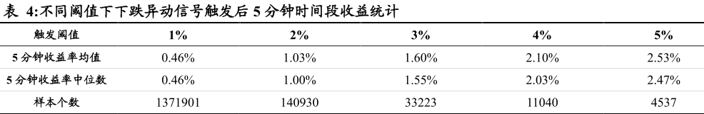
二 可行性分析：
1 收益序列分析
验证结果：
文献结果：
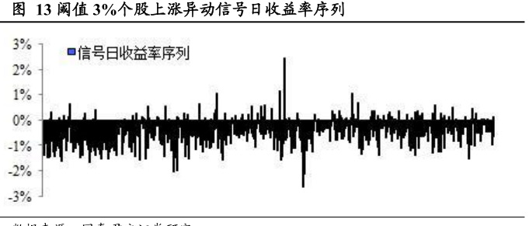
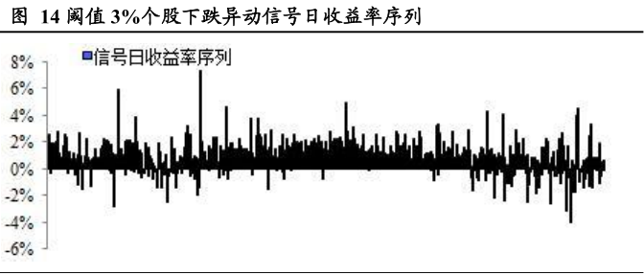
2 累积收益分析
验证结果：
文献结果
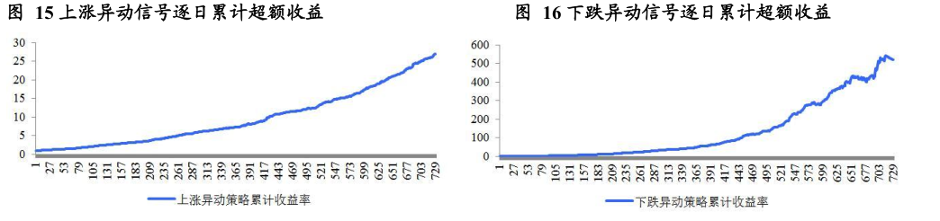
结论：
1 文献论点 收益短时异动后上涨、下跌规律正确
2 验证结果趋势和文献相同，数值和做法有差异。

下一步计划：
验证 3.1.2 集合竞价的有效性（计算时间比较长）
看3.2 盘中异动alfa再增强部分内容。

