1



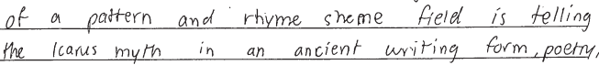

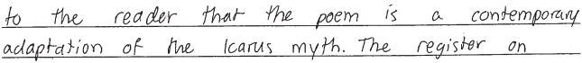

2



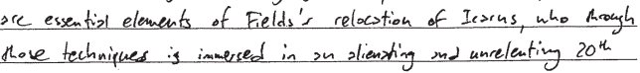

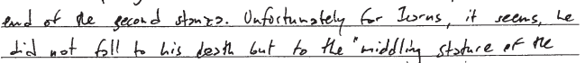

3

4

5

