Replication and Expansion: Card & Krueger (1994) Minimum Wage and Employment

I. Research problems and motivations

In April 1992, New Jersey, the United States, raised the minimum wage from $4.25 to $5.05 per hour, while Pennsylvania did not raise it, still $4.25.

The question studied in this paper is: Will raising the minimum wage cause fast food restaurants to reduce the number of employees they hire?

This question is very important. Because people have been arguing: is the minimum wage making low-income workers higher wages or making them unemployed?

The conclusion of the paper is that it has not been found that the minimum wage will make low-income workers unemployed, and not only that, employment in New Jersey has also increased compared with Pennsylvania.

II. Data sources and samples

The data comes from a survey of 410 fast food restaurants. These stores belong to four brands: Burger King, KFC, Roy Rogers and Wendy. They are distributed in New Jersey and Pennsylvania.

The investigation was carried out twice. The first time was before the salary increase, that is, from February to March 1992. The second time after the salary increase, that is, from November to December 1992.

In the sample, there are 331 stores in New Jersey and 79 stores in Pennsylvania.

The most important variable is the "full-time equivalent number of employees" (FTE). Its calculation method is:

FTE = full-time employee + manager + 0.5 × part-time employee

The variable STATE indicates which state the store is in. New Jersey is written as 1 and Pennsylvania is written as 0.

Due to the lack of some data, in the analysis, I only used 384 stores with complete data twice before and after.

III. EMPIRICAL METHOD

The method I use is double difference, that is, take New Jersey as the "treatment group" and Pennsylvania as the "control group", first calculate the change in employment in New Jersey, then calculate the change in employment in Pennsylvania, and then subtract the two.

DID = (the number of employees hired by New Jersey after the rise − the number of employees hired by New Jersey before the rise) − (the number of employees hired by Pennsylvania after the rise − the number of employees hired by Pennsylvania before the rise)

This method requires an assumption that if New Jersey does not raise wages, its employment should be the same as that of Pennsylvania. Because the two places are close to each other and the economic situation is similar, Pennsylvania is a good control group.

IV. Core reproduction results

Table 2 shows the FTE of the two states in two surveys.

FTE in New Jersey: from 20.44 to 21.03, an increase of 0.59.

Pennsylvania's FTE: from 23.33 to 21.17, a decrease of 2.16.

So the estimated value of DID is: 0.59 −(−2.16) = 2.75.

The DID calculated by regression is also 2.75, the robust standard error is 1.34, and the p value is 0.040. After adding the two control variables of brand and whether it is company-owned, the result is 2.78 (robust standard error 1.34), which has hardly changed.

In the original paper, DID is 2.76, and the standard error is 1.36, which is very close to my data.

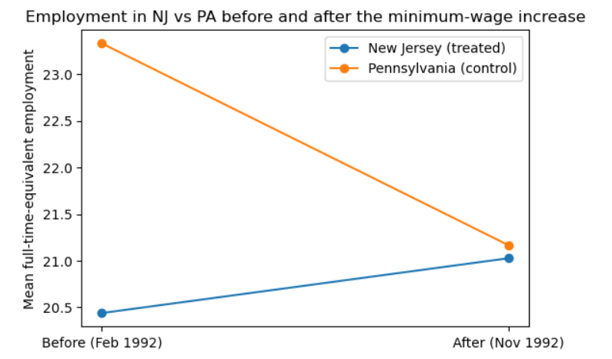
V. Independent expansion
Independent extension: Is the impact of salary increase different for different brands?

I separated the four brands and calculated the DID of each brand separately.
Brand | Number of stores | DID | Standard error
Burger King | 159 | 4.39 | 2.53
KFC | 79 | -1.59 | 1.06
Roy Rogers | 94 | 2.49 | 2.13
Wendy’s | 52 | 3.42 | 3.13

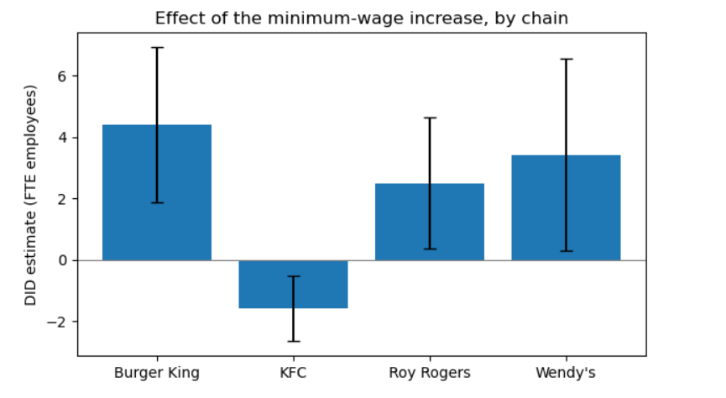
It can be seen from the figure that Burger King, Roy Rogers and Wendy's are all positively affected, and only KFC is negative.

The overall result hides some differences between brands. But none of these differences is statistically significant. Each brand has a small sample. So this result is only suggestive.

VI. Verification, limitations and conclusions

I have done some verifications. First of all, I used the robust standard error, which is more reliable than the ordinary standard error. Secondly, after I added the control variable, the result remained almost unchanged. Finally, my result is very close to the original paper. These all show that the results are more reliable.

This study also has some limitations. First of all, the sample of each brand in the extended analysis is relatively small. Secondly, only this pair of adjacent states in 1992 was studied.

My reproduction confirms Card and Krueger's findings that the increase in the minimum wage in New Jersey has not reduced employment in fast food restaurants. And in my independent expansion, I find that this impact is different between different brands.

AI-use disclosure

I used an AI assistant (Claude) in this project. It helped me understand the original paper. It drafted the Python code. It outlined the structure of this report. I checked all AI output before using it. I ran every line of the code myself. I compared every number with the original paper's Table 3. I also read the data dictionary and the paper. This confirmed the variable definitions and the FTE formula.

I also corrected one AI error. At first, the AI said my standard error differed because I used fewer control variables. I checked it myself. The real reason was the robust-standard-error setting. It was not the number of controls.

