Multimodal Emotion Recognition Using Speech and Facial Expressions
Group Final Report
NUS-ISS | Pattern Recognition Systems
Group 13
A0353874R Agarwal Hritik Kumar
A0353592X Jiang Yushan
A0351286B Lu Yujing
A0314662H Ma Bofei
A0330891A Zhang Yurun
Contents
Abstract 4
1. Introduction 5
1.1 Background and Motivation 5
1.2 Research Objectives 5
1.3 Project Scope and Contributions 5
2. Related Work 6
2.1 Handcrafted Features for Emotion Recognition 6
2.2 Deep Learning for Audio Emotion Recognition 8
2.3 Deep Learning for Facial Expression Recognition 10
2.4 Audio–Visual Fusion Methods 10
3. Dataset and Experimental Protocol 12
3.1 RAVDESS Speech Dataset 12
3.2 Data Preparation and Cross-Modal Alignment 13
3.3 Actor-Independent Data Partitioning 13
3.4 Evaluation Metrics 14
3.5 Model Selection and Evaluation Procedure 14
4. System Design and Implementation 16
4.1 Overall System Architecture 16
4.2 Audio Emotion Recognition M1 and M2 16
4.3 Visual Emotion Recognition M3 and M4 27
4.4 Multimodal Fusion 35
5. Experiments and Results 39
5.1 Audio Encoder Comparison 39
5.2 Audio Representation Comparison 40
5.3 WavLM Extension Results 42
5.4 Visual Encoder Comparison 46
5.5 Visual Representation Comparison 47
5.6 Unimodal versus Multimodal Comparison 48
5.7 Ablation and Diagnostic Results 48
5.8 Final Model Selection and Test Performance 54
5.9 External Dataset Evaluation 57
5.10 Paired Uncertainty and Calibration 58
5.11 Fusion with MFCC Transformer Representations 59
6. Discussion 62
6.1 Effectiveness of Handcrafted and Learned Representations 62
6.2 Benefits and Limitations of Multimodal Fusion 63
6.3 Per-Class Performance and Error Complementarity 64
6.4 Generalisation Across Actors and Datasets 65
6.5 Interpretation of Gating and Attention 66
6.6 Study Limitations 67
7. Final System and Reproducibility 70
7.1 Selected End-to-End Pipeline 70
7.2 Input and Output Specifications 70
7.3 Software Environment and Dependencies 71
7.4 Execution Instructions and Model Availability 71
7.5 Demonstration Interface 72
8. Conclusion and Future Work 75
8.1 Main Findings 75
8.2 Answers to the Research Objectives 75
8.3 Future Work 75
References 77
Appendix A Detailed hyperparameters and model architectures 80
Appendix B Supplementary experiment tables and training curves 82
B.1 Audio Deep Learning 82
B.2 Handcrafted Audio Preprocessing and Classifier Sweep 90
B.3 Handcrafted Audio Hyperparameter Search 93
B.4 Earlier MFCC Audio Representation Comparison 95
B.5 Handcrafted Audio Baseline V1 96
B.6 Historical Handcrafted Feature Group Ablation 97
Appendix C Per-class metrics and confusion matrices 98
C.1 Selected Deep Learned Audio System 98
C.2 Selected Visual System 103
Appendix D Feature and Model Artifact Inventory 106
Appendix E Team Contributions 108

Abstract
This project investigates whether combining speech and facial expressions improves eight-class emotion recognition under actor-independent evaluation. We use 1,440 paired RAVDESS speech trials from 24 actors, partitioned into 960 training, 240 validation and 240 test trials. The system compares compact handcrafted audio descriptors, MFCC-based CNN, BiLSTM and Transformer encoders, and a frozen WavLM backbone with supervised adaptation. Visual alternatives include local wavelet features with an RBF-SVM and frozen ImageNet-pretrained encoders. Decision fusion, feature concatenation, gating and cross-attention are evaluated alongside corresponding unimodal controls, using validation macro-F1 for model selection.
The final WavLM audio head achieves test macro-F1 of 0.8321. Concatenation, selected among the three primary neural fusion candidates by mean validation macro-F1, achieves 0.8116 ± 0.0057 across three seeds, compared with 0.8209 ± 0.0038 for the matched audio-only MLP. Tuned decision fusion reaches 0.8349, but paired analyses do not resolve its small difference from the original audio head. In the earlier MFCC Transformer setting, concatenation and gating improve the matched audio control by 7.50 and 11.02 percentage points on the fixed test partition. A local application completes inference on all 24 CREMA-D pilot clips, although concatenation recognises only 9/24. Fusion therefore provides representation-dependent benefits rather than a consistent gain over strong audio. Repeated validation use, prior test exposure and the small number of evaluation actors limit generalisation claims.
Keywords: multimodal emotion recognition; speech; facial expressions; RAVDESS; actor-independent evaluation.

1. Introduction

1.1 Background and Motivation
Emotion recognition from speech and facial expressions uses acoustic and visual observations to estimate expressed affect. Speech conveys changes in intensity, spectral structure and temporal delivery, while facial video provides spatial and temporal expression cues (Juslin & Laukka, 2003; Tzirakis et al., 2017). These sources may complement one another, but their reliability and ability to generalise can differ. Adding an informative modality can correct errors; adding weak or poorly transferred evidence can also disturb correct predictions (Wang et al., 2020).
Actor-independent evaluation is essential for this project because recordings from the same speaker share appearance, voice and recording characteristics. A random recording-level split could reward recognition of these characteristics rather than transfer to new actors. We therefore compare complete audio, visual and fusion pipelines under one shared actor partition, separating upstream representation choice from downstream classifier and fusion design.

1.2 Research Objectives
The project has four objectives: compare MFCC-based audio encoders and handcrafted, learned and combined audio representations; compare visual encoders and handcrafted, learned and combined visual systems; evaluate decision, concatenation, gated and cross-attention fusion against corresponding unimodal controls; and deliver a reproducible application that connects video input to predictions and inspectable diagnostics. Macro-F1 is the primary comparison and selection metric.
Central research question: Does combining speech and facial-expression information improve eight-class emotion recognition compared with the corresponding unimodal systems under actor-independent evaluation?

1.3 Project Scope and Contributions
The main task uses paired RAVDESS speech and facial video for eight expressed-emotion labels (Livingstone & Russo, 2018). M1 covers handcrafted audio and audio representations; M2 covers learned audio and the WavLM extension; M3 covers handcrafted vision and visual representation integration; M4 compares learned visual encoders; and M5 evaluates fusion and system integration. WavLM is distinguished from the MFCC encoders because it adds external pretraining and waveform input.
The contributions include aligned exports, matched unimodal controls, fusion ablations, paired error analysis and a local video interface. A CREMA-D pilot examines external processing and recognition. The evidence indicates representation-dependent fusion gains, with limitations from repeated validation and prior test exposure.

2. Related Work
Audio–visual affect research motivates separating representation quality from fusion complexity. We connect domain-specific emotion models, tensor interactions and constrained attention to the controlled comparisons used in this study.

2.1 Handcrafted Features for Emotion Recognition

2.1.1 Handcrafted Acoustic Features for Speech
Research on vocal emotion has shown that emotional state changes measurable properties of the speech signal: loudness, pitch level and range, speaking rate, voice quality and the distribution of spectral energy (Murray & Arnott, 1993). In a review of more than one hundred studies, Juslin and Laukka (2003) found that these acoustic cues reliably separate high-arousal emotions such as anger and fear from low-arousal emotions such as sadness and tenderness, whereas emotions of similar arousal but different valence are much harder to separate. Conventional speech emotion recognition systems therefore compute frame-level low-level descriptors (LLDs) and summarise each descriptor over the utterance with statistical functionals such as the mean, standard deviation and extrema. This produces a fixed-length vector for a conventional classifier (El Ayadi et al., 2011).
This LLD-plus-functionals design was standardised in benchmark feature sets. The INTERSPEECH 2009 Emotion Challenge baseline applied functionals to energy, zero-crossing rate, pitch, voicing probability and MFCC contours (Schuller et al., 2009), and the openSMILE toolkit made such feature sets widely reproducible (Eyben et al., 2010). The Geneva Minimalistic Acoustic Parameter Set (GeMAPS) later showed that a small, theory-motivated set of parameters can remain competitive with brute-force feature sets of several thousand dimensions while being easier to interpret (Eyben et al., 2016). Spectral-shape descriptors, namely centroid, bandwidth and roll-off, originated in general audio classification (Tzanetakis & Cook, 2002), and spectral flatness measures how noise-like rather than tonal a frame is (Johnston, 1988).
Wavelet analysis offers a complementary time–frequency view. The discrete wavelet transform (DWT) decomposes a signal into octave sub-bands with a time resolution that varies with frequency (Mallat, 1989). Statistics of the sub-band coefficients have been used successfully for speech emotion recognition, where they capture energy and variability in frequency regions associated with voicing, formants and fricative noise (Daqrouq et al., 2024).
How this informed the design. The handcrafted audio baseline (M1) follows the LLD-plus-functionals pattern but restricts the representation to three compact, interpretable descriptor families (time-domain, FFT-spectral and DWT) with four statistics each, giving 48 dimensions (Section 4.2.2). The descriptors named in the proposal were kept, while the wavelet family, amplitude normalisation, frame length and classifier were treated as experimental factors rather than fixed in advance. Because the handcrafted vector is low-dimensional and its features have known physical meaning, it serves both as the classical baseline for the audio modality and as a candidate complement to the learned audio representations reviewed in Section 2.2.

2.1.2 Handcrafted Visual Features for Facial Expression Recognition
Before deep convolutional models became dominant, facial expression recognition commonly relied on handcrafted representations derived from facial geometry or appearance. Geometric approaches describe the positions and movements of facial landmarks, whereas appearance-based approaches encode changes in facial texture, edges and gradients. Because expressions often produce subtle deformations around the eyes, eyebrows and mouth, local appearance descriptors can preserve discriminative information that may be weakened when the entire face is represented using only global statistics. For example, Shan et al. (2009) showed that dividing a face into local regions and concatenating their texture descriptors can support person-independent facial expression recognition.
Wavelet transforms provide an alternative handcrafted representation with joint spatial and frequency localisation. A two-dimensional discrete wavelet transform decomposes an image into a low-frequency approximation subband and horizontal, vertical and diagonal detail subbands. The approximation coefficients retain coarse facial structure, while the detail coefficients capture edge and texture changes associated with facial muscle movement. Qayyum et al. (2017) demonstrated that wavelet subbands can represent expression-related horizontal and vertical movements, while other studies have combined wavelet-derived features with conventional classifiers for facial expression recognition (Ali et al., 2018). Haar wavelets are particularly suitable for a lightweight system because they provide a simple and computationally efficient decomposition of an image into coarse and directional components.
The spatial distribution of these responses is also important. Pooling statistics over an entire face can discard information about where a texture change occurs, even though similar edge responses may have different meanings in the eye, cheek and mouth regions. Region-based facial-expression methods therefore partition the face and describe each region separately before concatenating the local descriptors. This retains a coarse spatial layout while avoiding the dimensionality and data requirements of learning directly from pixels. Such a representation is appropriate for relatively small datasets because it introduces an explicit structural prior: expressions are characterised not only by the presence of particular frequency responses, but also by their locations within the face.
Support vector machines are frequently paired with handcrafted facial representations because they can construct nonlinear decision boundaries in moderate-dimensional feature spaces. In particular, the radial basis function kernel can model nonlinear relationships between local facial patterns and emotion classes, while feature standardisation prevents descriptors with larger numerical ranges from dominating the classifier. Previous facial-expression systems have successfully combined wavelet-based representations with SVM classification, supporting this combination as a lightweight alternative or complement to deep visual encoders (Ali et al., 2018).
These findings informed the design of the M3 handcrafted visual stream. The system uses aligned grayscale face crops, Haar two-dimensional DWT subbands and region-wise statistical aggregation to preserve both frequency information and coarse spatial structure. The resulting representation is classified using a standardised RBF-SVM. Rather than assuming that either global or local wavelet statistics would be sufficient, the implementation compared alternative crop and spatial-partitioning designs experimentally. The selected Full-320 representation and its experimental evaluation are described in Sections 4.3 and 5.5, respectively.

2.2 Deep Learning for Audio Emotion Recognition
Deep learning approaches to speech emotion recognition use neural networks to learn emotion-related representations from speech. Emotional cues appear in both local spectral characteristics and patterns that evolve over time. Models therefore need to capture local acoustic information as well as longer-range contextual relationships. Common approaches include convolutional neural networks, recurrent neural networks, Transformers, and self-supervised pretrained speech models.
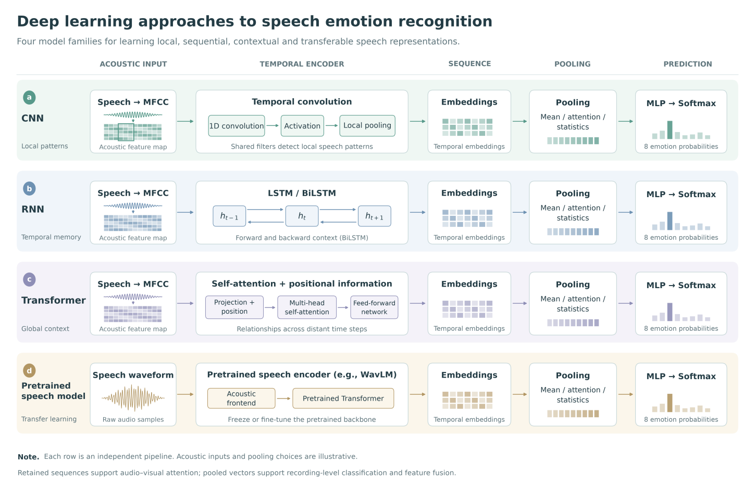
Figure 2.1. Overview of audio encoder families considered in this study.

2.2.1 Convolutional and Recurrent Neural Networks
Convolutional neural networks (CNNs) learn acoustic patterns through local connections and shared parameters. For sequential inputs such as mel-frequency cepstral coefficients (MFCCs), one-dimensional convolutions can capture changes across neighbouring speech frames. Previous research has combined MFCCs with 1D-CNNs for speech emotion recognition, illustrating the use of acoustic features alongside convolutional modelling. However, a convolutional network’s ability to capture distant relationships depends on its receptive field and architecture (Mary Little Flower & Jaya, 2024).
Recurrent neural networks process sequences by progressively updating hidden states. Long short-term memory (LSTM) networks introduce gating mechanisms to improve the learning of longer-term dependencies (Hochreiter & Schmidhuber, 1997). Bidirectional LSTMs (BiLSTMs) combine forward and backward contextual information, making them suitable for examining relationships between earlier and later segments of a complete recording. Compared with local convolutions, recurrent models explicitly represent sequential evolution, although their recursive computation limits parallel processing across time steps.

2.2.2 Transformers and Temporal Aggregation
Transformers use self-attention to establish relationships between different sequence positions and incorporate positional information to represent temporal order. Unlike recurrent models, self-attention supports parallel sequence processing and can directly connect distant segments, providing an alternative approach to contextual modelling in speech. Nevertheless, its computational and memory requirements increase with sequence length, while learning effective representations from limited labelled data can remain challenging (Vaswani et al., 2017).
These encoders typically produce temporal features, whereas recording-level emotion classification requires a representation of the complete utterance. Temporal aggregation bridges this gap. Mean pooling provides a simple overall summary, attention pooling assigns learnable weights to different segments, and statistics pooling uses measures such as the mean and standard deviation to describe feature distributions. Retaining the sequence before pooling also supports subsequent cross-modal attention, allowing fusion models to exploit temporal relationships between audio and visual information.

2.2.3 Self-Supervised Pretrained Speech Models
Self-supervised learning uses large speech datasets to construct pretraining tasks, reducing dependence on manual annotations. The resulting representations can then be transferred to downstream tasks. WavLM is a representative approach that combines masked speech prediction and denoising to learn general speech representations relevant to spoken content, speaker characteristics, and other speech attributes (Chen et al., 2022). WavLM Base+ was pretrained on approximately 94,000 hours of speech, providing a transferable representation foundation for tasks with limited labelled data (Microsoft, n.d.).
Pretrained models can be adapted to emotion recognition by freezing the backbone and training downstream modules, or by updating some or all backbone parameters. Freezing reduces the number of trainable parameters and the cost of downstream training. Updating the backbone provides greater scope for task-specific adaptation but may increase overfitting risk. Comparisons with models trained from scratch should therefore distinguish the contributions of architecture, input representation, and external pretraining data.
Overall, CNNs, BiLSTMs, and Transformers offer complementary capabilities for modelling local patterns, bidirectional temporal dependencies, and global context. Self-supervised pretraining additionally provides access to representations learned from large external speech datasets. Together, these approaches establish the conceptual basis for comparing speech representations and temporal modelling strategies, while informing subsequent audio classification and audio–visual fusion.

2.3 Deep Learning for Facial Expression Recognition
Deep learning is commonly used for facial expression recognition because it can automatically extract useful facial features from images. Convolutional Neural Networks (CNNs) are particularly suitable for this task, as they can capture visual patterns such as changes in facial muscles, eyes, and mouth movements.
Different CNN architectures offer different advantages. MobileNetV3 is a lightweight model designed for efficient feature extraction, while ResNet18 uses residual connections to learn more complex visual features. Pretrained models can also be used to extract features without training the entire network from scratch, which is useful when the available dataset is relatively small.
For video-based emotion recognition, information from multiple frames needs to be combined into a single representation. Mean pooling provides a simple approach by averaging the features extracted from each frame. However, it does not consider the order of the frames. BiLSTM provides an alternative by learning temporal relationships across the frame sequence, which may help capture changes in facial expressions over time.
Based on these approaches, we explored three models for visual emotion recognition: MobileNetV3-Small with Mean Pooling, ResNet18 with Mean Pooling, and ResNet18 with BiLSTM. These models allow us to compare different feature extraction architectures and temporal modeling methods.

2.4 Audio–Visual Fusion Methods
The central question is when vision can improve emotion recognition while preserving correct audio decisions. We compare decision, feature and sequence fusion with matched unimodal heads in MFCC Transformer and WavLM representation settings, and use paired errors to measure both corrections and interference.
Audio–visual emotion recognition depends on both the quality of each representation and the mechanism that combines them. Tzirakis et al. (2017) jointly model raw speech and facial video using convolutional encoders and recurrent temporal processing for continuous affect on RECOLA. Their work motivates evaluating representation learning alongside fusion. Our task instead uses eight categorical RAVDESS labels and frozen exports, allowing the downstream fusion heads to be compared on common inputs.
Decision fusion combines class probabilities, while feature concatenation learns over pooled vectors. Gated multimodal units add input-dependent multiplicative weights (Arevalo et al., 2017). These methods provide progressively more flexible combinations, with corresponding unimodal and fixed-gate controls.
Tensor Fusion Networks explicitly represent cross-modal interactions through outer products (Zadeh et al., 2017). Low-rank fusion factorises such interactions to reduce their cost (Liu et al., 2018). TFN was developed for multimodal sentiment analysis; it is a mechanism reference here, while rank-4 fusion is the implemented interaction model. Projected concatenation tests whether the projections alone account for its performance.
MulT uses directional crossmodal attention over differently sampled sequences (Tsai et al., 2019). We implement audio-query attention and a bidirectional variant. Multimodal Bottleneck Transformers restrict information exchange to a small set of latent tokens, reducing unrestricted pairwise interaction (Nagrani et al., 2021). MBT was evaluated on audiovisual classification benchmarks, including AudioSet and VGGSound. It motivates a constrained-interaction comparison, but is not an implemented experiment in this study.
Different generalisation rates can make additional interactions disturb a stronger modality (Wang et al., 2020). Residual corrections, auxiliary objectives and repair/harm counts therefore test how fusion preserves correct audio predictions. Supervised contrastive losses use an auxiliary cross-entropy control (Khosla et al., 2020).

3. Dataset and Experimental Protocol

3.1 RAVDESS Speech Dataset
The main experiments use the RAVDESS speech recordings associated with Livingstone and Russo (2018), excluding the song channel. There are 24 actors, with 12 male and 12 female actors, and 60 speech trials per actor, giving 1,440 paired audio–visual trials. Each actor performs two statements with two repetitions. The eight labels are neutral, calm, happy, sad, angry, fearful, disgust and surprise. All non-neutral emotions have normal and strong intensity; neutral has normal intensity only. Table 3.1 reports the resulting counts. The supplied manifests retain every trial; no sample exclusion is reported for the main comparisons.
The audio-only speech files and corresponding visual exports share trial metadata. Dataset provenance is recorded through manifests, file and checkpoint hashes, and the RAVDESS citation. The separate CREMA-D pilot contributes no data to RAVDESS training or model selection.
Emotion class | Paired samples | Train | Validation | Test
neutral | 96 | 64 | 16 | 16
calm | 192 | 128 | 32 | 32
happy | 192 | 128 | 32 | 32
sad | 192 | 128 | 32 | 32
angry | 192 | 128 | 32 | 32
fearful | 192 | 128 | 32 | 32
disgust | 192 | 128 | 32 | 32
surprise | 192 | 128 | 32 | 32
Total | 1,440 | 960 | 240 | 240
Table 3.1. Final class distribution after integrity checks and exclusions.

3.2 Data Preparation and Cross-Modal Alignment
RAVDESS filenames contain seven two-digit fields: modality, vocal channel, emotion, intensity, statement, repetition and actor. Metadata checks validate the speech channel, the ranges of the emotion and trial fields, the absence of strong neutral trials, and agreement between actor IDs and actor folders. Dataset checks require unique trial IDs, 60 trials per actor and the class counts in Table 3.1. Only the modality field and extension are removed to form the canonical six-field sample_id; for example, 03-01-06-01-02-01-12.wav becomes 01-06-01-02-01-12. Leading zeros are preserved.
Audio and visual exports are joined one-to-one by this canonical ID rather than by row order. The integration checks reject duplicate or missing IDs, mismatched labels, actors or split tags, incompatible feature dimensions, non-finite values and probability-class misalignment. Probability rows must be finite, non-negative and normalised. The shared class order is given in Section 3.4; surprised is treated only as an alias of surprise. A corrupt or unmatched record must be resolved consistently across both modalities before a comparison; it must not be silently dropped from one branch. The accepted final exports contain all 1,440 original trials.
Audio preprocessing produces non-empty finite mono signals at 16 kHz after boundary-silence trimming. Visual preprocessing samples 16 frames uniformly in temporal order, aligns detected faces and resizes them to 224 × 224 pixels. A missed detection reuses the nearest successful frame’s bounding box; a clip with no successful detections uses a centre-crop fallback. Thus, detection failure alone does not exclude a trial. Frame indices, timestamps and detection flags are retained. Chapter 4 gives branch-specific preprocessing and augmentation parameters.

3.3 Actor-Independent Data Partitioning
The fixed manifest multimodal_fusion/configs/actor_splits.csv defines the partition in Table 3.2. It was constructed with seed 42 by shuffling male and female actors separately and assigning 8 + 8 actors to training, 2 + 2 to validation and 2 + 2 to test. Actors are disjoint across partitions. M1–M5 use the same assignments, with 960/240/240 original trials. The equivalent fusion configuration is configs/actors_m2.json; the historical configs/actors.json development default is not the main experimental split.
Partition | Actor IDs | Actors | Paired samples
Training | 1, 4, 5, 6, 7, 10, 11, 12, 13, 15, 16, 18, 19, 20, 23, 24 | 16 | 960
Validation | 9, 14, 21, 22 | 4 | 240
Test | 2, 3, 8, 17 | 4 | 240
Table 3.2. Shared actor-independent partition manifest.
All fitted scalers, feature statistics and normalisers use training data only. Sequence statistics exclude padded positions. Augmentation applies only to training data and preserves each source actor’s assignment. Actor-grouped inner folds fit their own preprocessing and classifiers on fit actors, keeping all augmented copies with their source trial. In M1, StratifiedGroupKFold uses four actor groups with shuffling and seed 42; M3 uses four deterministic GroupKFold partitions without shuffling and seed 0 for its classifiers.
M1 and M3 export out-of-fold probabilities for the 960 original training trials: each fold fits on 12 training actors and predicts the four held-out training actors. Validation and test probabilities come from the final classifier fitted on the full training split. M2 audio training probabilities are in-sample, not out-of-fold. The reported decision fusion selects its weight using validation probabilities, without fitting a second-level classifier on those in-sample audio predictions. Feature-based fusion consumes frozen representations. An actor-grouped classifier fit on fixed M2 features is not end-to-end cross-validation of the supervised audio adapter, which already saw all 16 training actors; Section 6.6 discusses this limitation.

3.4 Evaluation Metrics
For class c, precision is TP_c/(TP_c + FP_c), recall is TP_c/(TP_c + FN_c), and F1_c is 2TP_c/(2TP_c + FP_c + FN_c). Undefined scores are set to zero. The primary metric is macro-F1 = (1/8) Σ_c F1_c, giving each of the eight classes equal weight despite neutral having half the support of each other class. Macro-precision and macro-recall likewise average the eight class-wise values; accuracy is the number of correct predictions divided by the number of evaluated trials. Macro-F1 is not the harmonic mean of macro-precision and macro-recall.
The fixed label and probability-column order is 0 neutral, 1 calm, 2 happy, 3 sad, 4 angry, 5 fearful, 6 disgust and 7 surprise. Predictions use argmax over all eight classes unless a separately documented analysis states otherwise. Main comparisons report scores on a 0–1 scale; audio-development tables that use percentage accuracy label that scale explicitly. Differences between percentage scores are expressed in percentage points. Per-class precision, recall, F1 and support accompany confusion matrices with true labels on rows and predicted labels on columns. A single-run matrix sums to its evaluation count; any mean matrix across seeds is explicitly labelled.
The 24-clip CREMA-D pilot has six intended-emotion reference classes but retains the eight-class prediction space. Its primary macro-F1 averages the six reference classes, so it is not directly comparable with RAVDESS eight-class macro-F1. Calm and surprise predictions remain errors. The sample-selection and label policy are described in Section 5.9.

3.5 Model Selection and Evaluation Procedure
Model and configuration choices use validation macro-F1 within declared comparison groups. Neural checkpoints retain the epoch with the highest validation score, keeping the earlier epoch on a tie. M1 uses actor-grouped training-fold searches followed by validation comparison; M3 selects the visual representation, augmentation and SVM settings on validation. In the final WavLM fusion setting, the primary neural comparison is restricted to concatenation, gating and forward cross-attention on the selected inputs. The highest mean validation macro-F1 selects concatenation. This is not a claim that it is the best validation model among all supplementary architectures.
Decision fusion separately searches the audio weight α over {0, 0.05, …, 1}, selecting validation macro-F1 and breaking ties by proximity to 0.50. The paper’s exported audio-plus-visual-SVM configuration selects α = 0.60; the application’s visual-MLP configuration selects α = 0.70. These are different classifier configurations. The earlier MFCC Transformer fusion study retains its own validation-selected model and is not reselected using its test rankings.
The MFCC audio study contains 33 fits and the WavLM extension 15 fits; most use seed 42, while later MFCC settings also use seeds 7 or 17 with changed hyperparameters. They are not repeated-seed runs of one configuration. M1’s main sweep contains 270 fits, followed by grouped tuning and representation comparisons. M3’s visual comparison uses seed 0. The final WavLM fusion suite contains 93 neural fits, 27 SVM configurations and 10 fixed probability pipelines. Neural fusion comparisons use seeds 42, 43 and 44 and report the arithmetic mean of seed-specific metrics ± sample standard deviation, rather than metrics of averaged probabilities. These standard deviations measure optimisation variation on one partition, not uncertainty across actor populations. Fixed classifiers receive no artificial seed standard deviation.
Each experiment is identified by its input version, complete extractor–representation–fusion–classifier pipeline, trainable and frozen components, seed, selection rule and run or artifact ID, following docs/experiment-recording.md. Saved configurations, manifests, hashes, validation/test predictions and training histories support traceability. Seeds and implementation settings are recorded where available; the study does not claim bitwise determinism across devices or library versions. Appendix B records audio run identities and Appendix D identifies final artifacts.
For the reported final evaluation pass, checkpoints and configurations were locked before test inference. However, the test partition was not untouched throughout project development: M1’s V1 prototype produced test scores; W05 test results preceded the later WavLM refinements; and fusion development had inspected the same test actors. Retrospective reporting subsequently completed test records for all 48 audio fits. The recorded training workflows used training/validation data, and final selections were not replaced by higher test-ranked candidates, but prior exposure still limits confirmatory interpretation. These results are therefore exploratory estimates on a fixed partition. Paired actor-bootstrap and correctness analyses use saved predictions without refitting; they do not repeat model selection or correct for all comparisons.

4. System Design and Implementation
The system uses frozen audio and visual representations with common sample IDs and actor partitions. Fusion heads share the same input artifacts, while a local application connects raw-video extraction to prediction and inspection.

4.1 Overall System Architecture
The system separates upstream representation learning from downstream fusion. Audio and visual modules export pooled vectors, temporal sequences and class probabilities under the alignment contract in Chapter 3. Frozen exports feed independently trained unimodal and multimodal heads, allowing representation controls and fusion comparisons on common inputs.
At inference, a local application extracts the required audio and facial representations from an uploaded video and applies a compatible saved head. Figure 4.1 shows the final WavLM configuration; Chapter 7 describes execution and the distinction between exported-data evaluation and raw-video inference.
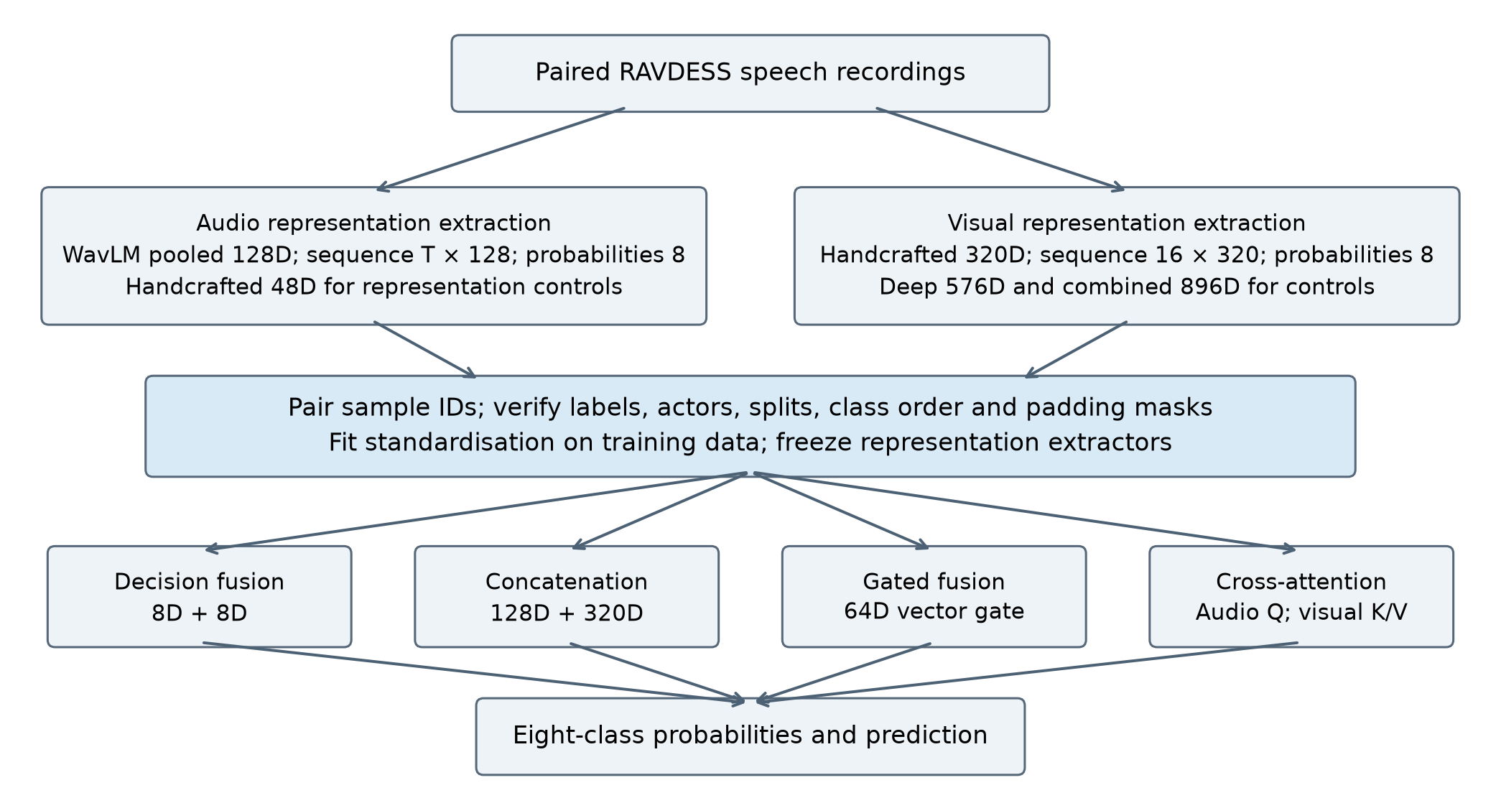
Figure 4.1. Audio and visual representation exports and fusion branches in the final WavLM configuration. Each fusion branch is trained and evaluated separately.

4.2 Audio Emotion Recognition M1 and M2
The audio subsystem includes the M1 handcrafted baseline, the M2 MFCC encoder comparison and the WavLM transfer-learning extension. Their preprocessing, feature dimensions, classifiers and exports are specified below; the common data and evaluation protocol is defined in Chapter 3.

4.2.1 Audio Preprocessing and Training-Only Augmentation

Handcrafted Audio Processing Overview
Figure 4.2 summarises the handcrafted audio branch (M1), from the RAVDESS recordings to the hand-over to multimodal fusion (M5).
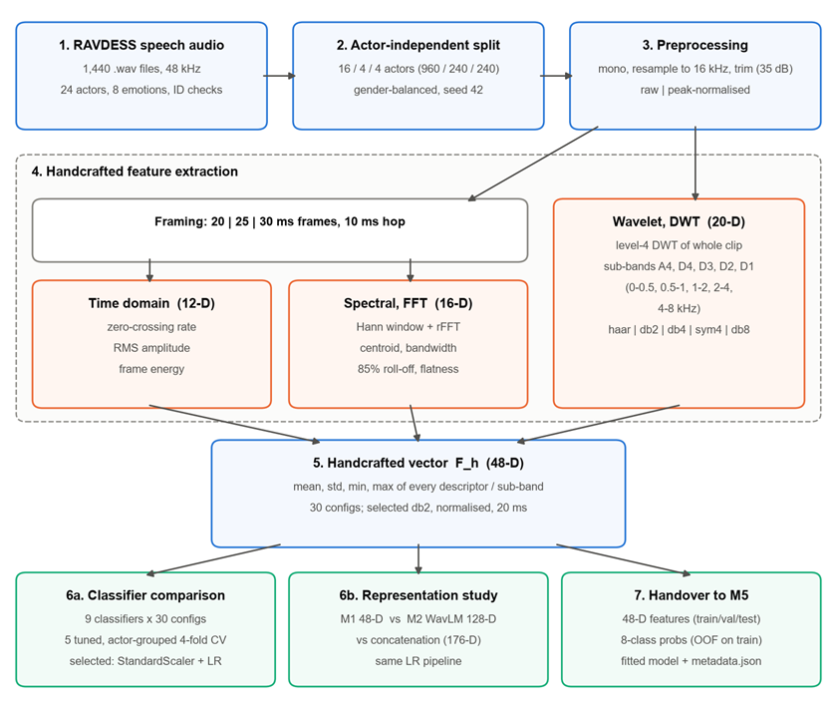
Figure 4.2. Handcrafted audio pipeline (M1): data preparation, preprocessing, feature extraction, classifier and representation studies, and hand-over to fusion.

Preprocessing for Handcrafted Features
Each recording is loaded as mono at its native 48 kHz rate and resampled to 16 kHz with librosa (McFee et al., 2015). The 0–8 kHz band retained at this rate contains the speech information relevant to emotion, and resampling reduces computation threefold. Leading and trailing silence is trimmed with librosa.effects.trim at top_db = 35. Two amplitude variants are then produced: raw, which keeps the recording's absolute level, and normalised, which divides by the absolute peak so that the maximum amplitude is 1. The proposed denoising step was not applied because RAVDESS consists of studio recordings with very low background noise, and the handcrafted branch uses no training augmentation (Section 6.6).
Before feature extraction, every recording was passed through both variants and checked (src/experimental_v2/run_preprocessing_validation.py): a 16 kHz output rate, a non-empty and finite signal after trimming, equal lengths for the raw and normalised variants, and a normalised peak of 1.0 (±10⁻⁶). All 1,440 recordings passed (Table 4.1). Trimming at 35 dB below the peak removed on average 46% of each file, mainly the leading and trailing silence present in every RAVDESS recording.
Statistic | Original duration (s) | After trimming (s) | Retained (%)
Mean | 3.70 | 2.01 | 54.0
Median | 3.67 | 1.89 | 50.7
Minimum | 2.94 | 1.18 | 38.6
Maximum | 5.27 | 4.31 | 100.0
Table 4.1. Preprocessing validation over all 1,440 recordings.

Preprocessing and Augmentation for Deep Learning Features
The deep audio branch uses mono 16 kHz recordings with boundary-silence trimming, variable valid durations and batch padding. The common split, training-only standardisation and padding-mask conventions follow Chapter 3. The MFCC and WavLM branches differ in waveform normalisation and training augmentation as described below.
After silence trimming, the MFCC branch normalises the waveform peak amplitude to 0.95. Training augmentation includes additive noise, piecewise time warping, and amplitude scaling. The experiment configuration determines whether augmentation is enabled and its application probability. Augmentation is disabled during validation, testing, and feature export. The implementation includes optional denoising, but this option is disabled in the reported configurations.
The WavLM branch uses waveform processing compatible with the pretrained model. It uses the official processor settings, with do_normalize set to False, rather than the peak normalisation used by the MFCC branch. The final WavLM model does not apply waveform augmentation; mixup is applied only to pooled learned features during training. Processing settings are documented separately for the two branches to distinguish their input preparation procedures.

4.2.2 Handcrafted Time-Domain Spectral and Wavelet Features
The handcrafted branch describes each trimmed utterance with three families of descriptors (time-domain, FFT-spectral and discrete-wavelet) and summarises every descriptor with the same four statistics, giving a 48-dimensional vector F_h (Table 4.2).

Frame-Level Time-Domain and Spectral Descriptors
Time-domain and spectral descriptors are computed on overlapping frames of N samples with a 10 ms hop (160 samples). For frame lengths of 20, 25 and 30 ms, N = 320, 400 and 480 samples, giving frequency resolutions of 50, 40 and 33.3 Hz. For a frame x_t[n], n = 0, …, N − 1, the zero-crossing rate, root-mean-square (RMS) amplitude and energy are
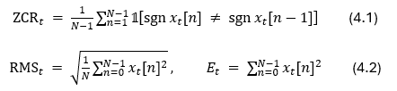
Spectral descriptors use the magnitude spectrum X_t[k] = |rFFT(w[n] · x_t[n])| of the Hann-windowed frame, with bin frequencies f_k = k · f_s / N and power P_t[k] = X_t[k]²:
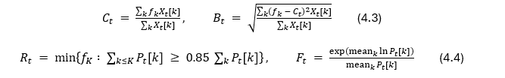
Here C is the spectral centroid (the brightness of the frame), B the spectral bandwidth (its spread around the centroid), R the 85% roll-off frequency and F the spectral flatness, which approaches 1 for noise-like frames and 0 for tonal ones.

Discrete Wavelet Transform Features
The wavelet features use a level-4 DWT of the whole trimmed utterance (pywt.wavedec, PyWavelets; Lee et al., 2019), which yields one approximation and four detail coefficient vectors:
Table 4.3 gives the nominal frequency range of each sub-band at 16 kHz. Because they are computed on the whole utterance, the DWT features do not depend on the frame length.

Statistical Aggregation and the 48-D Representation
Every frame-level descriptor sequence and every DWT coefficient vector v is summarised with the same four statistics, φ(v) = [mean(v), std(v), min(v), max(v)]. The resulting 12 descriptors × 4 statistics form the 48-D representation in Table 4.2.
Group | Descriptors (per frame or per sub-band) | Statistics | Dim.
Time domain | Zero-crossing rate, RMS amplitude, frame energy | mean, std, min, max | 12
Spectral (FFT) | Spectral centroid, bandwidth, 85% roll-off, flatness | mean, std, min, max | 16
Wavelet (DWT) | Coefficients of sub-bands A4, D4, D3, D2, D1 | mean, std, min, max | 20
Total |  |  | 48
Table 4.2. The 48-D handcrafted representation F_h. Columns are named <descriptor>_<statistic> (for example zcr_mean or d1_max) and carry an m1_ prefix in the hand-over files.
Sub-band | A4 | D4 | D3 | D2 | D1
Nominal band (kHz) | 0–0.5 | 0.5–1 | 1–2 | 2–4 | 4–8
Typical content (approx.) | F0 and first harmonics | F1 region | F1–F2 | F2–F3, upper formants | fricatives, breath noise
Table 4.3. Level-4 DWT sub-bands at a 16 kHz sampling rate.
The time-domain group mainly encodes intensity and voicing: RMS and energy follow loudness, which correlates with arousal, and the zero-crossing rate rises in unvoiced and noisy segments. The spectral group describes the balance of low- and high-frequency energy, which shifts upward in tense, high-arousal speech. The wavelet group adds a multi-resolution view of how energy and amplitude extremes are distributed across octave bands.

Preprocessing Configuration Space
Instead of fixing the front end in advance, M1 treated three settings as experimental factors: wavelet ψ ∈ {haar, db2, db4, sym4, db8}, amplitude normalisation ∈ {raw, normalised} and frame length ∈ {20, 25, 30} ms. This gives 30 complete 48-D datasets of 1,440 rows each, built from 22 group-level feature files (6 time-domain, 6 spectral and 10 DWT). combine_features.py joins the three groups on sample_id with one-to-one validation and checks that the metadata agree, that there are exactly 48 feature columns and that every value is finite.

Scaling, Feature Selection and Handcrafted Classifier
Features are standardised by a StandardScaler placed inside each scikit-learn pipeline (Pedregosa et al., 2011), so its mean and variance are estimated only on the training recordings of each fit or cross-validation fold. No feature selection is applied in the final pipeline; all 48 features are used, and a reduced 43-D set was tested only in the first prototype (Appendix B.6). The selected classifier is a StandardScaler followed by multinomial LogisticRegression (L2 penalty, C = 1.0, lbfgs, max_iter = 3000, random_state = 42), trained on the db2 / normalised / 20 ms features. It was chosen over eight other classifiers and over tuned variants by validation macro-F1 (Sections 5.2.1–5.2.2).

4.2.3 MFCC-Based CNN BiLSTM and Transformer Encoders

MFCC Input and Shared Output Structure
CNN, BiLSTM, and Transformer encoders are implemented as three independent audio classification models. They model local changes, bidirectional temporal dependencies, and global contextual relationships, respectively. All three receive MFCC sequences of the same form and are optimised separately rather than connected in series.
MFCC extraction uses 40 coefficients, 64 Mel filters, a 512-point FFT, and a hop length of 160 samples. At a sampling rate of 16 kHz, the FFT window corresponds to 32 ms and the frame shift to 10 ms. Each recording is represented as a T × 40 feature sequence, where T is the number of frames. The temporal dimension is retained after feature extraction; frames are not averaged before encoding.
Before model input, feature-wise means and standard deviations are estimated from valid MFCC frames in the clean training set. These statistics are stored as model buffers in the checkpoint and reused during validation, testing, and inference. The three models share the following output structure: MFCC sequence, independent encoder, temporal representation, masked mean pooling, 128-dimensional recording-level vector, MLP, and eight-class logits.

1D-CNN Encoder
The CNN treats MFCC coefficients as input channels and applies two one-dimensional convolutions along the temporal axis. The first maps 40 input channels to 128 hidden channels, and the second retains 128 channels. Both use a kernel size of 3, stride 1, padding 1, and ReLU activation. The first layer learns local acoustic changes across neighbouring frames, while the second combines these patterns.
Max pooling with kernel size 2 and stride 2 follows the convolutions. The valid output length is the original valid length divided by two and rounded up. Each output time step retains 128 features. Padding positions are explicitly handled at convolution and pooling boundaries to prevent convolutional biases or maximum operations from contaminating valid representations.

BiLSTM Encoder
The BiLSTM uses a single bidirectional LSTM layer with 64 hidden units in each direction. It processes the sequence in forward and backward directions, then concatenates the two hidden states at each time step to produce a 128-dimensional temporal representation. The valid output length matches the input MFCC sequence, allowing the model to use both preceding and following context within a complete recording.
Packed sequences ensure that the LSTM processes only valid frames according to each recording’s true length, without recurrently processing padded positions. The batched tensor is then restored and invalid positions are set to zero. This architecture is used for offline classification of complete recordings.

Transformer Encoder
The Transformer first projects each 40-dimensional MFCC frame into a 128-dimensional embedding and adds sinusoidal positional encoding. The sequence then passes through two Transformer Encoder layers. Each layer uses four attention heads and a feed-forward network with a hidden dimension of 256. Encoder dropout is set to 0.1.
Self-attention establishes relationships across the sequence, while positional encoding supplies order information. A padding mask is passed to the attention mechanism so that valid positions do not attend to padded frames. The encoder preserves the valid input length and produces a 128-dimensional representation at each time step.

Pooling Classification and Training
All three encoders use masked global mean pooling. Valid output vectors are summed and divided by the recording’s valid output length to obtain a 128-dimensional learned pooled representation. The CNN uses its updated length after temporal pooling; the BiLSTM and Transformer use the original valid frame count.
The pooled vector is passed to a common MLP classifier structure: a linear mapping from 128 to 64 dimensions, ReLU, dropout, and a final linear mapping to eight logits. Classifier dropout is recorded in each experiment configuration, with a default value of 0.2 in the base implementation. Training applies cross-entropy directly to logits. Class weighting and label smoothing are enabled according to the relevant configuration. Softmax is used to produce probabilities during validation, testing, and inference and is not applied before cross-entropy.
Each encoder is jointly trained with its own classifier using AdamW, gradient clipping, and learning-rate scheduling and early stopping based on validation Macro-F1. Some later experiments warm-start from an existing checkpoint of the same encoder type, while continuing to update both the encoder and classifier. The actual parent model and training settings are recorded.
Best-checkpoint selection follows Section 3.5. Saved artifacts include weights, preprocessing settings, standardisation statistics, class order, training histories and validation predictions. Appendix A summarises the architectures and Appendix B lists experiment-specific settings.

4.2.4 WavLM Transfer-Learning Extension

Pretrained Backbone and Input Representation
In addition to the MFCC-based comparison, the system includes a transfer-learning branch based on microsoft/wavlm-base-plus. WavLM Base+ contains 12 Transformer layers with a hidden dimension of 768. The model source, pinned revision, and weight checksum are recorded to ensure that training and inference load the same backbone.
This branch directly receives preprocessed 16 kHz waveforms rather than MFCCs. The WavLM backbone remains in evaluation mode with all parameters frozen. Training updates only the downstream feature adaptation, temporal convolution, pooling, and classification modules; the WavLM Transformer layers are not updated through end-to-end training.
Different hidden layers and pooling strategies were compared during development. The final model uses the sixth-layer hidden states, with 768 features per time step. Frozen backbone outputs for the training and validation sets are cached to reduce repeated extraction costs. Cached features are stored as float16 and converted back to float32 before downstream processing. Independent waveform inference applies the same conversion to maintain numerical consistency.

Trainable Feature Adaptation and Residual Temporal Convolution
The sixth-layer representations are standardised feature-wise using means and standard deviations estimated from valid training frames. Each time step then passes through a linear projection from 768 to 128 dimensions, Layer Normalization, and GELU. This adaptation maps general speech representations into a task-specific feature space while reducing the dimensionality of subsequent processing.
The final architecture adds a residual depthwise temporal convolution after projection. Both input and output contain 128 channels, with groups set to 128, kernel size 3, stride 1, and padding 1. The convolution learns changes across neighbouring time steps independently within each channel. Its output is added to its input, preserving the existing representation while learning an incremental adjustment.
The new convolutional weights and biases are initialised to zero so that adding the layer initially preserves the parent model’s output. The convolution retains the valid temporal length and produces a sequence representation with T′ time steps and 128 features per step. Padding positions are masked before and after convolution to prevent invalid frames from affecting valid outputs.

Attentive Statistics Pooling
The final model uses attentive statistics pooling to convert a variable-length sequence into a fixed-length vector. Each time step passes through an attention network that maps 128 dimensions to 64 and then to one scalar, with Tanh activation between the linear layers. After padded positions are masked, Softmax converts valid-frame scores into weights that sum to one.
These weights are used to calculate a weighted mean and weighted standard deviation for each feature dimension. The weighted mean is the sum of valid-frame features multiplied by their corresponding weights. The weighted standard deviation is calculated by taking squared deviations from the weighted mean, summing them with the attention weights, adding a stability term of 0.00001, and taking the square root. The two statistics describe the overall feature level and its variation over time.
The 128-dimensional weighted mean and 128-dimensional weighted standard deviation are concatenated into a 256-dimensional statistics vector. A linear projection, Layer Normalization, and GELU then produce a 128-dimensional learned pooled representation. This representation therefore incorporates attention weighting and a learned projection and is not the arithmetic mean of the sequence representation.

Classification Head and Downstream Training
The pooled vector is passed to an MLP that maps 128 dimensions to 64 and then to eight outputs. The hidden layer uses ReLU, and classifier dropout is 0.3 in the final configuration. Training uses class-weighted cross-entropy. For each class, its weight is the square root of the total training sample count divided by eight times that class’s sample count. Class counts are obtained from the training set only.
The final configuration applies mixup to pooled vectors during training. A mixing coefficient is sampled from a Beta distribution with both parameters set to 0.1. Two pooled vectors from the batch are combined using this coefficient and its complement, and the cross-entropy losses for their original labels are combined in the same proportions. Validation, testing, and feature export use unmixed representations with dropout disabled.
The model warm-starts from an existing downstream adaptation model. The new convolutional layer uses zero initialisation, and a fresh optimiser is created. The final settings use AdamW with a learning rate of 0.0001, weight decay of 0.01, batch size of 32, maximum gradient norm of 1.0, and random seed of 42. Label smoothing is not used.
Learning-rate scheduling monitors validation Macro-F1 and halves the learning rate after four consecutive epochs without improvement. Early-stopping patience is 14, and the maximum training budget is 65 epochs. A checkpoint is saved when validation Macro-F1 strictly improves. After training, the best weights are reloaded and validation predictions are recomputed to verify save-and-load consistency.
During inference, a preprocessed waveform enters the frozen WavLM backbone. The sixth-layer output is standardised, projected through the trainable adapter, and processed by the residual temporal convolution to obtain temporal features. Attentive statistics pooling converts these features into a recording-level vector. The MLP produces eight logits, and Softmax converts them into emotion probabilities.
Because the WavLM extension uses external pretraining and waveform input, its results are reported separately from the MFCC models trained from scratch. Selection and test-access history follow Section 3.5.

4.2.5 Representations Classification Heads and Feature Exports

Representations and Output Interfaces for the Deep Learning Branch
The audio deep learning branch exports temporal features, F_sequence [T′,128], a pooled vector, F_audio_learned_feature_only [128], and emotion probabilities, P_audio_learned_feature_only [8]. These support multimodal fusion and the combination of handcrafted and learned audio features. The pooled vectors and probabilities are learned-only outputs, without handcrafted-feature fusion.
Export files retain the IDs and metadata defined in Chapter 3. Individual temporal arrays are stored without padding; in a batch, True denotes a padded position.
Export uses fixed weights with augmentation and dropout disabled, without refitting standardisation. Model metadata and checksums accompany the outputs. Training probabilities are in-sample predictions, not out-of-fold predictions.

Handcrafted, Learned and Combined Audio Representations
The audio representation comparison (Section 5.2) uses three inputs built for the same 1,440 recordings: the selected M1 handcrafted vector F_h ∈ ℝ⁴⁸ (db2 / normalised / 20 ms), M2's exported pooled learned vector F_learned ∈ ℝ¹²⁸ and their concatenation:
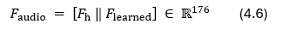
F_learned is the pooled vector of M2's Round 05 WavLM model, the version M2 handed over for fusion. It uses the frozen WavLM Base+ encoder, which was self-supervised on about 94,000 hours of unlabelled speech (Chen et al., 2022), takes its sixth-layer hidden states and reduces them to 128 dimensions with a trained 768→128 projection and attentive statistics pooling. It does not include the residual temporal convolution of M2's later refinement model (Section 4.2.4). M2's own MLP head reaches a validation macro-F1 of 0.806 on these features; M1 uses only the 128-D vector, not M2's head or probabilities.
The three M1 inputs were saved as handcrafted_48d.csv, learned_128d.csv and combined_176d.csv after the alignment checks in Section 3.2. The --m2-source option selects wavlm for the W05-based comparison or mfcc_transformer for the archived comparison. Each classifier pipeline fits its own training standardiser.

Handcrafted Classifier Export and Fusion Interface
The M1 hand-over package in Table 4.4 supplies 48-D features, eight-class probabilities and metadata. Its training probabilities use the four-fold actor-grouped procedure in Section 3.3; validation and test probabilities use the full-training classifier (Wolpert, 1992).
Artefact | Rows | Content
features/{train,val,test}.csv | 960 / 240 / 240 | 5 metadata columns + 48 features (m1_ prefix)
probabilities/train.csv | 960 | 4-fold actor-independent OOF probabilities, 8 columns p_<emotion>
probabilities/{val,test}.csv | 240 / 240 | Probabilities from the full-training model
model/logistic_regression.joblib | — | Fitted StandardScaler + LogisticRegression pipeline; regenerated by the export script (not tracked)
metadata.json | — | Model parameters, preprocessing settings, ordered feature and probability columns, class order, probability methods, split counts
Table 4.4. M1 hand-over package (audio/handcrafted/outputs/handover/m1_audio/).
M1 names its final probability column surprised. This is the surprise alias defined in Section 3.4; the numerical class order is unchanged. Exported probability rows sum to one within numerical tolerance.

Audio Input Selected for Fusion
The representation comparison (Section 5.2.3) selected the WavLM learned-only features, so no M1 features are added to the audio input for fusion. The selected audio input is M2's WavLM Round 05 delivery (m5_learned_feature_only), which already holds the pooled features, M2's probabilities and the sequence used for cross-attention. M5 loads it directly with the fusion module's fusion/audio_pilot.py importer, so M1 does not need to send any audio data for the selected configuration.
For convenience, src/handover/export_final_audio.py also packages the audio input as single NPZ files in the multimodal_fusion format, written to outputs/handover/final_audio/ (Table 4.5). audio_wavlm.npz contains exactly M2's data in that format and can be passed to the fusion command-line interface without conversion. audio_combined.npz holds the handcrafted + WavLM concatenation; it is kept as M1's record of the combined representation and is not needed for fusion, because the selection was made at the audio level, in the same way as the visual representation is selected before fusion. Both files carry M2's WavLM temporal-adapter sequence (F_sequence, 128-D per step) unchanged, zero-padded at the end to the longest recording (215 steps; valid lengths 58–215).
Optional file | pooled | probs | Train probabilities | Val acc. | Val macro-F1
audio_wavlm.npz  (M2 data; selected representation) | M2 WavLM 128-D | M2 WavLM Round 05 MLP head | In-sample (M2 model trained on these actors) | 0.813 | 0.806
audio_combined.npz  (M1 record; not used in fusion) | M1 48-D ‖ M2 WavLM 128-D = 176-D | M1 StandardScaler + LR (C = 1.0) on 176-D | 4-fold actor-grouped OOF; still optimistic (adapter saw these actors) | 0.796 | 0.789
Table 4.5. Optional ready-to-load audio files in the fusion module's NPZ format (outputs/handover/final_audio/). The selected audio input itself is M2's delivery. Validation and test probabilities come from the full-training model; test probabilities were generated but not scored.
Each file contains sample_ids [1440] (six-field trial IDs), labels and actors [1440] (int64), class_names [8] in the fusion order with the spelling surprise, pooled [1440, D] and probs [1440, 8] (float32), and sequence [1440, 215, 128] with lengths [1440]. Both files passed the fusion module's own loading, splitting (960 / 240 / 240, all eight classes in every partition) and normalisation checks, and their sequences, pooled vectors and probabilities equal M2's per-sample files exactly. Training-set audio probabilities are over-confident in both files, as they are in M2's delivery, so decision-fusion weights should be tuned on the validation partition. The NPZ files are not tracked and are shared separately to M5.

Inputs, Outputs and Reproduction of the Handcrafted Branch
- Input: RAVDESS audio-only speech files under data/raw/Actor_XX/, with filename fields and validation rules defined in Section 3.2.
- Intermediate: data/metadata.csv (nine metadata fields), data/actor_splits.csv and data/audio_splits.csv; 22 group-level feature CSVs and 30 combined 48-D datasets under outputs/features/experimental_v2/.
- Output: the M1 feature/probability package in Table 4.4, using the common ID and class-order contract in Chapter 3.
- Per-recording inference: load model/logistic_regression.joblib, compute the 48 features in the column order of metadata.json (db2, normalised, 20 ms) and call predict_proba to obtain the eight-class probability vector P_audio,M1.
The branch runs on CPU with Python 3.11 managed by uv, and exact versions are pinned in uv.lock. The main libraries (minimum versions from pyproject.toml) are librosa 0.11, PyWavelets 1.9, NumPy 2.4, pandas 3.0, SciPy 1.17, scikit-learn 1.9.1, XGBoost 3.2, joblib 1.6 and soundfile 0.14. Table 4.6 lists the reproduction sequence.
Stage | Modules (run as uv run --locked python -m <module>) | Output
Environment | uv sync --locked (Python 3.11; uv.lock) | .venv with pinned packages
Metadata and split | src.dataset; src.split_dataset | data/metadata.csv; actor_splits.csv; audio_splits.csv
Preprocessing check | src.experimental_v2.run_preprocessing_validation | outputs/preprocessing_validation.csv
Feature extraction | src.experimental_v2.extract_time_dataset, .extract_spectral_dataset, .extract_wavelet_dataset, .combine_features | 22 group-level CSVs; 30 combined 48-D datasets
Classifier sweep and tuning | src.experiments.compare_preprocessing, .tune_logistic_regression, .tune_mlp, .tune_svc, .tune_xgboost, .tune_random_forest | outputs/metrics/experimental_v2/
Representation study | src.fusion.prepare_audio_features, .compare_audio_representations, .tune_audio_representations (--m2-source wavlm | mfcc_transformer) | outputs/features/audio_fusion/; outputs/metrics/audio_fusion/
Hand-over export | src.handover.export_m1_audio; src.handover.export_final_audio | outputs/handover/m1_audio/; outputs/handover/final_audio/
Table 4.6. Reproduction sequence of the M1 handcrafted branch, run from audio/handcrafted/ after placing the RAVDESS speech files in data/raw/.
Before the three src.fusion steps, M2's m5_learned_feature_only.zip must be extracted into data/external/ so that the WavLM pooled CSVs are in data/external/m5_learned_feature_only/pooled/; the optional NPZ export also reads its per-sample sequence files. With --m2-source mfcc_transformer, the fusion scripts regenerate the archived MFCC–Transformer comparison. Raw recordings, M2's external features, the fitted model file and the NPZ files are excluded from Git; the metrics, figures, feature CSVs, hand-over features and probabilities used in this report are shared under audio/handcrafted/outputs/.

4.3 Visual Emotion Recognition M3 and M4
The visual subsystem consisted of the M3 handcrafted branch and the M4 learned branch. Both branches operated on the same uniformly sampled and aligned facial sequences. M3 extracted local wavelet statistics and used an RBF-SVM classifier, whereas M4 learned spatial or spatiotemporal representations using deep visual encoders. Their outputs were subsequently evaluated as handcrafted-only, learned-only and combined visual representations.

4.3.1 Frame Sampling, Face Preprocessing, and Augmentation
The shared visual preprocessing in Section 3.2 produces 16 ordered facial frames per clip. Evenly spaced target positions are rounded to frame indices; frame_idx, video_fps and frame_time_sec retain their original temporal positions.
Face detection was performed independently on each sampled RGB frame using the MediaPipe short-range face detector with a minimum detection confidence of 0.5. When multiple faces were detected, the bounding box with the highest confidence was selected. The selected box was enlarged by a factor of 1.3 to retain the forehead, chin and surrounding facial region. MediaPipe eye keypoints were used to estimate the in-plane facial angle, and the frame was rotated using OpenCV so that the eyes were approximately horizontal. A square region centred on the aligned face was then cropped and resized to 224×224 pixels using area interpolation. If the crop extended beyond the image boundary, replicated border padding was applied before resizing.
The detection fallbacks in Section 3.2 retain every recording. Each clip produces an RGB uint8 array of shape 16 × 224 × 224 × 3; per-frame face_found flags and a preprocessing log preserve detection status for inspection.
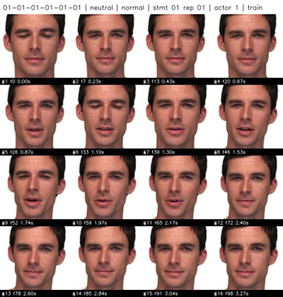
Figure 4.3. Example of the 16 uniformly sampled and preprocessed facial frames from one RAVDESS video. The frame number and timestamp below each image indicate the position of the sampled frame in the original clip.
Data augmentation was applied after face preprocessing and before handcrafted DWT feature extraction. It operated directly on the 224×224 RGB facial-frame sequences and was restricted to the training partition. The validation and test sequences were never augmented. Augmentation was performed consistently at the clip level: one transformation parameter set was generated for each video and applied to all 16 frames. This preserved temporal consistency and avoided artificial frame-to-frame transformation changes within the facial sequence.
Three training-time augmentation configurations were evaluated while keeping the downstream handcrafted feature extractor fixed. AUG-0 was the non-augmented baseline and used only the 960 original training clips. AUG-1 added one horizontally flipped copy of every training clip, producing 960 additional training samples. AUG-2 also generated one additional copy of each training clip but applied a light combination of geometric and photometric transformations. These consisted of horizontal flipping with a probability of 0.5, rotation between -5° and 5°, horizontal and vertical translation within 3% of the frame size, scaling between 0.97 and 1.03, and brightness and contrast factors between 0.90 and 1.10.
For AUG-2, geometric transformations used bilinear interpolation and reflected border padding to avoid introducing artificial black borders. Contrast was adjusted around the mean intensity of the complete clip, after which a multiplicative brightness factor was applied. The transformed values were rounded, clipped to the valid pixel range of 0–255 and converted back to unsigned 8-bit integers. A deterministic per-clip random seed was derived from the augmentation configuration, source sample_id and global seed. The generated transformations were therefore reproducible and independent of file-processing order or worker count.
AUG-1 was selected according to validation Macro-F1, as reported in Section 5.7.2. The selected handcrafted training set consequently contained 960 original clips and 960 horizontally flipped copies, giving 1,920 training samples. All original and augmented training clips subsequently passed through the same Full-320 DWT feature extractor described in Section 4.3.2. Augmented clips were used only for training the handcrafted DWT-SVM; the exported visual representations and probabilities continued to correspond to the original 1,440 recordings.

4.3.2 DWT Handcrafted Features and SVM Baseline
The M3 handcrafted visual branch transformed each preprocessed facial sequence into a fixed-dimensional wavelet representation and classified it using an RBF-SVM. As summarised in Figure 4.4, the branch consisted of training-only augmentation, frame-level DWT feature extraction, temporal mean pooling, training-fitted standardisation and probabilistic SVM classification. The handcrafted representation was developed in two stages: an initial global-statistics implementation, denoted as V1, and an improved local-statistics implementation, denoted as V2 or Full-320.
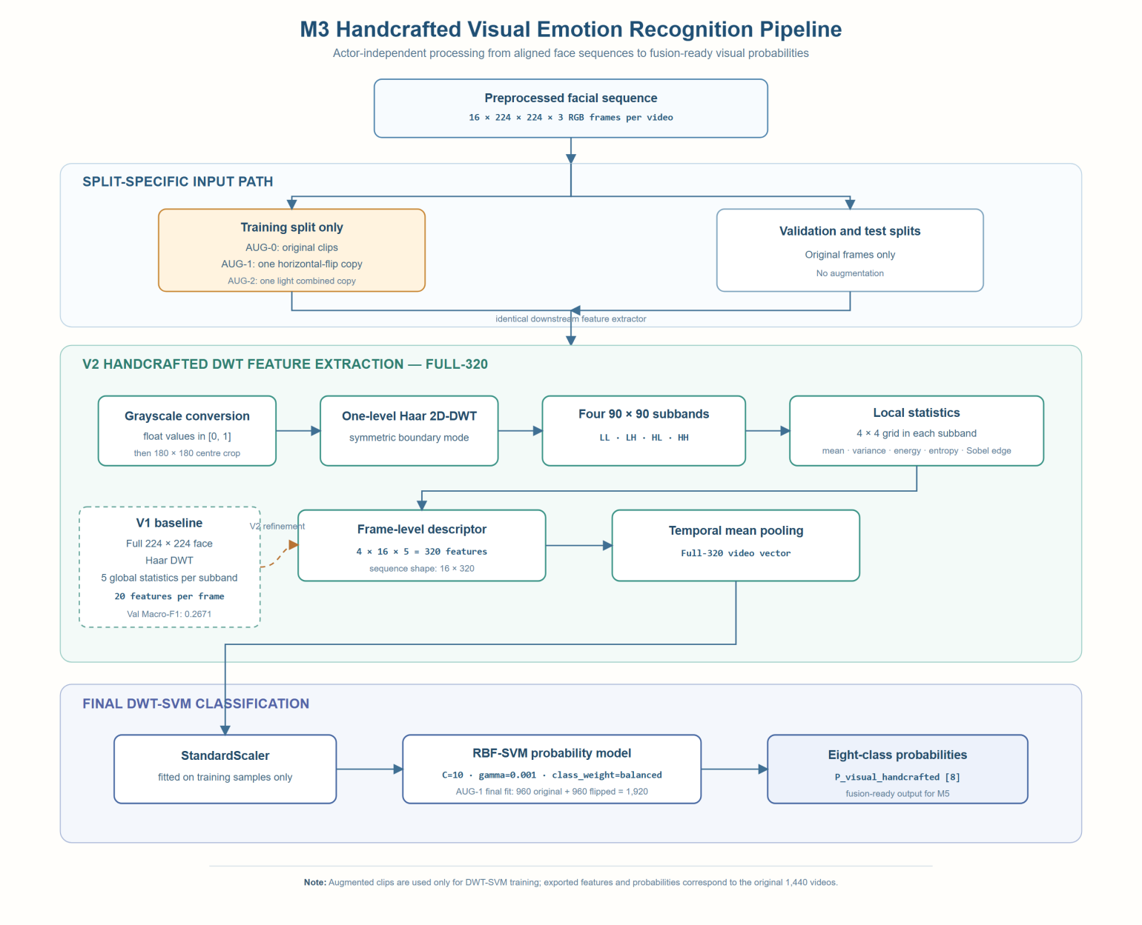
Figure 4.4. M3 handcrafted visual emotion-recognition pipeline. Training-only augmentation, Full-320 DWT feature extraction, temporal mean pooling and RBF-SVM classification produce eight-class visual emotion probabilities.

V1 Global DWT Representation
The initial V1 implementation converted each 224×224 RGB facial frame to grayscale and normalised the pixel intensities from the unsigned 8-bit range to floating-point values between 0 and 1. A single-level two-dimensional discrete wavelet transform was then applied using the Haar wavelet. This produced four 112×112 coefficient subbands: the low-frequency approximation subband LL, together with the horizontal, vertical and diagonal detail subbands LH, HL and HH.
Five statistics were calculated over each complete subband: the mean coefficient, coefficient variance, energy, Shannon entropy and edge strength. Energy was defined as the mean squared wavelet coefficient. Entropy was calculated from a 64-bin histogram of the coefficients, while edge strength was represented by the mean Sobel gradient magnitude. Concatenating the five statistics from the four subbands produced
$$4 subbands ×5 statistics =20$$
features per frame. Temporal mean pooling was subsequently applied over the 16 frames, producing a 20-dimensional representation for each video.
Although V1 was computationally compact, calculating one set of statistics over an entire subband discarded the spatial locations of the wavelet responses. Changes around the eyes, eyebrows and mouth were therefore aggregated with responses from other facial regions, including less informative boundary, hair and background areas. Its limited validation performance motivated the development of a representation that retained more local facial structure.

V2 Full-320 DWT Representation
The improved V2 implementation introduced two modifications. First, after grayscale conversion and normalisation, the central 180×180 region was retained from each 224×224 aligned facial frame. This centre crop was performed only within the M3 handcrafted branch and did not modify the shared 224×224 face sequences used by the M4 learned visual models. The crop was intended to reduce the contribution of surrounding background and hair while retaining the principal facial regions.
Second, V2 replaced the global subband statistics with local grid-based statistics. A single-level Haar 2D-DWT was applied to the 180×180 grayscale crop using symmetric boundary handling. The transform produced four 90×90 subbands: LL, LH, HL and HH. Each subband was divided into a 4×4 spatial grid, resulting in 16 cells per subband. Because 90 pixels cannot be divided evenly by four, integer grid boundaries produced cells with side lengths of either 22 or 23 pixels.
The same five statistics used in V1 were calculated independently within every grid cell:
- mean wavelet coefficient;
- coefficient variance;
- energy, calculated as the mean squared coefficient;
- Shannon entropy calculated from a 64-bin coefficient histogram; and
- edge strength, calculated as the mean Sobel gradient magnitude.
The cell statistics were concatenated in subband, grid-position and statistic order. Each frame was therefore represented by
$$4 subbands ×16 cells×5 statistics =320 features$$
For each video, the 16 sampled frames initially produced a feature sequence with shape 16×320. Temporal mean pooling was then applied across the frame dimension, resulting in a single 320-dimensional video-level vector. This selected representation is referred to as Full-320. The frame-level sequence was retained for export, while the pooled vector was used as the input to the handcrafted classifier.
A controlled ablation evaluated the centre crop and local grid separately using four combinations of facial region and spatial aggregation. All configurations used the same face files, actor-independent splits, label order, temporal pooling procedure, random seed and SVM search space. The combination of the 180×180 centre crop and 4×4 local grid achieved the strongest validation performance and was therefore fixed as the final Full-320 representation. The complete ablation results are reported in Section 5.7.2.

Standardisation and RBF-SVM Classification
The pooled Full-320 representations were classified using a scikit-learn pipeline consisting of a StandardScaler followed by a support vector machine with a radial basis function kernel. The scaler was fitted only on the corresponding training features, ensuring that validation and test statistics did not influence feature standardisation.
The SVM hyperparameters were selected according to validation Macro-F1. The evaluated search space contained
$$C∈\left\{0.1, 1, 10, 100\right\},$$
$$γ∈\left\{scale, 0.001, 0.01, 0.1\right\},$$
and class_weight values of either None or balanced. Probability estimation was enabled to provide eight-class probability vectors for subsequent decision-level and gated multimodal fusion.
After the Full-320 representation and AUG-1 training strategy had been selected, the final handcrafted classifier used an RBF kernel with C = 10, γ = 0.001 and balanced class weights. Both the StandardScaler and RBF-SVM were fitted using the 1,920-sample AUG-1 training set, which contained 960 original training clips and 960 horizontally flipped copies. The validation samples were used for hyperparameter and configuration selection but were not added to the final training set.
The fitted scaler and classifier were retained together in outputs_augmentation/selected_svm.joblib. For each original recording, the model produced an eight-dimensional probability vector in the project’s fixed emotion-class order. The detailed export fields and the distinction between final-model and fusion-safe OOF probabilities are described in Section 4.3.4, while the representation and augmentation ablation results are presented in Section 5.7.

4.3.3 Implemented Deep Visual Encoders and Temporal Aggregation
The M4 branch loads the shared 16 × 224 × 224 RGB facial sequences from M3 and compares three learned visual encoders under the common protocol in Chapter 3.
Three deep learning models were implemented: MobileNetV3-Small with mean pooling, ResNet18 with mean pooling, and ResNet18 with Bidirectional LSTM (BiLSTM). Both MobileNetV3-Small and ResNet18 used ImageNet pretrained weights, and their backbone layers were frozen during training. The CNN backbones extracted visual features from each of the 16 frames.
For the first two models, mean pooling was applied across the 16 frame features to generate a single video-level representation. MobileNetV3-Small produced a 576-dimensional feature vector, while ResNet18 produced a 512-dimensional vector. For the third model, a BiLSTM with 64 units in each direction was used instead of mean pooling to learn temporal relationships between frames, producing a 128-dimensional video-level representation.
All three models used a Dense layer with 128 units and ReLU activation, followed by a Dropout layer with a rate of 0.3 and a Softmax output layer for eight emotion classes. The models were trained using the RMSprop optimizer with a learning rate of 0.0001, categorical cross-entropy loss, a batch size of 2 and a maximum of 10 epochs. Validation Macro-F1 was used to monitor performance, and the best checkpoint for each model was saved for later feature extraction and comparison.
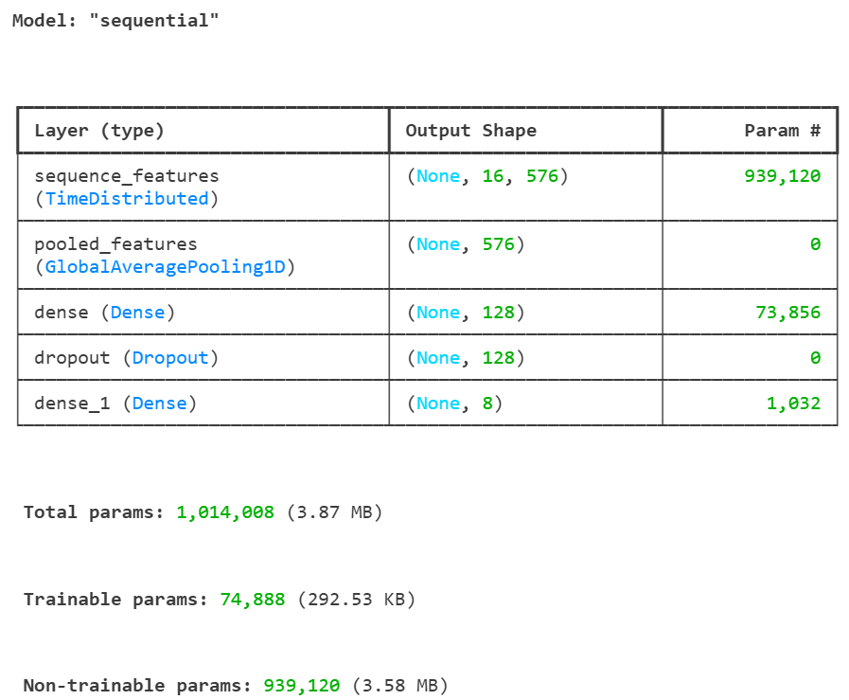
Figure 4.5. Model summary of the MobileNetV3-Small with mean pooling architecture used for visual emotion recognition.
The MobileNetV3-Small model architecture is shown in Figure 4.5. The model contains 1,014,008 parameters, of which 939,120 are frozen backbone parameters and 74,888 are trainable parameters. The 16 facial frames are converted into 576-dimensional frame features, which are then averaged into a single video-level representation for emotion classification.

4.3.4 Representations, Feature Exports and OOF Probabilities

Visual Representations and Classification Heads
Three recording-level visual representations were constructed from the aligned outputs of M3 and M4. The handcrafted representation consisted of the 320-dimensional Full-320 DWT vector described in Section 4.3.2. The learned representation was the 576-dimensional pooled feature supplied by the selected upstream M4 model, MobileNetV3-Small with an ImageNet-pretrained frozen backbone and checkpoint mobilenetv3_mean.keras. The combined representation concatenated these two vectors to form an 896-dimensional feature vector.
For clarity, these representations were denoted as handcrafted-only, learned-only and combined during reporting. In the implementation and output metadata, they were additionally identified as A, B and A+B, respectively. The handcrafted-only representation reused the locked StandardScaler–RBF-SVM pipeline described in Section 4.3.2. The learned-only representation used a StandardScaler followed by an MLP with hidden-layer dimensions of 128 and 64 and an L2 regularisation parameter of 0.0001. The combined representation used a StandardScaler and an MLP with one 128-unit hidden layer and an L2 regularisation parameter of 0.01.
Representation selection was based on validation Macro-F1. The handcrafted-only representation was selected as the final visual representation. Consequently, the generic selected feature and probability fields, F_visual and P_visual, refer to the 320-dimensional handcrafted representation and its RBF-SVM probabilities. The corresponding comparison results are reported in Section 5.5.

Feature and Probability Export Interface
The final visual outputs were consolidated into visual_representation_outputs.npz, containing 1,440 original recordings: 960 training, 240 validation and 240 test samples. The principal recording-level feature fields were:
- F_visual_handcrafted, with shape [1440, 320];
- F_visual_deep, with shape [1440, 576];
- F_visual_combined, with shape [1440, 896]; and
- F_visual, with shape [1440, 320], representing the selected handcrafted feature.
The corresponding final-model probability fields were P_visual_handcrafted, P_visual_deep_mlp, P_visual_combined and the selected field P_visual, each with shape [1440, 8]. The raw class probabilities supplied directly by the upstream M4 model were retained separately as P_visual_deep_source; these were not the learned-only MLP probabilities used in the representation comparison.
Frame-level representations were also retained when available. The handcrafted sequence field, F_visual_handcrafted_sequence, has shape [1440, 16, 320], while the learned sequence field, F_visual_deep_sequence, has shape [1440, 16, 576]. Because every video was represented by exactly 16 sampled frames, these arrays have a fixed temporal dimension and the final visual artifact does not require separate sequence-length or padding-mask fields.
Rows retain the common sample ID, split, actor and label metadata, plus oof_fold. The original export spelling surprised follows the alias rule in Section 3.4. Upstream checkpoint metadata and frame_idx, frame_time_sec and video_fps preserve feature and temporal provenance.

Actor-Grouped OOF Probability Generation
The visual fusion-safe probability fields use the deterministic four-fold actor-grouped procedure in Section 3.3. Each fold holds out four training actors, or 240 original clips, and fits on the remaining 12 actors, or 720 original clips.
For the handcrafted branch, each fold-specific RBF-SVM pipeline was fitted using the 720 original recordings belonging to the fit actors together with their 720 AUG-1 horizontally flipped counterparts. Augmented samples were aligned with their originals through source_sample_id, and no augmentation belonging to a held-out actor was included in that fold’s training data. For the learned-only and combined representations, the scaler and MLP were fitted from scratch using only the 720 original recordings belonging to the fit actors. All preprocessing operations, including feature standardisation, were therefore estimated separately within each fold.
The three OOF outputs are stored in P_visual_handcrafted_fusion, P_visual_deep_mlp_fusion and P_visual_combined_fusion. P_visual_fusion aliases the selected handcrafted output. Training rows retain oof_fold values 0–3; validation and test rows use −1.
After the representation and hyperparameters had been locked using the validation set, the final classifiers were fitted using the complete training split. The locked handcrafted classifier used 960 original training recordings and their 960 AUG-1 counterparts, whereas the learned-only and combined MLPs used the 960 original training recordings. These final classifiers generated the validation and test entries in both the standard and fusion-safe probability fields. Thus, the _fusion fields contain actor-grouped OOF probabilities for training rows and final locked-model probabilities for validation and test rows.
The standard P_visual* fields are in-sample for training rows. The corresponding _fusion fields should be used if a downstream model is fitted to visual probabilities. The reported feature-based gating model instead operates directly on pooled vectors (Section 4.4.3).

4.4 Multimodal Fusion
Two frozen-representation settings are evaluated. The MFCC Transformer setting combines 48D handcrafted audio with a 128D mean-pooled learned representation and pairs the resulting 176D audio vector with 576D MobileNetV3 visual features. Its attention branch uses the learned T × 128 audio sequence and 16 × 576 visual sequence. The WavLM setting uses 128D learned audio with 320D handcrafted vision as its primary configuration; additional runs retain the same MobileNetV3 visual features as the MFCC Transformer comparison. Both settings follow Chapter 3 and use seeds 42/43/44. Matched unimodal heads use the corresponding features and the same classifier training protocol.
In the WavLM setting, audio representations use frozen WavLM Base+ (Chen et al., 2022), followed by a supervised temporal adapter, residual depthwise temporal convolution and attentive statistics pooling. Each recording has a learned 128D pooled vector, a variable-length T × 128 sequence and eight original-head probabilities. Checkpoint verification reproduced all 1,200 exported training/validation probability vectors within tolerance.
The selected visual representation contains a 320D handcrafted pooled vector, 16 × 320 frame descriptors and probabilities from an RBF SVM. MobileNetV3-Small exports (Howard et al., 2019), with 576D pooled features, and combined 896D handcrafted/deep exports provide representation controls. Combined sequences concatenate aligned channels at each frame. Appendix D identifies the artifacts and checkpoint versions.
Figure 4.6 summarises the WavLM fusion experiments. A shared actor split and input-validation stage feed unimodal references and three complementary comparison families: probability fusion, pooled-feature fusion and sequence-based fusion. Representation controls vary handcrafted, learned and combined inputs; architectural controls vary projections, interaction rank, residual corrections, auxiliary objectives and attention pathways. Gate interventions test the dependence on sample-specific weighting. Validation selects checkpoints and settings, after which saved predictions support test error analysis and paired uncertainty estimates. The separate raw-video pilot assesses extraction, inference and confidence on external recordings.
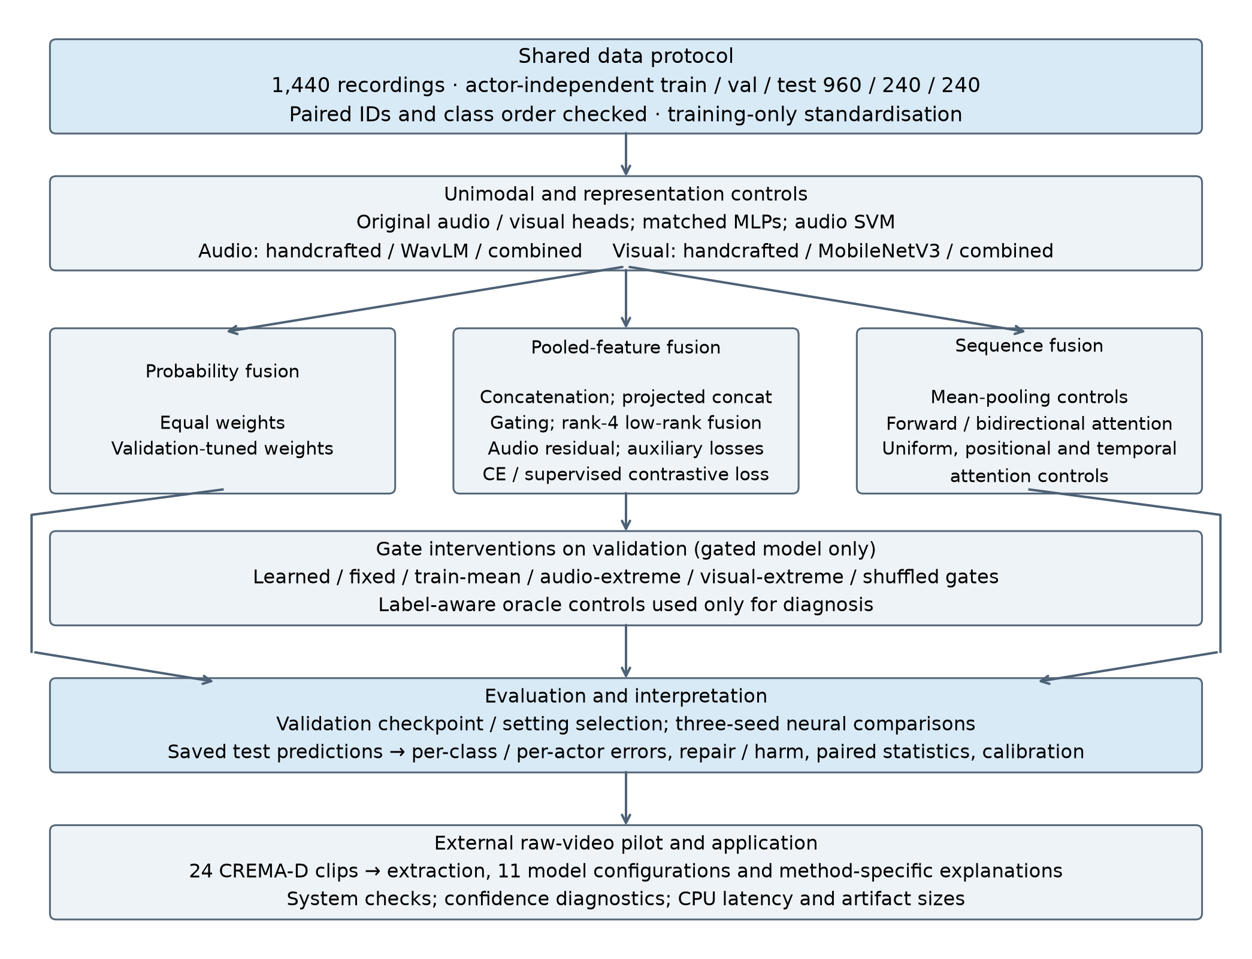
Figure 4.6. Structure of the WavLM fusion experiment suite. Shared actor partitions and aligned recordings support representation controls, fusion comparisons, gate interventions and evaluation.

4.4.1 Equal-Weight and Validation-Tuned Decision Fusion
After class alignment, the decision distribution is a convex combination of the delivered audio and visual probabilities:
p = α pₐ + (1 − α) pᵥ, 0 ≤ α ≤ 1
Equal fusion fixes α = 0.50. Validation tuning follows the grid and tie-break rule in Section 3.5 and selects α = 0.60 for the exported handcrafted visual classifier. Fusion directly combines the supplied validation or test distributions; it does not train a new MLP.

4.4.2 Feature Concatenation
Training-standardised pooled vectors are concatenated in audio-then-visual order, producing a 448-dimensional input (128 + 320). The classifier is Linear(448,64), ReLU, Dropout(0.20), Linear(64,8), followed by softmax for exported probabilities. Audio-only and visual-only MLP controls use the same hidden width, activation, dropout and optimisation budget on their respective inputs. They are distinct from the delivered WavLM classifier and visual SVM, which remain separate system-level references.

4.4.3 Gated Fusion
Audio and visual pooled vectors are separately projected to 64 dimensions with tanh. A sigmoid gate receives their original standardised concatenation and produces 64 channel-wise values. The gate and classification head are trained jointly with the modality projections:
a = tanh(Wₐ xₐ + bₐ), v = tanh(Wᵥ xᵥ + bᵥ)
g = sigmoid(Wg [xₐ ; xᵥ] + bg), h = g ⊙ a + (1 − g) ⊙ v
The fused vector enters a 64 → 64 → 8 MLP with ReLU and dropout 0.20. Per-sample gate vectors are saved for diagnostics. Inference-time controls replace learned gates with fixed 0.5, the training-set mean, audio/visual extremes or gates shuffled across samples while holding features and model parameters fixed.

4.4.4 Cross-Attention Fusion and Unimodal Controls
The audio sequence has shape T × 128 and the primary visual sequence has shape 16 × 320. Separate linear projections map both to 64 channels. A four-head attention block uses audio queries and visual keys/values. Padded visual keys are masked; the attention output is added to the projected audio sequence and layer-normalised. Only valid audio positions enter temporal mean pooling, followed by a 64 → 64 → 8 MLP. No positional encoding is added in this primary implementation; relative-index encoding is an explicit extension.
Audio-sequence-mean and sequence-mean-concatenation controls compare arithmetic sequence pooling with the upstream attentive pooled representation. Additional controls use projected means, uniform valid-token weights, relative-index positions, temporal convolutions and reverse-direction attention. Training budgets match across variants. Uniform attention leaves Q/K parameters inactive and omits attention-weight dropout; bidirectional attention adds parameters through a reverse branch.

4.4.5 Training Settings and Additional Controls
All neural fusion models use cross-entropy and AdamW (Loshchilov & Hutter, 2019), with learning rate 0.001, weight decay 0.0001, batch size 64 and gradient clipping at norm 1. The budget is 30 epochs with early-stopping patience 8. Checkpoint selection and three-seed aggregation follow Section 3.5.
The residual variant adds a visual-informed logit correction to the frozen original audio head. Its final layer is zero-initialised and its trainable scale starts at 0.1. A 2 × 2 control varies visual embedding dropout (0.25) and auxiliary audio/visual cross-entropy (0.20 each). SupCon uses loss weight 0.10 and temperature 0.10. Rank-4 fusion and projected concatenation share the subsequent classifier. Only added heads/projections are trained.

5. Experiments and Results
Fusion benefits differ between the two representation settings. In the MFCC Transformer setting, concatenation and gating improve test Macro-F1 over their matched audio-only control. In the WavLM setting, no tested fusion method consistently outperforms the strong original audio baseline; the small differences among original audio, tuned decision fusion and audio SVM are unresolved by paired analyses. The WavLM comparisons are presented first, followed by the MFCC Transformer results.

5.1 Audio Encoder Comparison

5.1.1 Experimental Setup and Scope of Comparison
The MFCC encoder comparison evaluates complete encoder–pooling–classifier pipelines under Chapter 3. All three receive 40-D MFCC sequences, produce 128-D pooled representations and use a 128 → 64 → 8 MLP. Tables in this audio-development section label accuracy in percent; other metrics use a 0–1 scale.
The MFCC experiments comprised 11 groups and 33 model-training runs: an initial comparison followed by two batches of five tuning groups. Models within each group shared the data split, preprocessing, and principal training settings. The initial three models were randomly initialised and trained using seed 42, AdamW, a learning rate of 0.001, a batch size of 32, and a maximum of 30 epochs. Some subsequent runs started from previously trained parent checkpoints, with changes to the training budget and regularisation. These runs should therefore be distinguished from the initial controlled comparison. Selection and retrospective test reporting follow Section 3.5.
Run | Encoder | Val Acc % | Val F1 | Test Acc % | Test F1
F00-C | CNN | 42.50 | 0.3836 | 51.25 | 0.4714
F00-B | BiLSTM | 41.67 | 0.3593 | 53.33 | 0.4924
F00-T | Transformer | 47.08 | 0.4508 | 55.42 | 0.5466
Table 5.1. Initial encoder comparison under shared training settings; 240 recordings per evaluation split
Under the initial configuration, the Transformer achieved a validation macro-F1 of 0.4508, compared with 0.3836 for CNN and 0.3593 for BiLSTM. Its test macro-F1 was 0.5466. These results favoured the Transformer under the specified configuration and actor split, but do not establish that this architecture is universally superior for speech emotion recognition.

5.1.2 Results after Tuning and Model Selection
Run | Encoder | Val Acc % | Val F1 | Test Acc % | Test F1
F02-C | CNN | 44.58 | 0.4282 | 56.25 | 0.5409
F03-B | BiLSTM | 43.75 | 0.3914 | 52.08 | 0.4937
F09-T | Transformer | 54.58 | 0.5328 | 64.17 | 0.6235
Table 5.2. Best configuration within each architecture by validation macro-F1; configurations differ across rows
The best configurations within the CNN, BiLSTM, and Transformer families were F02-C, F03-B, and F09-T, respectively. The Transformer retained the highest validation macro-F1 and was selected to represent the MFCC branch. F09-T achieved 54.58% validation accuracy and 0.5328 validation macro-F1, with 64.17% test accuracy and 0.6235 test macro-F1. Its validation macro-F1 exceeded that of the initial Transformer by 0.0820. The rows in Table 5.2 originate from different tuning rounds, so their differences cannot be attributed solely to encoder architecture.
F09-T was initialised from an existing Transformer checkpoint and used seed 7, a batch size of 16, initial learning rates of 0.000005 for the encoder and 0.00002 for the classifier, and weight decay of 0.001. The training augmentation probability was 0.5, classifier dropout was 0.25, label smoothing was 0.05, and class weights were proportional to the inverse square root of class frequency. Training allowed up to 16 epochs with early-stopping patience of 5. The run completed 6 epochs, and the checkpoint from epoch 1 was selected. Appendix B lists all 33 runs and their parent checkpoints; Appendix A provides the detailed architectures.
MFCC models generally performed better on the test set than on the validation set. This observation applies to the fixed actor split used here and does not demonstrate a general improvement in generalisation. Each configuration was evaluated using one recorded random seed. The runs using seeds 7 and 17 also changed other parameters, so they are not repeated-seed evaluations of a single configuration. No mean, standard deviation, or statistical significance is inferred from these runs.

5.2 Audio Representation Comparison
M1 fixed its handcrafted configuration using a preprocessing–classifier sweep and actor-grouped tuning, then compared handcrafted, W05 learned and combined inputs under one Logistic Regression pipeline. Table 5.3 gives the complete representation comparison, and Table B.6 distinguishes current and historical inputs. The earlier MFCC and V1 studies are retained separately because their features and classifiers differ.
M1’s classifier searches use four-fold actor-grouped training CV followed by validation comparison, with seed 42. The exact common selection and evaluation rules are defined in Section 3.5; Section 5.8 reports the frozen handcrafted baseline’s final test result.
The W05-based comparison uses handcrafted_48d.csv, learned_128d.csv and combined_176d.csv with StandardScaler and multinomial Logistic Regression (L2, lbfgs, max_iter 3000). Default C = 1.0 is compared with representation-specific grouped-CV tuning. Source scripts are src.fusion.compare_audio_representations and src.fusion.tune_audio_representations; results are under outputs/metrics/audio_fusion/.

5.2.1 Preprocessing and Classifier Selection
Nine classifiers were compared over 30 preprocessing configurations. Default Logistic Regression on db2 / normalised / 20 ms features achieved the highest validation macro-F1 of 0.389. Classifier choice had a larger effect than front-end settings, and the higher-capacity models showed substantially larger training–validation gaps. Appendix B.2 retains the complete comparison and preprocessing plots.

5.2.2 Hyperparameter Tuning
Four-fold actor-grouped searches tuned the five shortlisted classifiers. Tuning reduced overfitting but did not improve the best validation result, so the default Logistic Regression was retained. Appendix B.3 records search spaces, selected settings and full tuning comparisons.

5.2.3 Stage 3 and Handcrafted versus Learned versus Combined Representations
With the M1 representation fixed, the same StandardScaler + Logistic Regression pipeline was trained separately on the handcrafted, learned and concatenated inputs (Section 4.2.5). The classifier, training data and evaluation actors were identical, so only the representation varied. Two settings were run: the default C = 1.0, and C selected for each representation from 11 values (10⁻⁴ to 100) by actor-grouped 4-fold CV.
The same Logistic Regression family controls the classifier in this representation comparison. It was selected for M1 using handcrafted features, so its results do not establish the best attainable performance of every representation. On W05 features, its validation macro-F1 of 0.800 is nevertheless close to the original W05 MLP head’s 0.806.
Representation | Dim. | Train F1 | Val acc. | Val F1 | Gap | Tuned C | CV F1 | Tuned val acc. | Tuned val F1
Handcrafted (M1) | 48 | 0.508 | 0.400 | 0.389 | 0.120 | 0.10 | 0.339 | 0.408 | 0.390
WavLM learned (M2) | 128 | 1.000 | 0.808 | 0.800 | 0.200 | 0.001† | 1.000 | 0.813 | 0.807
Concatenated | 176 | 1.000 | 0.796 | 0.789 | 0.211 | 0.001† | 1.000 | 0.804 | 0.800
Table 5.3. Full representation comparison with M2's WavLM features and an identical Logistic Regression pipeline (default C = 1.0, then CV-tuned C). †First of ten tied values (see text). Source: outputs/metrics/audio_fusion/.
With the default classifier, the WavLM learned representation gave the best validation macro-F1 (0.800; accuracy 80.8%), 0.411 above the handcrafted features. A linear classifier nearly matches M2's own MLP head on these features, which shows that the exported WavLM features are already close to linearly separable by emotion. Concatenating the handcrafted block lowered validation macro-F1 to 0.789. After tuning, the ranking was unchanged: learned-only 0.807, concatenated 0.800 and handcrafted 0.390.
Tuning is uninformative for the learned features. For both representations that contain WavLM features, mean CV macro-F1 on the training actors was 1.000 for every C from 0.001 to 100 (0.859 at C = 10⁻⁴), and training macro-F1 was 1.000. M2's adapter was trained on the same 16 training actors, so their learned features are perfectly separable inside training-actor CV, and GridSearchCV broke the ten-way tie by taking the first value, C = 0.001. For learned features the training and CV scores therefore say nothing about generalisation, and only the validation actors give a meaningful comparison. For the handcrafted features, the CV (0.339) and validation (0.390) scores remain close.
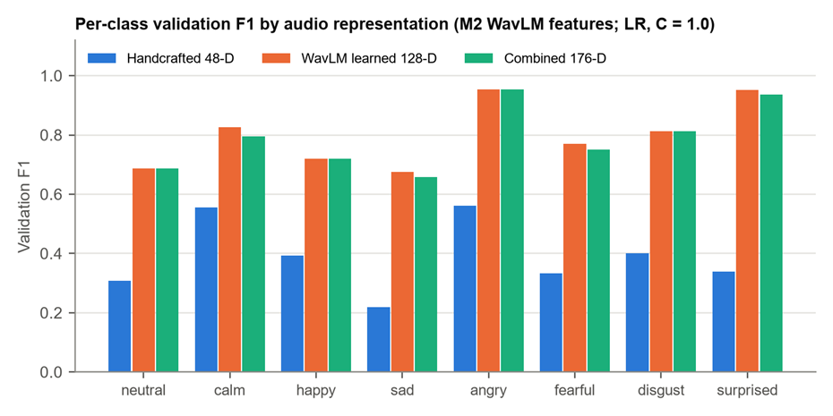
Figure 5.1. Per-class validation F1 of the three audio representations with M2's WavLM features (default Logistic Regression). The WavLM features are stronger for every emotion; concatenation matches or slightly trails them.
The per-class view (Figure 5.1) shows the same ordering for every emotion. The WavLM features were strongest on angry (0.954) and surprised (0.952) and weakest on sad (0.676) and neutral (0.688), where they were still far above the handcrafted features (0.220 and 0.308). Concatenation matched the learned features alone on neutral, happy, angry and disgust and was slightly lower on calm, sad, fearful and surprised (by at most 0.032). No emotion benefited from adding the handcrafted block.

5.2.4 Historical Comparisons
The earlier MFCC-feature comparison and V1 prototype use different feature definitions or classifiers and are retained in Appendices B.4–B.5. They provide development context and are not ranked as controlled comparisons against the final-input study.

5.3 WavLM Extension Results

5.3.1 Transfer Learning Setup and Comparison Boundaries
The WavLM extension comprised five initial representation experiments followed by ten downstream refinement experiments, all using the shared 960/240/240 actor-independent split. The backbone was the official microsoft/wavlm-base-plus model, fixed at revision 4c66d4806a428f2e922ccfa1a962776e232d487b. Inputs were 16 kHz waveforms. The backbone remained frozen throughout; only adaptation, aggregation, and classification modules were trained. Relative to the MFCC branch, this extension changed the input representation, preprocessing, pretraining source, and downstream architecture. It is therefore a comparison of extended systems rather than an architecture ablation with identical inputs.
Run | Representation and main change | Val Acc % | Val F1 | Test Acc % | Test F1
W01 | Layer 12 mean pooling | 67.50 | 0.6841 | 72.08 | 0.7226
W02 | Layer 12 mean and standard deviation | 72.50 | 0.7271 | 75.83 | 0.7570
W03 | Learned mixture of layer 6/9/12 statistics | 78.75 | 0.7807 | 80.42 | 0.8015
W04 | Layer 6 attentive statistics pooling | 80.83 | 0.8017 | 82.50 | 0.8246
W05 | Continue W04 with mixup and regularisation changes | 81.25 | 0.8063 | 82.92 | 0.8280
Table 5.4. Initial five WavLM experiments; backbone frozen in every run
W01 achieved a validation macro-F1 of 0.6841. With statistical pooling and a learned combination of layers, W03 reached 0.7807. Layer 6 received the largest learned weight in W03 and was subsequently used for attentive statistics pooling. W05 was selected as the best configuration in this initial stage, achieving 81.25% validation accuracy and 0.8063 validation macro-F1, with 82.92% test accuracy and 0.8280 test macro-F1. Adjacent experiments could change representations, optimisation settings, and initialisation simultaneously, so this progression represents iterative development rather than isolated component effects.

5.3.2 Ten Downstream Refinements and the Final Configuration
The ten subsequent experiments examined classifier-only training, freezing the input projection, low-learning-rate updates, a residual frame adaptation layer, depthwise temporal convolution, a deeper classifier, freezing the classifier, feature noise with mixup, focal loss, and conservative low-learning-rate updates. A distinct configuration was recorded before each run. Runs continued from the best completed model available at that point by validation macro-F1, or from the original W05 checkpoint. Appendix B records the parent relationships
Run | Main change | Val Acc % | Val F1 | Test Acc % | Test F1
R01 | Train classifier only | 80.83 | 0.8026 | 83.33 | 0.8335
R03 | Update all downstream modules at a low learning rate | 82.08 | 0.8102 | 82.50 | 0.8215
R04 | Add residual frame adaptation | 82.08 | 0.8097 | 82.50 | 0.8230
R05 | Add residual temporal convolution, kernel width 3 | 84.17 | 0.8312 | 83.33 | 0.8321
R06 | Add residual classifier block | 82.08 | 0.8112 | 81.25 | 0.8082
R08 | Training feature noise and stronger mixup | 80.83 | 0.7993 | 83.33 | 0.8326
R09 | focal loss | 80.83 | 0.7947 | 82.50 | 0.8210
R10 | Conservative low-learning-rate updates | 81.67 | 0.8068 | 81.67 | 0.8117
Table 5.5. Key configurations from the ten refinements; all runs are listed in Appendix B
Figure 5.2 summarises validation macro-F1 across all 48 experiments, showing the progression from MFCC encoder tuning to WavLM adaptation and downstream refinement.
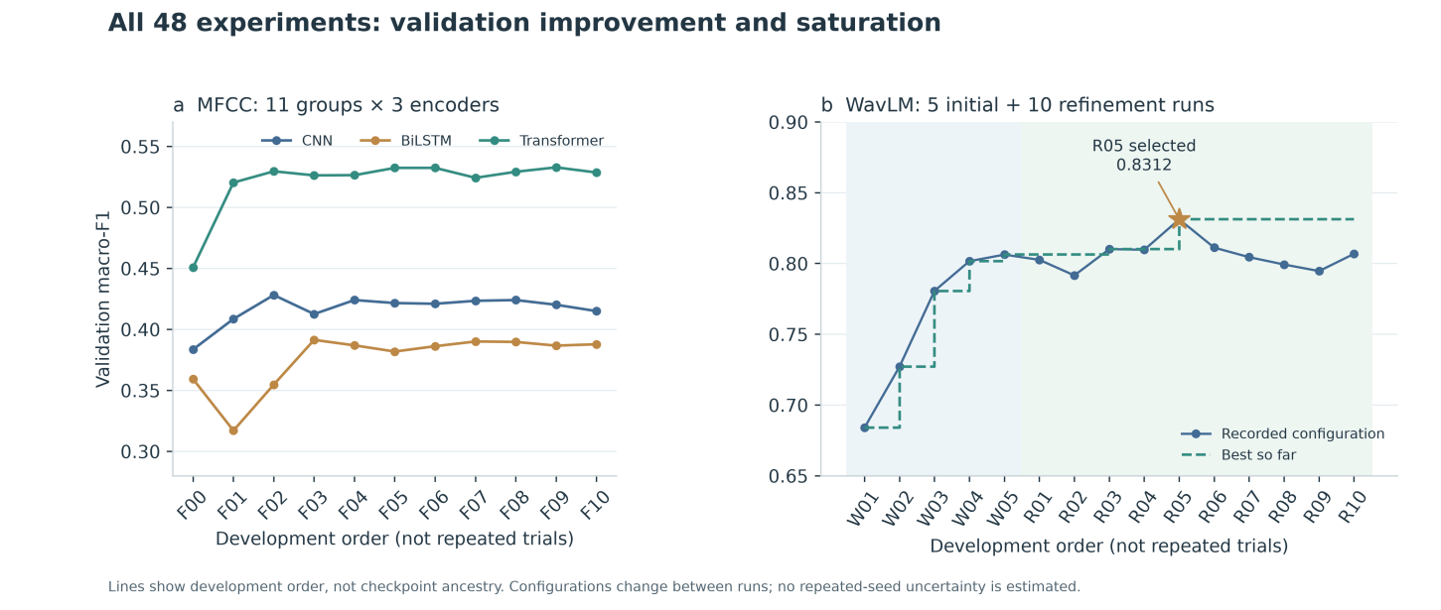
Figure 5.2. Validation Performance Across 48 Experiments
R05 achieved the highest validation macro-F1, with 84.17% accuracy and 0.8312 macro-F1. Relative to W05, validation accuracy increased by 2.92 percentage points and macro-F1 by 0.0249. The fixed R05 checkpoint achieved 83.33% test accuracy (200/240), 0.8321 macro-F1, 0.8522 macro-precision, and 0.8281 macro-recall. Compared with W05, this corresponds to one additional correct test prediction and an increase of approximately 0.0041 in test macro-F1.
The final configuration added a residual depthwise temporal convolution with kernel width 3 to the downstream branch using frozen WavLM layer-6 representations and attentive statistics pooling. R05 also changed the learning rate and classifier dropout relative to its parent, R03. The improvement therefore cannot be attributed solely to the convolution. Greater depth or stronger regularisation did not consistently improve validation performance: R06, R08, and R09 did not exceed R05.
Component | Actual setting
Input and backbone | 16 kHz waveform; fully frozen WavLM Base+; 768-dimensional layer-6 representation
Downstream temporal modelling | 768 → 128 projection, Layer Normalization, and GELU; residual depthwise convolution with kernel width 3; new convolution zero-initialised
Aggregation and classification | Concatenate attention-weighted mean and standard deviation into 256 dimensions, then project to 128; MLP 128 → 64 → 8; dropout 0.3
Initialisation and training | Parent R03; AdamW; learning rate 0.0001; weight decay 0.01; batch size 32; seed 42
Loss and augmentation | Cross-entropy weighted by inverse square-root class frequency; pooled-vector mixup α = 0.1; label smoothing = 0; no waveform augmentation
Scheduling and selection | ReduceLROnPlateau factor 0.5, patience 4; gradient clipping 1; maximum 65 epochs; early-stopping patience 14
Completed training and selection | 16 completed epochs; epoch-2 checkpoint selected by validation macro-F1; no reselection using test results
Table 5.6. Final WavLM configuration selected by validation macro-F1
Among the 15 WavLM configurations, R01 achieved a test macro-F1 of 0.8335, slightly above R05's 0.8321; both achieved 83.33% test accuracy. However, R01's validation macro-F1 was only 0.8026, and the final model was not replaced on the basis of test rankings. R05 is therefore described as the final model selected by validation performance, rather than the model with the highest test macro-F1.
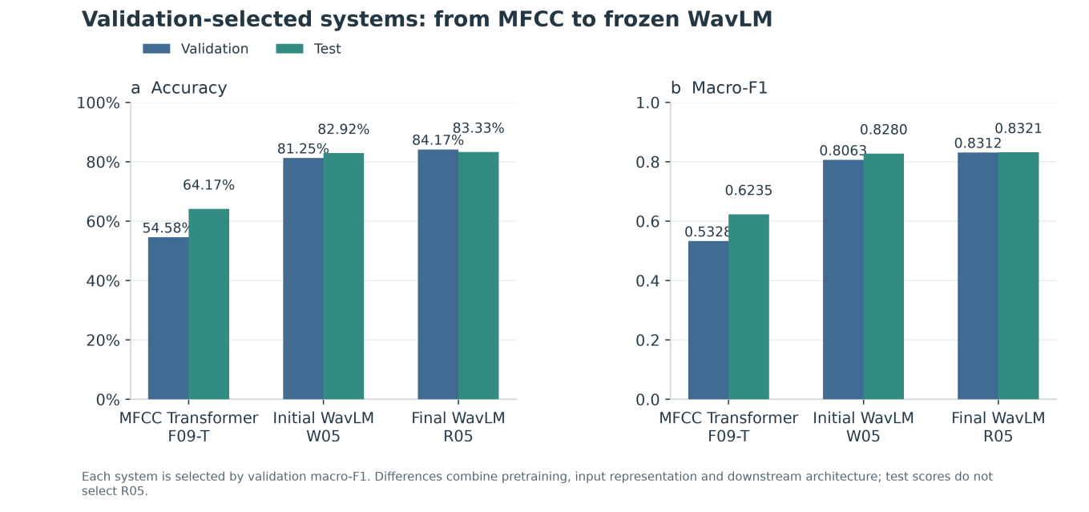
Figure 5.3. Performance Comparison of Selected Audio Models
Figure 5.3 compares the three audio systems selected at successive development stages. R05 exceeds the validation-selected MFCC Transformer by 19.17 percentage points in test accuracy and approximately 0.2086 in test macro-F1. This difference includes external pretraining, waveform input and downstream adaptation; it does not isolate encoder architecture. The test-access history in Section 3.5 applies to these retrospective results.
All per-class results and confusion matrices were obtained by inference with fixed models. R05 achieved test F1 scores of 0.9394 for surprise and 0.9275 for disgust, but only 0.6897 for sad. Sad recordings were most often misclassified as fearful (6/32) and calm (5/32), indicating that aggregate scores conceal substantial class differences. Appendix C provides per-class metrics and confusion matrices with raw counts.

5.4 Visual Encoder Comparison
Three deep learning models were compared using validation Macro-F1. MobileNetV3-Small with mean pooling achieved the highest score of 0.3771, followed by ResNet18 with BiLSTM (0.2128) and ResNet18 with mean pooling (0.2099).
Model / setting | Input version | Val macro-F1
MobileNetV3-Small + Mean Pooling | M3 face-16, 224×224 | 0.3771
ResNet18 + Mean Pooling | M3 face-16, 224×224 | 0.2099
ResNet18 + BiLSTM | M3 face-16, 224×224 | 0.2128
Table 5.7. Visual Encoder Comparison.
Although ResNet18 with BiLSTM achieved a higher training Macro-F1, its validation performance remained relatively low, suggesting possible overfitting. MobileNetV3-Small showed better validation performance under the tested settings and was therefore selected as the final deep learning visual model for subsequent feature extraction and multimodal fusion.

5.5 Visual Representation Comparison
The visual comparison evaluates Full-320 with the locked AUG-1 RBF-SVM, MobileNetV3-Small pooled 576-D features with an MLP, and their 896-D concatenation with a separately selected MLP. It follows the common actor partition in Chapter 3.
All three visual comparison runs use seed 0 and validation macro-F1 for selection. Test scores are descriptive and do not determine the chosen representation.
Model / setting | Input version | Val macro-F1 | Test macro-F1 | Accuracy
DWT handcrafted | Full-320; AUG-1; RBF-SVM | 0.5290 | 0.4718 | 0.4667
Learned | MobileNetV3-Small; 576-D; MLP | 0.5048 | 0.3661 | 0.3667
Combined | Full-320 + MobileNetV3-Small; 896-D; MLP | 0.5188 | 0.4024 | 0.4167
Table 5.8. Comparison of handcrafted-only, learned-only and combined visual representations.
The handcrafted-only representation achieved the highest validation Macro-F1 of 0.5290 and was therefore selected as the final visual representation. Although the combined representation achieved the highest validation accuracy of 0.5375, its validation Macro-F1 was lower at 0.5188. This supports the use of Macro-F1 as the selection criterion because it gives equal importance to all eight emotion classes. On the test split, the selected handcrafted-only system achieved a Macro-F1 of 0.4718 and an accuracy of 0.4667.
The comparison evaluates three complete visual system configurations rather than changing only the feature representation. The handcrafted system used an augmented RBF-SVM pipeline, whereas the learned-only and combined systems used MLP classifiers trained on the original recordings.

5.6 Unimodal versus Multimodal Comparison
Unless stated otherwise, the following fusion comparisons use R05 WavLM-128 audio and HC-320 vision. Neural entries follow the three-seed aggregation in Section 3.5. The original upstream heads and retrained MLP controls are separate references.
Model / setting | Validation Macro-F1 | Test Macro-F1 | Test Accuracy
Original audio head | 0.8312 | 0.8321 | 0.8333
Visual HC SVM probabilities | 0.5239 | 0.4570 | 0.4500
Audio-only MLP | 0.8325 ± 0.0127 | 0.8209 ± 0.0038 | 0.8222
Visual-only MLP | 0.4767 ± 0.0179 | 0.4806 ± 0.0493 | 0.4681
Equal decision fusion | 0.8347 | 0.7758 | 0.7792
Tuned decision fusion α = 0.60 | 0.8654 | 0.8349 | 0.8375
Concatenation | 0.8693 ± 0.0064 | 0.8116 ± 0.0057 | 0.8125
Gated fusion | 0.8553 ± 0.0142 | 0.8213 ± 0.0111 | 0.8236
Cross-attention | 0.7642 ± 0.0138 | 0.7406 ± 0.0297 | 0.7389
Table 5.9. Unimodal and multimodal comparison with WavLM-128 and visual HC-320 inputs. Decision rows use original visual SVM probabilities; tuned audio α = 0.60.
Concatenation obtains validation/test Macro-F1 0.8693/0.8116, and gating obtains 0.8553/0.8213. The corresponding audio-only MLP test score is 0.8209; the original audio head scores 0.8321. Single-direction cross-attention obtains 0.7406 test Macro-F1.
Equal decision fusion scores 0.7758 on test; validation-tuned decision fusion scores 0.8349. Original audio classifies 200/240 recordings correctly and tuned decision fusion 201/240. Paired uncertainty is reported with the statistical results below.

5.7 Ablation and Diagnostic Results

5.7.1 Handcrafted Audio Ablations and Diagnostics
Experiment record: feature-group ablation – historical (Baseline V1 features: db4 / raw / 25 ms with V1 statistics), RBF-SVM and MLP (64, 32); factor analysis – final-input V2 features with the five shortlisted Stage 1 classifiers; error overlap – final-input M1 48-D features against M2's WavLM Round 05 and archived MFCC–Transformer exports, StandardScaler + LR (C = 1.0); shared actor split, seed 42, validation actors only.
The V1 feature-group ablation is retained in Appendix B.6 because its statistics differ from the final V2 representation. In V1, the time-domain group was the strongest single group, and additional features helped the MLP. The ablation was not repeated on V2.
Preprocessing factor analysis (V2). Table 5.10 gives the marginal mean validation macro-F1 of each preprocessing factor over the five shortlisted classifiers (30 runs per wavelet, 75 per normalisation setting and 50 per frame length). The spread across wavelets (0.011) and frame lengths (0.005) is far smaller than the spread across classifiers (0.125 between the best LR and the best KNN result). Raw audio was 0.011 better on average, plausibly because peak normalisation removes absolute loudness, an arousal cue that the RMS and energy features otherwise carry. The selected configuration (db2, normalised, 20 ms) therefore reflects the Logistic Regression optimum rather than a uniformly superior front end.
Factor | Level: mean validation macro-F1 (5 shortlisted classifiers)
Wavelet | sym4 0.318 · db4 0.316 · db2 0.316 · haar 0.310 · db8 0.308
Normalisation | raw 0.319 · normalised 0.308
Frame length | 20 ms 0.316 · 25 ms 0.313 · 30 ms 0.311
Table 5.10. Marginal effect of each preprocessing factor (computed from all_classifier_preprocessing_comparison.csv).
Error overlap between representations. Table 5.11 compares the validation predictions of the default handcrafted classifier with those of each learned classifier. An oracle that always picks whichever of the two is correct shows how much the handcrafted features could add at most.
Learned features | Both correct | Handcrafted only | Learned only | Neither | Oracle acc. | Best single acc.
WavLM (final input) | 87 | 9 | 107 | 37 | 84.6% | 80.8%
MFCC–Transformer (historical) | 57 | 39 | 58 | 86 | 64.2% | 47.9%
Table 5.11. Error overlap on the 240 validation clips between the handcrafted model and each learned model (default Logistic Regression).
Against the MFCC–Transformer features, the handcrafted model was correct on 39 clips that the learned model missed, which shows real complementarity. Against WavLM, that falls to 9 clips, and the oracle gain shrinks from 16.3 to 3.8 percentage points. Simple concatenation followed by one linear model exploited neither (Section 6.3).

5.7.2 Handcrafted Visual Ablation Studies
Two controlled ablation studies were conducted for the M3 handcrafted visual branch. The first examined the effects of the facial centre crop and local DWT grid, while the second compared three training-only augmentation strategies. In both studies, model and configuration selection was based on validation Macro-F1, and the test split was not used to select the final configuration.

DWT Representation Ablation
Four DWT configurations were evaluated to isolate the effects of facial centre cropping and local spatial aggregation. Configuration A used the complete 224×224 face with one set of global statistics calculated over each DWT subband. Configuration B introduced only the 180×180 centre crop. Configuration C retained the complete face but divided each subband into a 4×4 local grid. Configuration D combined the centre crop and local grid. All configurations used the same 16-frame inputs, actor-independent split, temporal mean pooling, SVM search space and random seed of 0. Configuration selection was based on validation Macro-F1.
Configuration | Facial region | Spatial aggregation | Feature dimension | Val macro-F1 | Accuracy
A | Full 224×224 face | Global statistics | 20 | 0.2671 | 0.2792
B | Centre 180×180 crop | Global statistics | 20 | 0.2840 | 0.3083
C | Full 224×224 face | 4×4 local grid | 320 | 0.3760 | 0.3750
D | Centre 180×180 crop | 4×4 local grid | 320 | 0.4785 | 0.4792
Table 5.12. Ablation of facial region and DWT spatial aggregation for the handcrafted visual representation.
The centre crop alone produced a small improvement in validation Macro-F1, increasing the score from 0.2671 for Configuration A to 0.2840 for Configuration B. Replacing global statistics with the 4×4 local grid produced a larger improvement: Configuration C achieved 0.3760 without the centre crop, while Configuration D achieved the highest validation Macro-F1 of 0.4785 by combining both modifications. Configuration D was therefore selected as the Full-320 handcrafted representation used in the subsequent augmentation comparison and final visual system. The results show that retaining the spatial locations of wavelet responses was more important than centre cropping alone under the implemented experimental settings.

Training Augmentation Comparison
After selecting the Full-320 DWT representation, three training-only augmentation configurations were compared. AUG-0 used the 960 original training clips without augmentation. AUG-1 added one horizontally flipped copy of each training clip. AUG-2 added one lightly augmented copy of each clip using the geometric and photometric transformations described in Section 4.3.1. Validation and test clips were not augmented. All configurations used the same actor-independent split, Full-320 feature extractor, SVM hyperparameter search space and random seed of 0. Configuration selection was based on validation Macro-F1.
Configuration | Training input | Total training samples | Selected SVM | Val macro-F1 | Accuracy
AUG-0 | Original clips only | 960 | C=100, γ=0.001, class weight=None | 0.4785 | 0.4792
AUG-1 | Originals + horizontal flips | 1920 | C=10, γ=0.001, class weight=balanced | 0.5290 | 0.5208
AUG-2 | Originals + light combined augmentation | 1920 | C=10, γ=scale, class weight=balanced | 0.4596 | 0.4792
Table 5.13. Comparison of training-only augmentation configurations for the Full-320 DWT representation.
AUG-1 achieved the highest validation Macro-F1 of 0.5290 and was therefore selected for the final handcrafted visual model. Relative to the non-augmented AUG-0 baseline, horizontal flipping improved validation Macro-F1 by 0.0505. In contrast, the more varied AUG-2 configuration reduced validation Macro-F1 to 0.4596.

5.7.3 Multimodal Fusion Ablations and Diagnostics
The WavLM experiment suite comprises 93 neural fits, 27 SVM configurations and 10 fixed probability pipelines. The following comparisons examine representation choice, architectural and loss components, sequence pooling, and inference-time gate interventions.

Representation Controls
Representation / MLP control | Validation Macro-F1 | Test Macro-F1 | Test Accuracy
Audio HC 48D | 0.3575 ± 0.0099 | 0.3678 ± 0.0116 | 0.3667
Audio WavLM 128D | 0.8325 ± 0.0127 | 0.8209 ± 0.0038 | 0.8222
Audio combined 176D | 0.8243 ± 0.0104 | 0.8158 ± 0.0074 | 0.8181
Visual HC 320D | 0.4767 ± 0.0179 | 0.4806 ± 0.0493 | 0.4681
Visual deep 576D | 0.5178 ± 0.0172 | 0.3918 ± 0.0174 | 0.3931
Visual combined 896D | 0.5751 ± 0.0353 | 0.4105 ± 0.0193 | 0.4069
Table 5.14. Representation comparisons within the matched MLP classifier family.
The representation comparison covers handcrafted, learned and combined inputs within the same MLP family. Input dimensionality and first-layer parameter counts differ between representations.

Residual and Auxiliary Loss Controls
Residual setting | Validation Macro-F1 | Test Macro-F1 | Test Accuracy
Frozen-audio residual | 0.8392 ± 0.0045 | 0.8225 ± 0.0089 | 0.8264
+ visual dropout | 0.8372 ± 0.0028 | 0.8266 ± 0.0058 | 0.8292
+ auxiliary CE | 0.8536 ± 0.0022 | 0.8302 ± 0.0053 | 0.8333
+ dropout + auxiliary CE | 0.8515 ± 0.0075 | 0.8280 ± 0.0033 | 0.8319
+ auxiliary CE + intra SupCon | 0.8496 ± 0.0006 | 0.8252 ± 0.0055 | 0.8292
+ auxiliary CE + cross SupCon | 0.8505 ± 0.0096 | 0.8311 ± 0.0039 | 0.8333
Table 5.15. Residual 2 × 2 controls and added contrastive objectives.
The residual comparison crosses visual dropout with auxiliary supervision. Contrastive variants are added to the auxiliary-CE configuration; the identically configured aux_control supplies the same control result.

Sequence and Interaction Controls
Sequence model | Val Macro-F1 | Test Macro-F1 | Test Accuracy | Parameters
Audio sequence mean | 0.7854 ± 0.0114 | 0.8244 ± 0.0026 | 0.8222 | 8,776
Sequence mean concatenation | 0.7855 ± 0.0057 | 0.7993 ± 0.0179 | 0.7958 | 29,256
Projected visual mean | 0.7543 ± 0.0129 | 0.7706 ± 0.0107 | 0.7667 | 33,608
Uniform attention | 0.7597 ± 0.0326 | 0.7334 ± 0.0361 | 0.7361 | 50,248
Learned single-direction attention | 0.7642 ± 0.0138 | 0.7406 ± 0.0297 | 0.7389 | 50,248
+ relative-index position | 0.7596 ± 0.0121 | 0.7393 ± 0.0321 | 0.7375 | 50,248
+ temporal convolution | 0.7782 ± 0.0221 | 0.7277 ± 0.0502 | 0.7333 | 51,016
Bidirectional attention | 0.8628 ± 0.0104 | 0.8265 ± 0.0198 | 0.8375 | 71,112
Table 5.16. Pooling and attention controls on the primary sequences.
The sequence comparison includes mean pooling, projected visual means, uniform attention, relative-index positions, temporal convolutions and bidirectional attention. The listed parameters are total fusion-head parameters; uniform attention leaves its Q/K weights inactive.
The projected-interaction comparison below lists plain concatenation, projected concatenation and rank-4 fusion, including their model sizes.
Interaction model | Val Macro-F1 | Test Macro-F1 | Test Accuracy | Parameters
Plain concatenation | 0.8693 ± 0.0064 | 0.8116 ± 0.0057 | 0.8125 | 29,256
Projected concatenation | 0.8380 ± 0.0173 | 0.8283 ± 0.0164 | 0.8278 | 41,864
Rank-4 low-rank fusion | 0.8309 ± 0.0028 | 0.7914 ± 0.0099 | 0.7931 | 66,956
Table 5.17. Projection and interaction controls with the same inputs.

Gate Intervention and Error Complementarity
Gate condition | Val Macro-F1 | Val Accuracy | Predictions changed
Learned gate | 0.8553 | 0.8583 | 0.00%
Fixed 0.50 | 0.8418 | 0.8472 | 3.47%
Train-mean gate | 0.8435 | 0.8486 | 2.50%
Audio extreme g = 1 | 0.8256 | 0.8306 | 7.78%
Visual extreme g = 0 | 0.2772 | 0.3431 | 64.31%
Shuffled sample-to-gate | 0.8067 | 0.8131 | 7.69%
Label-aware oracle† | 0.8892 | 0.8958 | 10.97%
Shuffled oracle control† | 0.7327 | 0.7393 | 18.96%
Table 5.18. Validation gate interventions, averaged over seeds. † Ground-truth-dependent positive controls, excluded from model ranking.
Each seed uses 20 gate shuffles. The extreme conditions select branches of the jointly trained gated model. Oracle conditions use the known label to select a route and are diagnostic controls, not deployable predictors.
Fusion method | Val repair / harm | Test repair / harm
Concatenation | 12.67 / 5.00 | 5.00 / 10.00
Gated fusion | 10.00 / 6.00 | 3.67 / 6.00
Cross-attention | 25.33 / 42.67 | 18.67 / 41.33
Table 5.19. Mean counts per seed relative to the original audio head, with 240 samples per split.
A repair is an audio error corrected by fusion; a harm is a correct audio prediction changed into an error. Concatenation repairs more predictions than it harms on validation, but this balance reverses on test. Its net loss of five correct test predictions accounts for the Accuracy decrease from 0.8333 to 0.8125. Class-specific changes determine the associated Macro-F1 difference.
Per-recording training-mean replacement and attention visualisation are also available in the application.

5.8 Final Model Selection and Test Performance
The validation rule in Section 3.5 selects concatenation among the three primary neural fusion candidates. Decision fusion is tuned separately. Table 5.20 summarises the locked final evaluation; these scores retain the exploratory interpretation required by the project’s earlier test exposure.
Configuration / selection role | Validation Macro-F1 | Test Macro-F1 | Test Accuracy
Selected audio reference | 0.8312 | 0.8321 | 0.8333
Selected visual reference | 0.5239 | 0.4570 | 0.4500
Validation-selected primary fusion: concat | 0.8693 ± 0.0064 | 0.8116 ± 0.0057 | 0.8125
Separately tuned decision reference | 0.8654 | 0.8349 | 0.8375
Table 5.20. Selected-input references and validation-preselected fusion.
For concatenation, test macro-precision is 0.8384 ± 0.0115, macro-recall is 0.8086 ± 0.0039 and Accuracy is 0.8125 ± 0.0042. These summarise three independently trained heads. Class-wise results appear in the discussion; exact run identities and artifact paths are retained in Appendix D.
Concatenation remains the primary fusion for the system. Tuned decision fusion and validation-selected audio SVM are supplementary references; their test Macro-F1 values are 0.8349 and 0.8360.

Handcrafted Audio Baseline Selection and Test Performance
The frozen M1 baseline is default Logistic Regression on db2 / normalised / 20 ms features (Section 4.2.2). It is the handcrafted unimodal reference, rather than the learned audio input selected for fusion. Its exported probabilities were scored on 26 October 2026 after selection was complete. Tables 5.21 and 5.22 and Figure 5.4 give the resulting metrics and confusion matrices.
The final M1 run uses seed 42, no augmentation and C = 1.0. Predictions are retained under outputs/handover/m1_audio/probabilities/{train,val,test}.csv.
Partition | Recordings | Accuracy | Macro-precision | Macro-recall | Macro-F1 | Weighted F1
Training, in-sample | 960 | 0.519 | 0.509 | 0.510 | 0.508 | 0.515
Training, 4-fold OOF | 960 | 0.339 | 0.325 | 0.331 | 0.327 | 0.336
Validation | 240 | 0.400 | 0.421 | 0.391 | 0.389 | 0.394
Test (held out) | 240 | 0.396 | 0.392 | 0.383 | 0.381 | 0.393
Table 5.21. Selected M1 handcrafted model: training, validation and held-out test performance.
Emotion | n | Val P | Val R | Val F1 | Test P | Test R | Test F1
neutral | 16 | 0.400 | 0.250 | 0.308 | 0.231 | 0.188 | 0.207
calm | 32 | 0.500 | 0.625 | 0.556 | 0.448 | 0.406 | 0.426
happy | 32 | 0.526 | 0.313 | 0.392 | 0.380 | 0.594 | 0.463
sad | 32 | 0.180 | 0.281 | 0.220 | 0.357 | 0.313 | 0.333
angry | 32 | 0.460 | 0.719 | 0.561 | 0.531 | 0.531 | 0.531
fearful | 32 | 0.500 | 0.250 | 0.333 | 0.293 | 0.375 | 0.329
disgust | 32 | 0.429 | 0.375 | 0.400 | 0.522 | 0.375 | 0.436
surprised | 32 | 0.370 | 0.313 | 0.339 | 0.375 | 0.281 | 0.321
Macro average | 240 | 0.421 | 0.391 | 0.389 | 0.392 | 0.383 | 0.381
Table 5.22. Selected M1 model: per-class precision (P), recall (R) and F1 on validation and test (n recordings per class in each partition).
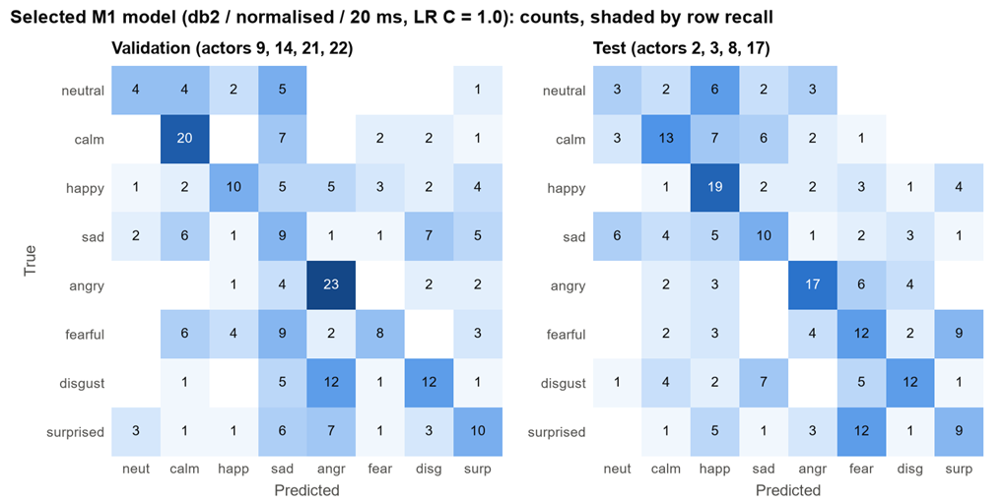
Figure 5.4. Confusion matrices of the selected M1 model on the validation and test actors (counts; colour shows the share of each true class).
The selected M1 baseline obtains test macro-F1 0.381, close to its validation value of 0.389; accuracies are 39.6% and 40.0%. The four-fold OOF training estimate is 0.327, with each fold trained on 12 rather than 16 actors. These figures describe this partition rather than uncertainty across new actor splits.

5.9 External Dataset Evaluation
Cross-dataset performance is evaluated on 24 CREMA-D recordings (Cao et al., 2014): actors 1001–1004, sentence DFA, unspecified intensity and six emotions, with four recordings per class. The sample list and seed-42 checkpoints are fixed before inference. The original video files pass through the same audio and handcrafted visual extractors used by the application. All 24 recordings complete inference, with face detection in all 384 sampled frames.
Reference labels are the intended emotions encoded in the official filenames. They map to neutral, happy, sad, angry, fearful and disgust. Predictions retain the eight RAVDESS classes; calm or surprise predictions count as errors. Macro-F1 averages the six reference classes. Raw-video decision fusion uses the visual-only MLP probabilities and validation-selected audio weight 0.70, as specified in Section 7.1.
Frozen model seed 42 | Correct | Accuracy | Macro-F1
Original audio head | 10/24 | 0.4167 | 0.4076
Audio-only MLP | 9/24 | 0.3750 | 0.3654
Visual-only MLP | 6/24 | 0.2500 | 0.1828
Concatenation | 9/24 | 0.3750 | 0.3346
Gated fusion | 9/24 | 0.3750 | 0.3346
Cross-attention | 5/24 | 0.2083 | 0.1143
Bidirectional attention | 9/24 | 0.3750 | 0.3635
Audio residual + auxiliary CE | 10/24 | 0.4167 | 0.4055
Low-rank fusion | 11/24 | 0.4583 | 0.4175
Equal decision fusion | 8/24 | 0.3333 | 0.3060
Tuned decision fusion α = 0.70 | 9/24 | 0.3750 | 0.3251
Table 5.23. CREMA-D pilot results for 24 recordings. Macro-F1 averages six reference classes; predictions remain eight-class. Decision rows use visual-only MLP probabilities; tuned audio α = 0.70.
Original audio has 10/24 correct predictions, concatenation and gating have 9/24, and low-rank fusion has 11/24. Concatenation differs from audio on correctness for only one recording: zero repairs and one harm, with exact McNemar p = 1.0. These small differences do not establish a cross-dataset ranking. The full eight-class prediction space is retained.

5.10 Paired Uncertainty and Calibration
Paired analyses use the frozen saved test predictions, aligned by recording. The actor-cluster bootstrap enumerates all 4⁴ = 256 ordered draws of the four test actors with replacement, preserving paired predictions within each selected actor. It reports the 2.5th/97.5th percentiles of candidate-minus-original-audio Macro-F1; neural statistics average the three seed-specific metrics, not probabilities.
Candidate | Test F1 | Accuracy | 95% actor-bootstrap ΔF1 | Exact p
Original audio | 0.8321 | 0.8333 | [+0.0000, +0.0000] | —
Tuned decision | 0.8349 | 0.8375 | [-0.0182, +0.0235] | 1.000
Audio SVM | 0.8360 | 0.8375 | [-0.0002, +0.0116] | 1.000
Concatenation | 0.8116 | 0.8125 | [-0.0715, +0.0164] | 0.180–0.454
Gated fusion | 0.8213 | 0.8236 | [-0.0529, +0.0118] | 0.267–1.000
Projected concat | 0.8283 | 0.8278 | [-0.0076, +0.0033] | 0.210–1.000
Bidirectional | 0.8265 | 0.8375 | [-0.0253, +0.0360] | 0.487–1.000
Table 5.24. Post-hoc paired analyses relative to original audio. Intervals are conditional on four observed actors; exact McNemar p-values concern clip correctness and are unadjusted. Three-seed p ranges are shown for neural models.
Tuned decision fusion repairs four original-audio errors and introduces three; audio SVM repairs two and introduces one. Both exact McNemar tests give p = 1.0, and both actor-bootstrap F1 difference intervals include zero. These analyses do not resolve the small point-estimate differences. Clip-level tests do not model within-actor dependence, and neither this test nor the bootstrap repeats model selection.
Calibration is evaluated without fitting a calibrator. Top-label expected calibration error uses ten fixed equal-width probability bins, weighted by their sample counts (Guo et al., 2017). Multiclass Brier score is the mean sum of squared class-probability errors. The CREMA-D estimates use all eight predicted probabilities and the intended labels; sparse bins make them descriptive.
Dataset | Model | N | ECE ↓ | Brier ↓
RAVDESS | Audio head | 240 | 0.0746 | 0.2767
RAVDESS | Concatenation | 240 | 0.0650 | 0.2721
RAVDESS | Gated fusion | 240 | 0.0653 | 0.2617
RAVDESS | Tuned decision | 240 | 0.1586 | 0.3215
CREMA-D | Audio head | 24 | 0.4850 | 0.9781
CREMA-D | Concatenation | 24 | 0.3899 | 0.9567
CREMA-D | Gated fusion | 24 | 0.2533 | 0.8444
Table 5.25. Uncalibrated probability diagnostics. Neural RAVDESS entries average seed-specific scores; CREMA-D uses seed 42. Brier is summed over eight classes.

5.11 Fusion with MFCC Transformer Representations
This comparison evaluates the earlier MFCC Transformer feature configuration using the same actor partition and eight-class metric definitions as the WavLM study. Each neural configuration uses seeds 42/43/44, hidden width 64, dropout 0.20, AdamW at learning rate 0.001, batches of 64, at most 30 epochs and patience 8. Best epochs are selected by validation Macro-F1. Pooled fusion receives 176D audio and 576D vision; sequence models receive the learned 128D audio tokens and 576D visual frame descriptors.
Model / setting | Validation Macro-F1 | Test Macro-F1 | Test Accuracy
Original audio head | 0.4565 | 0.5445 | 0.5750
Original visual head | 0.3033 | 0.2150 | 0.2833
Audio-only MLP | 0.4682 ± 0.0163 | 0.5730 ± 0.0075 | 0.5986
Visual-only MLP | 0.5178 ± 0.0172 | 0.3918 ± 0.0174 | 0.3931
Concatenation | 0.6392 ± 0.0154 | 0.6480 ± 0.0126 | 0.6250
Gated fusion | 0.6011 ± 0.0109 | 0.6831 ± 0.0243 | 0.6944
Cross-attention | 0.6608 ± 0.0163 | 0.5749 ± 0.0072 | 0.5722
Audio sequence mean | 0.4325 ± 0.0136 | 0.5346 ± 0.0188 | 0.5681
Sequence mean concatenation | 0.6224 ± 0.0062 | 0.6057 ± 0.0158 | 0.5917
Equal decision fusion | 0.4906 | 0.5579 | 0.5917
Tuned decision fusion α = 0.15 | 0.5455 | 0.4741 | 0.5208
Table 5.26. MFCC Transformer setting: handcrafted-plus-learned audio (176D) and MobileNetV3 vision (576D). Neural rows are three-seed means ± sample SD. Decision rows use original exported probabilities and validation-selected weights.
The matched audio-only MLP obtains validation/test Macro-F1 0.4682/0.5730. Concatenation obtains 0.6392/0.6480 and gating 0.6011/0.6831. Their mean test improvements over audio-only are 7.50 and 11.02 percentage points; both are positive in every paired seed. Gating increases test Accuracy from 0.5986 to 0.6944, a 9.58-point gain. Relative to audio-only, it repairs 43 errors and introduces 20 per seed on average, a net gain of 23 correct recordings.
Forward cross-attention has the highest mean validation Macro-F1 and is the configuration selected by the recorded validation rule. Its test score is 0.5749, close to the audio-only control. Gating’s higher test score is reported as a candidate comparison and does not replace that validation selection. Equal decision fusion scores 0.5579 on test, whereas validation-tuned decision fusion scores 0.4741; the latter does not improve on the original audio head.
Paired actor-cluster resampling follows the same procedure as the WavLM analysis, using saved predictions without refitting. The 95% percentile intervals for Macro-F1 differences from matched audio-only are [−0.1922, 0.2235] for concatenation and [−0.0172, 0.1880] for gating. These intervals are conditional on four observed test actors. The positive three-seed results therefore describe this partition, with substantial uncertainty across actors.
A fixed-visual comparison pairs WavLM audio with the same MobileNetV3 features used above. After sample-ID alignment, all 1,440 pooled visual vectors and frame sequences are numerically identical between the two deliveries. The visual-only control is therefore unchanged; the audio branch and resulting fusion inputs differ. The table below reports these existing three-seed WavLM runs using the same training and validation-selection protocol.
Model / setting | Validation Macro-F1 | Test Macro-F1 | Test Accuracy
WavLM audio-only MLP | 0.8325 ± 0.0127 | 0.8209 ± 0.0038 | 0.8222
MobileNetV3 visual-only MLP | 0.5178 ± 0.0172 | 0.3918 ± 0.0174 | 0.3931
WavLM + vision: concatenation | 0.8709 ± 0.0076 | 0.7988 ± 0.0197 | 0.7917
WavLM + vision: gating | 0.8554 ± 0.0150 | 0.7942 ± 0.0425 | 0.7944
WavLM + vision: cross-attention | 0.8104 ± 0.0094 | 0.6160 ± 0.0323 | 0.6028
Table 5.27. WavLM audio with fixed MobileNetV3 visual features (576D), matching the visual input of Table 5.26. Mean ± sample SD over seeds 42/43/44.
With vision held fixed, WavLM audio-only obtains test Macro-F1 0.8209, while concatenation obtains 0.7988 and gating 0.7942: differences of −2.21 and −2.67 percentage points. The corresponding MFCC-setting differences are +7.50 and +11.02 points. Thus, the observed reversal in fusion gain persists without changing visual feature values. Audio representation, pooling, upstream training and input dimensionality still differ between the settings.

6. Discussion
The results indicate that fusion value depends on the available representations and on how corrections trade off against new errors. This chapter interprets the comparisons in Chapter 5, distinguishing observations on the fixed partition from explanations that require further controls.

6.1 Effectiveness of Handcrafted and Learned Representations
Audio and vision have substantially different strengths in the final configuration: the original R05 audio head reaches test macro-F1 0.8321, whereas argmax over the visual probabilities imported by M5 gives 0.4570. The matched MLP controls likewise favour WavLM audio. Consequently, these experiments test fusion with a strong audio representation and a weaker available visual representation; they do not establish a general limit on audio–visual recognition.
The available visual representations are substantially weaker than audio. In the matched MLP controls, handcrafted vision transfers better to test than the supplied MobileNetV3 representation. The current fusion controls do not test emotion-pretrained visual encoders or encoder fine-tuning, so they cannot establish a general limit on multimodal recognition.

Handcrafted and Learned Audio Representations
M1’s fixed-classifier comparison favours learned over handcrafted audio on validation. The M5 representation controls also support learned-only audio within the matched MLP family. These comparisons assess the available complete pipelines; classifier and upstream training choices remain part of their interpretation.
- The handcrafted classifier sweep shows a large training–validation gap for high-capacity models. This is consistent with overfitting under limited training-actor coverage, although it does not identify the specific speaker characteristics learned. A regularised linear model gives the strongest validation result among the tested M1 configurations.
- The handcrafted confusion patterns are consistent with intensity and spectral cues separating some arousal differences while leaving within-group confusions (Juslin & Laukka, 2003). Explicit pitch and voice-quality descriptors were not included, so their possible contribution remains untested. Confusion matrices alone do not prove which acoustic cues caused an error.
- External pretraining is a plausible contributor to WavLM’s advantage. However, the WavLM and MFCC systems also differ in input representation, pooling, adaptation and optimisation, so the study does not isolate the contribution of pretraining. The close W05 validation scores of Logistic Regression and the original MLP suggest that useful discrimination is already present in the exported representation.
- Adding handcrafted audio does not improve the W05 representation under Logistic Regression. The historical V1 MLP comparison does show a gain with weaker MFCC features, indicating dependence on both features and classifier. The validation oracle is an upper bound using true labels, not an attainable fusion result; the small W05 error complementarity does not demonstrate that a deployable combination can exploit it.

Handcrafted and Learned Visual Representations
The controlled DWT ablation supports retaining local spatial layout: the 4 × 4 grid contributes more to validation performance than the centre crop alone. Horizontal flipping improves the selected handcrafted configuration, whereas the stronger AUG-2 transformations reduce its score. This supports the selected preprocessing for the tested setting, without establishing why each transformed cue helps or harms.
MobileNetV3-Small is the strongest of the three frozen visual encoders under the tested validation protocol. ResNet18 with BiLSTM has only a small advantage over ResNet18 mean pooling and a larger training–validation gap. The limited ten-epoch budget, frozen ImageNet backbones and single actor split constrain any architecture-level conclusion.
The M3 handcrafted-only system also exceeds the learned-only and combined visual systems on the reported validation and test metrics. This compares complete configurations: the handcrafted branch uses an augmented RBF-SVM, while the other branches use MLPs on original recording-level exports. It therefore does not isolate representation type. More suitable emotion pretraining or controlled visual fine-tuning remains a reasonable hypothesis to test.

6.2 Benefits and Limitations of Multimodal Fusion
The MFCC Transformer setting provides evidence that vision can help the matched audio control on this partition. Gating has the highest descriptive test score, but forward cross-attention was selected by validation and is not replaced after viewing test results. The wide actor-bootstrap intervals qualify the positive three-seed gains: optimisation consistency across seeds does not establish transfer across actor populations.
Holding the MobileNetV3 visual values fixed preserves the reversal in fusion gain between MFCC and WavLM audio. A change in vision alone therefore cannot explain it. Stronger audio leaves fewer errors available to correct, while the added branch can still disrupt correct decisions. The comparison also changes audio dimensionality, pooling and supervised adaptation, so it does not identify the backbone as the sole cause.
Repair and harm counts make this trade-off concrete. Final concatenation introduces more test errors than it repairs, despite the opposite balance on validation. Tuned decision fusion changes only seven correctness outcomes and adds one correct recording overall; the paired checks do not resolve its small advantage over original audio. The CREMA-D differences are similarly too small to support method ranking.
Projected concatenation improves the point estimate over plain concatenation using the same source features, but its paired actor-bootstrap interval includes zero. Rank-4 interactions do not exceed this control. These findings motivate testing projection and parameterisation before adding interactions, while leaving the validation-defined primary model unchanged.

6.3 Per-Class Performance and Error Complementarity
Class | Support | Audio head F1 | Concat mean F1 | Decision F1
neutral | 16 | 0.8571 | 0.8374 | 0.8571
calm | 32 | 0.8493 | 0.8310 | 0.8857
happy | 32 | 0.8333 | 0.8818 | 0.8710
sad | 32 | 0.6897 | 0.6456 | 0.6786
angry | 32 | 0.8070 | 0.8121 | 0.8364
fearful | 32 | 0.7536 | 0.7063 | 0.7761
disgust | 32 | 0.9275 | 0.8643 | 0.8889
surprise | 32 | 0.9394 | 0.9144 | 0.8857
Table 6.1. Test class-wise F1. Concat is the mean over three seeds; other columns are fixed upstream-probability predictions.
The class-wise trade-offs in Table 6.1 explain why an overall gain need not benefit every emotion. Concatenation improves happy F1 but reduces several other classes. The confusion matrices locate these errors; they do not identify the facial or vocal cues responsible.
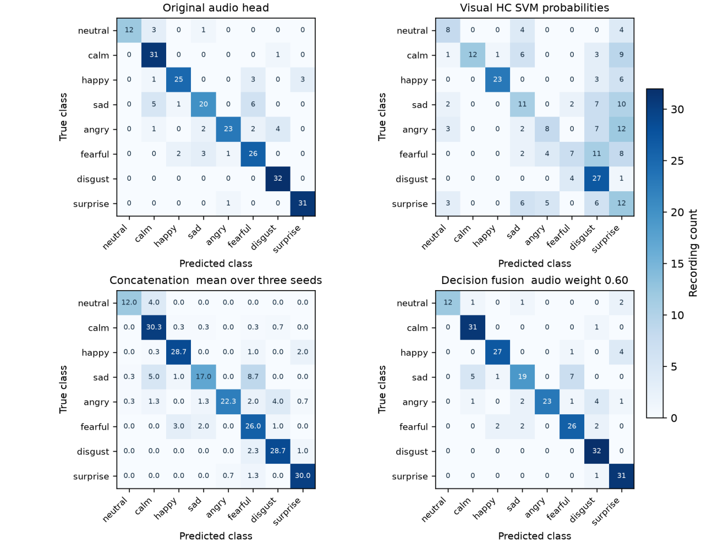
Figure 6.1. Test confusion matrices with true labels on rows and predictions on columns. Each panel covers the same 240 recordings. Concat displays mean counts over seeds 42/43/44; the other panels show fixed integer counts. Colour scale is 0–32, without row normalisation.

Handcrafted Audio Per-Class Errors and Complementarity
The M1 baseline also varies across classes and actors. Its weak neutral performance occurs in a class with half the support of the others, while several negative-emotion confusions remain frequent. A small number of actors and class observations limits interpretation of the larger per-class differences between validation and test.
The M1 error-overlap study finds more potential complementarity with the earlier MFCC representation than with W05. This is consistent with the representation-dependent fusion findings, but it is a separate audio-only comparison with a different classifier and must not be treated as evidence that a particular multimodal mechanism works.

6.4 Generalisation Across Actors and Datasets
Repeated checkpoint, hyperparameter and method comparisons on four validation actors can make retained validation estimates optimistic (Cawley & Talbot, 2010). The final test gaps may reflect selection, actor composition and model capacity together. The current evidence does not separate these contributions.
Actor | N | Audio head | Visual SVM | Audio MLP | Concat | Gated | Decision
2 | 60 | 0.8326 | 0.4015 | 0.8190 | 0.8330 | 0.8275 | 0.8326
3 | 60 | 0.8777 | 0.2426 | 0.8745 | 0.8659 | 0.8854 | 0.8868
8 | 60 | 0.9369 | 0.6044 | 0.9370 | 0.9647 | 0.9543 | 0.9686
17 | 60 | 0.6060 | 0.2658 | 0.5796 | 0.5026 | 0.5239 | 0.5773
Table 6.2. Test Macro-F1 by actor. Audio/visual heads and decision fusion are fixed; MLP/fusion entries average three seed-specific metrics. All columns use eight labels.
Actor 17 has the weakest original-audio and concatenation performance, while Actor 8 benefits from fusion. For Actor 17, concatenation increases sad-to-fearful errors. This supports reporting actor-level outcomes alongside the aggregate metric; it does not establish whether expressions, recording conditions or preprocessing caused the failures.
The CREMA-D pilot confirms that the raw-video path can complete decoding, face extraction and inference on independent clips. Its low recognition performance and high calibration error nevertheless limit practical reliability. The pilot covers four actors and one acted English sentence; intended-emotion labels and unverified raw-RAVDESS extraction parity also prevent attributing the full gap to domain shift.

6.5 Interpretation of Gating and Attention
Replacing or shuffling learned gates changes validation predictions, showing functional dependence on sample-specific weighting. Gate extremes select the jointly trained modality projections, not the independently trained unimodal models. Label-aware oracle routes use the target label and serve only as positive controls; they are not deployable strategies.
Bidirectional attention improves the observed scores over forward attention, but also adds a reverse information path, visual-side pooling and about 41.5% more head parameters. Its positive paired actor-bootstrap interval is conditional on the four observed actors. Matched-capacity and pooled-context controls are needed before attributing the gain to a particular pathway or temporal mechanism.
Probability decomposition reconstructs decision fusion exactly. Gate values and attention maps describe internal weighting, while modality replacement describes output sensitivity. None establishes causal emotional cues or physical audio–video synchronisation. Relative sequence indices also do not replace timing alignment after audio trimming.
The reliability plots show that maximum probability and correctness diverge, especially in the external pilot. Five original-audio mistakes exceed probability 0.90. No calibrator was fitted; the sparse external bins make ECE descriptive. These observations justify explicit confidence diagnostics rather than interpreting softmax values as accuracy guarantees.
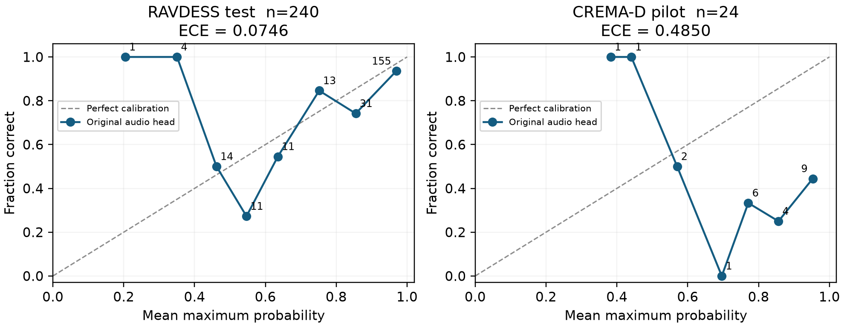
Figure 6.2. Original-audio reliability diagrams using ten fixed equal-width bins. Numbers annotate samples per occupied bin; dashed lines indicate perfect calibration. ECE is descriptive, especially for the 24-clip external pilot.

6.6 Study Limitations
The main study uses one actor partition and a small number of evaluation actors. Three-seed standard deviations describe optimisation variability; actor-bootstrap intervals are conditional on four test clusters. Neither estimates the performance of a full retraining and model-selection procedure on a new actor population.
Repeated validation use and the test exposures documented in Section 3.5 limit confirmatory interpretation. Post-hoc intervals and unadjusted correctness tests do not account for the entire search or multiple-comparison burden. The close validation/test result of one model cannot establish that its selection bias is small.
The external pilot is narrow, and the application substitutes a visual MLP because the upstream SVM checkpoint was not delivered. A raw-RAVDESS feature/prediction parity check is still needed. Noise, occlusion, missing modalities, broader language coverage and probability recalibration have not been established by the current results.

Changes and Limitations in the Handcrafted Audio Branch
Table 6.3 records M1 implementation changes relative to the proposal; these are documented deviations rather than additional experiments.
Proposal | Implemented in M1 | Reason / consequence
Preprocessing including basic denoising | Resampling, silence trimming and optional peak normalisation; no denoising | Studio-quality recordings; normalisation was made an experimental factor instead
Training-only augmentation (noise, time-warp, scaling) | Not applied to handcrafted features | Clip-level statistics; augmentation was used in M2's learned branch. Its effect on handcrafted features is untested
Spectral: centroid, bandwidth, energy, roll-off | V1 as proposed; V2 replaced spectral energy with spectral flatness | Spectral energy duplicates time-domain energy; flatness adds tonal versus noise information
DWT, e.g. 3 levels; mean, variance, energy | Level-4 DWT; V1 mean / variance / energy / entropy; V2 mean / std / min / max | Level 4 aligns D1–A4 with octave bands at 16 kHz; uniform statistics across groups
MLP classifier on the fused audio vector | Nine classifiers compared; Logistic Regression selected | The MLP overfitted (train F1 0.92 vs val 0.37); LR had the best validation F1 and the smallest gap
Final audio feature = concatenation | Concatenation evaluated with M2's WavLM features; it did not beat learned-only features under LR (0.789 vs 0.800) | Selected audio input is M2's WavLM delivery, used directly by M5; the concatenation is kept as an M1 record (audio_combined.npz)
Comparison of learned audio features from MFCC encoders (CNN, BiLSTM, Transformer) | M2's delivered features come from a frozen, externally pretrained WavLM Base+ with a trained adapter (Round 05) | Comparison re-run with WavLM; the MFCC–Transformer comparison is kept as a historical run
Table 6.3. M1 implementation changes relative to the proposal.
- The learned audio exports were produced by an adapter trained on all 16 training actors and selected using the same validation actors. Classifier-only CV on these frozen features is not end-to-end grouped CV, which explains the saturated W05 training-fold scores. M1’s W05 learned/combined Logistic Regression comparison is validation-only; its test coverage is limited to the frozen handcrafted baseline. Pitch, jitter/shimmer and several other handcrafted descriptors remain outside scope.

Limitations of the Handcrafted Visual Experiments
M3 reused validation actors to choose representation, augmentation and SVM parameters, and used one classifier seed. Its visual systems also differ in classifier family and training augmentation, so their comparison cannot isolate the effect of combining handcrafted and learned features.

Limitations of the Deep Visual Models
M4 keeps ImageNet backbones frozen and trains for at most ten epochs with a small batch size and limited tuning. Its results compare the implemented configurations under those constraints, not the attainable performance of fine-tuned facial emotion encoders.

7. Final System and Reproducibility
The final application processes short local videos and displays predictions with method-specific diagnostics. Its reproducibility package preserves input identities and checkpoint provenance, while measured CPU timings describe the tested deployment workload.

7.1 Selected End-to-End Pipeline
The final application connects the frozen audio and visual extractors to the trained fusion models. A short video supplies an audio track and sampled face frames, which are converted into pooled and sequence representations. The selected classifier returns emotion probabilities, and the interface presents modality comparisons and method-specific explanations.
Concatenation is the primary fusion selected in the validation-defined comparison. The interface uses its fixed seed-42 checkpoint, running one saved model at a time. Artifact identities and exact paths appear in Appendix D.
Audio is decoded to floating-point WAV, converted to mono at 16 kHz and silence-trimmed with librosa at top_db = 35. WavLM Base+ layer 6 and the supervised audio temporal adapter produce a T × 128 sequence, an attentive 128D pooled representation and original audio-head probabilities. Visual processing uniformly samples 16 frames, detects and eye-aligns faces, and computes 320D Haar DWT descriptors. Temporal averaging yields the 320D visual vector. Concatenation applies the saved training standardisers and the 448 → 64 → 8 classifier.
For raw-video probability fusion, the visual reference is the trained visual-only MLP. Its validation-selected audio weight is 0.70. In contrast, the RAVDESS decision result in Table 5.9 uses exported visual SVM probabilities and weight 0.60. These are separate classifier configurations. Feature-based concatenation and gating use the HC-320 vectors directly.

7.2 Input and Output Specifications
The upload interface accepts MP4, MOV, AVI, WebM and MKV files up to 100 MB and 30 seconds. Input validation checks readable frames, frame rate and a non-empty, non-silent audio track. Invalid media or missing audio produces an error. The intended input is a short video containing a visible speaking person.
Raw multimodal inference supports WavLM-128 audio with HC-320 vision. Handcrafted audio (48D) and combined audio (176D) are available through matching audio-only heads. Validation replay additionally supports exported deep and combined visual features. Available methods are filtered by checkpoint compatibility. For missed face detections, the extractor reuses a nearby valid box; if no face is detected, it applies a centre crop and displays a warning.
RAVDESS exports are aligned by the six-field sample_id, preserving leading zeros and verifying labels, actors, split tags and class order. Uploaded videos receive an external ID derived from their file-content SHA-256. Their filenames supply neither labels nor cached features. A separate replay mode loads any of the 240 stored validation samples for inspection.
The output is an eight-element probability vector ordered as neutral, calm, happy, sad, angry, fearful, disgust and surprise. The prediction is its argmax. Each upload session saves the source video, audio.wav, 16 face images, extracted_features.npz and result.json under demo/sessions/<job_id>/. The NPZ contains pooled and sequence features, valid lengths, class order and the external ID. JSON records probabilities, selected representations, checkpoint provenance, warnings and explanation data. Frame timestamps and estimated audio-token centres are retained with the audio trim offset.

7.3 Software Environment and Dependencies
The implementation runs on macOS 26.6.2, ARM64, with an Apple M5 processor. PyTorch inference uses two CPU threads; MediaPipe (Lugaresi et al., 2019) creates a local OpenGL context. The browser and HTTP server run locally, and inference uses the pinned WavLM assets and saved project heads.
Component | Version | Role
Python | 3.12.12 | Runtime
NumPy / PyTorch | 1.26.4 / 2.13.0 | Arrays and inference
scikit-learn | 1.9.0 | Metrics and classical models
Transformers | 4.57.6 | WavLM loading
librosa / soundfile | 0.11.0 / 0.13.1 | Audio decoding/preprocessing
MediaPipe / OpenCV | 0.10.21 / 4.11.0.86 | Face and frame processing
PyWavelets | 1.10.0 | DWT features
imageio-ffmpeg | 0.6.0 | FFmpeg binary
Table 7.1. Recorded software environment.
The backbone, adapter and fusion heads are verified by SHA-256. Extraction source and environment manifests accompany the checkpoint inventory in Appendix D. The model card provides the exact WavLM revision (Microsoft, n.d.); dataset and software components retain their applicable licences.

7.4 Execution Instructions and Model Availability
Execution starts from the repository root using the supplied reproduction script. Setup installs the scientific/media requirements and retrieves the pinned backbone; feature preparation verifies paired IDs and the actor manifest. Exact script and artifact locations are listed in Appendix D.
Feature preparation validates the learned-audio feature directory, visual feature NPZ, handcrafted-audio CSV and shared actor manifest, then writes the training/validation cache. The study stage trains the declared heads, selects checkpoints and the primary fusion by validation Macro-F1, records checkpoint hashes and evaluates the saved models on test. A fresh output directory keeps reproduction runs separate from the recorded study.
Operation | Invocation from repository root | Purpose
Environment and assets | bash "$REPRO" setup | Install dependencies and pinned WavLM files
Prepare features | bash "$REPRO" prepare | Validate and export train/val cache only
Full fusion study | bash "$REPRO" study | Train, select on val, lock and evaluate test
Launch interface | bash "$REPRO" serve | Open http://127.0.0.1:8765/
Regression checks | bash "$REPRO" verify | Model and HTTP checks; server must be running
External pilot | bash "$REPRO" external | Download fixed clips, infer and export records
Table 7.2. Reproduction and demonstration commands. Full studies write to a separate output directory.
The saved study contains configurations, checkpoint hashes and per-sample validation/test predictions. The application requires the selected fusion head, audio backbone/adapter, development cache and saved validation probabilities. Raw extraction supports WavLM audio and HC vision; exported deep visual representations remain available in replay mode.

7.5 Demonstration Interface
The interface provides video upload, validation replay, compatible representation selection and fusion-method selection. It compares the active model with the original audio head and the relevant visual reference, displays all eight probabilities, and provides downloads for results and features. Sampled faces have clickable timestamps for video inspection. Uploaded media is processed locally through a serial inference queue, with session files retained for review.
The explanation panel changes with the selected method. Decision fusion shows weighted audio and visual probability terms. Gating shows 64 weights and a fixed-gate comparison. Cross-attention shows an audio-to-visual heatmap, while the residual model shows corrections to the frozen audio logits. Neural models also expose fixed-target sensitivity to replacing one standardised modality with its training mean. Section 6.5 discusses the interpretation of these diagnostics.
System verification comprises ten model regression tests and eleven HTTP checks. These cover agreement with recorded validation predictions, artifact hashes, gate and attention outputs, probability decomposition, input compatibility, video upload/extraction, downloads and invalid-media handling. Browser testing includes a complete CREMA-D upload and prediction. Figure 7.1 presents the complete interface from video input to predictions and inspection for one external recording.
The external recognition results complement the integration checks. All 24 videos pass through extraction and inference. The experiment plan, media hashes, 11-model results and 264 predictions are included in the inventory in Appendix D.
A small local timing benchmark uses four fixed short CREMA-D MP4 clips and the default concatenation pipeline. It includes decoding, face extraction, features, inference, diagnostics and intermediate writes, while excluding HTTP transfer/queueing and browser rendering. One first request loads model weights; eight subsequent sequential requests estimate warm latency. These timings describe this machine and workload, not concurrent throughput.
Measurement | Observed value
First model-loading request | 6.287 s
Warm median / range | 0.356 s / 0.341–0.375 s
Warm requests | 8 over 4 clips
Clip duration range | 2.24–3.14 s
Concatenation parameters | 29,256
Fusion checkpoint disk size | 133.9 KiB
WavLM backbone disk size | 360.1 MiB
Audio adapter disk size | 0.583 MiB
Table 7.3. Local CPU pipeline timing and serialised artifact sizes. Disk size is not peak memory usage.
 | 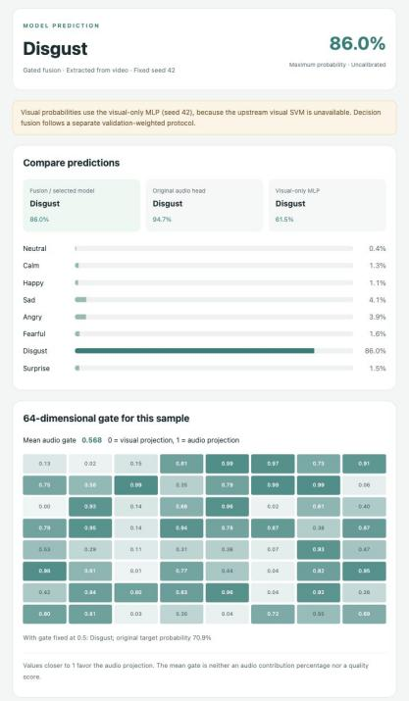 | 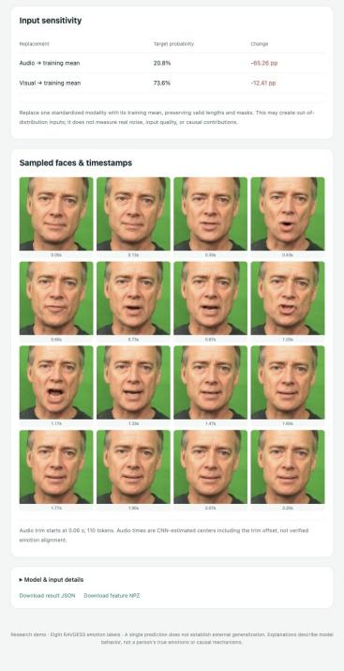
Figure 7.1. Application interface: input and model controls (left), predictions and gate diagnostics (centre), and sensitivity, faces and downloads (right). Reference: angry; prediction: disgust (0.860).

8. Conclusion and Future Work
This project delivers an eight-class emotion-recognition system and reproducible audio–visual comparisons. Fusion gains depend on representation quality and on whether corrections outweigh new errors.

8.1 Main Findings
The final WavLM audio head achieves test macro-F1 0.8321. Validation-selected concatenation reaches 0.8116 ± 0.0057, compared with 0.8209 ± 0.0038 for its matched audio-only MLP. Tuned decision fusion reaches 0.8349, but paired analyses do not resolve its small advantage over original audio. These fusion configurations therefore show no stable gain over strong WavLM audio.
In the earlier MFCC Transformer setting, concatenation and gating improve the matched audio control by 7.50 and 11.02 test macro-F1 percentage points on the fixed partition. These candidate results demonstrate potential value from complementary vision; they do not change the model selected by validation or establish gains across actor populations. Handcrafted audio remains a compact interpretable baseline, while local DWT vision is the strongest visual system in the M3 comparison under its tested training conditions.

8.2 Answers to the Research Objectives
The encoder and representation objectives are met through audio and visual comparisons with recorded inputs, classifiers and selection rules. Fusion receives conditional support: vision helps some weaker-audio configurations, while its benefit does not transfer automatically to stronger audio. Matched controls and repair/harm counts qualify this result.
The local video interface, saved checkpoints, manifests and predictions support reproducible system delivery. All 24 CREMA-D clips complete inference, but concatenation recognises only 9/24. This demonstrates an executable research pipeline with limited external recognition reliability.

8.3 Future Work
First, verify raw-video extraction against saved RAVDESS exports and obtain the original visual SVM. Compare emotion-pretrained or fine-tuned visual encoders with fixed audio and fusion settings, then extend the factorial representation comparison.
Second, use nested actor-grouped evaluation, refitting every supervised adapter, normaliser and classifier within each outer training fold. Predeclare the primary comparison and preserve paired predictions to assess actor variation and selection bias.
Third, test matched-capacity fusion controls, raw-media corruption and missing modalities. Additional acoustic descriptors and OOF combinations could assess remaining complementarity. Broader external recordings, reviewed labels, separate calibration data and deployment measurements are needed before extending reliability claims.

References
Ali, H., Sritharan, V., Hariharan, M., Elshaikh, M., & Khairunizam, W. (2018). Facial expression recognition based on Radon and discrete wavelet transform using support vector machines. Journal of Telecommunication, Electronic and Computer Engineering, 10(1–13), 49–54.https://jtec.utem.edu.my/jtec/article/view/4121
Arevalo, J., Solorio, T., Montes-y-Gómez, M., & González, F. A. (2017). Gated multimodal units for information fusion. arXiv:1702.01992. https://arxiv.org/abs/1702.01992
Cao, H., Cooper, D. G., Keutmann, M. K., Gur, R. C., Nenkova, A., & Verma, R. (2014). CREMA-D: Crowd-sourced emotional multimodal actors dataset. IEEE Transactions on Affective Computing, 5(4), 377–390. https://doi.org/10.1109/TAFFC.2014.2336244
Cawley, G. C., & Talbot, N. L. C. (2010). On over-fitting in model selection and subsequent selection bias in performance evaluation. Journal of Machine Learning Research, 11, 2079–2107.
Chen, S., Wang, C., Chen, Z., Wu, Y., Liu, S., Chen, Z., Li, J., Kanda, N., Yoshioka, T., Xiao, X., Wu, J., Zhou, L., Ren, S., Qian, Y., Qian, Y., Wu, J., Zeng, M., Yu, X., & Wei, F. (2022). WavLM: Large-scale self-supervised pre-training for full stack speech processing. IEEE Journal of Selected Topics in Signal Processing, 16(6), 1505–1518. https://doi.org/10.1109/JSTSP.2022.3188113
Chen, T., & Guestrin, C. (2016). XGBoost: A scalable tree boosting system. In Proceedings of the 22nd ACM SIGKDD International Conference on Knowledge Discovery and Data Mining (pp. 785–794). https://doi.org/10.1145/2939672.2939785
Daqrouq, K., Balamesh, A., Alrusaini, O., Alkhateeb, A., & Balamash, A. S. (2024). Emotion modeling in speech signals: Discrete wavelet transform and machine learning tools for emotion recognition system. Applied Computational Intelligence and Soft Computing, 2024(1), Article 7184018. https://doi.org/10.1155/2024/7184018
El Ayadi, M., Kamel, M. S., & Karray, F. (2011). Survey on speech emotion recognition: Features, classification schemes, and databases. Pattern Recognition, 44(3), 572–587. https://doi.org/10.1016/j.patcog.2010.09.020
Eyben, F., Scherer, K. R., Schuller, B. W., Sundberg, J., André, E., Busso, C., Devillers, L. Y., Epps, J., Laukka, P., Narayanan, S. S., & Truong, K. P. (2016). The Geneva Minimalistic Acoustic Parameter Set (GeMAPS) for voice research and affective computing. IEEE Transactions on Affective Computing, 7(2), 190–202. https://doi.org/10.1109/TAFFC.2015.2457417
Eyben, F., Wöllmer, M., & Schuller, B. (2010). openSMILE: The Munich versatile and fast open-source audio feature extractor. In Proceedings of the 18th ACM International Conference on Multimedia (pp. 1459–1462). https://doi.org/10.1145/1873951.1874246
Guo, C., Pleiss, G., Sun, Y., & Weinberger, K. Q. (2017). On calibration of modern neural networks. Proceedings of ICML, PMLR 70, 1321–1330. https://proceedings.mlr.press/v70/guo17a.html
Hochreiter, S., & Schmidhuber, J. (1997). Long short-term memory. Neural Computation, 9(8), 1735–1780. https://doi.org/10.1162/neco.1997.9.8.1735
Howard, A., Sandler, M., Chu, G., Chen, L.-C., Chen, B., Tan, M., Wang, W., Zhu, Y., Pang, R., Vasudevan, V., Le, Q. V., & Adam, H. (2019). Searching for MobileNetV3. Proceedings of ICCV. https://arxiv.org/abs/1905.02244
Johnston, J. D. (1988). Transform coding of audio signals using perceptual noise criteria. IEEE Journal on Selected Areas in Communications, 6(2), 314–323. https://doi.org/10.1109/49.608
Juslin, P. N., & Laukka, P. (2003). Communication of emotions in vocal expression and music performance: Different channels, same code? Psychological Bulletin, 129(5), 770–814. https://doi.org/10.1037/0033-2909.129.5.770
Khosla, P., Teterwak, P., Wang, C., Sarna, A., Tian, Y., Isola, P., Maschinot, A., Liu, C., & Krishnan, D. (2020). Supervised contrastive learning. Advances in Neural Information Processing Systems, 33, 18661–18673. https://proceedings.neurips.cc/paper_files/paper/2020/hash/d89a66c7c80a29b1bdbab0f2a1a94af8-Abstract.html
Lee, G. R., Gommers, R., Waselewski, F., Wohlfahrt, K., & O'Leary, A. (2019). PyWavelets: A Python package for wavelet analysis. Journal of Open Source Software, 4(36), 1237. https://doi.org/10.21105/joss.01237
Liu, Z., Shen, Y., Lakshminarasimhan, V. B., Liang, P. P., Zadeh, A. B., & Morency, L.-P. (2018). Efficient low-rank multimodal fusion with modality-specific factors. Proceedings of ACL, 2247–2256. https://doi.org/10.18653/v1/P18-1209
Livingstone, S. R., & Russo, F. A. (2018). The Ryerson Audio-Visual Database of Emotional Speech and Song (RAVDESS): A dynamic, multimodal set of facial and vocal expressions in North American English. PLoS ONE, 13(5), e0196391. https://doi.org/10.1371/journal.pone.0196391
Loshchilov, I., & Hutter, F. (2019). Decoupled weight decay regularization. International Conference on Learning Representations. https://arxiv.org/abs/1711.05101
Lugaresi, C., Tang, J., Nash, H., McClanahan, C., Uboweja, E., Hays, M., Zhang, F., Chang, C.-L., Yong, M. G., Lee, J., Chang, W.-T., Hua, W., Georg, M., & Grundmann, M. (2019). MediaPipe: A framework for building perception pipelines. arXiv:1906.08172. https://arxiv.org/abs/1906.08172
Mallat, S. G. (1989). A theory for multiresolution signal decomposition: The wavelet representation. IEEE Transactions on Pattern Analysis and Machine Intelligence, 11(7), 674–693. https://doi.org/10.1109/34.192463
Mary Little Flower, T., & Jaya, T. (2024). A novel concatenated 1D-CNN model for speech emotion recognition. Biomedical Signal Processing and Control, 93, Article 106201. https://doi.org/10.1016/j.bspc.2024.106201
McFee, B., Raffel, C., Liang, D., Ellis, D. P. W., McVicar, M., Battenberg, E., & Nieto, O. (2015). librosa: Audio and music signal analysis in Python. In Proceedings of the 14th Python in Science Conference (pp. 18–25). https://doi.org/10.25080/Majora-7b98e3ed-003
Microsoft. (n.d.). WavLM-Base-Plus [Pretrained model and model card, revision 4c66d4806a428f2e922ccfa1a962776e232d487b]. https://huggingface.co/microsoft/wavlm-base-plus/blob/4c66d4806a428f2e922ccfa1a962776e232d487b/README.md
Murray, I. R., & Arnott, J. L. (1993). Toward the simulation of emotion in synthetic speech: A review of the literature on human vocal emotion. The Journal of the Acoustical Society of America, 93(2), 1097–1108. https://doi.org/10.1121/1.405558
Nagrani, A., Yang, S., Arnab, A., Jansen, A., Schmid, C., & Sun, C. (2021). Attention bottlenecks for multimodal fusion. Advances in Neural Information Processing Systems, 34. https://proceedings.neurips.cc/paper/2021/hash/76ba9f564ebbc35b1014ac498fafadd0-Abstract.html
Pedregosa, F., Varoquaux, G., Gramfort, A., Michel, V., Thirion, B., Grisel, O., et al. (2011). Scikit-learn: Machine learning in Python. Journal of Machine Learning Research, 12, 2825–2830.
Qayyum, H., Majid, M., Anwar, S. M., & Khan, B. (2017). Facial expression recognition using stationary wavelet transform features. Mathematical Problems in Engineering, 2017, Article 9854050.https://doi.org/10.1155/2017/9854050
Schuller, B., Steidl, S., & Batliner, A. (2009). The INTERSPEECH 2009 Emotion Challenge. In Proceedings of Interspeech 2009 (pp. 312–315).
Shan, C., Gong, S., & McOwan, P. W. (2009). Facial expression recognition based on local binary patterns: A comprehensive study. Image and Vision Computing, 27(6), 803–816.https://doi.org/10.1016/j.imavis.2008.08.005
Tsai, Y.-H. H., Bai, S., Liang, P. P., Kolter, J. Z., Morency, L.-P., & Salakhutdinov, R. (2019). Multimodal Transformer for unaligned multimodal language sequences. Proceedings of ACL, 6558–6569. https://doi.org/10.18653/v1/P19-1656
Tzanetakis, G., & Cook, P. (2002). Musical genre classification of audio signals. IEEE Transactions on Speech and Audio Processing, 10(5), 293–302. https://doi.org/10.1109/TSA.2002.800560
Tzirakis, P., Trigeorgis, G., Nicolaou, M. A., Schuller, B., & Zafeiriou, S. (2017). End-to-end multimodal emotion recognition using deep neural networks. IEEE Journal of Selected Topics in Signal Processing. https://doi.org/10.1109/JSTSP.2017.2764438
Vaswani, A., Shazeer, N., Parmar, N., Uszkoreit, J., Jones, L., Gomez, A. N., Kaiser, Ł., & Polosukhin, I. (2017). Attention is all you need. In Advances in neural information processing systems (Vol. 30, pp. 5998–6008). Curran Associates. https://papers.nips.cc/paper/7181-attention-is-all-you-need
Wang, W., Tran, D., & Feiszli, M. (2020). What makes training multi-modal classification networks hard? Proceedings of CVPR, 12695–12705. https://arxiv.org/abs/1905.12681
Wolpert, D. H. (1992). Stacked generalization. Neural Networks, 5(2), 241–259. https://doi.org/10.1016/S0893-6080(05)80023-1
Zadeh, A., Chen, M., Poria, S., Cambria, E., & Morency, L.-P. (2017). Tensor fusion network for multimodal sentiment analysis. Proceedings of EMNLP, 1103–1114. https://doi.org/10.18653/v1/D17-1115

Appendix A Detailed hyperparameters and model architectures
Table A.1 consolidates the implemented architectures and principal training settings. The cited method sections and run records retain fuller configuration details; Appendix B lists experiment-specific audio settings.
Module or model | Input and architecture | Classifier and training | Source or run identity
M1 handcrafted audio | 48-D; db2, level 4; 20 ms frame, 10 ms hop; peak-normalised | StandardScaler + multinomial LR; L2 C=1, lbfgs, max_iter=3000; seed42 | Section 4.2.2; model/logistic_regression.joblib
M2 MFCC encoders | 40 MFCC; 64 Mel filters; FFT512, hop160; learned128-D | CNN: 40→128→128, k3; BiLSTM:64×2; Transformer:128, 2 layers, 4 heads, FF256; MLP128→64→8 | Section 4.2.3; Appendix B.1
Selected MFCC Transformer | F09-T; parent F05-T; seed7 | AdamW; LR encoder/head 5e−6/2e−5; WD0.001; batch16; max16, patience5; dropout0.25, LS0.05 | Table B.2; Table B.4
M2 WavLM final R05 | Frozen Base+ layer6,768-D; adapter768→128; residual depthwise conv k3; attentive mean/std pooling; pooled128-D | MLP128→64→8; dropout0.3; AdamW LR1e−4, WD0.01; batch32; max65, patience14; mixup0.1; seed42 | Section 4.2.4; M2_encoder_wavlm_refinement_s42_20261021_05
M3 handcrafted vision | 16×224×224 RGB; 180×180 crop; Haar DWT, 4×4 grid; five statistics; mean pool320-D | StandardScaler + RBF-SVM; C10, gamma0.001, balanced; AUG-1:960 originals +960 flips; seed0 | Sections 4.3.1–4.3.2
M4 visual encoders | Frozen ImageNet backbones; MobileNetV3-Small576-D; ResNet18 512-D; ResNet18+BiLSTM64×2→128-D | Dense128 ReLU, dropout0.3, output8; RMSprop LR1e−4; categorical CE; batch2, max10; validation checkpoint | Section 4.3.3; mobilenetv3_mean.keras
M3 learned/combined vision | Learned576-D / combined896-D; train-only scaling | MLP(128,64), L2 alpha0.0001 / MLP(128), L2 alpha0.01; seed0; original training clips | Section 4.3.4; visual_representation_outputs.npz
M5 pooled feature heads | Audio128-D, vision320-D; concat448-D | Concat448→64→8, ReLU, dropout0.20; gated modality projections64, 64-D sigmoid gate, head64→64→8 | Sections 4.4.2–4.4.3
M5 forward attention | T×128 audio; 16×320 vision; projections64-D | 4 attention heads; audio Q, visual K/V; residual + LayerNorm; masked mean; MLP64→64→8; no positional encoding | Section 4.4.4
M5 neural training | Frozen upstream exports; seeds42/43/44 | CE; AdamW LR0.001, WD0.0001; batch64; max30, patience8; clip norm1; validation macro-F1 | Sections 3.5 and 4.4.5
M5 decision fusion | Eight aligned probabilities per modality; no added classifier | Equal alpha0.50; grid0:0.05:1; validation selection; paper alpha0.60; raw-video MLP alpha0.70 | Sections 4.4.1 and 7.1
M5 supplementary controls | Residual scale0.1, zero final layer; visual dropout0.25 | Auxiliary CE0.20 per modality; SupCon loss0.10, temperature0.10; LMF rank4; other settings as above | Section 4.4.5; study configs in Appendix D
Table A.1. Hyperparameters and architecture specifications.

Appendix B Supplementary experiment tables and training curves

B.1 Audio Deep Learning

B.1.1 Coverage and Run Identifiers
This appendix covers all 48 audio deep learning training runs: 33 MFCC runs, five initial WavLM experiments, and ten downstream WavLM refinements. Each entry represents an actual training configuration with one random seed. Loading a parent checkpoint, repeated feature exports, and synthetic checks are not counted as additional training runs. Both run_status and test_status are completed for all records.
Sources were GitHub main at commit 556e565 and the desktop repository at commit 55805a6. All 48 run.json files matched between the two sources, and the local and remote audio code also matched. Tables were compiled from run.json and history.csv. All validation and test predictions, comprising 23,040 rows, were checked again. Checkpoint hashes matched the original records. No models were retrained for this report.
Set | Date | Original round | seed
F00 | 20261015 | 00 | 42
F01 | 20261017 | 01 | 42
F02 | 20261017 | 02 | 42
F03 | 20261017 | 03 | 42
F04 | 20261017 | 04 | 42
F05 | 20261017 | 05 | 42
F06 | 20261018 | 01 | 42
F07 | 20261018 | 02 | 42
F08 | 20261018 | 03 | 42
F09 | 20261018 | 04 | 7
F10 | 20261018 | 05 | 17
Table B.1. MFCC group aliases and components of the original run IDs
Full MFCC run IDs follow M2_encoder_{model}_s{seed}_{date}_{round}. The suffixes C, B, and T denote cnn, bilstm, and transformer, respectively. For example, F02-C maps to M2_encoder_cnn_s42_20261017_02. W01–W05 map to M2_encoder_wavlm_s42_20261020_01 through _05; R01–R10 map to M2_encoder_wavlm_refinement_s42_20261021_01 through _10. These strings are immutable experiment artifact identifiers. Each record is stored in the identically named directory under experiment_records in the repository.

B.1.2 Complete Experimental Results
Run | Parent | Selected/completed epochs | Val Acc | Val F1 | Test Acc | Test F1 | Test P | Test R
F00-C | — | 27/30 | 42.50 | 0.3836 | 51.25 | 0.4714 | 0.4892 | 0.4883
F00-B | — | 22/29 | 41.67 | 0.3593 | 53.33 | 0.4924 | 0.4937 | 0.5000
F00-T | — | 14/21 | 47.08 | 0.4508 | 55.42 | 0.5466 | 0.5836 | 0.5391
F01-C | — | 43/45 | 43.75 | 0.4086 | 57.50 | 0.5374 | 0.5760 | 0.5508
F01-B | — | 15/25 | 38.75 | 0.3171 | 40.00 | 0.3340 | 0.3452 | 0.3750
F01-T | — | 26/36 | 52.92 | 0.5204 | 58.75 | 0.5621 | 0.5887 | 0.5703
F02-C | F01-C | 4/12 | 44.58 | 0.4282 | 56.25 | 0.5409 | 0.5717 | 0.5625
F02-B | F01-B | 16/24 | 39.17 | 0.3548 | 46.25 | 0.4446 | 0.4528 | 0.4648
F02-T | F01-T | 3/11 | 54.58 | 0.5296 | 62.50 | 0.6090 | 0.6336 | 0.6172
F03-C | F02-C | 5/11 | 43.33 | 0.4126 | 57.92 | 0.5591 | 0.5929 | 0.5781
F03-B | F00-B | 5/11 | 43.75 | 0.3914 | 52.08 | 0.4937 | 0.5092 | 0.4922
F03-T | F02-T | 3/9 | 53.33 | 0.5263 | 62.92 | 0.6106 | 0.6310 | 0.6250
F04-C | F02-C | 15/20 | 44.17 | 0.4241 | 56.25 | 0.5401 | 0.5748 | 0.5586
F04-B | F03-B | 13/19 | 43.33 | 0.3869 | 52.08 | 0.5007 | 0.5206 | 0.5000
F04-T | F02-T | 6/12 | 53.75 | 0.5264 | 63.33 | 0.6194 | 0.6416 | 0.6328
F05-C | F02-C | 9/14 | 44.17 | 0.4216 | 56.25 | 0.5346 | 0.5591 | 0.5508
F05-B | F03-B | 1/6 | 42.92 | 0.3818 | 52.08 | 0.4895 | 0.5012 | 0.4922
F05-T | F02-T | 1/6 | 54.58 | 0.5324 | 63.75 | 0.6203 | 0.6509 | 0.6289
F06-C | F02-C | 4/11 | 43.75 | 0.4210 | 55.83 | 0.5267 | 0.5537 | 0.5469
F06-B | F03-B | 1/8 | 43.33 | 0.3862 | 52.92 | 0.4986 | 0.5117 | 0.5000
F06-T | F05-T | 1/8 | 54.58 | 0.5324 | 63.33 | 0.6155 | 0.6472 | 0.6250
F07-C | F02-C | 15/16 | 44.17 | 0.4234 | 56.25 | 0.5328 | 0.5485 | 0.5508
F07-B | F03-B | 1/6 | 43.75 | 0.3901 | 53.75 | 0.5065 | 0.5163 | 0.5078
F07-T | F05-T | 3/8 | 52.92 | 0.5243 | 64.17 | 0.6215 | 0.6436 | 0.6328
F08-C | F02-C | 10/16 | 44.17 | 0.4241 | 57.08 | 0.5419 | 0.5596 | 0.5586
F08-B | F03-B | 7/13 | 43.75 | 0.3897 | 52.08 | 0.4877 | 0.5027 | 0.4922
F08-T | F05-T | 1/7 | 54.17 | 0.5292 | 63.75 | 0.6203 | 0.6509 | 0.6289
F09-C | F02-C | 12/16 | 44.17 | 0.4202 | 57.08 | 0.5433 | 0.5602 | 0.5586
F09-B | F03-B | 3/8 | 43.33 | 0.3867 | 52.08 | 0.4909 | 0.5031 | 0.4922
F09-T | F05-T | 1/6 | 54.58 | 0.5328 | 64.17 | 0.6235 | 0.6537 | 0.6328
F10-C | F02-C | 1/8 | 43.33 | 0.4150 | 57.08 | 0.5455 | 0.5668 | 0.5664
F10-B | F03-B | 8/15 | 42.92 | 0.3878 | 52.50 | 0.4961 | 0.5102 | 0.4961
F10-T | F09-T | 2/9 | 54.17 | 0.5286 | 63.75 | 0.6219 | 0.6452 | 0.6289
Table B.2. All 33 MFCC training runs; accuracy in percent, all other metrics on a 0–1 scale
Run | Parent | Selected/completed epochs | Val Acc | Val F1 | Test Acc | Test F1 | Test P | Test R
W01 | — | 18/30 | 67.50 | 0.6841 | 72.08 | 0.7226 | 0.7433 | 0.7266
W02 | — | 43/55 | 72.50 | 0.7271 | 75.83 | 0.7570 | 0.7681 | 0.7617
W03 | — | 13/25 | 78.75 | 0.7807 | 80.42 | 0.8015 | 0.8108 | 0.8086
W04 | — | 16/26 | 80.83 | 0.8017 | 82.50 | 0.8246 | 0.8486 | 0.8242
W05 | W04 | 6/16 | 81.25 | 0.8063 | 82.92 | 0.8280 | 0.8628 | 0.8242
R01 | W05 | 5/19 | 80.83 | 0.8026 | 83.33 | 0.8335 | 0.8616 | 0.8320
R02 | W05 | 13/27 | 80.00 | 0.7916 | 82.50 | 0.8243 | 0.8414 | 0.8281
R03 | W05 | 18/32 | 82.08 | 0.8102 | 82.50 | 0.8215 | 0.8388 | 0.8242
R04 | R03 | 1/15 | 82.08 | 0.8097 | 82.50 | 0.8230 | 0.8416 | 0.8242
R05 | R03 | 2/16 | 84.17 | 0.8312 | 83.33 | 0.8321 | 0.8522 | 0.8281
R06 | R05 | 1/15 | 82.08 | 0.8112 | 81.25 | 0.8082 | 0.8309 | 0.8086
R07 | R05 | 2/16 | 81.67 | 0.8045 | 82.08 | 0.8148 | 0.8284 | 0.8164
R08 | R05 | 13/27 | 80.83 | 0.7993 | 83.33 | 0.8326 | 0.8576 | 0.8320
R09 | R05 | 6/20 | 80.83 | 0.7947 | 82.50 | 0.8210 | 0.8513 | 0.8203
R10 | R05 | 2/16 | 81.67 | 0.8068 | 81.67 | 0.8117 | 0.8324 | 0.8125
Table B.3. All 15 WavLM training runs; P and R denote macro-precision and macro-recall
Runs are listed in development order rather than ranked by test score. Each validation and test split contains 240 recordings: 16 neutral recordings and 32 recordings for each of the other seven classes. The selected epoch is the checkpoint with the highest validation macro-F1 within that run. Completed epochs include subsequent epochs before early stopping.

B.1.3 Configurations and Training Conditions
Set | LR encoder/head | Batch/max/patience | Weight decay | Dropout/LS | Aug. probability | Class-weight exponent
F00 | 0.001/0.001 | 32/30/7 | 0.0001 | 0.2/0 | 1.0 | Off
F01 | 0.0005/0.0005 | 32/45/10 | 0.001 | 0.3/0.0 | 0.5 | Off
F02 | 0.0002/0.0002 | 32/25/8 | 0.001 | 0.3/0.05 | 0.5 | 1.0
F03 | 0.0001/0.0001 | 32/20/6 | 0.001 | 0.3/0.05 | 0.75 | 1.0
F04 | 0.0001/0.0001 | 32/20/6 | 0.003 | 0.3/0.1 | 0.5 | 1.0
F05 | 5e-05/5e-05 | 32/15/5 | 0.001 | 0.25/0.05 | 0.5 | 0.5
F06 | 2e-05/2e-05 | 32/20/7 | 0.0005 | 0.2/0.0 | 0.5 | 0.25
F07 | 0.0001/0.0001 | 32/16/5 | 0.003 | 0.35/0.1 | 0.75 | 0.5
F08 | 5e-06/0.0001 | 32/20/6 | 0.001 | 0.25/0.05 | 0.5 | 0.5
F09 | 5e-06/2e-05 | 16/16/5 | 0.001 | 0.25/0.05 | 0.5 | 0.5
F10 | 1e-05/2e-05 | 32/20/7 | 0.001 | 0.3/0.1 | 1.0 | 0.5
Table B.4. Principal MFCC group settings; encoder and classifier learning rates shown separately
MFCC extraction used 40 coefficients, 64 Mel filters, a 512-point FFT, and a hop length of 160 samples. Audio was mono at 16 kHz, with leading and trailing silence trimmed using a 35 dB threshold and peak amplitude normalised to 0.95. Denoising was disabled. Training-only augmentation included additive noise at an SNR of 20–35 dB, amplitude scaling of 0.8–1.1, and piecewise time warping. All groups used AdamW and gradient clipping at 1.0. Model-specific parent checkpoints are listed in Table B.2; subsequent groups should not be interpreted as comparisons from identical random initialisation.
Run | Layer/pooling | Freezing and architecture | LR | WD | Dropout/LS | Mixup α | Max/patience
W01 | 12/mean | All downstream trainable | 0.001 | 0.01 | 0.3/0.05 | 0.0 | 80/12
W02 | 12/mean + SD | All downstream trainable | 0.001 | 0.01 | 0.3/0.05 | 0.0 | 80/12
W03 | 6/9/12 mixture/mean + SD | All downstream trainable | 0.001 | 0.01 | 0.3/0.05 | 0.0 | 80/12
W04 | 6/attentive statistics | All downstream trainable | 0.0005 | 0.01 | 0.3/0.05 | 0.0 | 60/10
W05 | 6/attentive statistics | All downstream trainable | 0.0002 | 0.02 | 0.4/0.02 | 0.2 | 50/10
R01 | 6/attentive statistics | Freeze projection, attention, statistics | 0.0003 | 0.02 | 0.3/0.0 | 0.0 | 65/14
R02 | 6/attentive statistics | Freeze projection | 0.0001 | 0.02 | 0.3/0.01 | 0.1 | 65/14
R03 | 6/attentive statistics | All downstream trainable | 5e-05 | 0.01 | 0.25/0.0 | 0.1 | 65/14
R04 | 6/attentive statistics | Residual frame layer | 0.00015 | 0.01 | 0.3/0.0 | 0.1 | 65/14
R05 | 6/attentive statistics | Conv k3 | 0.0001 | 0.01 | 0.3/0.0 | 0.1 | 65/14
R06 | 6/attentive statistics | Conv k3; residual head | 0.0001 | 0.01 | 0.35/0.0 | 0.2 | 65/14
R07 | 6/attentive statistics | Freeze head; conv k3 | 0.0001 | 0.01 | 0.25/0.01 | 0.0 | 65/14
R08 | 6/attentive statistics | Conv k3; noise 0.03 | 0.0001 | 0.03 | 0.35/0.0 | 0.35 | 65/14
R09 | 6/attentive statistics | Conv k3; focal γ 1.0 | 5e-05 | 0.01 | 0.25/0.0 | 0.0 | 65/14
R10 | 6/attentive statistics | Conv k3 | 2e-05 | 0.005 | 0.2/0.0 | 0.05 | 65/14
Table B.5. WavLM configurations; seed 42, batch size 32, and frozen backbone in all runs
W01–W03 trained adaptation modules on pooled statistics, with input dropout of 0.1 before projection. W04 and subsequent temporal branches used a 768 → 128 projection and attentive statistics pooling. W03 learned mixture weights over standardised layer-wise statistics vectors; this is not equivalent to mixing raw sequences before computing their standard deviation. Runs with a parent checkpoint inherited its weights. New residual components used zero initialisation to preserve the initial function, and optimisers were reinitialised. Runs without a parent used newly initialised downstream modules. The external WavLM backbone always used the same fixed pretrained weights.
The class-weight exponent was 0.5, except in R10, where it was 0 (equal weights). The learning-rate scheduler used a factor of 0.5 and patience of 4; gradient clipping was 1.0. R01–R10 allowed up to 65 epochs with early-stopping patience of 14. In R05, freeze=[] means that no additional downstream modules were frozen; it does not mean that the WavLM backbone was unfrozen. R07 froze classifier parameters, but retained the configured classifier dropout in training mode. Dropout was disabled during validation.

B.1.4 Training Curves and Interpretation
Figure B.1 shows the complete training-loss and validation macro-F1 histories for the initial three encoders; Figure B.2 shows representative selected models. Vertical dashed lines mark the saved best validation epochs. Training macro-F1 and validation loss were not consistently logged for WavLM, so only recorded training loss and validation macro-F1 are shown. Losses using class weights, label smoothing, or mixup do not have identical definitions across configurations and are not used to compare representation quality directly. The history.csv files for all 48 runs remain available under their corresponding run IDs.
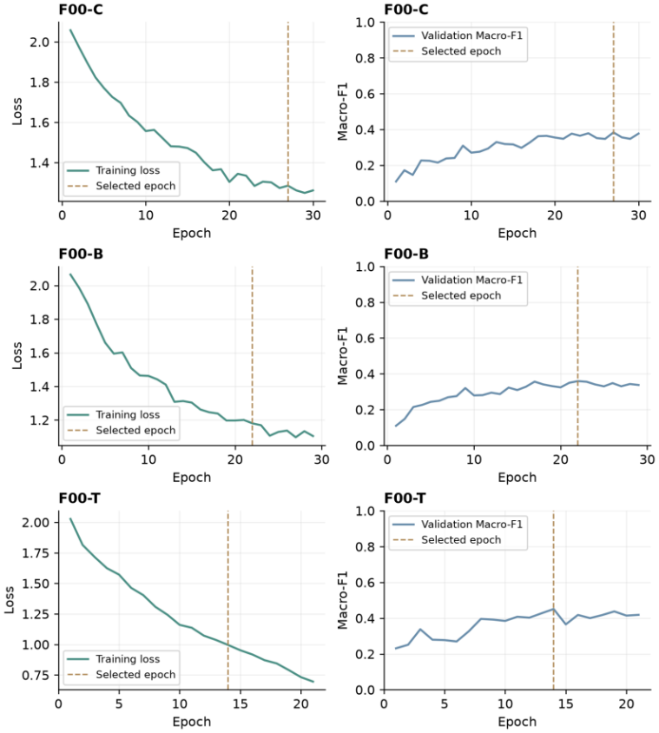
Figure B.1. Training loss and validation macro-F1 for the initial MFCC models
F00-C, F00-B, and F00-T denote the initial CNN, BiLSTM, and Transformer, respectively. Their different completed epoch counts reflect the shared maximum epoch budget and early-stopping rule. Histories were not padded or interpolated to equalise their lengths.
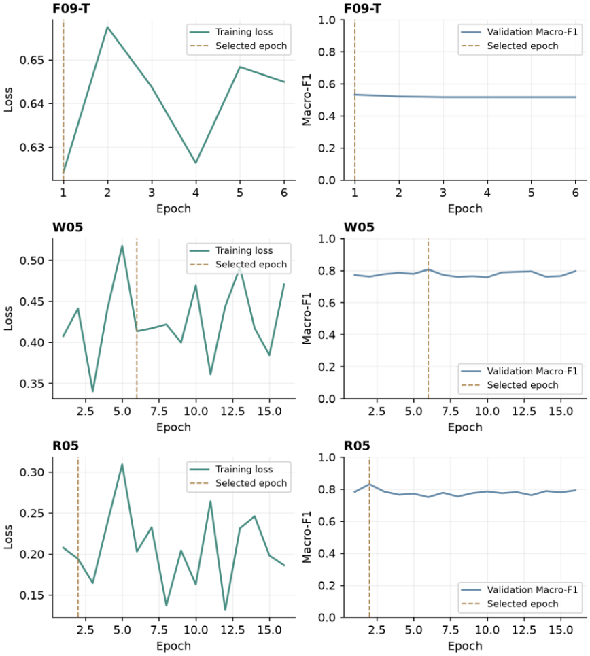
Figure B.2. Training loss and validation macro-F1 for representative selected models
F09-T, W05, and R05 were initialised from parent checkpoints, and epoch numbering restarts at the beginning of each continuation run. R05 achieved its best validation macro-F1 at epoch 2 and continued to epoch 16 before early stopping. The subsequent decline supports using the selected checkpoint rather than the final epoch's weights.

B.2 Handcrafted Audio Preprocessing and Classifier Sweep
Stage | Input version | Classifier(s) | Training conditions | Selection criterion
1. Sweep (270 runs) | 30 × 48-D V2 handcrafted datasets | 9 classifiers, default settings | Fit on 960 training recordings; no augmentation | Validation macro-F1
2. Tuning | Best 48-D dataset per classifier | LR, SVC, MLP, XGBoost, RF | Grid or random search, 4-fold actor-grouped CV; refit on 960 | Mean CV macro-F1, then validation
3. Representation study (final input) | M1 48-D (db2 / norm / 20 ms); M2 WavLM Round 05 128-D; 176-D concatenation | StandardScaler + LR (default C = 1 and CV-tuned C) | Fit on 960; C grid of 11 values under 4-fold actor-grouped CV | Validation macro-F1
Historical: earlier M2 export | M1 48-D (same); M2 MFCC–Transformer 128-D; 176-D concatenation | Same as stage 3 | Same as stage 3 | Validation macro-F1
Historical: Baseline V1 | V1 48-D (db4, raw, 25 ms; different statistics); M2 MFCC–Transformer export | RBF-SVM, MLP (64, 32) | Fit on 960 | Validation macro-F1; test reported once
Table B.6. Experimental conditions of the M1 comparisons. Historical and final-input experiments are reported separately because their upstream features differ.
Nine classifiers were trained with default or near-default settings on each of the 30 preprocessing configurations (270 runs): Logistic Regression, SVC, k-nearest neighbours (KNN), Decision Tree, Gaussian Naive Bayes, Random Forest, AdaBoost, XGBoost (Chen & Guestrin, 2016) and an MLP. Scale-sensitive models (LR, SVC, KNN and MLP) were wrapped with a StandardScaler. Figure B.3 and Table B.7 report the best configuration of each classifier.
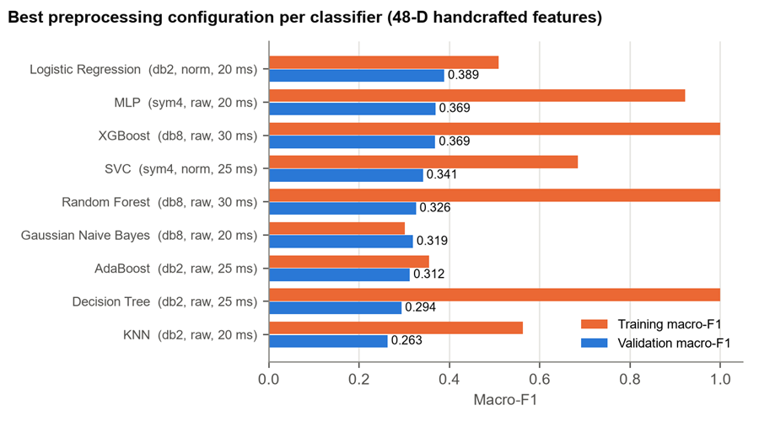
Figure B.3. Training versus validation macro-F1 for the best preprocessing configuration of each classifier. Tree ensembles and the MLP fit the training actors almost perfectly but generalise no better than the linear model.
Classifier | Wavelet | Norm. | Frame | Train F1 | Val acc. | Val F1 | Gap | Mean val F1 (30 configs)
Logistic Regression | db2 | norm | 20 ms | 0.508 | 0.400 | 0.389 | 0.120 | 0.353
MLP | sym4 | raw | 20 ms | 0.922 | 0.383 | 0.369 | 0.553 | 0.311
XGBoost | db8 | raw | 30 ms | 1.000 | 0.396 | 0.369 | 0.631 | 0.315
SVC | sym4 | norm | 25 ms | 0.684 | 0.363 | 0.341 | 0.343 | 0.301
Random Forest | db8 | raw | 30 ms | 1.000 | 0.354 | 0.326 | 0.674 | 0.288
Gaussian Naive Bayes | db8 | raw | 20 ms | 0.301 | 0.342 | 0.319 | −0.018 | 0.273
AdaBoost | db2 | raw | 25 ms | 0.355 | 0.333 | 0.312 | 0.042 | 0.264
Decision Tree | db2 | raw | 25 ms | 1.000 | 0.300 | 0.294 | 0.706 | 0.222
KNN | db2 | raw | 20 ms | 0.562 | 0.283 | 0.263 | 0.299 | 0.232
Table B.7. Best preprocessing configuration per classifier (macro-F1; gap = training − validation macro-F1). The last column is the mean validation macro-F1 over all 30 configurations. Sources: best_preprocessing_per_classifier.csv and all_classifier_preprocessing_comparison.csv.
Logistic Regression achieved the highest validation macro-F1 (0.389) and the best average over all 30 configurations (0.353, compared with 0.315 for XGBoost and 0.311 for the MLP). Its mean generalisation gap (0.159) was also far smaller than those of the MLP, XGBoost, Random Forest and Decision Tree (0.650–0.778). The five strongest classifiers (LR, MLP, XGBoost, SVC and Random Forest) were shortlisted for tuning. Preprocessing mattered much less than the choice of classifier: averaged over all nine classifiers, the wavelet means ranged only from 0.281 (haar) to 0.287 (sym4) and the frame-length means from 0.283 to 0.286. Raw audio averaged slightly higher than normalised audio (0.295 vs 0.274), although the best single configuration used normalised audio. Figure B.4 shows the full 30-configuration surface for Logistic Regression.
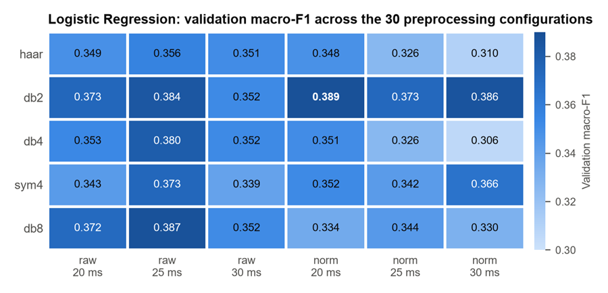
Figure B.4. Logistic Regression validation macro-F1 for every wavelet, normalisation and frame-length combination. db2 is consistently strong, and the top four cells lie within 0.005 of each other.

B.3 Handcrafted Audio Hyperparameter Search
Each shortlisted classifier was tuned on its own best dataset from Stage 1 using 4-fold StratifiedGroupKFold grouped by actor, with mean CV macro-F1 as the selection metric. Exhaustive grid search was used for LR (88 candidates covering L2, L1 and elastic-net penalties) and SVC (72 candidates, linear and RBF kernels), and randomised search with 60 draws for the MLP, XGBoost and Random Forest. Table B.8 reports the selected settings and Table B.9 the search spaces.
Classifier | Selected hyperparameters | CV F1 (± sd) | Train F1 | Val F1 default | Val F1 tuned | Change
Logistic Regression | C = 0.1, saga, elastic-net l1_ratio = 0.25 | 0.340 ± 0.017 | 0.470 | 0.389 | 0.374 | −0.014
MLP (round 2) | (64,), ReLU, α = 2.0, lr = 0.002 | 0.363 ± 0.025 | 0.662 | 0.369 | 0.333 | −0.036
XGBoost | depth 2, lr 0.05, 500 trees, λ = 10, α = 1, subsample 0.7 | 0.364 ± 0.017 | 0.807 | 0.369 | 0.363 | −0.006
SVC | RBF, C = 10, γ = 0.001, balanced | 0.338 ± 0.013 | 0.478 | 0.341 | 0.354 | +0.012
Random Forest | 500 trees, depth 20, leaf 2, max_samples 0.6, balanced_subsample | 0.364 ± 0.019 | 0.978 | 0.326 | 0.331 | +0.006
Table B.8. Tuned classifiers: CV and validation macro-F1 compared with the Stage 1 defaults (sources: default_vs_tuned_comparison.csv and the tuning summaries).
Tuning generally selected stronger regularisation, reducing training–validation gaps without improving validation macro-F1 for LR, MLP or XGBoost. SVC and Random Forest improved by about 0.01. Training-fold CV and the four validation actors ranked candidates differently, and small score changes cannot establish a reliable ordering across actors. The default Logistic Regression was retained because it had the highest observed validation macro-F1 and a comparatively small training–validation gap. Its selection still reuses the validation actors and remains subject to selection bias.
Model | Search | Search space | Dataset
Logistic Regression | Grid, 88 | L2: solver ∈ {lbfgs, newton-cg}, C ∈ {0.001, 0.01, 0.05, 0.1, 0.5, 1, 2, 5, 10, 100}; saga: C ∈ {0.01, 0.1, 0.5, 1, 5, 10}, l1_ratio ∈ {0.25, 0.5, 0.75, 1}; class_weight ∈ {None, balanced} | db2 / norm / 20
SVC | Grid, 72 | linear: C ∈ {0.01, 0.1, 1, 10, 100, 300}; RBF: same C × γ ∈ {scale, 10⁻⁴, 10⁻³, 10⁻², 10⁻¹}; class_weight ∈ {None, balanced} | sym4 / norm / 25
MLP (round 2) | Random, 60 | hidden ∈ {(16,) … (128,), (24,12) … (128,64), (64,32,16), (128,64,32)}; α ∈ {0.001, 0.01, 0.1, 0.5, 1, 2, 5, 10}; lr ∈ {10⁻⁴, 5·10⁻⁴, 10⁻³, 2·10⁻³}; activation ∈ {relu, tanh} | sym4 / raw / 20
XGBoost | Random, 60 | max_depth 2–6; min_child_weight {1, 3, 5, 10}; lr {0.01, 0.03, 0.05, 0.1}; n_estimators {100, 200, 300, 500}; subsample, colsample_bytree {0.7, 0.85, 1}; λ {1, 5, 10, 20}; α {0, 0.1, 1, 5}; γ {0, 0.1, 1} | db8 / raw / 30
Random Forest | Random, 60 | n_estimators {100, 200, 300, 500}; max_depth {5, 10, 15, 20, None}; min_samples_split {2, 5, 10, 20}; min_samples_leaf {1, 2, 5, 10}; max_features {sqrt, log2, 0.5, 1.0}; class_weight {None, balanced, balanced_subsample}; max_samples {0.6, 0.8, 1.0} | db8 / raw / 30
LR (representation study) | Grid, 11 | C ∈ {10⁻⁴, 10⁻³, 0.01, 0.05, 0.1, 0.5, 1, 2, 5, 10, 100}; lbfgs, L2, max_iter 3000 | 48-D / 128-D / 176-D
Table B.9. Hyperparameter search spaces. All searches use 4-fold StratifiedGroupKFold grouped by actor (shuffled, seed 42) and refit on mean CV macro-F1.
Fixed settings. Stage 1 defaults were LR max_iter = 2000, MLP max_iter = 400 and XGBoost eval_metric = mlogloss, with random_state = 42 for every stochastic model. The tuned XGBoost also used subsample 0.7, colsample_bytree 0.85, γ = 1 and min_child_weight 1, and the tuned Random Forest used min_samples_split 5 and max_features 1.0. A first MLP search (30 draws, narrower space) selected (64,), ReLU, α = 1.0 and lr = 0.001 (CV 0.358, validation 0.340, gap 0.410); the second round widened the architectures and regularisation and is reported as the tuned MLP. The consolidated comparison file gives the tuned XGBoost a validation macro-F1 of 0.363, while the standalone summary of a separate run records 0.366; the difference does not affect any conclusion.

B.4 Earlier MFCC Audio Representation Comparison
Before M2 delivered the WavLM features, the same comparison was run on M2's earlier export: the 128-D time-averaged output of the MFCC-based Transformer encoder from M2's Stage 3 (epoch 14; validation macro-F1 0.451 with M2's own head). The handcrafted input, classifier and protocol were identical, so the two runs differ only in the learned features. Table B.10 keeps these results as a historical record; they are archived under archive/mfcc_transformer/ and can be regenerated with --m2-source mfcc_transformer.
Representation (MFCC–Transformer run) | Dim. | Train F1 | Val acc. | Val F1 | Tuned C | CV F1 | Tuned val F1
Handcrafted (M1) | 48 | 0.508 | 0.400 | 0.389 | 0.10 | 0.339 | 0.390
MFCC–Transformer learned (M2) | 128 | 0.881 | 0.479 | 0.473 | 0.01 | 0.667 | 0.426
Concatenated | 176 | 0.956 | 0.471 | 0.452 | 0.05 | 0.666 | 0.449
Table B.10. Historical representation comparison with M2's MFCC–Transformer features (archive/mfcc_transformer/).
The conclusion was the same, since concatenation (0.452) did not beat the learned features alone (0.473). With these weaker learned features, however, the handcrafted features scored higher on two emotions, disgust (0.400 vs 0.275) and fearful (0.333 vs 0.298), and were correct on 39 validation clips that the learned model missed (Section 5.7.1). Both advantages disappear with the WavLM features: as the learned representation gets stronger, the information the handcrafted features add shrinks from noticeable to marginal.

B.5 Handcrafted Audio Baseline V1
Before the V2 pipeline above, M1 built a first prototype (Baseline V1) with fixed preprocessing (db4, raw audio, 25 ms frames) and different statistics: spectral energy was used instead of flatness, and the DWT sub-bands were summarised by mean, variance, mean energy and Shannon entropy. V1 was combined with the same M2 MFCC–Transformer export as in Appendix B.4, using an MLP (64, 32) with early stopping. Because the handcrafted inputs differ from V2, these results are reported separately and are not directly comparable with Tables 5.3 and B.10. V1 is the only M1 stage in which test-set scores were computed during development (Section 6.6).
V1 model (MLP 64-32) | Dim. | Val acc. | Val F1 | Test acc. | Test F1
Handcrafted V1 only | 48 | 0.358 | 0.352 | 0.354 | 0.350
M2 Transformer export only | 128 | 0.438 | 0.396 | 0.546 | 0.515
Handcrafted V1 + Transformer | 176 | 0.479 | 0.456 | 0.575 | 0.544
Reduced V1 (43-D) + Transformer | 171 | 0.479 | 0.451 | — | —
Table B.11. Historical Baseline V1 results (outputs/metrics/baseline_v1/).
With the V1 MLP classifier, concatenation improved on the MFCC–Transformer features alone on both the validation (+0.060) and the test (+0.029) actors. With the V2 Logistic Regression it did not, whether on the same MFCC–Transformer features (Table B.10) or on the WavLM features (Table 5.3). Whether the handcrafted block adds value therefore depends on both the classifier that consumes the concatenated vector and the strength of the learned features (Section 6.1).

B.6 Historical Handcrafted Feature Group Ablation
Feature-group ablation (historical, V1). In the V1 prototype each feature group was evaluated on its own with an RBF-SVM and an MLP (Table B.12). The time-domain group was the strongest single group (SVM 0.333), close to the full 48-D vector (0.339). The spectral and DWT groups alone were much weaker (0.270 and 0.241), but adding them still helped the MLP (time-only 0.315 → full 0.352). Removing the five DWT mean-energy features (43-D), which are nearly redundant with the variance when the coefficients are zero-mean, did not hurt the SVM (0.341). This motivated the V2 decision to use a uniform set of statistics (mean, std, min, max) instead of energy and entropy. The ablation was not repeated on the V2 features.
Feature subset (V1) | Dim. | RBF-SVM val F1 | MLP val F1
Time domain | 12 | 0.333 | 0.315
Spectral | 16 | 0.270 | 0.265
DWT | 20 | 0.241 | 0.243
Full | 48 | 0.339 | 0.352
Reduced (no DWT energy) | 43 | 0.341 | 0.288
Table B.12. Historical V1 feature-group ablation on the validation actors (handcrafted_baselines.csv).

Appendix C Per-class metrics and confusion matrices

C.1 Selected Deep Learned Audio System
Five models selected by validation performance are shown. P, R, and F1 range from 0 to 1, and class support is identical across the validation and test splits. Matrices show raw counts, with true classes in rows and predicted classes in columns, using a common colour scale of 0–32. Appendix B provides the full run IDs.

C.1.1 F02-C Best CNN by Validation Macro-F1
Class | Val P | Val R | Val F1 | Test P | Test R | Test F1 | Support per split
neutral | 0.4615 | 0.3750 | 0.4138 | 0.3600 | 0.5625 | 0.4390 | 16
calm | 0.3971 | 0.8438 | 0.5400 | 0.6250 | 0.7812 | 0.6944 | 32
happy | 0.4375 | 0.4375 | 0.4375 | 0.9167 | 0.3438 | 0.5000 | 32
sad | 0.4231 | 0.3438 | 0.3793 | 0.3750 | 0.1875 | 0.2500 | 32
angry | 0.6774 | 0.6562 | 0.6667 | 0.6667 | 0.6875 | 0.6769 | 32
fearful | 0.4615 | 0.1875 | 0.2667 | 0.5135 | 0.5938 | 0.5507 | 32
disgust | 0.3714 | 0.4062 | 0.3881 | 0.5581 | 0.7500 | 0.6400 | 32
surprise | 0.4091 | 0.2812 | 0.3333 | 0.5588 | 0.5938 | 0.5758 | 32
Macro | 0.4548 | 0.4414 | 0.4282 | 0.5717 | 0.5625 | 0.5409 | 240 total
Table C.1. F02-C per-class validation and test metrics
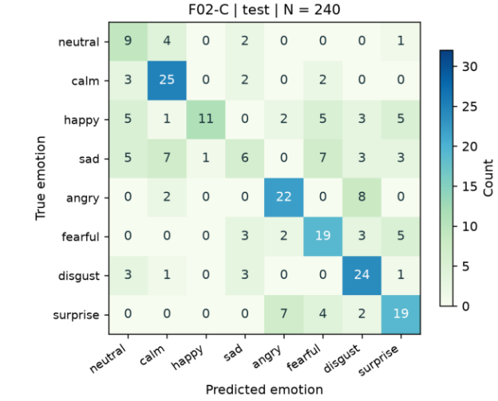
Figure C.1. F02-C test confusion matrix with raw counts

C.1.2 F03-B Best BiLSTM by Validation Macro-F1
Run ID: M2_encoder_bilstm_s42_20261017_03. Each evaluation split contains 240 recordings. Validation and test accuracies are 43.75% and 52.08%, respectively.
Class | Val P | Val R | Val F1 | Test P | Test R | Test F1 | Support per split
neutral | 0.2857 | 0.1250 | 0.1739 | 0.1250 | 0.0625 | 0.0833 | 16
calm | 0.4493 | 0.9688 | 0.6139 | 0.4359 | 0.5312 | 0.4789 | 32
happy | 0.3333 | 0.4688 | 0.3896 | 0.5357 | 0.4688 | 0.5000 | 32
sad | 0.2800 | 0.2188 | 0.2456 | 0.2564 | 0.3125 | 0.2817 | 32
angry | 0.6571 | 0.7188 | 0.6866 | 0.9167 | 0.6875 | 0.7857 | 32
fearful | 0.4667 | 0.2188 | 0.2979 | 0.4750 | 0.5938 | 0.5278 | 32
disgust | 0.5385 | 0.2188 | 0.3111 | 0.6800 | 0.5312 | 0.5965 | 32
surprise | 0.4194 | 0.4062 | 0.4127 | 0.6486 | 0.7500 | 0.6957 | 32
Macro | 0.4287 | 0.4180 | 0.3914 | 0.5092 | 0.4922 | 0.4937 | 240 total
Table C.2. F03-B per-class validation and test metrics
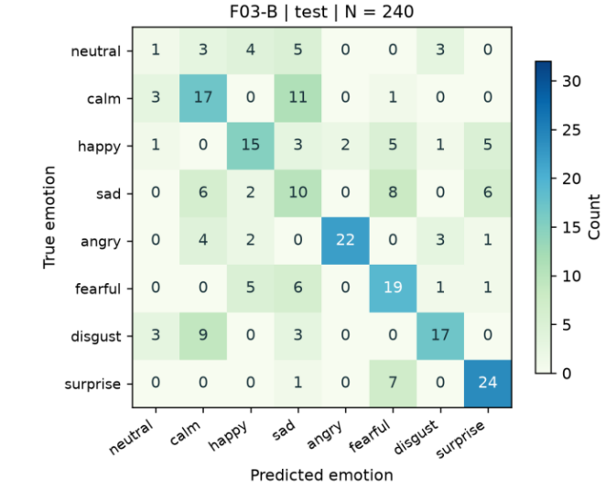
Figure C.2. F03-B test confusion matrix with raw counts

C.1.3 F09-T Best MFCC Transformer by Validation Macro-F1
Run ID: M2_encoder_transformer_s7_20261018_04. Each evaluation split contains 240 recordings. Validation and test accuracies are 54.58% and 64.17%, respectively.
Class | Val P | Val R | Val F1 | Test P | Test R | Test F1 | Support per split
neutral | 0.4211 | 0.5000 | 0.4571 | 0.4211 | 0.5000 | 0.4571 | 16
calm | 0.5652 | 0.8125 | 0.6667 | 0.6000 | 0.8438 | 0.7013 | 32
happy | 0.5263 | 0.3125 | 0.3922 | 0.7500 | 0.4688 | 0.5769 | 32
sad | 0.3393 | 0.5938 | 0.4318 | 0.6667 | 0.3750 | 0.4800 | 32
angry | 0.6098 | 0.7812 | 0.6849 | 0.6800 | 0.5312 | 0.5965 | 32
fearful | 0.7368 | 0.4375 | 0.5490 | 0.7027 | 0.8125 | 0.7536 | 32
disgust | 0.6429 | 0.2812 | 0.3913 | 0.5294 | 0.8438 | 0.6506 | 32
surprise | 0.7692 | 0.6250 | 0.6897 | 0.8800 | 0.6875 | 0.7719 | 32
Macro | 0.5763 | 0.5430 | 0.5328 | 0.6537 | 0.6328 | 0.6235 | 240 total
Table C.3. F09-T per-class validation and test metrics
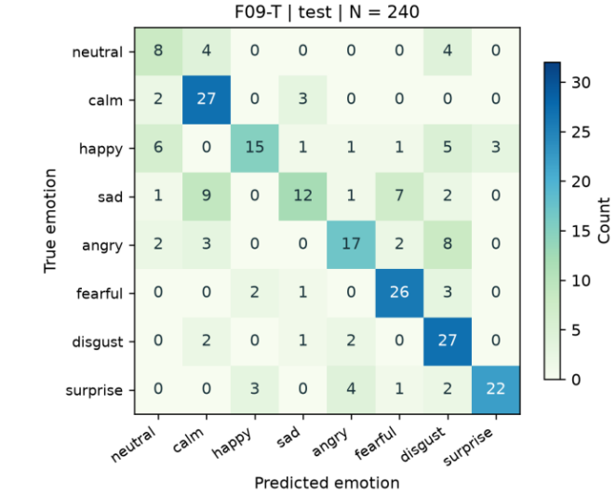
Figure C.3. F09-T test confusion matrix with raw counts

C.1.4 W05 Best Initial WavLM by Validation Macro-F1
Run ID: M2_encoder_wavlm_s42_20261020_05. Each evaluation split contains 240 recordings. Validation and test accuracies are 81.25% and 82.92%, respectively.
Class | Val P | Val R | Val F1 | Test P | Test R | Test F1 | Support per split
neutral | 0.7333 | 0.6875 | 0.7097 | 1.0000 | 0.7500 | 0.8571 | 16
calm | 0.7045 | 0.9688 | 0.8158 | 0.7381 | 0.9688 | 0.8378 | 32
happy | 1.0000 | 0.5938 | 0.7451 | 0.9600 | 0.7500 | 0.8421 | 32
sad | 0.6410 | 0.7812 | 0.7042 | 0.7727 | 0.5312 | 0.6296 | 32
angry | 0.9375 | 0.9375 | 0.9375 | 1.0000 | 0.7188 | 0.8364 | 32
fearful | 0.7576 | 0.7812 | 0.7692 | 0.6522 | 0.9375 | 0.7692 | 32
disgust | 0.8929 | 0.7812 | 0.8333 | 0.8421 | 1.0000 | 0.9143 | 32
surprise | 0.9667 | 0.9062 | 0.9355 | 0.9375 | 0.9375 | 0.9375 | 32
Macro | 0.8292 | 0.8047 | 0.8063 | 0.8628 | 0.8242 | 0.8280 | 240 total
Table C.4. W05 per-class validation and test metrics
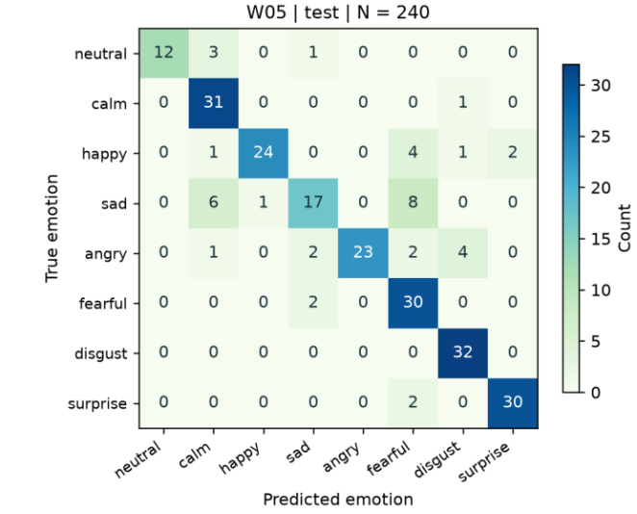
Figure C.4. W05 test confusion matrix with raw counts

C.1.5 R05 Final Selected WavLM with Temporal Convolution
Run ID: M2_encoder_wavlm_refinement_s42_20261021_05. Each evaluation split contains 240 recordings. Validation and test accuracies are 84.17% and 83.33%, respectively.
Class | Val P | Val R | Val F1 | Test P | Test R | Test F1 | Support per split
neutral | 0.6875 | 0.6875 | 0.6875 | 1.0000 | 0.7500 | 0.8571 | 16
calm | 0.7692 | 0.9375 | 0.8451 | 0.7561 | 0.9688 | 0.8493 | 32
happy | 1.0000 | 0.6875 | 0.8148 | 0.8929 | 0.7812 | 0.8333 | 32
sad | 0.6944 | 0.7812 | 0.7353 | 0.7692 | 0.6250 | 0.6897 | 32
angry | 0.8889 | 1.0000 | 0.9412 | 0.9200 | 0.7188 | 0.8070 | 32
fearful | 0.8929 | 0.7812 | 0.8333 | 0.7027 | 0.8125 | 0.7536 | 32
disgust | 0.8667 | 0.8125 | 0.8387 | 0.8649 | 1.0000 | 0.9275 | 32
surprise | 0.9394 | 0.9688 | 0.9538 | 0.9118 | 0.9688 | 0.9394 | 32
Macro | 0.8424 | 0.8320 | 0.8312 | 0.8522 | 0.8281 | 0.8321 | 240 total
Table C.5. R05 per-class validation and test metrics
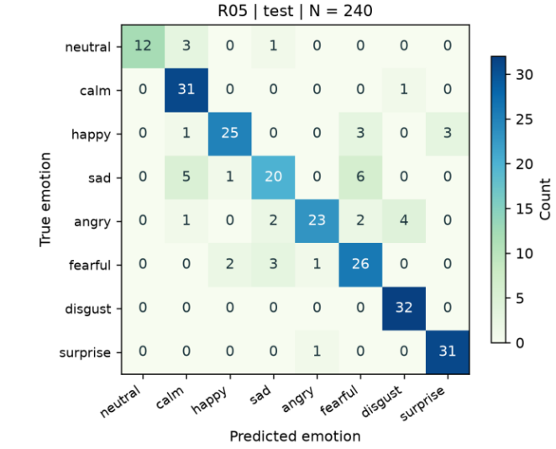
Figure C.5. R05 test confusion matrix with raw counts

C.1.6 Validation Errors of the Final Model
The R05 validation confusion matrix is also provided to complement the final test results. Validation accuracy was 84.17% (202/240), compared with 83.33% (200/240) on the test set; the corresponding macro-F1 scores were 0.8312 and 0.8321. The two splits contain different actors and may exhibit different class-specific error patterns. Similar aggregate scores therefore do not establish consistent performance across all classes.
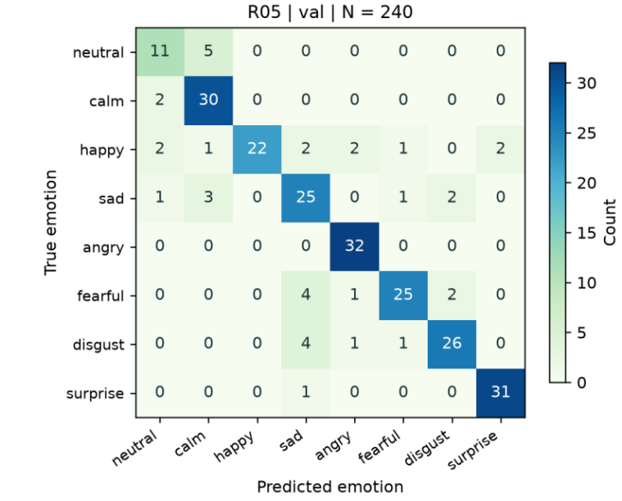
Figure C.6. R05 validation confusion matrix with raw counts
Per-sample predictions, complete per-class metrics, and raw confusion matrices for all 48 experiments are stored in their respective experiment_records directories. The main text and this appendix expand only the five representative models selected by validation performance. Full numerical precision is retained in the source files. Displayed values are rounded to four decimal places or two decimal places for percentages, so calculations based on displayed values may differ slightly in the last digit.

C.2 Selected Visual System
Table C.6 reports the per-class test performance of the final visual system selected by M3. The handcrafted-only configuration was selected over the learned-only and combined configurations based on validation Macro-F1. It uses the Full-320 DWT representation, training-only AUG-1 horizontal flipping and an RBF-SVM classifier with random seed 0. The unaugmented test partition contains 240 original recordings from the held-out Actors 2, 3, 8 and 17. The class order is neutral, calm, happy, sad, angry, fearful, disgust and surprised. The accompanying confusion matrix reports raw counts, with true classes represented by rows and predicted classes by columns.
Class | Precision | Recall | F1 | Support
Neutral | 0.3462 | 0.5625 | 0.4286 | 16
Calm | 1.0000 | 0.5000 | 0.6667 | 32
Happy | 1.0000 | 0.6875 | 0.8148 | 32
Sad | 0.3548 | 0.3438 | 0.3492 | 32
Angry | 0.5294 | 0.2813 | 0.3673 | 32
Fearful | 0.5385 | 0.2188 | 0.3111 | 32
Disgust | 0.4426 | 0.8438 | 0.5806 | 32
Surprised | 0.2037 | 0.3438 | 0.2558 | 32
Macro average | 0.5519 | 0.4727 | 0.4718 | 240
Table C.6. Per-class test metrics for the selected M3 handcrafted visual system using Full-320, AUG-1 and an RBF-SVM.
Figure C.7 presents the corresponding raw-count confusion matrix. Rows represent the true emotion classes and columns represent the predicted classes, using the fixed class order of neutral, calm, happy, sad, angry, fearful, disgust and surprised.
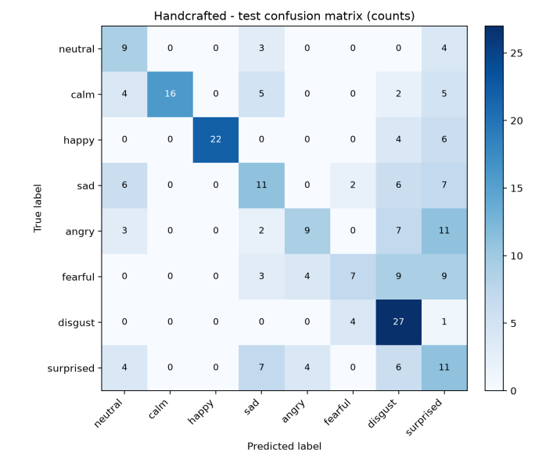
Figure C.7. Raw-count test confusion matrix for the selected M3 handcrafted visual system. Rows represent true classes and columns represent predicted classes; N=240.
The selected visual model recognises happy and disgust most reliably. Calm has perfect precision but only 0.50 recall, while fearful, angry and surprise remain difficult. The model also over-predicts disgust for several other classes. These patterns describe the observed errors; they do not establish which facial cues caused them.

Appendix D Feature and Model Artifact Inventory
This inventory identifies the exact inputs and saved models used by the main text. The visual export filename is preserved as received so that checksums remain traceable. Full hashes are recorded in the checkpoint and input manifests.
Artifact | Exact identifier or path | Contents
Handcrafted audio | audio/handcrafted/outputs/handover/m1_audio/ | 48-D features, 8 probabilities (OOF for training) and metadata; schema in Table 4.4
Audio representation | M2_encoder_wavlm_refinement_s42_20261021_05 | 128D pooled, T×128 sequence, eight probabilities
Visual export | features/Video_handcraft/visual_representation_outputs(1).npz | HC320 / deep576 / combined896
Selected head | M5_final_base_concat_learned_hc_s42_20261027 | Seed42 default; seeds43/44 retained for aggregate
Study records | multimodal_fusion/results/m5_final_delivery_20261027/ | runs.json, aggregate.json, evaluation_lock.json
Audio adapter | multimodal_fusion/data/final_delivery_20261027/upstream_audio_best.pt | SHA256 prefix 0db8f833f3d3
Backbone | demo/assets/wavlm-base-plus/ | Revision 4c66d4806a428f2e922ccfa1a962776e232d487b
Reproduction script | reports/m5_finalreport_20261027/Chapter_7_reproduce.sh | Set REPRO to this path before table commands
Analysis records | reports/m5_finalreport_20261027/statistical_analysis/ | Paired tests, actors, calibration and benchmark
External protocol | demo/external_evaluation_20261027/ | plan, summary, predictions and media hashes
MFCC comparison | multimodal_fusion/results/m5_final_evaluation_20261019/ | Saved predictions, locked validation selection and complete metrics
Table D.1. Reproduction artifact inventory.
For execution commands, set REPRO to the reproduction-script path above and run from the repository root. The setup stage accepts PRS_BASE_PYTHON for the scientific environment. The study stage includes test evaluation and writes a fresh output directory. Paired statistics are computed from existing predictions without refitting.

Appendix E Team Contributions
The table records the member-specific contribution statements supplied with the merged report. Module responsibilities for the full team are defined in Section 1.3.
Member / student ID | Module / responsibility | Delivered work / evidence
Agarwal Hritik Kumar (A0353874R) | M1 – Handcrafted audio features and audio representation comparison | Implemented and validated handcrafted audio preprocessing and 48-D feature extraction; ran the 270-fit classifier/preprocessing sweep, grouped tuning and audio representation comparisons; exported features, OOF probabilities and models; wrote the corresponding M1 report sections.
Lu Yujing  (A0351286B) | M3 — Handcrafted Visual Modelling and Visual Representation Integration and Comparison | Implemented 16-frame visual preprocessing, alignment, Full-320 DWT-SVM and augmentation/crop/grid studies; integrated handcrafted and learned visual representations; exported features, OOF probabilities and models; wrote the corresponding M3 report sections.
Jiang Yushan (A0353592X) | M5 - Multimodal fusion, system integration, experimental evaluation and interpretation | Implemented fusion methods, feature alignment and interpretability diagnostics; conducted baseline comparisons, ablations and external evaluation; developed the video demonstration interface and contributed report sections. Evidence includes code, checkpoints, predictions, experiment records and reproducibility documentation.
Table E.1. Actual team contributions.

