skills — Deep Research Report
Generated: 2026-03-19 | Mode: quick | Commit: 4bd2d7e
────────────────────────────────────────────────────────────

1. Project Overview
skills is a Claude Code skills repository containing three orchestration skills for complex agentic workflows. It provides a shared child-agent role library and a documentation structure that separates design specs from implementation plans. The three skills cover: codebase research for downstream agents (context-research-orchestrator), user-facing codebase research reports (deepresearch), and large-scale semantic code refactoring (semantic-batch-refactor-orchestrator). All skills share a common three-layer architecture: Role Contract + Task Packet + Skill.

Directory Structure

Skill Relationship Map
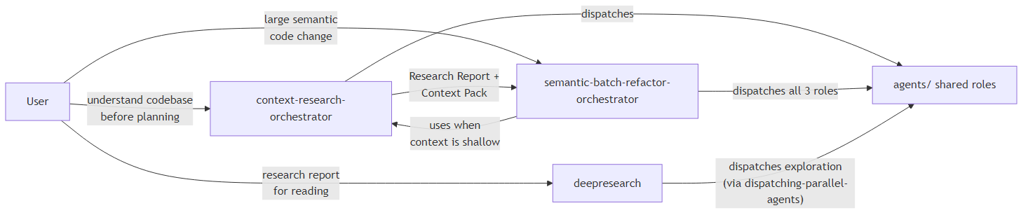

────────────────────────────────────────────────────────────

2. Core Flows

Skill Invocation Flow (any skill)
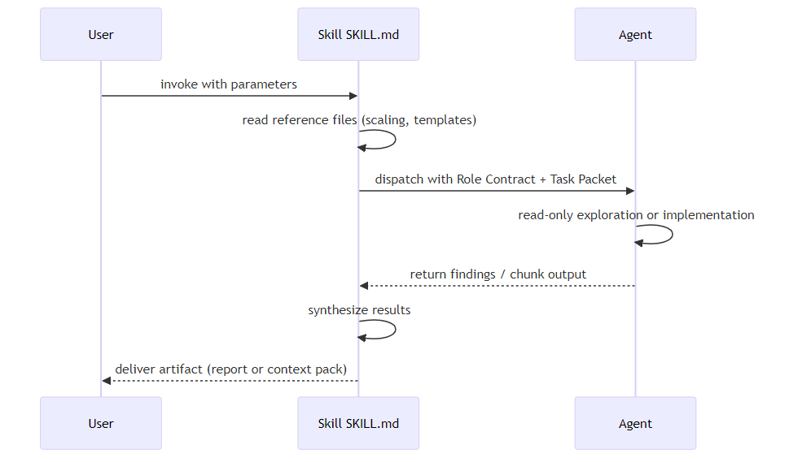

deepresearch Resume Flow
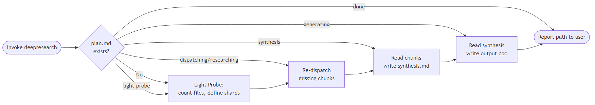

────────────────────────────────────────────────────────────

Appendix

Coverage
- README.md
- agents/ — all 3 role contracts
- context-research-orchestrator/ — all files
- deepresearch/ — all files
- semantic-batch-refactor-orchestrator/ — all files
- docs/orchestration/specs/ — all 4 specs
- docs/orchestration/plans/ — CRO and deepresearch plans (fully), SBRO plan (skipped)

Exclusions
- superpowers/ — git submodule, excluded per research scope
- .git/ — version control internals
- docs/orchestration/plans/2026-03-18-semantic-batch-refactor-orchestrator.md — structural duplicate of CRO plan at quick depth

Confidence Markers
- [Fact] Three active skills: context-research-orchestrator, deepresearch, semantic-batch-refactor-orchestrator
- [Fact] Three-layer agent architecture (Role Contract + Task Packet + Skill) is the central pattern
- [Fact] dispatching-parallel-agents referenced by deepresearch but absent from repo (likely in superpowers/ submodule)
- [Fact] docs/orchestration/research/ is empty — no persisted CRO artifacts yet
- [Inference] superpowers/ submodule provides dispatching-parallel-agents and execution skills referenced in plans
- [Open Question] Is dispatching-parallel-agents available inside superpowers/?
- [Open Question] Should deepresearch plan.md support a paused status for long deep-mode runs?

