**PCA Tutorials**

**Example (1)**

Training data (x)

x = 1 1 2 0 7 6 7 8

3 2 3 3 4 5 5 4

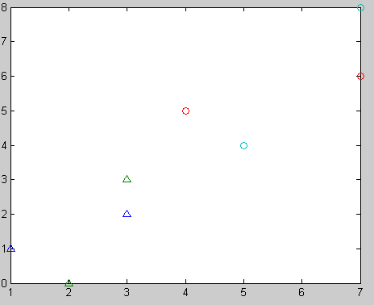

Fig. shows the positions of the observations of x

Mean of the data (m)

m = 4.0000

3.6250

Centered data (Training Data- Mean) (d)

d = -3.0000 -3.0000 -2.0000 -4.0000 3.0000 2.0000 3.0000 4.0000

-0.6250 -1.6250 -0.6250 -0.6250 0.3750 1.3750 1.3750 0.3750

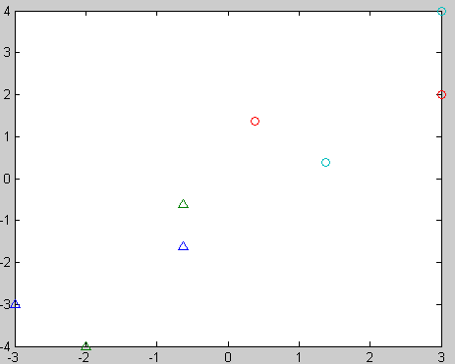

Fig. shows the positions of the observations of d

Covariance matrix (c=d*d’)

c = 76.0000 20.0000

20.0000 7.8750

Eigen values and Eigen vectors of the covariance matrix

evalue =

2.4375 0

0 81.4375

evec =

0.2624 -0.9650

-0.9650 -0.2624

Sorting eigen vectors according eigen values

evec_sorted =

-0.9650 0.2624

-0.2624 -0.9650

Projected data(evec_sorted’* d)

P = 3.0589 3.3212 2.0939 4.0239 -2.9933 -2.2907 -3.2557 -3.9583

-0.1840 0.7810 0.0784 -0.4463 0.4252 -0.8021 -0.5398 0.6876

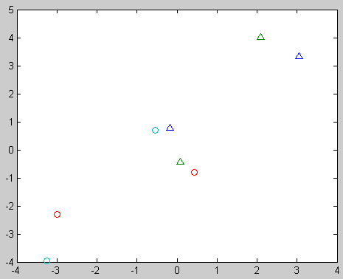

Fig. shows the positions of the observations of x after projection

Select the first eigen vector only to project data on it

e =

-0.9650

-0.2624

Projected data on the first eigen vectors

P = 3.0589 3.3212 2.0939 4.0239 -2.9933 -2.2907 -3.2557 -3.9583

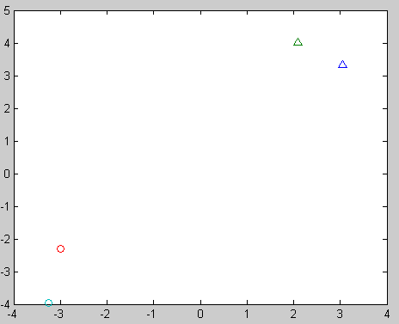

Fig. shows the positions of the observations of the first principal component of x

Select the second eigen vector only to project data on it

e =

0.2624

-0.9650

Projected data on the first eigen vectors

P =-0.1840 0.7810 0.0784 -0.4463 0.4252 -0.8021 -0.5398 0.6876

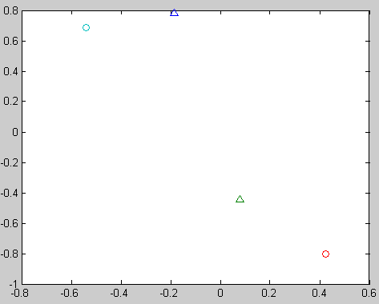

Fig. shows the positions of the observations of the second principal component of x

**Example (2)**

x =

1 1 1 1 1 1 1 1

2 3 0 1 5 6 7 5

Note: that the data are the similar in one of the two dimensions

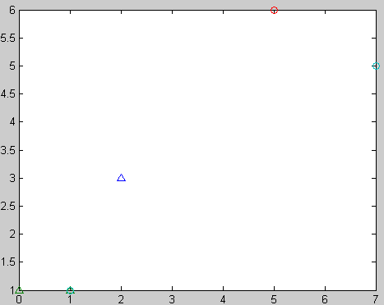

Fig. shows the positions of the observations of x

m =

1.0000

3.6250

d =0 0 0 0 0 0 0 0

-1.6250 -0.6250 -3.6250 -2.6250 1.3750 2.3750 3.3750 1.3750

c = 0 0

1. 43.8750

evec = 1 0

0 1

evalue =

0 0

1. 43.8750

Note: There is only one eigen value more than zero because the second one is zero because the data are similar in one of the two dimensions

e =

0

1

P =

-1.6250 -0.6250 -3.6250 -2.6250 1.3750 2.3750 3.3750 1.3750

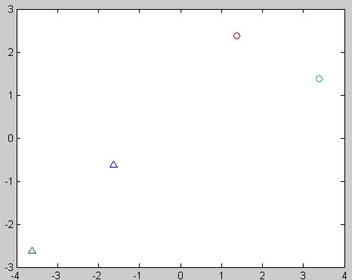

Fig. shows the positions of the observations of the first component of x

e = 1

0

P=e'*d

P = 0 0 0 0 0 0 0 0

Note: Projecting data on the eigen vectors that has zero eigen values has no meaning because the eigen vector in that direction is neglected

plot(P(:,1),P(:,2),'^',P(:,3),P(:,4),'^',P(:,5),P(:,6),'o',P(:,7),P(:,8),'o');

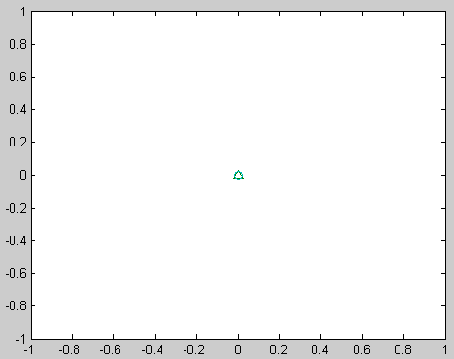

Fig. shows the positions of the observations of the second component of x

**Example (3)**

3D example

x =

1 1 1 1 8 8 8 8

1 2 2 1 9 8 9 10

2 3 1 2 8 10 9 7

m=mean(x')'

m = 4.5000

5.2500

5.2500

d=x-repmat(m,1,8)

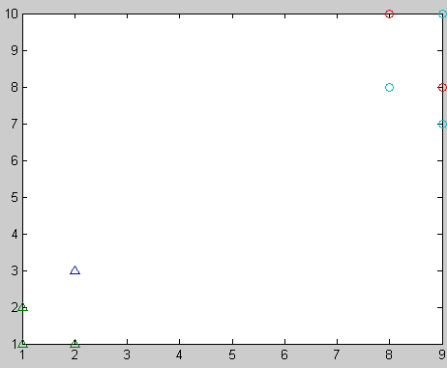

Fig. shows the positions of the observations of x

d =

-3.5000 -3.5000 -3.5000 -3.5000 3.5000 3.5000 3.5000 3.5000

-4.2500 -3.2500 -3.2500 -4.2500 3.7500 2.7500 3.7500 4.7500

-3.2500 -2.2500 -4.2500 -3.2500 2.7500 4.7500 3.7500 1.7500

c=d*d';

c= 98.0000 105.0000 91.0000

105.0000 115.5000 94.5000

91.0000 94.5000 91.5000

evec = 0.8132 0.0958 0.5741

-0.5060 0.6039 0.6159

-0.2877 -0.7913 0.5396

evalue =

0.4755 0 0

0 8.3505 0

1. 0 296.1740

e =

0.5741

0.6159

0.5396

P = -6.3803 -5.2249 -6.3041 -6.3803 5.8026 6.2659 6.3422 5.8789

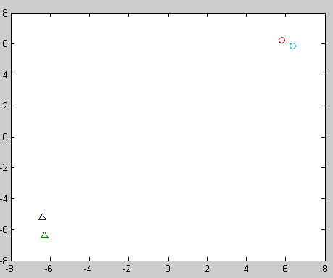

Fig. shows the positions of the observations of the first component of x

e =

0.0958

0.6039

-0.7913

P = -0.3305 -0.5179 1.0646 -0.3305 0.4242 -1.7622 -0.3670 1.8194

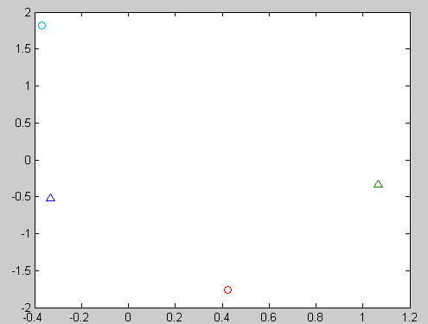

Fig. shows the positions of the observations of the second component of x

e =

0.8132

-0.5060

-0.2877

P = 0.2392 -0.5545 0.0209 0.2392 0.1576 0.0883 -0.1300 -0.0606

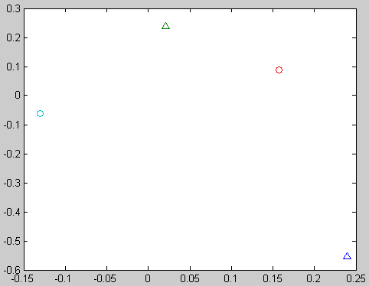

Fig. shows the positions of the observations of the third component of x