An Analytic Solution for the Spline-DV Mean–CV–Dropout Curve
A closed-form gamma-Poisson replacement for the fitted 3-D smoothing spline

1. The problem
Spline-DV places every gene at the point $\left(x, y, z\right) = \left(\text{log}\left(1 + μ\right), \text{log}\left(1 + C_{σ}\right), D_{r}\right)$ — log mean expression, log coefficient of variation, dropout rate — and fits a smoothing spline through the resulting cloud (15 pieces, robustness weight 0.75, arclength parameterization). Each gene's deviation from that curve is the per-condition statistic, and the difference of the two deviation vectors is the DV score.
The curve does not have to be estimated nonparametrically. Under the standard count model for droplet scRNA-seq it has a closed form with one fitted parameter, and its dropout coordinate has a closed form with none.

2. Notation and count model
Let $K_{ij}$ be the raw count of gene $i$ in cell $j$, let $L_{j} = \sum_{i}{K_{ij}}$ be the library size of that cell, let $n$ be the number of cells, and let $c$ be the normalization scale (the pipeline uses $c =$10⁴, counts per 10,000). The analysis operates on
$X_{ij} = c \frac{K_{ij}}{L_{j}}$ (1)
Model the counts as gamma-Poisson (negative binomial) with a cell-independent gene rate $λ_{i}$ — an expression fraction — and dispersion $φ$:
$\text{E}\left[K_{ij}\right] = L_{j}λ_{i}, \text{Var}\left(K_{ij}\right) = L_{j}λ_{i} + φ {\left(L_{j}λ_{i}\right)}^{2}$ (2)
The limit $φ → 0$ is pure Poisson sampling, i.e. technical noise only.

3. The mean coordinate
Because $\text{E}\left[X_{ij}\right] = c λ_{i}$ for every cell $j$, library-size normalization has removed all cell-to-cell variation in the mean. This is what makes the rest of the derivation exact rather than approximate:
$μ_{i} = c λ_{i}$ (3)

4. The coefficient-of-variation coordinate
Since every cell shares the same mean, the pooled variance across cells is simply the average of the per-cell variances:
$\text{Var}\left(X_{i}\right) = \frac{1}{n}\sum_{j=1}^{n}{\frac{c^{2}}{{L_{j}}^{2}}\left(L_{j}λ_{i} + φ {L_{j}}^{2}{λ_{i}}^{2}\right)}$ (4)
$= c^{2}λ_{i}\frac{1}{n}\sum_{j=1}^{n}{\frac{1}{L_{j}}} + φ c^{2}{λ_{i}}^{2}$
Dividing by the square of the mean gives the first key result.
${C_{σ}}^{2}\left(μ\right) = \frac{α}{μ} + φ, α = \frac{c}{n}\sum_{j=1}^{n}{\frac{1}{L_{j}}}$ (5)
The constant $α$ is not fitted: it is $c$ divided by the harmonic mean of the library sizes, and so is known the moment the count matrix is loaded. On the bundled GSM3308547 / GSM3308548 data, $α$ = 1.997 and 1.597.

5. The dropout coordinate
Zeros are invariant under a positive per-cell rescaling, so the dropout rate of the normalized data equals that of the raw counts. For the gamma-Poisson, $\text{P}\left(K_{ij} = 0\right) = {\left(1 + φ L_{j}λ_{i}\right)}^{−1/φ}$, hence
$D_{r}\left(μ\right) = \frac{1}{n}\sum_{j=1}^{n}{{\left(1 + φ_{z}\frac{L_{j} μ}{c}\right)}^{−1/φ_{z}}}$ (6)
Taking the Poisson limit gives the second key result.
$D_{r}\left(μ\right) = \frac{1}{n}\sum_{j=1}^{n}{{\text{e}}^{−L_{j} μ / c}}$ (7)
Equation (7) is exactly the empirical Laplace transform of the library sizes, evaluated at the gene's rate $λ = μ / c$. It contains no free parameter at all — it is a deterministic function of quantities already known. This is the strongest part of the result: the mean–dropout relation of a scRNA-seq dataset is fixed by its library-size distribution alone.

6. The analytic curve
Parameterized by the normalized mean $μ > 0$, the curve is
$x\left(μ\right) = \text{log}\left(1 + μ\right)$ (8)
$y\left(μ\right) = \text{log}\left(1 + \sqrt{\frac{α}{μ} + φ}\right)$ (9)
$z\left(μ\right) = \frac{1}{n}\sum_{j=1}^{n}{{\left(1 + φ_{z}\frac{L_{j} μ}{c}\right)}^{−1/φ_{z}}}$ (10)
with $α$ given in closed form by (5), $φ$ the single fitted overdispersion, and $φ_{z} = 0$ (Poisson dropout) working best in practice — see Section 10.

6.1 Implicit form
Eliminating the parameter shows that the mean–CV relation is a cylinder over the $\left(x, y\right)$ plane:
${\left({\text{e}}^{y} − 1\right)}^{2}\left({\text{e}}^{x} − 1\right) = α + φ \left({\text{e}}^{x} − 1\right)$ (11)
In the idealized case of equal library sizes ($L_{j} ≡ L$, $φ = 0$, $α = c / L$) the dropout coordinate collapses to a relation in $y$ alone that is free of every parameter:
$z = {\text{e}}^{−{\left({\text{e}}^{y} − 1\right)}^{−2}}$ (12)
So the 3-D curve is structurally the intersection of two surfaces; only library-size heterogeneity and biological overdispersion perturb that picture.

7. Inputs and outputs
The solution is a parametric space curve, not a surface or a regression of one axis on the others. It therefore has one independent variable and three dependent ones.

7.1 Independent variable
The curve parameter is the normalized mean expression $μ > 0$, equivalently the expression fraction $λ = μ / c$. One value of $μ$ is one point on the curve; sweeping it from 0 to ∞ traces the whole thing. Nothing else varies along the curve.

7.2 Dependent variables
All three coordinates are outputs of that single parameter, given by equations (8)–(10):
$μ ⟶ \left(x\left(μ\right), y\left(μ\right), z\left(μ\right)\right) = \left(\text{log mean}, \text{log CV}, \text{dropout rate}\right)$
Because $x$ is strictly increasing in $μ$ it can be inverted, $μ = {\text{e}}^{x} − 1$, so the curve can also be written as two ordinary functions $y$($x$) and $z$($x$) — that is what Figure 2 plots. The parametric form is the natural one to keep, because the projection step of Section 8 needs the tangent $r^{′}\left(μ\right)$.

7.3 Inputs: what must be supplied to instantiate the curve
Input | Meaning | Where it comes from | Fitted?
$L_{j}, j = 1 … n$ | raw library size of each cell | sum(Xraw,1) on the count matrix | no — it is data
$c$ | normalization scale | pipeline constant, $c =$10⁴ (CP10K) | no — a convention
$α$ | $c$ divided by the harmonic mean of the $L_{j}$ | derived from the library sizes, equation (5) | no — closed form
$φ$ | gene-level overdispersion; sets how far the CV branch sits above the Poisson floor | robust L1 regression on the gene cloud, equation (16) | yes — the only one
$φ_{z}$ | overdispersion used for the dropout branch | set to 0 (pure Poisson) by default | no — fixed at 0

So the entire reference curve costs one fitted scalar. The dropout coordinate costs none: it is determined completely by the vector of library sizes.

7.4 Outputs, per gene
Once the curve exists, each gene enters as its observed triple $p_{i} = \left(x_{i}, y_{i}, z_{i}\right)$ and the projection of Section 8 returns:
Output | Interpretation
${μ̂}_{i}$ | the fitted expression rate at the foot point — an interpretable by-product the spline never produced
$r\left({μ̂}_{i}\right)$ | the foot point on the curve (xyzFit in the implementation)
$v_{i} = p_{i} − r\left({μ̂}_{i}\right)$ | the deviation vector; its length $d_{i}$ is the per-condition variability statistic
$‖{v_{i}}^{(2)} − {v_{i}}^{(1)}‖$ | the DV score across the two conditions, exactly as in the original method

One consequence is worth stating plainly. In the spline version, all 9,654 genes are collectively inputs to estimating the reference curve, so the reference depends on the sample in an uncontrolled way. In the analytic version the genes enter the reference only through the single scalar $φ$; its shape is otherwise fixed by the library sizes. That is what makes the two conditions' reference curves comparable to each other.

8. Projecting a gene onto the curve
Because the curve is analytic, the foot point of a gene is the root of a scalar equation rather than a nearest-neighbour search over a discretized polyline. The derivatives are
$x^{′}\left(μ\right) = \frac{1}{1 + μ}, y^{′}\left(μ\right) = \frac{w^{′}}{1 + w}, w = \sqrt{\frac{α}{μ} + φ}, w^{′} = − \frac{α}{2μ^{2} w}$ (13)
$z^{′}\left(μ\right) = − \frac{1}{n}\sum_{j=1}^{n}{\frac{L_{j}}{c}{\text{e}}^{−L_{j} μ / c}}$ (14)
and the foot point of a gene at $p$ is the value of $μ$ satisfying the orthogonality condition
$\left[r\left(μ\right) − p\right] · r^{′}\left(μ\right) = 0$ (15)
In the shipped implementation this is solved by a coarse grid search refined parabolically in $\text{log} μ$, which agrees with a 150,000-point brute-force search to within 1.5 × 10⁻⁶.

9. Estimating the single free parameter
The overdispersion can be fitted by a one-dimensional robust regression directly on the gene cloud, so no spline is needed anywhere in the pipeline:
$φ̂ = {\text{arg min}}_{φ}\sum_{i}{ | \text{log}\left(1 + \sqrt{\frac{α}{μ_{i}} + φ}\right) − \text{log}\left(1 + C_{σ,i}\right) | }$ (16)
The L1 loss keeps genuinely variable genes from dragging the reference curve upward — the role the spline's 0.75 robustness weight plays today.

10. Numerical validation
Bundled data (MATLAB/GSM3308547_GSM3308548.mat), QC-filtered with the gene sets intersected: 9,654 genes, 994 and 875 cells.
Quantity | Sample 1 (994 cells) | Sample 2 (875 cells)
$α$ (closed form, not fitted) | 1.9973 | 1.5970
$φ̂$ (L1 fit on genes / fit to spline) | 0.152 / 0.129 | 0.200 / 0.159
$\text{log}\left(1 + C_{σ}\right)$ : RMSE vs. spline | 0.0110 | 0.0132
$\text{log}\left(1 + C_{σ}\right)$ : $R^{2}$ vs. spline | 0.99934 | 0.99896
$D_{r}$, Poisson (0 fitted parameters): RMSE vs. spline | 0.0071 | 0.0116
$D_{r}$, Poisson: $R^{2}$ vs. spline | 0.99868 | 0.99688
$D_{r}$, Poisson: $R^{2}$ vs. the 9,654 genes | 0.9944 | 0.9915
Minimum of the spline's dropout coordinate (must be non-negative) | −0.086 | −0.165
Runtime of sc_analyticfit | 3.15 s | 2.26 s

Substituting the analytic curve for the spline throughout the DV pipeline of test.m reproduces the spline-based gene ranking at Spearman $ρ$ = 0.93, with 73 of the top 100 and 388 of the top 500 genes shared. The residual disagreement is concentrated in the tails, which is where the spline is extrapolating or leaving the feasible region.
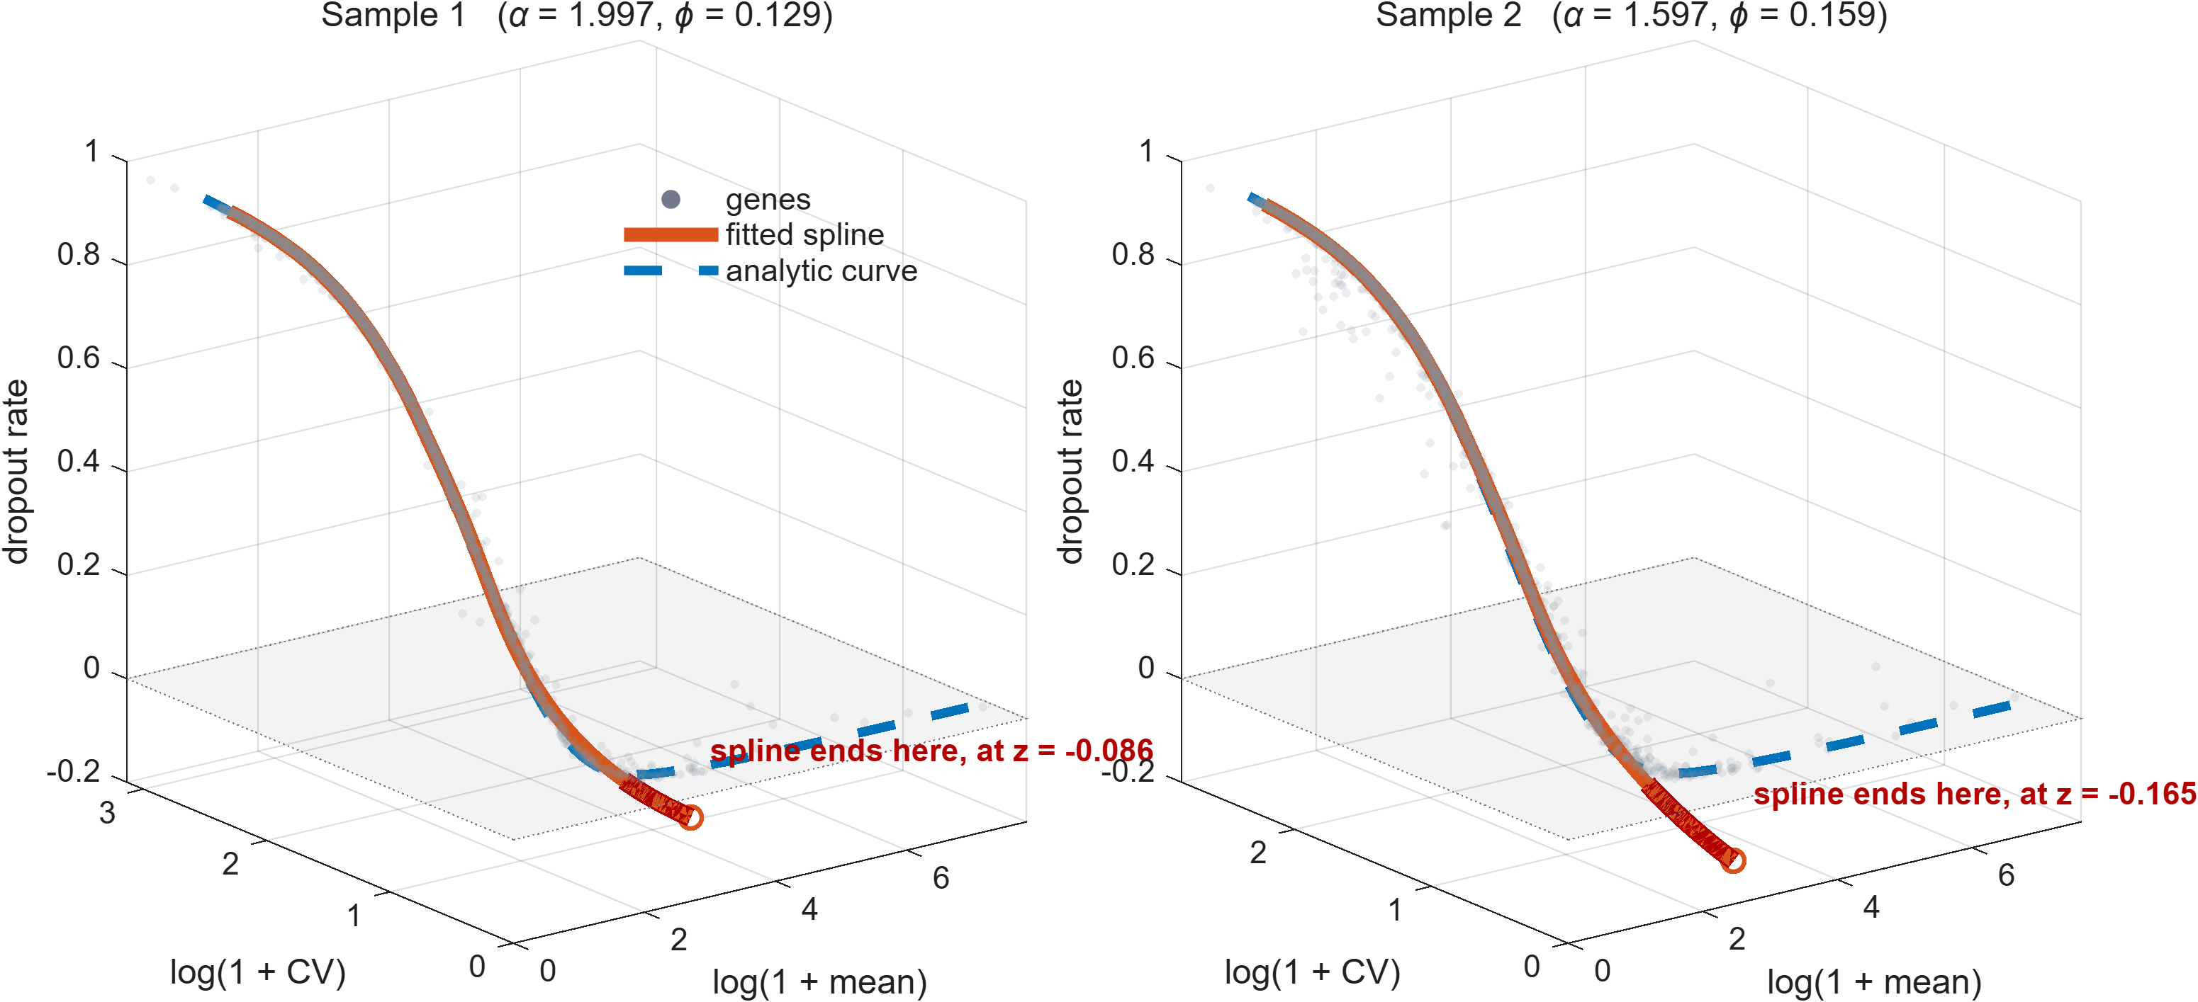
Figure 1. The gene cloud in the three-dimensional space the method actually works in (grey), with the fitted spline (solid) and the analytic curve of equations (8)–(10) (dashed). The shaded surface is the plane z = 0. The two curves are indistinguishable over the body of the data; the spline then terminates where the genes thin out, having already left the feasible region, while the analytic curve stays on the plane and continues across the full range of gene means.
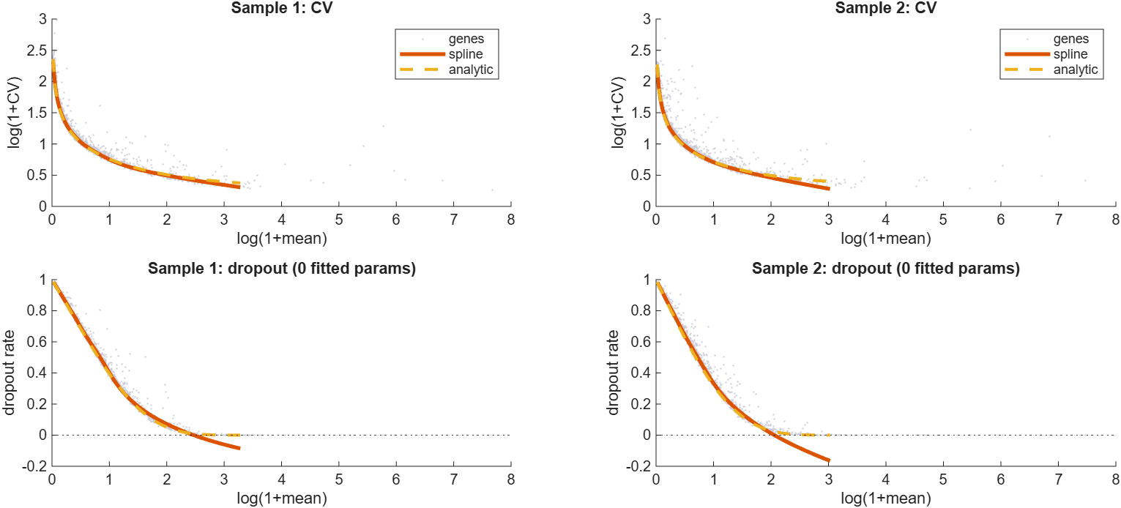
Figure 2. The same comparison coordinate by coordinate, which makes the size of the discrepancy readable. The bottom row is the zero-parameter Poisson dropout law of equation (7); note the spline descending below zero on the right.

11. Why the analytic curve is preferable where the two disagree
- The spline leaves the feasible region. Its dropout coordinate reaches −0.086 in sample 1 and −0.165 in sample 2 — a negative rate. The largest analytic-versus-spline discrepancies occur exactly there. The analytic curve is a mixture of survival functions, so $0 < z ≤ 1$ by construction, and $y$ is monotonically decreasing as it must be.
- The curve is defined for all μ > 0. The spline spans only the arclength of the observed genes, which is why sc_splinefit rescales distances by 1/100 and 1/10 beyond either end, and why test.m zeroes out genes whose nearest index is the first or last knot. Those patches become unnecessary. On these data the spline stops near $\text{log}\left(1 + μ\right) = 3.3$ while genes extend to 7.7.
- No hyperparameters. The 15 pieces, the 0.75 robustness weight, the arclength parameterization and the suppressed rank-deficiency warning all disappear.
- The reference is comparable across conditions. At present the two deviation vectors are measured against two independently estimated splines, so the DV score mixes per-gene deviation with sampling noise in the two reference curves. Analytically the references differ only through $α$, $φ$ and the library sizes, all of which are interpretable and separately estimable.
- The residual becomes interpretable. The parameter value at the foot point estimates the gene's expression rate, and the CV residual is excess variability relative to a gamma-Poisson expectation rather than relative to an empirical trend.

12. Implementation
MATLAB/sc_analyticfit.m is a drop-in replacement for sc_splinefit, returning the same table columns and preserving the xyzFit(T.nearidx,:) call pattern:
[T, xyzFit, curve, params] = sc_analyticfit(Xraw, genelist);
v = [T.lgu T.lgcv T.dropr] - xyzFit(T.nearidx, :);
Pass IsNormalized=true together with LibSize= if the matrix has already been through sc_norm. Dispersion=0 gives the pure-Poisson technical null; the default fits $φ$ robustly by equation (16).

