**Doctoral Defense**

Deciphering Cell Systems: Machine Learning Perspectives and Approaches for the Analysis of Single-Cell Data

**Yongjian Yang**

Doctor of Philosophy Degree Candidate

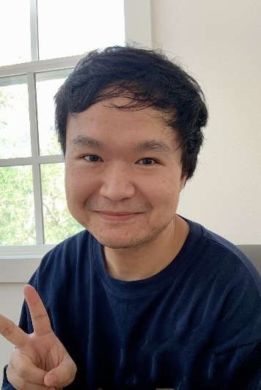

**Thursday, October 12, 2023 | 2:00 p.m.**

***via Zoom***

Meeting ID: <https://tamu.zoom.us/j/96971362093>

Dr. James Cai, Chair

*Department of Electrical & Computer Engineering*

*Department of Veterinary Integrative Biosciences*