1. TT8 Book 테이블에서 VSSE, NJAC 코드 체크
- SELECT * FROM jac.book where name like '%VSSE%' and active = true;
mock.vsse.code=117
mock.njac.code=212

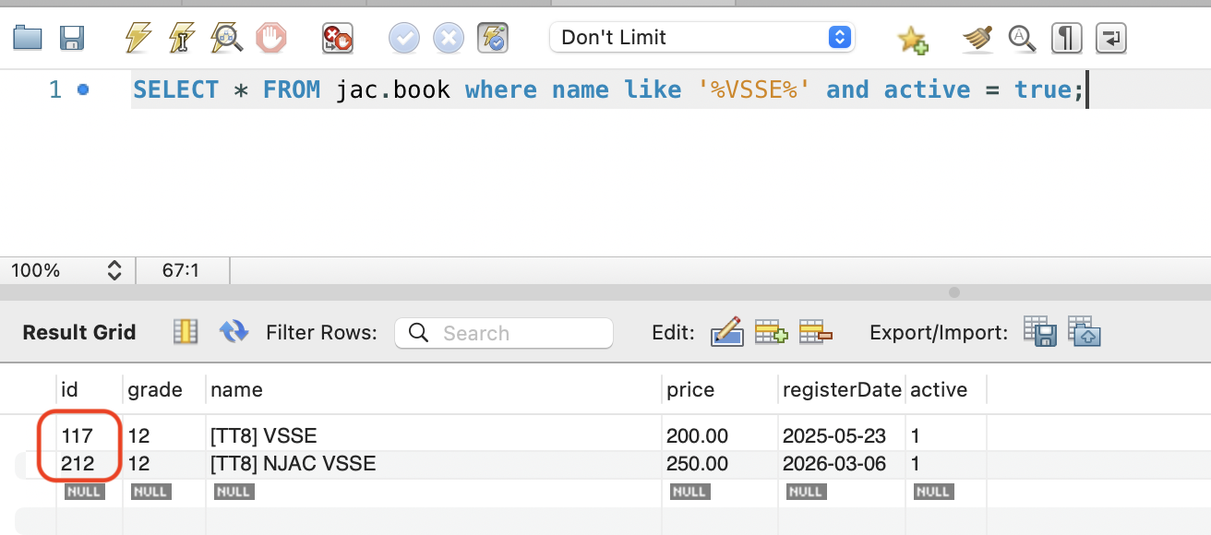

2. application.properties 수정
mock.explanation.enabled=true
mock.vsse.code=117
mock.njac.code=212

3. Mock Test 등록/수정 - JAC Manager
JAC Study menu -> Class Test -> List -> 등록/수정
답안지 등록
Answer Document, Answer Video 등록
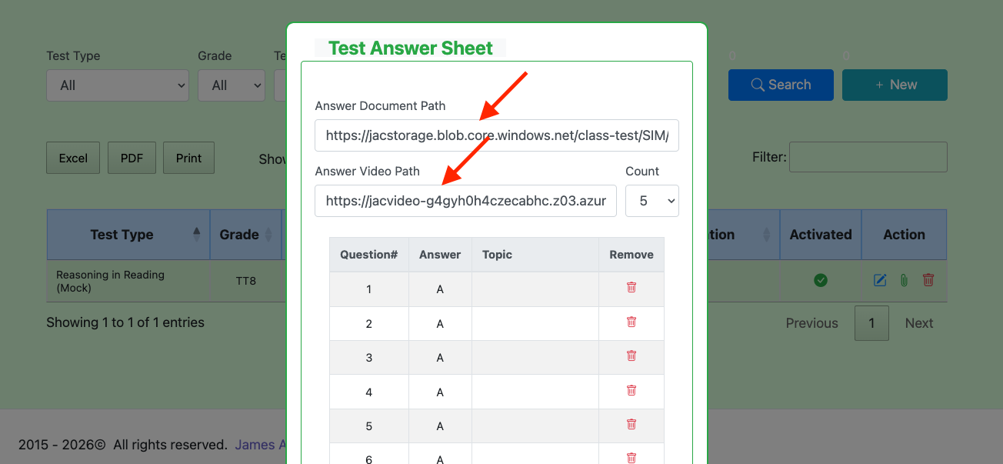

4. Mock Test Schecule 등록/수정 - JAC Manager
JAC Study menu -> Class Test -> Schedule -> 등록/수정
Explanation Result Schedule 등록