Coocox to Make File

The purpose of this project is to convert a Coocox project into a makefile, note that the makefile needs to be refined (I found that because coocox runs only in Windows, the filenames are not case sensitive, when moving to Linux the compilation failed because of this)

Running the project

java -jar CoocoxToMakefile.jar

The Main window is then displayed

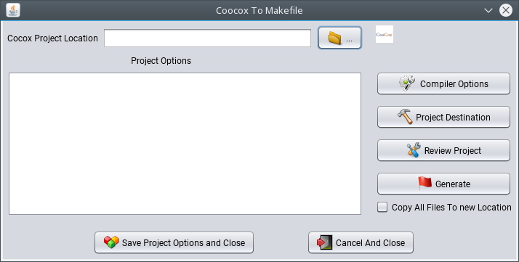
To start click the Coox project location (I will use one of my projects as example)

c:\projects/arm_projects/updated_lpc1768/

Locate the project file: project.pbxproj this file just points to the actual file which is in the
c:/CooCox/CoIDE/configuration/ProgramData ( in this case will be the lpc_1768_controller) (the name of the project)

After the project is loaded

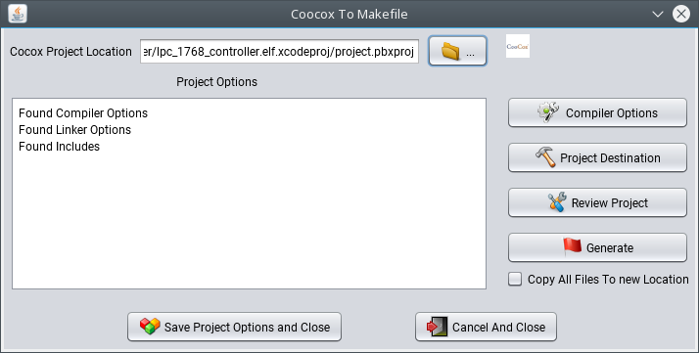

Note: Copy All files to new location will copy the old project folder to the NEW project location
Now the compiler options can be set (or modified)

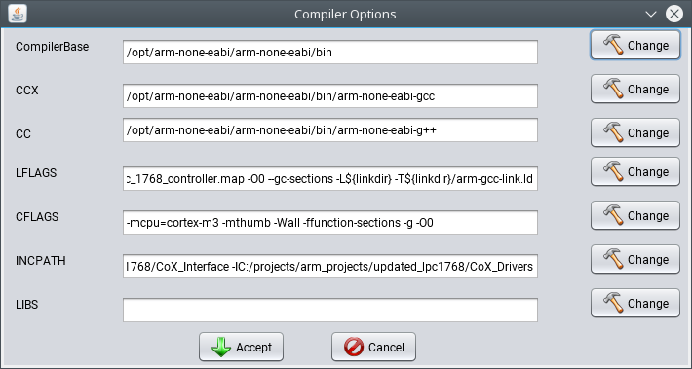

Note: that the mandatory options are:

CompilerBase
CCX
CC

The rest you can use the default provided or alter the values

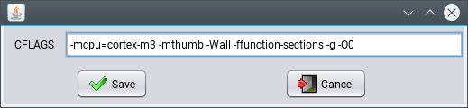

After the compiler options are setup please set up the NEW project location
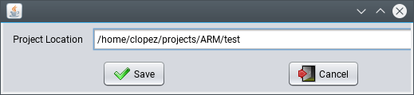

After this is done you can click review

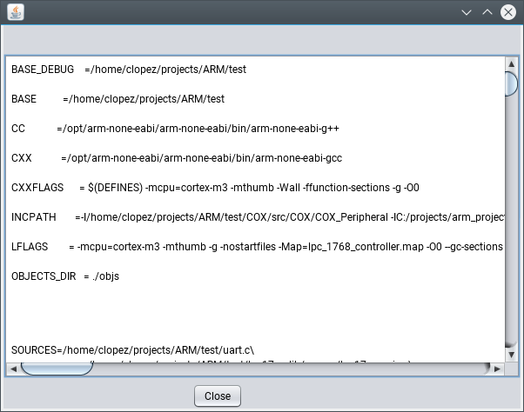

if the project generation looks correct then click generate

