BST5220 multilevel HW1

Due Wednesday by 12:00 pm, 2/11

Miao Cai <miao.cai@slu.edu>

2/4/2019

You will first need to run the SAS code (homework1_data.sas) to create the SAS data set. The purpose of this study is to assess how job-related stress is related to hospital size (0=small, 1=medium, 2=large) and nurse’s job experience (years). Data are from nurses working in 25 hospitals. In each hospital, a sample of about 40 nurses is selected and given a test that measures job-related stress (coded on a scale of 0-7).

1. Identify the type of the data structure (cross-sectional clustered, longitudinal, or clustered longitudinal).
2. Identify the variables at each level.
3. Graphically examine the association between job stress and nurse’s experience within each hospital. Refer to slides 8-11, lecture 2.
4. Use the model building strategies discussed in lecture 3 to select the best model for the data

dat = rio::import("data/a1.sas7bdat")  
head(dat)

## hospital hospital_size nurse stress experience  
## 1 1 2 1 7 11  
## 2 1 2 2 7 20  
## 3 1 2 3 7 7  
## 4 1 2 4 6 25  
## 5 1 2 5 6 22  
## 6 1 2 6 6 22

1. This is a cross-sectional clustered data struture
2. Variables at each level:

* Hospital level: hospital, hospital_size
* Nurse level: stress, experience

1. Graphically examine the association between job stress and nurse’s experience within each hospital

pacman::p_load(tidyverse)  
  
dat %>%   
 ggplot(aes(experience, stress,)) + geom_point(alpha = 0.5) + geom_jitter() +   
 geom_smooth(method = "lm", se=FALSE, color="blue") +   
 facet_wrap(.~hospital, ncol = 5)

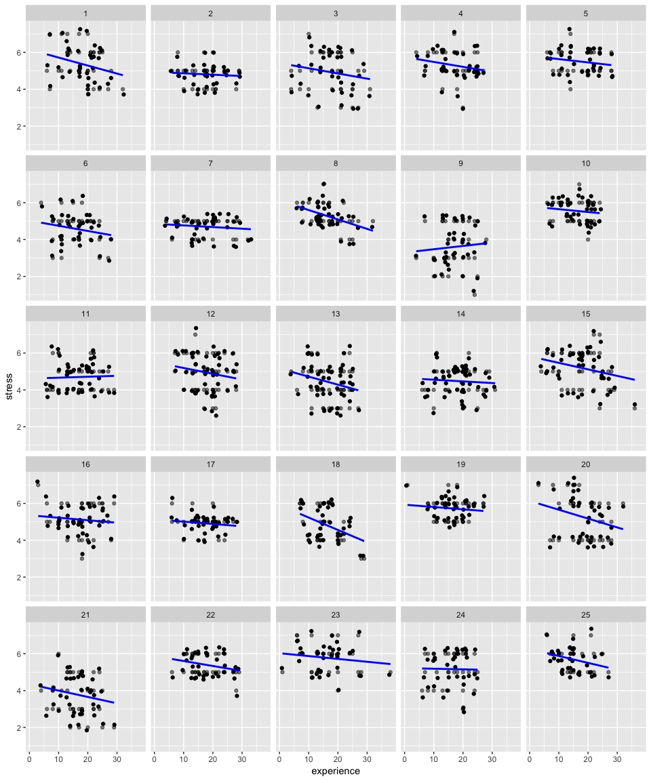

pacman::p_load(rstanarm, brms)  
  
fit0 = stan_lmer(stress ~ (1|hospital), data = dat,  
 chains = 1, iter = 1000, warmup = 500)  
fitbrms0 = brm(  
 stress ~ (1|hospital), data = dat,  
 chains = 1, iter = 1000, warmup = 500  
)

## Compiling the C++ model

## Start sampling

summary(fit0)

##   
## Model Info:  
##   
## function: stan_lmer  
## family: gaussian [identity]  
## formula: stress ~ (1 | hospital)  
## algorithm: sampling  
## priors: see help('prior_summary')  
## sample: 500 (posterior sample size)  
## observations: 1000  
## groups: hospital (25)  
##   
## Estimates:  
## mean sd 2.5% 25%   
## (Intercept) 5.0 0.1 4.8 4.9  
## b[(Intercept) hospital:1] 0.4 0.2 0.1 0.2  
## b[(Intercept) hospital:2] -0.2 0.2 -0.5 -0.3  
## b[(Intercept) hospital:3] -0.1 0.2 -0.4 -0.2  
## b[(Intercept) hospital:4] 0.3 0.2 0.0 0.2  
## b[(Intercept) hospital:5] 0.5 0.2 0.2 0.4  
## b[(Intercept) hospital:6] -0.4 0.2 -0.7 -0.5  
## b[(Intercept) hospital:7] -0.3 0.2 -0.6 -0.4  
## b[(Intercept) hospital:8] 0.3 0.2 0.0 0.2  
## b[(Intercept) hospital:9] -1.3 0.2 -1.6 -1.4  
## b[(Intercept) hospital:10] 0.5 0.2 0.2 0.4  
## b[(Intercept) hospital:11] -0.3 0.2 -0.6 -0.4  
## b[(Intercept) hospital:12] 0.0 0.2 -0.3 -0.1  
## b[(Intercept) hospital:13] -0.5 0.1 -0.8 -0.6  
## b[(Intercept) hospital:14] -0.5 0.1 -0.8 -0.6  
## b[(Intercept) hospital:15] 0.2 0.2 -0.1 0.1  
## b[(Intercept) hospital:16] 0.1 0.2 -0.2 0.0  
## b[(Intercept) hospital:17] -0.1 0.2 -0.4 -0.2  
## b[(Intercept) hospital:18] -0.2 0.2 -0.5 -0.3  
## b[(Intercept) hospital:19] 0.7 0.2 0.4 0.6  
## b[(Intercept) hospital:20] 0.3 0.2 -0.1 0.2  
## b[(Intercept) hospital:21] -1.1 0.2 -1.4 -1.3  
## b[(Intercept) hospital:22] 0.4 0.2 0.0 0.3  
## b[(Intercept) hospital:23] 0.7 0.2 0.4 0.6  
## b[(Intercept) hospital:24] 0.2 0.2 -0.1 0.1  
## b[(Intercept) hospital:25] 0.7 0.2 0.3 0.6  
## sigma 0.8 0.0 0.8 0.8  
## Sigma[hospital:(Intercept),(Intercept)] 0.3 0.1 0.2 0.2  
## mean_PPD 5.0 0.0 4.9 5.0  
## log-posterior -1274.5 4.9 -1284.2 -1278.1  
## 50% 75% 97.5%  
## (Intercept) 5.0 5.1 5.2  
## b[(Intercept) hospital:1] 0.4 0.5 0.7  
## b[(Intercept) hospital:2] -0.2 -0.1 0.2  
## b[(Intercept) hospital:3] -0.1 0.1 0.3  
## b[(Intercept) hospital:4] 0.3 0.4 0.6  
## b[(Intercept) hospital:5] 0.5 0.6 0.8  
## b[(Intercept) hospital:6] -0.4 -0.3 0.0  
## b[(Intercept) hospital:7] -0.3 -0.2 0.0  
## b[(Intercept) hospital:8] 0.3 0.4 0.6  
## b[(Intercept) hospital:9] -1.3 -1.2 -1.0  
## b[(Intercept) hospital:10] 0.5 0.6 0.9  
## b[(Intercept) hospital:11] -0.3 -0.2 0.0  
## b[(Intercept) hospital:12] 0.0 0.1 0.2  
## b[(Intercept) hospital:13] -0.5 -0.4 -0.2  
## b[(Intercept) hospital:14] -0.5 -0.4 -0.2  
## b[(Intercept) hospital:15] 0.2 0.3 0.5  
## b[(Intercept) hospital:16] 0.1 0.2 0.4  
## b[(Intercept) hospital:17] 0.0 0.0 0.3  
## b[(Intercept) hospital:18] -0.2 0.0 0.2  
## b[(Intercept) hospital:19] 0.7 0.8 1.0  
## b[(Intercept) hospital:20] 0.3 0.4 0.6  
## b[(Intercept) hospital:21] -1.1 -1.0 -0.8  
## b[(Intercept) hospital:22] 0.4 0.5 0.7  
## b[(Intercept) hospital:23] 0.7 0.9 1.1  
## b[(Intercept) hospital:24] 0.2 0.3 0.5  
## b[(Intercept) hospital:25] 0.7 0.8 1.0  
## sigma 0.8 0.8 0.9  
## Sigma[hospital:(Intercept),(Intercept)] 0.3 0.3 0.5  
## mean_PPD 5.0 5.0 5.1  
## log-posterior -1274.3 -1270.6 -1266.1  
##   
## Diagnostics:  
## mcse Rhat n_eff  
## (Intercept) 0.0 1.0 87   
## b[(Intercept) hospital:1] 0.0 1.0 215   
## b[(Intercept) hospital:2] 0.0 1.0 199   
## b[(Intercept) hospital:3] 0.0 1.0 175   
## b[(Intercept) hospital:4] 0.0 1.0 234   
## b[(Intercept) hospital:5] 0.0 1.0 198   
## b[(Intercept) hospital:6] 0.0 1.0 200   
## b[(Intercept) hospital:7] 0.0 1.0 204   
## b[(Intercept) hospital:8] 0.0 1.0 177   
## b[(Intercept) hospital:9] 0.0 1.0 177   
## b[(Intercept) hospital:10] 0.0 1.0 189   
## b[(Intercept) hospital:11] 0.0 1.0 175   
## b[(Intercept) hospital:12] 0.0 1.0 177   
## b[(Intercept) hospital:13] 0.0 1.0 177   
## b[(Intercept) hospital:14] 0.0 1.0 179   
## b[(Intercept) hospital:15] 0.0 1.0 195   
## b[(Intercept) hospital:16] 0.0 1.0 200   
## b[(Intercept) hospital:17] 0.0 1.0 154   
## b[(Intercept) hospital:18] 0.0 1.0 166   
## b[(Intercept) hospital:19] 0.0 1.0 187   
## b[(Intercept) hospital:20] 0.0 1.0 197   
## b[(Intercept) hospital:21] 0.0 1.0 218   
## b[(Intercept) hospital:22] 0.0 1.0 226   
## b[(Intercept) hospital:23] 0.0 1.0 201   
## b[(Intercept) hospital:24] 0.0 1.0 183   
## b[(Intercept) hospital:25] 0.0 1.0 188   
## sigma 0.0 1.0 366   
## Sigma[hospital:(Intercept),(Intercept)] 0.0 1.0 83   
## mean_PPD 0.0 1.0 444   
## log-posterior 0.5 1.0 100   
##   
## For each parameter, mcse is Monte Carlo standard error, n_eff is a crude measure of effective sample size, and Rhat is the potential scale reduction factor on split chains (at convergence Rhat=1).