Code function description: watch the MethodEntryEvent, and record relevant information, then write information into buffer, when the buffer row more than 900000 write them into DB.

And I think if there only one thread process this EVENT, the method writeCGdb() will be executed by only one thread before the Agent be unload.

The output should be:

…

writeCGdb--begin--CgBufferCount: 900000

writeCGdb--end--CgBufferCount: 0

…

writeCGdb--begin--CgBufferCount: 900000

writeCGdb--end--CgBufferCount: 0

…

oooooooooooooooooooooooooooooooooooooooooooo

writeCGdb--begin--CgBufferCount: xxxxx

writeCGdb--end--CgBufferCount: 0

but through run it, this is some output screenshot:(the other information is output by maven surefire plugin and ignore them please.)

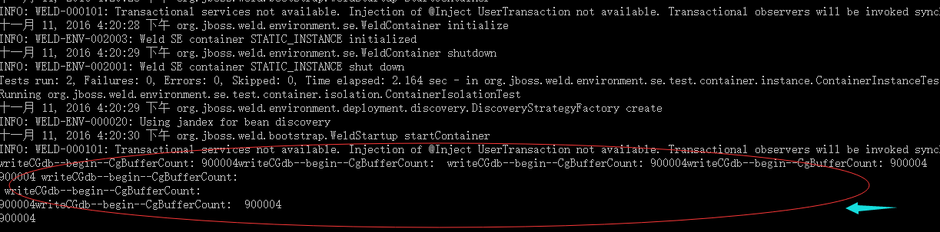



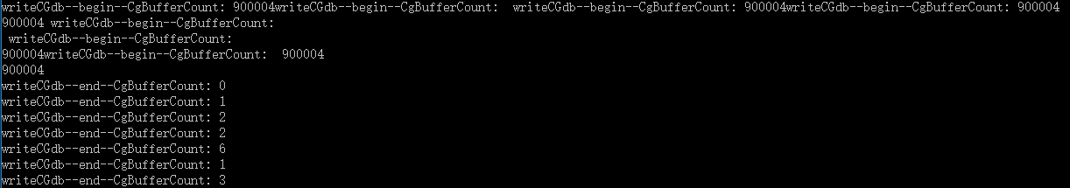

I am afraid the screenshot is not clearly, the red words is content copied from console.

writeCGdb--begin--CgBufferCount: 900004writeCGdb--begin--CgBufferCount: writeCGdb--begin--CgBufferCount: 900004writeCGdb--begin--CgBufferCount: 900004

900004 writeCGdb--begin--CgBufferCount:

writeCGdb--begin--CgBufferCount:

900004writeCGdb--begin--CgBufferCount: 900004

900004

writeCGdb--end--CgBufferCount: 0

writeCGdb--end--CgBufferCount: 1

writeCGdb--end--CgBufferCount: 2

writeCGdb--end--CgBufferCount: 2

writeCGdb--end--CgBufferCount: 6

writeCGdb--end--CgBufferCount: 1

writeCGdb--end--CgBufferCount: 3

as for the real output I think this Event processed by more than one thread.