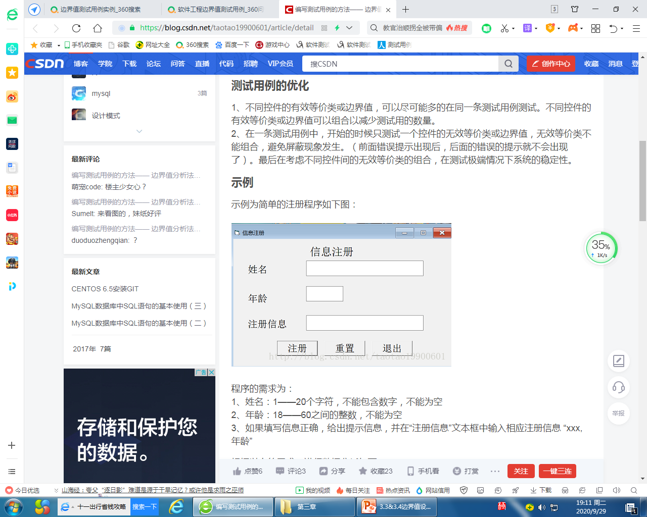

**练习**

**根据以上的需求，进行数据分析如下：**

|  |  |  |  |
| --- | --- | --- | --- |
| 控件名称 | 有效等价类 | 无效等价 | 边界值 |
| 姓名 |  |  |  |
|  |  |  |
|  |  |  |
|  |  |  |
|  |  |  |
| 年龄 |  |  |  |
|  |  |  |
|  |  |  |
|  |  |  |
|  |  |  |
|  |  |  |
|  |  |  |