Pet-Care App Funnel Report

Period: May – July 2025

# 1 Combined Funnel

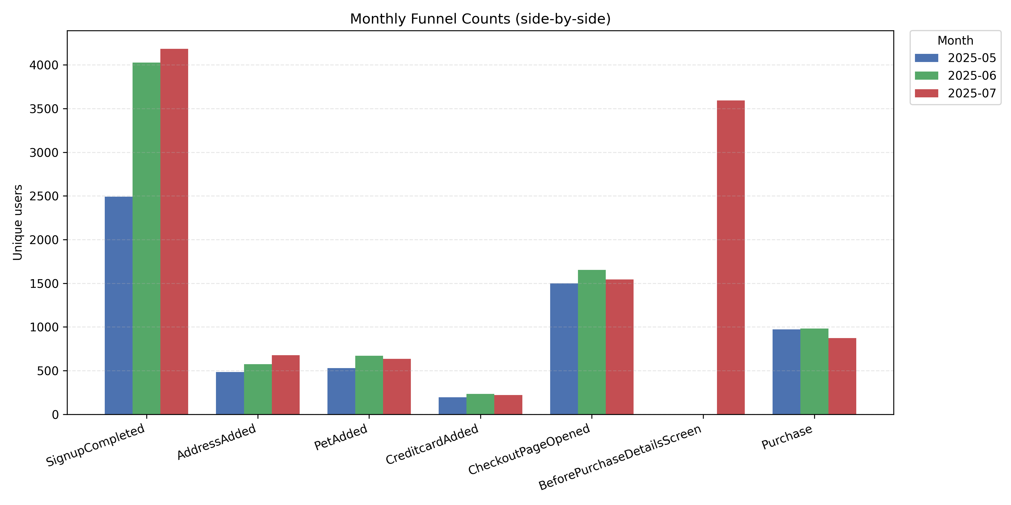

# 2 Monthly Funnels

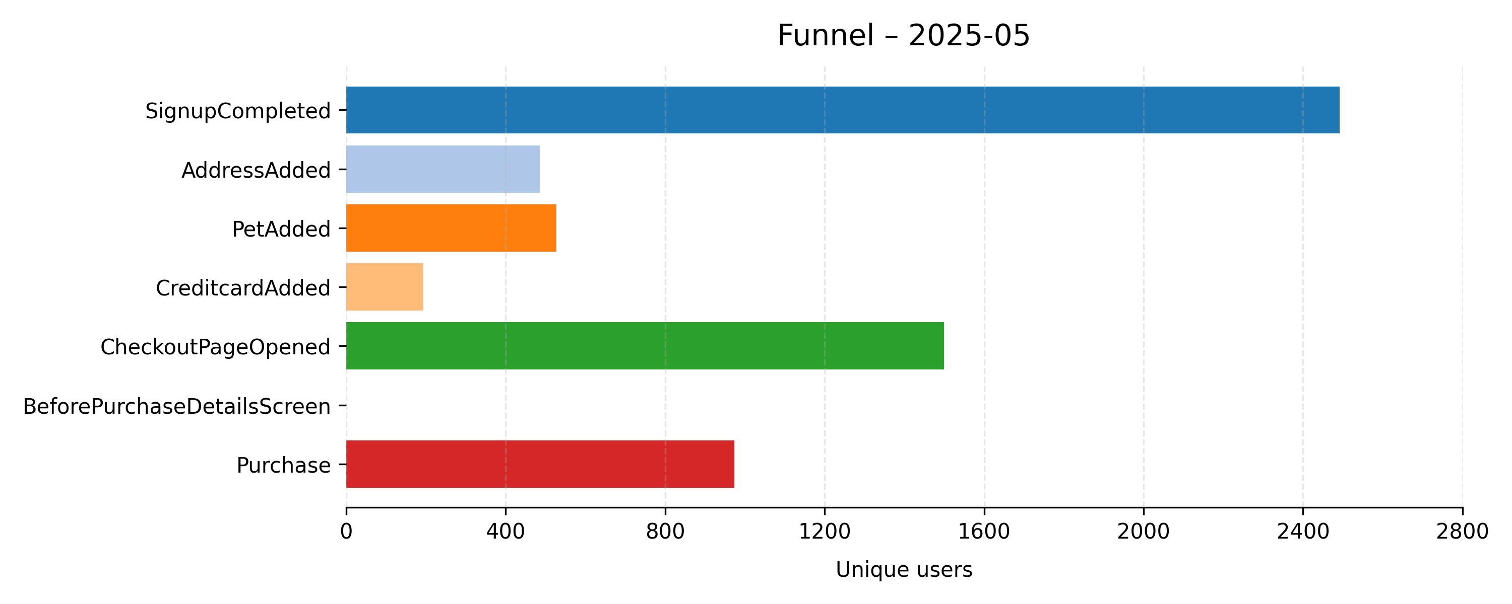

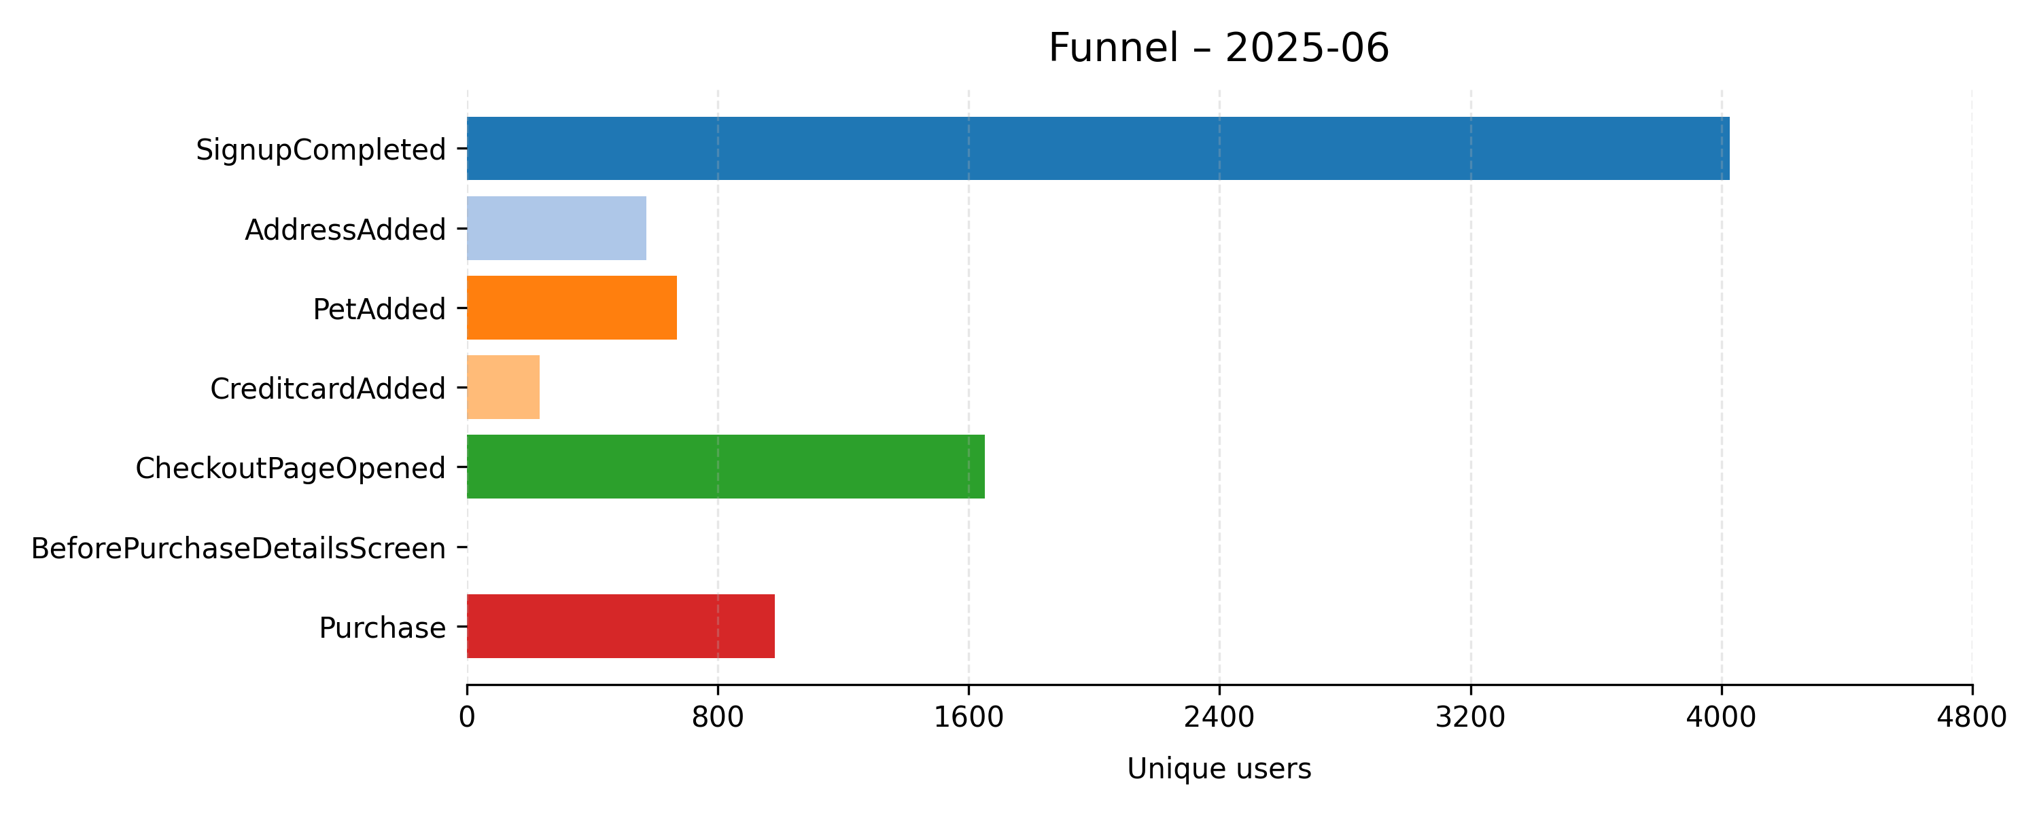

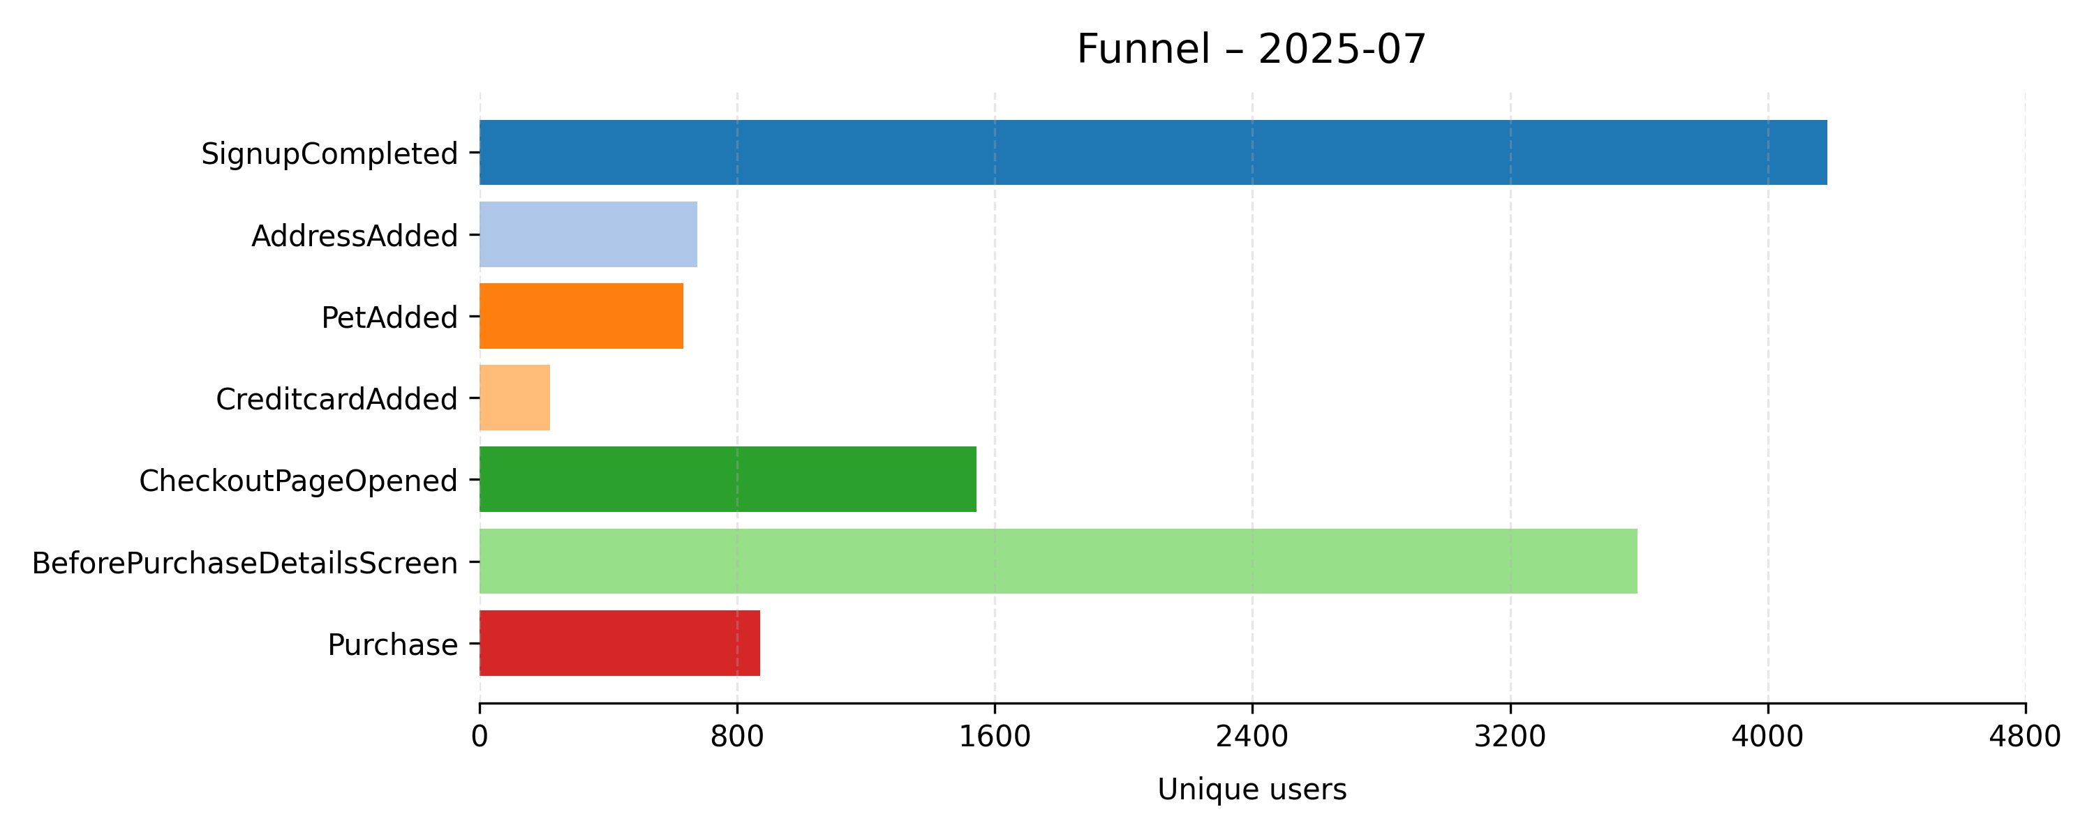

# 3 Service-Type Purchases

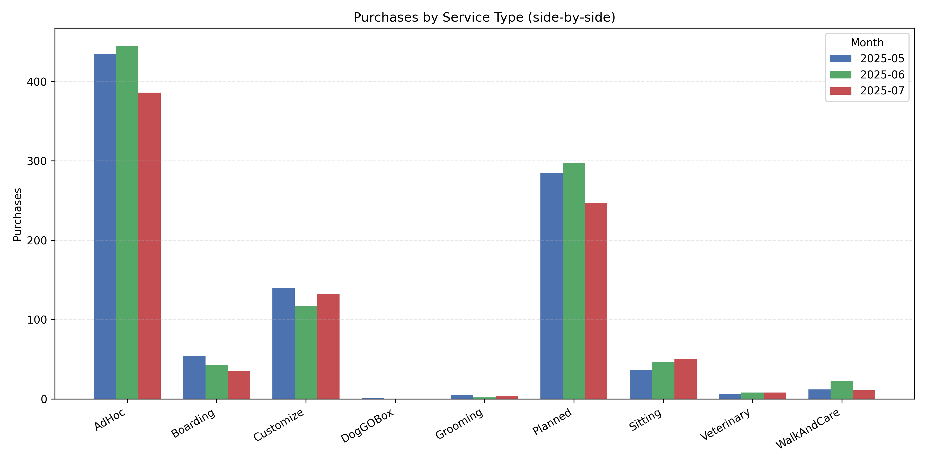

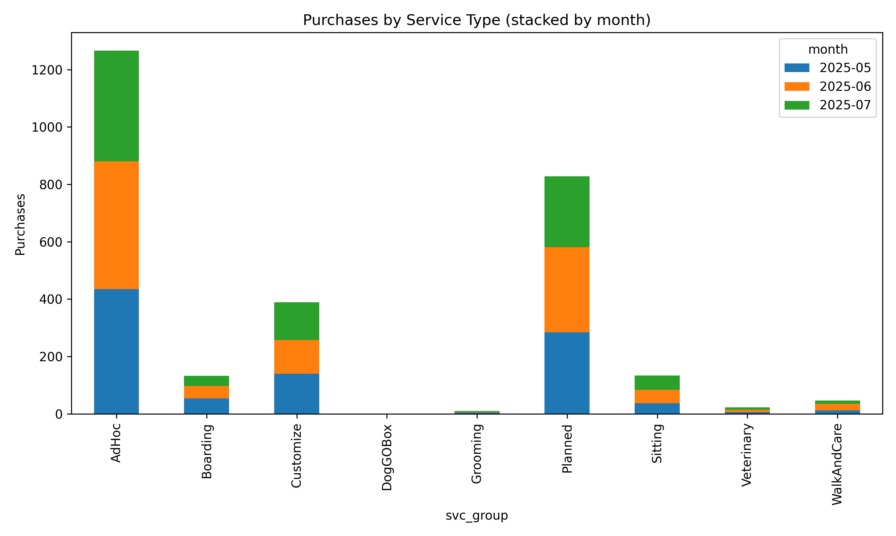

# 4 Funnel Counts

|  |  |  |  |
| --- | --- | --- | --- |
|  | 2025-05 | 2025-06 | 2025-07 |
| SignupCompleted | 2492.0 | 4027.0 | 4184.0 |
| AddressAdded | 486.0 | 573.0 | 676.0 |
| PetAdded | 528.0 | 670.0 | 634.0 |
| CreditcardAdded | 194.0 | 233.0 | 220.0 |
| CheckoutPageOpened | 1500.0 | 1652.0 | 1543.0 |
| BeforePurchaseDetailsScreen | nan | nan | 3595.0 |
| Purchase | 974.0 | 982.0 | 872.0 |

# 5 Conversion (%)

|  |  |  |  |
| --- | --- | --- | --- |
|  | 2025-05 | 2025-06 | 2025-07 |
| SignupCompleted | 100.0 | 100.0 | 100.0 |
| AddressAdded | 19.5 | 14.23 | 16.16 |
| PetAdded | 2707.69 | 4708.36 | 3923.27 |
| CreditcardAdded | 7.16 | 4.95 | 5.61 |
| CheckoutPageOpened | 20949.72 | 33373.74 | 27504.46 |
| BeforePurchaseDetailsScreen | nan | nan | 13.07 |
| Purchase | nan | nan | 6671.77 |

# 6 Cohort Purchase %

|  |  |  |  |
| --- | --- | --- | --- |
|  | 30d | 60d | 90d |
| 2025-05 | 2.25 | 2.33 | 2.33 |
| 2025-06 | 1.37 | 1.42 | 1.42 |
| 2025-07 | 1.65 | 1.65 | 1.65 |

# 7 Service Metrics

|  |  |  |  |  |
| --- | --- | --- | --- | --- |
|  | CheckoutUsers | PurchaseUsers | Conversion_% | PurchaseShare_% |
| AdHoc | 1053.0 | 754.0 | 71.6 | 39.64 |
| Boarding | 586.0 | 120.0 | 20.48 | 6.31 |
| Customize | 361.0 | 267.0 | 73.96 | 14.04 |
| DogGOBox | 44.0 | 1.0 | 2.27 | 0.05 |
| Grooming | 108.0 | 9.0 | 8.33 | 0.47 |
| Planned | 824.0 | 566.0 | 68.69 | 29.76 |
| Sitting | 462.0 | 119.0 | 25.76 | 6.26 |
| TrainingService | 80.0 | 0.0 | 0.0 | 0.0 |
| Unknown | 21.0 | 0.0 | 0.0 | 0.0 |
| Veterinary | 92.0 | 22.0 | 23.91 | 1.16 |
| WalkAndCare | 0.0 | 44.0 | inf | 2.31 |

# 8 Key Insights

* Credit-card step narrow (~5-6 % of sign-ups).
* AdHoc & Planned convert >65 % from checkout.
* Boarding & Sitting under-convert (<22 %).
* Only ~2 % of new users purchase within 90 days.

Suggested next actions:

* A/B test shorter card-add flow / alt payments.
* Investigate Boarding/Sitting drop-offs.
* Start nurture comms in first 30 days.
* Back-fill BeforePurchaseDetailsScreen data.

# 9 Data-Quality Appendix

|  |  |  |  |
| --- | --- | --- | --- |
|  | Rows | Null_serviceType | Duplicate_user_month |
| SignupCompleted | 10703 | 10703 | 0 |
| AddressAdded | 1735 | 1735 | 0 |
| DogAdded | 1480 | 1480 | 0 |
| CatAdded | 392 | 392 | 0 |
| CreditcardAdded | 647 | 647 | 0 |
| CheckoutPageOpened | 4695 | 21 | 0 |
| BeforePurchaseDetailsScreen | 3595 | 0 | 0 |
| Purchase | 2829 | 0 | 0 |
| PetAdded | 1821 | 0 | 0 |