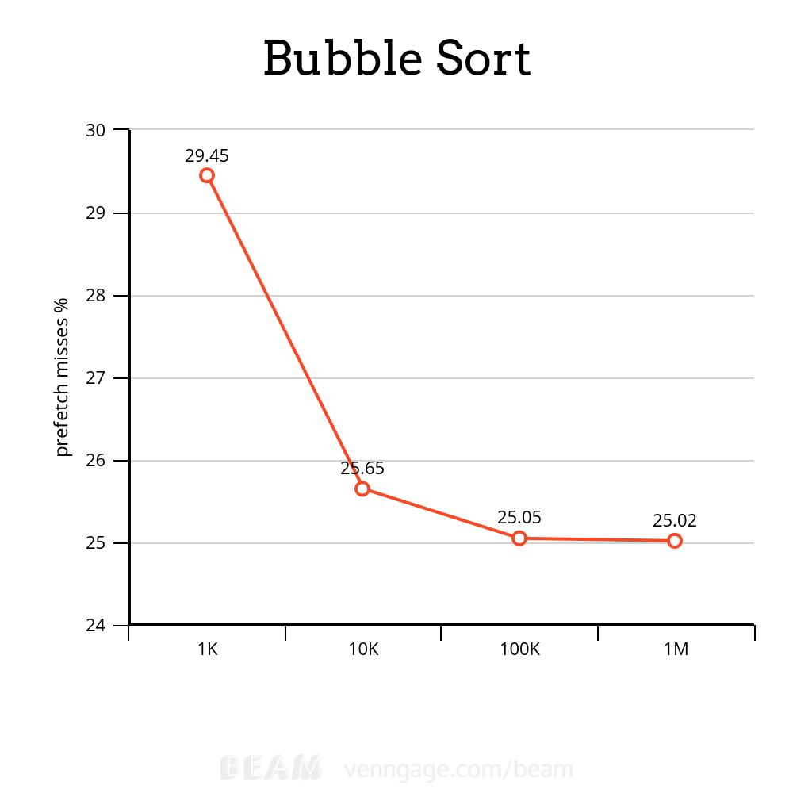
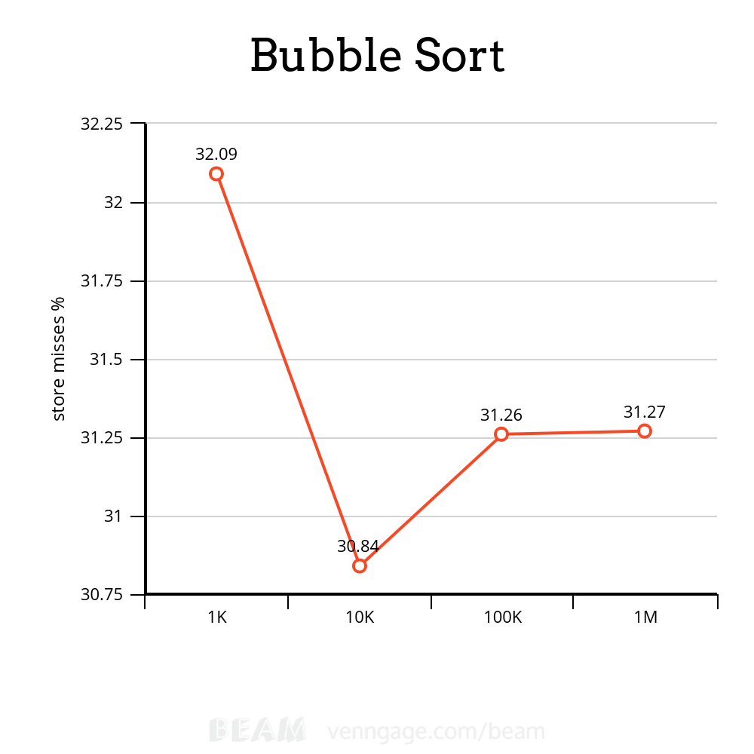
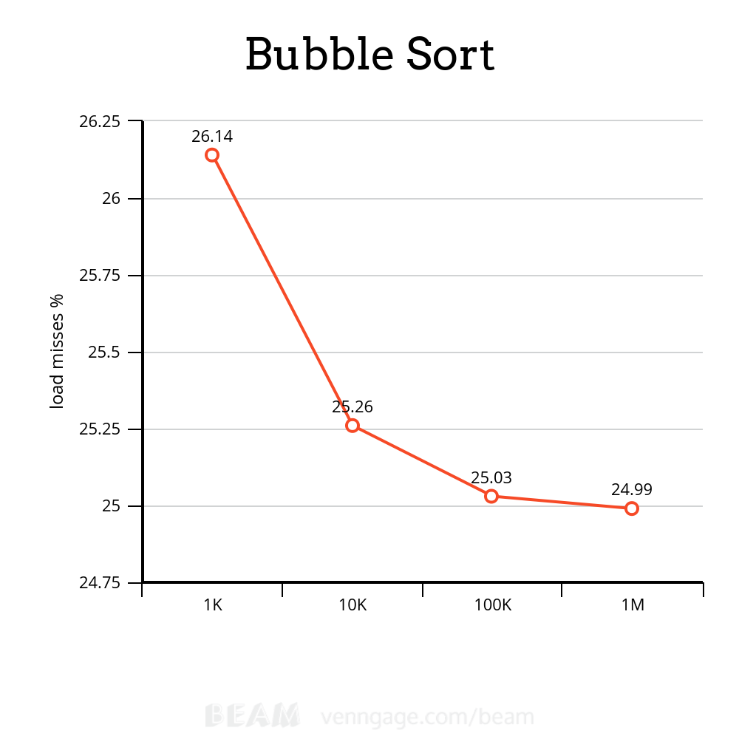
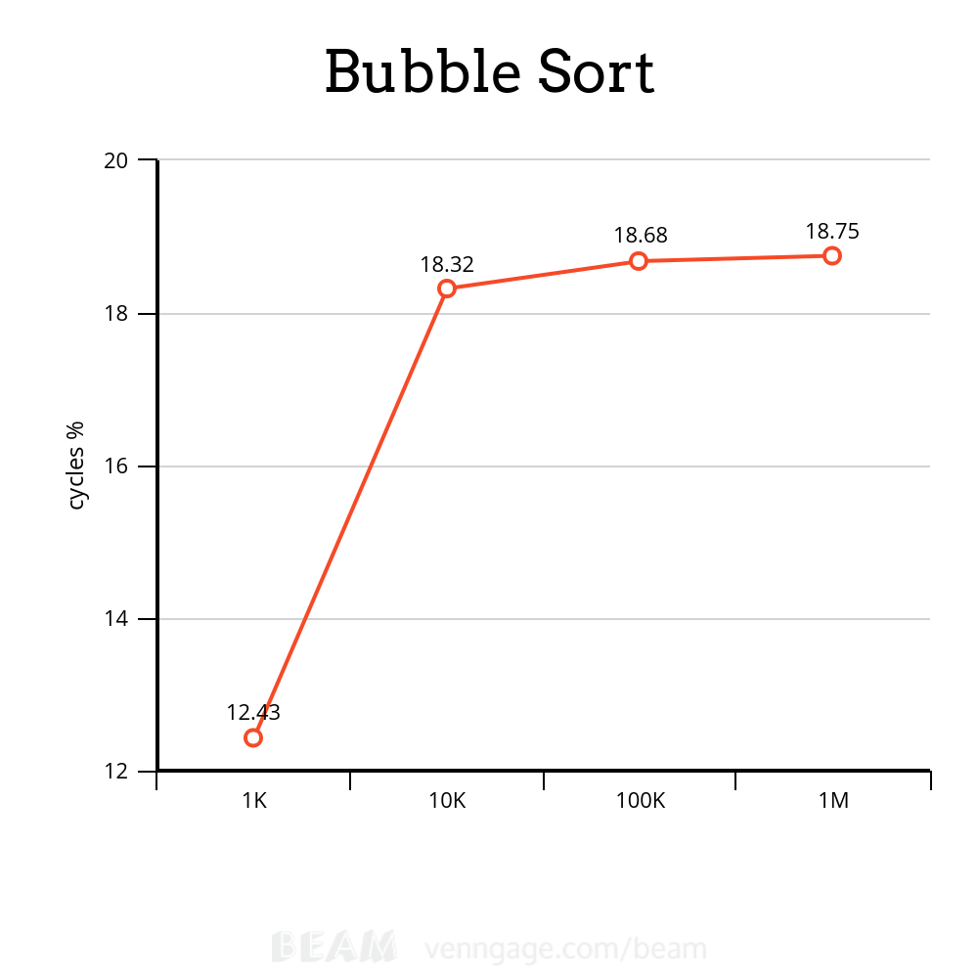
1K
317.729.200 cycles (12,43%)
371.293.379 instructions # 1,17 insn per
cycle (19,17%)
46.933 cache-misses (25,64%)
22.143 LLC-load-misses # 61,25% of all LL-cache hits (29,01%)
13.110 L1-dcache-store-misses (32,09%)
137.837.031 L1-dcache-loads (32,88%)
59.774 L1-dcache-load-misses # 0,04% of all L1-dcache hits (26,14%)
33.212.497 L1-dcache-stores (26,44%)
5.463 L1-dcache-store-misses (29,76%)
1.279.154 L1-dcache-prefetches (29,44%)
3.049 L1-dcache-prefetch-misses (29,45%)
36.149 LLC-loads (29,17%)
11.275 LLC-load-misses # 31,19% of all LL-cache hits (26,15%)
23.849 LLC-stores (12,32%)
3.383 LLC-store-misses (8,60%)
1.333 LLC-prefetch-misses (6,45%)

0,122739743 seconds time elapsed

0,114262000 seconds user
0,004080000 seconds sys

10k
1.658.110.036 cycles (18,32%)
1.525.597.684 instructions # 0,92 insn per
cycle (24,40%)
227.903 cache-misses (30,56%)
123.057 LLC-load-misses # 42,56% of all LL-cache hits (30,57%)
44.596 L1-dcache-store-misses (30,84%)
549.572.675 L1-dcache-loads (31,03%)
833.133 L1-dcache-load-misses # 0,15% of all L1-dcache hits (25,26%)
131.001.156 L1-dcache-stores (25,79%)
34.113 L1-dcache-store-misses (25,73%)
5.473.107 L1-dcache-prefetches (25,68%)
10.798 L1-dcache-prefetch-misses (25,65%)
289.107 LLC-loads (25,11%)
118.021 LLC-load-misses # 40,82% of all LL-cache hits (25,46%)
113.974 LLC-stores (12,40%)
12.237 LLC-store-misses (12,07%)
6.070 LLC-prefetch-misses (12,04%)

1,447229615 seconds time elapsed

1,396618000 seconds user
0,008026000 seconds sys

100k
145.932.670.009 cycles (18,68%)
153.205.597.684 instructions # 1,05 insn per
cycle (24,94%)
11.636.514 cache-misses (31,19%)
6.042.163 LLC-load-misses # 26,50% of all LL-cache hits (31,24%)
1.723.205 L1-dcache-store-misses (31,26%)
55.240.253.076 L1-dcache-loads (31,29%)
274.222.070 L1-dcache-load-misses # 0,50% of all L1-dcache hits (25,03%)
13.181.756.706 L1-dcache-stores (24,99%)
1.752.359 L1-dcache-store-misses (25,03%)
505.759.223 L1-dcache-prefetches (25,04%)
141.272 L1-dcache-prefetch-misses (25,05%)
22.802.927 LLC-loads (25,07%)
6.313.304 LLC-load-misses # 27,69% of all LL-cache hits (25,00%)
27.360.642 LLC-stores (12,47%)
644.437 LLC-store-misses (12,49%)
2.690.025 LLC-prefetch-misses (12,45%)

95,901157902 seconds time elapsed

93,191022000 seconds user
0,828931000 seconds sys

1M
156.260.985.925 cycles (18,75%)
153.029.439.850 instructions # 0,98 insn per
cycle (25,01%)
15.145.419 cache-misses (31,26%)
8.247.903 LLC-load-misses # 26,65% of all LL-cache hits (31,26%)
2.281.340 L1-dcache-store-misses (31,27%)
55.231.936.635 L1-dcache-loads (31,25%)
309.352.023 L1-dcache-load-misses # 0,56% of all L1-dcache hits (24,99%)
13.237.623.799 L1-dcache-stores (25,02%)
2.335.300 L1-dcache-store-misses (25,01%)
519.593.501 L1-dcache-prefetches (24,99%)
99.456 L1-dcache-prefetch-misses (25,02%)
30.952.097 LLC-loads (24,96%)
8.336.705 LLC-load-misses # 26,93% of all LL-cache hits (24,97%)
39.841.389 LLC-stores (12,52%)
808.777 LLC-store-misses (12,52%)
3.490.711 LLC-prefetch-misses (12,48%)

135,895993645 seconds time elapsed

131,094192000 seconds user
1,263960000 seconds sys

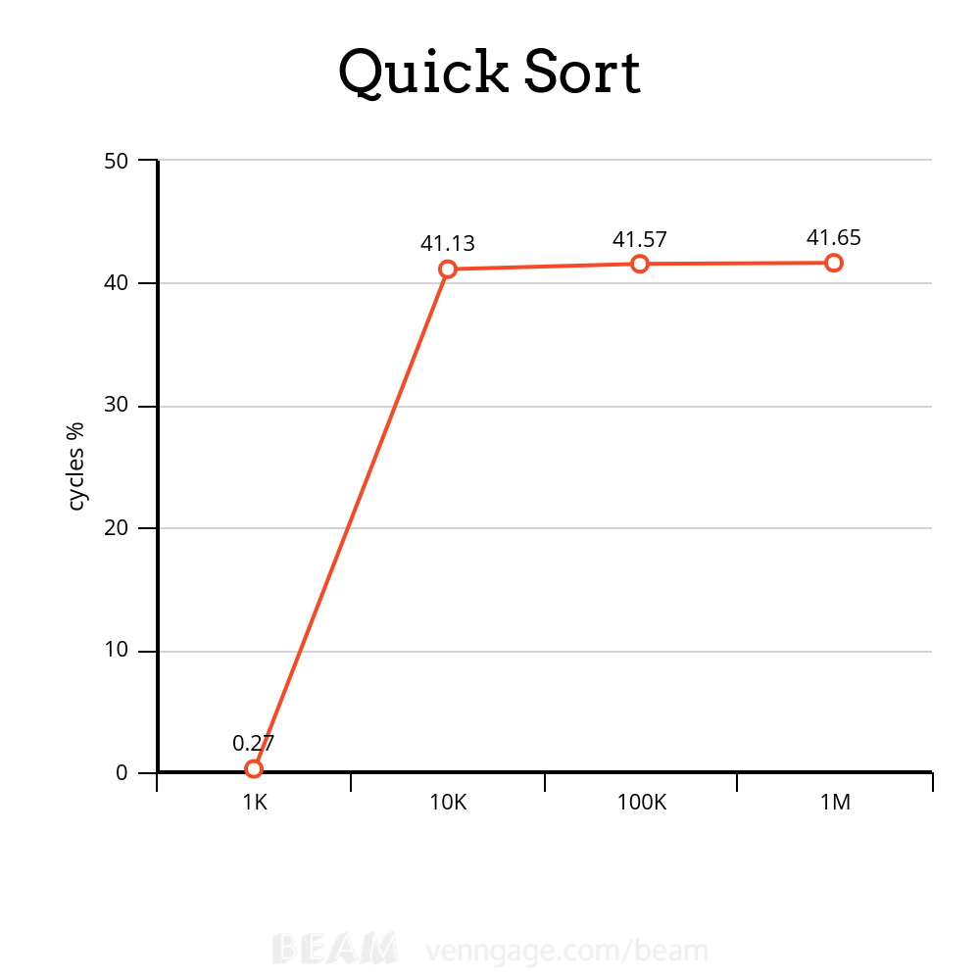
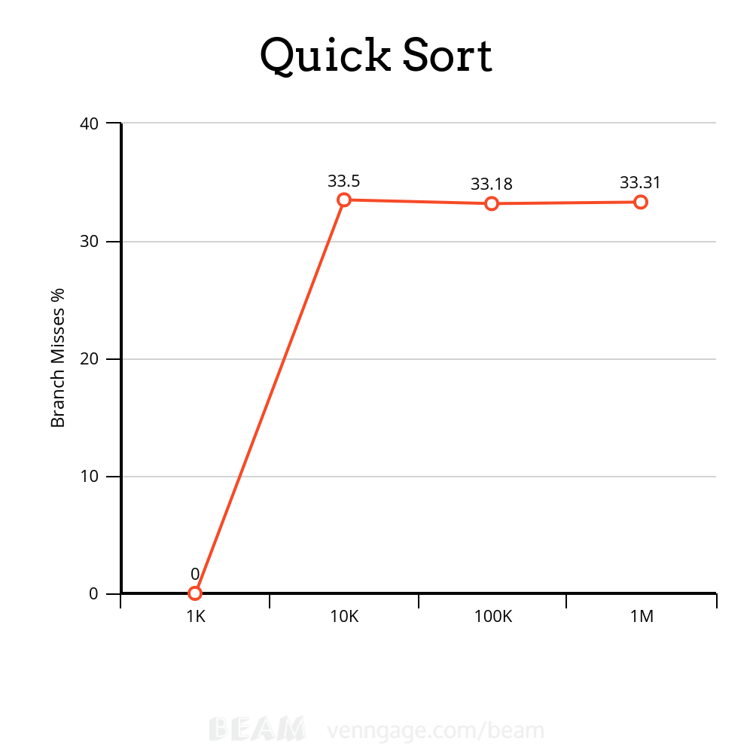
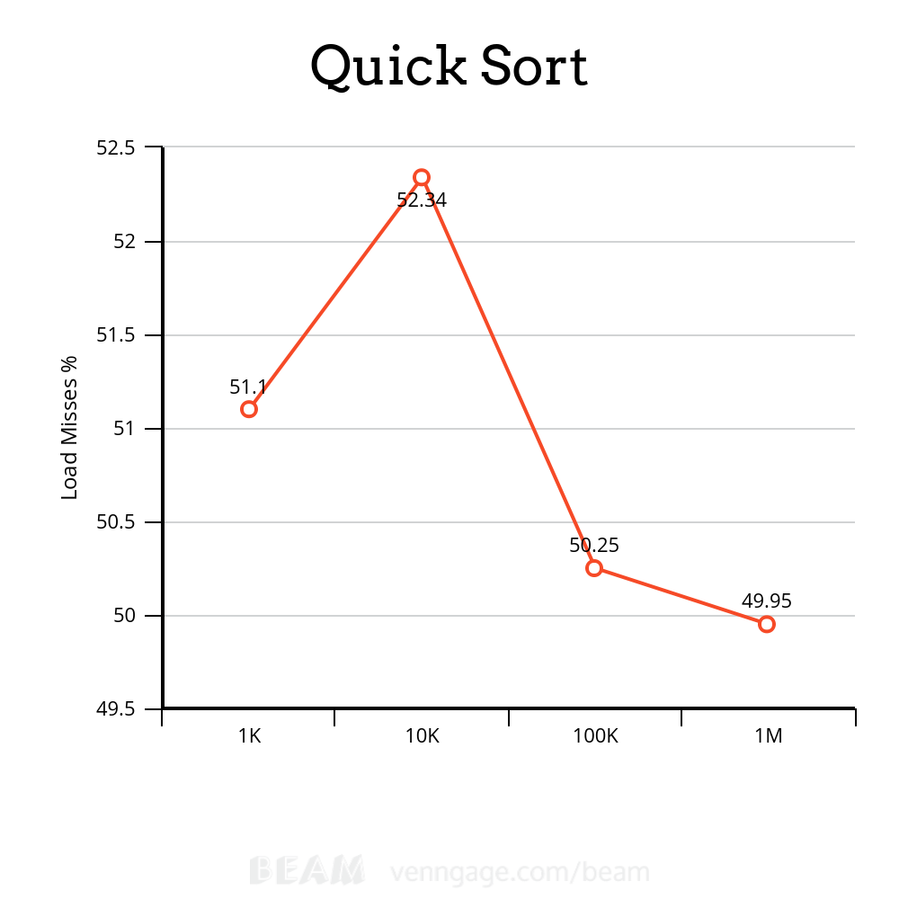

1K
30.614.281 cycles (0,27%)
31.813.486 instructions # 1,04 insn per cycle (21,15%)
14.275.284 L1-dcache-load (40,84%)
102.885 L1-dcache-load-misses # 0,72% of all L1-dcache hits (51,10%)
3.664.280 L1-dcache-stores (62,86%)
8.102 L1-dcache-store-misses (83,71%)
19.856 LLC-loads (59,16%)
3.747 LLC-load-misses # 18,87% of all LL-cache hits (48,90%)
<not counted> LLC-stores (0,00%)
<not counted> LLC-store-misses (0,00%)
<not counted> branches (0,00%)
<not counted> branch-misses (0,00%)

0,024155996 seconds time elapsed

0,016250000 seconds user
0,003250000 seconds sys

10K
560.933.638 cycles (41,13%)
376.108.927 instructions # 0,67 insn per cycle (52,72%)
172.525.817 L1-dcache-load (52,65%)
662.058 L1-dcache-load-misses # 0,38% of all L1-dcache hits (52,34%)
42.454.148 L1-dcache-stores (49,69%)
16.898 L1-dcache-store-misses (49,70%)
86.458 LLC-loads (30,52%)
23.177 LLC-load-misses # 26,81% of all LL-cache hits (31,70%)
67.615 LLC-stores (16,83%)
2.225 LLC-store-misses (15,96%)
39.769.605 branches (25,44%)
7.702.676 branch-misses # 19,37% of all branches (33,50%)

0,258981043 seconds time elapsed

0,247612000 seconds user
0,000000000 seconds sys

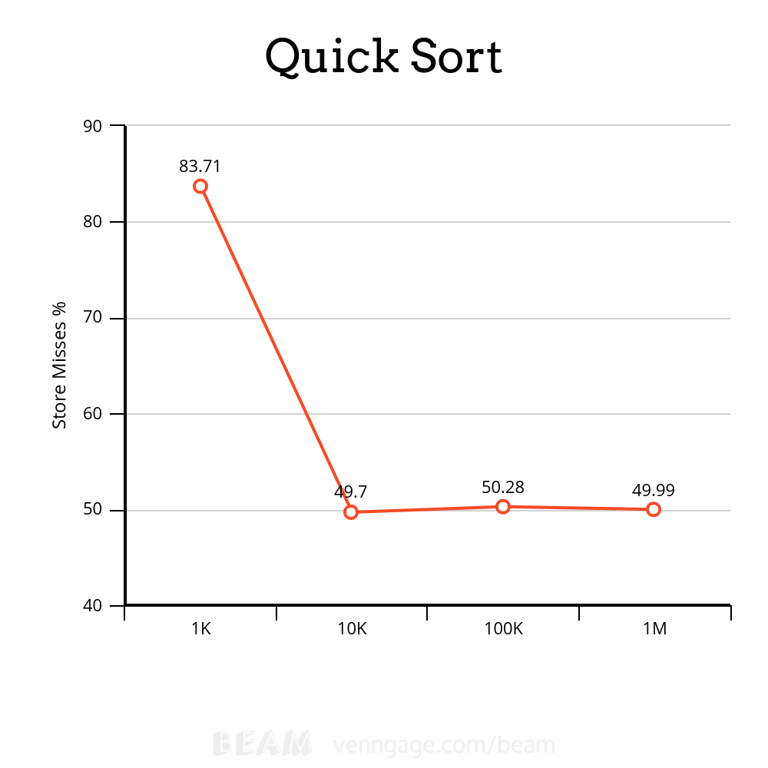

100K
5.746.571.278 cycles (41,57%)
4.076.470.781 instructions # 0,71 insn per cycle (49,96%)
2.015.220.595 L1-dcache-load (50,18%)
6.489.790 L1-dcache-load-misses # 0,32% of all L1-dcache hits (50,25%)
457.341.488 L1-dcache-stores (50,29%)
83.487 L1-dcache-store-misses (50,28%)
1.228.611 LLC-loads (33,29%)
605.523 LLC-load-misses # 49,29% of all LL-cache hits (33,20%)
3.425.992 LLC-stores (16,53%)
26.501 LLC-store-misses (16,55%)
432.802.147 branches (24,93%)
97.900.389 branch-misses # 22,62% of all branches (33,18%)

4,909015401 seconds time elapsed

4,846192000 seconds user
0,008003000 seconds sys

1M
60.325.060.680 cycles (41,65%)
52.417.257.097 instructions # 0,87 insn per cycle (49,99%)
25.013.465.315 L1-dcache-load (49,98%)
98.699.219 L1-dcache-load-misses # 0,39% of all L1-dcache hits (49,95%)
5.722.290.112 L1-dcache-stores (49,98%)
607.024 L1-dcache-store-misses (49,99%)
10.669.365 LLC-loads (33,37%)
5.726.250 LLC-load-misses # 53,67% of all LL-cache hits (33,38%)
36.904.352 LLC-stores (16,65%)
288.330 LLC-store-misses (16,67%)
5.452.166.180 branches (24,97%)
890.953.894 branch-misses # 16,34% of all branches (33,31%)

35,994956581 seconds time elapsed

35,506614000 seconds user
0,124051000 seconds sys

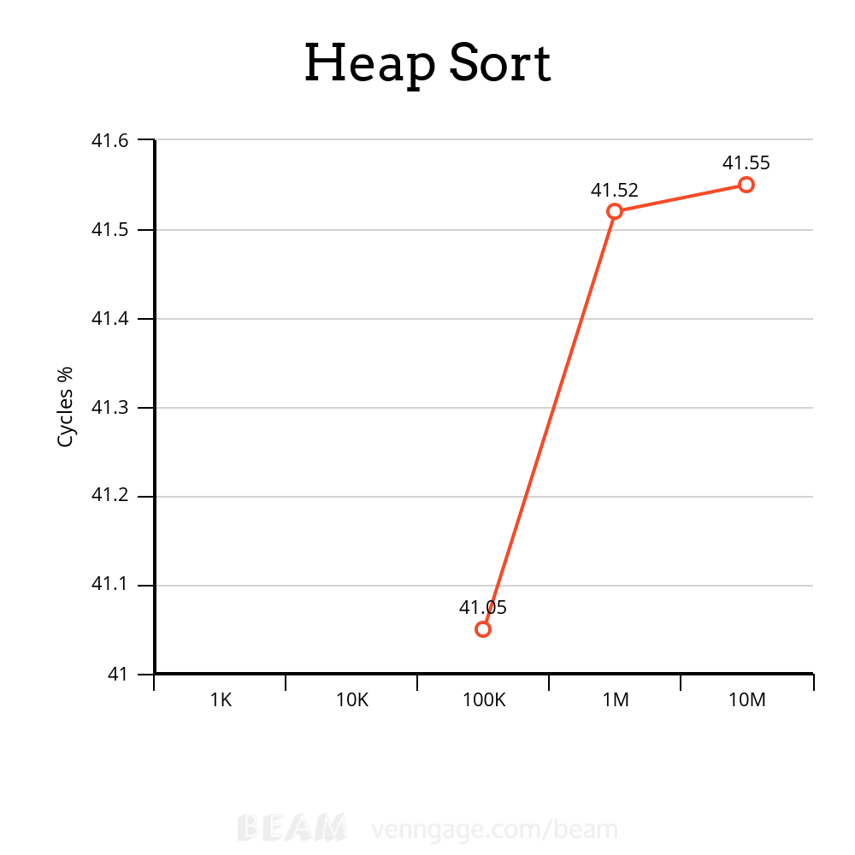

1K
1.433.637 cycles
1.191.481 instructions # 0,83 insn per cycle
418.727 L1-dcache-load
13.573 L1-dcache-load-misses # 3,24% of all L1-dcache hits
129.998 L1-dcache-stores
2.681 L1-dcache-store-misses
<not counted> LLC-loads (0,00%)
<not counted> LLC-load-misses (0,00%)
<not counted> LLC-stores (0,00%)
<not counted> LLC-store-misses (0,00%)
<not counted> branches (0,00%)
<not counted> branch-misses (0,00%)

0,001774072 seconds time elapsed

0,001836000 seconds user
0,000000000 seconds sys

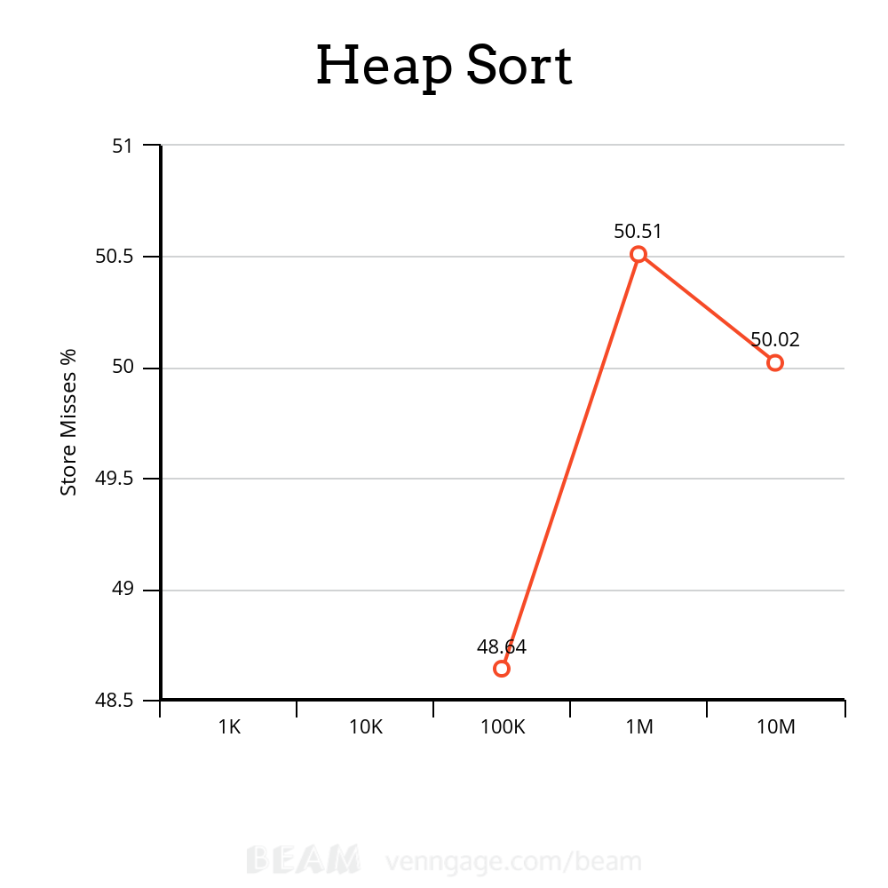
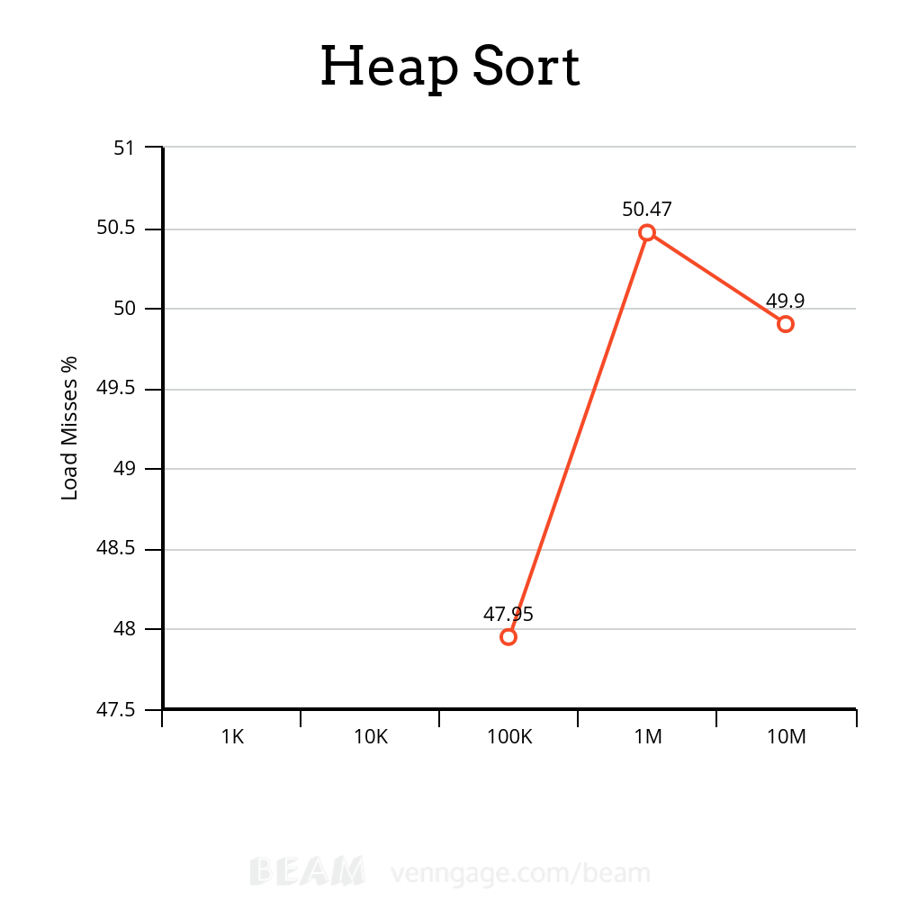

10K
9.703.917 cycles
7.076.424 instructions # 0,73 insn per cycle
3.178.930 L1-dcache-load
49.106 L1-dcache-load-misses # 1,54% of all L1-dcache hits
644.115 L1-dcache-stores
4.251 L1-dcache-store-misses
<not counted> LLC-loads (0,00%)
<not counted> LLC-load-misses (0,00%)
<not counted> LLC-stores (0,00%)
<not counted> LLC-store-misses (0,00%)
<not counted> branches (0,00%)
<not counted> branch-misses (0,00%)

0,003941744 seconds time elapsed

0,003973000 seconds user
0,000000000 seconds sys

100K
101.716.545 cycles (41,05%)
80.279.489 instructions # 0,79 insn per cycle (50,30%)
37.492.753 L1-dcache-load (48,00%)
1.032.125 L1-dcache-load-misses # 2,75% of all L1-dcache hits (47,95%)
7.460.347 L1-dcache-stores (49,02%)
36.109 L1-dcache-store-misses (48,64%)
548.907 LLC-loads (34,52%)
49.185 LLC-load-misses # 8,96% of all LL-cache hits (35,73%)
203.693 LLC-stores (17,48%)
515 LLC-store-misses (16,33%)
8.380.496 branches (24,48%)
991.970 branch-misses # 11,84% of all branches (32,87%)

0,107011825 seconds time elapsed

0,087007000 seconds user
0,000000000 seconds sys

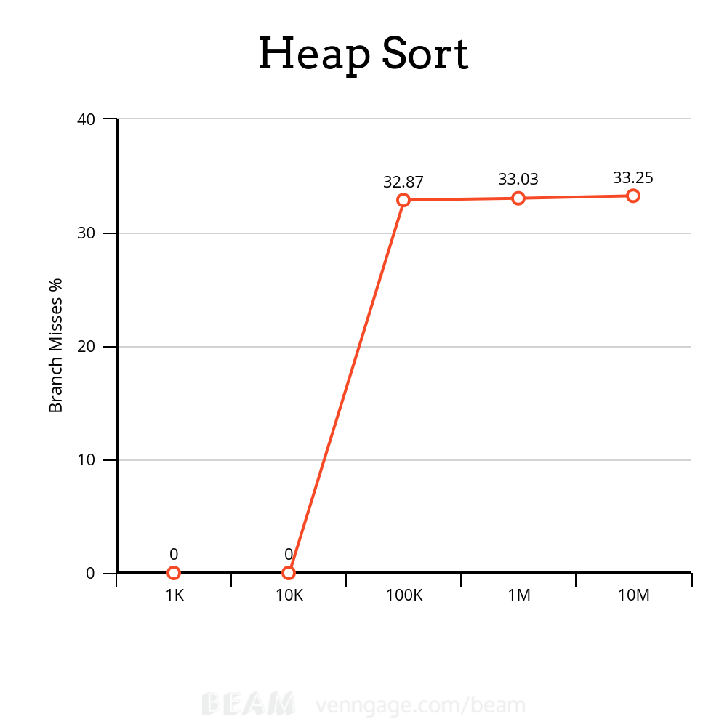

1M
19.374.491.838 cycles (41,55%)
11.011.099.331 instructions # 0,57 insn per cycle (49,88%)
5.234.230.603 L1-dcache-load (49,90%)
299.357.665 L1-dcache-load-misses # 5,72% of all L1-dcache hits (49,90%)
908.814.602 L1-dcache-stores (49,98%)
1.828.778 L1-dcache-store-misses (50,02%)
233.741.989 LLC-loads (33,40%)
136.488.965 LLC-load-misses # 58,39% of all LL-cache hits (33,43%)
93.131.299 LLC-stores (16,70%)
1.459.923 LLC-store-misses (16,67%)
1.205.659.010 branches (24,96%)
124.718.952 branch-misses # 10,34% of all branches (33,25%)

16,559784257 seconds time elapsed

16,250662000 seconds user
0,115592000 seconds sys
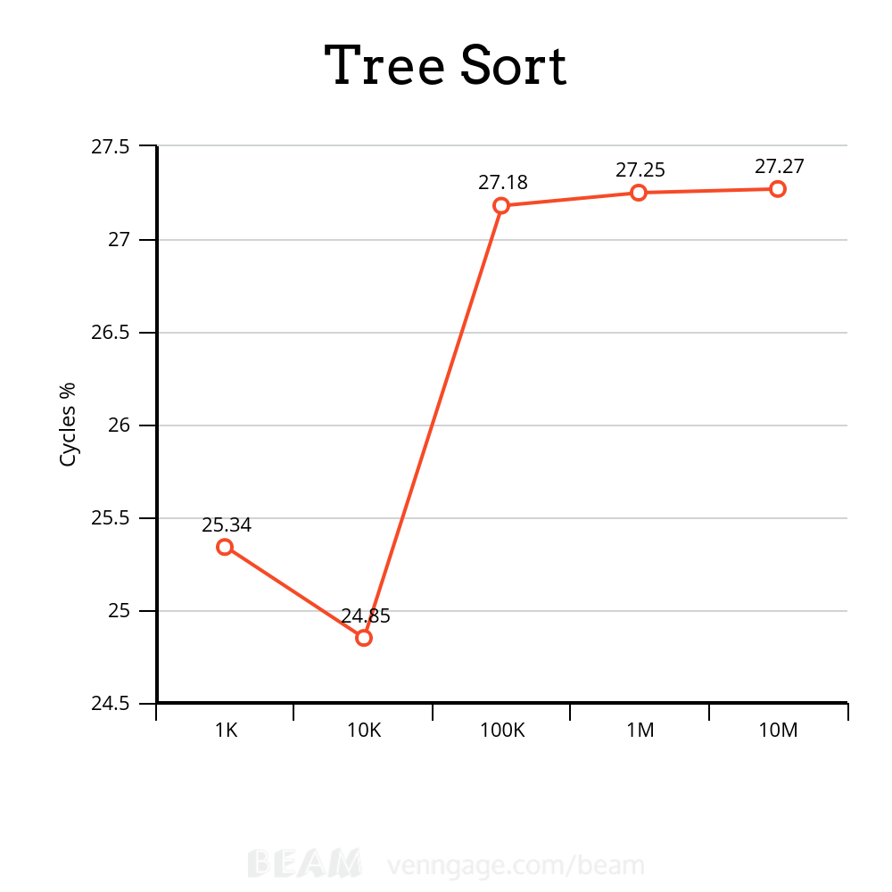
1K
48.277.570 cycles (25.34%)
62.008.872 instructions # 1.28 insn per cycle (56.65%)
81.167 cache-misses (87.98%)
3.261 LLC-load-misses # 0.00% of all LL-cache hits
<not supported> L1-dcache-store-misses
21.665.980 L1-dcache-loads
212.555 L1-dcache-load-misses # 0.98% of all L1-dcache hits (74.66%)
10.432.297 L1-dcache-stores (12.02%)
<not supported> L1-dcache-store-misses
<not supported> L1-dcache-prefetches
<not supported> L1-dcache-prefetch-misses
<not counted> LLC-loads (0.00%)
<not counted> LLC-load-misses (0.00%)
<not counted> LLC-stores (0.00%)
<not counted> LLC-store-misses (0.00%)
<not supported> LLC-prefetch-misses

0.013014660 seconds time elapsed

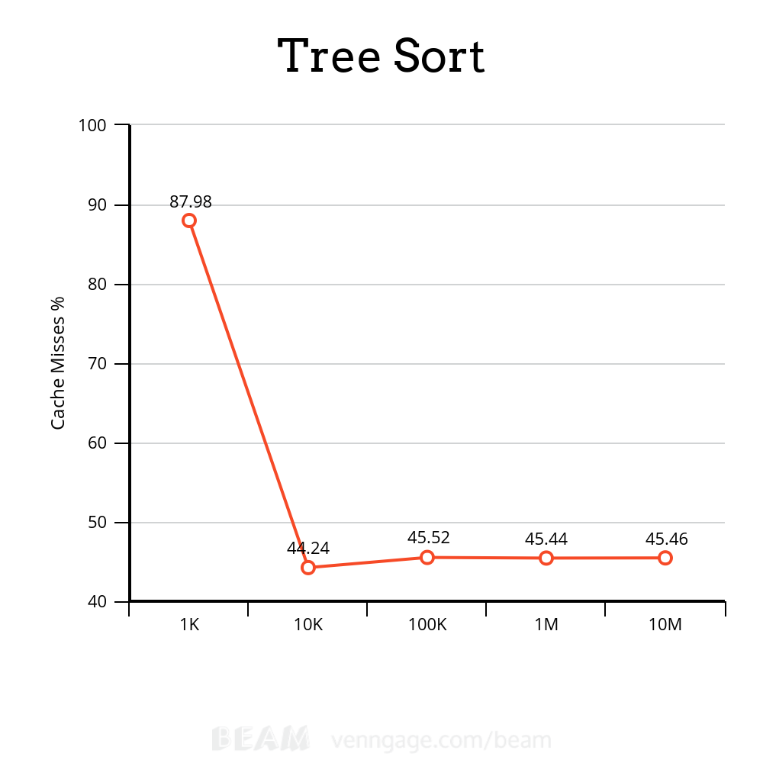
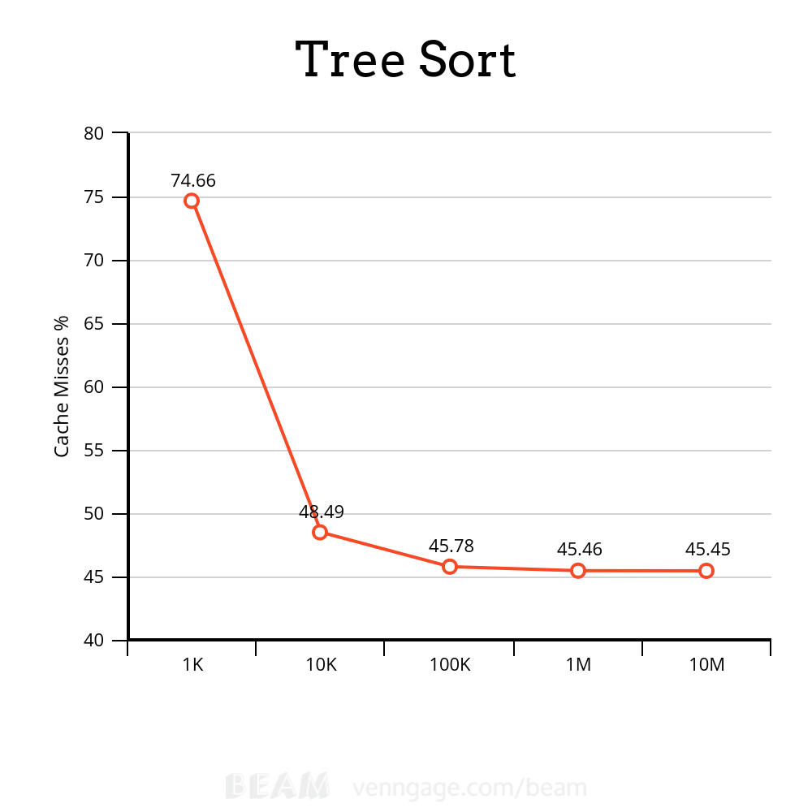
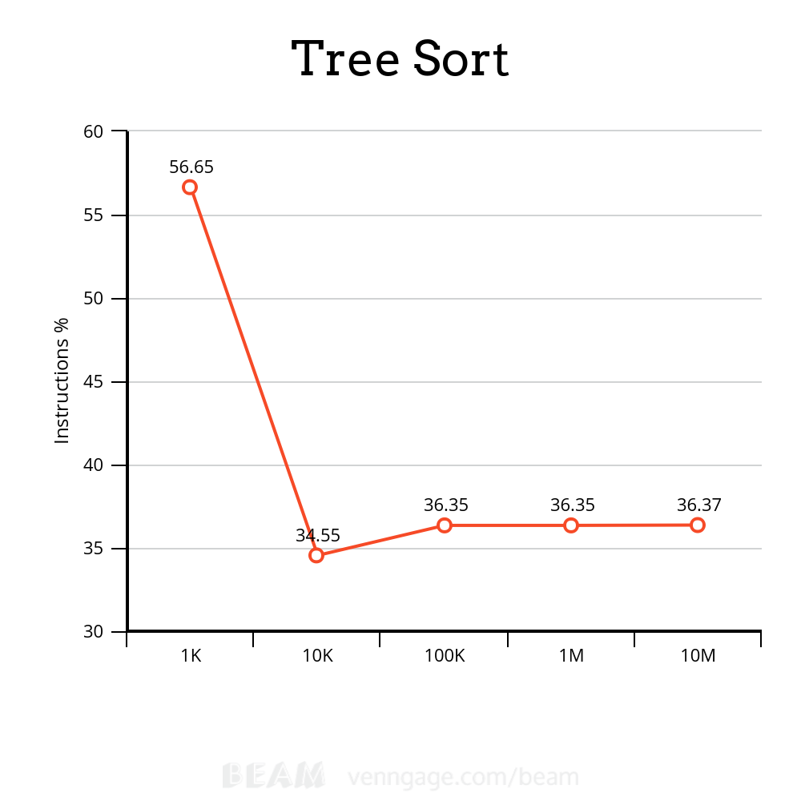

10K
746.395.961 cycles (24.85%)
729.175.897 instructions # 0.98 insn per cycle (34.55%)
845.800 cache-misses (44.24%)
27.168 LLC-load-misses # 2.62% of all LL-cache hits (46.18%)
<not supported> L1-dcache-store-misses
263.004.531 L1-dcache-loads (48.12%)
11.083.199 L1-dcache-load-misses # 4.21% of all L1-dcache hits (48.49%)
119.341.656 L1-dcache-stores (38.79%)
<not supported> L1-dcache-store-misses
<not supported> L1-dcache-prefetches
<not supported> L1-dcache-prefetch-misses
1.037.497 LLC-loads (38.30%)
33.331 LLC-load-misses # 3.21% of all LL-cache hits (36.36%)
585.781 LLC-stores (15.52%)
555.231 LLC-store-misses (15.52%)
<not supported> LLC-prefetch-misses

0.206454389 seconds time elapsed

100K
9.485.315.985 cycles (27.18%)
7.209.371.683 instructions # 0.76 insn per cycle (36.35%)
5.084.958 cache-misses (45.52%)
102.537 LLC-load-misses # 0.27% of all LL-cache hits (45.68%)
<not supported> L1-dcache-store-misses
2.844.638.725 L1-dcache-loads (45.84%)
154.375.414 L1-dcache-load-misses # 5.43% of all L1-dcache hits (45.78%)
1.166.016.325 L1-dcache-stores (36.45%)
<not supported> L1-dcache-store-misses
<not supported> L1-dcache-prefetches
<not supported> L1-dcache-prefetch-misses
38.408.705 LLC-loads (36.29%)
64.099 LLC-load-misses # 0.17% of all LL-cache hits (36.13%)
3.640.206 LLC-stores (18.03%)
3.472.034 LLC-store-misses (18.03%)
<not supported> LLC-prefetch-misses

2.529566533 seconds time elapsed

1M
92.103.890.636 cycles (27.25%)
58.423.969.260 instructions # 0.63 insn per cycle (36.35%)
59.681.015 cache-misses (45.44%)
6.343.071 LLC-load-misses # 1.67% of all LL-cache hits (45.45%)
<not supported> L1-dcache-store-misses
26.547.109.020 L1-dcache-loads (45.47%)
1.445.783.099 L1-dcache-load-misses # 5.45% of all L1-dcache hits (45.46%)
9.589.821.505 L1-dcache-stores (36.36%)
<not supported> L1-dcache-store-misses
<not supported> L1-dcache-prefetches
<not supported> L1-dcache-prefetch-misses
380.115.148 LLC-loads (36.36%)
6.439.321 LLC-load-misses # 1.69% of all LL-cache hits (36.38%)
3.671.654 LLC-stores (18.18%)
3.081.995 LLC-store-misses (18.15%)
<not supported> LLC-prefetch-misses

25.123645016 seconds time elapsed

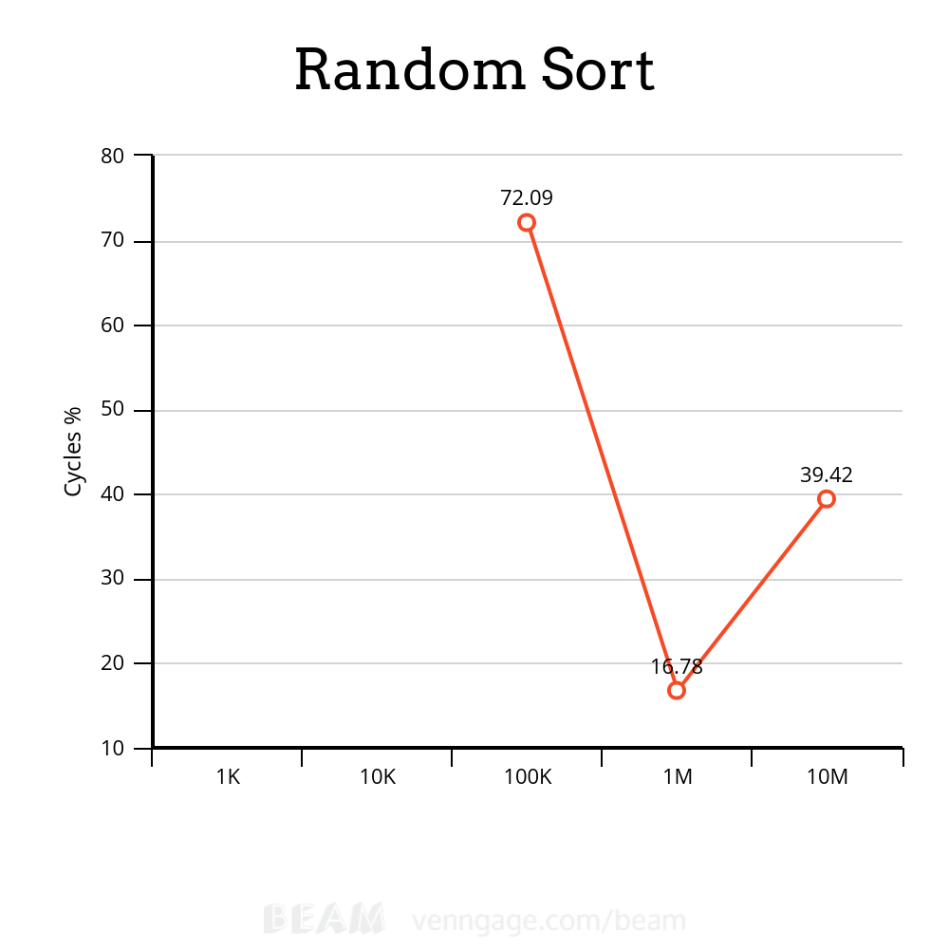
1K
1.665.041 cycles
735.912 instructions # 0,44 insn per cycle
198.527 L1-dcache-load
14.853 L1-dcache-load-misses # 7,48% of all L1-dcache hits
90.804 L1-dcache-stores
2.735 L1-dcache-store-misses
<not counted> LLC-loads (0,00%)
<not counted> LLC-load-misses (0,00%)
<not counted> LLC-stores (0,00%)
<not counted> LLC-store-misses (0,00%)
<not counted> branches (0,00%)
<not counted> branch-misses (0,00%)

0,001043782 seconds time elapsed

0,001062000 seconds user
0,000000000 seconds sys

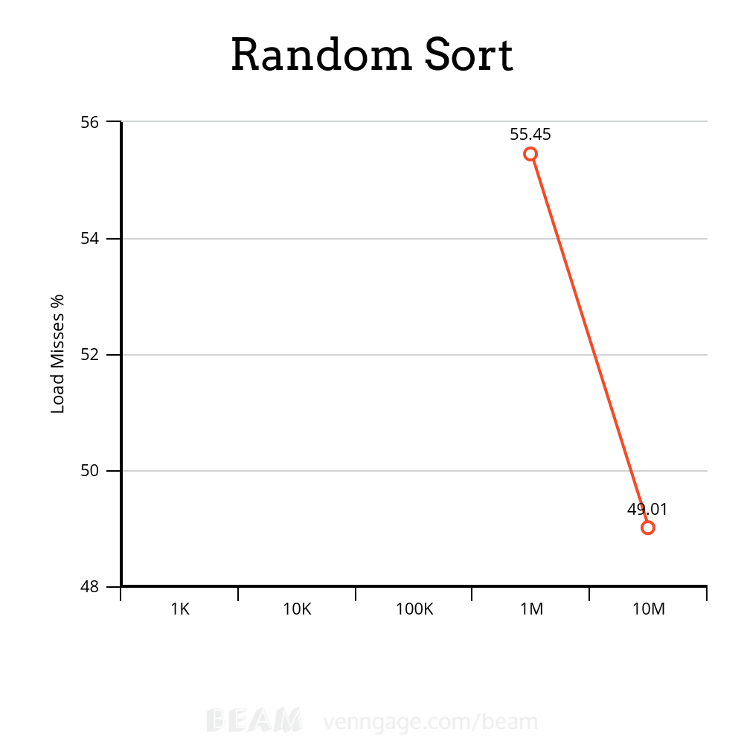

10K
1.660.465 cycles
1.029.705 instructions # 0,62 insn per cycle
272.144 L1-dcache-load
17.885 L1-dcache-load-misses # 6,57% of all L1-dcache hits
136.250 L1-dcache-stores
3.013 L1-dcache-store-misses
<not counted> LLC-loads (0,00%)
<not counted> LLC-load-misses (0,00%)
<not counted> LLC-stores (0,00%)
<not counted> LLC-store-misses (0,00%)
<not counted> branches (0,00%)
<not counted> branch-misses (0,00%)

0,002176868 seconds time elapsed

0,002148000 seconds user
0,000000000 seconds sys

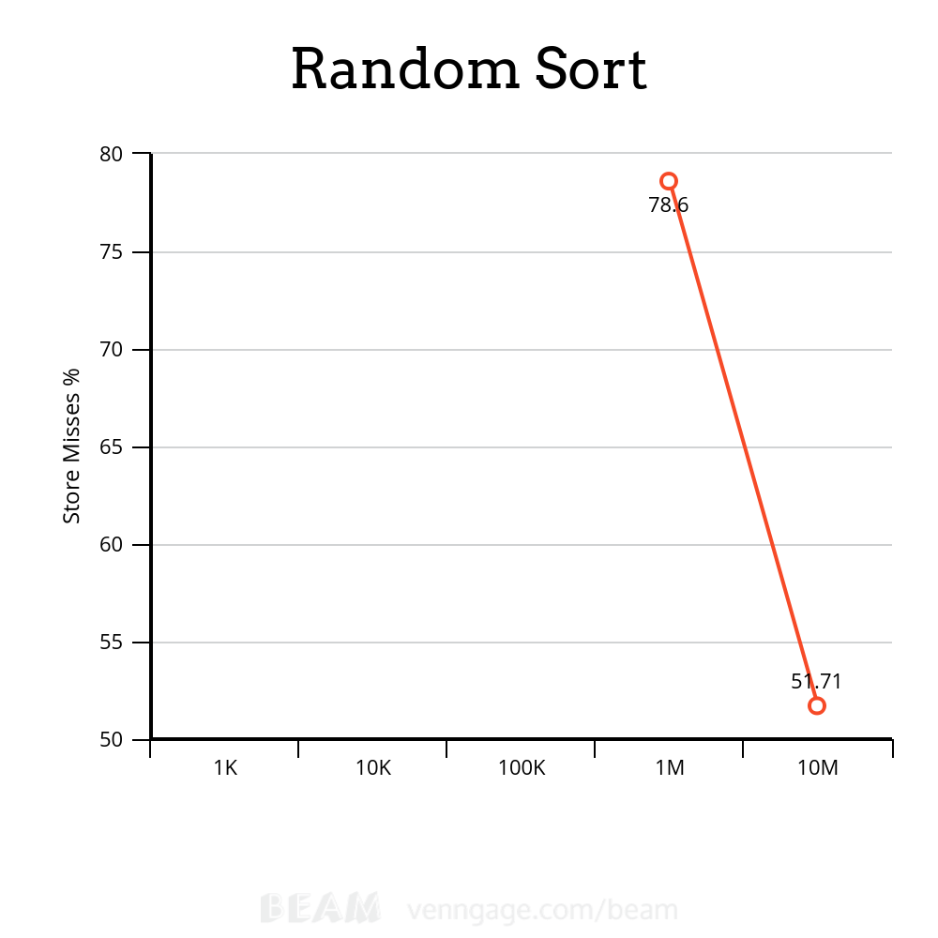

100K
4.773.302 cycles (72,09%)
3.911.435 instructions # 0,82 insn per cycle
992.545 L1-dcache-load
19.959 L1-dcache-load-misses # 2,01% of all L1-dcache hits
586.773 L1-dcache-stores
3.217 L1-dcache-store-misses
<not counted> LLC-loads (0,00%)
<not counted> LLC-load-misses (0,00%)
<not counted> LLC-stores (0,00%)
<not counted> LLC-store-misses (0,00%)
<not counted> branches (0,00%)
<not counted> branch-misses (0,00%)

0,004724268 seconds time elapsed

0,004810000 seconds user
0,000000000 seconds sys

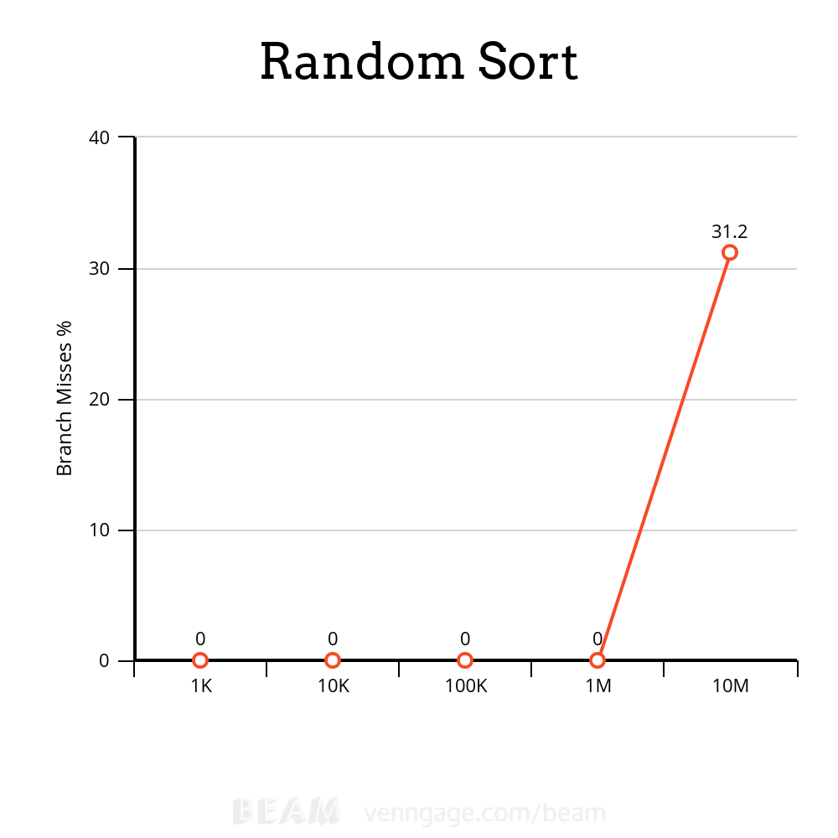

1M
34.822.042 cycles (16,78%)
32.018.025 instructions # 0,92 insn per cycle (30,28%)
8.189.031 L1-dcache-load (43,84%)
24.079 L1-dcache-load-misses # 0,29% of all L1-dcache hits (55,45%)
5.106.324 L1-dcache-stores (65,09%)
3.466 L1-dcache-store-misses (78,60%)
4.504 LLC-loads (48,32%)
4.657 LLC-load-misses # 103,40% of all LL-cache hits (44,55%)
15.342 LLC-stores (7,84%)
<not counted> LLC-store-misses (0,00%)
<not counted> branches (0,00%)
<not counted> branch-misses (0,00%)

0,034164597 seconds time elapsed

0,030219000 seconds user
0,000000000 seconds sys

Testes de Associatividade

BubbleSort

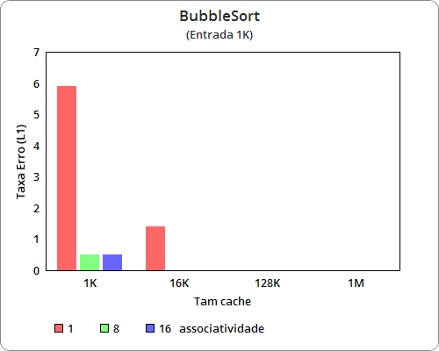
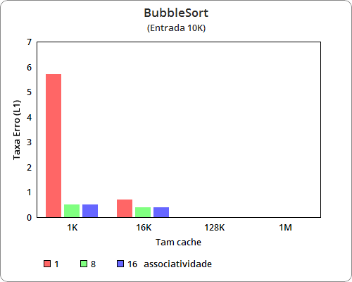
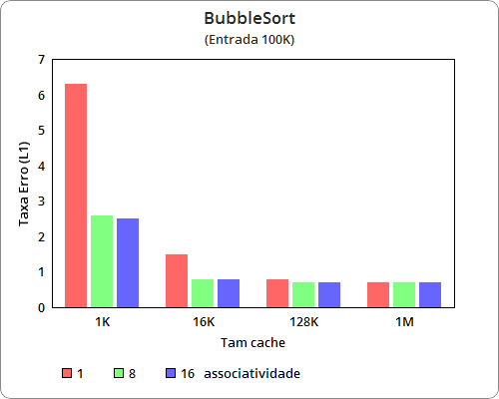
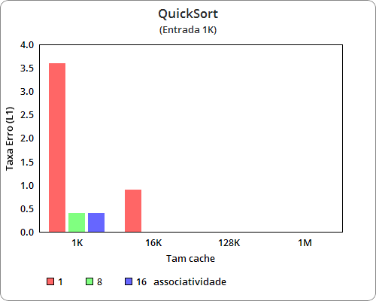
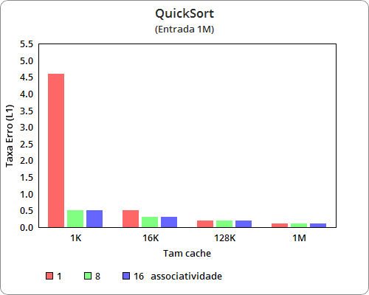
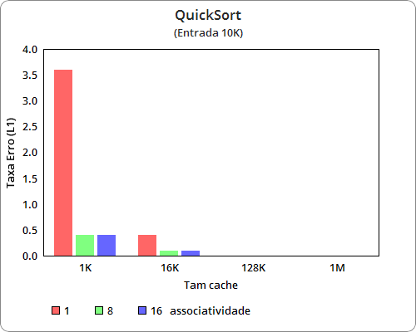
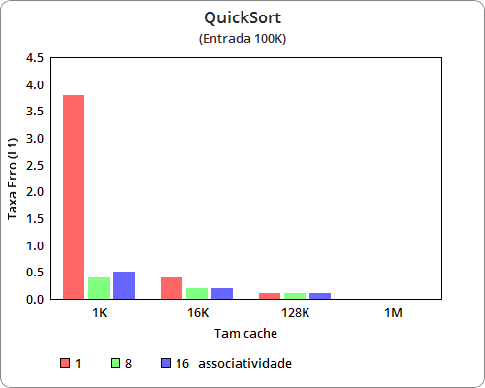
QuickSort

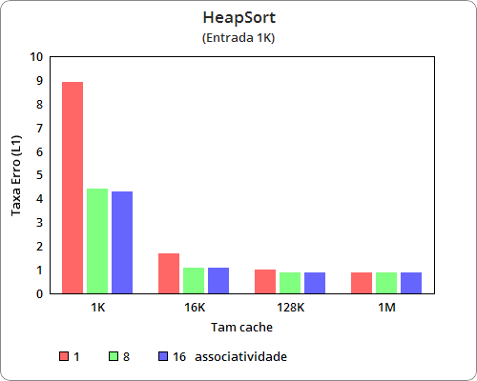
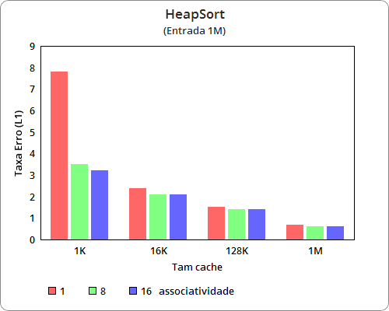
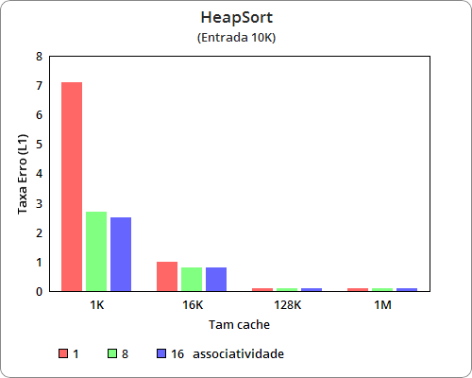
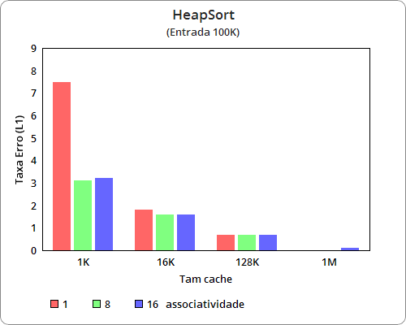
HeapSort

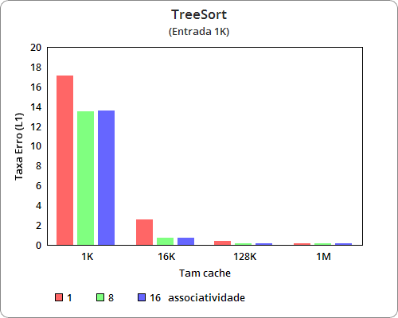
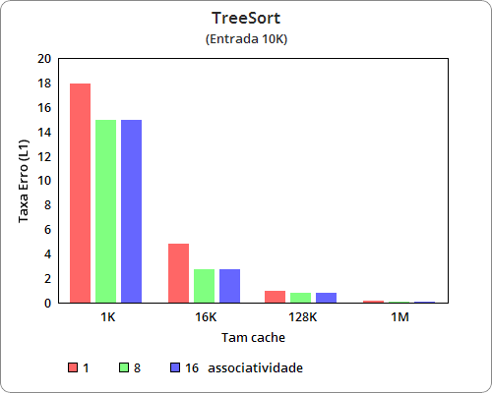
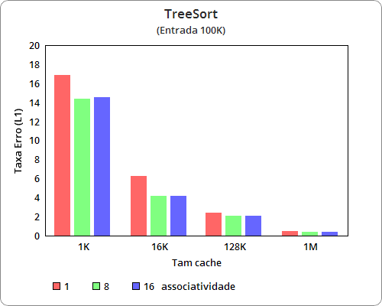
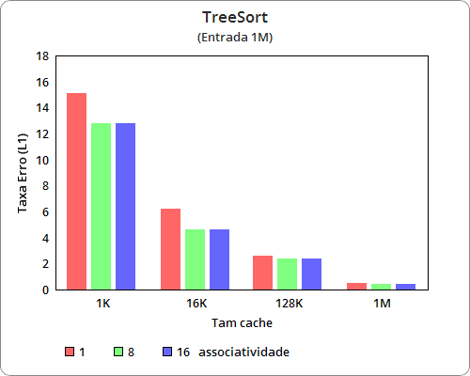
TreeSort
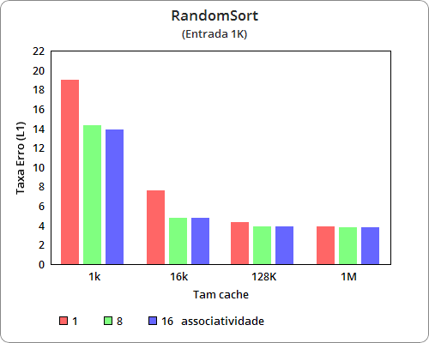
RandomSort
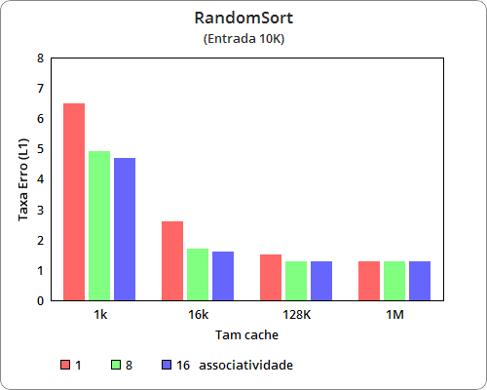
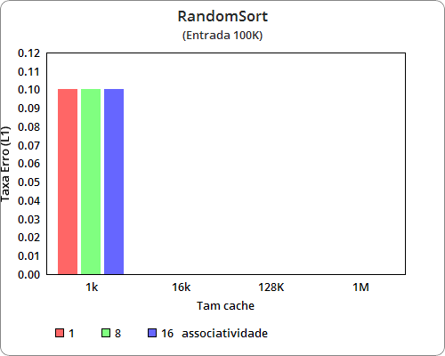

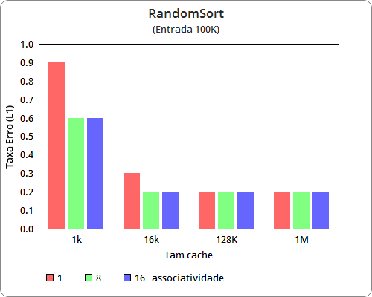
RadixSort1
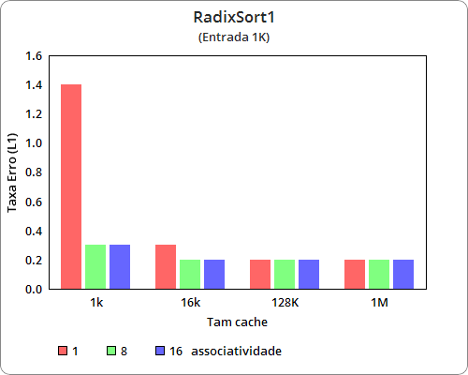
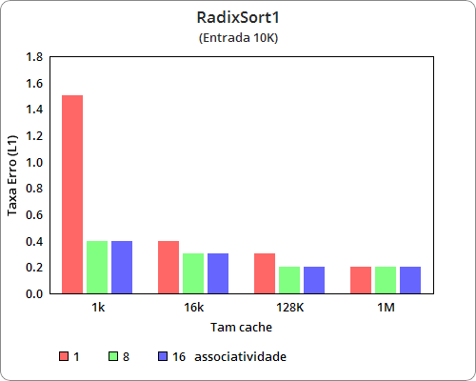
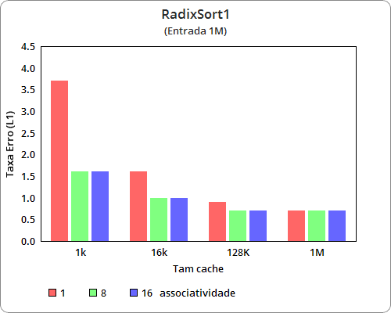

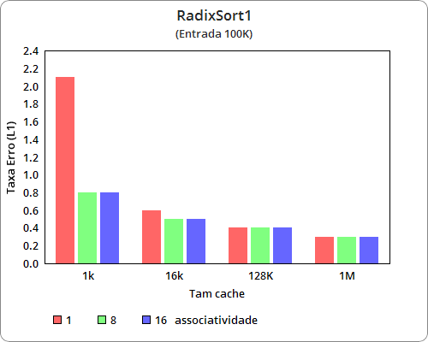
RadixSort3
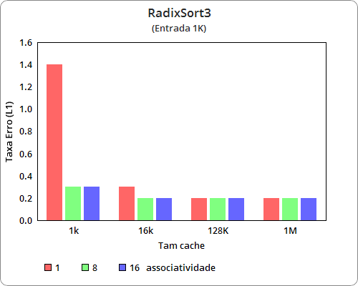
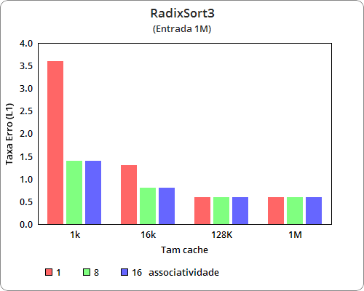
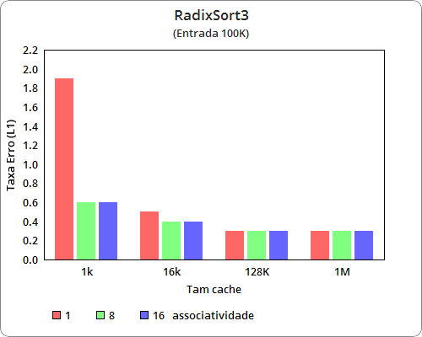
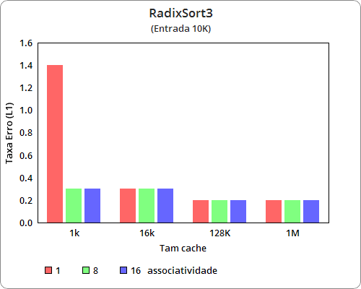
RadixSort6
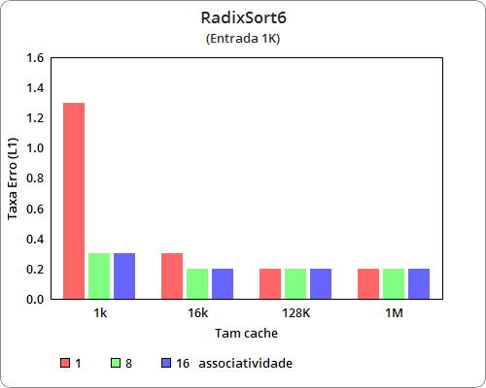
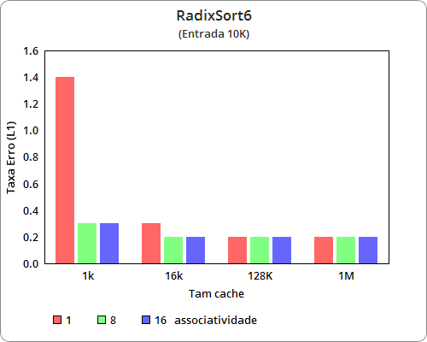
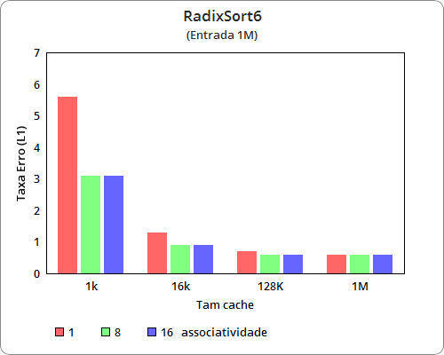

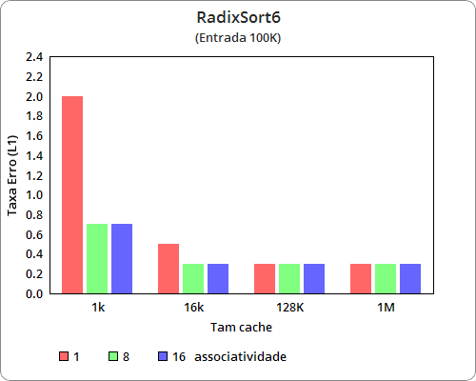

Lista Encadeada
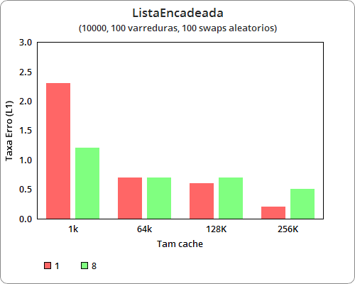

Códigos Antigos

PharmaHard

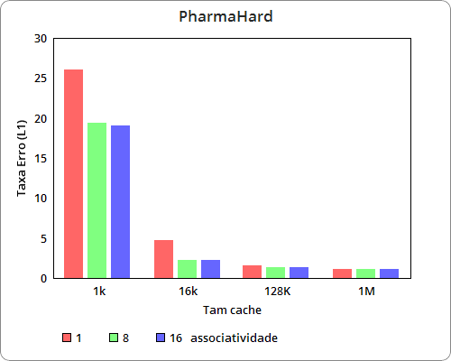
75.775.857 cycles (72,22%)
55.600.092 instructions # 0,73 insn per cycle
1.464.683 cache-misses
89.814 LLC-load-misses # 0,00% of all LL-cache hits
<not supported> L1-dcache-store-misses
15.068.322 L1-dcache-loads
1.101.879 L1-dcache-load-misses # 7,31% of all L1-dcache hits (27,78%)
<not counted> L1-dcache-stores (0,00%)
<not supported> L1-dcache-store-misses
<not supported> L1-dcache-prefetches
<not supported> L1-dcache-prefetch-misses
<not counted> LLC-loads (0,00%)
<not counted> LLC-load-misses (0,00%)
<not counted> LLC-stores (0,00%)
<not counted> LLC-store-misses (0,00%)
<not supported> LLC-prefetch-misses
91,018531353 seconds time elapsed

Inversões com árvore binária

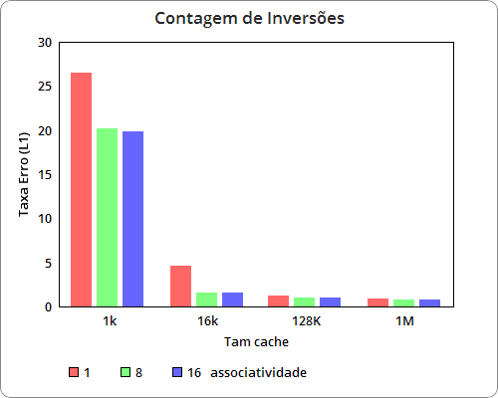
2.726.116 cycles (21,57%)
4.190.225 instructions # 1,54 insn per cycle
40.904 cache-misses
2.714 LLC-load-misses # 0,00% of all LL-cache hits
<not supported> L1-dcache-store-misses
1.054.184 L1-dcache-loads
40.266 L1-dcache-load-misses # 3,82% of all L1-dcache hits (78,43%)
<not counted> L1-dcache-stores (0,00%)
<not supported> L1-dcache-store-misses
<not supported> L1-dcache-prefetches
<not supported> L1-dcache-prefetch-misses
<not counted> LLC-loads (0,00%)
<not counted> LLC-load-misses (0,00%)
<not counted> LLC-stores (0,00%)
<not counted> LLC-store-misses (0,00%)
<not supported> LLC-prefetch-misses
0,003743991 seconds time elapsed

Tetris
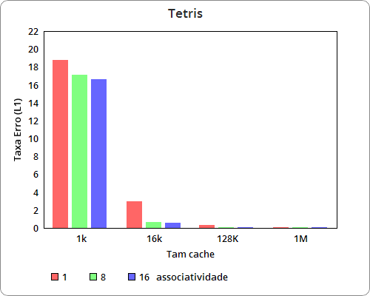
186.146.524 cycles (25,46%)
344.457.523 instructions # 1,85 insn per cycle (40,83%)
4.700.282 cache-misses (53,50%)
391.524 LLC-load-misses # 59,14% of all LL-cache hits (46,97%)
<not supported> L1-dcache-store-misses
80.597.080 L1-dcache-loads (41,74%)
2.227.507 L1-dcache-load-misses # 2,76% of all L1-dcache hits (46,42%)
54.414.234 L1-dcache-stores (32,36%)
<not supported> L1-dcache-store-misses
<not supported> L1-dcache-prefetches
<not supported> L1-dcache-prefetch-misses
662.015 LLC-loads (33,74%)
425.488 LLC-load-misses # 64,27% of all LL-cache hits (36,60%)
139.880 LLC-stores (19,29%)
98.833 LLC-store-misses (21,66%)
<not supported> LLC-prefetch-misses
186,307869044 seconds time elapsed

