**Universidad Complutense de Madrid**

Trabajo final: Análisis de una serie.

Alumno: Caio Fernandes Moreno

Correo: [caiofern@ucm.es](mailto:caiofern@ucm.es)

Índice:

**1. Introducción: Presentación de la serie a analizar.**

La serie escogida ha sido “Ocupación hotelera de viajeros total (residentes en España y en el extranjero) en la Comunidad Autónoma de Zaragoza”, que se encuentra en la página de INE (Instituto Nacional de Estadísticas).

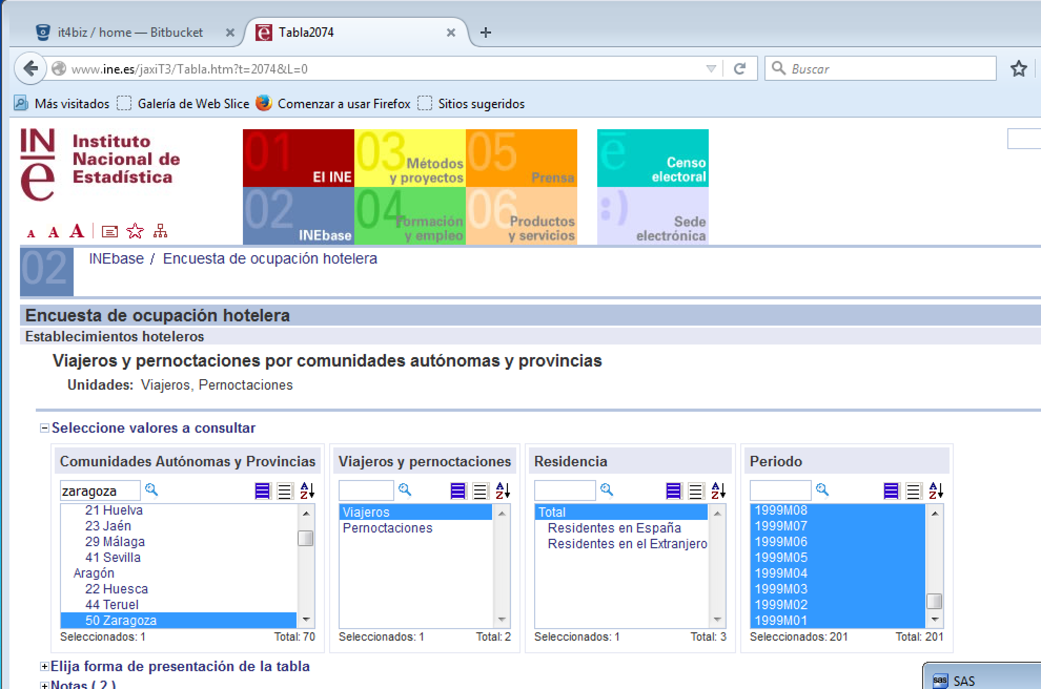

El enlace para la serie es:

<http://www.ine.es/jaxiT3/Tabla.htm?t=2074&L=0>

Más información:

La **Encuesta de Ocupación Hotelera** ha sustituido desde enero de 1999 a la antigua Encuesta de Movimiento de Viajeros en Establecimientos Hoteleros (MVEH), ampliando la investigación a la categoría de una estrella y similares puesto que además de suponer más del 50 por ciento del total de establecimientos, representan más del 5 por ciento de entrada de viajeros.

Las unidades de análisis son todos los establecimientos hoteleros inscritos como tales en el correspondiente registro de las Consejerías de Turismo de cada Comunidad Autónoma.

Son establecimientos hoteleros aquellos establecimientos que prestan servicios de alojamiento colectivo mediante precio con o sin otros servicios complementarios (hotel, hotel-apartamento o apartahotel, motel, hostal, pensión,...).

<http://www.ine.es/dynt3/metadatos/es/RespuestaDatos.htm?oe=30235>

**2. Representación gráfica y descomposición estacional (si tuviera comportamiento estacional).**

Código SAS:

**DATA** SERIES.ZARAGOZA;

SET SERIES.ZARAGOZA;

DROP FECHA;

**RUN**;

**DATA** SERIES.ZARAGOZA;

SET SERIES.ZARAGOZA;

FECHA = intnx( 'month', **'01jan1999'd**, _n_-**1** );

format FECHA DATE.;

**RUN**;

ods html;

ods graphics on;

**proc** **sgplot** data=SERIES.ZARAGOZA;

series x=FECHA y=VIAJEROS;

**run**;

ods graphics off;

ods html close;

Representación grafica de la serie temporal

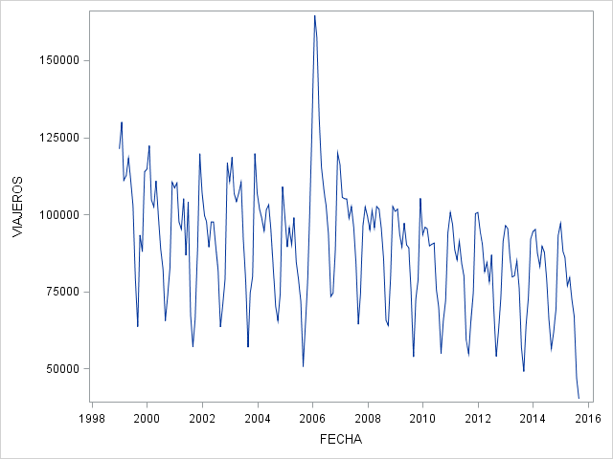

He hecho la descomposición estacional, si la serie tiene comportamiento estacional.

Código SAS:

ods html;

ods graphics on;

**proc** **timeseries** data=SERIES.ZARAGOZA PLOTS=(DECOMP PERIODOGRAM SERIES) PRINT=(SEASONS DECOMP);

id FECHA interval=month ;

var VIAJEROS;

**run**;

ods graphics off;

ods html close;

|  |
| --- |
| The SAS System |

The TIMESERIES Procedure

| **Input Data Set** | |
| --- | --- |
| **Name** | SERIES.ZARAGOZA |
| **Label** |  |
| **Time ID Variable** | FECHA |
| **Time Interval** | MONTH |
| **Length of Seasonal Cycle** | 12 |

| **Variable Information** | |
| --- | --- |
| **Name** | VIAJEROS |
| **Label** | VIAJEROS |
| **First** | JAN1999 |
| **Last** | SEP2015 |
| **Number of Observations Read** | 201 |

| **Season Statistics for Variable VIAJEROS** | | | | | | |
| --- | --- | --- | --- | --- | --- | --- |
| **Season Index** | **N** | **Minimum** | **Maximum** | **Sum** | **Mean** | **Standard Deviation** |
| **1** | 17 | 93382.00 | 133884.0 | 1801023 | 105942.5 | 10776.297 |
| **2** | 17 | 88102.00 | 164520.0 | 1803945 | 106114.4 | 19008.382 |
| **3** | 17 | 85991.00 | 157244.0 | 1702880 | 100169.4 | 16507.966 |
| **4** | 17 | 76871.00 | 131166.0 | 1606304 | 94488.5 | 13564.183 |
| **5** | 17 | 79494.00 | 118176.0 | 1667861 | 98109.5 | 11336.902 |
| **6** | 17 | 72240.00 | 110949.0 | 1593014 | 93706.7 | 11498.429 |
| **7** | 17 | 66929.00 | 104001.0 | 1498864 | 88168.5 | 10735.292 |
| **8** | 17 | 47028.00 | 93669.0 | 1247218 | 73365.8 | 11886.485 |
| **9** | 17 | 40202.00 | 73385.0 | 994346 | 58490.9 | 8330.193 |
| **10** | 16 | 61729.00 | 93288.0 | 1112901 | 69556.3 | 7851.813 |
| **11** | 16 | 69347.00 | 96190.0 | 1277216 | 79826.0 | 7428.619 |
| **12** | 16 | 91226.00 | 119847.0 | 1694736 | 105921.0 | 10146.253 |

| **Seasonal Decomposition for Variable VIAJEROS** | | | | | | |
| --- | --- | --- | --- | --- | --- | --- |
| **Obs** | **Time** | **Season** | **Trend-Cycle** | **Seasonal** | **Irregular** | **Seasonally Adjusted** |
| **1** | **JAN1999** | 1 | . | 1.177971 | . | 102896.4 |
| **2** | **FEB1999** | 2 | . | 1.170905 | . | 110958.6 |
| **3** | **MAR1999** | 3 | . | 1.115695 | . | 99558.6 |
| **4** | **APR1999** | 4 | . | 1.049414 | . | 107221.8 |
| **5** | **MAY1999** | 5 | . | 1.094136 | . | 108008.5 |
| **6** | **JUN1999** | 6 | . | 1.050876 | . | 105577.7 |
| **7** | **JUL1999** | 7 | 103378.3 | 0.992249 | 1.001365 | 103519.4 |
| **8** | **AUG1999** | 8 | 102784.3 | 0.830886 | 0.920634 | 94626.7 |
| **9** | **SEP1999** | 9 | 102197.1 | 0.663434 | 0.937935 | 95854.3 |
| **10** | **OCT1999** | 10 | 101511.2 | 0.775560 | 1.184941 | 120284.7 |
| **11** | **NOV1999** | 11 | 100786.8 | 0.892449 | 0.977419 | 98510.9 |
| **12** | **DEC1999** | 12 | 99999.0 | 1.186424 | 0.959497 | 95948.8 |
| **13** | **JAN2000** | 1 | 98937.3 | 1.177971 | 0.983600 | 97314.8 |
| **14** | **FEB2000** | 2 | 98499.8 | 1.170905 | 1.059888 | 104398.7 |
| **15** | **MAR2000** | 3 | 98721.8 | 1.115695 | 0.950271 | 93812.4 |
| **16** | **APR2000** | 4 | 97974.4 | 1.049414 | 0.996628 | 97644.0 |
| **17** | **MAY2000** | 5 | 96941.6 | 1.094136 | 1.045016 | 101305.5 |
| **18** | **JUN2000** | 6 | 96591.9 | 1.050876 | 0.979015 | 94565.0 |
| **19** | **JUL2000** | 7 | 96196.7 | 0.992249 | 0.930414 | 89502.7 |
| **20** | **AUG2000** | 8 | 95442.1 | 0.830886 | 1.034419 | 98727.1 |
| **21** | **SEP2000** | 9 | 94642.3 | 0.663434 | 1.043385 | 98748.3 |
| **22** | **OCT2000** | 10 | 94043.5 | 0.775560 | 1.006796 | 94682.6 |
| **23** | **NOV2000** | 11 | 93501.8 | 0.892449 | 0.994468 | 92984.6 |
| **24** | **DEC2000** | 12 | 92736.3 | 1.186424 | 1.003194 | 93032.5 |
| **25** | **JAN2001** | 1 | 92843.0 | 1.177971 | 0.993075 | 92200.0 |
| **26** | **FEB2001** | 2 | 92862.5 | 1.170905 | 1.013076 | 94076.8 |
| **27** | **MAR2001** | 3 | 91898.2 | 1.115695 | 0.951484 | 87439.7 |
| **28** | **APR2001** | 4 | 91240.9 | 1.049414 | 0.994355 | 90725.9 |
| **29** | **MAY2001** | 5 | 91161.3 | 1.094136 | 1.053720 | 96058.4 |
| **30** | **JUN2001** | 6 | 91774.4 | 1.050876 | 0.899439 | 82545.5 |
| **31** | **JUL2001** | 7 | 92091.2 | 0.992249 | 1.138148 | 104813.4 |
| **32** | **AUG2001** | 8 | 91584.0 | 0.830886 | 0.884516 | 81007.5 |
| **33** | **SEP2001** | 9 | 91144.5 | 0.663434 | 0.944147 | 86053.8 |
| **34** | **OCT2001** | 10 | 90900.1 | 0.775560 | 0.937326 | 85203.0 |
| **35** | **NOV2001** | 11 | 90342.4 | 0.892449 | 1.096718 | 99080.1 |
| **36** | **DEC2001** | 12 | 90476.1 | 1.186424 | 1.114660 | 100850.1 |
| **37** | **JAN2002** | 1 | 90324.0 | 1.177971 | 1.005065 | 90781.5 |
| **38** | **FEB2002** | 2 | 90325.4 | 1.170905 | 0.942234 | 85107.7 |
| **39** | **MAR2002** | 3 | 91195.7 | 1.115695 | 0.958352 | 87397.6 |
| **40** | **APR2002** | 4 | 91646.5 | 1.049414 | 0.929461 | 85181.8 |
| **41** | **MAY2002** | 5 | 91447.1 | 1.094136 | 0.974808 | 89143.4 |
| **42** | **JUN2002** | 6 | 90939.9 | 1.050876 | 1.020430 | 92797.9 |
| **43** | **JUL2002** | 7 | 90974.2 | 0.992249 | 0.992333 | 90276.7 |
| **44** | **AUG2002** | 8 | 91919.4 | 0.830886 | 1.070593 | 98408.2 |
| **45** | **SEP2002** | 9 | 93090.9 | 0.663434 | 1.028486 | 95742.7 |
| **46** | **OCT2002** | 10 | 94092.8 | 0.775560 | 0.965693 | 90864.7 |
| **47** | **NOV2002** | 11 | 95098.0 | 0.892449 | 0.933756 | 88798.3 |
| **48** | **DEC2002** | 12 | 96023.2 | 1.186424 | 1.023970 | 98324.8 |
| **49** | **JAN2003** | 1 | 96660.0 | 1.177971 | 0.972724 | 94023.5 |
| **50** | **FEB2003** | 2 | 96625.5 | 1.170905 | 1.047540 | 101219.1 |
| **51** | **MAR2003** | 3 | 96216.1 | 1.115695 | 0.994534 | 95690.1 |
| **52** | **APR2003** | 4 | 96115.4 | 1.049414 | 1.032897 | 99277.3 |
| **53** | **MAY2003** | 5 | 96321.3 | 1.094136 | 1.014047 | 97674.3 |
| **54** | **JUN2003** | 6 | 96479.7 | 1.050876 | 1.088776 | 105044.8 |
| **55** | **JUL2003** | 7 | 96441.5 | 0.992249 | 0.961294 | 92708.6 |
| **56** | **AUG2003** | 8 | 95573.5 | 0.830886 | 0.988872 | 94510.0 |
| **57** | **SEP2003** | 9 | 94538.1 | 0.663434 | 0.907704 | 85812.6 |
| **58** | **OCT2003** | 10 | 93810.8 | 0.775560 | 1.025924 | 96242.8 |
| **59** | **NOV2003** | 11 | 93192.6 | 0.892449 | 0.962106 | 89661.1 |
| **60** | **DEC2003** | 12 | 92667.5 | 1.186424 | 1.088637 | 100881.3 |
| **61** | **JAN2004** | 1 | 92477.3 | 1.177971 | 0.980451 | 90669.4 |
| **62** | **FEB2004** | 2 | 92739.2 | 1.170905 | 0.935990 | 86802.9 |
| **63** | **MAR2004** | 3 | 93445.0 | 1.115695 | 0.947589 | 88547.5 |
| **64** | **APR2004** | 4 | 93623.0 | 1.049414 | 0.963834 | 90237.0 |
| **65** | **MAY2004** | 5 | 93014.9 | 1.094136 | 0.997524 | 92784.6 |
| **66** | **JUN2004** | 6 | 92337.7 | 1.050876 | 1.062869 | 98142.9 |
| **67** | **JUL2004** | 7 | 91578.7 | 0.992249 | 1.041919 | 95417.6 |
| **68** | **AUG2004** | 8 | 90758.6 | 0.830886 | 1.089046 | 98840.3 |
| **69** | **SEP2004** | 9 | 90118.4 | 0.663434 | 1.175394 | 105924.6 |
| **70** | **OCT2004** | 10 | 89798.3 | 0.775560 | 0.941517 | 84546.7 |
| **71** | **NOV2004** | 11 | 89503.2 | 0.892449 | 0.932608 | 83471.4 |
| **72** | **DEC2004** | 12 | 88623.9 | 1.186424 | 1.036268 | 91838.1 |
| **73** | **JAN2005** | 1 | 87197.9 | 1.177971 | 0.966912 | 84312.7 |
| **74** | **FEB2005** | 2 | 86106.5 | 1.170905 | 0.887143 | 76388.8 |
| **75** | **MAR2005** | 3 | 84852.1 | 1.115695 | 1.010056 | 85705.3 |
| **76** | **APR2005** | 4 | 83987.3 | 1.049414 | 1.023243 | 85939.4 |
| **77** | **MAY2005** | 5 | 84160.2 | 1.094136 | 1.074523 | 90432.0 |
| **78** | **JUN2005** | 6 | 84203.0 | 1.050876 | 0.956154 | 80511.0 |
| **79** | **JUL2005** | 7 | 85465.0 | 0.992249 | 0.931387 | 79601.0 |
| **80** | **AUG2005** | 8 | 90033.4 | 0.830886 | 0.957444 | 86202.0 |
| **81** | **SEP2005** | 9 | 95729.2 | 0.663434 | 0.797827 | 76375.3 |
| **82** | **OCT2005** | 10 | 100004.3 | 0.775560 | 0.830577 | 83061.3 |
| **83** | **NOV2005** | 11 | 102390.6 | 0.892449 | 0.873259 | 89413.5 |
| **84** | **DEC2005** | 12 | 104046.1 | 1.186424 | 0.848020 | 88233.2 |
| **85** | **JAN2006** | 1 | 106012.6 | 1.177971 | 1.072103 | 113656.4 |
| **86** | **FEB2006** | 2 | 107921.0 | 1.170905 | 1.301940 | 140506.7 |
| **87** | **MAR2006** | 3 | 109786.0 | 1.115695 | 1.283753 | 140938.2 |
| **88** | **APR2006** | 4 | 111150.9 | 1.049414 | 1.124505 | 124989.8 |
| **89** | **MAY2006** | 5 | 111946.9 | 1.094136 | 0.940816 | 105321.4 |
| **90** | **JUN2006** | 6 | 112956.4 | 1.050876 | 0.910229 | 102816.2 |
| **91** | **JUL2006** | 7 | 112852.1 | 0.992249 | 0.917515 | 103543.6 |
| **92** | **AUG2006** | 8 | 109657.8 | 0.830886 | 1.028051 | 112733.9 |
| **93** | **SEP2006** | 9 | 105026.2 | 0.663434 | 1.053202 | 110613.8 |
| **94** | **OCT2006** | 10 | 101763.6 | 0.775560 | 0.943455 | 96009.4 |
| **95** | **NOV2006** | 11 | 99988.8 | 0.892449 | 0.995788 | 99567.6 |
| **96** | **DEC2006** | 12 | 99071.3 | 1.186424 | 1.019622 | 101015.3 |
| **97** | **JAN2007** | 1 | 98557.7 | 1.177971 | 1.001024 | 98658.6 |
| **98** | **FEB2007** | 2 | 97890.6 | 1.170905 | 0.920637 | 90121.7 |
| **99** | **MAR2007** | 3 | 97129.8 | 1.115695 | 0.969675 | 94184.4 |
| **100** | **APR2007** | 4 | 96766.3 | 1.049414 | 1.034251 | 100080.6 |
| **101** | **MAY2007** | 5 | 97083.7 | 1.094136 | 0.929932 | 90281.2 |
| **102** | **JUN2007** | 6 | 96661.1 | 1.050876 | 1.008911 | 97522.5 |
| **103** | **JUL2007** | 7 | 95225.5 | 0.992249 | 1.015775 | 96727.7 |
| **104** | **AUG2007** | 8 | 94079.1 | 0.830886 | 1.079993 | 101604.8 |
| **105** | **SEP2007** | 9 | 93479.6 | 0.663434 | 1.037964 | 97028.5 |
| **106** | **OCT2007** | 10 | 92931.1 | 0.775560 | 1.037120 | 96380.7 |
| **107** | **NOV2007** | 11 | 92700.6 | 0.892449 | 1.162689 | 107782.0 |
| **108** | **DEC2007** | 12 | 92825.9 | 1.186424 | 0.929566 | 86287.8 |
| **109** | **JAN2008** | 1 | 92783.4 | 1.177971 | 0.907955 | 84243.1 |
| **110** | **FEB2008** | 2 | 92816.0 | 1.170905 | 0.874044 | 81125.3 |
| **111** | **MAR2008** | 3 | 92916.4 | 1.115695 | 0.976469 | 90730.0 |
| **112** | **APR2008** | 4 | 92525.9 | 1.049414 | 0.985767 | 91209.0 |
| **113** | **MAY2008** | 5 | 91372.5 | 1.094136 | 1.025857 | 93735.1 |
| **114** | **JUN2008** | 6 | 90673.4 | 1.050876 | 1.067434 | 96787.9 |
| **115** | **JUL2008** | 7 | 90751.8 | 0.992249 | 1.063095 | 96477.8 |
| **116** | **AUG2008** | 8 | 91102.6 | 0.830886 | 1.128873 | 102843.2 |
| **117** | **SEP2008** | 9 | 91061.7 | 0.663434 | 1.088384 | 99110.1 |
| **118** | **OCT2008** | 10 | 90480.8 | 0.775560 | 0.911985 | 82517.2 |
| **119** | **NOV2008** | 11 | 89994.4 | 0.892449 | 0.986846 | 88810.7 |
| **120** | **DEC2008** | 12 | 89284.1 | 1.186424 | 0.967895 | 86417.6 |
| **121** | **JAN2009** | 1 | 88525.2 | 1.177971 | 0.968199 | 85710.1 |
| **122** | **FEB2009** | 2 | 87791.3 | 1.170905 | 0.989150 | 86838.8 |
| **123** | **MAR2009** | 3 | 86834.0 | 1.115695 | 0.965687 | 83854.5 |
| **124** | **APR2009** | 4 | 86692.2 | 1.049414 | 0.983182 | 85234.2 |
| **125** | **MAY2009** | 5 | 87025.4 | 1.094136 | 1.020347 | 88796.1 |
| **126** | **JUN2009** | 6 | 87114.1 | 1.050876 | 0.983865 | 85708.5 |
| **127** | **JUL2009** | 7 | 86909.1 | 0.992249 | 1.033902 | 89855.5 |
| **128** | **AUG2009** | 8 | 86348.6 | 0.830886 | 1.037106 | 89552.6 |
| **129** | **SEP2009** | 9 | 86179.2 | 0.663434 | 0.941351 | 81124.9 |
| **130** | **OCT2009** | 10 | 86268.8 | 0.775560 | 1.083989 | 93514.4 |
| **131** | **NOV2009** | 11 | 85998.0 | 0.892449 | 1.025761 | 88213.4 |
| **132** | **DEC2009** | 12 | 85739.7 | 1.186424 | 1.034076 | 88661.4 |
| **133** | **JAN2010** | 1 | 85199.0 | 1.177971 | 0.930452 | 79273.6 |
| **134** | **FEB2010** | 2 | 84446.2 | 1.170905 | 0.968967 | 81825.6 |
| **135** | **MAR2010** | 3 | 84303.8 | 1.115695 | 1.013850 | 85471.4 |
| **136** | **APR2010** | 4 | 84059.0 | 1.049414 | 1.017904 | 85564.0 |
| **137** | **MAY2010** | 5 | 83493.5 | 1.094136 | 0.988601 | 82541.8 |
| **138** | **JUN2010** | 6 | 82756.3 | 1.050876 | 1.043068 | 86320.4 |
| **139** | **JUL2010** | 7 | 82596.3 | 0.992249 | 0.921700 | 76129.1 |
| **140** | **AUG2010** | 8 | 82935.0 | 0.830886 | 1.015245 | 84199.3 |
| **141** | **SEP2010** | 9 | 82689.5 | 0.663434 | 0.999853 | 82677.4 |
| **142** | **OCT2010** | 10 | 82216.2 | 0.775560 | 1.029146 | 84612.4 |
| **143** | **NOV2010** | 11 | 82064.1 | 0.892449 | 0.983901 | 80743.0 |
| **144** | **DEC2010** | 12 | 81827.5 | 1.186424 | 0.969921 | 79366.2 |
| **145** | **JAN2011** | 1 | 81739.4 | 1.177971 | 1.044506 | 85377.3 |
| **146** | **FEB2011** | 2 | 81474.5 | 1.170905 | 1.014131 | 82625.8 |
| **147** | **MAR2011** | 3 | 81024.3 | 1.115695 | 0.979365 | 79352.3 |
| **148** | **APR2011** | 4 | 81015.3 | 1.049414 | 1.002827 | 81244.4 |
| **149** | **MAY2011** | 5 | 81087.0 | 1.094136 | 1.027883 | 83347.9 |
| **150** | **JUN2011** | 6 | 81421.5 | 1.050876 | 0.983488 | 80077.0 |
| **151** | **JUL2011** | 7 | 81677.5 | 0.992249 | 0.986953 | 80611.8 |
| **152** | **AUG2011** | 8 | 81585.0 | 0.830886 | 0.872620 | 71192.7 |
| **153** | **SEP2011** | 9 | 81562.0 | 0.663434 | 1.013731 | 82681.9 |
| **154** | **OCT2011** | 10 | 81476.8 | 0.775560 | 1.035035 | 84331.4 |
| **155** | **NOV2011** | 11 | 81035.5 | 0.892449 | 1.023188 | 82914.5 |
| **156** | **DEC2011** | 12 | 80506.2 | 1.186424 | 1.049599 | 84499.3 |
| **157** | **JAN2012** | 1 | 80548.2 | 1.177971 | 1.060511 | 85422.3 |
| **158** | **FEB2012** | 2 | 81237.2 | 1.170905 | 0.993198 | 80684.6 |
| **159** | **MAR2012** | 3 | 81602.3 | 1.115695 | 0.991331 | 80894.9 |
| **160** | **APR2012** | 4 | 81441.5 | 1.049414 | 0.953539 | 77657.6 |
| **161** | **MAY2012** | 5 | 81271.0 | 1.094136 | 0.948768 | 77107.4 |
| **162** | **JUN2012** | 6 | 80848.3 | 1.050876 | 0.921312 | 74486.5 |
| **163** | **JUL2012** | 7 | 80294.2 | 0.992249 | 1.090348 | 87548.6 |
| **164** | **AUG2012** | 8 | 80153.8 | 0.830886 | 1.033129 | 82809.2 |
| **165** | **SEP2012** | 9 | 80025.5 | 0.663434 | 1.016431 | 81340.4 |
| **166** | **OCT2012** | 10 | 79786.9 | 0.775560 | 1.008977 | 80503.2 |
| **167** | **NOV2012** | 11 | 79537.7 | 0.892449 | 1.026663 | 81658.4 |
| **168** | **DEC2012** | 12 | 79636.2 | 1.186424 | 0.965535 | 76891.5 |
| **169** | **JAN2013** | 1 | 79471.4 | 1.177971 | 1.029247 | 81795.7 |
| **170** | **FEB2013** | 2 | 78535.0 | 1.170905 | 1.037179 | 81454.9 |
| **171** | **MAR2013** | 3 | 77834.4 | 1.115695 | 0.993489 | 77327.6 |
| **172** | **APR2013** | 4 | 77698.7 | 1.049414 | 0.978059 | 75993.8 |
| **173** | **MAY2013** | 5 | 77773.1 | 1.094136 | 0.941672 | 73236.8 |
| **174** | **JUN2013** | 6 | 77812.6 | 1.050876 | 1.037943 | 80765.0 |
| **175** | **JUL2013** | 7 | 77768.1 | 0.992249 | 0.989006 | 76913.2 |
| **176** | **AUG2013** | 8 | 77680.9 | 0.830886 | 0.881353 | 68464.3 |
| **177** | **SEP2013** | 9 | 77717.5 | 0.663434 | 0.951640 | 73959.1 |
| **178** | **OCT2013** | 10 | 77904.4 | 0.775560 | 1.060502 | 82617.8 |
| **179** | **NOV2013** | 11 | 78441.8 | 0.892449 | 1.043093 | 81822.0 |
| **180** | **DEC2013** | 12 | 78957.2 | 1.186424 | 0.982400 | 77567.5 |
| **181** | **JAN2014** | 1 | 79182.0 | 1.177971 | 1.012972 | 80209.1 |
| **182** | **FEB2014** | 2 | 79643.9 | 1.170905 | 1.020327 | 81262.8 |
| **183** | **MAR2014** | 3 | 80309.0 | 1.115695 | 0.975197 | 78317.1 |
| **184** | **APR2014** | 4 | 80520.4 | 1.049414 | 0.983796 | 79215.6 |
| **185** | **MAY2014** | 5 | 80269.5 | 1.094136 | 1.020736 | 81934.0 |
| **186** | **JUN2014** | 6 | 80168.7 | 1.050876 | 1.041315 | 83480.9 |
| **187** | **JUL2014** | 7 | 80327.2 | 0.992249 | 0.989378 | 79474.0 |
| **188** | **AUG2014** | 8 | 80139.8 | 0.830886 | 0.982639 | 78748.5 |
| **189** | **SEP2014** | 9 | 79788.3 | 0.663434 | 1.067097 | 85141.8 |
| **190** | **OCT2014** | 10 | 79469.7 | 0.775560 | 1.001549 | 79592.8 |
| **191** | **NOV2014** | 11 | 78785.9 | 0.892449 | 0.986270 | 77704.1 |
| **192** | **DEC2014** | 12 | 77717.5 | 1.186424 | 1.011670 | 78624.5 |
| **193** | **JAN2015** | 1 | 76575.1 | 1.177971 | 1.075737 | 82374.7 |
| **194** | **FEB2015** | 2 | 75311.3 | 1.170905 | 0.999088 | 75242.6 |
| **195** | **MAR2015** | 3 | 73866.0 | 1.115695 | 1.043429 | 77073.9 |
| **196** | **APR2015** | 4 | . | 1.049414 | . | 73251.4 |
| **197** | **MAY2015** | 5 | . | 1.094136 | . | 72654.6 |
| **198** | **JUN2015** | 6 | . | 1.050876 | . | 68742.7 |
| **199** | **JUL2015** | 7 | . | 0.992249 | . | 67451.8 |
| **200** | **AUG2015** | 8 | . | 0.830886 | . | 56599.8 |
| **201** | **SEP2015** | 9 | . | 0.663434 | . | 60596.8 |

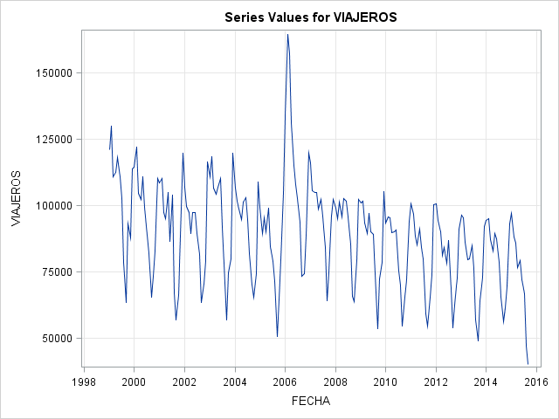

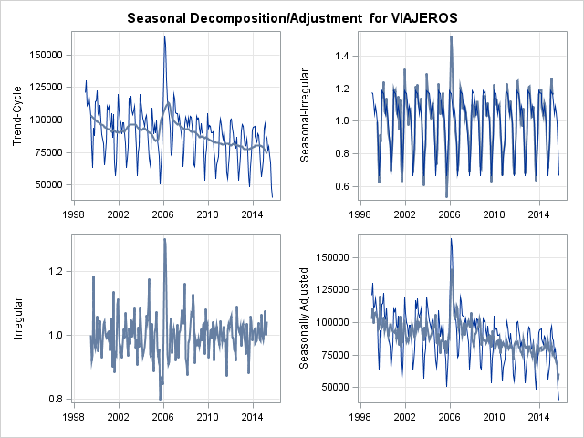

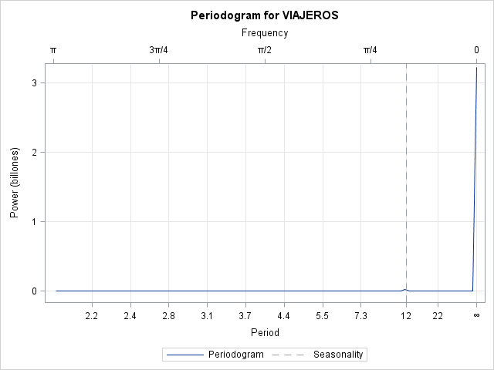

**3. Encontrar el modelo de suavizado exponencial más adecuado.**

**Para dicho representar gráficamente la serie observada y la suavizada con las predicciones para un periodo que se considere adecuado.**

Prueba 1:

En el código SAS abajo he creado un filtro para eliminar el año de 2014 y 2015, con el objetivo de predecir el año de 2014 y mirar los resultados comparados con los datos de 2014 que ya son conocidos.

Como se puede mirar en la imagen arriba algunos meses la predicción ha sido cerca de la realidad para algunos meses.

El modelo utilizado ha sido MULTwinters por ser el más adecuado. También he probado otros modelos y he puesto el resultado en este documento.

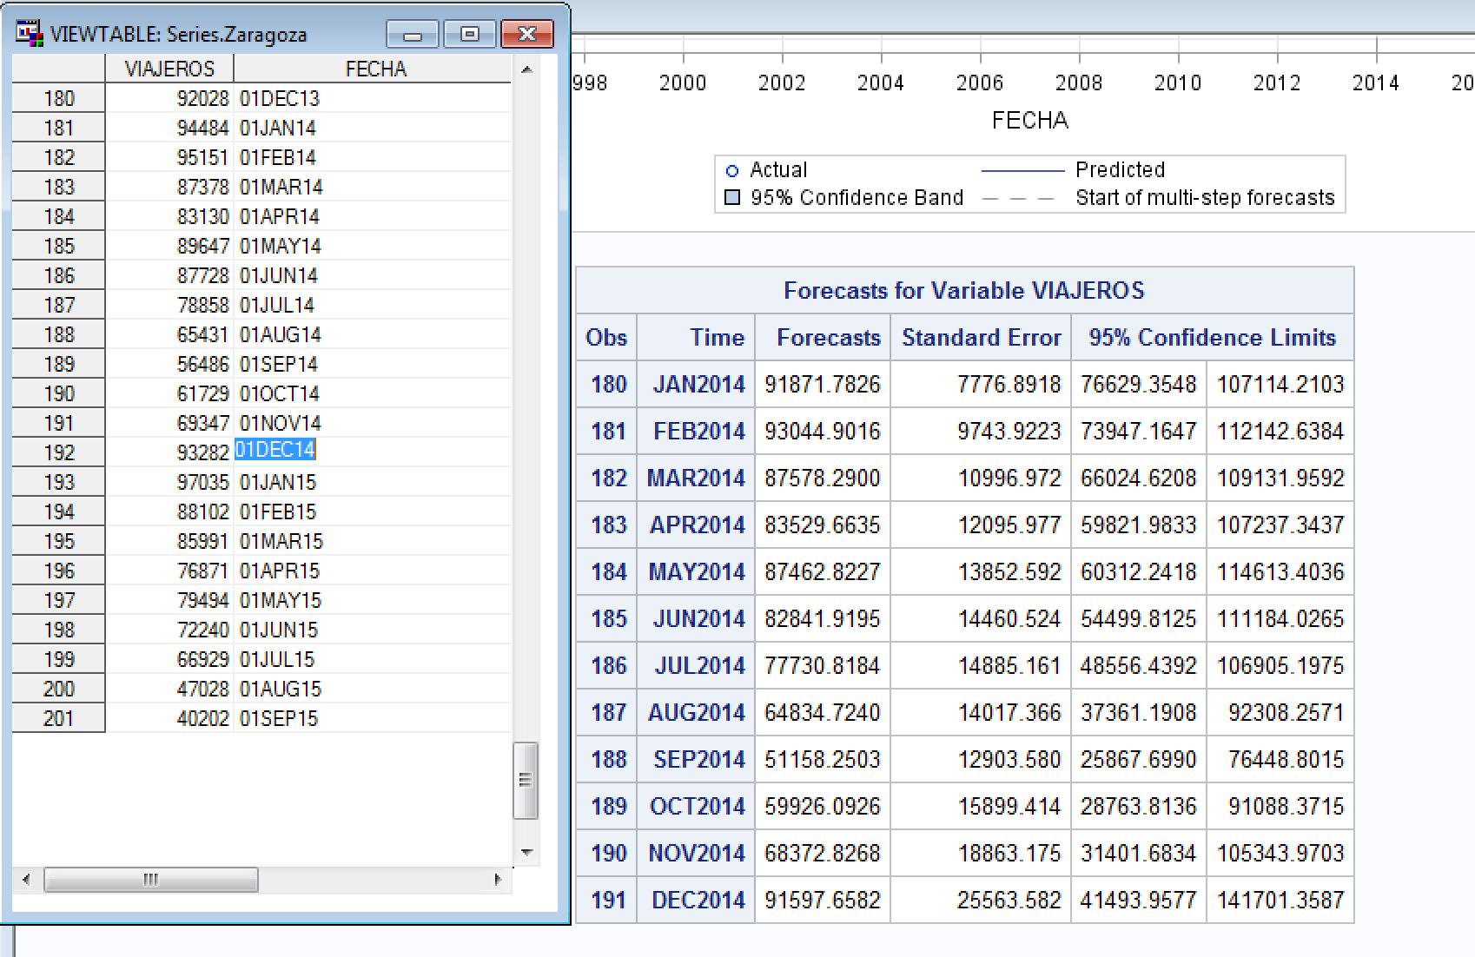

Código SAS:

ods html;

ods graphics on;

**proc** **esm** data=SERIES.ZARAGOZA out=salida lead=**12** print=(FORECASTS)

plots=(FORECASTS MODELS SEASONS);

id FECHA interval=month;

forecast VIAJEROS / model=MULTwinters;

where **'01jan1999'd** < FECHA < **'01jan2014'd**;

**run**;

ods graphics off;

ods html close;

Prueba 2:

La predicción utilizando el modelo Lineal de SAS (model=Lineal) no ha sido buena.

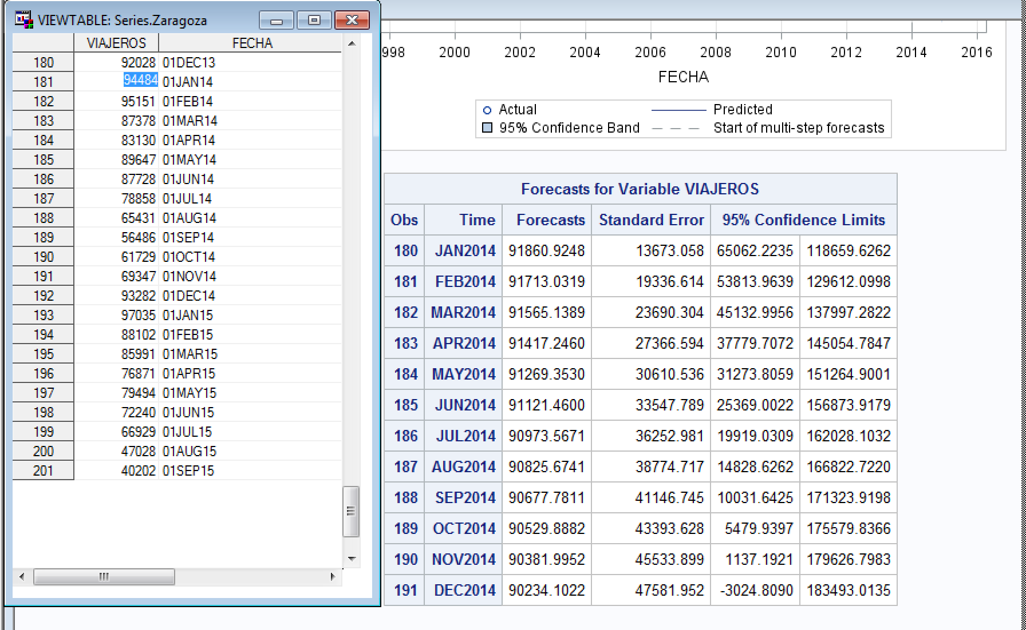

Código SAS:

ods html;

ods graphics on;

**proc** **esm** data=SERIES.ZARAGOZA out=salida lead=**12** print=(FORECASTS)

plots=(FORECASTS MODELS SEASONS);

id FECHA interval=month;

forecast VIAJEROS / model=Lineal;

where **'01jan1999'd** < FECHA < **'01jan2014'd**;

**run**;

ods graphics off;

ods html close;

Prueba 3:

A bajo se puede ver el resultado de la predicción con el modelo default de SAS.

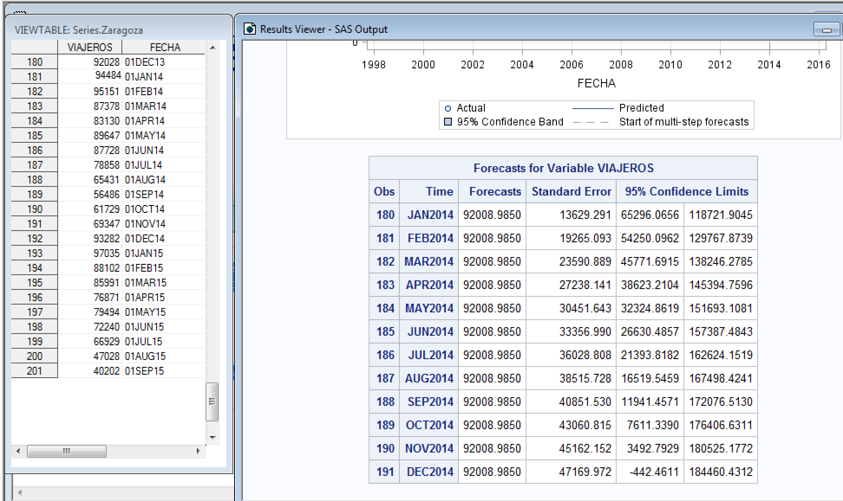

Código SAS:

ods html;

ods graphics on;

**proc** **esm** data=SERIES.ZARAGOZA out=salida lead=**12** print=(FORECASTS)

plots=(FORECASTS MODELS SEASONS);

id FECHA interval=month;

forecast VIAJEROS;

where **'01jan1999'd** < FECHA < **'01jan2014'd**;

**run**;

ods graphics off;

ods html close;

4. Representar la serie y los correlogramas. Decidir que modelo puede ser ajustado. Ajustar el modelo adecuado comprobando que sus residuales están incorrelados. (Sintaxis, tablas de los parámetros estimados y gráficos)

Código SAS:

ods html;

ods graphics on;

**proc** **timeseries** data=SERIES.ZARAGOZA PLOTS=( SERIES ACF PACF) OUTCORR=AUTOCOR PRINT=ALL;

id FECHA interval=month ;

var VIAJEROS;

**run**;

**PROC** **PRINT** DATA=AUTOCOR;

**RUN**;

ods graphics off;

ods html close;

|  |
| --- |
| The SAS System |

The TIMESERIES Procedure

| **Input Data Set** | |
| --- | --- |
| **Name** | SERIES.ZARAGOZA |
| **Label** |  |
| **Time ID Variable** | FECHA |
| **Time Interval** | MONTH |
| **Length of Seasonal Cycle** | 12 |

| **Variable Information** | |
| --- | --- |
| **Name** | VIAJEROS |
| **Label** | VIAJEROS |
| **First** | JAN1999 |
| **Last** | SEP2015 |
| **Number of Observations Read** | 201 |

| **Time Series Descriptive Statistics** | |
| --- | --- |
| **Variable** | VIAJEROS |
| **Number of Observations** | 201 |
| **Number of Missing Observations** | 0 |
| **Minimum** | 40202 |
| **Maximum** | 164520 |
| **Mean** | 89553.77 |
| **Standard Deviation** | 19210.89 |



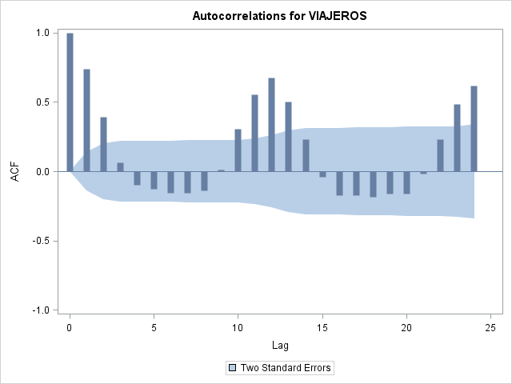

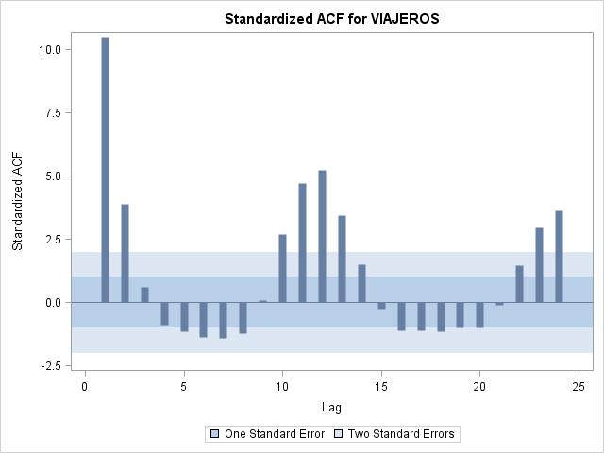

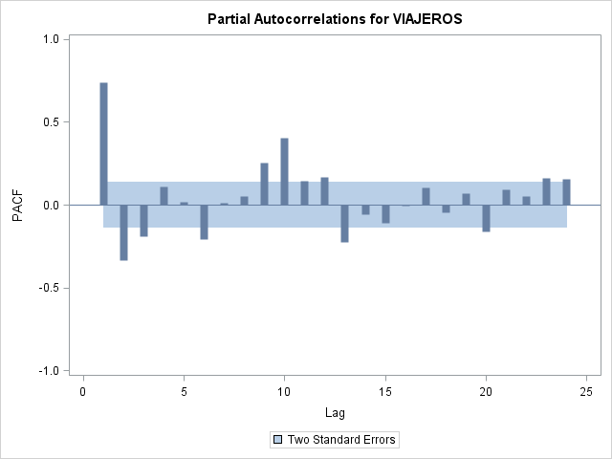

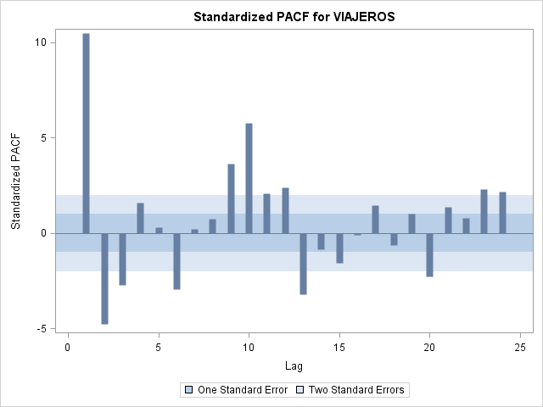

| **Statistics Summary** | | | | | | | | |
| --- | --- | --- | --- | --- | --- | --- | --- | --- |
| **Variable** | **NObs** | **N** | **NMiss** | **Minimum** | **Maximum** | **Mean** | **Standard Deviation** | **Sum** |
| **VIAJEROS** | 201 | 201 | 0 | 40202.00 | 164520.0 | 89553.77 | 19210.892 | 18000308 |

|  |
| --- |
| The SAS System |

| **Obs** | **_NAME_** | **LAG** | **N** | **ACOV** | **ACF** | **ACFSTD** | **PACF** | **PACFSTD** | **IACF** | **IACFSTD** | **WN** | **WNPROB** |
| --- | --- | --- | --- | --- | --- | --- | --- | --- | --- | --- | --- | --- |
| **1** | VIAJEROS | 0 | 201 | 367222253.28 | 1.00000 | 0.00000 | . | . | 1.00000 | . | . | . |
| **2** | VIAJEROS | 1 | 200 | 271681509.14 | 0.73983 | 0.07053 | 0.73983 | 0.070535 | -0.50566 | 0.070535 | 111.667 | 0 |
| **3** | VIAJEROS | 2 | 199 | 145062632.07 | 0.39503 | 0.10209 | -0.33650 | 0.070535 | 0.05480 | 0.070535 | 143.663 | 6.3689E-32 |
| **4** | VIAJEROS | 3 | 198 | 23625531.16 | 0.06434 | 0.10943 | -0.19259 | 0.070535 | 0.02137 | 0.070535 | 144.516 | 4.01529E-31 |
| **5** | VIAJEROS | 4 | 197 | -35747930.63 | -0.09735 | 0.10961 | 0.11227 | 0.070535 | -0.03565 | 0.070535 | 146.478 | 1.15683E-30 |
| **6** | VIAJEROS | 5 | 196 | -46503526.84 | -0.12664 | 0.11004 | 0.02031 | 0.070535 | -0.02187 | 0.070535 | 149.817 | 1.46056E-30 |
| **7** | VIAJEROS | 6 | 195 | -56649717.18 | -0.15427 | 0.11077 | -0.20903 | 0.070535 | -0.01410 | 0.070535 | 154.796 | 7.48232E-31 |
| **8** | VIAJEROS | 7 | 194 | -57994899.38 | -0.15793 | 0.11183 | 0.01341 | 0.070535 | 0.09414 | 0.070535 | 160.042 | 3.14279E-31 |
| **9** | VIAJEROS | 8 | 193 | -51442415.90 | -0.14009 | 0.11293 | 0.05208 | 0.070535 | -0.10347 | 0.070535 | 164.191 | 2.12397E-31 |
| **10** | VIAJEROS | 9 | 192 | 3847050.61 | 0.01048 | 0.11380 | 0.25602 | 0.070535 | 0.17772 | 0.070535 | 164.214 | 9.87829E-31 |
| **11** | VIAJEROS | 10 | 191 | 112160059.80 | 0.30543 | 0.11380 | 0.40649 | 0.070535 | -0.20085 | 0.070535 | 184.143 | 3.23019E-34 |
| **12** | VIAJEROS | 11 | 190 | 203978162.47 | 0.55546 | 0.11781 | 0.14572 | 0.070535 | 0.11842 | 0.070535 | 250.402 | 2.30121E-47 |
| **13** | VIAJEROS | 12 | 189 | 249302116.34 | 0.67889 | 0.13019 | 0.16800 | 0.070535 | -0.19168 | 0.070535 | 349.903 | 1.47071E-67 |
| **14** | VIAJEROS | 13 | 188 | 185271391.35 | 0.50452 | 0.14675 | -0.22751 | 0.070535 | 0.11579 | 0.070535 | 405.148 | 1.82888E-78 |
| **15** | VIAJEROS | 14 | 187 | 85298399.22 | 0.23228 | 0.15514 | -0.05934 | 0.070535 | -0.00807 | 0.070535 | 416.920 | 3.43819E-80 |
| **16** | VIAJEROS | 15 | 186 | -13688965.44 | -0.03728 | 0.15686 | -0.10992 | 0.070535 | 0.01003 | 0.070535 | 417.225 | 1.65184E-79 |
| **17** | VIAJEROS | 16 | 185 | -64261936.82 | -0.17499 | 0.15690 | -0.00790 | 0.070535 | 0.06611 | 0.070535 | 423.979 | 3.39118E-80 |
| **18** | VIAJEROS | 17 | 184 | -64100641.67 | -0.17456 | 0.15787 | 0.10317 | 0.070535 | -0.09175 | 0.070535 | 430.736 | 6.82074E-81 |
| **19** | VIAJEROS | 18 | 183 | -67684444.21 | -0.18431 | 0.15883 | -0.04479 | 0.070535 | 0.11606 | 0.070535 | 438.311 | 9.09093E-82 |
| **20** | VIAJEROS | 19 | 182 | -59629901.64 | -0.16238 | 0.15989 | 0.07136 | 0.070535 | -0.17226 | 0.070535 | 444.222 | 2.65762E-82 |
| **21** | VIAJEROS | 20 | 181 | -59567075.05 | -0.16221 | 0.16071 | -0.15958 | 0.070535 | 0.14514 | 0.070535 | 450.154 | 7.5723E-83 |
| **22** | VIAJEROS | 21 | 180 | -7182522.04 | -0.01956 | 0.16152 | 0.09505 | 0.070535 | -0.07545 | 0.070535 | 450.240 | 3.49769E-82 |
| **23** | VIAJEROS | 22 | 179 | 85789866.36 | 0.23362 | 0.16153 | 0.05441 | 0.070535 | 0.04432 | 0.070535 | 462.681 | 4.28438E-84 |
| **24** | VIAJEROS | 23 | 178 | 177435651.86 | 0.48318 | 0.16320 | 0.16154 | 0.070535 | 0.04005 | 0.070535 | 516.199 | 1.49641E-94 |
| **25** | VIAJEROS | 24 | 177 | 227349569.71 | 0.61911 | 0.17017 | 0.15426 | 0.070535 | -0.07977 | 0.070535 | 604.557 | 2.6386E-112 |

El modelo ajustado ha sido el Modelo ARIMA.

Codigo SAS:

ods html;

ods graphics on;

**proc** **arima** data=SERIES.ZARAGOZA;

identify var = viajeros;

**run**;

ods graphics off;

ods html close;

|  |
| --- |
| The SAS System |

The ARIMA Procedure

| **Name of Variable = VIAJEROS** | |
| --- | --- |
| **Mean of Working Series** | 89553.77 |
| **Standard Deviation** | 19163.04 |
| **Number of Observations** | 201 |

| **Autocorrelation Check for White Noise** | | | | | | | | | |
| --- | --- | --- | --- | --- | --- | --- | --- | --- | --- |
| **To Lag** | **Chi-Square** | **DF** | **Pr > ChiSq** | **Autocorrelations** | | | | | |
| **6** | 154.80 | 6 | <.0001 | 0.740 | 0.395 | 0.064 | -0.097 | -0.127 | -0.154 |
| **12** | 349.90 | 12 | <.0001 | -0.158 | -0.140 | 0.010 | 0.305 | 0.555 | 0.679 |
| **18** | 438.31 | 18 | <.0001 | 0.505 | 0.232 | -0.037 | -0.175 | -0.175 | -0.184 |
| **24** | 604.56 | 24 | <.0001 | -0.162 | -0.162 | -0.020 | 0.234 | 0.483 | 0.619 |

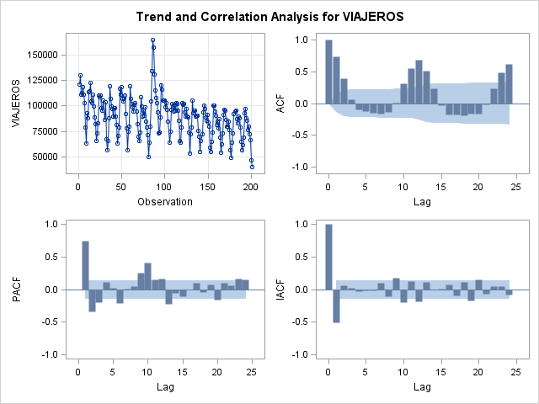

Codigo SAS:

ods html;

ods graphics on;

**proc** **arima** data=SERIES.ZARAGOZA;

identify var = viajeros(**1**);

**run**;

ods graphics off;

ods html close;

|  |
| --- |
| The SAS System |

The ARIMA Procedure

| **Name of Variable = VIAJEROS** | |
| --- | --- |
| **Period(s) of Differencing** | 1 |
| **Mean of Working Series** | -405.035 |
| **Standard Deviation** | 13216.83 |
| **Number of Observations** | 200 |
| **Observation(s) eliminated by differencing** | 1 |

| **Autocorrelation Check for White Noise** | | | | | | | | | |
| --- | --- | --- | --- | --- | --- | --- | --- | --- | --- |
| **To Lag** | **Chi-Square** | **DF** | **Pr > ChiSq** | **Autocorrelations** | | | | | |
| **6** | 47.70 | 6 | <.0001 | 0.180 | 0.015 | -0.351 | -0.275 | -0.001 | -0.031 |
| **12** | 180.57 | 12 | <.0001 | -0.021 | -0.254 | -0.337 | 0.066 | 0.233 | 0.620 |
| **18** | 225.77 | 18 | <.0001 | 0.212 | 0.029 | -0.264 | -0.297 | 0.022 | -0.051 |
| **24** | 347.68 | 24 | <.0001 | 0.063 | -0.287 | -0.244 | -0.028 | 0.202 | 0.589 |

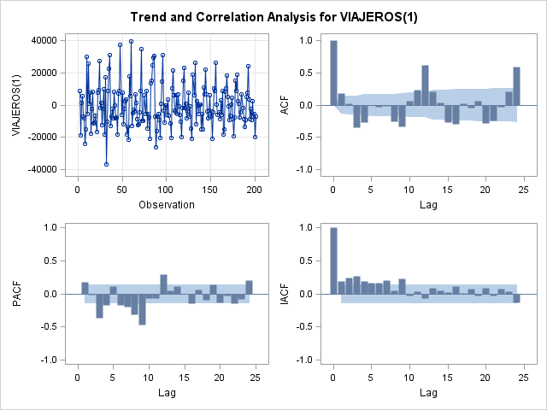

Codigo SAS:

ods html;

ods graphics on;

**proc** **arima** data=SERIES.ZARAGOZA;

identify var = viajeros(**1** **12**);

**run**;

ods graphics off;

ods html close;

|  |
| --- |
| The SAS System |

The ARIMA Procedure

| **Name of Variable = VIAJEROS** | |
| --- | --- |
| **Period(s) of Differencing** | 1,12 |
| **Mean of Working Series** | -51.6436 |
| **Standard Deviation** | 10867.06 |
| **Number of Observations** | 188 |
| **Observation(s) eliminated by differencing** | 13 |

| **Autocorrelation Check for White Noise** | | | | | | | | | |
| --- | --- | --- | --- | --- | --- | --- | --- | --- | --- |
| **To Lag** | **Chi-Square** | **DF** | **Pr > ChiSq** | **Autocorrelations** | | | | | |
| **6** | 11.54 | 6 | 0.0730 | -0.143 | -0.124 | -0.139 | 0.041 | -0.032 | 0.044 |
| **12** | 78.27 | 12 | <.0001 | -0.141 | 0.073 | -0.075 | 0.218 | 0.119 | -0.487 |
| **18** | 81.87 | 18 | <.0001 | -0.044 | 0.073 | 0.083 | -0.043 | 0.015 | -0.035 |
| **24** | 110.56 | 24 | <.0001 | 0.194 | -0.088 | 0.189 | -0.226 | -0.030 | -0.031 |

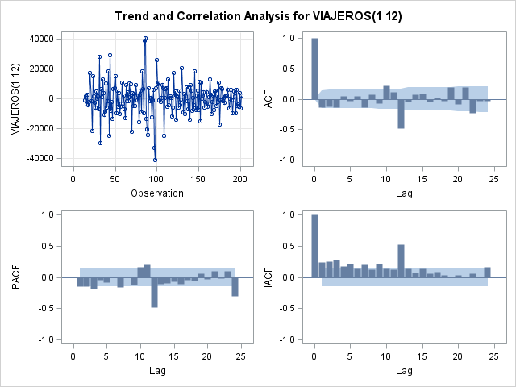

5. Escribir la expresión algebraica del modelo ajustado con los parámetros estimados.

modelo ARIMA(0, 1, 0)(0,1, 1)12:

ods html;

ods graphics on;

**PROC** **ARIMA** data=SERIES.ZARAGOZA; identify var=viajeros(**1** **12**) nlag=**10**; estimate Q= (**12**);

**run**;

ods graphics off;

ods html close;

|  |
| --- |
| The SAS System |

The ARIMA Procedure

| **Name of Variable = VIAJEROS** | |
| --- | --- |
| **Period(s) of Differencing** | 1,12 |
| **Mean of Working Series** | -51.6436 |
| **Standard Deviation** | 10867.06 |
| **Number of Observations** | 188 |
| **Observation(s) eliminated by differencing** | 13 |

| **Autocorrelation Check for White Noise** | | | | | | | | | |
| --- | --- | --- | --- | --- | --- | --- | --- | --- | --- |
| **To Lag** | **Chi-Square** | **DF** | **Pr > ChiSq** | **Autocorrelations** | | | | | |
| **6** | 11.54 | 6 | 0.0730 | -0.143 | -0.124 | -0.139 | 0.041 | -0.032 | 0.044 |

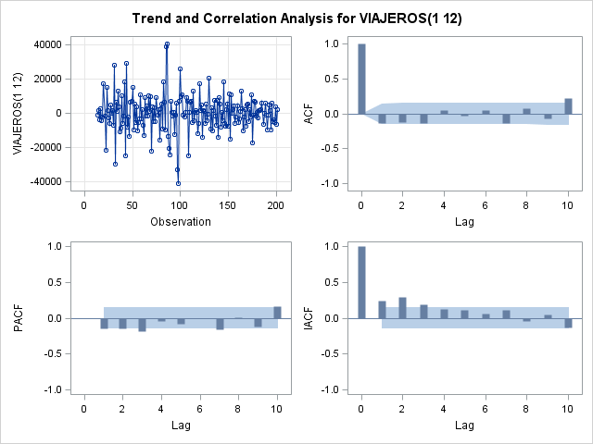

| **Conditional Least Squares Estimation** | | | | | |
| --- | --- | --- | --- | --- | --- |
| **Parameter** | **Estimate** | **Standard Error** | **t Value** | **Approx Pr > |t|** | **Lag** |
| **MU** | 1.76985 | 212.19624 | 0.01 | 0.9934 | 0 |
| **MA1,1** | 0.71100 | 0.05234 | 13.59 | <.0001 | 12 |

|  |  |
| --- | --- |
| **Constant Estimate** | 1.769848 |
| **Variance Estimate** | 76234503 |
| **Std Error Estimate** | 8731.237 |
| **AIC** | 3947.583 |
| **SBC** | 3954.056 |
| **Number of Residuals** | 188 |

|  |
| --- |
| **\* AIC and SBC do not include log determinant.** |

| **Correlations of Parameter Estimates** | | |
| --- | --- | --- |
| **Parameter** | **MU** | **MA1,1** |
| **MU** | 1.000 | 0.027 |
| **MA1,1** | 0.027 | 1.000 |

| **Autocorrelation Check of Residuals** | | | | | | | | | |
| --- | --- | --- | --- | --- | --- | --- | --- | --- | --- |
| **To Lag** | **Chi-Square** | **DF** | **Pr > ChiSq** | **Autocorrelations** | | | | | |
| **6** | 15.51 | 5 | 0.0084 | -0.188 | -0.111 | -0.133 | 0.074 | -0.090 | 0.045 |
| **12** | 22.00 | 11 | 0.0244 | -0.116 | 0.081 | -0.059 | 0.082 | 0.017 | -0.048 |
| **18** | 26.25 | 17 | 0.0700 | -0.097 | -0.042 | 0.085 | -0.018 | 0.002 | -0.045 |
| **24** | 46.76 | 23 | 0.0024 | 0.149 | -0.059 | 0.173 | -0.196 | -0.044 | -0.009 |
| **30** | 57.31 | 29 | 0.0013 | 0.075 | -0.138 | 0.127 | -0.005 | 0.054 | -0.064 |
| **36** | 59.85 | 35 | 0.0055 | 0.002 | -0.006 | 0.009 | 0.006 | -0.046 | 0.092 |

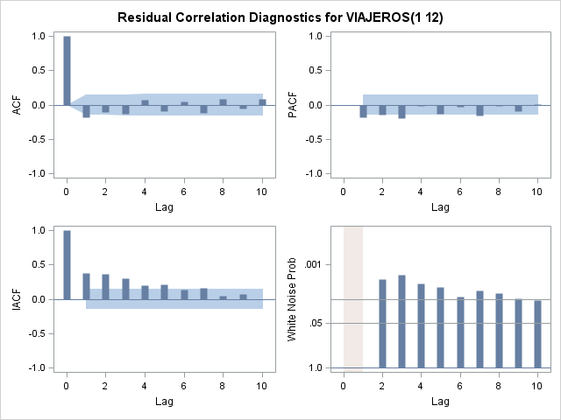

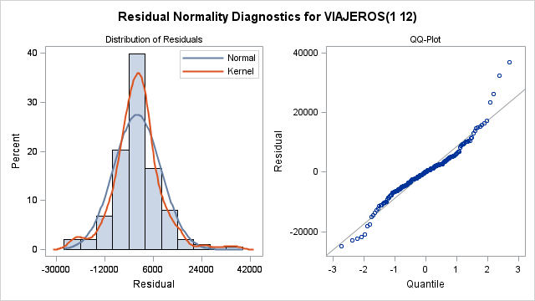

| **Model for variable VIAJEROS** | |
| --- | --- |
| **Estimated Mean** | 1.769848 |
| **Period(s) of Differencing** | 1,12 |

| **Moving Average Factors** | |
| --- | --- |
| **Factor 1:** | 1 - 0.711 B**(12) |

modelo ARIMA(0, 1, 0)(1,1, 0)12:

ods html;

ods graphics on;

**PROC** **ARIMA** data=SERIES.ZARAGOZA;

identify var=viajeros(**1** **12**) nlag=**10**;

estimate P= (**12**);

**run**;

ods graphics off;

ods html close;

|  |
| --- |
| The SAS System |

The ARIMA Procedure

| **Name of Variable = VIAJEROS** | |
| --- | --- |
| **Period(s) of Differencing** | 1,12 |
| **Mean of Working Series** | -51.6436 |
| **Standard Deviation** | 10867.06 |
| **Number of Observations** | 188 |
| **Observation(s) eliminated by differencing** | 13 |

| **Autocorrelation Check for White Noise** | | | | | | | | | |
| --- | --- | --- | --- | --- | --- | --- | --- | --- | --- |
| **To Lag** | **Chi-Square** | **DF** | **Pr > ChiSq** | **Autocorrelations** | | | | | |
| **6** | 11.54 | 6 | 0.0730 | -0.143 | -0.124 | -0.139 | 0.041 | -0.032 | 0.044 |



| **Conditional Least Squares Estimation** | | | | | |
| --- | --- | --- | --- | --- | --- |
| **Parameter** | **Estimate** | **Standard Error** | **t Value** | **Approx Pr > |t|** | **Lag** |
| **MU** | -10.89095 | 472.36771 | -0.02 | 0.9816 | 0 |
| **AR1,1** | -0.49571 | 0.06440 | -7.70 | <.0001 | 12 |

|  |  |
| --- | --- |
| **Constant Estimate** | -16.2897 |
| **Variance Estimate** | 90526637 |
| **Std Error Estimate** | 9514.549 |
| **AIC** | 3979.887 |
| **SBC** | 3986.36 |
| **Number of Residuals** | 188 |

|  |
| --- |
| **\* AIC and SBC do not include log determinant.** |

| **Correlations of Parameter Estimates** | | |
| --- | --- | --- |
| **Parameter** | **MU** | **AR1,1** |
| **MU** | 1.000 | -0.008 |
| **AR1,1** | -0.008 | 1.000 |

| **Autocorrelation Check of Residuals** | | | | | | | | | |
| --- | --- | --- | --- | --- | --- | --- | --- | --- | --- |
| **To Lag** | **Chi-Square** | **DF** | **Pr > ChiSq** | **Autocorrelations** | | | | | |
| **6** | 22.11 | 5 | 0.0005 | -0.184 | -0.015 | -0.223 | 0.083 | -0.134 | 0.076 |
| **12** | 39.19 | 11 | <.0001 | -0.122 | 0.084 | -0.090 | 0.129 | 0.085 | -0.177 |
| **18** | 45.64 | 17 | 0.0002 | -0.065 | -0.052 | 0.109 | -0.060 | 0.060 | -0.072 |
| **24** | 97.66 | 23 | <.0001 | 0.201 | -0.129 | 0.242 | -0.172 | 0.036 | -0.309 |
| **30** | 115.30 | 29 | <.0001 | 0.158 | -0.124 | 0.145 | -0.040 | 0.112 | -0.065 |
| **36** | 118.98 | 35 | <.0001 | 0.007 | -0.046 | 0.019 | 0.020 | -0.041 | 0.106 |

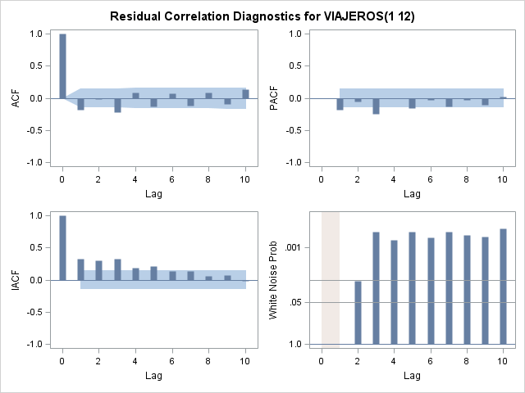

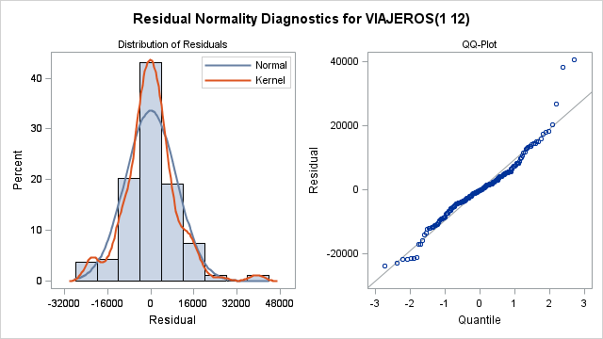

| **Model for variable VIAJEROS** | |
| --- | --- |
| **Estimated Mean** | -10.8909 |
| **Period(s) of Differencing** | 1,12 |

| **Autoregressive Factors** | |
| --- | --- |
| **Factor 1:** | 1 + 0.49571 B**(12) |

Con log

**data** SERIES.ZARAGOZA;

set SERIES.ZARAGOZA;

Lviajeros=log(viajeros);

**run**;

/* ARIMA(0,1, 0)(0,1,1)12 */

ods html;

ods graphics on;

**PROC** **ARIMA** data=SERIES.ZARAGOZA;

identify var=Lviajeros(**1** **12**) nlag=**10**;

estimate Q= (**12**);

**run**;

ods graphics off;

ods html close;

|  |
| --- |
| The SAS System |

The ARIMA Procedure

| **Name of Variable = Lviajeros** | |
| --- | --- |
| **Period(s) of Differencing** | 1,12 |
| **Mean of Working Series** | -0.00151 |
| **Standard Deviation** | 0.118465 |
| **Number of Observations** | 188 |
| **Observation(s) eliminated by differencing** | 13 |

| **Autocorrelation Check for White Noise** | | | | | | | | | |
| --- | --- | --- | --- | --- | --- | --- | --- | --- | --- |
| **To Lag** | **Chi-Square** | **DF** | **Pr > ChiSq** | **Autocorrelations** | | | | | |
| **6** | 16.55 | 6 | 0.0111 | -0.263 | -0.084 | -0.063 | 0.044 | -0.054 | 0.039 |

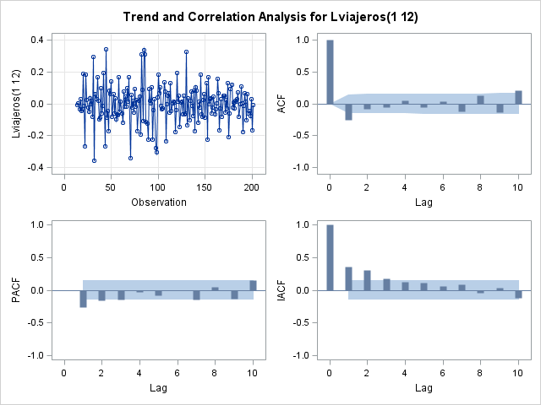

| **Conditional Least Squares Estimation** | | | | | |
| --- | --- | --- | --- | --- | --- |
| **Parameter** | **Estimate** | **Standard Error** | **t Value** | **Approx Pr > |t|** | **Lag** |
| **MU** | -0.0003649 | 0.0023287 | -0.16 | 0.8756 | 0 |
| **MA1,1** | 0.70561 | 0.05321 | 13.26 | <.0001 | 12 |

|  |  |
| --- | --- |
| **Constant Estimate** | -0.00036 |
| **Variance Estimate** | 0.008917 |
| **Std Error Estimate** | 0.09443 |
| **AIC** | -351.812 |
| **SBC** | -345.339 |
| **Number of Residuals** | 188 |

|  |
| --- |
| **\* AIC and SBC do not include log determinant.** |

| **Correlations of Parameter Estimates** | | |
| --- | --- | --- |
| **Parameter** | **MU** | **MA1,1** |
| **MU** | 1.000 | 0.040 |
| **MA1,1** | 0.040 | 1.000 |

| **Autocorrelation Check of Residuals** | | | | | | | | | |
| --- | --- | --- | --- | --- | --- | --- | --- | --- | --- |
| **To Lag** | **Chi-Square** | **DF** | **Pr > ChiSq** | **Autocorrelations** | | | | | |
| **6** | 22.81 | 5 | 0.0004 | -0.295 | -0.072 | -0.073 | 0.091 | -0.107 | 0.038 |
| **12** | 32.11 | 11 | 0.0007 | -0.096 | 0.127 | -0.095 | 0.075 | 0.028 | -0.077 |
| **18** | 35.14 | 17 | 0.0060 | -0.059 | -0.034 | 0.083 | -0.040 | -0.002 | -0.040 |
| **24** | 62.91 | 23 | <.0001 | 0.167 | -0.102 | 0.176 | -0.239 | 0.001 | 0.059 |
| **30** | 77.48 | 29 | <.0001 | 0.088 | -0.197 | 0.113 | -0.005 | 0.061 | -0.056 |
| **36** | 78.53 | 35 | <.0001 | 0.004 | -0.014 | 0.019 | 0.016 | -0.049 | 0.036 |

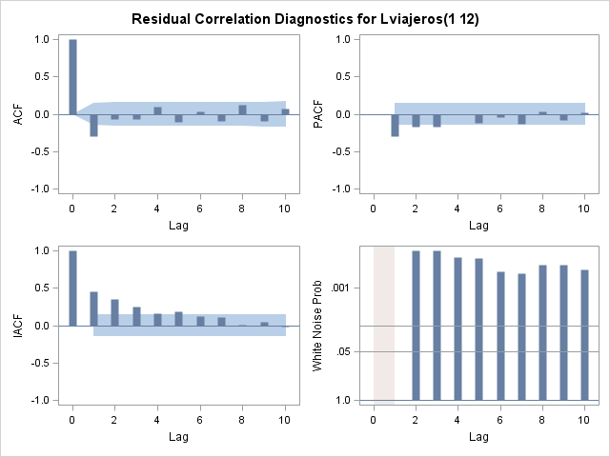

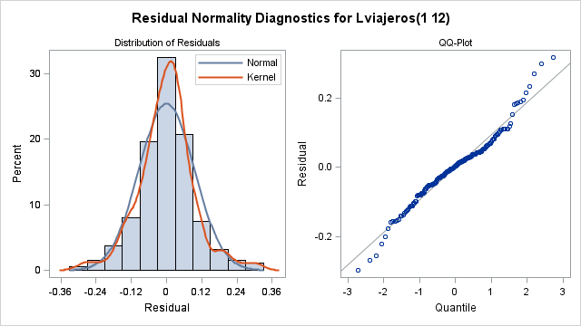

| **Model for variable Lviajeros** | |
| --- | --- |
| **Estimated Mean** | -0.00036 |
| **Period(s) of Differencing** | 1,12 |

| **Moving Average Factors** | |
| --- | --- |
| **Factor 1:** | 1 - 0.70561 B**(12) |

Otro teste:

/*ARIMA(0,1, 0)(1,1, 0)12*/

ods html;

ods graphics on;

**PROC** **ARIMA** data=SERIES.ZARAGOZA;

identify var=Lviajeros(**1** **12**) nlag=**10**;

estimate P= (**12**);

**run**;

ods graphics off;

ods html close;

|  |
| --- |
| The SAS System |

The ARIMA Procedure

| **Name of Variable = Lviajeros** | |
| --- | --- |
| **Period(s) of Differencing** | 1,12 |
| **Mean of Working Series** | -0.00151 |
| **Standard Deviation** | 0.118465 |
| **Number of Observations** | 188 |
| **Observation(s) eliminated by differencing** | 13 |

| **Autocorrelation Check for White Noise** | | | | | | | | | |
| --- | --- | --- | --- | --- | --- | --- | --- | --- | --- |
| **To Lag** | **Chi-Square** | **DF** | **Pr > ChiSq** | **Autocorrelations** | | | | | |
| **6** | 16.55 | 6 | 0.0111 | -0.263 | -0.084 | -0.063 | 0.044 | -0.054 | 0.039 |



| **Conditional Least Squares Estimation** | | | | | |
| --- | --- | --- | --- | --- | --- |
| **Parameter** | **Estimate** | **Standard Error** | **t Value** | **Approx Pr > |t|** | **Lag** |
| **MU** | -0.0006378 | 0.0048516 | -0.13 | 0.8956 | 0 |
| **AR1,1** | -0.54308 | 0.06310 | -8.61 | <.0001 | 12 |

|  |  |
| --- | --- |
| **Constant Estimate** | -0.00098 |
| **Variance Estimate** | 0.010144 |
| **Std Error Estimate** | 0.10072 |
| **AIC** | -327.566 |
| **SBC** | -321.093 |
| **Number of Residuals** | 188 |

|  |
| --- |
| **\* AIC and SBC do not include log determinant.** |

| **Correlations of Parameter Estimates** | | |
| --- | --- | --- |
| **Parameter** | **MU** | **AR1,1** |
| **MU** | 1.000 | -0.014 |
| **AR1,1** | -0.014 | 1.000 |

| **Autocorrelation Check of Residuals** | | | | | | | | | |
| --- | --- | --- | --- | --- | --- | --- | --- | --- | --- |
| **To Lag** | **Chi-Square** | **DF** | **Pr > ChiSq** | **Autocorrelations** | | | | | |
| **6** | 37.18 | 5 | <.0001 | -0.331 | 0.067 | -0.171 | 0.119 | -0.176 | 0.071 |
| **12** | 57.01 | 11 | <.0001 | -0.104 | 0.148 | -0.142 | 0.112 | 0.090 | -0.159 |
| **18** | 65.89 | 17 | <.0001 | -0.027 | -0.063 | 0.127 | -0.112 | 0.063 | -0.076 |
| **24** | 129.30 | 23 | <.0001 | 0.234 | -0.190 | 0.246 | -0.213 | 0.117 | -0.291 |
| **30** | 154.26 | 29 | <.0001 | 0.211 | -0.184 | 0.120 | -0.045 | 0.123 | -0.056 |
| **36** | 157.94 | 35 | <.0001 | 0.020 | -0.067 | 0.039 | 0.027 | -0.063 | 0.069 |

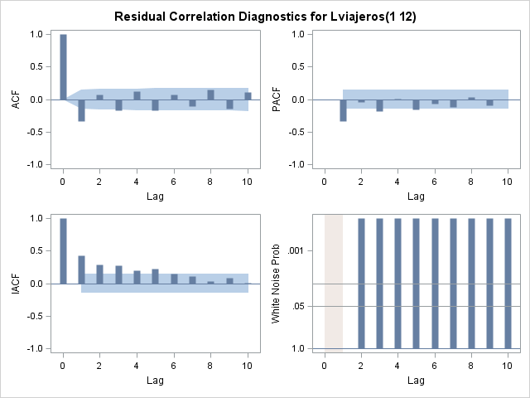

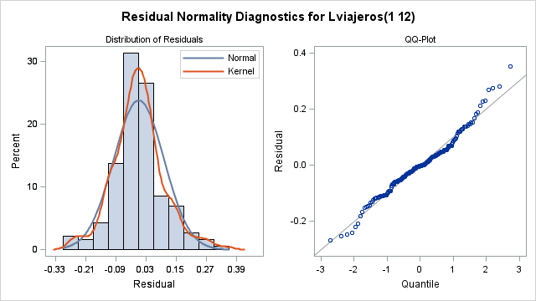

| **Model for variable Lviajeros** | |
| --- | --- |
| **Estimated Mean** | -0.00064 |
| **Period(s) of Differencing** | 1,12 |

| **Autoregressive Factors** | |
| --- | --- |
| **Factor 1:** | 1 + 0.54308 B**(12) |

6. Calcular las predicciones y los intervalos de confianza para los 10 días siguientes al último valor observado. Representarlas gráficamente.

ods html;

ods graphics on;

**PROC** **ARIMA** data=SERIES.ZARAGOZA;

identify var=Lviajeros(**1** **12**) nlag=**10**;

estimate Q= (**12**) noconstant;

forecast lead=**12** id=fecha interval=month out=predicciones Printall;

**run**;

title "Estimaciones";

title "Estimaciones";

**PROC** **PRINT** DATA= predicciones;

where fecha >= **'01oct2015'd**;

**RUN**;

ods graphics off;

ods html close;

|  |
| --- |
| The SAS System |

The ARIMA Procedure

| **Name of Variable = Lviajeros** | |
| --- | --- |
| **Period(s) of Differencing** | 1,12 |
| **Mean of Working Series** | -0.00151 |
| **Standard Deviation** | 0.118465 |
| **Number of Observations** | 188 |
| **Observation(s) eliminated by differencing** | 13 |

| **Autocorrelation Check for White Noise** | | | | | | | | | |
| --- | --- | --- | --- | --- | --- | --- | --- | --- | --- |
| **To Lag** | **Chi-Square** | **DF** | **Pr > ChiSq** | **Autocorrelations** | | | | | |
| **6** | 16.55 | 6 | 0.0111 | -0.263 | -0.084 | -0.063 | 0.044 | -0.054 | 0.039 |



| **Conditional Least Squares Estimation** | | | | | |
| --- | --- | --- | --- | --- | --- |
| **Parameter** | **Estimate** | **Standard Error** | **t Value** | **Approx Pr > |t|** | **Lag** |
| **MA1,1** | 0.70564 | 0.05306 | 13.30 | <.0001 | 12 |

|  |  |
| --- | --- |
| **Variance Estimate** | 0.00887 |
| **Std Error Estimate** | 0.094183 |
| **AIC** | -353.787 |
| **SBC** | -350.55 |
| **Number of Residuals** | 188 |

|  |
| --- |
| **\* AIC and SBC do not include log determinant.** |

| **Autocorrelation Check of Residuals** | | | | | | | | | |
| --- | --- | --- | --- | --- | --- | --- | --- | --- | --- |
| **To Lag** | **Chi-Square** | **DF** | **Pr > ChiSq** | **Autocorrelations** | | | | | |
| **6** | 22.78 | 5 | 0.0004 | -0.295 | -0.072 | -0.073 | 0.091 | -0.107 | 0.038 |
| **12** | 32.08 | 11 | 0.0007 | -0.096 | 0.127 | -0.095 | 0.075 | 0.028 | -0.077 |
| **18** | 35.12 | 17 | 0.0060 | -0.059 | -0.034 | 0.083 | -0.040 | -0.002 | -0.040 |
| **24** | 62.87 | 23 | <.0001 | 0.167 | -0.102 | 0.176 | -0.239 | 0.000 | 0.059 |
| **30** | 77.44 | 29 | <.0001 | 0.088 | -0.196 | 0.113 | -0.005 | 0.061 | -0.056 |
| **36** | 78.49 | 35 | <.0001 | 0.004 | -0.014 | 0.018 | 0.016 | -0.049 | 0.036 |



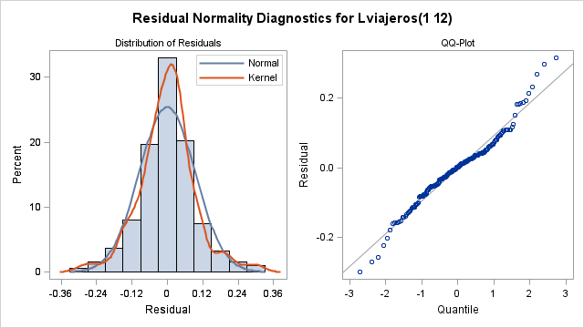

| **Model for variable Lviajeros** | |
| --- | --- |
| **Period(s) of Differencing** | 1,12 |

|  |
| --- |
| **No mean term in this model.** |

| **Moving Average Factors** | |
| --- | --- |
| **Factor 1:** | 1 - 0.70564 B**(12) |

| **Forecasts for variable Lviajeros** | | | | | | |
| --- | --- | --- | --- | --- | --- | --- |
| **Obs** | **Forecast** | **Std Error** | **95% Confidence Limits** | | **Actual** | **Residual** |
| **14** | 11.7189 | 0.0942 | 11.5343 | 11.9035 | 11.7137 | -0.0052 |
| **15** | 11.5570 | 0.0942 | 11.3724 | 11.7416 | 11.5585 | 0.0015 |
| **16** | 11.5714 | 0.0942 | 11.3868 | 11.7560 | 11.5373 | -0.0341 |
| **17** | 11.5864 | 0.0942 | 11.4018 | 11.7710 | 11.6159 | 0.0295 |
| **18** | 11.5528 | 0.0942 | 11.3682 | 11.7374 | 11.5067 | -0.0461 |
| **19** | 11.4296 | 0.0942 | 11.2450 | 11.6142 | 11.3942 | -0.0353 |
| **20** | 11.1269 | 0.0942 | 10.9423 | 11.3115 | 11.3149 | 0.1879 |
| **21** | 11.1027 | 0.0942 | 10.9181 | 11.2873 | 11.0900 | -0.0127 |
| **22** | 11.4732 | 0.0942 | 11.2886 | 11.6578 | 11.2041 | -0.2691 |
| **23** | 11.1448 | 0.0942 | 10.9602 | 11.3294 | 11.3264 | 0.1816 |
| **24** | 11.5848 | 0.0942 | 11.4002 | 11.7694 | 11.6116 | 0.0269 |
| **25** | 11.6186 | 0.0942 | 11.4340 | 11.8032 | 11.5955 | -0.0231 |
| **26** | 11.6634 | 0.0942 | 11.4788 | 11.8480 | 11.6096 | -0.0538 |
| **27** | 11.4534 | 0.0942 | 11.2688 | 11.6380 | 11.4882 | 0.0348 |
| **28** | 11.4910 | 0.0942 | 11.3064 | 11.6756 | 11.4638 | -0.0272 |
| **29** | 11.5216 | 0.0942 | 11.3370 | 11.7062 | 11.5627 | 0.0411 |
| **30** | 11.4860 | 0.0942 | 11.3014 | 11.6706 | 11.3707 | -0.1153 |
| **31** | 11.2832 | 0.0942 | 11.0986 | 11.4678 | 11.5522 | 0.2689 |
| **32** | 11.3402 | 0.0942 | 11.1556 | 11.5248 | 11.1170 | -0.2231 |
| **33** | 10.9011 | 0.0942 | 10.7165 | 11.0857 | 10.9524 | 0.0513 |
| **34** | 11.2564 | 0.0942 | 11.0718 | 11.4410 | 11.0986 | -0.1578 |
| **35** | 11.0928 | 0.0942 | 10.9082 | 11.2774 | 11.3899 | 0.2971 |
| **36** | 11.6562 | 0.0942 | 11.4716 | 11.8408 | 11.6923 | 0.0361 |
| **37** | 11.6925 | 0.0942 | 11.5079 | 11.8771 | 11.5800 | -0.1125 |
| **38** | 11.6321 | 0.0942 | 11.4475 | 11.8167 | 11.5094 | -0.1226 |
| **39** | 11.3634 | 0.0942 | 11.1788 | 11.5480 | 11.4877 | 0.1243 |
| **40** | 11.4826 | 0.0942 | 11.2980 | 11.6671 | 11.4008 | -0.0818 |
| **41** | 11.4706 | 0.0942 | 11.2860 | 11.6552 | 11.4880 | 0.0174 |
| **42** | 11.3774 | 0.0942 | 11.1928 | 11.5620 | 11.4878 | 0.1104 |
| **43** | 11.4795 | 0.0942 | 11.2949 | 11.6641 | 11.4029 | -0.0766 |
| **44** | 11.1252 | 0.0942 | 10.9406 | 11.3098 | 11.3116 | 0.1864 |
| **45** | 11.1108 | 0.0942 | 10.9262 | 11.2954 | 11.0591 | -0.0517 |
| **46** | 11.3166 | 0.0942 | 11.1320 | 11.5012 | 11.1630 | -0.1537 |
| **47** | 11.2446 | 0.0942 | 11.0600 | 11.4292 | 11.2803 | 0.0358 |
| **48** | 11.5573 | 0.0942 | 11.3727 | 11.7419 | 11.6670 | 0.1097 |
| **49** | 11.6340 | 0.0942 | 11.4494 | 11.8186 | 11.6151 | -0.0189 |
| **50** | 11.6311 | 0.0942 | 11.4465 | 11.8157 | 11.6828 | 0.0518 |
| **51** | 11.5734 | 0.0942 | 11.3888 | 11.7580 | 11.5783 | 0.0050 |
| **52** | 11.5491 | 0.0942 | 11.3645 | 11.7337 | 11.5539 | 0.0048 |
| **53** | 11.6288 | 0.0942 | 11.4443 | 11.8134 | 11.5794 | -0.0495 |
| **54** | 11.5013 | 0.0942 | 11.3167 | 11.6859 | 11.6118 | 0.1105 |
| **55** | 11.5809 | 0.0942 | 11.3963 | 11.7655 | 11.4294 | -0.1514 |
| **56** | 11.2066 | 0.0942 | 11.0220 | 11.3912 | 11.2712 | 0.0646 |
| **57** | 11.0552 | 0.0942 | 10.8706 | 11.2398 | 10.9496 | -0.1056 |
| **58** | 11.1619 | 0.0942 | 10.9773 | 11.3465 | 11.2205 | 0.0586 |
| **59** | 11.3126 | 0.0942 | 11.1280 | 11.4972 | 11.2900 | -0.0226 |
| **60** | 11.5992 | 0.0942 | 11.4146 | 11.7838 | 11.6926 | 0.0934 |
| **61** | 11.6541 | 0.0942 | 11.4695 | 11.8387 | 11.5788 | -0.0754 |
| **62** | 11.6100 | 0.0942 | 11.4254 | 11.7946 | 11.5292 | -0.0808 |
| **63** | 11.4212 | 0.0942 | 11.2366 | 11.6058 | 11.5008 | 0.0796 |
| **64** | 11.4730 | 0.0942 | 11.2884 | 11.6576 | 11.4584 | -0.0145 |
| **65** | 11.5188 | 0.0942 | 11.3342 | 11.7034 | 11.5280 | 0.0092 |
| **66** | 11.4824 | 0.0942 | 11.2978 | 11.6670 | 11.5438 | 0.0614 |
| **67** | 11.4683 | 0.0942 | 11.2837 | 11.6529 | 11.4582 | -0.0101 |
| **68** | 11.2544 | 0.0942 | 11.0699 | 11.4390 | 11.3160 | 0.0615 |
| **69** | 11.0689 | 0.0942 | 10.8843 | 11.2535 | 11.1602 | 0.0913 |
| **70** | 11.3897 | 0.0942 | 11.2051 | 11.5743 | 11.0909 | -0.2988 |
| **71** | 11.1764 | 0.0942 | 10.9918 | 11.3610 | 11.2185 | 0.0421 |
| **72** | 11.5552 | 0.0942 | 11.3706 | 11.7398 | 11.5987 | 0.0435 |
| **73** | 11.5380 | 0.0942 | 11.3534 | 11.7226 | 11.5061 | -0.0319 |
| **74** | 11.5135 | 0.0942 | 11.3289 | 11.6981 | 11.4014 | -0.1121 |
| **75** | 11.3168 | 0.0942 | 11.1322 | 11.5014 | 11.4681 | 0.1513 |
| **76** | 11.4361 | 0.0942 | 11.2515 | 11.6207 | 11.4096 | -0.0264 |
| **77** | 11.4727 | 0.0942 | 11.2881 | 11.6573 | 11.5023 | 0.0296 |
| **78** | 11.4748 | 0.0942 | 11.2902 | 11.6594 | 11.3458 | -0.1290 |
| **79** | 11.2673 | 0.0942 | 11.0827 | 11.4519 | 11.2770 | 0.0097 |
| **80** | 11.0913 | 0.0942 | 10.9067 | 11.2759 | 11.1792 | 0.0879 |
| **81** | 10.9589 | 0.0942 | 10.7743 | 11.1435 | 10.8331 | -0.1259 |
| **82** | 10.9747 | 0.0942 | 10.7901 | 11.1593 | 11.0732 | 0.0985 |
| **83** | 11.1710 | 0.0942 | 10.9864 | 11.3556 | 11.2872 | 0.1162 |
| **84** | 11.6368 | 0.0942 | 11.4522 | 11.8214 | 11.5587 | -0.0781 |
| **85** | 11.4886 | 0.0942 | 11.3040 | 11.6732 | 11.8047 | 0.3161 |
| **86** | 11.7791 | 0.0942 | 11.5945 | 11.9637 | 12.0108 | 0.2316 |
| **87** | 11.9708 | 0.0942 | 11.7862 | 12.1554 | 11.9656 | -0.0052 |
| **88** | 11.9257 | 0.0942 | 11.7411 | 12.1103 | 11.7842 | -0.1415 |
| **89** | 11.8560 | 0.0942 | 11.6714 | 12.0406 | 11.6547 | -0.2013 |
| **90** | 11.5892 | 0.0942 | 11.4047 | 11.7738 | 11.5903 | 0.0011 |
| **91** | 11.5147 | 0.0942 | 11.3301 | 11.6993 | 11.5400 | 0.0252 |
| **92** | 11.3802 | 0.0942 | 11.1956 | 11.5648 | 11.4475 | 0.0674 |
| **93** | 11.1902 | 0.0942 | 11.0056 | 11.3748 | 11.2035 | 0.0132 |
| **94** | 11.3741 | 0.0942 | 11.1895 | 11.5586 | 11.2180 | -0.1560 |
| **95** | 11.3501 | 0.0942 | 11.1655 | 11.5347 | 11.3948 | 0.0447 |
| **96** | 11.7214 | 0.0942 | 11.5368 | 11.9059 | 11.6940 | -0.0274 |
| **97** | 11.7169 | 0.0942 | 11.5323 | 11.9015 | 11.6632 | -0.0537 |
| **98** | 11.7058 | 0.0942 | 11.5212 | 11.8904 | 11.5667 | -0.1391 |
| **99** | 11.5251 | 0.0942 | 11.3406 | 11.7097 | 11.5625 | 0.0373 |
| **100** | 11.4810 | 0.0942 | 11.2964 | 11.6656 | 11.5620 | 0.0810 |
| **101** | 11.5745 | 0.0942 | 11.3899 | 11.7591 | 11.5007 | -0.0739 |
| **102** | 11.4355 | 0.0942 | 11.2509 | 11.6201 | 11.5375 | 0.1020 |
| **103** | 11.4693 | 0.0942 | 11.2847 | 11.6539 | 11.4719 | 0.0026 |
| **104** | 11.3319 | 0.0942 | 11.1473 | 11.5165 | 11.3436 | 0.0117 |
| **105** | 11.0902 | 0.0942 | 10.9056 | 11.2748 | 11.0724 | -0.0178 |
| **106** | 11.1971 | 0.0942 | 11.0125 | 11.3817 | 11.2219 | 0.0248 |
| **107** | 11.3671 | 0.0942 | 11.1825 | 11.5517 | 11.4741 | 0.1069 |
| **108** | 11.7926 | 0.0942 | 11.6080 | 11.9772 | 11.5364 | -0.2562 |
| **109** | 11.5435 | 0.0942 | 11.3589 | 11.7281 | 11.5053 | -0.0383 |
| **110** | 11.5069 | 0.0942 | 11.3223 | 11.6915 | 11.4615 | -0.0454 |
| **111** | 11.4310 | 0.0942 | 11.2464 | 11.6156 | 11.5251 | 0.0941 |
| **112** | 11.4674 | 0.0942 | 11.2829 | 11.6520 | 11.4691 | 0.0017 |
| **113** | 11.4599 | 0.0942 | 11.2754 | 11.6445 | 11.5382 | 0.0782 |
| **114** | 11.5030 | 0.0942 | 11.3184 | 11.6876 | 11.5299 | 0.0269 |
| **115** | 11.4625 | 0.0942 | 11.2779 | 11.6471 | 11.4693 | 0.0068 |
| **116** | 11.3327 | 0.0942 | 11.1482 | 11.5173 | 11.3557 | 0.0230 |
| **117** | 11.0971 | 0.0942 | 10.9125 | 11.2817 | 11.0937 | -0.0034 |
| **118** | 11.2256 | 0.0942 | 11.0410 | 11.4102 | 11.0666 | -0.1590 |
| **119** | 11.2433 | 0.0942 | 11.0587 | 11.4279 | 11.2805 | 0.0372 |
| **120** | 11.5236 | 0.0942 | 11.3390 | 11.7081 | 11.5379 | 0.0143 |
| **121** | 11.5338 | 0.0942 | 11.3492 | 11.7184 | 11.5225 | -0.0113 |
| **122** | 11.5108 | 0.0942 | 11.3262 | 11.6954 | 11.5296 | 0.0188 |
| **123** | 11.5267 | 0.0942 | 11.3421 | 11.7113 | 11.4463 | -0.0804 |
| **124** | 11.3891 | 0.0942 | 11.2045 | 11.5737 | 11.4014 | 0.0122 |
| **125** | 11.4152 | 0.0942 | 11.2306 | 11.5998 | 11.4841 | 0.0688 |
| **126** | 11.4568 | 0.0942 | 11.2722 | 11.6414 | 11.4083 | -0.0485 |
| **127** | 11.3429 | 0.0942 | 11.1583 | 11.5275 | 11.3982 | 0.0553 |
| **128** | 11.2684 | 0.0942 | 11.0838 | 11.4530 | 11.2173 | -0.0511 |
| **129** | 10.9577 | 0.0942 | 10.7731 | 11.1423 | 10.8934 | -0.0643 |
| **130** | 10.9786 | 0.0942 | 10.7940 | 11.1632 | 11.1917 | 0.2131 |
| **131** | 11.3794 | 0.0942 | 11.1948 | 11.5640 | 11.2737 | -0.1056 |
| **132** | 11.5210 | 0.0942 | 11.3364 | 11.7056 | 11.5635 | 0.0425 |
| **133** | 11.5561 | 0.0942 | 11.3715 | 11.7407 | 11.4445 | -0.1116 |
| **134** | 11.4383 | 0.0942 | 11.2537 | 11.6229 | 11.4701 | 0.0319 |
| **135** | 11.4436 | 0.0942 | 11.2590 | 11.6282 | 11.4654 | 0.0218 |
| **136** | 11.4118 | 0.0942 | 11.2273 | 11.5964 | 11.4053 | -0.0066 |
| **137** | 11.4394 | 0.0942 | 11.2548 | 11.6239 | 11.4110 | -0.0283 |
| **138** | 11.3695 | 0.0942 | 11.1849 | 11.5541 | 11.4154 | 0.0459 |
| **139** | 11.3663 | 0.0942 | 11.1817 | 11.5509 | 11.2324 | -0.1339 |
| **140** | 11.0876 | 0.0942 | 10.9030 | 11.2722 | 11.1557 | 0.0681 |
| **141** | 10.8771 | 0.0942 | 10.6925 | 11.0617 | 10.9124 | 0.0352 |
| **142** | 11.0603 | 0.0942 | 10.8757 | 11.2449 | 11.0917 | 0.0314 |
| **143** | 11.2482 | 0.0942 | 11.0636 | 11.4328 | 11.1852 | -0.0630 |
| **144** | 11.4450 | 0.0942 | 11.2605 | 11.6296 | 11.4528 | 0.0077 |
| **145** | 11.4125 | 0.0942 | 11.2279 | 11.5971 | 11.5186 | 0.1062 |
| **146** | 11.5218 | 0.0942 | 11.3372 | 11.7064 | 11.4799 | -0.0420 |
| **147** | 11.4598 | 0.0942 | 11.2752 | 11.6444 | 11.3911 | -0.0686 |
| **148** | 11.3356 | 0.0942 | 11.1510 | 11.5202 | 11.3534 | 0.0178 |
| **149** | 11.3792 | 0.0942 | 11.1946 | 11.5638 | 11.4207 | 0.0415 |
| **150** | 11.3927 | 0.0942 | 11.2082 | 11.5773 | 11.3404 | -0.0524 |
| **151** | 11.2518 | 0.0942 | 11.0672 | 11.4364 | 11.2896 | 0.0378 |
| **152** | 11.1648 | 0.0942 | 10.9802 | 11.3494 | 10.9879 | -0.1770 |
| **153** | 10.7197 | 0.0942 | 10.5351 | 10.9043 | 10.9124 | 0.1927 |
| **154** | 11.0696 | 0.0942 | 10.8850 | 11.2542 | 11.0883 | 0.0188 |
| **155** | 11.2264 | 0.0942 | 11.0418 | 11.4110 | 11.2118 | -0.0146 |
| **156** | 11.4739 | 0.0942 | 11.2893 | 11.6585 | 11.5154 | 0.0416 |
| **157** | 11.5064 | 0.0942 | 11.3218 | 11.6910 | 11.5192 | 0.0128 |
| **158** | 11.5100 | 0.0942 | 11.3254 | 11.6946 | 11.4561 | -0.0539 |
| **159** | 11.4158 | 0.0942 | 11.2312 | 11.6004 | 11.4104 | -0.0054 |
| **160** | 11.3601 | 0.0942 | 11.1755 | 11.5447 | 11.3083 | -0.0518 |
| **161** | 11.3463 | 0.0942 | 11.1617 | 11.5309 | 11.3429 | -0.0034 |
| **162** | 11.2995 | 0.0942 | 11.1149 | 11.4841 | 11.2680 | -0.0315 |
| **163** | 11.1906 | 0.0942 | 11.0060 | 11.3752 | 11.3722 | 0.1816 |
| **164** | 11.1953 | 0.0942 | 11.0107 | 11.3799 | 11.1390 | -0.0563 |
| **165** | 10.9276 | 0.0942 | 10.7430 | 11.1122 | 10.8961 | -0.0315 |
| **166** | 11.0587 | 0.0942 | 10.8741 | 11.2433 | 11.0419 | -0.0168 |
| **167** | 11.1756 | 0.0942 | 10.9910 | 11.3602 | 11.1965 | 0.0209 |
| **168** | 11.4708 | 0.0942 | 11.2862 | 11.6554 | 11.4211 | -0.0497 |
| **169** | 11.4158 | 0.0942 | 11.2312 | 11.6004 | 11.4758 | 0.0600 |
| **170** | 11.4507 | 0.0942 | 11.2661 | 11.6353 | 11.4656 | 0.0148 |
| **171** | 11.4237 | 0.0942 | 11.2391 | 11.6083 | 11.3653 | -0.0584 |
| **172** | 11.2998 | 0.0942 | 11.1152 | 11.4844 | 11.2866 | -0.0131 |
| **173** | 11.3236 | 0.0942 | 11.1390 | 11.5082 | 11.2914 | -0.0322 |
| **174** | 11.2387 | 0.0942 | 11.0541 | 11.4233 | 11.3489 | 0.1102 |
| **175** | 11.3250 | 0.0942 | 11.1404 | 11.5095 | 11.2427 | -0.0823 |
| **176** | 11.0492 | 0.0942 | 10.8646 | 11.2338 | 10.9488 | -0.1004 |
| **177** | 10.7281 | 0.0942 | 10.5435 | 10.9127 | 10.8009 | 0.0729 |
| **178** | 10.9586 | 0.0942 | 10.7740 | 11.1432 | 11.0678 | 0.1092 |
| **179** | 11.2077 | 0.0942 | 11.0231 | 11.3923 | 11.1985 | -0.0092 |
| **180** | 11.4582 | 0.0942 | 11.2736 | 11.6428 | 11.4298 | -0.0283 |
| **181** | 11.4422 | 0.0942 | 11.2576 | 11.6268 | 11.4562 | 0.0140 |
| **182** | 11.4355 | 0.0942 | 11.2509 | 11.6201 | 11.4632 | 0.0277 |
| **183** | 11.4041 | 0.0942 | 11.2195 | 11.5887 | 11.3780 | -0.0261 |
| **184** | 11.3086 | 0.0942 | 11.1240 | 11.4932 | 11.3282 | 0.0195 |
| **185** | 11.3557 | 0.0942 | 11.1711 | 11.5403 | 11.4036 | 0.0480 |
| **186** | 11.3834 | 0.0942 | 11.1988 | 11.5680 | 11.3820 | -0.0014 |
| **187** | 11.3338 | 0.0942 | 11.1492 | 11.5184 | 11.2754 | -0.0584 |
| **188** | 11.0524 | 0.0942 | 10.8678 | 11.2370 | 11.0888 | 0.0363 |
| **189** | 10.8895 | 0.0942 | 10.7049 | 11.0741 | 10.9417 | 0.0523 |
| **190** | 11.1316 | 0.0942 | 10.9470 | 11.3162 | 11.0305 | -0.1011 |
| **191** | 11.1677 | 0.0942 | 10.9831 | 11.3523 | 11.1469 | -0.0208 |
| **192** | 11.3982 | 0.0942 | 11.2136 | 11.5828 | 11.4434 | 0.0452 |
| **193** | 11.4599 | 0.0942 | 11.2753 | 11.6445 | 11.4828 | 0.0230 |
| **194** | 11.4703 | 0.0942 | 11.2857 | 11.6549 | 11.3863 | -0.0841 |
| **195** | 11.3195 | 0.0942 | 11.1349 | 11.5041 | 11.3620 | 0.0425 |
| **196** | 11.2984 | 0.0942 | 11.1138 | 11.4830 | 11.2499 | -0.0485 |
| **197** | 11.2915 | 0.0942 | 11.1069 | 11.4761 | 11.2834 | -0.0081 |
| **198** | 11.2628 | 0.0942 | 11.0782 | 11.4474 | 11.1877 | -0.0750 |
| **199** | 11.1224 | 0.0942 | 10.9378 | 11.3070 | 11.1114 | -0.0110 |
| **200** | 10.8991 | 0.0942 | 10.7145 | 11.0837 | 10.7585 | -0.1406 |
| **201** | 10.5746 | 0.0942 | 10.3900 | 10.7592 | 10.6017 | 0.0271 |
| **202** | 10.7618 | 0.0942 | 10.5772 | 10.9463 | . | . |
| **203** | 10.8928 | 0.1332 | 10.6318 | 11.1539 | . | . |
| **204** | 11.1574 | 0.1631 | 10.8377 | 11.4772 | . | . |
| **205** | 11.1807 | 0.1884 | 10.8115 | 11.5499 | . | . |
| **206** | 11.1434 | 0.2106 | 10.7307 | 11.5562 | . | . |
| **207** | 11.0892 | 0.2307 | 10.6370 | 11.5413 | . | . |
| **208** | 11.0113 | 0.2492 | 10.5229 | 11.4997 | . | . |
| **209** | 11.0505 | 0.2664 | 10.5284 | 11.5726 | . | . |
| **210** | 11.0078 | 0.2825 | 10.4540 | 11.5616 | . | . |
| **211** | 10.9392 | 0.2978 | 10.3554 | 11.5229 | . | . |
| **212** | 10.6855 | 0.3124 | 10.0732 | 11.2977 | . | . |
| **213** | 10.5096 | 0.3263 | 9.8701 | 11.1490 | . | . |

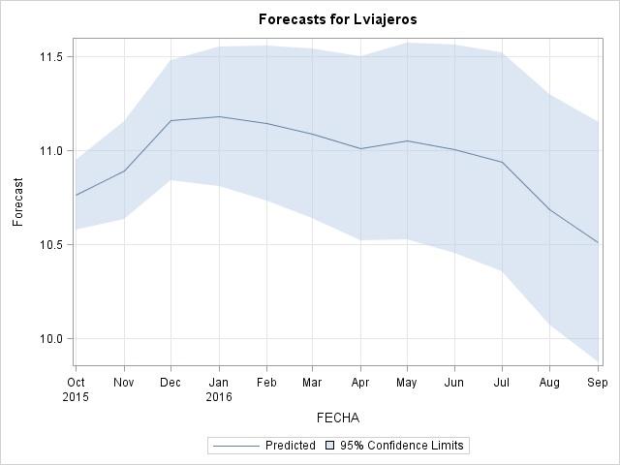

|  |
| --- |
| Estimaciones |

| **Obs** | **FECHA** | **Lviajeros** | **FORECAST** | **STD** | **L95** | **U95** | **RESIDUAL** |
| --- | --- | --- | --- | --- | --- | --- | --- |
| **202** | 01OCT15 | . | 10.7618 | 0.09418 | 10.5772 | 10.9463 | . |
| **203** | 01NOV15 | . | 10.8928 | 0.13320 | 10.6318 | 11.1539 | . |
| **204** | 01DEC15 | . | 11.1574 | 0.16313 | 10.8377 | 11.4772 | . |
| **205** | 01JAN16 | . | 11.1807 | 0.18837 | 10.8115 | 11.5499 | . |
| **206** | 01FEB16 | . | 11.1434 | 0.21060 | 10.7307 | 11.5562 | . |
| **207** | 01MAR16 | . | 11.0892 | 0.23070 | 10.6370 | 11.5413 | . |
| **208** | 01APR16 | . | 11.0113 | 0.24919 | 10.5229 | 11.4997 | . |
| **209** | 01MAY16 | . | 11.0505 | 0.26639 | 10.5284 | 11.5726 | . |
| **210** | 01JUN16 | . | 11.0078 | 0.28255 | 10.4540 | 11.5616 | . |
| **211** | 01JUL16 | . | 10.9392 | 0.29783 | 10.3554 | 11.5229 | . |
| **212** | 01AUG16 | . | 10.6855 | 0.31237 | 10.0732 | 11.2977 | . |
| **213** | 01SEP16 | . | 10.5096 | 0.32626 | 9.8701 | 11.1490 | . |

Prediciones

ods html;

ods graphics on;

/*Para quitar las transformaciones*/

**data** c;

set predicciones;

x = exp(Lviajeros);

forecast= exp(FORECAST);

l95=exp(L95);

u95=exp(U95);

**run**;

**PROC** **PRINT** DATA= c;

where fecha >= **'01oct2015'd**;

**RUN**;

ods graphics off;

ods html close;

|  |
| --- |
| Estimaciones |

| **Obs** | **FECHA** | **Lviajeros** | **FORECAST** | **STD** | **L95** | **U95** | **RESIDUAL** | **x** |
| --- | --- | --- | --- | --- | --- | --- | --- | --- |
| **202** | 01OCT15 | . | 47181.30 | 0.09418 | 39228.44 | 56746.46 | . | . |
| **203** | 01NOV15 | . | 53788.17 | 0.13320 | 41429.61 | 69833.32 | . | . |
| **204** | 01DEC15 | . | 70083.31 | 0.16313 | 50904.72 | 96487.52 | . | . |
| **205** | 01JAN16 | . | 71730.90 | 0.18837 | 49587.08 | 103763.36 | . | . |
| **206** | 01FEB16 | . | 69107.67 | 0.21060 | 45736.53 | 104421.35 | . | . |
| **207** | 01MAR16 | . | 65457.89 | 0.23070 | 41647.52 | 102880.91 | . | . |
| **208** | 01APR16 | . | 60552.23 | 0.24919 | 37155.51 | 98681.79 | . | . |
| **209** | 01MAY16 | . | 62976.38 | 0.26639 | 37361.63 | 106152.32 | . | . |
| **210** | 01JUN16 | . | 60341.13 | 0.28255 | 34682.21 | 104983.26 | . | . |
| **211** | 01JUL16 | . | 56339.53 | 0.29783 | 31426.57 | 101001.88 | . | . |
| **212** | 01AUG16 | . | 43716.15 | 0.31237 | 23700.19 | 80636.55 | . | . |
| **213** | 01SEP16 | . | 36664.03 | 0.32626 | 19343.15 | 69494.97 | . | . |

**7. Conclusiones.**

Predecir una serie temporal es muy difícil. Pero me ha gustado el ejercicio, pero tengo que estudiar mucho más para de verdad entender todo eso, porque aún es muy difícil para mi entender todo lo que he hecho, todos los conceptos, parámetros, etc.

(Incluir la sintaxis sas en cada apartado)

Codigo completo SAS:

**DATA** SERIES.ZARAGOZA;

SET SERIES.ZARAGOZA;

DROP FECHA;

**RUN**;

**DATA** SERIES.ZARAGOZA;

SET SERIES.ZARAGOZA;

FECHA = intnx( 'month', **'01jan1999'd**, _n_-**1** );

format FECHA DATE.;

**RUN**;

ods html;

ods graphics on;

**proc** **sgplot** data=SERIES.ZARAGOZA;

series x=FECHA y=VIAJEROS;

**run**;

ods graphics off;

ods html close;

ods html;

ods graphics on;

**proc** **timeseries** data=SERIES.ZARAGOZA PLOTS=(DECOMP PERIODOGRAM SERIES) PRINT=(SEASONS DECOMP);

id FECHA interval=month ;

var VIAJEROS;

**run**;

ods graphics off;

ods html close;

ods html;

ods graphics on;

**proc** **timeseries** data=SERIES.ZARAGOZA PLOTS=(DECOMP) PRINT=(SEASONS DECOMP);

id FECHA interval=month ;

var VIAJEROS;

**run**;

ods graphics off;

ods html close;

ods html;

ods graphics on;

**proc** **esm** data=SERIES.ZARAGOZA out=salida lead=**12** print=(FORECASTS)

plots=(FORECASTS MODELS SEASONS);

id FECHA interval=month;

forecast VIAJEROS;

**run**;

ods graphics off;

ods html close;

ods html;

ods graphics on;

**proc** **esm** data=SERIES.ZARAGOZA out=salida lead=**12** print=(FORECASTS)

plots=(FORECASTS MODELS SEASONS);

id FECHA interval=month;

forecast VIAJEROS / model=MULTwinters;

**run**;

ods graphics off;

ods html close;

ods html;

ods graphics on;

**proc** **sgplot** data=SERIES.ZARAGOZA;

series x=FECHA y=VIAJEROS;

where **'01jan1999'd** < FECHA < **'01jan2014'd**;

**run**;

ods graphics off;

ods html close;

ods html;

ods graphics on;

**proc** **esm** data=SERIES.ZARAGOZA out=salida lead=**12** print=(FORECASTS)

plots=(FORECASTS MODELS SEASONS);

id FECHA interval=month;

forecast VIAJEROS / model=MULTwinters;

where **'01jan1999'd** < FECHA < **'01jan2014'd**;

**run**;

ods graphics off;

ods html close;

ods html;

ods graphics on;

**proc** **esm** data=SERIES.ZARAGOZA out=salida lead=**12** print=(FORECASTS)

plots=(FORECASTS MODELS SEASONS);

id FECHA interval=month;

forecast VIAJEROS / model=Lineal;

where **'01jan1999'd** < FECHA < **'01jan2014'd**;

**run**;

ods graphics off;

ods html close;

ods html;

ods graphics on;

**proc** **esm** data=SERIES.ZARAGOZA out=salida lead=**12** print=(FORECASTS)

plots=(FORECASTS MODELS SEASONS);

id FECHA interval=month;

forecast VIAJEROS;

where **'01jan1999'd** < FECHA < **'01jan2014'd**;

**run**;

ods graphics off;

ods html close;

ods html;

ods graphics on;

**proc** **timeseries** data=SERIES.ZARAGOZA PLOTS=( SERIES ACF PACF) OUTCORR=AUTOCOR PRINT=ALL;

id FECHA interval=month ;

var VIAJEROS;

**run**;

**PROC** **PRINT** DATA=AUTOCOR;

**RUN**;

ods graphics off;

ods html close;

ods html;

ods graphics on;

**proc** **arima** data=SERIES.ZARAGOZA;

identify var = viajeros;

**run**;

ods graphics off;

ods html close;

ods html;

ods graphics on;

**proc** **arima** data=SERIES.ZARAGOZA;

identify var = viajeros(**1**);

**run**;

ods graphics off;

ods html close;

ods html;

ods graphics on;

**proc** **arima** data=SERIES.ZARAGOZA;

identify var = viajeros(**1** **12**);

**run**;

ods graphics off;

ods html close;

ods html;

ods graphics on;

**PROC** **ARIMA** data=SERIES.ZARAGOZA; identify var=viajeros(**1** **12**) nlag=**10**; estimate Q= (**12**);

**run**;

ods graphics off;

ods html close;

ods html;

ods graphics on;

**PROC** **ARIMA** data=SERIES.ZARAGOZA;

identify var=viajeros(**1** **12**) nlag=**10**;

estimate P= (**12**);

**run**;

ods graphics off;

ods html close;

**data** SERIES.ZARAGOZA;

set SERIES.ZARAGOZA;

Lviajeros=log(viajeros);

**run**;

/* ARIMA(0,1, 0)(0,1,1)12 */

ods html;

ods graphics on;

**PROC** **ARIMA** data=SERIES.ZARAGOZA;

identify var=Lviajeros(**1** **12**) nlag=**10**;

estimate Q= (**12**);

**run**;

ods graphics off;

ods html close;

/*ARIMA(0,1, 0)(1,1, 0)12*/

ods html;

ods graphics on;

**PROC** **ARIMA** data=SERIES.ZARAGOZA;

identify var=Lviajeros(**1** **12**) nlag=**10**;

estimate P= (**12**);

**run**;

ods graphics off;

ods html close;

ods html;

ods graphics on;

**PROC** **ARIMA** data=SERIES.ZARAGOZA;

identify var=Lviajeros(**1** **12**) nlag=**10**;

estimate Q= (**12**) noconstant;

forecast lead=**12** id=fecha interval=month out=predicciones Printall;

**run**;

title "Estimaciones";

title "Estimaciones";

**PROC** **PRINT** DATA= predicciones;

where fecha >= **'01oct2015'd**;

**RUN**;

ods graphics off;

ods html close;

ods html;

ods graphics on;

/*Para quitar las transformaciones*/

**data** c;

set predicciones;

x = exp(Lviajeros);

forecast= exp(FORECAST);

l95=exp(L95);

u95=exp(U95);

**run**;

**PROC** **PRINT** DATA= c;

where fecha >= **'01oct2015'd**;

**RUN**;

ods graphics off;

ods html close;

Entrega:

Enviar Fichero Word a través del enlace del Campus ‘Serie final

analizada‘.

Fecha límite: 9/11/2015 a las 23 horas.