Economic Assessment of Health Care – 2021/1
Vrije Universiteit Amsterdam
Federal University of Health Sciences of Porto Alegre
Practical Exercise
Exercise 1: Decision trees

This exercise is a continuation of the presented model for the cost-effectiveness of diagnostic strategies for the detection of thyroid cancer. The PET scan will be added to the list of possible diagnostic tools. The goals of the exercise are to understand how to estimate model parameters and how to evaluate different diagnostic strategies.

The list below is a rough sketch of the tasks you will perform in this exercise. A detailed description of every step in the exercise follows.

- Construct 2 new decision trees
- Estimate the sensitivity of the PET scan on the basis of published studies.
- Compare the different diagnostic strategies
- Estimate the impact of varying an important model parameter

Detailed explanation of exercise 1: Decision trees

- Construct decision trees

Two possible strategies (A en B) are shown together in the one decision tree that is depicted below. These strategies are based on the Technetiumscan (Tc scan, current practice) and the colouring of biomarker Galectine-3 (Gal-3).

Figure 1: Decision tree for strategies A and B

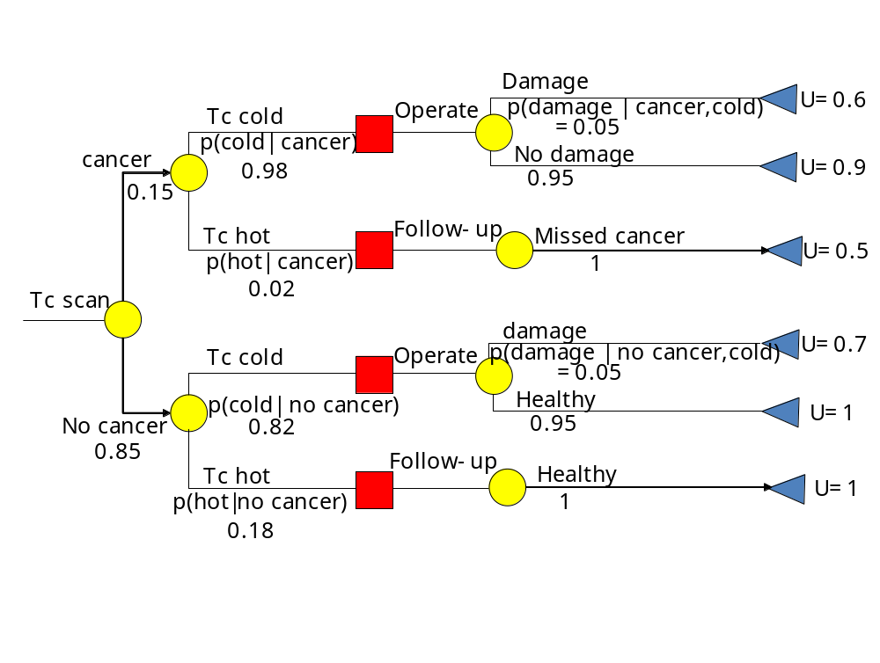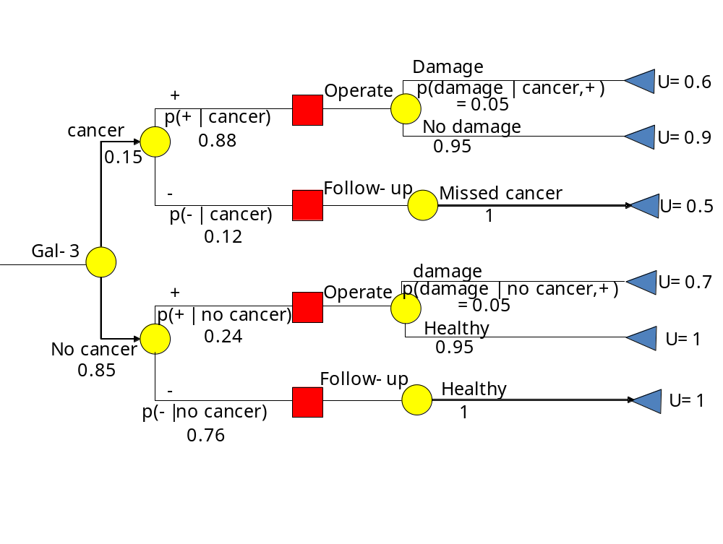
Two other possible strategies are:
strategy C: only PET scan. After a positive PET, an operation follows and after a negative PET follow-up.
strategy D: PET after Gal-3 colouring. A positive Gal-3 colouring leads to an operation. After a negative Gal-3 colouring a PET scan is performed. After a positive PET an operation follows, after a negative PET follow-up is done.

Draw the decision tree for strategies C and D below. Fill in the probabilities and utilities as far as they are known from the decision tree for strategy A and B.

Figure 1.2. Decision tree strategy C (PET scan) 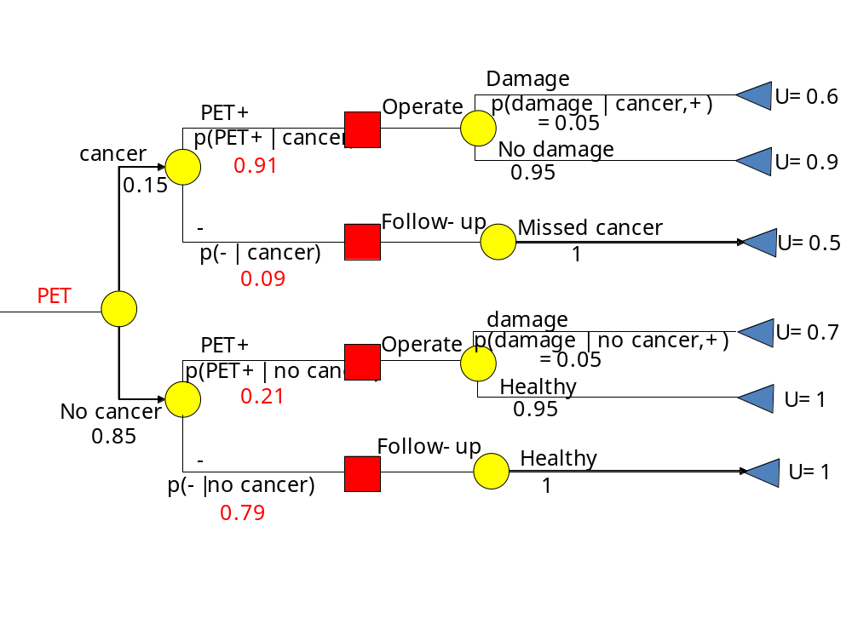
Figure 1.3: Decision tree strategy D (Pet scan after Gal-3 colouring)

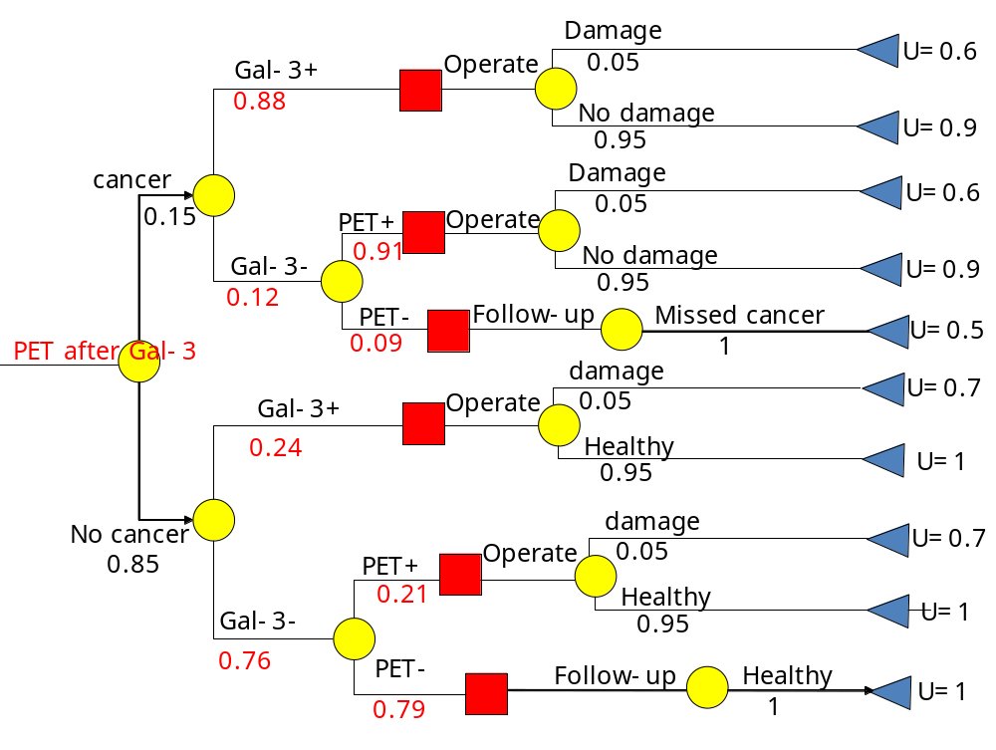

b) Estimating the sensitivity of the PET scan

Below, the results of several studies into the diagnostic value of the PET scan for thyroid cancer are given. Calculate the pooled sensitivity and specificity (percentages) and fill these in into the decision trees of strategies C and D.

Table 1.1. PET scan results
 |  | Correct positive | False positive | False negative | Correct negative
Uematsu |  | 4 | 3 | 0 | 4
Joensuu |  | 4 | 3 | 2 | 5
Kresnik |  | 8 | 2 | 1 | 13
Wolf |  | 7 | 1 | 0 | 8
Sasaki |  | 2 | 1 | 0 | 7
Bloom |  | 4 | 3 | 0 | 12
Totaal |  | 29 | 13 | 3 | 49

Pooled sensitivity: 29/32 = 91%
Pooled specificity: 49/62 = 79%

c) Cost-effectiveness analysis

The medical costs of diagnosis/treatment/follow-up per patient are:

Table 1.2. Medical costs
Cost source | €
Tc scan | 154
Gal-3 colouring | 174
PET scan | 450
Operation (malignancy) | 5000
Operation (benign) | 3000
Follow-up | 147

1. Calculate the expected costs and utilities per strategy.
The expected costs are calculated by multiplying the probability of reaching each endpoint by the costs associated with reaching that endpoint. Subsequently, the 6 values are summed. The expected utility is calculated analogously. Assume in the calculation of the costs that cancer patients missed in the diagnostic strategy are discovered after 1 year of follow-up and operated. For strategies A and B, the expected costs and utilities have been calculated already and are presented in Table 1.3. Fill in the costs and utilities for strategies C and D in Table 1.4. Note that the number of endpoints for strategy D is 10, not 6.

Table 1.3. costs and utilities strategies A and B
Endpoint | Strategy A |  |  | Strategy B
 | Probability | Costs(€) | Utility | Probability | Costs(€) | Utility
Cancer present
Treated,  Morbidity | 0.0074 | 5154 | 0.6 | 0.0066 | 5174 | 0.6
Treated,  no morbidity | 0.1397 | 5154 | 0.9 | 0.1254 | 5174 | 0.9
Missed cancer,  treated after follow-up | 0.0030 | 5301 | 0.5 | 0.0180 | 5321 | 0.5
Cancer absent
Treated,  Morbidity | 0.0349 | 3154 | 0.7 | 0.0102 | 3174 | 0.7
Treated,  no morbidity,  or not treated | 0.6622 | 3154 | 1 | 0.1938 | 3174 | 1
Not treated,  No cancer | 0.1530 | 301 | 1 | 0.6460 | 321 | 1
Total | Sum probability  1 | Expected costs:  3018 | Expected utility  0.9711 | Sum probability  1 | Expected costs:  1633 | Expected utility  0.9728

Table 1.4. Costs and utilities strategies C and D.
Eindstadium | Strategy C |  |  | Strategy D
 | Probability | Costs(€) | Utility | Probability | Costs(€) | Utility
Cancer present
Treated,  Morbidity | 0.0068 | 5450 | 0.6 | 0.0066 | 5174 | 0.6
 |  |  |  | 0.0008 | 5624 | 0.6
Treated,  No morbidity | 0.1297 | 5450 | 0.9 | 0.1254 | 5174 | 0.9
 |  |  |  | 0.0156 | 5624 | 0.9
Missed cancer,  treated after follow-up | 0.0135 | 5597 | 0.5 | 0.0016 | 5771 | 0.5
Cancer absent
Treated,  Morbidity | 0.0089 | 3450 | 0.7 | 0.0102 | 3174 | 0.7
 |  |  |  | 0.0068 | 3624 | 0.7
Treated,  No morbidity | 0.1696 | 3450 | 1 | 0.1938 | 3174 | 1
 |  |  |  | 0.1289 | 3624 | 1
Not treated,  No cancer | 0.6715 | 597 | 1 | 0.5103 | 771 | 1
Total | Sum probability  1 | Expected costs:  1836 | Expected utility  0.9749 | Sum probability  1 | Expected costs:  2317 | Expected utility  0.9770

With respect to the calculations:
The expected costs are obtained by multiplying the costs per endpoint with the probability of each endpoint and then sum over all endpoints. So the expected costs of strategy C are: 5450x 0.0068+5450x0.1297+5597x0.0135+ ..... = 1836.
The expected utility is computed analogously.

2. Indicate the position of the four strategies on the cost-effectiveness plane below and draw the cost-effectiveness frontier that connects dominant strategies. The strategies that lie on this cost-effectiveness frontier are not dominated by any other strategy.

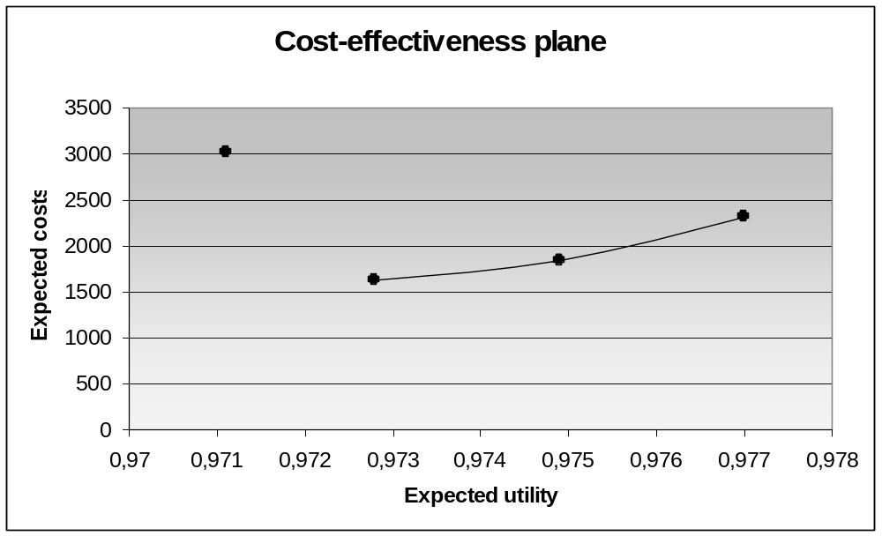
3. From Table 1.4, it follows that strategies B, C and D are cheaper than strategy A and that they have a higher utility. Check whether strategies with PET (strategies C and D) are cost-effective when compared to strategy B (Gal-3 colouring). For this purpose, calculate the extra costs per utility that is gained by replacing strategy B by strategy C or D and fill in the values in Table 1.5.

Table 1.5. Cost-effectiveness of C and D compared B.
 | Extra costs | Extra utility | Extra costs per utility gained
C compared to B | 203 | 0.0021 | 96,667
D compared to B | 684 | 0.0042 | 162,857

4. Which strategy with PET would you choose on the basis of Table 1.5 if the extra costs per utility gained should not be higher than 150,000? Which of the 6 endpoints contributes most to the difference between the costs of strategies C and D? Wat can be concluded with respect to the choice of strategy.?
Choice: strategy C.
Endpoint: No cancer – treated – No morbidity.
Conclusion: with strategy D, more patients are treated unnecessarily than with strategy C. This leads to a strong increase in costs.

d) The sensitivity of the PET scan

1. We are interested to know what the influence is of the sensitivity of the PET scan on the cost-effectiveness results. For this purpose, we lower the sensitivity to 81%. The re-calculated expected utilities and costs per patient for strategies C and D are shown in Table 1.6.

Table 1.6. Costs and utilities of strategies C and D for a sensitivity of the PET scan of 81%.
 | Expected costs | Expected utility
Strategy C | €1838 | 0.9691
Strategy D | €2317 | 0.9763

Interpret the outcomes of these calculations.
The outcomes of strategy D have changed less than the outcomes of strategy C when the sensitivity of the PET scan is lowered. This suggests that the evidence of cost-effectiveness of strategy C compared to strategy A is insufficient, because after lowering the sensitivity of PET, the expected utility of strategy C is lower than the expected utility of strategy A.

2. Indicate again the position of the four strategies on the cost-effectiveness plane below and draw the cost-effectiveness frontier that connects dominant strategies.

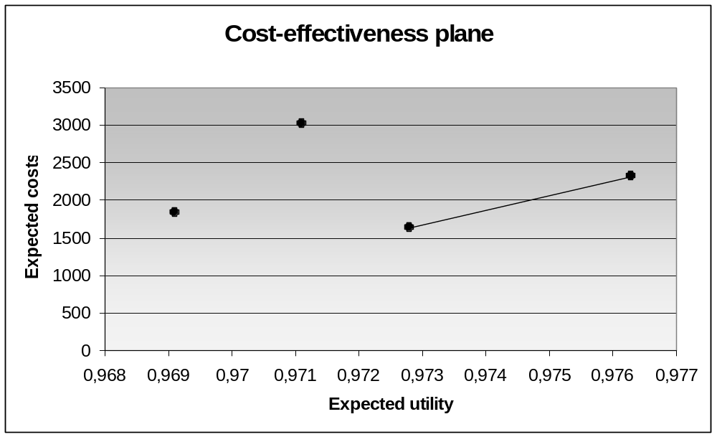

3. Which assumption with respect to the sensitivities of Gal-3 colouring and the PET scan has been done in the decision tree of strategy D?
Sensitivities of Gal-3 colouring and PET scan are independent.

