Economic Assessment of Health Care – 2021/1
Vrije Universiteit Amsterdam
Federal University of Health Sciences of Porto Alegre
Practical Exercise
Exercise 2: Markov models

This exercise is a continuation of the presented Markov model for the cost-effectiveness of screening for cervical cancer. In the exercise, the file `exercise-markov-model.xls` is used. This file contains a module for computations on the basis of the presented Markov model. The goals of the exercise are to understand how to estimate model parameters, to understand the structure of the Markov model and to be able to evaluate different strategies.

The cells in the excel sheets that should be filled out are highlighted in yellow. The cells with model results are blue. The list below is a rough sketch of the tasks you will perform in this exercise. A detailed description of every step in the exercise follows.

a) Estimate the probability of spontaneous cure of a CIN1/2 lesion on the basis of a Kaplan-Meier figure.
- Interpret the outcomes of the Markov model.
- Compare the different strategies in a cost-effectiveness plane.

Detailed explanation of exercise 2: Markov models

Open the spreadsheet `exercise-markov-model.xls`. In the cells of worksheet `Frequencies`, the Markov model is programmed. The model has a cycle length of 1 year and starts at age 30. The parameters for the model can be found in the worksheet `Model parameters`.

a) Estimating a transition probability: yearly probability to cure from CIN1/2.

The probability of the transition from CIN1/2 to Healthy (yearly probability to cure CIN1/2 in worksheet `Model parameters`) can be estimated from the Kaplan-Meier survival curve shown below (Figure 2.1) (Nobbenhuis et al., Lancet, 2001, p.1782-3). The graph shows the percentage of women that is not cured at any point in time.

Figure 2.1. Kaplan-Meier curve for cure of CIN1/2.
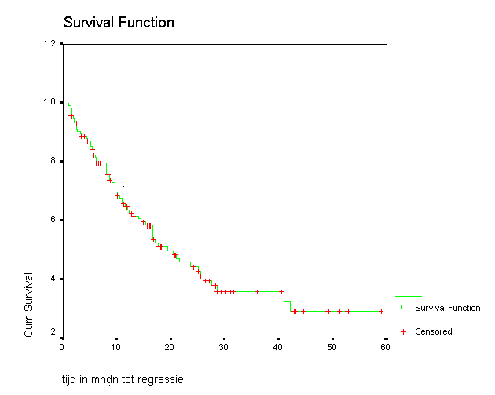

Estimate the yearly probability to cure from CIN1/2 from Figure 2.1. (Method: read from the graph the proportion of women who still has a CIN1/2 at 12 months. The remaining women were cured after one year)
Fill in this value in the worksheet `Model parameters` (rounded upwards in unities of 10 percent, so 10%, 20%, 30% …)
At 12 months, the proportion of women who still has a CIN1/2 is 63%. This is the chance not to be cured in 1 year, so the probability of yearly cure is 100% - 63% = 37%. Rounding gives 40%.

b) Interpretation of model outcomes and effectiveness outcomes

1. In the worksheet `Model parameters`, the parameter yearly probability of HPV infection is different for the age categories 30-34, 35-39, and 40 years or older. Therefore, the transition matrix will not be the same for all ages.
Go to the worksheet `Frequencies`. When you enter a specific age in cell C1, the transition matrix of the Markov model appears. Do you understand the matrix, and do you understand how the cells of the matrix depend on age?

Look at the formula in cell B4:
=hpvinf1*IF(C1<35;1;0) + hpvinf2*IF(C1>34;1;0)*IF(C1<40;1;0) + hpvinf3*IF(C1>39;1;0)

If age less than 35, multiply hvpinf1 by 1.
If age greater than 34 and less than 40, multiply hpvinf2 by 1.
If age greater than 39, multiply hpvinf3 by 1.

2. To use the model for computations, first the start prevalences of the model have to be entered in cells B15 to F15 of worksheet `Frequencies`. These start prevalences are shown in Table 1.1.

Table 1.1. Start prevalences of each disease state at 30 years of age.
State | Start prevalence
Healthy | 0.87
HPV infection | 0.09
CIN1/2 | 0.018
CIN3 | 0.018
Cancer | 0.004

The Markov model formulas for the transition of age 30 to age 31 are programmed in cells B16 to F16. Do you understand the formulas in cells B16 to F16? Note that the transitions from state CIN1/2 and state CIN3 depend on the presence of screening. In the absence of screening, the transition matrix is applied simply as shown in the upper left corner of the worksheet `Frequencies`. To calculate the frequencies in the absence of screening, adapt the maximum age of screening (in the worksheet 1 `Model parameters`) to 0 instead of 60 years. Check the proportions of women you find in each state at age 31 in the worksheet `Frequencies` by making a flowchart for the transitions between age 30 and 31 and calculating manually the proportions in each state (as shown in sheet 9 of the lecture on Markov models).
0.87
0.051
0.904
0.023
0.018
0.09
0.018
0.018
Healthy
HPV+
CIN1/2
CIN3
* 0.967
* 0. 033
* 0. 15
Age 30
Age 31
0.0047
0.004
Cancer
* 0.6
* 0.25
* 0. 1
* 0.40
* 0.5
* 0. 04
* 0.06
* 0.9
* 1

3. In the worksheet `Model parameters`, the screening parameters have been chosen such that they correspond to the current screening situation in The Netherlands.
- Screening with the Pap smear (cytology)
- Screening interval 5 years
- Attendance rate 80%
- Maximum age of screening 60 years
What is the cumulative incidence of cancer until age 80, according to the model?
0,01003429

4. Model predictions for a situation without screening are obtained by changing the maximum age of screening to 0 in worksheet `Model parameters`. How strong is the reduction in cumulative incidence until age 80 due to Pap screening in comparison to a situation without screening? [Hint: cumulative incidence reduction = (cumulative incidence without screening – cumulative incidence with screening/ cumulative incidence without screening].
(0,0224268 - 0,01003429) / 0,0224268 = 0,5525759 = -55%
5. Go to the worksheet `Incidence cancer`. The graph shows the smoothed mean incidence of cancer. Study the graph for the current Dutch situation (screening each 5 years) and the situation without screening. Read from the graph the minimum and maximum incidences in both situations.
No screening: maximum at age of 33 years with incidence of 73 per 100,000 women years; minimum at age of 78 years with 20 per 100,000 women years.
Screening each 5 years: maximum at age of 33 years with 32 cases per 100,000 women years, minimum at age of 63 years with 5 cases per 100,000 women years.

6. Explain why the ages at which the incidences are minimal and maximal change when we go from a situation without screening to a situation of screening each 5 years?
The reduction of incidence occurs earlier when women are screened every 5 years compared to no screening. As screening stops at age 60, the incidence starts to rise after 63 years of age.

c) Cost-effectiveness analysis

1. Go to the worksheet `Costs`. Are the formulas in cells C3 to J3 clear to you? Calculate the number of cancer free life years per woman and the costs per women in the situation without screening (use the discounted numbers). Enter these numbers in Table 1.2.

2. Calculate the number of discounted cancer free life years per woman and the discounted costs per women for the following screening strategies:
- Pap smear screening with intervals of 3 years and 5 years,
- HPV-DNA screening with intervals of 3 years and 5 years
- Combined screening (Pap+HPV-DNA) with intervals of 3 years and 5 years.

To perform the calculation, the screening interval, the probabilities of a positive test result and the screening costs must be changed to the correct value in worksheet Model parameters. The values for the parameters in each of the screening strategies are given in Table 1.2.

Table 1.2. Probability of a positive test result and the costs per test
 | Pap smear test | HPV-DNA test | Combined tests
Positive if healthy | 2% | 0% | 2%
Positive if HPV infected | 2% | 95% | 95.1%
Positive if CIN1/2 | 50% | 95% | 97.5%
Positive if CIN3/cancer | 80% | 95% | 99%
Costs per test | €50 | €60 | €80
Write the discounted cancer free life years per woman and the discounted costs per women in the first two column of Table 1.3 below and complete the worksheet `CE-plane data`.

Table 1.3. Effects and costs of the screening strategies
 | Discounted cancer free life years | Discounted costs (€) | Gained cancer free life years | Extra costs (€)
No screening | 26.368 | 155.05 | 0 | 0
Pap smear screening
Interval 3 year | 26.572 | 493.90 | 0.204 | 338.85
Interval 5 years | 26.547 | 365.79 | 0.179 | 210.74
HPV-DNA screening
Interval 3 years | 26.594 | 600.17 | 0.226 | 445.12
Interval 5 years | 26.574 | 441.69 | 0.206 | 286.64
Combined screening
Interval 3 years | 26.597 | 752.62 | 0.229 | 597.57
Interval 5 years | 26.578 | 538.75 | 0.21 | 383.70

3. For each screening strategy, calculate the number of cancer free life years gained, and the extra costs compared to no screening in the `CE-plane data. Enter the calculated values in the last two columns of Table 1.3 and fill in cells A3 to N3) with the numbers in the worksheet `CE-plane` to plot Figure 1.2.

4. Find the dominant strategies by drawing the cost-effectiveness frontier. To draw the cost-effectiveness frontier, one searches the strategy for which the line that connects it to the origin has the highest inclination. When this is done, start again from the strategy that you found and search the next strategy for which the connecting line has the highest inclination. Draw this line until no strategy can be found with a connecting line with positive inclination. The strategies that lie on this frontier are not dominated by any other strategy.

5. Can you interpret the inclination of the cost-effectiveness frontier?
The cost-effectiveness frontier is the difference in y (i.e., gained cancer free life years) divided by the difference in x (i.e., extra costs) between each two consecutive points on the line. The incremental cost-effectiveness ratio (ICER) is just the inverse of this ratio.

6. Which non-dominated strategy would you choose if you accept a cost-effectiveness ratio of at most €5000 per cancer free life year that is gained in comparison to the cheaper non-dominated strategy that lies closest on the cost-effectiveness frontier? (Hint: to decide which strategy to choose, calculate the ICER between non-dominated strategies in the worksheet `CE-plane`).
PAP screening every 3 years and combined screening every 5 years are dominated strategies.
To decide which strategy to choose, the ICERs have to be calculated.
ICER Pap 5 compared to no screening = (365.79 – 155.05) / (26.547 – 26.368) = 1177.32
ICER HPV-DNA 5 compared to Pap 5 = (441.69 – 365.79) / (26.574 – 26.547) = 2811.11
ICER HPV-DNA 3 compared to HPV-DNA 5 = (600.17 – 441.69) / (26.594 – 26.574) = 7924
ICER Combined 3 compared to HPV-DNA 3 = (752.62 – 600.17) / (26.597 – 26.594) = 50816.67

The ICERs of combined screening every 3 years and HPV-DNA screening every 3 years exceeds € 5000 per cancer free life year that is gained. Therefore, HPV-DNA screening every 5 years is chosen.
Figure 1.2. Cost-effectiveness plane
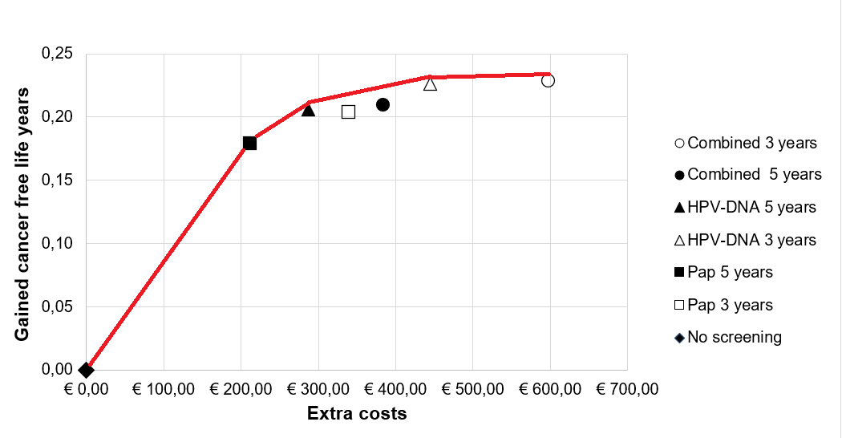
Red line = cost-effectiveness frontier

