NARRATIVE ATTRACTORS: WHY STORIES CONVERGE WHEN LANGUAGE-MODEL AGENTS SHARE A ROLE-PLAYING WORLD
Abstract
Generative AI is entering classrooms as co-author and game master. We asked whether a shared fictional world where language-model agents act freely produces many storylines or collapses into one. From the causal graphs of 44 simulated sessions (3,744 events, four models, two worlds), storylines vanish by fusion, not closure: 64% merge into another and under 5% reach a stable end. Almost all are born on day two, and most sessions keep a single story by day five. Convergence is driven by density, as almost every event cites a cause, and its path is shaped by attractors: first fusions join characters whose premises already referred to each other (75% vs. 61% under a null model) in the places those premises name. We discuss implications for critical AI literacy and educational role-play.
Keywords: generative AI; role-playing games; emergent narrative; causal graphs; attractors; AI literacy; media literacy

Introduction
Tabletop role-playing games have long been used in education as spaces for shared imagination, perspective-taking and collaborative problem solving (Bowman, 2010; Daniau, 2016; Fine, 1983). Their narrative is not written in advance: it emerges from what the participants do inside a shared world, under explicit and implicit rules (Montola, 2008). Large language models (LLMs) now make it possible to populate such worlds with artificial characters that remember, plan and talk to each other (Park et al., 2023), and to place an AI in the role of the game master (Callison-Burch et al., 2022). Teachers and students are already experimenting with these uses.
At the same time, a growing body of evidence shows that generative models homogenise what they help to produce. Writers assisted by a model produce less diverse texts (Padmakumar & He, 2024); stories written with AI ideas are individually rated as more creative but are more similar to each other (Doshi & Hauser, 2024); LLM stories reuse a narrow repertoire of plot elements (Xu et al., 2025) and follow more uniform arcs than human stories (Beguš, 2024; Tian et al., 2024). These studies look at single texts produced from a prompt. Much less is known about what happens to the structure of a story when it is not written by one model in one pass but emerges, day after day, from the actions of several agents in a shared world, the situation closest to a role-playing game.
This paper reports an experiment on that question. We built a simulator in which language-model agents live in a small fictional town, each with an objective, a secret and a few beliefs, and act freely for 12 to 20 in-game days. Nothing in the prompts mentions acts, climax, resolution or any other narrative structure. Every action is recorded as an event, together with the earlier events the agent declares as its causes. The result is a causal graph in which a storyline can be read as a connected set of events (Trabasso & van den Broek, 1985). Our pre-registered hypothesis was that such a free story converges: storylines that emerge tend to close, and beginning, middle and end appear as properties of the graph rather than as phases imposed on the generation.
The answer we found is more specific, and more relevant for education, than a simple yes or no. Storylines do converge, but almost never by closing: they merge until a single story remains. We describe that process in the vocabulary of dynamical systems, where an attractor is a state, or set of states, toward which trajectories starting from many different initial conditions evolve (Lorenz, 1963; Strogatz, 2015). We show that the single-story state behaves as a global attractor of these simulated worlds, and we identify the attractor events that pull separate storylines together: events in which characters whose premises were already entangled meet, in the places those premises name.
The contributions are threefold. First, an auditable method to measure convergence in emergent narratives that separates two processes usually confounded, the closure of a storyline and its fusion with another. Second, empirical evidence, from 44 sessions with four versioned models, that fusion dominates and that its course is shaped by the initial conditions authored by humans. Third, a discussion of what this means for critical AI literacy: when generative agents tell stories together, the story that emerges is less open than it looks, and the levers that shape it are visible and can be taught.

Background

Stories as causal graphs
Structuralist narratology distinguishes the events that hold a plot together, kernels or nuclei, from those that elaborate it, satellites or catalysers (Barthes & Duisit, 1975; Chatman, 1978). Cognitive studies of comprehension operationalised this idea as a causal network: an event belongs to the main chain of a story when it has causal antecedents and consequences, and readers remember and judge as important the events with more causal connections (Trabasso & van den Broek, 1985). Computational narrative inherited the representation. Narrative planners build plots as partially ordered causal structures (Riedl & Young, 2010), and simulation-driven storytelling treats the log of a simulated world as raw material from which stories are later curated (Ryan, 2018). We follow this tradition: each event records its declared causes, and a storyline is a connected component of the resulting graph.

Emergent narrative and shared worlds
Emergent narrative is the idea that a story can arise from the interaction of autonomous characters and participants rather than from a script (Aylett, 1999; Louchart & Aylett, 2004). Its persistent difficulty is shape: autonomous agents produce events, but events do not necessarily add up to stories with beginnings and endings (Riedl & Bulitko, 2013). Interactive drama addressed the problem with a drama manager that steers the action toward a planned arc (Mateas & Stern, 2003); storylet systems address it by authoring small, conditioned narrative fragments (Kreminski & Wardrip-Fruin, 2018). Game studies add a spatial perspective: game worlds tell stories through the arrangement of places, which channel movement and encounters (Jenkins, 2004). Role-playing studies, in turn, show that the rules that shape a shared fiction are often invisible and social rather than written (Fine, 1983; Montola, 2008).
Generative agents change the terms of this debate. Their behaviour is believable and memory-driven (Park et al., 2023), but it is produced by a model trained to continue text coherently, which may favour connecting new events to existing ones over starting new threads. Whether that tendency yields well-shaped stories, endless sprawl or something else is an empirical question.

Attractors
In a dynamical system, an attractor is a set of states toward which the system evolves from a wide range of initial conditions; the set of initial conditions that lead to it is its basin of attraction (Strogatz, 2015). Chaotic systems combine sensitivity to initial conditions at the level of individual trajectories with stable large-scale structure: two trajectories of the Lorenz system diverge quickly, yet both remain on the same attractor (Lorenz, 1963). We use the concept in two ways. At the macro level, we ask whether different sessions, with different models, worlds, seeds and conditions, end in the same structural state. At the micro level, we call attractor events the events through which separate storylines are pulled into one, directly (an event that cites causes in both storylines) or indirectly (through intermediate events), and we ask what they have in common. The analogy is heuristic: a simulated story is not a low-dimensional deterministic system. But it gives precise questions: what is the end state, how fast is it reached, how large is its basin, and which initial conditions decide the path.

AI literacy and media literacy
Media literacy asks learners to analyse how messages are constructed and by whom (Hobbs, 2010). AI literacy extends the question to systems that generate content: learners should understand what AI can and cannot do, how it represents knowledge and how its outputs are shaped (Long & Magerko, 2020; UNESCO, 2024). Homogenisation findings (Doshi & Hauser, 2024; Xu et al., 2025) have made the shaping of generated stories a topic in its own right. Most work, however, considers a single generated text. Shared-world play with AI agents is a different object: the story is co-produced over time by many prompts, and the forces that shape it are distributed across the world design, the agents and the rules of play. Making those forces visible is a precondition for using such play critically in education.

Method

The simulator
The simulator runs a small fictional town for a fixed number of in-game days. Each world defines five or six places, three factions and a cast of agents, each with an objective, a secret and two beliefs (Table 1). We used two worlds written for the study: Porto das Brumas, a harbour town where salt merchants, a smuggling brotherhood and the harbour guard compete, and Vale Silente, a mountain village isolated by a landslide before winter. Sessions used six agents. Every day, one call to the agents’ model decides what each character does; for each action, the model writes a short text, names the place and the witnesses, and lists the identifiers of the recent events (from the previous three days) that made the action possible. The prompt explicitly allows the list to be empty. A second call writes what characters tell each other. A fixed curator model narrates storylines that become stable, and a fixed synthetic player can take part in some conditions. The model of the agents is the experimental variable; the curator and the player are held constant across conditions.
Table 1
The two worlds and the premises of their six active agents (abridged; translated).
World | Agents (objective; secret or belief that refers to another agent)
Porto das Brumas | Odete, merchant (wants the late Vasco’s warehouse; owes money to the smuggling brotherhood) · Brás, guard captain (takes bribes; believes the new inspector is spying on him) · Lia, smuggler (wants to lead the brotherhood; informs the guard) · Tomás, chaplain (knows who was in the warehouse the night Vasco died) · Iracema, Vasco’s widow (believes her husband hid papers in the warehouse) · Nuno, customs inspector (investigates why the customs books do not add up)
Vale Silente | Anselmo, elder (secretly sold the village’s grain) · Marta, shepherd (blames wolves for losses she caused) · Sister Clara (believes the miller hides something) · Joaquim, miller (shelters a wounded stranger in the mill) · Benedita (wants to open a trail before winter) · Rui, goatherd (saw someone leaving the mill at dawn)
Nothing in any prompt refers to narrative structure. An automated test scans every prompt for structural terms (act, phase, climax, resolution, hero’s journey and their Portuguese equivalents) and for instructions to converge (tie up, conclude, resolve, close), and fails the build if any is present. As a control, the simulator also runs a conventional three-act game master over the same worlds.

From events to storylines
Each session yields an event log and a directed graph whose edges go from a declared cause to its effect. Following the causal-network view of narrative (Trabasso & van den Broek, 1985), a storyline is a connected component of the graph of events with causal connections, recomputed every day. A storyline is stable when it receives no new consequence for k = 3 consecutive days.
Our pre-registration defined convergence through the number of open storylines, which should stop growing in the last third of the session (Nosek et al., 2018). A first round of validation showed that this measure was confounded: the number of open storylines fell in almost every session, but mostly because storylines merged, not because they ended. We therefore amended the pre-registration, before any confirmatory campaign, to track the lineage of each storyline: its birth (a component whose events belonged to no storyline the day before), its fusion (its events become part of another storyline) and its closure by stability. The main metric became the share of storylines that close by stability before being absorbed. All amendments are dated and public in the repository.
Formally, let G_{d} = (V_{d}, E_{d}) be the causal graph at the end of day d, where V_{d} holds the events of days 1,…,d and (u, v) ∈ E_{d} when event v declares u as a cause and u is not later than v. Let L_{d} be the set of connected components of the subgraph of events that have at least one causal connection. A storyline T ∈ L_{d} is born on day d if none of its events belonged to a storyline in L_{d−1}; it fuses on day d if its events belong, on day d, to a storyline with a different identifier; and it closes on day d if it is stable on day d for the first time. A storyline that keeps its events but receives a new identifier because of a fusion is a renaming, not a birth. If N storylines are born in a session, C of them close before fusing and F fuse before closing, the main metric is C/N and its companion is F/N. Because components only grow or merge as events are added, L_{d} can only lose members by fusion or gain them by birth; closure does not remove a storyline from the graph, it only marks it as having stopped growing. The number of open storylines falls by one both when a storyline closes and when two of them merge, which is why that number alone cannot distinguish an ending from a merger.

Sessions
We analyse 44 sessions of the shared world, generated with four versioned models as agents (claude-haiku-4-5-20251001, claude-sonnet-4-6, claude-sonnet-5 and claude-opus-5), in four rounds: (1) 16 sessions of 12 days, crossing the four models, the two worlds and whether the state of storylines is shown to the agents; (2) 8 sessions in which each cause carries a declared type and strength; (3) 8 sessions in which agents may cite at most two causes per action; and (4) 12 sessions of 20 days, with two models, two worlds and three repetitions with new seeds. Rounds 2 and 3 use the same models, worlds and seeds as the corresponding sessions of round 1. Eight sessions of the three-act control serve as a reference. In total, the shared-world sessions contain 3,744 events.

Validation of the declared causes
A causal graph built from what a model declares is only as good as those declarations. We validated them in three ways. A blind judge model, not used as a generator, rated declared links as plausible far more often than distractor pairs from the same session (97% against 73%). In a counterfactual test, a judge estimated how necessary event A was for event B on a 0–100 scale: 67 on average for declared direct links, 44 for indirect ancestors and 21 for unlinked pairs, with an area under the ROC curve of 0.92 between direct and unlinked pairs. Finally, a null model rewired every event’s causes at random among earlier events, keeping how many causes each event has, and the analysis was repeated 500 times per session. Human annotation of a stratified sample of 216 links by two annotators has been prepared and is reported separately.

Measuring attractors
We use four measures. The basin is the number of storylines not yet absorbed on each day, and the day on which a single storyline remains. Direct fusions are those in which the event that merges two storylines cites causes in both of them; the others are indirect. Premise attraction compares, for the first fusion between two storylines that had not merged before, whether the characters who started them are linked in the world premises. Two characters are linked when the objective, secret or a belief of one of them mentions the other by name, title or unique role, or something only the other owns (Table 1); the coding is published with the analysis script. The comparison is made against the same pairs under the null model, so that the effect of link density is discounted. Spatial attraction compares the share of fusion events that happen in the places named in more than one premise (the warehouse and the customs house in Porto das Brumas; the mill in Vale Silente) with the same share under the null model. We also measure the entropy of the distribution of events over places on each day, and the concentration of incoming links, to check whether a few events act as hubs (Barabási & Albert, 1999; Newman, 2018). All analyses are scripted and reproducible from the event logs.

Results

Storylines merge; they rarely close
Figure 1 shows what happens to the storylines of the 32 twelve-day sessions. By day 12, 64% of them have been absorbed by another storyline, and only 4.5% have reached a stable ending. In the first round alone (16 sessions), 59% of the storylines were absorbed and 8% closed; only 2 of the 16 sessions (12.5%) satisfy the amended definition of convergence, whereas 15 of 16 (94%) satisfied the original one. The original measure would have confirmed the hypothesis by an artefact.
Figure 1
Cumulative share of storylines absorbed by fusion and closed by stability, mean of the 32 twelve-day shared-world sessions.
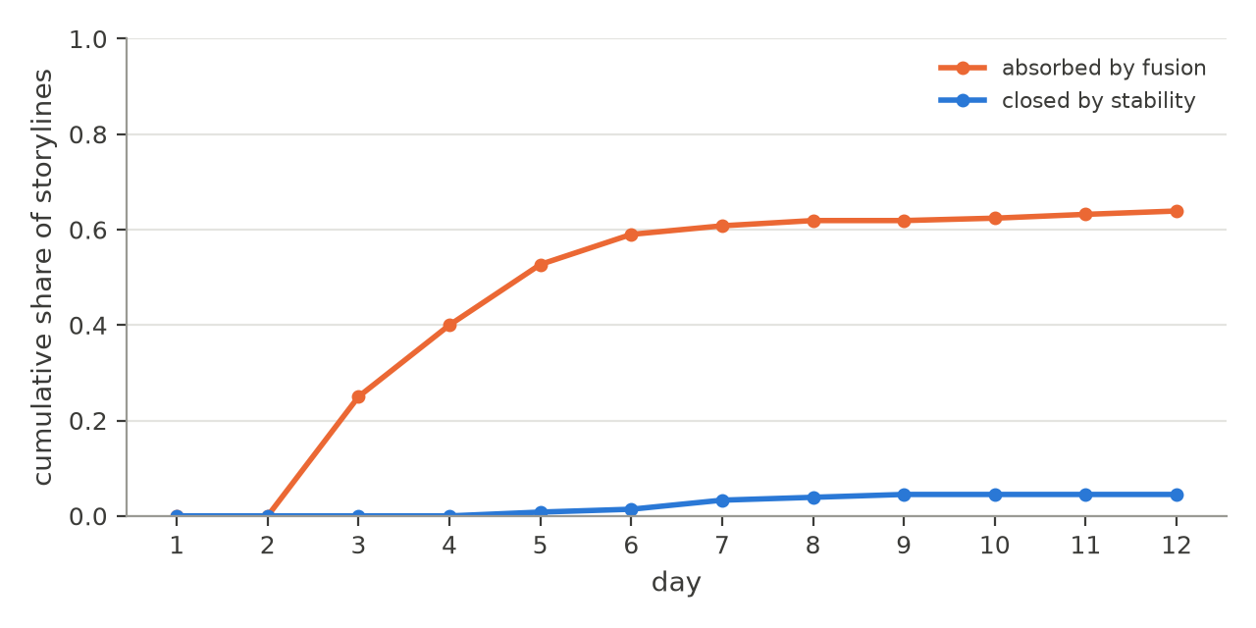

A single-story attractor
Across the 44 sessions, 191 of the 194 storylines were born on the second day, when the first actions start citing each other. After that, new storylines practically never appear: of the 3,480 events generated after the first day, only 9 (0.3%) cite no cause, although the prompt says that the list may be empty. Each event cites 1.95 causes on average. An event with a cause always joins an existing storyline, so the world’s initial storylines are the only ones it will ever have.
The storylines then merge quickly (Figure 2). Half of all fusions happen by day 4, and 81% by day 5. In 37 of the 44 sessions a single unabsorbed storyline remains at some point, at a median of day 5 (interquartile range 4–7), and 36 sessions end that way. Twenty-day sessions do not reopen the story: the curve keeps approaching one. In 11 of the 12 twenty-day sessions a single unabsorbed storyline remained at the end (in the twelfth, one storyline closed and another absorbed the rest), and in ten of them the last fusion happened by day 7. The end state is the same across the four models, both worlds, both levels of information about the storylines, and every intervention we tried: asking for the type and strength of each cause made agents cite more causes (1.71 to 2.30 per event in paired sessions) and removed all closures; limiting causes to two per action barely reduced the density (1.71 to 1.57) and did not reduce fusion. The single-story state behaves as a global attractor, with a basin that covers every condition we sampled.
Figure 2
Storylines not yet absorbed by another storyline, mean per day. Blue: 32 sessions of 12 days; orange: 12 sessions of 20 days.
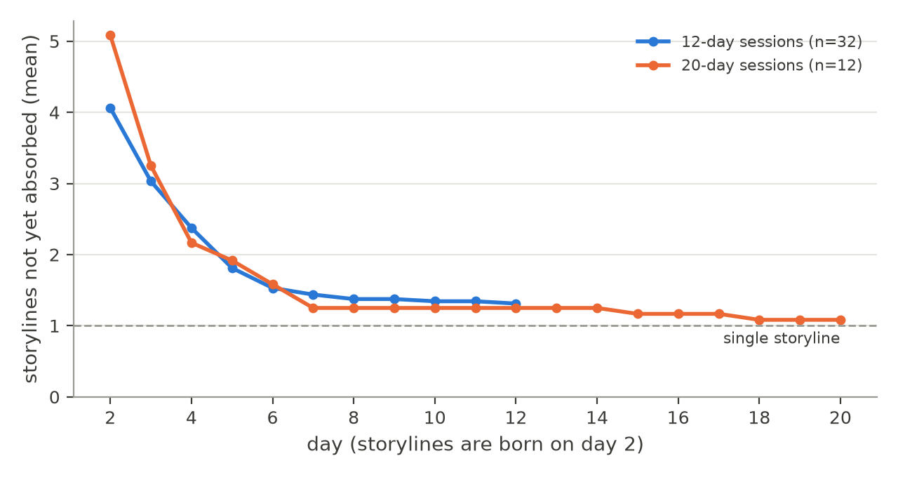
The null model shows how much of this follows from density alone. When every event’s causes are rewired at random, keeping their number, sessions end with 1.05 storylines on average, against 1.5 observed in the first round. In other words, the agents’ links are somewhat more local than random links would be, and still, with almost two causes per event in a world of six characters, everything connects. The existence of the attractor is a consequence of linking almost every event to the past. What remains to explain is its path: which storylines merge first, where and through what.

Attractor events
Most fusions are direct: in 74% of them, the event that merges two storylines cites causes in both. Attractor events are not hubs: incoming links are only moderately concentrated (Gini coefficient 0.33; the top 5% of events receive 13% of the links), so storylines are not pulled together by a few central events that everything refers to.
What attractor events share is the world’s premises. Of the 56 first fusions between storylines that had not merged before, 75% joined characters whose premises already referred to each other, against 45% of all pairs of storylines in the same sessions and 61% under the null model (95% interval of the null 45–76%; one-sided p = .036; Figure 3). The premise effect survives the discount for density, but it is smaller than the naive comparison suggests: part of the apparent attraction comes from the fact that well-connected characters start larger storylines.
Figure 3
Share of pairs of storylines whose initiating characters are linked in the world premises: all pairs, and the pairs that merged first.
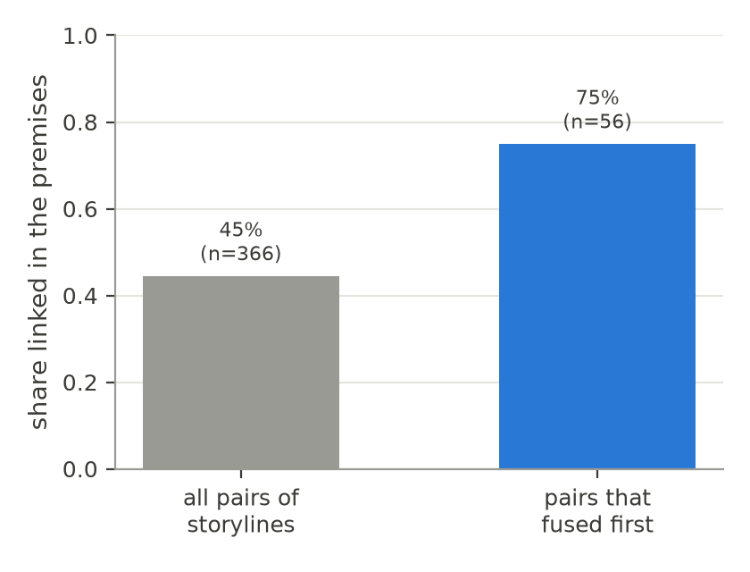
Space tells the same story (Figure 4). Although agents start spread across the town, the events concentrate in the places named in more than one premise: Vasco’s warehouse and the customs house in Porto das Brumas, the mill in Vale Silente. These places hold 49% of all events and 57% of the fusion events, against 52% under the null model (one-sided p = .014). The entropy of the distribution of events over places falls from 1.96 bits in the first two days to 1.34 bits between days 6 and 12, against a maximum of 2.32 to 2.58 bits for five or six places: the world contracts around a few places. The objects of the premises (the warehouse, the debt, the customs books; the mill, the stranger, the grain) appear in 75% of the fusion events, against 68% of the other events (Fisher’s exact test, p = .028).
Figure 4
Share of all events and of fusion events in each place of the two worlds.
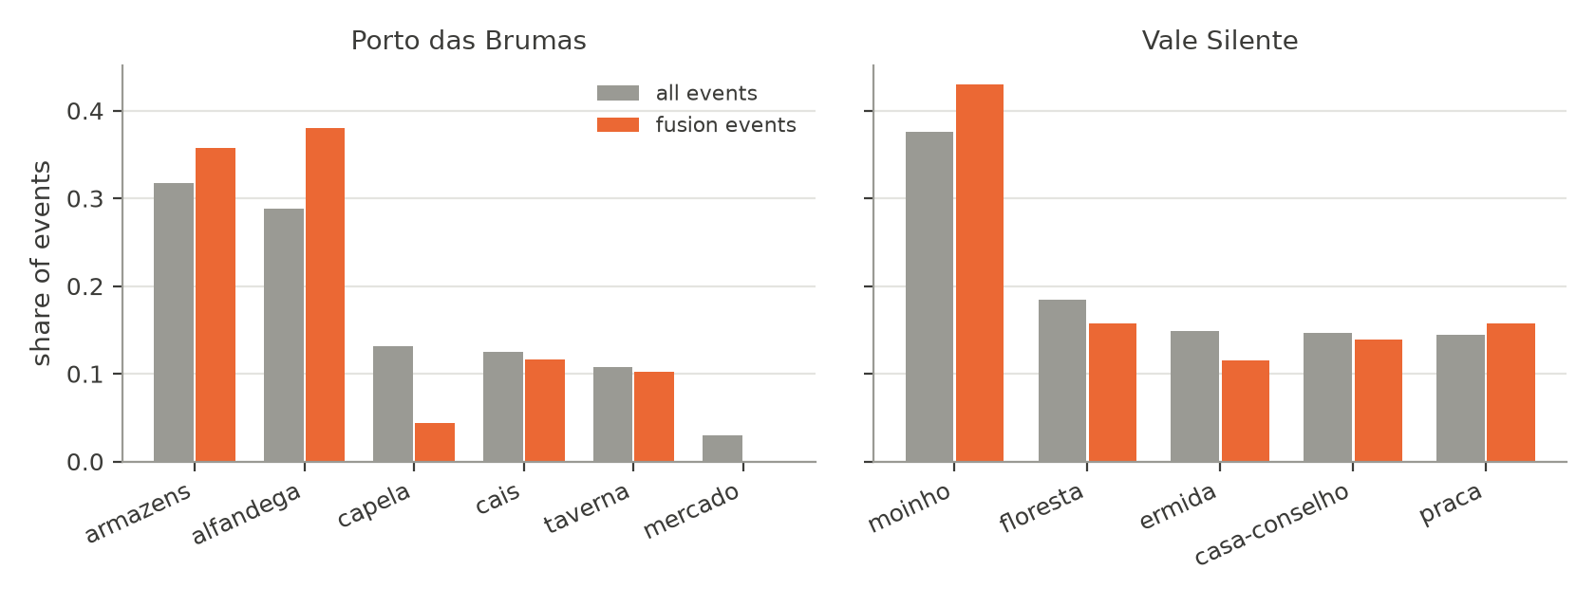
A session of Porto das Brumas generated by claude-opus-5 (translated from Portuguese) shows the mechanism. On day 1, the merchant goes to the warehouse to offer the widow a low price for it; the captain orders the last weeks’ pages of the customs books set aside “before the new inspector reads them”; the chaplain writes down the names he saw in the warehouse the night its owner died. Each action starts a storyline. On day 2, in the customs house, the merchant offers the captain a purse to have the warehouse sealed for “unpaid duties”; the captain accepts and has the pages rewritten; the inspector asks for the books and notices the missing pages. On day 3 the captain seals the warehouse, an action whose declared causes are the bribe, his own acceptance and the inspector’s inquiry: the captain’s and the merchant’s storylines become one, in the place both of their premises point to. The same day, the inspector goes to the warehouse looking for the widow and finds it sealed by the captain’s order. The secrets written into the premises work as appointments: they tell the agents where the other characters’ stories are to be found.
Table 2 summarises the measures of attraction against the null model. The pattern is consistent: on every measure the observed sessions deviate from random linking in the direction of the premises, and on every measure the deviation is moderate.
Table 2
Measures of attraction: observed sessions and the density-preserving null model (500 rewirings per session; one-sided p from 5,000 resamples).
Measure | Observed | Null (95% interval) | p
First fusions joining premise-linked characters (n = 56) | 75% | 61% (45–76%) | .036
Fusion events in places named by the premises (n = 302) | 57% | 52% (47–56%) | .014
Descriptive measures (no null comparison)
Fusions that cite causes in both storylines | 74%
Fusion events mentioning objects of the premises | 75% | 68% (other events) | .028
Place entropy, days 1–2 → days 6–12 (bits) | 1.96 → 1.34
Share of links received by the top 5% of events | 13%

Sensitivity
Because the storyline is defined by connectivity, we repeated the lineage analysis with alternative definitions that remove links before detection. Removing the single links whose removal would separate two storylines of at least three events raises the share closed by stability from 8% to 20%, but does not reduce fusion (59% to 60%): separated storylines merge again through other links. Cutting all links between densely connected communities (Blondel et al., 2008) gives the most permissive reading, 41% closed and 46% absorbed, and is best taken as an upper bound, since it also splits the single plot of the three-act control. The direction of the result is the same under every definition: fusion is as common as closure or more.

Discussion

Two forces: density and attraction
The convergence of these stories has two layers. The first is structural. Language-model agents almost never act without citing something that happened before; in a small world, a graph in which nearly every new node links to the past becomes connected quickly, as random networks do once the average degree passes a threshold (Newman, 2018). The null model shows that density alone would merge the storylines even more completely. This layer explains that the story becomes one. It is a property of how the agents relate their actions to the past, not of a particular model: it appears with every model we tested and under every instruction we tried. A design choice of the simulator reinforces it: a single model call decides what every character does, and that call sees all the recent events of the town. The characters are told to act only on what they know, but nothing prevents the author behind them from connecting everything it sees. In a role-playing game around a table, by contrast, players know only what their characters witnessed or were told.
The second layer is the path. Within the time the story takes to become one, which storylines meet, where and over what is not random. Fusions happen when characters whose premises were written to refer to each other meet, in the places those premises name, around the objects they mention. These are the attractor events. Their pull is real but moderate (75% against 61% expected by chance for first fusions; 57% against 52% for places), which is what one would expect if the premises bias the path without dictating it. In the language of dynamical systems, the end state is fixed by the regime, and the premises shape the trajectory inside the basin. The analogy with chaotic systems is apt in one more respect: two sessions of the same world with different seeds produce different texts, characters do different things on different days, yet the macroscopic outcome, a single story organised around the same few places and secrets, is the same.
This explains why interventions on the generation did not help. Asking for typed and weighted causes made agents more explicit about connections and therefore more connected. Asking for fewer causes changed the count, not the choice: agents kept citing the events of other storylines that their premises pointed to. Longer sessions only extended the time spent in the attractor.

What this means for AI and media literacy
The findings matter for educational uses of generative role-play in three ways.
First, an open world is less open than it looks. When a teacher or a group of students sets up a shared world and lets AI characters act, the experience is one of freedom: nobody imposed a plot, and every session is different. Our data show that, structurally, these sessions converge to the same kind of story, and do so quickly. This is a structural counterpart to the homogenisation already documented at the level of texts and plot elements (Doshi & Hauser, 2024; Xu et al., 2025): even when no single prompt asks for a story, the dynamics of generation pull toward one. Recognising this convergence is part of understanding how AI shapes the content it helps create (Long & Magerko, 2020; UNESCO, 2024).
Second, the forces are authored, and visible. The attractors we found are not hidden in the model weights; they are in the premises a human wrote: who owes whom, who knows what, where the secret is kept. This turns a critical question about media, “who constructed this message, and how?” (Hobbs, 2010), into something students can manipulate. The same world with differently entangled premises should converge along a different path, and the event graph makes the path visible. Tracing why two storylines merged, and which premise brought the characters together, is an exercise in reading how a generated narrative was constructed.
Third, the design levers are spatial and social, not textual. Instructions in the prompt did not change the outcome; the structure of the world did. For designers of educational role-play this suggests acting on the world rather than on the wording: separating characters in space, limiting who can learn what and when, and introducing events from outside the cast, which would be the only way to start new storylines once every action cites the past. These are, not by coincidence, the levers of board and tabletop game design, in which space and information channel what can happen (Jenkins, 2004; Salen & Zimmerman, 2004). They are also levers that students can understand without knowing anything about language models.

A classroom protocol for critical AI literacy
The results suggest a concrete activity, which we describe as a proposal to be evaluated rather than as a finding. It requires only the simulator, which runs on local open models as well as on commercial ones, and a projector.
Step 1: play. The class designs a small world together: five or six places, six characters, and for each character an objective, a secret and two beliefs. Students are not told about attractors. The simulator runs for ten in-game days, and groups follow different characters, reading the events as a story.
Step 2: predict. Before seeing any graph, each group writes down how many separate stories it thinks are happening and which ones will end. In our data, the honest answer after day five is almost always “one”, and students’ predictions are a measure of how open the experience felt.
Step 3: read the graph. The class looks at the causal graph and at the lineage of each storyline: when it was born, which event merged it with which other storyline, and in which place. Groups trace each fusion back to the premises and mark the ones that were “appointments” written into the world: two secrets about the same object, a belief about another character, a place mentioned twice.
Step 4: intervene. Groups rewrite the premises to move the attractors, for example by giving two characters secrets about different places, or by removing the object everyone wants, and run the same world again (with the same seed, where the model accepts one). Comparing the two graphs shows what changed and what did not: the story will probably still become one, but along a different path.
Step 5: generalise. The discussion connects the exercise to other generated media. A recommendation feed, a chatbot conversation or a generated news summary also has initial conditions written by someone, and dynamics that pull toward some outcomes more than others. The question that media literacy asks of any message, who made it and how, becomes a question about which premises a system was given and which attractors those premises create.
The protocol makes three abstract ideas tangible: that generated content has structure beyond its surface text, that the structure depends on human design choices, and that it can be inspected. Its evaluation, with measures of students’ understanding before and after, is left for future work.

Limitations
All agents were models of a single family; models from other providers, including open models run locally, are supported by the instrument and are the obvious next step. The sessions are short and few per condition, and they come from a validation stage: the confirmatory campaign registered in advance has not yet been run. Because one call decides all characters and sees all recent events, the agents are not informationally separated; a version in which each character receives only what it could know is the natural next experiment. The storyline is defined by graph connectivity, a standard but debatable operationalisation of “storyline”; we reported alternative definitions for that reason. The premise coding was done by a single coder from the world texts; a second, independent coding is needed. The declared causes were validated by judge models of the same family and not yet by human annotators, whose annotation has been prepared. Finally, no learners took part in this study: the educational implications are arguments for future classroom work, not results.

Conclusion
Left to act freely in a shared world, language-model agents do not produce a web of stories that open and close. They produce one story, quickly, because almost every action is tied to something that already happened. Which threads merge first, and where, is decided by attractors: the entangled premises and the places they name, written by the humans who designed the world. For education, the lesson is double. Generative role-play is not as open as it feels, and the reasons are structural rather than stylistic; and the forces that shape it are authored, legible and teachable. Making students read the causal graph of a story they co-created with AI, and change the world to see it converge differently, is a concrete way of practising critical AI literacy.

Data and code availability
The simulator, the pre-registration and its amendments, the event logs of all sessions and the analysis scripts are available in a public repository [repository link removed for anonymous review].

References
Aylett, R. (1999). Narrative in virtual environments: Towards emergent narrative. Narrative Intelligence: Papers from the AAAI Fall Symposium, 83–86.
Barabási, A.-L., & Albert, R. (1999). Emergence of scaling in random networks. Science, 286(5439), 509–512. https://doi.org/10.1126/science.286.5439.509
Barthes, R., & Duisit, L. (1975). An introduction to the structural analysis of narrative. New Literary History, 6(2), 237–272. https://doi.org/10.2307/468419
Beguš, N. (2024). Experimental narratives: A comparison of human crowdsourced storytelling and AI storytelling. Humanities and Social Sciences Communications, 11(1). https://doi.org/10.1057/s41599-024-03868-8
Blondel, V. D., Guillaume, J.-L., Lambiotte, R., & Lefebvre, E. (2008). Fast unfolding of communities in large networks. Journal of Statistical Mechanics: Theory and Experiment, 2008(10), P10008. https://doi.org/10.1088/1742-5468/2008/10/p10008
Bowman, S. L. (2010). The functions of role-playing games: How participants create community, solve problems and explore identity. McFarland.
Callison-Burch, C., Tomar, G. S., Martin, L. J., Ippolito, D., Bailis, S., & Reitter, D. (2022). Dungeons and Dragons as a dialog challenge for artificial intelligence. Proceedings of the 2022 Conference on Empirical Methods in Natural Language Processing, 9379–9393. https://doi.org/10.18653/v1/2022.emnlp-main.637
Chatman, S. (1978). Story and discourse: Narrative structure in fiction and film. Cornell University Press.
Daniau, S. (2016). The transformative potential of role-playing games: From play skills to human skills. Simulation & Gaming, 47(4), 423–444. https://doi.org/10.1177/1046878116650765
Doshi, A. R., & Hauser, O. P. (2024). Generative AI enhances individual creativity but reduces the collective diversity of novel content. Science Advances, 10(28). https://doi.org/10.1126/sciadv.adn5290
Fine, G. A. (1983). Shared fantasy: Role-playing games as social worlds. University of Chicago Press.
Hobbs, R. (2010). Digital and media literacy: A plan of action. The Aspen Institute.
Jenkins, H. (2004). Game design as narrative architecture. In N. Wardrip-Fruin & P. Harrigan (Eds.), First person: New media as story, performance, and game (pp. 118–130). MIT Press.
Kreminski, M., & Wardrip-Fruin, N. (2018). Sketching a map of the storylets design space. In Interactive storytelling (pp. 160–164). Springer International Publishing. https://doi.org/10.1007/978-3-030-04028-4_14
Long, D., & Magerko, B. (2020). What is AI literacy? Competencies and design considerations. Proceedings of the 2020 CHI Conference on Human Factors in Computing Systems, 1–16. https://doi.org/10.1145/3313831.3376727
Lorenz, E. N. (1963). Deterministic nonperiodic flow. Journal of the Atmospheric Sciences, 20(2), 130–141. https://doi.org/10.1175/1520-0469(1963)020<0130:dnf>2.0.co;2
Louchart, S., & Aylett, R. (2004). Narrative theory and emergent interactive narrative. International Journal of Continuing Engineering Education and Lifelong Learning, 14(6), 506–518. https://doi.org/10.1504/ijceell.2004.006017
Mateas, M., & Stern, A. (2003). Façade: An experiment in building a fully-realized interactive drama. Game Developers Conference, Game Design Track.
Montola, M. (2008). The invisible rules of role-playing: The social framework of role-playing process. International Journal of Role-Playing, (1), 22–36. https://doi.org/10.33063/ijrp.vi1.184
Newman, M. (2018). Networks (2nd ed.). Oxford University Press. https://doi.org/10.1093/oso/9780198805090.001.0001
Nosek, B. A., Ebersole, C. R., DeHaven, A. C., & Mellor, D. T. (2018). The preregistration revolution. Proceedings of the National Academy of Sciences, 115(11), 2600–2606. https://doi.org/10.1073/pnas.1708274114
Padmakumar, V., & He, H. (2024). Does writing with language models reduce content diversity? The Twelfth International Conference on Learning Representations (ICLR). https://arxiv.org/abs/2309.05196
Park, J. S., O’Brien, J., Cai, C. J., Morris, M. R., Liang, P., & Bernstein, M. S. (2023). Generative agents: Interactive simulacra of human behavior. Proceedings of the 36th Annual ACM Symposium on User Interface Software and Technology, 1–22. https://doi.org/10.1145/3586183.3606763
Riedl, M. O., & Bulitko, V. (2013). Interactive narrative: An intelligent systems approach. AI Magazine, 34(1), 67–77. https://doi.org/10.1609/aimag.v34i1.2449
Riedl, M. O., & Young, R. M. (2010). Narrative planning: Balancing plot and character. Journal of Artificial Intelligence Research, 39, 217–268. https://doi.org/10.1613/jair.2989
Ryan, J. (2018). Curating simulated storyworlds [PhD thesis]. University of California, Santa Cruz.
Salen, K., & Zimmerman, E. (2004). Rules of play: Game design fundamentals. MIT Press.
Strogatz, S. H. (2015). Nonlinear dynamics and chaos: With applications to physics, biology, chemistry, and engineering (2nd ed.). Westview Press.
Tian, Y., Huang, T., Liu, M., Jiang, D., Spangher, A., Chen, M., May, J., & Peng, N. (2024). Are large language models capable of generating human-level narratives? Proceedings of the 2024 Conference on Empirical Methods in Natural Language Processing, 17659–17681. https://doi.org/10.18653/v1/2024.emnlp-main.978
Trabasso, T., & van den Broek, P. (1985). Causal thinking and the representation of narrative events. Journal of Memory and Language, 24(5), 612–630. https://doi.org/10.1016/0749-596x(85)90049-x
UNESCO. (2024). AI competency framework for students. UNESCO. https://doi.org/10.54675/JKJB9835
Xu, W., Jojic, N., Rao, S., Brockett, C., & Dolan, B. (2025). Echoes in AI: Quantifying lack of plot diversity in LLM outputs. Proceedings of the National Academy of Sciences, 122(35). https://doi.org/10.1073/pnas.2504966122

