NARRATIVE ATTRACTORS AND BOARD-BASED WORLD MODELS: TWO ARTICLES ON STORY CONVERGENCE IN SHARED-WORLD ROLE-PLAY
Caio Silva Azeredo and Geraldo Xexéo
Systems Engineering and Computer Science Program (PESC/COPPE), Federal University of Rio de Janeiro (UFRJ), Brazil
Article 1. Narrative attractors: why stories converge when language-model agents share a role-playing world.
Article 2. From board to graph: a hybrid human-AI role-playing board for critical media and AI literacy.
Both articles were prepared for The International Journal of Games and Social Impact (Vol. 5, No. 4, “Games, Gamification, Media Literacy and Transformation in Educational Contexts”). This compilation is a reading version with authorship; the anonymised submission files are generated separately. Each article keeps its own figures, tables and reference list (APA 7). Every reference was checked against its source: entries with a DOI against the Crossref record, the others against the publisher or repository page. The literature reviews follow PRISMA 2020; their search strings, records and screening decisions are in the repository (https://github.com/caiosilvaazeredo/cronicas-de-aethelgard, folder experimentos/revisao).

NARRATIVE ATTRACTORS: WHY STORIES CONVERGE WHEN LANGUAGE-MODEL AGENTS SHARE A ROLE-PLAYING WORLD
Abstract
Generative AI is entering classrooms as co-author and game master. We asked whether a shared fictional world where language-model agents act freely produces many storylines or collapses into one. From the causal graphs of 44 simulated sessions (3,744 events, four models, two worlds), storylines vanish by fusion, not closure: 64% merge into another and under 5% reach a stable end. Almost all are born on day two, and most sessions keep a single story by day five. Convergence is driven by density, as almost every event cites a cause, and its path is shaped by attractors: first fusions join characters whose premises already referred to each other (75% vs. 61% under a null model) in the places those premises name. We discuss implications for critical AI literacy and educational role-play.
Keywords: generative AI; role-playing games; emergent narrative; causal graphs; attractors; AI literacy; media literacy

Introduction
Tabletop role-playing games have long been used in education as spaces for shared imagination, perspective-taking and collaborative problem solving (Bowman, 2010; Daniau, 2016; Fine, 1983). Their narrative is not written in advance: it emerges from what the participants do inside a shared world, under explicit and implicit rules (Montola, 2008). Large language models (LLMs) now make it possible to populate such worlds with artificial characters that remember, plan and talk to each other (Park et al., 2023), and to place an AI in the role of the game master (Callison-Burch et al., 2022). Teachers and students are already experimenting with these uses.
At the same time, a growing body of evidence shows that generative models homogenise what they help to produce. Writers assisted by a model produce less diverse texts (Padmakumar & He, 2024); stories written with AI ideas are individually rated as more creative but are more similar to each other (Doshi & Hauser, 2024); LLM stories reuse a narrow repertoire of plot elements (Xu et al., 2025) and follow more uniform arcs than human stories (Beguš, 2024; Tian et al., 2024). These studies look at single texts produced from a prompt. Much less is known about what happens to the structure of a story when it is not written by one model in one pass but emerges, day after day, from the actions of several agents in a shared world, the situation closest to a role-playing game.
This paper reports an experiment on that question. We built a simulator in which language-model agents live in a small fictional town, each with an objective, a secret and a few beliefs, and act freely for 12 to 20 in-game days. Nothing in the prompts mentions acts, climax, resolution or any other narrative structure. Every action is recorded as an event, together with the earlier events the agent declares as its causes. The result is a causal graph in which a storyline can be read as a connected set of events (Trabasso & van den Broek, 1985). Our pre-registered hypothesis was that such a free story converges: storylines that emerge tend to close, and beginning, middle and end appear as properties of the graph rather than as phases imposed on the generation.
The answer we found is more specific, and more relevant for education, than a simple yes or no. Storylines do converge, but almost never by closing: they merge until a single story remains. We describe that process in the vocabulary of dynamical systems, where an attractor is a state, or set of states, toward which trajectories starting from many different initial conditions evolve (Lorenz, 1963; Strogatz, 2015). We show that the single-story state behaves as a global attractor of these simulated worlds, and we identify the attractor events that pull separate storylines together: events in which characters whose premises were already entangled meet, in the places those premises name.
The contributions are threefold. First, an auditable method to measure convergence in emergent narratives that separates two processes usually confounded, the closure of a storyline and its fusion with another. Second, empirical evidence, from 44 sessions with four versioned models, that fusion dominates and that its course is shaped by the initial conditions authored by humans. Third, a discussion of what this means for critical AI literacy: when generative agents tell stories together, the story that emerges is less open than it looks, and the levers that shape it are visible and can be taught.

Background

Stories as causal graphs
Structuralist narratology distinguishes the events that hold a plot together, kernels or nuclei, from those that elaborate it, satellites or catalysers (Barthes & Duisit, 1975; Chatman, 1978). Cognitive studies of comprehension operationalised this idea as a causal network: an event belongs to the main chain of a story when it has causal antecedents and consequences, and readers remember and judge as important the events with more causal connections (Trabasso & van den Broek, 1985). Computational narrative inherited the representation. Narrative planners build plots as partially ordered causal structures (Riedl & Young, 2010), and simulation-driven storytelling treats the log of a simulated world as raw material from which stories are later curated (Ryan, 2018). We follow this tradition: each event records its declared causes, and a storyline is a connected component of the resulting graph.

Emergent narrative and shared worlds
Emergent narrative is the idea that a story can arise from the interaction of autonomous characters and participants rather than from a script (Aylett, 1999; Louchart & Aylett, 2004). Its persistent difficulty is shape: autonomous agents produce events, but events do not necessarily add up to stories with beginnings and endings (Riedl & Bulitko, 2013). Interactive drama addressed the problem with a drama manager that steers the action toward a planned arc (Mateas & Stern, 2003); storylet systems address it by authoring small, conditioned narrative fragments (Kreminski & Wardrip-Fruin, 2018). Game studies add a spatial perspective: game worlds tell stories through the arrangement of places, which channel movement and encounters (Jenkins, 2004). Role-playing studies, in turn, show that the rules that shape a shared fiction are often invisible and social rather than written (Fine, 1983; Montola, 2008).
Generative agents change the terms of this debate. Their behaviour is believable and memory-driven (Park et al., 2023), but it is produced by a model trained to continue text coherently, which may favour connecting new events to existing ones over starting new threads. Whether that tendency yields well-shaped stories, endless sprawl or something else is an empirical question.

Attractors
In a dynamical system, an attractor is a set of states toward which the system evolves from a wide range of initial conditions; the set of initial conditions that lead to it is its basin of attraction (Strogatz, 2015). Chaotic systems combine sensitivity to initial conditions at the level of individual trajectories with stable large-scale structure: two trajectories of the Lorenz system diverge quickly, yet both remain on the same attractor (Lorenz, 1963). We use the concept in two ways. At the macro level, we ask whether different sessions, with different models, worlds, seeds and conditions, end in the same structural state. At the micro level, we call attractor events the events through which separate storylines are pulled into one, directly (an event that cites causes in both storylines) or indirectly (through intermediate events), and we ask what they have in common. The analogy is heuristic: a simulated story is not a low-dimensional deterministic system. But it gives precise questions: what is the end state, how fast is it reached, how large is its basin, and which initial conditions decide the path.

AI literacy and media literacy
Media literacy asks learners to analyse how messages are constructed and by whom (Hobbs, 2010). AI literacy extends the question to systems that generate content: learners should understand what AI can and cannot do, how it represents knowledge and how its outputs are shaped (Long & Magerko, 2020; UNESCO, 2024). Homogenisation findings (Doshi & Hauser, 2024; Xu et al., 2025) have made the shaping of generated stories a topic in its own right. Most work, however, considers a single generated text. Shared-world play with AI agents is a different object: the story is co-produced over time by many prompts, and the forces that shape it are distributed across the world design, the agents and the rules of play. Making those forces visible is a precondition for using such play critically in education.

Systematic literature review
To position the study, we reviewed recent work on narratives generated by language models, following the PRISMA 2020 reporting structure.

Search.
On 13 October 2026 we searched OpenAlex (title and abstract), arXiv (abstract) and Semantic Scholar (bulk search) for records published from 2020 to 2026, combining three groups of terms: language models (“large language model”, LLM, “generative agents”); narrative generation (“story generation”, “narrative generation”, “emergent narrative”, “interactive narrative”, storytelling); and the aspects of interest (multi-agent, role-playing, tabletop, “plot diversity”, homogenization, convergence, “narrative structure”, “causal graph”). The exact strings, the raw responses of each database and every screening decision are in the supplementary material and in the public repository.

Eligibility criteria.
Records were included when they met all of the following: (I1) a language model generates or co-generates narrative content (stories, plots, game narratives, role-play); (I2) the study analyses the structure, diversity, coherence, convergence or plot of the generated narratives, or involves several interacting agents in a shared story world, or represents stories as graphs of events or causes; (I3) it is a peer-reviewed article, conference paper or preprint in English, from 2020 to 2026. Records were excluded when language models were not used to generate narrative (E1), when narrative was incidental to the study (E2), when the work was not about narrative at all (E3), when it was not a research contribution, such as an editorial or a talk listing (E4), or when it was not available in English (E5).

Process.
Duplicates were removed by DOI, arXiv identifier and title similarity, which also merged preprint and published versions of the same work; records without an abstract could not be screened. Titles and abstracts were screened against the criteria by a language model (claude-sonnet-5), and the records that passed were assessed again, with stricter instructions, by a second model (claude-opus-5-5). Each decision was logged with its reason, and one of the authors checked the included records as a second reviewer, which changed one decision. Model-assisted screening is a limitation: it is consistent and auditable, but it is not a substitute for two independent human reviewers.

Results.
The searches returned 388 records (Figure 1). After removing 188 duplicates and 19 records without an abstract, 181 were screened, 97 were assessed for eligibility and 44 were included. We grouped them into four strands.
Figure 1
PRISMA 2020 flow diagram of the systematic review on narratives generated by language models.
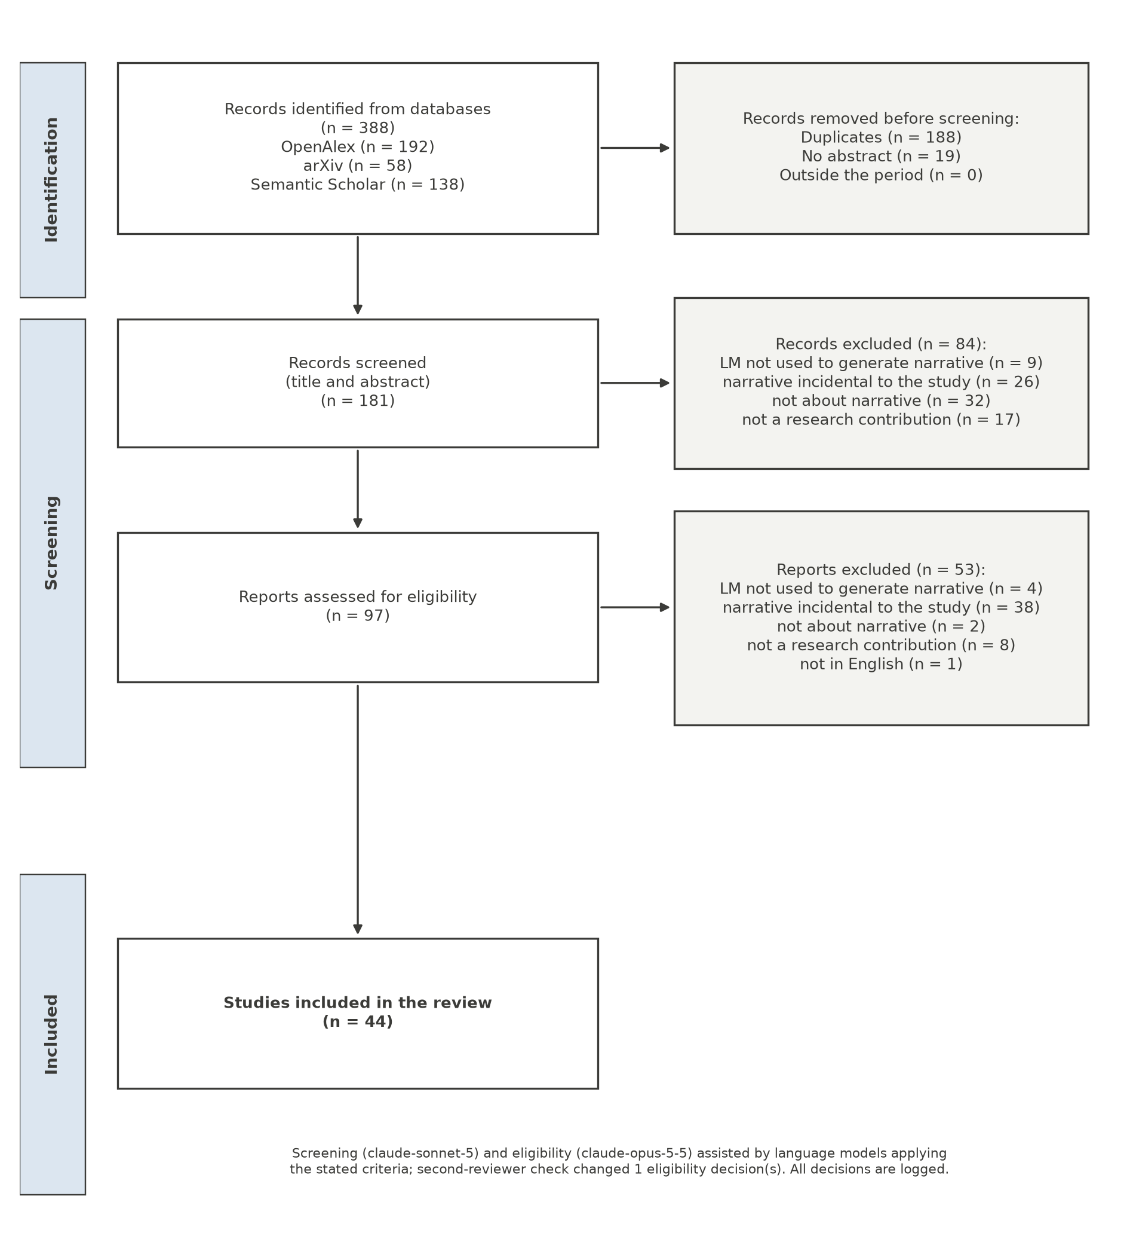
Homogenisation and diversity (12 studies). Several studies find that generated stories converge on repeated plot elements, arcs and structural templates: across samples of the same model (Xu et al., 2025), across genres analysed with Propp’s narrative functions (Ma et al., 2026), across five frontier models writing thriller outlines (Brito, 2025), and across cultural traditions, where a pilot study measures how far outputs drift towards a common archetype (Singh Rathore, 2026); and, unlike human-written stories, which are suspenseful and diverse in structure, generated stories are homogeneously positive and lack tension (Tian et al., 2024). Others propose remedies, such as persona-augmented agents (Sillano et al., 2026), noise steering (Khalid et al., 2026) and fine-tuning for possibility exploration (Mai & Carson-Berndsen, 2024).
Multi-agent and simulation-based generation (12 studies). A growing line of work generates stories from interacting agents: sandbox simulations whose emergent events become the plot (Chen et al., 2026), agent societies built from novels (Ran et al., 2025), and multi-agent pipelines for long stories (Habib & Sathyanath, 2025; Ho et al., 2026; Xia et al., 2025). Their goal is usually coherence and consistency over long texts. One study identifies a failure that is central to our results, “factual overreach”, in which a character agent uses facts outside its own perspective, and proposes memory that respects each character’s knowledge boundaries (Tang et al., 2026).
Structural representations (12 studies). Stories are represented as branching narrative graphs (Leandro et al., 2024), knowledge graphs (Shi et al., 2025), evidence trees for causal consistency (Lee et al., 2026), plans (Farrell & Ware, 2024) or event-state structures for game engines (Yu et al., 2025).
Game masters and interactive role-play (8 studies). Language models act as game masters that must balance player agency with an authored arc (Jørgensen et al., 2026), call functions to keep the game state consistent (Song et al., 2024), or let users enter a story as a character (Zhao et al., 2023).

Gap.
None of the 44 abstracts reports the lineage of storylines, that is, when they are born, merge or close, in a world shared by several agents, and none treats convergence over the course of a session as the object of study: homogenisation studies compare outputs across prompts or models, and multi-agent studies treat the merging of threads as coherence to be achieved. The present study addresses that gap.

Method

The simulator
The simulator runs a small fictional town for a fixed number of in-game days. Each world defines five or six places, three factions and a cast of agents, each with an objective, a secret and two beliefs (Table 1). We used two worlds written for the study: Porto das Brumas, a harbour town where salt merchants, a smuggling brotherhood and the harbour guard compete, and Vale Silente, a mountain village isolated by a landslide before winter. Sessions used six agents. Every day, one call to the agents’ model decides what each character does; for each action, the model writes a short text, names the place and the witnesses, and lists the identifiers of the recent events (from the previous three days) that made the action possible. The prompt explicitly allows the list to be empty. A second call writes what characters tell each other. A fixed curator model narrates storylines that become stable, and a fixed synthetic player can take part in some conditions. The model of the agents is the experimental variable; the curator and the player are held constant across conditions. The simulator also includes an interface, the Chronicle Map, which draws the causal graph of a session and the lineage of its storylines (Figure 2).
Figure 2
The simulator’s Chronicle Map (interface labels in Portuguese) for a session of Vale Silente: events and their causal links (top), the storylines and the fusions that absorbed them (right), and the lineage timeline of each storyline, with closures in green and absorptions in orange (bottom).
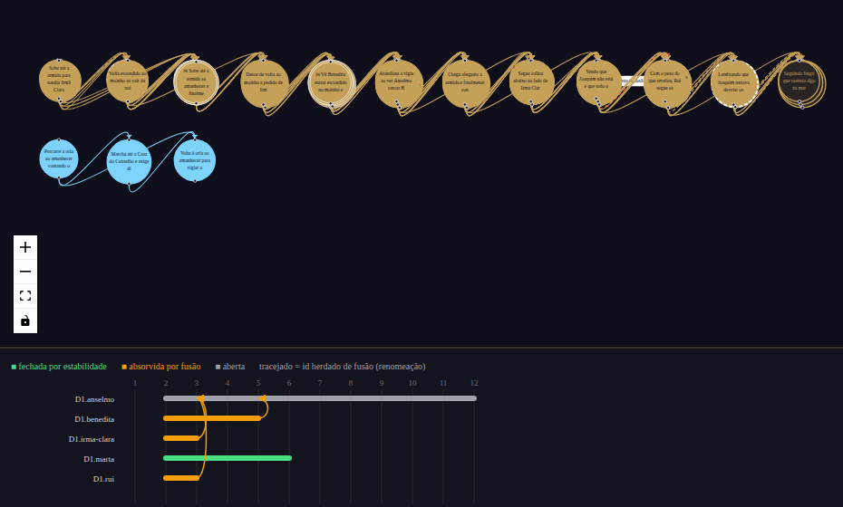
Table 1
The two worlds and the premises of their six active agents (abridged; translated).
World | Agents (objective; secret or belief that refers to another agent)
Porto das Brumas | Odete, merchant (wants the late Vasco’s warehouse; owes money to the smuggling brotherhood) · Brás, guard captain (takes bribes; believes the new inspector is spying on him) · Lia, smuggler (wants to lead the brotherhood; informs the guard) · Tomás, chaplain (knows who was in the warehouse the night Vasco died) · Iracema, Vasco’s widow (believes her husband hid papers in the warehouse) · Nuno, customs inspector (investigates why the customs books do not add up)
Vale Silente | Anselmo, elder (secretly sold the village’s grain) · Marta, shepherd (blames wolves for losses she caused) · Sister Clara (believes the miller hides something) · Joaquim, miller (shelters a wounded stranger in the mill) · Benedita (wants to open a trail before winter) · Rui, goatherd (saw someone leaving the mill at dawn)
Nothing in any prompt refers to narrative structure. An automated test scans every prompt for structural terms (act, phase, climax, resolution, hero’s journey and their Portuguese equivalents) and for instructions to converge (tie up, conclude, resolve, close), and fails the build if any is present. As a control, the simulator also runs a conventional three-act game master over the same worlds.

From events to storylines
Each session yields an event log and a directed graph whose edges go from a declared cause to its effect. Following the causal-network view of narrative (Trabasso & van den Broek, 1985), a storyline is a connected component of the graph of events with causal connections, recomputed every day. A storyline is stable when it receives no new consequence for k = 3 consecutive days.
Our pre-registration defined convergence through the number of open storylines, which should stop growing in the last third of the session (Nosek et al., 2018). A first round of validation showed that this measure was confounded: the number of open storylines fell in almost every session, but mostly because storylines merged, not because they ended. We therefore amended the pre-registration, before any confirmatory campaign, to track the lineage of each storyline: its birth (a component whose events belonged to no storyline the day before), its fusion (its events become part of another storyline) and its closure by stability. The main metric became the share of storylines that close by stability before being absorbed. All amendments are dated and public in the repository.
Formally, let G_{d} = (V_{d}, E_{d}) be the causal graph at the end of day d, where V_{d} holds the events of days 1,…,d and (u, v) ∈ E_{d} when event v declares u as a cause and u is not later than v. Let L_{d} be the set of connected components of the subgraph of events that have at least one causal connection. A storyline T ∈ L_{d} is born on day d if none of its events belonged to a storyline in L_{d−1}; it fuses on day d if its events belong, on day d, to a storyline with a different identifier; and it closes on day d if it is stable on day d for the first time. A storyline that keeps its events but receives a new identifier because of a fusion is a renaming, not a birth. If N storylines are born in a session, C of them close before fusing and F fuse before closing, the main metric is C/N and its companion is F/N. Because components only grow or merge as events are added, L_{d} can only lose members by fusion or gain them by birth; closure does not remove a storyline from the graph, it only marks it as having stopped growing. The number of open storylines falls by one both when a storyline closes and when two of them merge, which is why that number alone cannot distinguish an ending from a merger.

Sessions
We analyse 44 sessions of the shared world, generated with four versioned models as agents (claude-haiku-4-5-20251001, claude-sonnet-4-6, claude-sonnet-5 and claude-opus-5), in four rounds: (1) 16 sessions of 12 days, crossing the four models, the two worlds and whether the state of storylines is shown to the agents; (2) 8 sessions in which each cause carries a declared type and strength; (3) 8 sessions in which agents may cite at most two causes per action; and (4) 12 sessions of 20 days, with two models, two worlds and three repetitions with new seeds. Rounds 2 and 3 use the same models, worlds and seeds as the corresponding sessions of round 1. Eight sessions of the three-act control serve as a reference. In total, the shared-world sessions contain 3,744 events.

Validation of the declared causes
A causal graph built from what a model declares is only as good as those declarations. We validated them in three ways. A blind judge model, not used as a generator, rated declared links as plausible far more often than distractor pairs from the same session (97% against 73%). In a counterfactual test, a judge estimated how necessary event A was for event B on a 0–100 scale: 67 on average for declared direct links, 44 for indirect ancestors and 21 for unlinked pairs, with an area under the ROC curve of 0.92 between direct and unlinked pairs. The gradient holds for every generator model (Figure 3). Finally, a null model rewired every event’s causes at random among earlier events, keeping how many causes each event has, and the analysis was repeated 500 times per session. Human annotation of a stratified sample of 216 links by two annotators has been prepared and is reported separately.
Figure 3
Counterfactual necessity of event A for event B, estimated by a judge model that was not used as a generator, by generator model and type of pair (90 pairs).
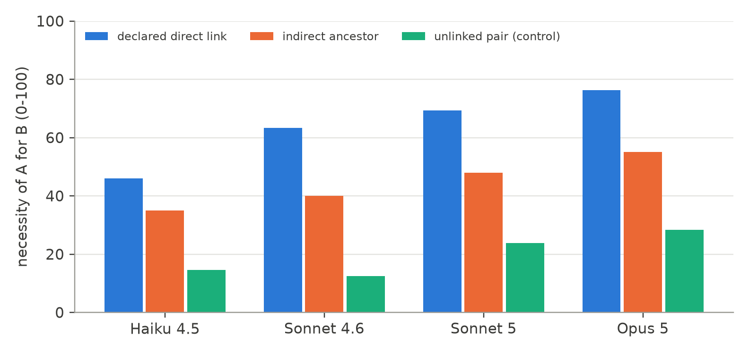

Measuring attractors
We use four measures. The basin is the number of storylines not yet absorbed on each day, and the day on which a single storyline remains. Direct fusions are those in which the event that merges two storylines cites causes in both of them; the others are indirect. Premise attraction compares, for the first fusion between two storylines that had not merged before, whether the characters who started them are linked in the world premises. Two characters are linked when the objective, secret or a belief of one of them mentions the other by name, title or unique role, or something only the other owns (Table 1); the coding is published with the analysis script. The comparison is made against the same pairs under the null model, so that the effect of link density is discounted. Spatial attraction compares the share of fusion events that happen in the places named in more than one premise (the warehouse and the customs house in Porto das Brumas; the mill in Vale Silente) with the same share under the null model. We also measure the entropy of the distribution of events over places on each day, and the concentration of incoming links, to check whether a few events act as hubs (Barabási & Albert, 1999; Newman, 2018). All analyses are scripted and reproducible from the event logs.

Results

Storylines merge; they rarely close
Figure 4 shows what happens to the storylines of the 32 twelve-day sessions. By day 12, 64% of them have been absorbed by another storyline, and only 4.5% have reached a stable ending. In the first round alone (16 sessions), 59% of the storylines were absorbed and 8% closed; only 2 of the 16 sessions (12.5%) satisfy the amended definition of convergence, whereas 15 of 16 (94%) satisfied the original one. The original measure would have confirmed the hypothesis by an artefact.
Figure 4
Cumulative share of storylines absorbed by fusion and closed by stability, mean of the 32 twelve-day shared-world sessions.
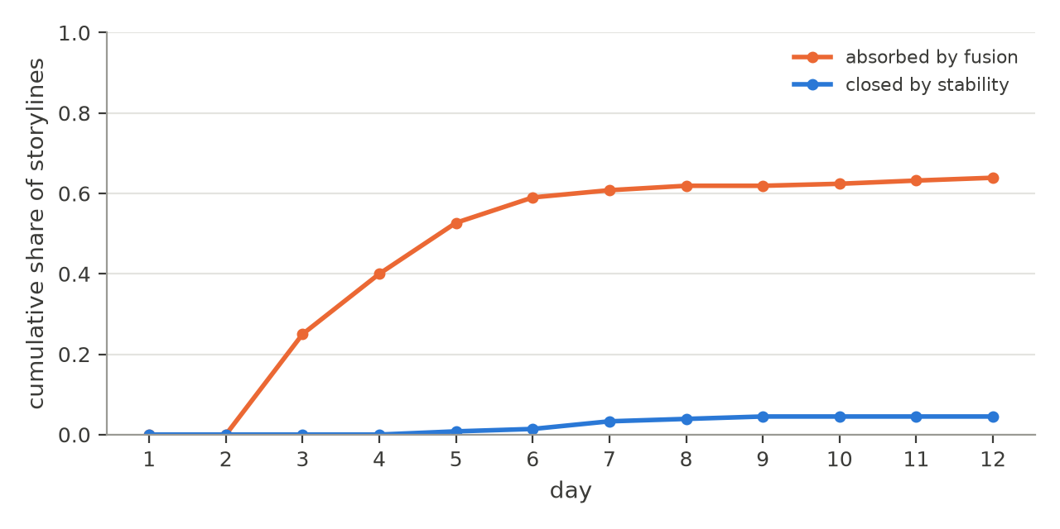

A single-story attractor
Across the 44 sessions, 191 of the 194 storylines were born on the second day, when the first actions start citing each other. After that, new storylines practically never appear: of the 3,480 events generated after the first day, only 9 (0.3%) cite no cause, although the prompt says that the list may be empty. Each event cites 1.95 causes on average. An event with a cause always joins an existing storyline, so the world’s initial storylines are the only ones it will ever have.
The storylines then merge quickly (Figure 5). Half of all fusions happen by day 4, and 81% by day 5. In 37 of the 44 sessions a single unabsorbed storyline remains at some point, at a median of day 5 (interquartile range 4–7), and 36 sessions end that way. Twenty-day sessions do not reopen the story: the curve keeps approaching one. In 11 of the 12 twenty-day sessions a single unabsorbed storyline remained at the end (in the twelfth, one storyline closed and another absorbed the rest), and in ten of them the last fusion happened by day 7. The end state is the same across the four models, both worlds, both levels of information about the storylines, and every intervention we tried: asking for the type and strength of each cause made agents cite more causes (1.71 to 2.30 per event in paired sessions) and removed all closures; limiting causes to two per action barely reduced the density (1.71 to 1.57) and did not reduce fusion. The single-story state behaves as a global attractor, with a basin that covers every condition we sampled.
Figure 5
Storylines not yet absorbed by another storyline, mean per day. Blue: 32 sessions of 12 days; orange: 12 sessions of 20 days.
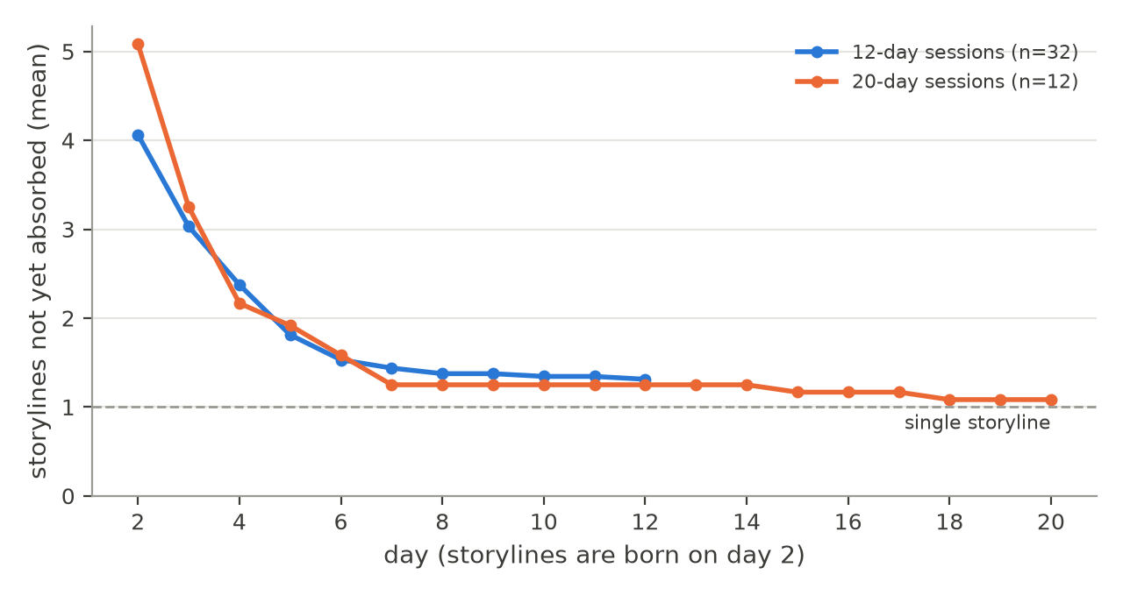
The null model shows how much of this follows from density alone. When every event’s causes are rewired at random, keeping their number, sessions end with 1.05 storylines on average, against 1.5 observed in the first round. In other words, the agents’ links are somewhat more local than random links would be, and still, with almost two causes per event in a world of six characters, everything connects. The existence of the attractor is a consequence of linking almost every event to the past. What remains to explain is its path: which storylines merge first, where and through what.

Attractor events
Most fusions are direct: in 74% of them, the event that merges two storylines cites causes in both. Attractor events are not hubs: incoming links are only moderately concentrated (Gini coefficient 0.33; the top 5% of events receive 13% of the links), so storylines are not pulled together by a few central events that everything refers to.
What attractor events share is the world’s premises. Of the 56 first fusions between storylines that had not merged before, 75% joined characters whose premises already referred to each other, against 45% of all pairs of storylines in the same sessions and 61% under the null model (95% interval of the null 45–76%; one-sided p = .036; Figure 6). The premise effect survives the discount for density, but it is smaller than the naive comparison suggests: part of the apparent attraction comes from the fact that well-connected characters start larger storylines.
Figure 6
Share of pairs of storylines whose initiating characters are linked in the world premises: all pairs, and the pairs that merged first.
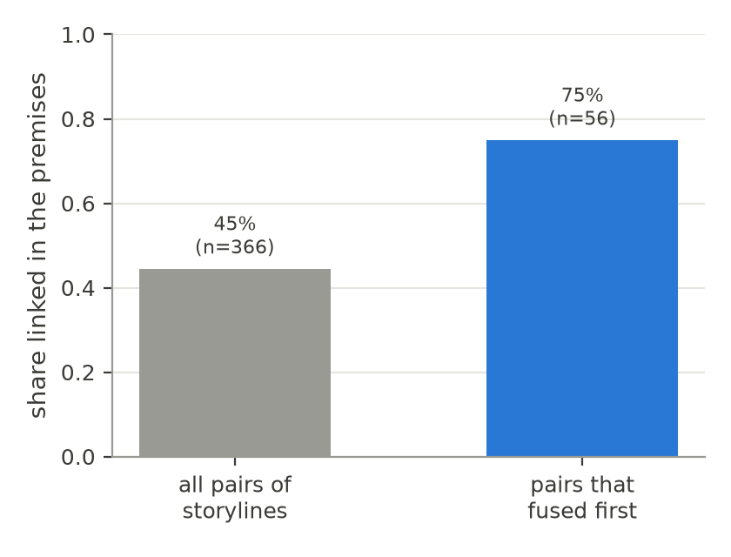
Space tells the same story (Figure 7). Although agents start spread across the town, the events concentrate in the places named in more than one premise: Vasco’s warehouse and the customs house in Porto das Brumas, the mill in Vale Silente. These places hold 49% of all events and 57% of the fusion events, against 52% under the null model (one-sided p = .014). The entropy of the distribution of events over places falls from 1.96 bits in the first two days to 1.34 bits between days 6 and 12, against a maximum of 2.32 to 2.58 bits for five or six places: the world contracts around a few places. The objects of the premises (the warehouse, the debt, the customs books; the mill, the stranger, the grain) appear in 75% of the fusion events, against 68% of the other events (Fisher’s exact test, p = .028).
Figure 7
Share of all events and of fusion events in each place of the two worlds.
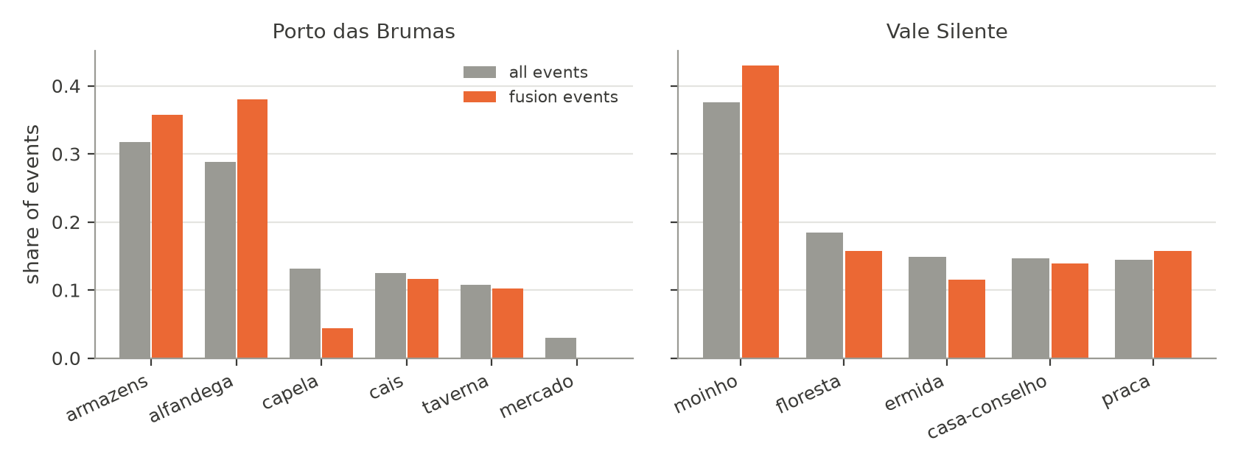
A session of Porto das Brumas generated by claude-opus-5 (translated from Portuguese) shows the mechanism (Figure 8). On day 1, the merchant goes to the warehouse to offer the widow a low price for it; the captain orders the last weeks’ pages of the customs books set aside “before the new inspector reads them”; the chaplain writes down the names he saw in the warehouse the night its owner died. On day 2 these actions are taken up and two storylines form: one that grows from the merchant’s offer for the warehouse, and one that grows from the captain’s handling of the customs books. In the customs house, the merchant offers the captain a purse to have the warehouse sealed for “unpaid duties”; the captain accepts and has the pages rewritten; the inspector asks for the books and notices the missing pages. On day 3 the captain seals the warehouse, an action whose declared causes are the bribe, his own acceptance and the inspector’s inquiry, and the two storylines become one, in the place the merchant’s objective names. The same day, the inspector goes to the warehouse looking for the widow and finds it sealed by the captain’s order. From then on, the session has a single storyline. The secrets written into the premises work as appointments: they tell the agents where the other characters’ stories are to be found.
Figure 8
Causal graph of one session (Porto das Brumas, claude-opus-5, 12 days). Each dot is an event, placed by day and by the character who caused it; colours show the storyline the event belonged to on the day it happened, and lines are declared causes. Two storylines form on day 2 and merge on day 3 through the events circled in black.
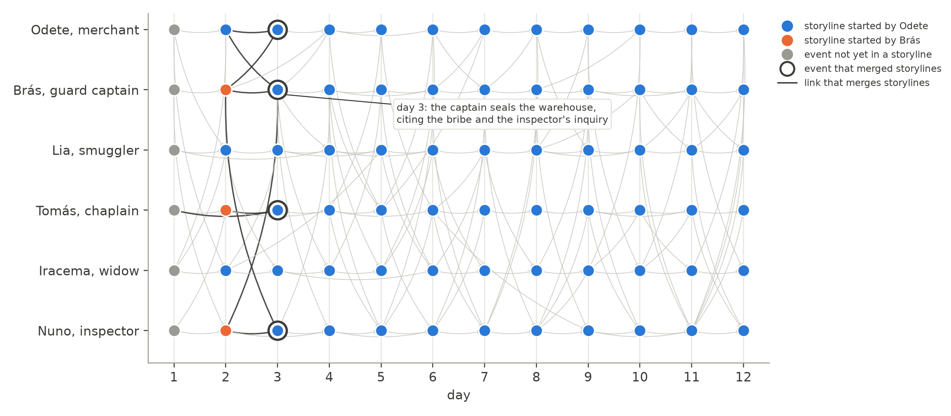
Table 2 summarises the measures of attraction against the null model. The pattern is consistent: on every measure the observed sessions deviate from random linking in the direction of the premises, and on every measure the deviation is moderate.
Table 2
Measures of attraction: observed sessions and the density-preserving null model (500 rewirings per session; one-sided p from 5,000 resamples).
Measure | Observed | Null (95% interval) | p
First fusions joining premise-linked characters (n = 56) | 75% | 61% (45–76%) | .036
Fusion events in places named by the premises (n = 302) | 57% | 52% (47–56%) | .014
Descriptive measures (no null comparison)
Fusions that cite causes in both storylines | 74%
Fusion events mentioning objects of the premises | 75% | 68% (other events) | .028
Place entropy, days 1–2 → days 6–12 (bits) | 1.96 → 1.34
Share of links received by the top 5% of events | 13%

Sensitivity
Because the storyline is defined by connectivity, we repeated the lineage analysis with alternative definitions that remove links before detection. Removing the single links whose removal would separate two storylines of at least three events raises the share closed by stability from 8% to 20%, but does not reduce fusion (59% to 60%): separated storylines merge again through other links. Cutting all links between densely connected communities (Blondel et al., 2008) gives the most permissive reading, 41% closed and 46% absorbed, and is best taken as an upper bound, since it also splits the single plot of the three-act control. The direction of the result is the same under every definition: fusion is as common as closure or more.

Discussion

Two forces: density and attraction
The convergence of these stories has two layers. The first is structural. Language-model agents almost never act without citing something that happened before; in a small world, a graph in which nearly every new node links to the past becomes connected quickly, as random networks do once the average degree passes a threshold (Newman, 2018). The null model shows that density alone would merge the storylines even more completely. This layer explains that the story becomes one. It is a property of how the agents relate their actions to the past, not of a particular model: it appears with every model we tested and under every instruction we tried. A design choice of the simulator reinforces it: a single model call decides what every character does, and that call sees all the recent events of the town. The characters are told to act only on what they know, but nothing prevents the author behind them from connecting everything it sees. In a role-playing game around a table, by contrast, players know only what their characters witnessed or were told.
The second layer is the path. Within the time the story takes to become one, which storylines meet, where and over what is not random. Fusions happen when characters whose premises were written to refer to each other meet, in the places those premises name, around the objects they mention. These are the attractor events. Their pull is real but moderate (75% against 61% expected by chance for first fusions; 57% against 52% for places), which is what one would expect if the premises bias the path without dictating it. In the language of dynamical systems, the end state is fixed by the regime, and the premises shape the trajectory inside the basin. The analogy with chaotic systems is apt in one more respect: two sessions of the same world with different seeds produce different texts, characters do different things on different days, yet the macroscopic outcome, a single story organised around the same few places and secrets, is the same.
This explains why interventions on the generation did not help. Asking for typed and weighted causes made agents more explicit about connections and therefore more connected. Asking for fewer causes changed the count, not the choice: agents kept citing the events of other storylines that their premises pointed to. Longer sessions only extended the time spent in the attractor.

What this means for AI and media literacy
The findings matter for educational uses of generative role-play in three ways.
First, an open world is less open than it looks. When a teacher or a group of students sets up a shared world and lets AI characters act, the experience is one of freedom: nobody imposed a plot, and every session is different. Our data show that, structurally, these sessions converge to the same kind of story, and do so quickly. This is a structural counterpart to the homogenisation already documented at the level of texts and plot elements (Doshi & Hauser, 2024; Xu et al., 2025): even when no single prompt asks for a story, the dynamics of generation pull toward one. Recognising this convergence is part of understanding how AI shapes the content it helps create (Long & Magerko, 2020; UNESCO, 2024).
Second, the forces are authored, and visible. The attractors we found are not hidden in the model weights; they are in the premises a human wrote: who owes whom, who knows what, where the secret is kept. This turns a critical question about media, “who constructed this message, and how?” (Hobbs, 2010), into something students can manipulate. The same world with differently entangled premises should converge along a different path, and the event graph makes the path visible. Tracing why two storylines merged, and which premise brought the characters together, is an exercise in reading how a generated narrative was constructed.
Third, the design levers are spatial and social, not textual. Instructions in the prompt did not change the outcome; the structure of the world did. For designers of educational role-play this suggests acting on the world rather than on the wording: separating characters in space, limiting who can learn what and when, and introducing events from outside the cast, which would be the only way to start new storylines once every action cites the past. These are, not by coincidence, the levers of board and tabletop game design, in which space and information channel what can happen (Jenkins, 2004; Salen & Zimmerman, 2004). They are also levers that students can understand without knowing anything about language models.

A classroom protocol for critical AI literacy
The results suggest a concrete activity, which we describe as a proposal to be evaluated rather than as a finding. It requires only the simulator, which runs on local open models as well as on commercial ones, and a projector.
Step 1: play. The class designs a small world together: five or six places, six characters, and for each character an objective, a secret and two beliefs. Students are not told about attractors. The simulator runs for ten in-game days, and groups follow different characters, reading the events as a story.
Step 2: predict. Before seeing any graph, each group writes down how many separate stories it thinks are happening and which ones will end. In our data, the honest answer after day five is almost always “one”, and students’ predictions are a measure of how open the experience felt.
Step 3: read the graph. The class looks at the causal graph and at the lineage of each storyline: when it was born, which event merged it with which other storyline, and in which place. Groups trace each fusion back to the premises and mark the ones that were “appointments” written into the world: two secrets about the same object, a belief about another character, a place mentioned twice.
Step 4: intervene. Groups rewrite the premises to move the attractors, for example by giving two characters secrets about different places, or by removing the object everyone wants, and run the same world again (with the same seed, where the model accepts one). Comparing the two graphs shows what changed and what did not: the story will probably still become one, but along a different path.
Step 5: generalise. The discussion connects the exercise to other generated media. A recommendation feed, a chatbot conversation or a generated news summary also has initial conditions written by someone, and dynamics that pull toward some outcomes more than others. The question that media literacy asks of any message, who made it and how, becomes a question about which premises a system was given and which attractors those premises create.
The protocol makes three abstract ideas tangible: that generated content has structure beyond its surface text, that the structure depends on human design choices, and that it can be inspected. Its evaluation, with measures of students’ understanding before and after, is left for future work.

Limitations
All agents were models of a single family; models from other providers, including open models run locally, are supported by the instrument and are the obvious next step. The sessions are short and few per condition, and they come from a validation stage: the confirmatory campaign registered in advance has not yet been run. Because one call decides all characters and sees all recent events, the agents are not informationally separated; a version in which each character receives only what it could know is the natural next experiment. The storyline is defined by graph connectivity, a standard but debatable operationalisation of “storyline”; we reported alternative definitions for that reason. The premise coding was done by a single coder from the world texts; a second, independent coding is needed. The declared causes were validated by judge models of the same family and not yet by human annotators, whose annotation has been prepared. Finally, no learners took part in this study: the educational implications are arguments for future classroom work, not results.

Conclusion
Left to act freely in a shared world, language-model agents do not produce a web of stories that open and close. They produce one story, quickly, because almost every action is tied to something that already happened. Which threads merge first, and where, is decided by attractors: the entangled premises and the places they name, written by the humans who designed the world. For education, the lesson is double. Generative role-play is not as open as it feels, and the reasons are structural rather than stylistic; and the forces that shape it are authored, legible and teachable. Making students read the causal graph of a story they co-created with AI, and change the world to see it converge differently, is a concrete way of practising critical AI literacy.

Data and code availability
The simulator, the pre-registration and its amendments, the event logs of all sessions and the analysis scripts are available in a public repository https://github.com/caiosilvaazeredo/cronicas-de-aethelgard.

References
Aylett, R. (1999). Narrative in virtual environments: Towards emergent narrative. Narrative Intelligence: Papers from the AAAI Fall Symposium, 83–86.
Barabási, A.-L., & Albert, R. (1999). Emergence of scaling in random networks. Science, 286(5439), 509–512. https://doi.org/10.1126/science.286.5439.509
Barthes, R., & Duisit, L. (1975). An introduction to the structural analysis of narrative. New Literary History, 6(2), 237–272. https://doi.org/10.2307/468419
Beguš, N. (2024). Experimental narratives: A comparison of human crowdsourced storytelling and AI storytelling. Humanities and Social Sciences Communications, 11(1). https://doi.org/10.1057/s41599-024-03868-8
Blondel, V. D., Guillaume, J.-L., Lambiotte, R., & Lefebvre, E. (2008). Fast unfolding of communities in large networks. Journal of Statistical Mechanics: Theory and Experiment, 2008(10), P10008. https://doi.org/10.1088/1742-5468/2008/10/p10008
Bowman, S. L. (2010). The functions of role-playing games: How participants create community, solve problems and explore identity. McFarland.
Brito, M. H. (2025). Many stories, one shape: Narrative convergence in AI-Generated fiction. Digital Kenyon (Kenyon College). https://openalex.org/W7125764248
Callison-Burch, C., Tomar, G. S., Martin, L. J., Ippolito, D., Bailis, S., & Reitter, D. (2022). Dungeons and Dragons as a dialog challenge for artificial intelligence. Proceedings of the 2022 Conference on Empirical Methods in Natural Language Processing, 9379–9393. https://doi.org/10.18653/v1/2022.emnlp-main.637
Chatman, S. (1978). Story and discourse: Narrative structure in fiction and film. Cornell University Press.
Chen, Z., Pan, R., & Li, H. (2026). StoryBox: Collaborative multi-agent simulation for hybrid bottom-up long-form story generation using large language models. Proceedings of the AAAI Conference on Artificial Intelligence, 40(36), 30359–30367. https://doi.org/10.1609/aaai.v40i36.40288
Daniau, S. (2016). The transformative potential of role-playing games: From play skills to human skills. Simulation & Gaming, 47(4), 423–444. https://doi.org/10.1177/1046878116650765
Doshi, A. R., & Hauser, O. P. (2024). Generative AI enhances individual creativity but reduces the collective diversity of novel content. Science Advances, 10(28). https://doi.org/10.1126/sciadv.adn5290
Farrell, R., & Ware, S. G. (2024). Planning stories neurally. https://doi.org/10.36227/techrxiv.171085113.35202301/v1
Fine, G. A. (1983). Shared fantasy: Role-playing games as social worlds. University of Chicago Press.
Habib, M., & Sathyanath, A. (2025). GENOME: A multi-agent NeuroSymbolic simulation framework for coherent, memory-evolved long-form story generation. 2025 International Conference on Emerging Research in Computational Science (ICERCS), 1–5. https://doi.org/10.1109/icercs65898.2025.11580934
Ho, C., Aluru, A., Hammouri, M., Luo, K., Lagasse, R., Bahuguna, A., & Sharma, V. (2026). From personas to plot: Character-grounded multi-agent story generation for long-form narratives. arXiv preprint. https://doi.org/10.48550/ARXIV.2607.00918
Hobbs, R. (2010). Digital and media literacy: A plan of action. The Aspen Institute.
Jenkins, H. (2004). Game design as narrative architecture. In N. Wardrip-Fruin & P. Harrigan (Eds.), First person: New media as story, performance, and game (pp. 118–130). MIT Press.
Jørgensen, N. H., Tharmabalan, S., Aslan, I., Brodersen Hansen, N., & Merritt, T. (2026). Guiding, not railroading: Design and evaluation of a multi-agent system for narrative redirection in role-playing games. Proceedings of the 31st International Conference on Intelligent User Interfaces, 1551–1601. https://doi.org/10.1145/3742413.3789218
Khalid, H., Shapsough, S., & Zualkernan, I. (2026). Noise steering for controlled text generation: Improving diversity and reading-level fidelity in arabic educational story generation. Proceedings of the 21st Workshop on Innovative Use of NLP for Building Educational Applications (BEA 2026), 581–597. https://doi.org/10.18653/v1/2026.bea-1.41
Kreminski, M., & Wardrip-Fruin, N. (2018). Sketching a map of the storylets design space. In Interactive storytelling (pp. 160–164). Springer International Publishing. https://doi.org/10.1007/978-3-030-04028-4_14
Leandro, J., Rao, S., Xu, M., Xu, W., Jojic, N., Brockett, C., & Dolan, B. (2024). GENEVA: GENErating and visualizing branching narratives using LLMs. 2024 IEEE Conference on Games (CoG), 1–5. https://doi.org/10.1109/cog60054.2024.10645625
Lee, S., Kim, H., Kang, S., Kim, H., & Oh, D. (2026). A structured reasoning framework for causally consistent narrative generation via evidence-conditioned candidate-set control. Knowledge-Based Systems, 352, 117032. https://doi.org/10.1016/j.knosys.2026.117032
Long, D., & Magerko, B. (2020). What is AI literacy? Competencies and design considerations. Proceedings of the 2020 CHI Conference on Human Factors in Computing Systems, 1–16. https://doi.org/10.1145/3313831.3376727
Lorenz, E. N. (1963). Deterministic nonperiodic flow. Journal of the Atmospheric Sciences, 20(2), 130–141. https://doi.org/10.1175/1520-0469(1963)020<0130:dnf>2.0.co;2
Louchart, S., & Aylett, R. (2004). Narrative theory and emergent interactive narrative. International Journal of Continuing Engineering Education and Lifelong Learning, 14(6), 506–518. https://doi.org/10.1504/ijceell.2004.006017
Ma, Y., Shi, K., He, H., Zhang, Z., Lei, Z., Qiu, Z., Hu, R., & Liu, J. (2026). Creative convergence or imitation? Genre-specific homogeneity in LLM-Generated chinese literature. arXiv preprint. https://doi.org/10.48550/ARXIV.2603.14430
Mai, L., & Carson-Berndsen, J. (2024). Improving linguistic diversity of large language models with possibility exploration fine-tuning. arXiv preprint. https://doi.org/10.48550/ARXIV.2412.03343
Mateas, M., & Stern, A. (2003). Façade: An experiment in building a fully-realized interactive drama. Game Developers Conference, Game Design Track.
Montola, M. (2008). The invisible rules of role-playing: The social framework of role-playing process. International Journal of Role-Playing, (1), 22–36. https://doi.org/10.33063/ijrp.vi1.184
Newman, M. (2018). Networks (2nd ed.). Oxford University Press. https://doi.org/10.1093/oso/9780198805090.001.0001
Nosek, B. A., Ebersole, C. R., DeHaven, A. C., & Mellor, D. T. (2018). The preregistration revolution. Proceedings of the National Academy of Sciences, 115(11), 2600–2606. https://doi.org/10.1073/pnas.1708274114
Padmakumar, V., & He, H. (2024). Does writing with language models reduce content diversity? The Twelfth International Conference on Learning Representations (ICLR). https://arxiv.org/abs/2309.05196
Park, J. S., O’Brien, J., Cai, C. J., Morris, M. R., Liang, P., & Bernstein, M. S. (2023). Generative agents: Interactive simulacra of human behavior. Proceedings of the 36th Annual ACM Symposium on User Interface Software and Technology, 1–22. https://doi.org/10.1145/3586183.3606763
Ran, Y., Wang, X., Qiu, T., Liang, J., Xiao, Y., & Yang, D. (2025). BOOKWORLD: From novels to interactive agent societies for story creation. Proceedings of the 63rd Annual Meeting of the Association for Computational Linguistics (Volume 1: Long Papers), 15898–15912. https://doi.org/10.18653/v1/2025.acl-long.773
Riedl, M. O., & Bulitko, V. (2013). Interactive narrative: An intelligent systems approach. AI Magazine, 34(1), 67–77. https://doi.org/10.1609/aimag.v34i1.2449
Riedl, M. O., & Young, R. M. (2010). Narrative planning: Balancing plot and character. Journal of Artificial Intelligence Research, 39, 217–268. https://doi.org/10.1613/jair.2989
Ryan, J. (2018). Curating simulated storyworlds [PhD thesis]. University of California, Santa Cruz.
Salen, K., & Zimmerman, E. (2004). Rules of play: Game design fundamentals. MIT Press.
Shi, G., Huang, K., & Feng, G. (2025). Long story generation via knowledge graph and literary theory. arXiv preprint. https://doi.org/10.48550/ARXIV.2508.03137
Sillano, A., Arbore, G., & De Russis, L. (2026). A persona-augmented multi-agent system for varied narrative generation. Companion Proceedings of the 18th ACM SIGCHI Symposium on Engineering Interactive Computing Systems, 32–39. https://doi.org/10.1145/3807968.3810931
Singh Rathore, P. (2026). Which india survives translation? Narrative homogenisation across indian oral traditions in LLMs. https://doi.org/10.2139/ssrn.7133858
Song, J., Zhu, A., & Callison-Burch, C. (2024). You have thirteen hours in which to solve the labyrinth: Enhancing AI game masters with function calling. arXiv preprint. https://doi.org/10.48550/ARXIV.2409.06949
Strogatz, S. H. (2015). Nonlinear dynamics and chaos: With applications to physics, biology, chemistry, and engineering (2nd ed.). Westview Press.
Tang, X., Zhang, J., Yang, Z., Tang, Y., Li, S., Lai, L., & Yang, Z. (2026). Staying in character: Perspective-bounded memory for book-based role-playing agents. arXiv preprint. https://doi.org/10.48550/ARXIV.2606.25632
Tian, Y., Huang, T., Liu, M., Jiang, D., Spangher, A., Chen, M., May, J., & Peng, N. (2024). Are large language models capable of generating human-level narratives? Proceedings of the 2024 Conference on Empirical Methods in Natural Language Processing, 17659–17681. https://doi.org/10.18653/v1/2024.emnlp-main.978
Trabasso, T., & van den Broek, P. (1985). Causal thinking and the representation of narrative events. Journal of Memory and Language, 24(5), 612–630. https://doi.org/10.1016/0749-596x(85)90049-x
UNESCO. (2024). AI competency framework for students. UNESCO. https://doi.org/10.54675/JKJB9835
Xia, H., Peng, H., Qi, Y., Xu, B., Li, J., Lei, H., & Wang, X. (2025). <Scp>StoryWriter:</scp> a multi-agent framework for long story generation. Proceedings of the 34th ACM International Conference on Information and Knowledge Management, 6559–6563. https://doi.org/10.1145/3746252.3761616
Xu, W., Jojic, N., Rao, S., Brockett, C., & Dolan, B. (2025). Echoes in AI: Quantifying lack of plot diversity in LLM outputs. Proceedings of the National Academy of Sciences, 122(35). https://doi.org/10.1073/pnas.2504966122
Yu, P., Shen, D., Meng, S., Lee, J., Yin, W., Cui, A. Y., Xu, Z., Zhu, Y., Shi, X., Li, M., & Smola, A. (2025). RPGBENCH: Evaluating large language models as role-playing game engines. arXiv preprint. https://doi.org/10.48550/ARXIV.2502.00595
Zhao, R., Zhang, W., Li, J., Zhu, L., Li, Y., He, Y., & Gui, L. (2023). NarrativePlay: Interactive narrative understanding. arXiv preprint. https://doi.org/10.48550/ARXIV.2310.01459

Appendix. Systematic review: search, criteria and included studies
Table A1. Databases and search strings
Search date: 2026-10-13. Period: 2020-01-01 to 2026-10-13.
Database | Field | Search string | Records
OpenAlex | title and abstract | ("large language model" OR LLM OR "language model" OR "generative agents") AND ("emergent narrative" OR "interactive narrative" OR "story generation" OR "narrative generation" OR storytelling) AND ("multi-agent" OR "role-playing" OR tabletop OR "shared world" OR "plot diversity" OR homogenization OR convergence OR "narrative structure" OR "causal graph") | 192
arXiv | abstract | (abs:"language model" OR abs:"generative agents") AND (abs:"emergent narrative" OR abs:"interactive narrative" OR abs:"story generation" OR abs:"narrative generation" OR abs:storytelling) AND (abs:"multi-agent" OR abs:"role-playing" OR abs:tabletop OR abs:"plot diversity" OR abs:homogenization OR abs:convergence OR abs:"narrative structure" OR abs:"causal graph") | 58
Semantic Scholar | bulk search | ("large language model" / LLM / "language model" / "generative agents") + ("emergent narrative" / "interactive narrative" / "story generation" / "narrative generation" / storytelling) + ("multi-agent" / "role-playing" / tabletop / "plot diversity" / homogenization / convergence / "narrative structure" / "causal graph") | 138
Inclusion criteria
- I1: empirical study, system or method in which a language model (any size) generates or co-generates narrative content (stories, plots, game narratives, role-play);
- I2: the study analyses the structure, diversity, coherence, convergence or plot of the generated narratives, OR involves multiple interacting agents/characters in a shared story world, OR models stories as graphs of events/causes;
- I3: peer-reviewed article, conference paper or preprint, in English, published 2020-2026.
Exclusion reasons
- E1: language models not used to generate narrative (e.g., only classification, summarisation, QA, code)
- E2: narrative is incidental: no analysis of narrative structure, diversity or convergence, no multi-agent story world, no event/causal representation
- E3: not about narrative or storytelling at all (e.g., ‘narrative’ in a policy/medical sense, counter-narratives, persuasion)
- E4: not a research contribution (editorial, abstract only, thesis summary, call for papers, workshop proposal)
- E5: out of scope of language: neither English nor a full text available in English
Table A2. Studies included in the review (n = 44), by category
Year | Title | Venue | DOI / arXiv | Category
2026 | A Persona-Augmented Multi-Agent System for Varied Narrative Generation | ACM SIGCHI Symposium on Engineering Interactive Computing Systems (EICS) | 10.1145/3807968.3810931 | Homogenisation and diversity of generated narratives
2026 | Algorithmic Narrative Structures: How Large Language Models Mimic and Disrupt Classical Structuralist Literary Syntax | Liberal Journal of Language & Literature Review | – | Homogenisation and diversity of generated narratives
2026 | Creative Convergence or Imitation? Genre-Specific Homogeneity in LLM-Generated Chinese Literature | arXiv (Cornell University) | 10.48550/arxiv.2603.14430 | Homogenisation and diversity of generated narratives
2026 | Noise Steering for Controlled Text Generation: Improving Diversity and Reading-Level Fidelity in Arabic Educational Story Generation | Workshop on Innovative Use of NLP for Building Educational Applications | 10.18653/v1/2026.bea-1.41 | Homogenisation and diversity of generated narratives
2026 | Which India Survives Translation? Narrative Homogenisation Across Indian Oral Traditions in LLMs | SSRN Electronic Journal | 10.2139/ssrn.7133858 | Homogenisation and diversity of generated narratives
2025 | All Stories Are One Story: Emotional Arc Guided Procedural Game Level Generation | arXiv (Cornell University) | 10.48550/arxiv.2508.02132 | Homogenisation and diversity of generated narratives
2025 | Echoes in AI: Quantifying lack of plot diversity in LLM outputs | Proceedings of the National Academy of Sciences | 10.1073/pnas.2504966122 | Homogenisation and diversity of generated narratives
2025 | Exploring Gender Bias in LLM-Generated Hero and Heroine Narratives | Lecture notes in computer science | 10.1007/978-3-032-02534-0_3 | Homogenisation and diversity of generated narratives
2025 | Many Stories, One Shape: Narrative Convergence in AI-Generated Fiction | Digital Kenyon (Kenyon College) | – | Homogenisation and diversity of generated narratives
2024 | Are Large Language Models Capable of Generating Human-Level Narratives? | arXiv (Cornell University) | 10.48550/arxiv.2407.13248 | Homogenisation and diversity of generated narratives
2024 | Improving Linguistic Diversity of Large Language Models with Possibility Exploration Fine-Tuning | arXiv (Cornell University) | 10.48550/arxiv.2412.03343 | Homogenisation and diversity of generated narratives
2024 | Once Upon a GPT-4: Enhancing Diversity in Automated Reading Comprehension Story Generation with Classic Tales | IEEE International Conference on Advanced Learning Technologies (ICALT) | 10.1109/icalt61570.2024.00063 | Homogenisation and diversity of generated narratives
2026 | DiaryPlay: AI-Assisted Creation of Interactive Story Vignettes for Everyday Storytelling | CHI Conference on Human Factors in Computing Systems | 10.1145/3772318.3790572 | Language models as game masters and in interactive role-play
2026 | Fun-Aware Modeling and Narrative Generation Using LLMs for Role-Playing Games | IEEE Access | 10.1109/access.2026.3710747 | Language models as game masters and in interactive role-play
2026 | Guiding, Not Railroading: Design and Evaluation of a Multi-Agent System for Narrative Redirection in Role-playing Games | ACM International Conference on Intelligent User Interfaces (IUI) | 10.1145/3742413.3789218 | Language models as game masters and in interactive role-play
2025 | Alignment, Exploration, and Novelty in Human-AI Interaction | arXiv (Cornell University) | 10.48550/arxiv.2512.17117 | Language models as game masters and in interactive role-play
2025 | Individualized Cognitive Simulation in Large Language Models: Evaluating Different Cognitive Representation Methods | arXiv (Cornell University) | 10.48550/arxiv.2510.20252 | Language models as game masters and in interactive role-play
2024 | From Role-Play to Drama-Interaction: An LLM Solution | Annual Meeting of the Association for Computational Linguistics | 10.18653/v1/2024.findings-acl.196 | Language models as game masters and in interactive role-play
2024 | You Have Thirteen Hours in Which to Solve the Labyrinth: Enhancing AI Game Masters with Function Calling | arXiv (Cornell University) | 10.48550/arxiv.2409.06949 | Language models as game masters and in interactive role-play
2023 | NarrativePlay: Interactive Narrative Understanding | arXiv (Cornell University) | 10.48550/arxiv.2310.01459 | Language models as game masters and in interactive role-play
2026 | AdaMARP: An Adaptive Multi-Agent Interaction Framework for General Immersive Role-Playing | arXiv (Cornell University) | 10.48550/arxiv.2601.11007 | Multi-agent and simulation-based story generation
2026 | From Personas to Plot: Character-Grounded Multi-Agent Story Generation for Long-Form Narratives | arXiv (Cornell University) | 10.48550/arxiv.2607.00918 | Multi-agent and simulation-based story generation
2026 | Multi-Agent Framework for Interactive Storytelling using Large Language Models | 2026 International Conference on Smart Futuristic Technology | 10.1109/icsft66733.2026.11507464 | Multi-agent and simulation-based story generation
2026 | One Sentence, One Drama: Personalized Short-Form Drama Generation via Multi-Agent Systems | arXiv (Cornell University) | 10.48550/arxiv.2605.22144 | Multi-agent and simulation-based story generation
2026 | Staying In Character: Perspective-Bounded Memory For Book-Based Role-Playing Agents | arXiv (Cornell University) | 10.48550/arxiv.2606.25632 | Multi-agent and simulation-based story generation
2026 | StoryBox: Collaborative Multi-Agent Simulation for Hybrid Bottom-Up Long-Form Story Generation Using Large Language Models | Proceedings of the AAAI Conference on Artificial Intelligence | 10.1609/aaai.v40i36.40288 | Multi-agent and simulation-based story generation
2025 | BOOKWORLD: From Novels to Interactive Agent Societies for Story Creation | Annual Meeting of the Association for Computational Linguistics (ACL) | 10.18653/v1/2025.acl-long.773 | Multi-agent and simulation-based story generation
2025 | Event-Driven Storytelling with Multiple Lifelike Humans in a 3D scene | Seoul National University Open Repository (Seoul National University) | 10.1109/iccv51701.2025.01084 | Multi-agent and simulation-based story generation
2025 | GENOME: A Multi-Agent NeuroSymbolic Simulation Framework for Coherent, Memory-Evolved Long-Form Story Generation | 2025 International Conference on Emerging Research in Computational Science (ICERCS) | 10.1109/icercs65898.2025.11580934 | Multi-agent and simulation-based story generation
2025 | HAMLET: A Hierarchical and Adaptive Multi-Agent Framework for Live Embodied Theatrics | arXiv (Cornell University) | 10.48550/arxiv.2507.15518 | Multi-agent and simulation-based story generation
2025 | MemAGent: A Cognitive-Hierarchical Multi-Agent System for Long-Form Story Generation | 2025 IEEE 3rd International Conference on Computer, Vision and Intelligent Technology (ICCVIT) | 10.1109/iccvit67848.2025.11391379 | Multi-agent and simulation-based story generation
2025 | StoryWriter: A Multi-Agent Framework for Long Story Generation | ACM International Conference on Information and Knowledge Management (CIKM) | 10.1145/3746252.3761616 | Multi-agent and simulation-based story generation
2026 | A Structured Reasoning Framework for Causally Consistent Narrative Generation via Evidence-Conditioned Candidate-Set Control | Knowledge-Based Systems | 10.1016/j.knosys.2026.117032 | Structural, causal and planning representations of stories
2026 | Archaeological-prototyping-based story generation with large language models: Envisioning technology development through science fiction | Entertainment Computing | 10.1016/j.entcom.2026.101172 | Structural, causal and planning representations of stories
2026 | Fabula: Building a Narrative Storytelling Sidekick with the Writers’ Community | arXiv | arXiv:2606.14411 | Structural, causal and planning representations of stories
2026 | From World-Gen to Quest-Line: A Dependency-Driven Prompt Pipeline for Coherent RPG Generation | arXiv (Cornell University) | 10.48550/arxiv.2604.25482 | Structural, causal and planning representations of stories
2026 | LLM-Driven MCTS for Conditional Story Generation via Logic-Guided Evidence Tree Optimization | IEEE Transactions on Audio Speech and Language Processing | 10.1109/taslpro.2026.3687020 | Structural, causal and planning representations of stories
2026 | Trait-guided detective story generation in seven classic investigative styles with Large Language Models | Entertainment Computing | 10.1016/j.entcom.2026.101166 | Structural, causal and planning representations of stories
2025 | CML-Bench: A Framework for Evaluating and Enhancing LLM-Powered Movie Scripts Generation | arXiv (Cornell University) | 10.48550/arxiv.2510.06231 | Structural, causal and planning representations of stories
2025 | COS(M+O)S: Curiosity and RL-Enhanced MCTS for Exploring Story Space via Language Models | arXiv (Cornell University) | 10.48550/arxiv.2501.17104 | Structural, causal and planning representations of stories
2025 | Long Story Generation via Knowledge Graph and Literary Theory | arXiv | 10.48550/arxiv.2508.03137 | Structural, causal and planning representations of stories
2025 | RPGBENCH: Evaluating Large Language Models as Role-Playing Game Engines | arXiv (Cornell University) | 10.48550/arxiv.2502.00595 | Structural, causal and planning representations of stories
2024 | GENEVA: GENErating and Visualizing branching narratives using LLMs | IEEE Conference on Games (CoG) | 10.1109/cog60054.2024.10645625 | Structural, causal and planning representations of stories
2024 | Planning Stories Neurally | – | 10.36227/techrxiv.171085113.35202301/v1 | Structural, causal and planning representations of stories

FROM BOARD TO GRAPH: A HYBRID HUMAN-AI ROLE-PLAYING BOARD FOR CRITICAL MEDIA AND AI LITERACY
Abstract
Communities come to share one version of events through who is where, who knows what and who controls central places. We present a role-playing board on which students, alone or with generative-AI characters, can experience and then inspect that process. The world is a grid, represented as a matrix; a character can only build on events it saw or heard about; and the causal links between events are drawn with yarn, so the story ends as a visible graph. A simulation with synthetic agents shows that limiting information only delays convergence to a single story, that central places decide where stories merge, and that two mechanics keep several stories alive. We describe the kit, a classroom protocol for critical media and AI literacy, a low-tech version for contexts without devices, and an evaluation plan.
Keywords: game-based learning; media literacy; AI literacy; role-playing games; board games; information disorder; network science

Introduction
Every community tells itself stories about what happened: who was responsible for a death, why the grain ran out, who is to blame for a debt. Which of those stories survive is rarely a matter of evidence alone. It depends on who was present, on who heard what from whom, and on who controls the places where people meet. Accounts told at the periphery of these networks are absorbed into the dominant one or never reach it. The same mechanics operate, at a much larger scale, in the information ecosystems that media literacy education is concerned with: rumours travel along social ties, some places and channels concentrate attention, and a shared account can form quickly around whatever happens to connect the most people (Hobbs, 2010; Wardle & Derakhshan, 2017).
Games have proved to be good vehicles for teaching how such processes work. Playing at producing misinformation, for instance, builds resistance to it (Basol et al., 2020; Roozenbeek & van der Linden, 2019), and games in general let learners inhabit a system and reflect on its rules (Flanagan, 2009; Gee, 2003). Role-playing games add something specific: the story is co-created by the participants as they play, so the process by which a shared account forms is not only represented but enacted by the group itself (Bowman, 2010; Daniau, 2016; Fine, 1983; Montola, 2008).
Generative AI makes this both more urgent and more interesting. Language models can now play characters in a shared world (Callison-Burch et al., 2022; Park et al., 2023), and learners increasingly co-create stories with them. A companion study, currently under review, simulated a small town whose inhabitants were all language-model agents and recorded every event with its declared causes. The storylines that appeared on the second day of play merged into a single story within a few days, and they merged along paths set by the premises of the world: characters whose secrets referred to each other met first, in the places those secrets named. One feature of that simulator matters for this paper: a single model call decided what every character did and saw everything that had happened recently, so the characters were effectively omniscient. In a tabletop game, by contrast, players only know what their characters witnessed or were told.
This paper turns that contrast into a learning tool. We propose a role-playing board on which a small community lives: a grid of cells with places, paths and a river; characters who can only build on what they saw or heard; and event cards whose causes are tied together with yarn, so that the story of the session ends as a physical graph on the table. The same board can be played by people, by AI characters through a simulator, or by mixed tables. The board is represented as a matrix, which lets us reason about what its geometry does to the story with the tools of graph theory, and test design options before taking them to a classroom.
The contributions are: (1) a formal model linking the board, the encounters between characters and the causal graph of the story; (2) a proof of concept with synthetic agents that identifies which mechanics change how fast and where a shared story converges; (3) a physical kit and a hybrid human–AI protocol; (4) a classroom protocol for critical media and AI literacy, including a low-tech version; and (5) an evaluation plan. The paper is a design and research proposal: the model and the simulation are complete, the kit and the classroom protocol have not yet been tested with learners.

Background

Media literacy, information disorder and games
Media literacy education asks learners to analyse who constructs messages, how and with what effects (Hobbs, 2010). Information disorder research has added a systemic view: false or misleading content matters less as isolated items than as flows through networks of people, platforms and places that amplify some accounts and silence others (Wardle & Derakhshan, 2017). AI literacy extends these questions to systems that generate content, asking learners to understand what such systems can do, how they represent the world and how their outputs are shaped (Long & Magerko, 2020; UNESCO, 2024). There is growing evidence that generative models homogenise what they help to produce, from individual texts to plot elements (Beguš, 2024; Doshi & Hauser, 2024; Padmakumar & He, 2024; Xu et al., 2025).
Games have been used to teach these competences in two ways. Some games simulate the production of misinformation so that players learn its techniques from the inside, an approach that has measurable effects on the ability to recognise manipulative content (Basol et al., 2020; Roozenbeek & van der Linden, 2019). Others use the procedural rhetoric of games, the way rules make an argument (Bogost, 2007), to let players experience a social process and then reflect on it (Flanagan, 2009; Flanagan & Nissenbaum, 2014). The board proposed here belongs to the second family. It does not teach players to recognise false content; it lets a group experience how a shared account forms, and then inspect the structure that produced it.

Space, grids and social processes
Game spaces tell stories by arranging places, paths and obstacles that channel movement and encounters (Jenkins, 2004). Rules constrain the fiction, and many rules are spatial (Juul, 2005; Salen & Zimmerman, 2004); modern board games make these structures particularly legible (Woods, 2012). Space syntax describes buildings and cities as graphs and shows that the position of a space in that graph predicts how much it is used and how people meet in it (Hillier & Hanson, 1984). Grids have a long history as minimal models of social processes, from segregation (Schelling, 1971) to whole artificial societies (Epstein & Axtell, 1996) and cellular automata (Wolfram, 1984), and they have been used in teaching precisely because they show collective outcomes emerging from local structure without anyone intending them.

Stories as graphs
Narrative comprehension can be modelled as a causal network of events (Trabasso & van den Broek, 1985); the kernels of a plot are the events with causal antecedents and consequences (Barthes & Duisit, 1975; Chatman, 1978). Network science supplies the tools to read such graphs: connected components, bridges and articulation points (Tarjan, 1972), communities (Blondel et al., 2008), time-respecting paths in networks whose links appear and disappear (Holme & Saramäki, 2012), and the conditions under which a growing graph becomes connected (Newman, 2018). Emergent narrative research has long observed that autonomous agents produce events more easily than stories with shape (Aylett, 1999; Louchart & Aylett, 2004; Riedl & Bulitko, 2013); the companion study suggests that, with language-model agents, the problem is the opposite of sprawl: everything connects.

Systematic literature review
We reviewed how analogue games have been used for media, information and AI literacy, and how tabletop play has been combined with generative AI, following the PRISMA 2020 reporting structure.

Search.
On 13 October 2026 we searched OpenAlex (title and abstract), arXiv (abstract) and Semantic Scholar (bulk search) for records from 2015 to 2026 that combine a game form (“board game”, “tabletop game”, “role-playing game”, “card game”, “tabletop role-playing”) with a literacy or AI term (“media literacy”, “information literacy”, misinformation, disinformation, “fake news”, “AI literacy”, “large language model”, “generative AI”). The exact strings, the raw responses and every screening decision are in the supplementary material and in the public repository.

Eligibility criteria.
Records were included when they met all of the following: (I1) the study designs, uses or evaluates an analogue game (board, card or tabletop role-playing game, including hybrid analogue-digital versions), or a tabletop role-playing setting with generative AI; (I2) the game targets media, information, news or AI literacy, misinformation or critical thinking about information, or combines tabletop play with generative AI; (I3) it is a peer-reviewed article, conference paper or preprint in English, from 2015 to 2026. Records were excluded when the game was not analogue or tabletop (E1), when it had no literacy or generative-AI focus (E2), when AI merely played a board game as a benchmark (E3), when the record was not a research contribution (E4), or when it was not available in English (E5).

Process.
Duplicates were removed by DOI, arXiv identifier and title similarity; records without an abstract could not be screened. Titles and abstracts were screened by a language model (claude-sonnet-5) and the records that passed were assessed again, with stricter instructions, by a second model (claude-opus-5-5). Every decision was logged with its reason; one of the authors reread the full abstracts of the doubtful inclusions as a second reviewer, which changed one decision. Model-assisted screening is consistent and auditable, but it does not replace two independent human reviewers.

Results.
The searches returned 477 records (Figure 1). After removing 195 duplicates and 23 records without an abstract, 259 were screened, 106 were assessed for eligibility and 69 were included, in four groups.
Figure 1
PRISMA 2020 flow diagram of the systematic review on analogue games for media, information and AI literacy and on tabletop play with generative AI.
Analogue games for media, information and news literacy (23 studies). Board games have been designed to simulate real-world media dynamics in media and information literacy workshops, evaluated from the perspective of teachers and facilitators (Tan et al., 2026a) and with hundreds of students (Tan et al., 2026b); to simulate journalistic work and test effects on news literacy and motivation (Oehmer-Pedrazzi & Pedrazzi, 2026); and to place players in a simulated post-truth context (XIE et al., 2024). Quasi-experimental studies report gains in learning achievement and flow (HSU & ZHANG, 2023) and compare competitive with cooperative play (HSU & Chiang, 2023). Card games address fake news directly (Pomichal & Trnka, 2022, 2023), and a board game based on inoculation theory helped mothers resist misinformation about breastfeeding (Natoli, 2015).
Analogue games for AI literacy (11 studies). Non-digital board and card games teach AI concepts and ethics without devices: a family board game aimed at lowering the digital divide (Ding & Holland, 2025), a card game in which players audit the harms of AI products (Ali et al., 2023), an unplugged card game on embeddings (Vandenberg et al., 2026) and a Turing-test role-play used in a school without computers (Sankpo & Kyei Asamoa, 2026). A board game with NFC-tagged pawns lets young children co-create stories with an AI (Choi et al., 2025).
Generative AI in tabletop role-play (26 studies). Most of this work supports or replaces the game master: language models assist Dungeon Masters with information and inspiration (Zhu et al., 2023), act as game masters (Triyason, 2023), or are combined in multi-agent systems that reduce some errors but introduce others, such as rule violations and spoilers (Association for Computational Linguistics 2025 et al., 2025). Other systems replace players who leave the table (Xin & Kimiya, 2025), or combine physical cards with generative AI that keeps a group story coherent (Zhang et al., 2026); design studies discuss how such companions could change collaborative storytelling (Santiago et al., 2023).
Generative AI in game design (9 studies). Generative AI is also used to design and adapt educational board games (Gatti Junior et al., 2023); in one case study it reduced the teacher’s workload (Amarilli & Timakova, 2024).

Gap.
The media-literacy games in the review simulate media dynamics and evaluate knowledge, attitudes, motivation or flow; none of the abstracts describes a game whose spatial and informational rules let players see how a shared account forms, or one that leaves an inspectable record of it. The generative-AI studies focus on assisting or replacing the game master; few combine physical play with AI characters at the same table, and none uses that combination to compare how humans and AI relate events. The board proposed here addresses these gaps.

The model

The board as a matrix
The board is a grid of n × n cells. Each cell is a passage, a barrier or part of a place; a place is a connected region of cells with a name and a description, such as the warehouse, the customs house or the chapel (Figure 2). Two non-barrier cells are adjacent when they share a side; hexagonal and eight-neighbour boards fit the same framework. The board is therefore a graph S = (C, A) whose vertices are cells, fully described by its adjacency matrix A, with A_{xy} = 1 when cells x and y are adjacent and 0 otherwise.
Matrix powers answer the board’s basic questions. Cell y can be reached from cell x in at most k steps when
$${\left[{\left(I+A\right)}^{k}\right]}_{xy}>0,$$
where I is the identity matrix. A character that moves m cells per turn can therefore reach, in one turn, the cells where row x of (I + A)^{m} is positive. Perception uses the same operator: a character at x with perception radius r sees what happens in the cells y for which [(I + A)^{r}]_{xy} > 0, that is, the cells at most r steps away. Bridges of S (passages whose removal disconnects the board) and articulation cells (cells whose removal does so) are its chokepoints (Tarjan, 1972). The places that many characters’ premises mention are attractor places.
Figure 2
An example board. Places are regions of cells; the warehouse and the customs house are attractor places, named in several premises; a river with a single bridge creates an articulation cell. Discs are characters; the shaded cells are what one character sees with perception radius 2.
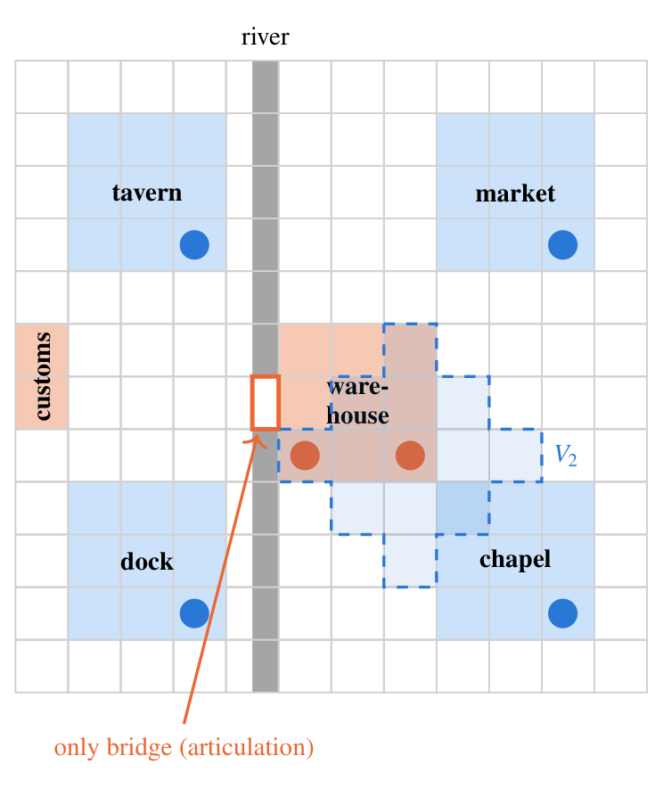

Characters, encounters and knowledge
Each character has a position on the board at every turn, a home place and premises: an objective, a secret and two beliefs. Characters move toward the places their premises make relevant. Two characters meet at turn t when one is within the other’s perception radius. Encounters form a temporal network over the characters (Holme & Saramäki, 2012): let M_{t} be the encounter matrix at turn t, with 1 for each pair of characters who meet. Information can travel from character a to character b between turns t₀ and t₁ only along a time-respecting path, which exists when
$$R=\prod_{t=t_{0}}^{t_{1}−1}{\left(I+M_{t}\right)}, R_{ab}>0,$$
with the product computed in Boolean arithmetic, so that R_{ab} is positive exactly when such a path exists. Each character holds a knowledge set: the events it caused, the events it saw and the events it heard about from characters it met, each passed on with a rumour probability q.

Events and the causal graph
Each turn, each character acts. The action becomes an event v with an author, a cell, a turn and a list of declared causes. The rule that defines the model is that a character can only build on what it knows:
$$u∈causes\left(v\right) ⇒ u∈K_{author\left(v\right)}\left(t\left(v\right)\right),$$
where K_{a}(t) is the knowledge set of character a at turn t. For AI characters the rule is enforced by prompting each character separately with only its knowledge set; for people it is enforced by the physical kit.
The causal graph G is built from the declared causes. Its connected components are the storylines, recomputed every turn: a storyline is born when a new component appears, fuses when its events become part of another storyline and closes when it stops receiving new events for three turns. The three graphs are nested (Figure 3): the board S bounds the encounters H, because characters can only meet where the board lets them go, and H bounds G, because an event can only cite another if information about it could have travelled to its author. This yields predictions that can be read off the board before anyone plays: attractor places should concentrate the fusions; chokepoints should be where separate storylines first meet; and storylines started far apart should merge later.
Figure 3
The three layers. Where characters can go (S) bounds whom they meet and when (H), which bounds what each event can cite (G). The highlighted event, at an attractor place, merges two storylines.
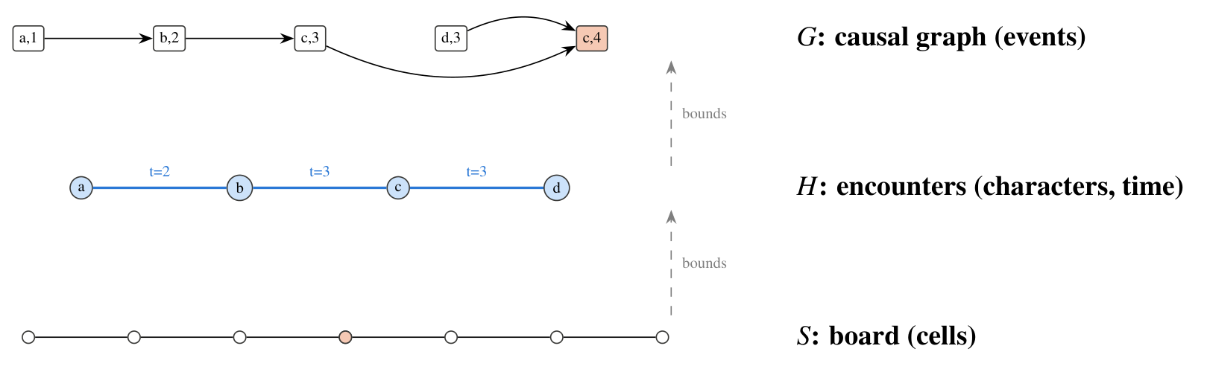

What the model makes visible
For media literacy, the value of the model is that it separates three things that are usually confounded when people explain why a community believes what it believes. The first is access: who could have known about an event, which is a property of space and encounters. The second is uptake: which known events a character chooses to build on, which is a property of the character, human or AI. The third is structure: the shape of the resulting story, which emerges from the first two. A rumour that spreads widely may do so because it was told in the place everyone passes through, because those who heard it chose to repeat it, or because the network had no other route. On the board, each of these explanations corresponds to something that can be pointed at.

A worked example
A sequence from the companion study, generated by language-model agents in the harbour town, shows what the board changes. On day 1, the merchant goes to the warehouse to offer the widow a low price for it; the captain of the guard orders some pages of the customs books set aside “before the new inspector reads them”. On day 2, in the customs house, the merchant offers the captain a purse to have the warehouse sealed for unpaid duties; the captain accepts and has the pages rewritten; the inspector asks for the books and notices the missing pages. On day 3 the captain seals the warehouse, citing the bribe, his own acceptance and the inspector’s inquiry, and the merchant’s and the captain’s storylines become one.
In the omniscient simulator, every character could cite every one of these events. On the board, each citation needs a route. The captain can cite the bribe because he received it in person. Whether he can cite the inspector’s inquiry depends on whether he was in the customs house, or met someone who was, before acting. The widow, who was at the warehouse on day 1 but not at the customs house on day 2, cannot know about the bribe unless someone tells her; if she later acts on it, the yarn will show who told her and where. The same sequence, replayed on the board, thus produces a causal graph in which every link has a visible explanation in space and time, and in which the merger of the two storylines happens where the board says it can: in the warehouse, the place the merchant’s objective points to, where the captain goes to seal it, made possible by what the two of them did in the customs house the day before.

Proof of concept with synthetic agents
Before involving language models or learners, we asked which board mechanics can change the convergence of a shared story at all. We wrote a minimal simulation in which six synthetic characters move on a 12 × 12 board with six places, two of them attractor places, and act once per day for 20 days. Each event cites a number of causes drawn from the distribution observed with language-model agents in the companion study (mostly one or two causes, almost never none), chosen at random among the recent events the author knows. The characters have no content and no intentions: what is tested is the effect of structure alone.
We compared the omniscient regime of the existing simulator, in which every character knows every recent event, with board regimes that vary the perception radius, rumours and the presence of attractor places. We also tested two design levers. Event cards are two world events per day that appear in random cells with no cause, such as a ship arriving or a storm. The focus rule requires that, in 80% of actions, all causes come from the same storyline, so that an action continues one thread rather than tying several together. Each condition was run 500 times; the script and its output are in the repository.
Figure 4
Separate storylines per day in the synthetic proof of concept, mean of 500 runs per condition, 20 days.
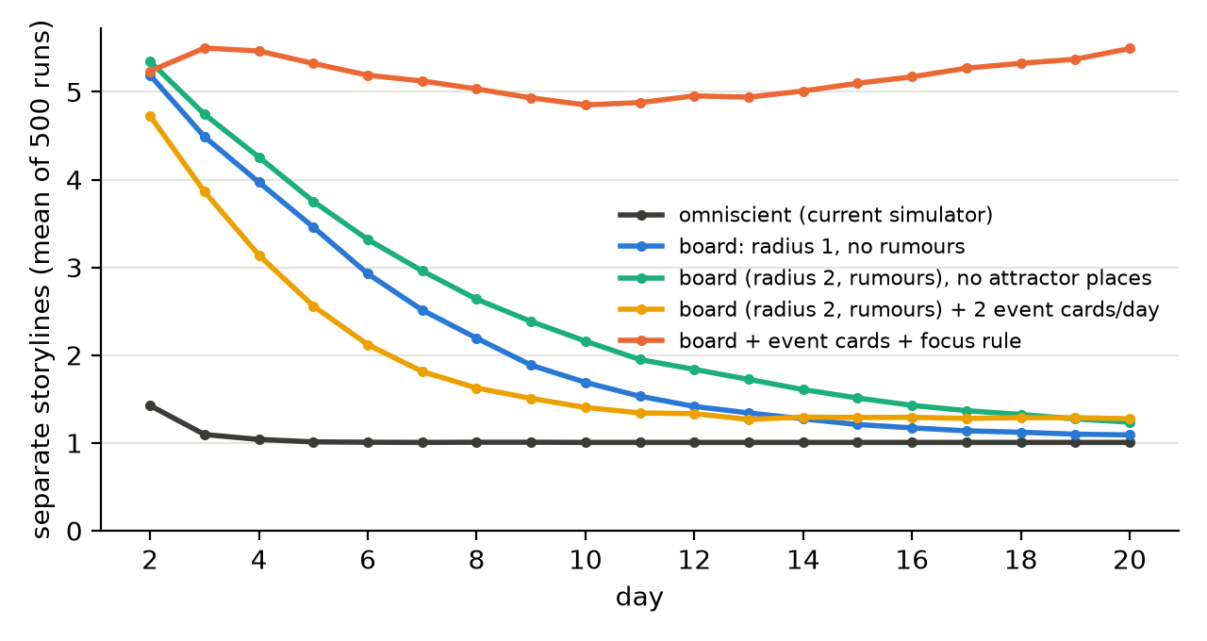
Table 1
Proof of concept with synthetic agents, 20 days, 500 runs per condition.
Condition | Storylines at the end | Runs ending with one | Born after day 2 | Fusions near attractors
Omniscient (current simulator) | 1.01 | 99% | 0.1 | 91%
Board, radius 2, rumours | 1.05 | 95% | 0.0 | 85%
Board, radius 1, no rumours | 1.09 | 91% | 0.0 | 85%
Board, radius 2, rumours, no attractor places | 1.24 | 79% | 0.0 | 66%
Board, radius 2, rumours, 2 event cards per day | 1.28 | 76% | 1.3 | 86%
Board, radius 2, rumours, event cards and focus rule | 5.49 | 2% | 6.0 | 84%
Three results stand out (Figure 4, Table 1).
Information changes the beginning, not the end. In the omniscient regime, the actions of the second day already cite each other across characters, and only 1.5 storylines are born on average. On the board, each character mostly knows its own past, and about five storylines are born, the same order observed with language-model agents. But on every board without further mechanics, almost all runs still end with a single storyline. Reducing the perception radius or removing rumours only slows the process. For teaching, this is the first lesson of the board: limiting who knows what delays the formation of a single account, but does not prevent it as long as everyone keeps building on what they know.
Attractor places decide where, and partly whether. With attractor places, more than 80% of fusions happen next to them; without them, the share falls to 66% and one run in five keeps more than one storyline. The places everyone needs are where separate accounts meet and merge.
New stories need new seeds and a reason not to knot. Because every character always knows its own past and almost always cites something, no storyline is born after the second day unless the world supplies events without causes. Event cards provide such seeds, but on their own they are soon absorbed. Combined with the focus rule, they sustain five to six storylines throughout the session, with new ones being born as others merge. In media terms, plurality of accounts requires both new, independent sources and a practice of not immediately connecting everything to the dominant story.
Figure 5 shows what these differences look like on the table after eight turns of one run of each condition: with the board rules alone, the yarn forms a single bundle around the attractor places; with world-event cards and the focus rule, several bundles of different colours stay apart.
Figure 5
The table after eight turns in one run of the synthetic proof of concept, under two conditions. Rectangles are event cards placed on the cell where they happened, diamonds are world-event cards, and lines are the yarn between each card and the cards it cites, coloured by the storyline the card belongs to at the end.
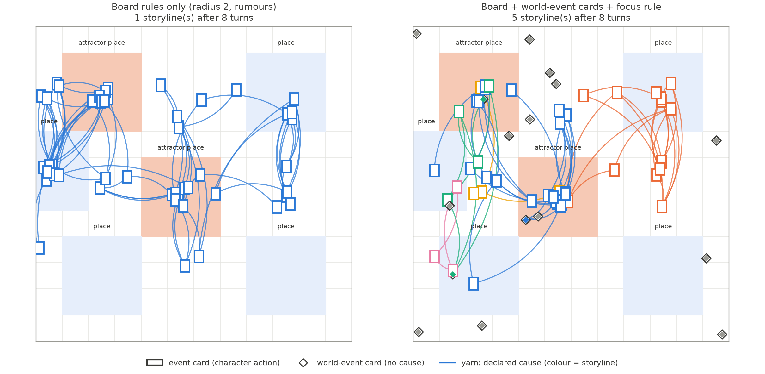
The proof of concept has obvious limits: synthetic characters choose at random and have no premises in the textual sense. Its value is to separate what the board can do from what content does, and to tell us which mechanics are worth taking to a classroom.

From findings to mechanics
Table 2 summarises how each observation, from the companion study or from the proof of concept, becomes a mechanic of the board and a point for discussion in class.
Table 2
From observations to board mechanics and learning points.
Observation | Board mechanic | Learning point
AI characters that see everything connect everything; storylines merge within days | Knowledge limited to what a character saw or heard; perception radius; rumours | Who could have known: access shapes which accounts can meet
Fusions happen in the places that several premises name | Attractor places on the board; chokepoints such as a single bridge | Central places and channels are where separate accounts merge
No new storyline is born once every action cites the past | World-event cards with no cause | Plurality needs new, independent sources
Limiting information only delays the merger | Focus rule: an action continues one thread | Norms of attribution and restraint keep accounts apart
The story is invisible while it is being made | Yarn between event cards | The structure of a shared account can be inspected

The physical kit and the hybrid protocol
The same board is printed for a table of four to eight participants. The kit contains the board, with places and a river; one token and one character sheet per character, with objective, secret and beliefs; blank event cards, on which a player writes what the character does, the turn and the identifier of each cause; coloured yarn, which connects each event card to the cards it cites; a deck of world-event cards; and screens that hide each player’s known cards. Figure 6 shows the main components.
Figure 6
Components of the physical kit: (a) a character sheet with objective, secret and beliefs; (b) an event card, with turn, cell, character, action and the identifiers of the cards it cites; (c) a world-event card, which has no cause; (d) on the table, each event card sits on the cell where it happened and yarn ties it to the cards it cites. Card 14, in the warehouse, cites three cards from the customs house: the yarn shows that its author could only know about them because he was there.
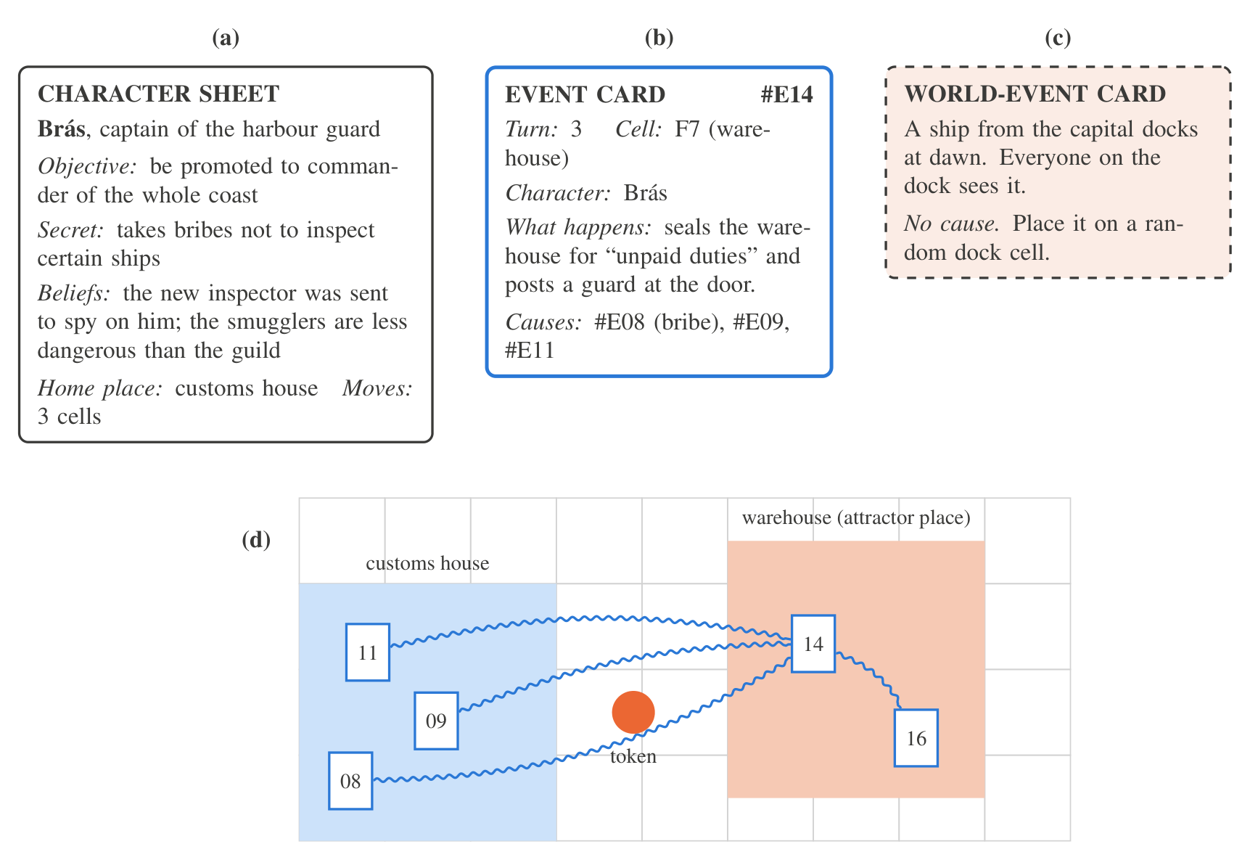
A turn has four steps. First, characters move up to a fixed number of cells. Second, the facilitator reveals world-event cards in the drawn cells. Third, each player writes an event card and places it on the cell where it happens; the card’s causes must be cards the character knows, and the facilitator ties the yarn. Fourth, knowledge is updated: a player adds to their hand the cards placed within their token’s perception radius, and players whose tokens meet may show each other cards from their hands. Optional rules switch the focus rule on or off, or change the radius and the number of world-event cards. Varying these rules between rounds is part of the learning design, as the classroom protocol below describes.
In hybrid tables, some characters are played by the simulator. The facilitator, or a companion app, enters the AI characters’ positions and known cards; the simulator, prompting each character separately with only its knowledge, returns the action and its causes, which are written on cards like any other. Because every event card carries the same fields as the simulator’s event log, a photographed or transcribed table yields the same data as a simulated session, and all analyses run unchanged on human, AI and hybrid tables. At the end of the session the yarn is the causal graph.

A classroom protocol

Learning objectives
The protocol targets four objectives, aligned with media literacy and AI literacy frameworks (Hobbs, 2010; Long & Magerko, 2020; UNESCO, 2024):
- explain how access to information, uptake and network structure each contribute to the formation of a shared account;
- identify, in a causal graph they built, the events and places through which separate accounts merged;
- compare how human and AI characters relate new events to past ones, and recognise the tendency of generative models to connect everything they see;
- propose and test changes to the rules of a community (more sources, more routes, norms of attribution) that would preserve a plurality of accounts.

A session of 100 minutes
Preparation (10 minutes). Groups of four to six receive the board and a scenario. We use the two worlds of the companion study: a harbour town with debt, bribery and smuggling, and a mountain village that must ration grain before winter. Each student takes one character sheet. In hybrid tables, one or two characters are played by the simulator.
First round (30 minutes). Eight turns with the default rules: radius 2, rumours allowed, one world-event card per turn, no focus rule. The yarn grows on the table as the story unfolds.
Prediction (10 minutes). Before looking at the yarn as a graph, each student writes how many separate stories they think the town has, which character’s account became dominant and why.
Reading the graph (20 minutes). The group lifts the yarn and reads it as a graph: which cards hold separate bundles together, at which place the first bundles merged, whose stories were absorbed and never had their own ending, and who knew what when. The facilitator asks the three questions that correspond to the model: who could have known this (access), who chose to build on it (uptake), and what would have happened without this card or this place (structure).
Second round (20 minutes). The group changes one rule and plays again: adds world-event cards, adopts the focus rule, adds a second bridge, or moves the place everyone needs. Students predict the effect before playing.
Debrief (10 minutes). The discussion connects the board to media they know: a group chat in which one message ties every conversation together, a recommendation feed that routes everyone through the same few channels, or a chatbot that, like the AI characters, connects whatever it is shown. The closing question is what a community, or a platform, could change in its rules to keep more than one account alive.

The facilitator’s role
The facilitator, usually the teacher, does not narrate the story. Their role is to keep the rules: checking that each card cites only cards its author knows, tying the yarn, revealing world-event cards, and, in hybrid tables, passing the AI characters’ knowledge to the simulator and their actions back to the table. This deliberately removes the figure of an omniscient game master, whose presence would reintroduce the single point of view that the board is meant to break. Preparation takes about an hour: printing the board and the cards, reading the two scenarios, and, for hybrid tables, testing the simulator with the chosen model. A short facilitator guide, with the rules on one page and the debrief questions below, accompanies the kit.

Debrief questions
The facilitator can draw on a small bank of questions, grouped by the three explanations the model separates.
Access. Which cards could your character have seen? Who told you about this event, where and when? Was there any story you never heard about until the end? What would have changed if you had been on the other side of the river?
Uptake. Among the cards you knew, why did you build on these and not others? Did you tie your card to the story everyone was following, or to your own? Did the AI characters choose differently from the people at the table?
Structure. Which card holds the largest bundle of yarn together? If we cut it, how many stories would the town have? Which place appears most often under the cards where bundles merge? Whose story was absorbed into another one and never had its own ending, and why?
Transfer. Where, in your own media use, is the “warehouse” that everyone passes through? Which messages work like the card that ties everything together? What rule would you add to a group chat, or to a platform, to keep more than one account alive?

A low-tech version
The AI characters are optional. The full protocol runs with paper, yarn and dice, which makes it usable in schools without devices or connectivity, a concern of the call for this issue. In this version, the facilitator plays one “connected” character who, unlike the others, sees every card on the table and must cite at least two of them. This character reproduces, by rule, the behaviour that the companion study observed in language-model agents, and lets students discuss AI-like omniscience without using AI.

Using generative AI with students
Hybrid tables bring generative AI into the classroom, and with it questions of privacy and control. The protocol is designed so that no personal data reach the model: the AI characters receive only the fictional cards they know, never students’ names or writing beyond the event cards of the game. The simulator also runs with open models on a local machine, which avoids sending any classroom content to an external service and keeps the activity possible where commercial services are restricted. The teacher decides which characters, if any, are played by AI, and every AI action passes through the facilitator before it becomes a card on the table, so the model never addresses students directly. Finally, the AI characters are presented as what they are, programs that write plausible actions from what they are given, which is itself part of the learning objective: students compare how these characters relate events with how they themselves do.

Accessibility
Cards can be printed in large type and read aloud; tokens can carry tactile marks; and the number of turns can be reduced for younger players. Writing an event card can be replaced by telling it to a scribe. The board’s logic does not depend on reading speed, which makes it suitable for mixed groups.

Evaluation plan
We plan two studies, to be pre-registered with the same procedures as the companion study (Nosek et al., 2018).
Study 1: simulation with language-model agents. The existing simulator will be extended with the board and with per-character prompts restricted to knowledge sets. With the same worlds and models as the companion study, we will cross the omniscient and board regimes, the perception radius, rumours, event cards and the focus rule. Hypotheses: (H1) on the board, more storylines are born and fusions happen later than in the omniscient regime; (H2) fusions concentrate at attractor places and chokepoints; (H3) without event cards, no storylines are born after the first days; (H4) event cards with the focus rule sustain several storylines and allow closures.
Study 2: classroom sessions. Upper-secondary and first-year university classes will play the protocol in three formats: human only, hybrid, and human only with the “connected” character of the low-tech version. Measures include the graph metrics of each table; the written predictions and explanations, coded for references to access, uptake and structure; and a short pre/post instrument on how participants explain the formation of shared accounts in a news scenario. Hypotheses: (H5) human tables cite fewer causes per event than AI characters and keep more storylines separate; (H6) after reading the graph, students refer more often to access and structure, not only to individual intentions, when explaining why an account became dominant; (H7) the second round, with rules chosen by the students, keeps more storylines alive than the first. Studies with students will follow the ethics procedures of the authors’ institution, with informed consent from students and guardians, and anonymised data.

Discussion
The board is a small model of a question at the heart of media literacy: how a community comes to share one version of events. Its main contribution is to make the structure of that process tangible and inspectable. Students who see their character’s story absorbed into someone else’s, because they were on the wrong side of the river or never heard the rumour, experience how access to information and to central places translates into narrative power; and the yarn graph gives them an object to reason about it with.
The proof of concept qualifies a common intuition. One might expect that limiting who knows what, the board’s basic rule, would be enough to keep several accounts alive. It is not: as long as every participant keeps building on what they know, the accounts eventually meet. What preserves plurality is the combination of new independent sources and a norm of not tying every new event to the dominant story. Both have recognisable counterparts in information ecosystems: diversity of sources, and practices of attribution and restraint in sharing. The board lets students discover this by changing the rules and seeing the graph change.
The hybrid format adds a dimension that is specific to generative AI. The companion study found that language-model agents almost never act without citing something that already happened, and the low-tech “connected” character turns that observation into a rule anyone can play. Comparing human and AI characters at the same table makes visible a property of these systems that is hard to see in a single conversation: their tendency to connect whatever they are shown, and with it, to pull separate stories into one.

Limitations
The model is a design proposal with a proof of concept, not an evaluated intervention. The proof of concept uses synthetic characters and says nothing about the content that language models or students would produce on the board. The formal model treats knowledge as sets of events, a simplification of what people believe, forget and misremember. The physical kit has not yet been playtested; its turn structure may be heavy for some groups, and a digital companion may be needed to manage knowledge in larger classes. The classroom protocol and its measures are proposals whose validity must be established in the planned studies.

Conclusion
Representing the world of a role-playing game as a board, and the board as a matrix, makes it possible to reason about a shared story with the tools of graph theory: the board bounds the encounters, the encounters bound the causal graph, and the causal graph is the story. A simulation shows that the board alone does not prevent a shared story from collapsing into one, that central places decide where it collapses, and that new sources together with a norm of focus keep several stories alive. Played with paper and yarn, with or without AI characters, the same board turns this structure into something a class can see, discuss and change: how space, information and power decide which story a community ends up telling.

Data and code availability
The simulation script, its results and the sources of the figures are available in a public repository https://github.com/caiosilvaazeredo/cronicas-de-aethelgard.

References
Ali, S., Kumar, V., & Breazeal, C. (2023). AI audit: A card game to reflect on everyday AI systems. Proceedings of the AAAI Conference on Artificial Intelligence, 37(13), 15981–15989. https://doi.org/10.1609/aaai.v37i13.26897
Amarilli, F., & Timakova, O. (2024). An exploratory study on the role of generative AI in designing educational board games. International Conference on AI Research, 4(1), 30–39. https://doi.org/10.34190/icair.4.1.3081
Association for Computational Linguistics 2025, Lee, A., Minari, Y., & Ueno, S. (2025). TRPG game mastering using LLM-Based multi-agent system. Underline Science Inc. https://doi.org/10.48448/3QE4-DD75
Aylett, R. (1999). Narrative in virtual environments: Towards emergent narrative. Narrative Intelligence: Papers from the AAAI Fall Symposium, 83–86.
Barthes, R., & Duisit, L. (1975). An introduction to the structural analysis of narrative. New Literary History, 6(2), 237–272. https://doi.org/10.2307/468419
Basol, M., Roozenbeek, J., & van der Linden, S. (2020). Good news about bad news: Gamified inoculation boosts confidence and cognitive immunity against fake news. Journal of Cognition, 3(1). https://doi.org/10.5334/joc.91
Beguš, N. (2024). Experimental narratives: A comparison of human crowdsourced storytelling and AI storytelling. Humanities and Social Sciences Communications, 11(1). https://doi.org/10.1057/s41599-024-03868-8
Blondel, V. D., Guillaume, J.-L., Lambiotte, R., & Lefebvre, E. (2008). Fast unfolding of communities in large networks. Journal of Statistical Mechanics: Theory and Experiment, 2008(10), P10008. https://doi.org/10.1088/1742-5468/2008/10/p10008
Bogost, I. (2007). Persuasive games: The expressive power of videogames. MIT Press.
Bowman, S. L. (2010). The functions of role-playing games: How participants create community, solve problems and explore identity. McFarland.
Callison-Burch, C., Tomar, G. S., Martin, L. J., Ippolito, D., Bailis, S., & Reitter, D. (2022). Dungeons and Dragons as a dialog challenge for artificial intelligence. Proceedings of the 2022 Conference on Empirical Methods in Natural Language Processing, 9379–9393. https://doi.org/10.18653/v1/2022.emnlp-main.637
Chatman, S. (1978). Story and discourse: Narrative structure in fiction and film. Cornell University Press.
Choi, N., Cyebukayire, P., & Choi, J. D. (2025). Tinker tales: Interactive storytelling framework for early childhood narrative development and AI literacy. arXiv preprint. https://doi.org/10.48550/ARXIV.2504.13969
Daniau, S. (2016). The transformative potential of role-playing games: From play skills to human skills. Simulation & Gaming, 47(4), 423–444. https://doi.org/10.1177/1046878116650765
Ding, L., & Holland, S. (2025). AI odyssey: Designing and evaluating a board game for family-based AI literacy. International Journal of Serious Games, 12(4), 121–145. https://doi.org/10.17083/dnza4k90
Doshi, A. R., & Hauser, O. P. (2024). Generative AI enhances individual creativity but reduces the collective diversity of novel content. Science Advances, 10(28). https://doi.org/10.1126/sciadv.adn5290
Epstein, J. M., & Axtell, R. L. (1996). Growing artificial societies: Social science from the bottom up. The MIT Press. https://doi.org/10.7551/mitpress/3374.001.0001
Fine, G. A. (1983). Shared fantasy: Role-playing games as social worlds. University of Chicago Press.
Flanagan, M. (2009). Critical play: Radical game design. The MIT Press. https://doi.org/10.7551/mitpress/7678.001.0001
Flanagan, M., & Nissenbaum, H. (2014). Values at play in digital games. The MIT Press. https://doi.org/10.7551/mitpress/9016.001.0001
Gatti Junior, W., Marasco, E., Kim, B., Behjat, L., & Eggermont, M. (2023). How ChatGPT can inspire and improve serious board game design. International Journal of Serious Games, 10(4), 33–54. https://doi.org/10.17083/ijsg.v10i4.645
Gee, J. P. (2003). What video games have to teach us about learning and literacy. Computers in Entertainment, 1(1), 20. https://doi.org/10.1145/950566.950595
Hillier, B., & Hanson, J. (1984). The social logic of space. Cambridge University Press. https://doi.org/10.1017/cbo9780511597237
Hobbs, R. (2010). Digital and media literacy: A plan of action. The Aspen Institute.
Holme, P., & Saramäki, J. (2012). Temporal networks. Physics Reports, 519(3), 97–125. https://doi.org/10.1016/j.physrep.2012.03.001
HSU, T.-C., & Chiang, Y.-Y. (2023). Exploring motivational differences in competitive and cooperative game-based learning through educational board games. International Conference on Computers in Education. https://doi.org/10.58459/icce.2023.1449
HSU, T.-C., & ZHANG, Y.-X. (2023). The impact of an educational board game on students’ learning achievement and flow state in media and information literacy. International Conference on Computers in Education. https://doi.org/10.58459/icce.2023.1445
Jenkins, H. (2004). Game design as narrative architecture. In N. Wardrip-Fruin & P. Harrigan (Eds.), First person: New media as story, performance, and game (pp. 118–130). MIT Press.
Juul, J. (2005). Half-real: Video games between real rules and fictional worlds. MIT Press.
Long, D., & Magerko, B. (2020). What is AI literacy? Competencies and design considerations. Proceedings of the 2020 CHI Conference on Human Factors in Computing Systems, 1–16. https://doi.org/10.1145/3313831.3376727
Louchart, S., & Aylett, R. (2004). Narrative theory and emergent interactive narrative. International Journal of Continuing Engineering Education and Lifelong Learning, 14(6), 506–518. https://doi.org/10.1504/ijceell.2004.006017
Montola, M. (2008). The invisible rules of role-playing: The social framework of role-playing process. International Journal of Role-Playing, (1), 22–36. https://doi.org/10.33063/ijrp.vi1.184
Natoli, K. (2015). Helping mothers defend their decision to breastfeed. Journal of International Crisis and Risk Communication Research. https://openalex.org/W2528689296
Newman, M. (2018). Networks (2nd ed.). Oxford University Press. https://doi.org/10.1093/oso/9780198805090.001.0001
Nosek, B. A., Ebersole, C. R., DeHaven, A. C., & Mellor, D. T. (2018). The preregistration revolution. Proceedings of the National Academy of Sciences, 115(11), 2600–2606. https://doi.org/10.1073/pnas.1708274114
Oehmer-Pedrazzi, F., & Pedrazzi, S. (2026). Empowerment through game-based learning? An experimental study on the effectiveness of games for teaching news media literacy and news engagement. OSF Registries. https://doi.org/10.17605/OSF.IO/ZFHCS
Padmakumar, V., & He, H. (2024). Does writing with language models reduce content diversity? The Twelfth International Conference on Learning Representations (ICLR). https://arxiv.org/abs/2309.05196
Park, J. S., O’Brien, J., Cai, C. J., Morris, M. R., Liang, P., & Bernstein, M. S. (2023). Generative agents: Interactive simulacra of human behavior. Proceedings of the 36th Annual ACM Symposium on User Interface Software and Technology, 1–22. https://doi.org/10.1145/3586183.3606763
Pomichal, V., & Trnka, A. (2022). Fighting against fake news using the card game “follow me.” European Conference on Games Based Learning, 16(1), 455–462. https://doi.org/10.34190/ecgbl.16.1.586
Pomichal, V., & Trnka, A. (2023). With games against fake news – developing critical thinking with the help of the card game follow me. Media Literacy and Academic Research, 55–69. https://doi.org/10.34135/mlar-23-01-04
Riedl, M. O., & Bulitko, V. (2013). Interactive narrative: An intelligent systems approach. AI Magazine, 34(1), 67–77. https://doi.org/10.1609/aimag.v34i1.2449
Roozenbeek, J., & van der Linden, S. (2019). Fake news game confers psychological resistance against online misinformation. Palgrave Communications, 5(1). https://doi.org/10.1057/s41599-019-0279-9
Salen, K., & Zimmerman, E. (2004). Rules of play: Game design fundamentals. MIT Press.
Sankpo, S., & Kyei Asamoa, P. (2026). Teaching AI concepts without devices: Unplugged AI literacy practice in the classroom. Proceedings of AIE Symposium 1, Understanding AI in the Classroom: Pupil Perspectives and Practice. https://doi.org/10.67388/sym.0004
Santiago, J. Ma., Parayno, R. L., Deja, J. A., & Samson, B. P. V. (2023). Rolling the dice: Imagining generative AI as a dungeons & dragons storytelling companion. arXiv preprint. https://arxiv.org/abs/2304.01860
Schelling, T. C. (1971). Dynamic models of segregation†. The Journal of Mathematical Sociology, 1(2), 143–186. https://doi.org/10.1080/0022250x.1971.9989794
Tan, H. S., Tan, H. Y. J., & Hew, S. H. (2026a). Board game experiential learning for media and information literacy: Teachers’ and facilitators’ perspectives in contemporary information environments. Social Sciences, 15(7), 467. https://doi.org/10.3390/socsci15070467
Tan, H. S., Tan, H. Y. J., & Hew, S. H. (2026b). Board game-based experiential learning as a sustainable innovation for media and information literacy. International Journal of Creative Multimedia, 7(1), 302. https://doi.org/10.33093/ijcm.2026.7.1.16
Tarjan, R. (1972). Depth-first search and linear graph algorithms. SIAM Journal on Computing, 1(2), 146–160. https://doi.org/10.1137/0201010
Trabasso, T., & van den Broek, P. (1985). Causal thinking and the representation of narrative events. Journal of Memory and Language, 24(5), 612–630. https://doi.org/10.1016/0749-596x(85)90049-x
Triyason, T. (2023). Exploring the potential of ChatGPT as a dungeon master in dungeons & dragons tabletop game. Proceedings of the 13th International Conference on Advances in Information Technology, 1–6. https://doi.org/10.1145/3628454.3628457
UNESCO. (2024). AI competency framework for students. UNESCO. https://doi.org/10.54675/JKJB9835
Vandenberg, J., Goslen, A., Aguiar, C., Min, W., Cateté, V., & Mott, B. (2026). From embeddings to chatbots: Playful NLP activities for middle school AI literacy. Proceedings of the AAAI Conference on Artificial Intelligence, 40(47), 40804–40812. https://doi.org/10.1609/aaai.v40i47.41530
Wardle, C., & Derakhshan, H. (2017). Information disorder: Toward an interdisciplinary framework for research and policy making (DGI(2017)09). Council of Europe.
Wolfram, S. (1984). Cellular automata as models of complexity. Nature, 311(5985), 419–424. https://doi.org/10.1038/311419a0
Woods, S. (2012). Eurogames: The design, culture and play of modern european board games. McFarland.
XIE, J., LI, X., HASEGAWA, K., LIU, Z., & REICHERT, F. (2024). Designing an educational game for facilitating development of media and information literacy. International Conference on Computers in Education. https://doi.org/10.58459/icce.2024.4898
Xin, T., & Kimiya, F. (2025). AI to replace players who temporarily leave the table in online tabletop RPGs. 2025 IEEE Cyber Science and Technology Congress (CyberSciTech), 749–753. https://doi.org/10.1109/cyberscitech68397.2025.00113
Xu, W., Jojic, N., Rao, S., Brockett, C., & Dolan, B. (2025). Echoes in AI: Quantifying lack of plot diversity in LLM outputs. Proceedings of the National Academy of Sciences, 122(35). https://doi.org/10.1073/pnas.2504966122
Zhang, C., Zeng, X., Zhang, J., Wen, R., Siu, V., Allen, R. W., & LC, R. (2026). FIERO: Empowering creative writing through collaborative game play. arXiv preprint. https://arxiv.org/abs/2607.11837
Zhu, A., Martin, L., Head, A., & Callison-Burch, C. (2023). CALYPSO: LLMs as dungeon master’s assistants. Proceedings of the AAAI Conference on Artificial Intelligence and Interactive Digital Entertainment, 19(1), 380–390. https://doi.org/10.1609/aiide.v19i1.27534

Appendix. Systematic review: search, criteria and included studies
Table A1. Databases and search strings
Search date: 2026-10-13. Period: 2015-01-01 to 2026-10-13.
Database | Field | Search string | Records
OpenAlex | title and abstract | ("board game" OR "tabletop game" OR "role-playing game" OR "card game" OR "tabletop role-playing") AND ("media literacy" OR "information literacy" OR misinformation OR disinformation OR "fake news" OR "AI literacy" OR "large language model" OR "generative AI") | 226
arXiv | abstract | (abs:"board game" OR abs:"tabletop game" OR abs:"tabletop role-playing" OR abs:"role-playing game" OR abs:"card game") AND (abs:"media literacy" OR abs:"information literacy" OR abs:misinformation OR abs:disinformation OR abs:"fake news" OR abs:"AI literacy" OR abs:"language model" OR abs:"generative AI") | 96
Semantic Scholar | bulk search | ("board game" / "tabletop game" / "role-playing game" / "card game" / "tabletop role-playing") + ("media literacy" / "information literacy" / misinformation / disinformation / "fake news" / "AI literacy" / "large language model" / "generative AI") | 155
Inclusion criteria
- I1: the study designs, uses or evaluates an analogue game (board, card or tabletop role-playing game, including hybrid analogue-digital versions) OR a tabletop role-playing setting with generative AI;
- I2: the game targets media, information, news or AI literacy, misinformation/disinformation, critical thinking about information, OR combines tabletop/role-play with generative AI or language models;
- I3: peer-reviewed article, conference paper or preprint, in English, published 2015-2026.
Exclusion reasons
- E1: not an analogue or tabletop game (purely digital/video game, gamified app, or no game)
- E2: game unrelated to media/information/AI literacy or misinformation, and not combined with generative AI
- E3: AI plays a board game as a benchmark (e.g., chess, Go, game-playing agents) with no educational, literacy or role-play purpose
- E4: not a research contribution (editorial, abstract only, call for papers, workshop proposal)
- E5: out of scope of language: neither English nor a full text available in English
Table A2. Studies included in the review (n = 69), by category
Year | Title | Venue | DOI / arXiv | Category
2026 | From Embeddings to Chatbots: Playful NLP Activities for Middle School AI Literacy | Proceedings of the AAAI Conference on Artificial Intelligence | 10.1609/aaai.v40i47.41530 | Analogue games for AI literacy
2026 | Prompt’n’Play: Improving Teachers’ AI literacy through Secondary Learning Outcomes of a Serious Game | European Conference on Games Based Learning | 10.34190/ecgbl.20.1.4928 | Analogue games for AI literacy
2026 | Students as Game Designers: Fostering AI Literacy through Project-Based Learning and Design Thinking | European Conference on Games Based Learning | 10.34190/ecgbl.20.1.5374 | Analogue games for AI literacy
2026 | Teaching AI Concepts Without Devices: Unplugged AI Literacy Practice in the Classroom | Proceedings of AIE Symposium 1, Understanding AI in the Classroom: Pupil Perspectives and Practice | 10.67388/sym.0004 | Analogue games for AI literacy
2025 | AI Odyssey: Designing and Evaluating a Board Game for Family-Based AI Literacy | International Journal of Serious Games | 10.17083/dnza4k90 | Analogue games for AI literacy
2025 | Effects of integrating image-GenAI with game-based learning and argumentation- based instruction on students’ learning effectiveness, computational thinking, skills, and metacognitive awareness | International Conference on Computers in Education | 10.58459/icce.2025.6057 | Analogue games for AI literacy
2025 | Teaching AI with games: the impact of generative AI drawing on computational thinking skills | Education and Information Technologies | 10.1007/s10639-025-13624-3 | Analogue games for AI literacy
2025 | Tinker Tales: Interactive Storytelling Framework for Early Childhood Narrative Development and AI Literacy | arXiv | 10.48550/arxiv.2504.13969 | Analogue games for AI literacy
2024 | Learning Effectiveness and Reflections on AI Literacy in Junior High School Students with Game-Based Learning and Problem-Based Learning | International Conference on Computers in Education | 10.58459/icce.2024.4933 | Analogue games for AI literacy
2023 | AI Audit: A Card Game to Reflect on Everyday AI Systems | Proceedings of the AAAI Conference on Artificial Intelligence | 10.1609/aaai.v37i13.26897 | Analogue games for AI literacy
2022 | Data Detectives | Annual Conference on Innovation and Technology in Computer Science Education | 10.1145/3502717.3532128 | Analogue games for AI literacy
2026 | Board Game Experiential Learning for Media and Information Literacy: Teachers’ and Facilitators’ Perspectives in Contemporary Information Environments | Social Sciences | 10.3390/socsci15070467 | Analogue games for media, information and news literacy
2026 | Board Game-Based Experiential Learning as a Sustainable Innovation for Media and Information Literacy | International Journal of Creative Multimedia | 10.33093/ijcm.2026.7.1.16 | Analogue games for media, information and news literacy
2026 | Empowerment through Game-Based Learning? An Experimental Study on the Effectiveness of Games for Teaching News Media Literacy and News Engagement. | – | 10.17605/osf.io/zfhcs | Analogue games for media, information and news literacy
2026 | Exploring the efficacy of games-based learning and pedagogy in visual literacy education | Research Portal (Queen’s University Belfast) | – | Analogue games for media, information and news literacy
2026 | From Virtual Romance to Tangible Risk Awareness: De-signing a Board Game to Physicalize Online Dating Fraud Scenarios | IIAI Letters on Informatics and Interdisciplinary Research | 10.52731/liir.v007.508 | Analogue games for media, information and news literacy
2025 | DEVELOPMENT OF ELECTRONIC BOARD GAME TO ENHANCE DIGITAL MEDIA LITERACY AMONG THE ELDERLY IN CHANTHABURI PROVINCE | International Journal of Industrial Education and Technology | 10.55003/ijiet.7212 | Analogue games for media, information and news literacy
2025 | ENHANCING MEDIA AND INFORMATION LITERACY THROUGH EXPERIENTIAL GAME-BASED LEARNING | Malaysian Journal of Learning and Instruction | 10.32890/mjli2025.22.2.1 | Analogue games for media, information and news literacy
2025 | Enhancing Media Literacy through two ludic tools | Observatorio (OBS) | 10.15847/obsobs19520252698 | Analogue games for media, information and news literacy
2024 | Designing an Educational Game for Facilitating Development of Media and Information Literacy | International Conference on Computers in Education | 10.58459/icce.2024.4898 | Analogue games for media, information and news literacy
2023 | Developing critical thinking skills through gamification | Thinking Skills and Creativity | 10.1016/j.tsc.2023.101354 | Analogue games for media, information and news literacy
2023 | Exploring Motivational Differences in Competitive and Cooperative Game-Based Learning through Educational Board Games | International Conference on Computers in Education | 10.58459/icce.2023.1449 | Analogue games for media, information and news literacy
2023 | Integration of associative board games into the university learning process when studying media literacy (using the example of the board game «Media Labyrinth») | Bulletin of L N Gumilyov Eurasian National University JOURNALISM Series | 10.32523/2616-7174-2023-145-4-96-106 | Analogue games for media, information and news literacy
2023 | The Impact of an Educational Board Game on Students’ Learning Achievement and Flow State in Media and Information Literacy | International Conference on Computers in Education | 10.58459/icce.2023.1445 | Analogue games for media, information and news literacy
2023 | With Games Against Fake News – Developing Critical Thinking with the Help of the Card Game Follow Me | Media Literacy and Academic Research | 10.34135/mlar-23-01-04 | Analogue games for media, information and news literacy
2022 | Designing a Library-use Instruction Educational Board Game with Situated History Story to Enhance Information Literacy Learning | IIAI Letters on Informatics and Interdisciplinary Research | 10.52731/liir.v001.014 | Analogue games for media, information and news literacy
2022 | Fighting against Fake News Using the Card Game “Follow Me” | European Conference on Games Based Learning | 10.34190/ecgbl.16.1.586 | Analogue games for media, information and news literacy
2022 | Playing with Copyright | The Journal of Play in Adulthood | 10.5920/jpa.1034 | Analogue games for media, information and news literacy
2020 | ‘Everybody’s Different: The Appearance Game’. A randomised controlled trial evaluating an appearance-related board game intervention with children aged 9–11 years | Body Image | 10.1016/j.bodyim.2020.09.010 | Analogue games for media, information and news literacy
2019 | Commercial tabletop games to teach information literacy | Reference Services Review | 10.1108/rsr-10-2018-0066 | Analogue games for media, information and news literacy
2019 | The Information Mapping Board Game: a Collaborative Investigation of Asylum Seekers and Refugees’ Information Practices in England, UK | Northumbria Research Link (Northumbria University) | – | Analogue games for media, information and news literacy
2015 | A Role-Play Game to Facilitate the Development of Students’ Reflective Internet Skills. | Leiden Repository (Leiden University) | – | Analogue games for media, information and news literacy
2015 | Helping Mothers Defend their Decision to Breastfeed | Journal of International Crisis and Risk Communication Research | – | Analogue games for media, information and news literacy
2015 | Play a Game, Make a Game: Getting Creative with Professional Development for Library Instruction | CUNY Academic Works (City University of New York) | – | Analogue games for media, information and news literacy
2026 | Evaluating Moral and Ethical Alignment in Large Language Models: A Dungeons & Dragons Benchmark | Applied Sciences | 10.3390/app16136769 | Generative AI in tabletop role-play and game mastering
2026 | FIERO: Empowering Creative Writing Through Collaborative Game Play | arXiv (Cornell University) | 10.1145/3831305 | Generative AI in tabletop role-play and game mastering
2026 | Improving Collaborative Storytelling with a Multi-Agent Framework Based on Large Language Models | arXiv (Cornell University) | 10.48550/arxiv.2605.29625 | Generative AI in tabletop role-play and game mastering
2026 | Interactive Role-Playing Game System Using Dice-Based Mechanics and AI Narration | INTERANTIONAL JOURNAL OF SCIENTIFIC RESEARCH IN ENGINEERING AND MANAGEMENT | 10.55041/ijsrem61180 | Generative AI in tabletop role-play and game mastering
2026 | Novel AI-Assisted Quest-Based Therapeutic Framework for Enhancing Engagement and Executive Functioning in Attention-Deficit/Hyperactivity Disorder (ADHD): A Case Report | Cureus | 10.7759/cureus.111426 | Generative AI in tabletop role-play and game mastering
2026 | The Fidelity Ladder Agentic Monte-Carlo Playtesting for Tabletop-RPG Encounter Calibration An experience report | Zenodo (CERN European Organization for Nuclear Research) | 10.5281/zenodo.20837217 | Generative AI in tabletop role-play and game mastering
2026 | Toward Inclusive Tabletop Gaming: A Prototype System Using LLMs, Computer Vision, and Extended Reality to Support Autistic Players with Neurotypical Peers | International Conference Industrial Revolution | 10.1109/icir70631.2026.11628274 | Generative AI in tabletop role-play and game mastering
2025 | AI to replace players who temporarily leave the table in online tabletop RPGs | 2025 IEEE Cyber Science and Technology Congress (CyberSciTech) | 10.1109/cyberscitech68397.2025.00113 | Generative AI in tabletop role-play and game mastering
2025 | Beyond Value Elicitation: Towards Moral Profiles in Early Requirements Engineering via Role-Playing Games and Anthropologist LLMs | arXiv | arXiv:2510.01189 | Generative AI in tabletop role-play and game mastering
2025 | Collaborative Storytelling and LLM: A Linguistic Analysis of Automatically-Generated Role-Playing Game Sessions | arXiv (Cornell University) | 10.48550/arxiv.2503.20623 | Generative AI in tabletop role-play and game mastering
2025 | Jury, Judge, and Executioner: Using LLMs to Steer Gamified Multi-Agent Decision-Making | 2025 2nd Beyond Technology Summit on Informatics International Conference (BTS-I2C) | 10.1109/bts-i2c67944.2025.11399472 | Generative AI in tabletop role-play and game mastering
2025 | PAYADOR: A Minimalist Approach to Grounding Language Models on Structured Data for Interactive Storytelling and Role-playing Games | arXiv | arXiv:2504.07304 | Generative AI in tabletop role-play and game mastering
2025 | ROBOPSY PL[AI]: Using Role-Play to Investigate how LLMs Present Collective Memory | arXiv (Cornell University) | 10.48550/arxiv.2510.09874 | Generative AI in tabletop role-play and game mastering
2025 | TRPG Game Mastering Using LLM-Based Multi-Agent System | Underline Science Inc. | 10.48448/3qe4-dd75 | Generative AI in tabletop role-play and game mastering
2025 | Trustworthiness of an LLM in the Classroom Through a Role-Playing Game: The Case of ChatGPT | International Conference on Information, Intelligence, Systems and Applications | 10.1109/iisa66859.2025.11311301 | Generative AI in tabletop role-play and game mastering
2025 | Who speaks next? Multi-party AI discussion leveraging the systematics of turn-taking in Murder Mystery games | Frontiers in Artificial Intelligence | 10.3389/frai.2025.1582287 | Generative AI in tabletop role-play and game mastering
2024 | Controlled Chain of Thought: Eliciting Role-Play Understanding in LLM Through Prompts | IEEE Conference on Games (CoG) | 10.1109/cog60054.2024.10645667 | Generative AI in tabletop role-play and game mastering
2024 | Deciphering Digital Detectives: Understanding LLM Behaviors and Capabilities in Multi-Agent Mystery Games | arXiv | 10.18653/v1/2024.findings-acl.490 | Generative AI in tabletop role-play and game mastering
2024 | Leveraging Large Language Models for Spell-Generation in Dungeons & Dragons | Proceedings of the 10th Workshop on Games and Natural Language Processing @ LREC-COLING 2024 | 10.63317/53phvu862rxj | Generative AI in tabletop role-play and game mastering
2024 | Long-Form Text-to-Music Generation with Adaptive Prompts: A Case Study in Tabletop Role-Playing Games Soundtracks | arXiv (Cornell University) | 10.48550/arxiv.2411.03948 | Generative AI in tabletop role-play and game mastering
2024 | You Have Thirteen Hours in Which to Solve the Labyrinth: Enhancing AI Game Masters with Function Calling | arXiv (Cornell University) | 10.48550/arxiv.2409.06949 | Generative AI in tabletop role-play and game mastering
2023 | CALYPSO: LLMs as Dungeon Master’s Assistants | Proceedings of the AAAI Conference on Artificial Intelligence and Interactive Digital Entertainment | 10.1609/aiide.v19i1.27534 | Generative AI in tabletop role-play and game mastering
2023 | Exploring the Potential of ChatGPT as a Dungeon Master in Dungeons & Dragons tabletop game | International Conference on Advances in Information Technology | 10.1145/3628454.3628457 | Generative AI in tabletop role-play and game mastering
2023 | Rolling the Dice: Imagining Generative AI as a Dungeons & Dragons Storytelling Companion | arXiv | arXiv:2304.01860 | Generative AI in tabletop role-play and game mastering
2023 | Tachikuma: Understading Complex Interactions with Multi-Character and Novel Objects by Large Language Models | arXiv (Cornell University) | 10.48550/arxiv.2307.12573 | Generative AI in tabletop role-play and game mastering
2023 | Towards Computational Support with Language Models for TTRPG Game Masters | International Conference on the Foundations of Digital Games (FDG) | 10.1145/3582437.3587202 | Generative AI in tabletop role-play and game mastering
2026 | From LLM-Driven Trading Card Generation to Procedural Relatedness: A Pokémon Case Study | arXiv | arXiv:2604.27972 | Generative AI in the design of board and card games
2026 | Generative Ontology: When Structured Knowledge Learns to Create | arXiv (Cornell University) | 10.48550/arxiv.2602.05636 | Generative AI in the design of board and card games
2026 | MeepleLM: A Virtual Playtester Simulating Diverse Subjective Experiences | arXiv | arXiv:2601.07251 | Generative AI in the design of board and card games
2025 | An AI-Driven Multi-Modal Framework for Creative Game Design Education | Proceedings of the 2025 9th International Conference on Education and E-Learning | 10.1145/3789859.3789923 | Generative AI in the design of board and card games
2025 | Integrating Sustainable Development Goals into Renewable Energy Monopoly: A Generative AI Approach to Sustainable Development Education | – | 10.3390/engproc2025103004 | Generative AI in the design of board and card games
2025 | OzLand: Exploring Dynamic Generative Game Design with Multi-level Runtime Authorization | UIST Adjunct | 10.1145/3746058.3758392 | Generative AI in the design of board and card games
2024 | An Exploratory Study on the Role of Generative AI in Designing Educational Board Games | Proceedings of the International Conference on AI Research. | 10.34190/icair.4.1.3081 | Generative AI in the design of board and card games
2024 | Towards AI-assisted Board Game-based Learning: Assessing LLMs in Game Personalisation | European Conference on Games Based Learning | 10.34190/ecgbl.18.1.3055 | Generative AI in the design of board and card games
2023 | How ChatGPT can inspire and improve serious board game design | International Journal of Serious Games | 10.17083/ijsg.v10i4.645 | Generative AI in the design of board and card games

