FROM BOARD TO GRAPH: A HYBRID HUMAN-AI ROLE-PLAYING BOARD FOR CRITICAL MEDIA AND AI LITERACY
Abstract
Communities come to share one version of events through who is where, who knows what and who controls central places. We present a role-playing board on which students, alone or with generative-AI characters, can experience and then inspect that process. The world is a grid, represented as a matrix; a character can only build on events it saw or heard about; and the causal links between events are drawn with yarn, so the story ends as a visible graph. A simulation with synthetic agents shows that limiting information only delays convergence to a single story, that central places decide where stories merge, and that two mechanics keep several stories alive. We describe the kit, a classroom protocol for critical media and AI literacy, a low-tech version for contexts without devices, and an evaluation plan.
Keywords: game-based learning; media literacy; AI literacy; role-playing games; board games; information disorder; network science

Introduction
Every community tells itself stories about what happened: who was responsible for a death, why the grain ran out, who is to blame for a debt. Which of those stories survive is rarely a matter of evidence alone. It depends on who was present, on who heard what from whom, and on who controls the places where people meet. Accounts told at the periphery of these networks are absorbed into the dominant one or never reach it. The same mechanics operate, at a much larger scale, in the information ecosystems that media literacy education is concerned with: rumours travel along social ties, some places and channels concentrate attention, and a shared account can form quickly around whatever happens to connect the most people (Hobbs, 2010; Wardle & Derakhshan, 2017).
Games have proved to be good vehicles for teaching how such processes work. Playing at producing misinformation, for instance, builds resistance to it (Basol et al., 2020; Roozenbeek & van der Linden, 2019), and games in general let learners inhabit a system and reflect on its rules (Flanagan, 2009; Gee, 2003). Role-playing games add something specific: the story is co-created by the participants as they play, so the process by which a shared account forms is not only represented but enacted by the group itself (Bowman, 2010; Daniau, 2016; Fine, 1983; Montola, 2008).
Generative AI makes this both more urgent and more interesting. Language models can now play characters in a shared world (Callison-Burch et al., 2022; Park et al., 2023), and learners increasingly co-create stories with them. A companion study, currently under review, simulated a small town whose inhabitants were all language-model agents and recorded every event with its declared causes. The storylines that appeared on the second day of play merged into a single story within a few days, and they merged along paths set by the premises of the world: characters whose secrets referred to each other met first, in the places those secrets named. One feature of that simulator matters for this paper: a single model call decided what every character did and saw everything that had happened recently, so the characters were effectively omniscient. In a tabletop game, by contrast, players only know what their characters witnessed or were told.
This paper turns that contrast into a learning tool. We propose a role-playing board on which a small community lives: a grid of cells with places, paths and a river; characters who can only build on what they saw or heard; and event cards whose causes are tied together with yarn, so that the story of the session ends as a physical graph on the table. The same board can be played by people, by AI characters through a simulator, or by mixed tables. The board is represented as a matrix, which lets us reason about what its geometry does to the story with the tools of graph theory, and test design options before taking them to a classroom.
The contributions are: (1) a formal model linking the board, the encounters between characters and the causal graph of the story; (2) a proof of concept with synthetic agents that identifies which mechanics change how fast and where a shared story converges; (3) a physical kit and a hybrid human–AI protocol; (4) a classroom protocol for critical media and AI literacy, including a low-tech version; and (5) an evaluation plan. The paper is a design and research proposal: the model and the simulation are complete, the kit and the classroom protocol have not yet been tested with learners.

Background

Media literacy, information disorder and games
Media literacy education asks learners to analyse who constructs messages, how and with what effects (Hobbs, 2010). Information disorder research has added a systemic view: false or misleading content matters less as isolated items than as flows through networks of people, platforms and places that amplify some accounts and silence others (Wardle & Derakhshan, 2017). AI literacy extends these questions to systems that generate content, asking learners to understand what such systems can do, how they represent the world and how their outputs are shaped (Long & Magerko, 2020; UNESCO, 2024). There is growing evidence that generative models homogenise what they help to produce, from individual texts to plot elements (Beguš, 2024; Doshi & Hauser, 2024; Padmakumar & He, 2024; Xu et al., 2025).
Games have been used to teach these competences in two ways. Some games simulate the production of misinformation so that players learn its techniques from the inside, an approach that has measurable effects on the ability to recognise manipulative content (Basol et al., 2020; Roozenbeek & van der Linden, 2019). Others use the procedural rhetoric of games, the way rules make an argument (Bogost, 2007), to let players experience a social process and then reflect on it (Flanagan, 2009; Flanagan & Nissenbaum, 2014). The board proposed here belongs to the second family. It does not teach players to recognise false content; it lets a group experience how a shared account forms, and then inspect the structure that produced it.

Space, grids and social processes
Game spaces tell stories by arranging places, paths and obstacles that channel movement and encounters (Jenkins, 2004). Rules constrain the fiction, and many rules are spatial (Juul, 2005; Salen & Zimmerman, 2004); modern board games make these structures particularly legible (Woods, 2012). Space syntax describes buildings and cities as graphs and shows that the position of a space in that graph predicts how much it is used and how people meet in it (Hillier & Hanson, 1984). Grids have a long history as minimal models of social processes, from segregation (Schelling, 1971) to whole artificial societies (Epstein & Axtell, 1996) and cellular automata (Wolfram, 1984), and they have been used in teaching precisely because they show collective outcomes emerging from local structure without anyone intending them.

Stories as graphs
Narrative comprehension can be modelled as a causal network of events (Trabasso & van den Broek, 1985); the kernels of a plot are the events with causal antecedents and consequences (Barthes & Duisit, 1975; Chatman, 1978). Network science supplies the tools to read such graphs: connected components, bridges and articulation points (Tarjan, 1972), communities (Blondel et al., 2008), time-respecting paths in networks whose links appear and disappear (Holme & Saramäki, 2012), and the conditions under which a growing graph becomes connected (Newman, 2018). Emergent narrative research has long observed that autonomous agents produce events more easily than stories with shape (Aylett, 1999; Louchart & Aylett, 2004; Riedl & Bulitko, 2013); the companion study suggests that, with language-model agents, the problem is the opposite of sprawl: everything connects.

Systematic literature review
We reviewed how analogue games have been used for media, information and AI literacy, and how tabletop play has been combined with generative AI, following the PRISMA 2020 reporting structure.

Search.
On 13 October 2026 we searched OpenAlex (title and abstract), arXiv (abstract) and Semantic Scholar (bulk search) for records from 2015 to 2026 that combine a game form (“board game”, “tabletop game”, “role-playing game”, “card game”, “tabletop role-playing”) with a literacy or AI term (“media literacy”, “information literacy”, misinformation, disinformation, “fake news”, “AI literacy”, “large language model”, “generative AI”). The exact strings, the raw responses and every screening decision are in the supplementary material and in the public repository.

Eligibility criteria.
Records were included when they met all of the following: (I1) the study designs, uses or evaluates an analogue game (board, card or tabletop role-playing game, including hybrid analogue-digital versions), or a tabletop role-playing setting with generative AI; (I2) the game targets media, information, news or AI literacy, misinformation or critical thinking about information, or combines tabletop play with generative AI; (I3) it is a peer-reviewed article, conference paper or preprint in English, from 2015 to 2026. Records were excluded when the game was not analogue or tabletop (E1), when it had no literacy or generative-AI focus (E2), when AI merely played a board game as a benchmark (E3), when the record was not a research contribution (E4), or when it was not available in English (E5).

Process.
Duplicates were removed by DOI, arXiv identifier and title similarity; records without an abstract could not be screened. Titles and abstracts were screened by a language model (claude-sonnet-5) and the records that passed were assessed again, with stricter instructions, by a second model (claude-opus-5-5). Every decision was logged with its reason; one of the authors reread the full abstracts of the doubtful inclusions as a second reviewer, which changed one decision. Model-assisted screening is consistent and auditable, but it does not replace two independent human reviewers.

Results.
The searches returned 477 records (Figure 1). After removing 195 duplicates and 23 records without an abstract, 259 were screened, 106 were assessed for eligibility and 69 were included, in four groups.
Figure 1
PRISMA 2020 flow diagram of the systematic review on analogue games for media, information and AI literacy and on tabletop play with generative AI.
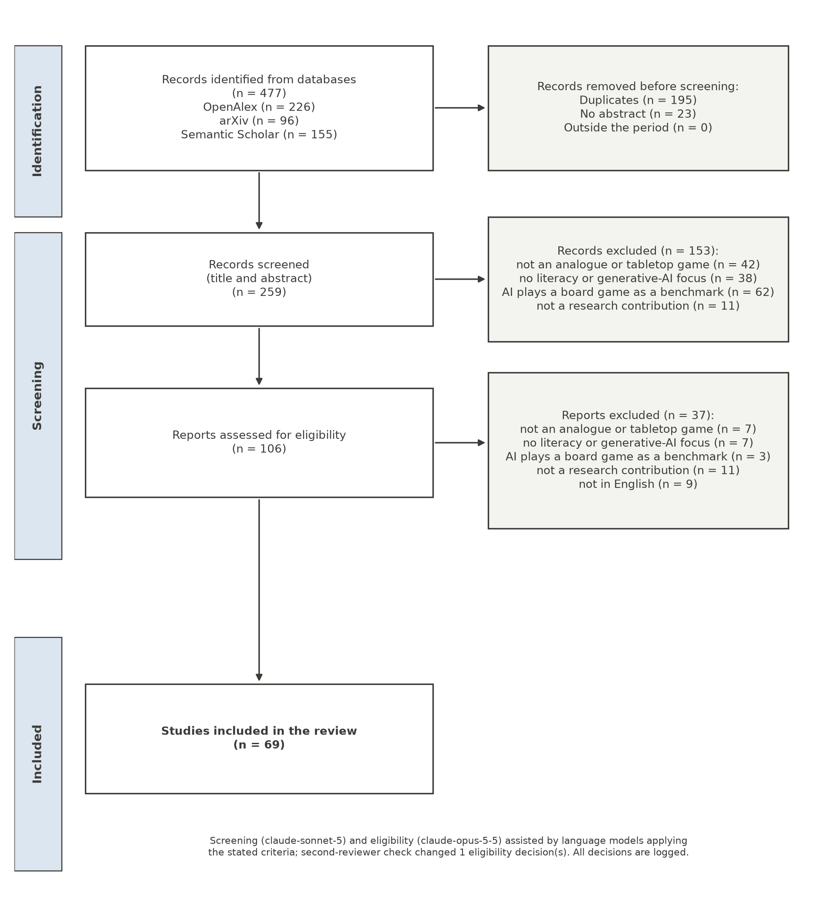
Analogue games for media, information and news literacy (23 studies). Board games have been designed to simulate real-world media dynamics in media and information literacy workshops, evaluated from the perspective of teachers and facilitators (Tan et al., 2026a) and with hundreds of students (Tan et al., 2026b); to simulate journalistic work and test effects on news literacy and motivation (Oehmer-Pedrazzi & Pedrazzi, 2026); and to place players in a simulated post-truth context (XIE et al., 2024). Quasi-experimental studies report gains in learning achievement and flow (HSU & ZHANG, 2023) and compare competitive with cooperative play (HSU & Chiang, 2023). Card games address fake news directly (Pomichal & Trnka, 2022, 2023), and a board game based on inoculation theory helped mothers resist misinformation about breastfeeding (Natoli, 2015).
Analogue games for AI literacy (11 studies). Non-digital board and card games teach AI concepts and ethics without devices: a family board game aimed at lowering the digital divide (Ding & Holland, 2025), a card game in which players audit the harms of AI products (Ali et al., 2023), an unplugged card game on embeddings (Vandenberg et al., 2026) and a Turing-test role-play used in a school without computers (Sankpo & Kyei Asamoa, 2026). A board game with NFC-tagged pawns lets young children co-create stories with an AI (Choi et al., 2025).
Generative AI in tabletop role-play (26 studies). Most of this work supports or replaces the game master: language models assist Dungeon Masters with information and inspiration (Zhu et al., 2023), act as game masters (Triyason, 2023), or are combined in multi-agent systems that reduce some errors but introduce others, such as rule violations and spoilers (Association for Computational Linguistics 2025 et al., 2025). Other systems replace players who leave the table (Xin & Kimiya, 2025), or combine physical cards with generative AI that keeps a group story coherent (Zhang et al., 2026); design studies discuss how such companions could change collaborative storytelling (Santiago et al., 2023).
Generative AI in game design (9 studies). Generative AI is also used to design and adapt educational board games (Gatti Junior et al., 2023); in one case study it reduced the teacher’s workload (Amarilli & Timakova, 2024).

Gap.
The media-literacy games in the review simulate media dynamics and evaluate knowledge, attitudes, motivation or flow; none of the abstracts describes a game whose spatial and informational rules let players see how a shared account forms, or one that leaves an inspectable record of it. The generative-AI studies focus on assisting or replacing the game master; few combine physical play with AI characters at the same table, and none uses that combination to compare how humans and AI relate events. The board proposed here addresses these gaps.

The model

The board as a matrix
The board is a grid of n × n cells. Each cell is a passage, a barrier or part of a place; a place is a connected region of cells with a name and a description, such as the warehouse, the customs house or the chapel (Figure 2). Two non-barrier cells are adjacent when they share a side; hexagonal and eight-neighbour boards fit the same framework. The board is therefore a graph S = (C, A) whose vertices are cells, fully described by its adjacency matrix A, with A_{xy} = 1 when cells x and y are adjacent and 0 otherwise.
Matrix powers answer the board’s basic questions. Cell y can be reached from cell x in at most k steps when
$${\left[{\left(I+A\right)}^{k}\right]}_{xy}>0,$$
where I is the identity matrix. A character that moves m cells per turn can therefore reach, in one turn, the cells where row x of (I + A)^{m} is positive. Perception uses the same operator: a character at x with perception radius r sees what happens in the cells y for which [(I + A)^{r}]_{xy} > 0, that is, the cells at most r steps away. Bridges of S (passages whose removal disconnects the board) and articulation cells (cells whose removal does so) are its chokepoints (Tarjan, 1972). The places that many characters’ premises mention are attractor places.
Figure 2
An example board. Places are regions of cells; the warehouse and the customs house are attractor places, named in several premises; a river with a single bridge creates an articulation cell. Discs are characters; the shaded cells are what one character sees with perception radius 2.
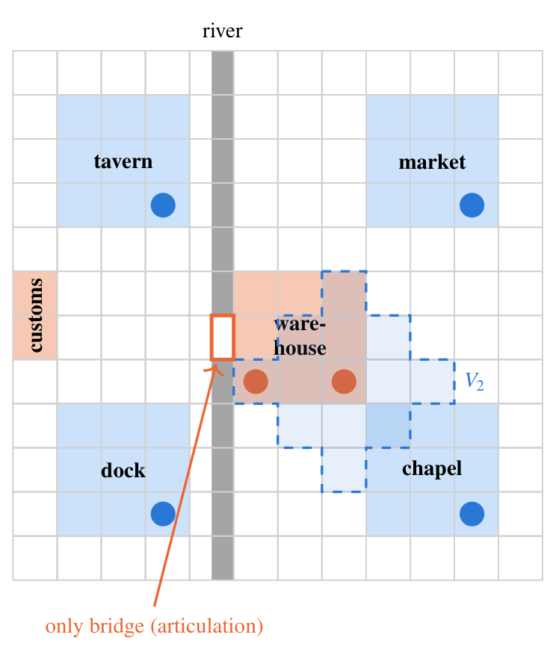

Characters, encounters and knowledge
Each character has a position on the board at every turn, a home place and premises: an objective, a secret and two beliefs. Characters move toward the places their premises make relevant. Two characters meet at turn t when one is within the other’s perception radius. Encounters form a temporal network over the characters (Holme & Saramäki, 2012): let M_{t} be the encounter matrix at turn t, with 1 for each pair of characters who meet. Information can travel from character a to character b between turns t₀ and t₁ only along a time-respecting path, which exists when
$$R=\prod_{t=t_{0}}^{t_{1}−1}{\left(I+M_{t}\right)}, R_{ab}>0,$$
with the product computed in Boolean arithmetic, so that R_{ab} is positive exactly when such a path exists. Each character holds a knowledge set: the events it caused, the events it saw and the events it heard about from characters it met, each passed on with a rumour probability q.

Events and the causal graph
Each turn, each character acts. The action becomes an event v with an author, a cell, a turn and a list of declared causes. The rule that defines the model is that a character can only build on what it knows:
$$u∈causes\left(v\right) ⇒ u∈K_{author\left(v\right)}\left(t\left(v\right)\right),$$
where K_{a}(t) is the knowledge set of character a at turn t. For AI characters the rule is enforced by prompting each character separately with only its knowledge set; for people it is enforced by the physical kit.
The causal graph G is built from the declared causes. Its connected components are the storylines, recomputed every turn: a storyline is born when a new component appears, fuses when its events become part of another storyline and closes when it stops receiving new events for three turns. The three graphs are nested (Figure 3): the board S bounds the encounters H, because characters can only meet where the board lets them go, and H bounds G, because an event can only cite another if information about it could have travelled to its author. This yields predictions that can be read off the board before anyone plays: attractor places should concentrate the fusions; chokepoints should be where separate storylines first meet; and storylines started far apart should merge later.
Figure 3
The three layers. Where characters can go (S) bounds whom they meet and when (H), which bounds what each event can cite (G). The highlighted event, at an attractor place, merges two storylines.
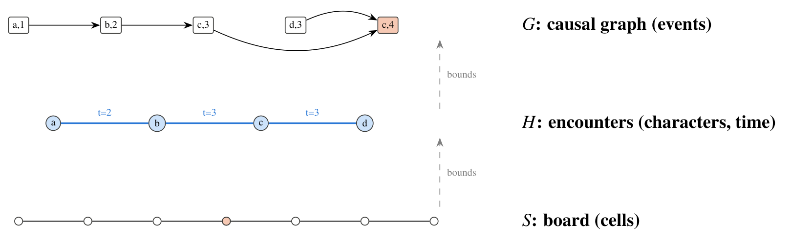

What the model makes visible
For media literacy, the value of the model is that it separates three things that are usually confounded when people explain why a community believes what it believes. The first is access: who could have known about an event, which is a property of space and encounters. The second is uptake: which known events a character chooses to build on, which is a property of the character, human or AI. The third is structure: the shape of the resulting story, which emerges from the first two. A rumour that spreads widely may do so because it was told in the place everyone passes through, because those who heard it chose to repeat it, or because the network had no other route. On the board, each of these explanations corresponds to something that can be pointed at.

A worked example
A sequence from the companion study, generated by language-model agents in the harbour town, shows what the board changes. On day 1, the merchant goes to the warehouse to offer the widow a low price for it; the captain of the guard orders some pages of the customs books set aside “before the new inspector reads them”. On day 2, in the customs house, the merchant offers the captain a purse to have the warehouse sealed for unpaid duties; the captain accepts and has the pages rewritten; the inspector asks for the books and notices the missing pages. On day 3 the captain seals the warehouse, citing the bribe, his own acceptance and the inspector’s inquiry, and the merchant’s and the captain’s storylines become one.
In the omniscient simulator, every character could cite every one of these events. On the board, each citation needs a route. The captain can cite the bribe because he received it in person. Whether he can cite the inspector’s inquiry depends on whether he was in the customs house, or met someone who was, before acting. The widow, who was at the warehouse on day 1 but not at the customs house on day 2, cannot know about the bribe unless someone tells her; if she later acts on it, the yarn will show who told her and where. The same sequence, replayed on the board, thus produces a causal graph in which every link has a visible explanation in space and time, and in which the merger of the two storylines happens where the board says it can: in the warehouse, the place the merchant’s objective points to, where the captain goes to seal it, made possible by what the two of them did in the customs house the day before.

Proof of concept with synthetic agents
Before involving language models or learners, we asked which board mechanics can change the convergence of a shared story at all. We wrote a minimal simulation in which six synthetic characters move on a 12 × 12 board with six places, two of them attractor places, and act once per day for 20 days. Each event cites a number of causes drawn from the distribution observed with language-model agents in the companion study (mostly one or two causes, almost never none), chosen at random among the recent events the author knows. The characters have no content and no intentions: what is tested is the effect of structure alone.
We compared the omniscient regime of the existing simulator, in which every character knows every recent event, with board regimes that vary the perception radius, rumours and the presence of attractor places. We also tested two design levers. Event cards are two world events per day that appear in random cells with no cause, such as a ship arriving or a storm. The focus rule requires that, in 80% of actions, all causes come from the same storyline, so that an action continues one thread rather than tying several together. Each condition was run 500 times; the script and its output are in the repository.
Figure 4
Separate storylines per day in the synthetic proof of concept, mean of 500 runs per condition, 20 days.
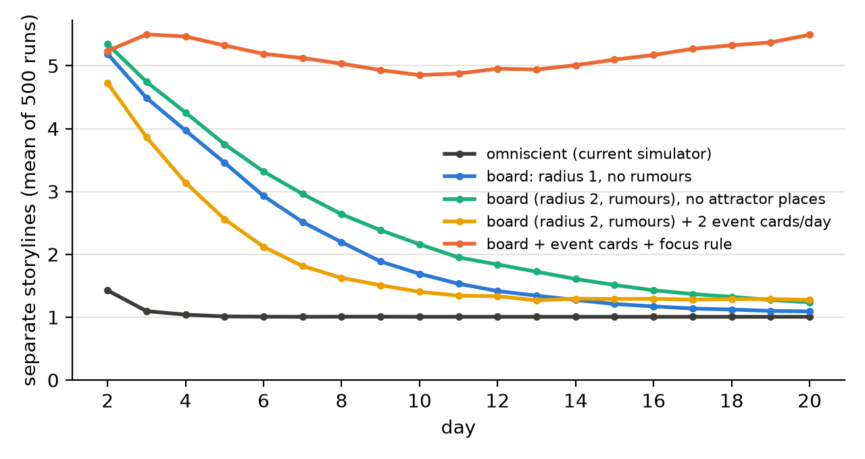
Table 1
Proof of concept with synthetic agents, 20 days, 500 runs per condition.
Condition | Storylines at the end | Runs ending with one | Born after day 2 | Fusions near attractors
Omniscient (current simulator) | 1.01 | 99% | 0.1 | 91%
Board, radius 2, rumours | 1.05 | 95% | 0.0 | 85%
Board, radius 1, no rumours | 1.09 | 91% | 0.0 | 85%
Board, radius 2, rumours, no attractor places | 1.24 | 79% | 0.0 | 66%
Board, radius 2, rumours, 2 event cards per day | 1.28 | 76% | 1.3 | 86%
Board, radius 2, rumours, event cards and focus rule | 5.49 | 2% | 6.0 | 84%
Three results stand out (Figure 4, Table 1).
Information changes the beginning, not the end. In the omniscient regime, the actions of the second day already cite each other across characters, and only 1.5 storylines are born on average. On the board, each character mostly knows its own past, and about five storylines are born, the same order observed with language-model agents. But on every board without further mechanics, almost all runs still end with a single storyline. Reducing the perception radius or removing rumours only slows the process. For teaching, this is the first lesson of the board: limiting who knows what delays the formation of a single account, but does not prevent it as long as everyone keeps building on what they know.
Attractor places decide where, and partly whether. With attractor places, more than 80% of fusions happen next to them; without them, the share falls to 66% and one run in five keeps more than one storyline. The places everyone needs are where separate accounts meet and merge.
New stories need new seeds and a reason not to knot. Because every character always knows its own past and almost always cites something, no storyline is born after the second day unless the world supplies events without causes. Event cards provide such seeds, but on their own they are soon absorbed. Combined with the focus rule, they sustain five to six storylines throughout the session, with new ones being born as others merge. In media terms, plurality of accounts requires both new, independent sources and a practice of not immediately connecting everything to the dominant story.
Figure 5 shows what these differences look like on the table after eight turns of one run of each condition: with the board rules alone, the yarn forms a single bundle around the attractor places; with world-event cards and the focus rule, several bundles of different colours stay apart.
Figure 5
The table after eight turns in one run of the synthetic proof of concept, under two conditions. Rectangles are event cards placed on the cell where they happened, diamonds are world-event cards, and lines are the yarn between each card and the cards it cites, coloured by the storyline the card belongs to at the end.
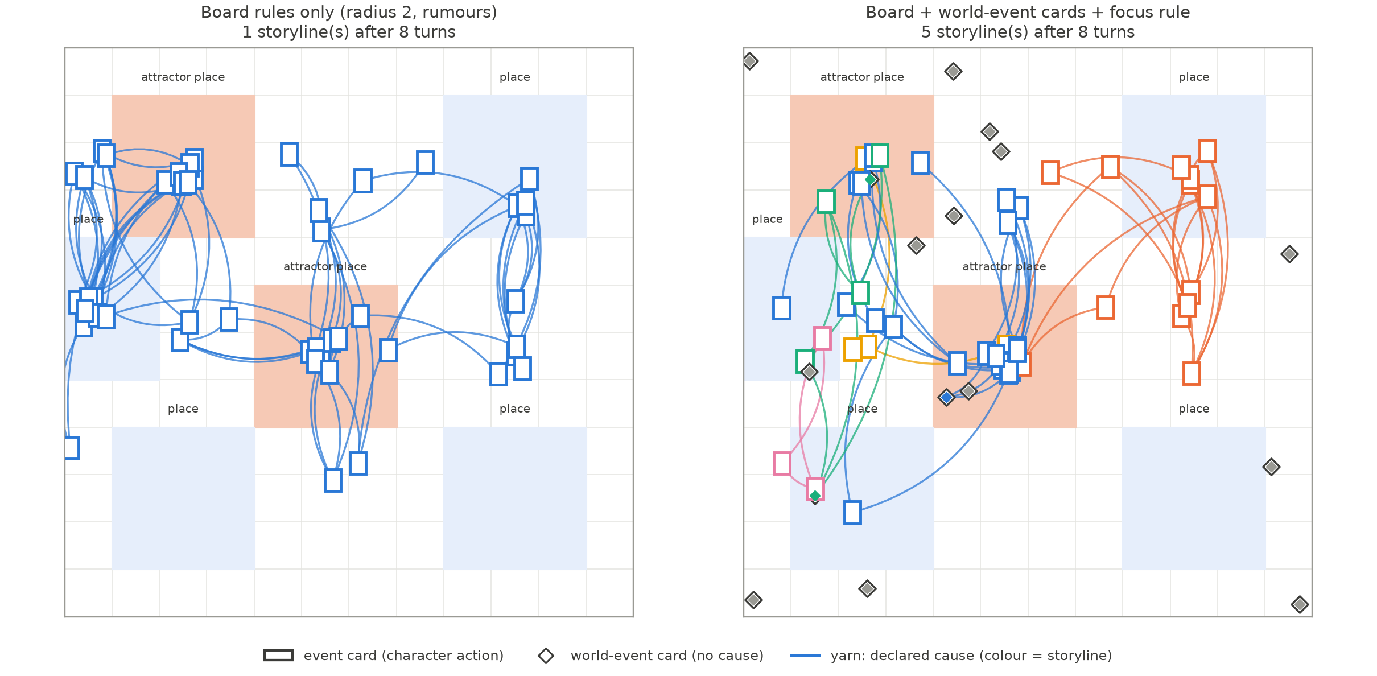
The proof of concept has obvious limits: synthetic characters choose at random and have no premises in the textual sense. Its value is to separate what the board can do from what content does, and to tell us which mechanics are worth taking to a classroom.

From findings to mechanics
Table 2 summarises how each observation, from the companion study or from the proof of concept, becomes a mechanic of the board and a point for discussion in class.
Table 2
From observations to board mechanics and learning points.
Observation | Board mechanic | Learning point
AI characters that see everything connect everything; storylines merge within days | Knowledge limited to what a character saw or heard; perception radius; rumours | Who could have known: access shapes which accounts can meet
Fusions happen in the places that several premises name | Attractor places on the board; chokepoints such as a single bridge | Central places and channels are where separate accounts merge
No new storyline is born once every action cites the past | World-event cards with no cause | Plurality needs new, independent sources
Limiting information only delays the merger | Focus rule: an action continues one thread | Norms of attribution and restraint keep accounts apart
The story is invisible while it is being made | Yarn between event cards | The structure of a shared account can be inspected

The physical kit and the hybrid protocol
The same board is printed for a table of four to eight participants. The kit contains the board, with places and a river; one token and one character sheet per character, with objective, secret and beliefs; blank event cards, on which a player writes what the character does, the turn and the identifier of each cause; coloured yarn, which connects each event card to the cards it cites; a deck of world-event cards; and screens that hide each player’s known cards. Figure 6 shows the main components.
Figure 6
Components of the physical kit: (a) a character sheet with objective, secret and beliefs; (b) an event card, with turn, cell, character, action and the identifiers of the cards it cites; (c) a world-event card, which has no cause; (d) on the table, each event card sits on the cell where it happened and yarn ties it to the cards it cites. Card 14, in the warehouse, cites three cards from the customs house: the yarn shows that its author could only know about them because he was there.
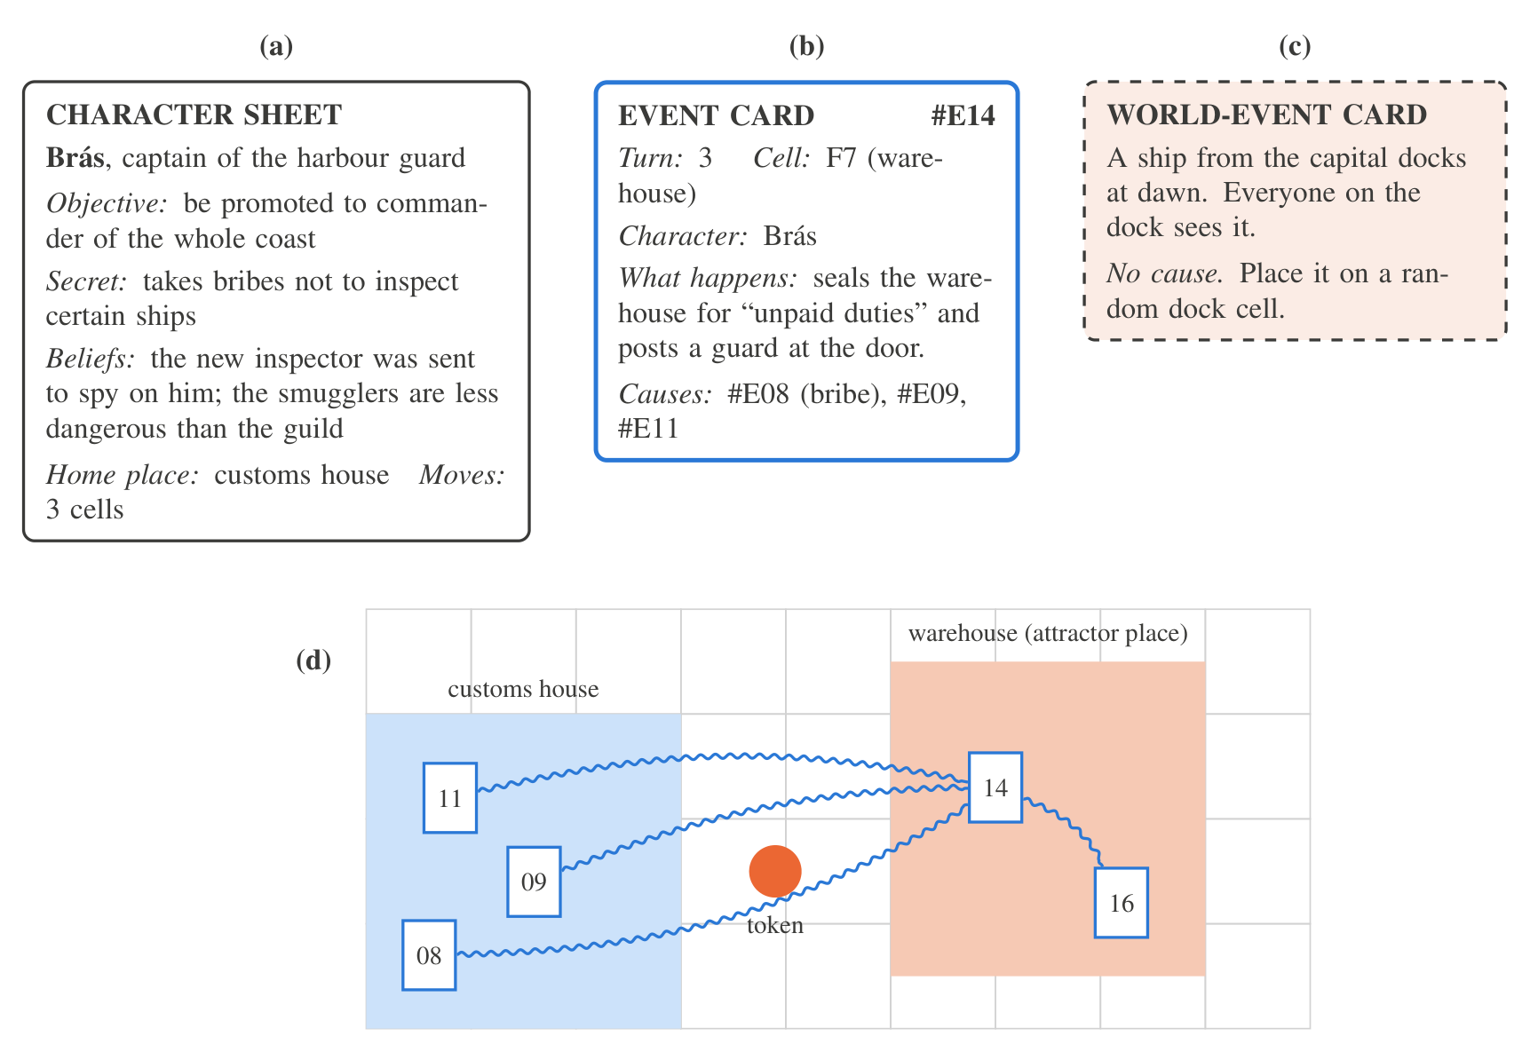
A turn has four steps. First, characters move up to a fixed number of cells. Second, the facilitator reveals world-event cards in the drawn cells. Third, each player writes an event card and places it on the cell where it happens; the card’s causes must be cards the character knows, and the facilitator ties the yarn. Fourth, knowledge is updated: a player adds to their hand the cards placed within their token’s perception radius, and players whose tokens meet may show each other cards from their hands. Optional rules switch the focus rule on or off, or change the radius and the number of world-event cards. Varying these rules between rounds is part of the learning design, as the classroom protocol below describes.
In hybrid tables, some characters are played by the simulator. The facilitator, or a companion app, enters the AI characters’ positions and known cards; the simulator, prompting each character separately with only its knowledge, returns the action and its causes, which are written on cards like any other. Because every event card carries the same fields as the simulator’s event log, a photographed or transcribed table yields the same data as a simulated session, and all analyses run unchanged on human, AI and hybrid tables. At the end of the session the yarn is the causal graph.

A classroom protocol

Learning objectives
The protocol targets four objectives, aligned with media literacy and AI literacy frameworks (Hobbs, 2010; Long & Magerko, 2020; UNESCO, 2024):
- explain how access to information, uptake and network structure each contribute to the formation of a shared account;
- identify, in a causal graph they built, the events and places through which separate accounts merged;
- compare how human and AI characters relate new events to past ones, and recognise the tendency of generative models to connect everything they see;
- propose and test changes to the rules of a community (more sources, more routes, norms of attribution) that would preserve a plurality of accounts.

A session of 100 minutes
Preparation (10 minutes). Groups of four to six receive the board and a scenario. We use the two worlds of the companion study: a harbour town with debt, bribery and smuggling, and a mountain village that must ration grain before winter. Each student takes one character sheet. In hybrid tables, one or two characters are played by the simulator.
First round (30 minutes). Eight turns with the default rules: radius 2, rumours allowed, one world-event card per turn, no focus rule. The yarn grows on the table as the story unfolds.
Prediction (10 minutes). Before looking at the yarn as a graph, each student writes how many separate stories they think the town has, which character’s account became dominant and why.
Reading the graph (20 minutes). The group lifts the yarn and reads it as a graph: which cards hold separate bundles together, at which place the first bundles merged, whose stories were absorbed and never had their own ending, and who knew what when. The facilitator asks the three questions that correspond to the model: who could have known this (access), who chose to build on it (uptake), and what would have happened without this card or this place (structure).
Second round (20 minutes). The group changes one rule and plays again: adds world-event cards, adopts the focus rule, adds a second bridge, or moves the place everyone needs. Students predict the effect before playing.
Debrief (10 minutes). The discussion connects the board to media they know: a group chat in which one message ties every conversation together, a recommendation feed that routes everyone through the same few channels, or a chatbot that, like the AI characters, connects whatever it is shown. The closing question is what a community, or a platform, could change in its rules to keep more than one account alive.

The facilitator’s role
The facilitator, usually the teacher, does not narrate the story. Their role is to keep the rules: checking that each card cites only cards its author knows, tying the yarn, revealing world-event cards, and, in hybrid tables, passing the AI characters’ knowledge to the simulator and their actions back to the table. This deliberately removes the figure of an omniscient game master, whose presence would reintroduce the single point of view that the board is meant to break. Preparation takes about an hour: printing the board and the cards, reading the two scenarios, and, for hybrid tables, testing the simulator with the chosen model. A short facilitator guide, with the rules on one page and the debrief questions below, accompanies the kit.

Debrief questions
The facilitator can draw on a small bank of questions, grouped by the three explanations the model separates.
Access. Which cards could your character have seen? Who told you about this event, where and when? Was there any story you never heard about until the end? What would have changed if you had been on the other side of the river?
Uptake. Among the cards you knew, why did you build on these and not others? Did you tie your card to the story everyone was following, or to your own? Did the AI characters choose differently from the people at the table?
Structure. Which card holds the largest bundle of yarn together? If we cut it, how many stories would the town have? Which place appears most often under the cards where bundles merge? Whose story was absorbed into another one and never had its own ending, and why?
Transfer. Where, in your own media use, is the “warehouse” that everyone passes through? Which messages work like the card that ties everything together? What rule would you add to a group chat, or to a platform, to keep more than one account alive?

A low-tech version
The AI characters are optional. The full protocol runs with paper, yarn and dice, which makes it usable in schools without devices or connectivity, a concern of the call for this issue. In this version, the facilitator plays one “connected” character who, unlike the others, sees every card on the table and must cite at least two of them. This character reproduces, by rule, the behaviour that the companion study observed in language-model agents, and lets students discuss AI-like omniscience without using AI.

Using generative AI with students
Hybrid tables bring generative AI into the classroom, and with it questions of privacy and control. The protocol is designed so that no personal data reach the model: the AI characters receive only the fictional cards they know, never students’ names or writing beyond the event cards of the game. The simulator also runs with open models on a local machine, which avoids sending any classroom content to an external service and keeps the activity possible where commercial services are restricted. The teacher decides which characters, if any, are played by AI, and every AI action passes through the facilitator before it becomes a card on the table, so the model never addresses students directly. Finally, the AI characters are presented as what they are, programs that write plausible actions from what they are given, which is itself part of the learning objective: students compare how these characters relate events with how they themselves do.

Accessibility
Cards can be printed in large type and read aloud; tokens can carry tactile marks; and the number of turns can be reduced for younger players. Writing an event card can be replaced by telling it to a scribe. The board’s logic does not depend on reading speed, which makes it suitable for mixed groups.

Evaluation plan
We plan two studies, to be pre-registered with the same procedures as the companion study (Nosek et al., 2018).
Study 1: simulation with language-model agents. The existing simulator will be extended with the board and with per-character prompts restricted to knowledge sets. With the same worlds and models as the companion study, we will cross the omniscient and board regimes, the perception radius, rumours, event cards and the focus rule. Hypotheses: (H1) on the board, more storylines are born and fusions happen later than in the omniscient regime; (H2) fusions concentrate at attractor places and chokepoints; (H3) without event cards, no storylines are born after the first days; (H4) event cards with the focus rule sustain several storylines and allow closures.
Study 2: classroom sessions. Upper-secondary and first-year university classes will play the protocol in three formats: human only, hybrid, and human only with the “connected” character of the low-tech version. Measures include the graph metrics of each table; the written predictions and explanations, coded for references to access, uptake and structure; and a short pre/post instrument on how participants explain the formation of shared accounts in a news scenario. Hypotheses: (H5) human tables cite fewer causes per event than AI characters and keep more storylines separate; (H6) after reading the graph, students refer more often to access and structure, not only to individual intentions, when explaining why an account became dominant; (H7) the second round, with rules chosen by the students, keeps more storylines alive than the first. Studies with students will follow the ethics procedures of the authors’ institution, with informed consent from students and guardians, and anonymised data.

Discussion
The board is a small model of a question at the heart of media literacy: how a community comes to share one version of events. Its main contribution is to make the structure of that process tangible and inspectable. Students who see their character’s story absorbed into someone else’s, because they were on the wrong side of the river or never heard the rumour, experience how access to information and to central places translates into narrative power; and the yarn graph gives them an object to reason about it with.
The proof of concept qualifies a common intuition. One might expect that limiting who knows what, the board’s basic rule, would be enough to keep several accounts alive. It is not: as long as every participant keeps building on what they know, the accounts eventually meet. What preserves plurality is the combination of new independent sources and a norm of not tying every new event to the dominant story. Both have recognisable counterparts in information ecosystems: diversity of sources, and practices of attribution and restraint in sharing. The board lets students discover this by changing the rules and seeing the graph change.
The hybrid format adds a dimension that is specific to generative AI. The companion study found that language-model agents almost never act without citing something that already happened, and the low-tech “connected” character turns that observation into a rule anyone can play. Comparing human and AI characters at the same table makes visible a property of these systems that is hard to see in a single conversation: their tendency to connect whatever they are shown, and with it, to pull separate stories into one.

Limitations
The model is a design proposal with a proof of concept, not an evaluated intervention. The proof of concept uses synthetic characters and says nothing about the content that language models or students would produce on the board. The formal model treats knowledge as sets of events, a simplification of what people believe, forget and misremember. The physical kit has not yet been playtested; its turn structure may be heavy for some groups, and a digital companion may be needed to manage knowledge in larger classes. The classroom protocol and its measures are proposals whose validity must be established in the planned studies.

Conclusion
Representing the world of a role-playing game as a board, and the board as a matrix, makes it possible to reason about a shared story with the tools of graph theory: the board bounds the encounters, the encounters bound the causal graph, and the causal graph is the story. A simulation shows that the board alone does not prevent a shared story from collapsing into one, that central places decide where it collapses, and that new sources together with a norm of focus keep several stories alive. Played with paper and yarn, with or without AI characters, the same board turns this structure into something a class can see, discuss and change: how space, information and power decide which story a community ends up telling.

Data and code availability
The simulation script, its results and the sources of the figures are available in a public repository [repository link removed for anonymous review].

References
Ali, S., Kumar, V., & Breazeal, C. (2023). AI audit: A card game to reflect on everyday AI systems. Proceedings of the AAAI Conference on Artificial Intelligence, 37(13), 15981–15989. https://doi.org/10.1609/aaai.v37i13.26897
Amarilli, F., & Timakova, O. (2024). An exploratory study on the role of generative AI in designing educational board games. International Conference on AI Research, 4(1), 30–39. https://doi.org/10.34190/icair.4.1.3081
Association for Computational Linguistics 2025, Lee, A., Minari, Y., & Ueno, S. (2025). TRPG game mastering using LLM-Based multi-agent system. Underline Science Inc. https://doi.org/10.48448/3QE4-DD75
Aylett, R. (1999). Narrative in virtual environments: Towards emergent narrative. Narrative Intelligence: Papers from the AAAI Fall Symposium, 83–86.
Barthes, R., & Duisit, L. (1975). An introduction to the structural analysis of narrative. New Literary History, 6(2), 237–272. https://doi.org/10.2307/468419
Basol, M., Roozenbeek, J., & van der Linden, S. (2020). Good news about bad news: Gamified inoculation boosts confidence and cognitive immunity against fake news. Journal of Cognition, 3(1). https://doi.org/10.5334/joc.91
Beguš, N. (2024). Experimental narratives: A comparison of human crowdsourced storytelling and AI storytelling. Humanities and Social Sciences Communications, 11(1). https://doi.org/10.1057/s41599-024-03868-8
Blondel, V. D., Guillaume, J.-L., Lambiotte, R., & Lefebvre, E. (2008). Fast unfolding of communities in large networks. Journal of Statistical Mechanics: Theory and Experiment, 2008(10), P10008. https://doi.org/10.1088/1742-5468/2008/10/p10008
Bogost, I. (2007). Persuasive games: The expressive power of videogames. MIT Press.
Bowman, S. L. (2010). The functions of role-playing games: How participants create community, solve problems and explore identity. McFarland.
Callison-Burch, C., Tomar, G. S., Martin, L. J., Ippolito, D., Bailis, S., & Reitter, D. (2022). Dungeons and Dragons as a dialog challenge for artificial intelligence. Proceedings of the 2022 Conference on Empirical Methods in Natural Language Processing, 9379–9393. https://doi.org/10.18653/v1/2022.emnlp-main.637
Chatman, S. (1978). Story and discourse: Narrative structure in fiction and film. Cornell University Press.
Choi, N., Cyebukayire, P., & Choi, J. D. (2025). Tinker tales: Interactive storytelling framework for early childhood narrative development and AI literacy. arXiv preprint. https://doi.org/10.48550/ARXIV.2504.13969
Daniau, S. (2016). The transformative potential of role-playing games: From play skills to human skills. Simulation & Gaming, 47(4), 423–444. https://doi.org/10.1177/1046878116650765
Ding, L., & Holland, S. (2025). AI odyssey: Designing and evaluating a board game for family-based AI literacy. International Journal of Serious Games, 12(4), 121–145. https://doi.org/10.17083/dnza4k90
Doshi, A. R., & Hauser, O. P. (2024). Generative AI enhances individual creativity but reduces the collective diversity of novel content. Science Advances, 10(28). https://doi.org/10.1126/sciadv.adn5290
Epstein, J. M., & Axtell, R. L. (1996). Growing artificial societies: Social science from the bottom up. The MIT Press. https://doi.org/10.7551/mitpress/3374.001.0001
Fine, G. A. (1983). Shared fantasy: Role-playing games as social worlds. University of Chicago Press.
Flanagan, M. (2009). Critical play: Radical game design. The MIT Press. https://doi.org/10.7551/mitpress/7678.001.0001
Flanagan, M., & Nissenbaum, H. (2014). Values at play in digital games. The MIT Press. https://doi.org/10.7551/mitpress/9016.001.0001
Gatti Junior, W., Marasco, E., Kim, B., Behjat, L., & Eggermont, M. (2023). How ChatGPT can inspire and improve serious board game design. International Journal of Serious Games, 10(4), 33–54. https://doi.org/10.17083/ijsg.v10i4.645
Gee, J. P. (2003). What video games have to teach us about learning and literacy. Computers in Entertainment, 1(1), 20. https://doi.org/10.1145/950566.950595
Hillier, B., & Hanson, J. (1984). The social logic of space. Cambridge University Press. https://doi.org/10.1017/cbo9780511597237
Hobbs, R. (2010). Digital and media literacy: A plan of action. The Aspen Institute.
Holme, P., & Saramäki, J. (2012). Temporal networks. Physics Reports, 519(3), 97–125. https://doi.org/10.1016/j.physrep.2012.03.001
HSU, T.-C., & Chiang, Y.-Y. (2023). Exploring motivational differences in competitive and cooperative game-based learning through educational board games. International Conference on Computers in Education. https://doi.org/10.58459/icce.2023.1449
HSU, T.-C., & ZHANG, Y.-X. (2023). The impact of an educational board game on students’ learning achievement and flow state in media and information literacy. International Conference on Computers in Education. https://doi.org/10.58459/icce.2023.1445
Jenkins, H. (2004). Game design as narrative architecture. In N. Wardrip-Fruin & P. Harrigan (Eds.), First person: New media as story, performance, and game (pp. 118–130). MIT Press.
Juul, J. (2005). Half-real: Video games between real rules and fictional worlds. MIT Press.
Long, D., & Magerko, B. (2020). What is AI literacy? Competencies and design considerations. Proceedings of the 2020 CHI Conference on Human Factors in Computing Systems, 1–16. https://doi.org/10.1145/3313831.3376727
Louchart, S., & Aylett, R. (2004). Narrative theory and emergent interactive narrative. International Journal of Continuing Engineering Education and Lifelong Learning, 14(6), 506–518. https://doi.org/10.1504/ijceell.2004.006017
Montola, M. (2008). The invisible rules of role-playing: The social framework of role-playing process. International Journal of Role-Playing, (1), 22–36. https://doi.org/10.33063/ijrp.vi1.184
Natoli, K. (2015). Helping mothers defend their decision to breastfeed. Journal of International Crisis and Risk Communication Research. https://openalex.org/W2528689296
Newman, M. (2018). Networks (2nd ed.). Oxford University Press. https://doi.org/10.1093/oso/9780198805090.001.0001
Nosek, B. A., Ebersole, C. R., DeHaven, A. C., & Mellor, D. T. (2018). The preregistration revolution. Proceedings of the National Academy of Sciences, 115(11), 2600–2606. https://doi.org/10.1073/pnas.1708274114
Oehmer-Pedrazzi, F., & Pedrazzi, S. (2026). Empowerment through game-based learning? An experimental study on the effectiveness of games for teaching news media literacy and news engagement. OSF Registries. https://doi.org/10.17605/OSF.IO/ZFHCS
Padmakumar, V., & He, H. (2024). Does writing with language models reduce content diversity? The Twelfth International Conference on Learning Representations (ICLR). https://arxiv.org/abs/2309.05196
Park, J. S., O’Brien, J., Cai, C. J., Morris, M. R., Liang, P., & Bernstein, M. S. (2023). Generative agents: Interactive simulacra of human behavior. Proceedings of the 36th Annual ACM Symposium on User Interface Software and Technology, 1–22. https://doi.org/10.1145/3586183.3606763
Pomichal, V., & Trnka, A. (2022). Fighting against fake news using the card game “follow me.” European Conference on Games Based Learning, 16(1), 455–462. https://doi.org/10.34190/ecgbl.16.1.586
Pomichal, V., & Trnka, A. (2023). With games against fake news – developing critical thinking with the help of the card game follow me. Media Literacy and Academic Research, 55–69. https://doi.org/10.34135/mlar-23-01-04
Riedl, M. O., & Bulitko, V. (2013). Interactive narrative: An intelligent systems approach. AI Magazine, 34(1), 67–77. https://doi.org/10.1609/aimag.v34i1.2449
Roozenbeek, J., & van der Linden, S. (2019). Fake news game confers psychological resistance against online misinformation. Palgrave Communications, 5(1). https://doi.org/10.1057/s41599-019-0279-9
Salen, K., & Zimmerman, E. (2004). Rules of play: Game design fundamentals. MIT Press.
Sankpo, S., & Kyei Asamoa, P. (2026). Teaching AI concepts without devices: Unplugged AI literacy practice in the classroom. Proceedings of AIE Symposium 1, Understanding AI in the Classroom: Pupil Perspectives and Practice. https://doi.org/10.67388/sym.0004
Santiago, J. Ma., Parayno, R. L., Deja, J. A., & Samson, B. P. V. (2023). Rolling the dice: Imagining generative AI as a dungeons &amp; dragons storytelling companion. arXiv preprint. https://arxiv.org/abs/2304.01860
Schelling, T. C. (1971). Dynamic models of segregation†. The Journal of Mathematical Sociology, 1(2), 143–186. https://doi.org/10.1080/0022250x.1971.9989794
Tan, H. S., Tan, H. Y. J., & Hew, S. H. (2026a). Board game experiential learning for media and information literacy: Teachers’ and facilitators’ perspectives in contemporary information environments. Social Sciences, 15(7), 467. https://doi.org/10.3390/socsci15070467
Tan, H. S., Tan, H. Y. J., & Hew, S. H. (2026b). Board game-based experiential learning as a sustainable innovation for media and information literacy. International Journal of Creative Multimedia, 7(1), 302. https://doi.org/10.33093/ijcm.2026.7.1.16
Tarjan, R. (1972). Depth-first search and linear graph algorithms. SIAM Journal on Computing, 1(2), 146–160. https://doi.org/10.1137/0201010
Trabasso, T., & van den Broek, P. (1985). Causal thinking and the representation of narrative events. Journal of Memory and Language, 24(5), 612–630. https://doi.org/10.1016/0749-596x(85)90049-x
Triyason, T. (2023). Exploring the potential of ChatGPT as a dungeon master in dungeons &amp; dragons tabletop game. Proceedings of the 13th International Conference on Advances in Information Technology, 1–6. https://doi.org/10.1145/3628454.3628457
UNESCO. (2024). AI competency framework for students. UNESCO. https://doi.org/10.54675/JKJB9835
Vandenberg, J., Goslen, A., Aguiar, C., Min, W., Cateté, V., & Mott, B. (2026). From embeddings to chatbots: Playful NLP activities for middle school AI literacy. Proceedings of the AAAI Conference on Artificial Intelligence, 40(47), 40804–40812. https://doi.org/10.1609/aaai.v40i47.41530
Wardle, C., & Derakhshan, H. (2017). Information disorder: Toward an interdisciplinary framework for research and policy making (DGI(2017)09). Council of Europe.
Wolfram, S. (1984). Cellular automata as models of complexity. Nature, 311(5985), 419–424. https://doi.org/10.1038/311419a0
Woods, S. (2012). Eurogames: The design, culture and play of modern european board games. McFarland.
XIE, J., LI, X., HASEGAWA, K., LIU, Z., & REICHERT, F. (2024). Designing an educational game for facilitating development of media and information literacy. International Conference on Computers in Education. https://doi.org/10.58459/icce.2024.4898
Xin, T., & Kimiya, F. (2025). AI to replace players who temporarily leave the table in online tabletop RPGs. 2025 IEEE Cyber Science and Technology Congress (CyberSciTech), 749–753. https://doi.org/10.1109/cyberscitech68397.2025.00113
Xu, W., Jojic, N., Rao, S., Brockett, C., & Dolan, B. (2025). Echoes in AI: Quantifying lack of plot diversity in LLM outputs. Proceedings of the National Academy of Sciences, 122(35). https://doi.org/10.1073/pnas.2504966122
Zhang, C., Zeng, X., Zhang, J., Wen, R., Siu, V., Allen, R. W., & LC, R. (2026). FIERO: Empowering creative writing through collaborative game play. arXiv preprint. https://arxiv.org/abs/2607.11837
Zhu, A., Martin, L., Head, A., & Callison-Burch, C. (2023). CALYPSO: LLMs as dungeon master’s assistants. Proceedings of the AAAI Conference on Artificial Intelligence and Interactive Digital Entertainment, 19(1), 380–390. https://doi.org/10.1609/aiide.v19i1.27534

