Locally Differentially Private Document Generation Using
Zero Shot Prompting
Saiteja Utpala Sara Hooker Pin Yu Chen
Cohere For AI Cohere For AI IBM Research
saitejautpala@gmail.com sarahooker@cohere.com pin-yu.chen@ibm.com

Abstract
Numerous studies have highlighted the privacy risks associated with pretrained large language models. In contrast, our research offers a unique perspective by demonstrating that pretrained large language models can effectively contribute to privacy preservation. We propose a locally differentially private mechanism called DP-Prompt, which leverages the power of pretrained large language models and zero-shot prompting to counter author de-anonymization attacks while minimizing the impact on downstream utility. When DP-Prompt is used with a powerful language model like ChatGPT (gpt-3.5), we observe a notable reduction in the success rate of deanonymization attacks, showing that it surpasses existing approaches by a considerable margin despite its simpler design. For instance, in the case of the IMDB dataset, DP-Prompt (with ChatGPT) perfectly recovers the clean sentiment F1 score while achieving a 46% reduction in author identification F1 score against static attackers and a 26% reduction against adaptive attackers. We conduct extensive experiments across six open-source large language models, ranging up to 7 billion parameters, to analyze various effects of the privacyutility tradeoff. Code is avaliable at https:
//github.com/SaitejaUtpala/dp_prompt

1 Introduction
The vast amount of online text data has the potential to reveal numerous user attributes, making individuals easily identifiable (Rao et al., 2000; Hovy et al., 2015; Preo¸tiuc-Pietro et al., 2015). While private information can be directly disclosed through specific phrases in the text, it can also be implicitly inferred. For instance, linguistic patterns embedded within the text can inadvertently facilitate authorship attribution (Kešelj et al., 2003; Shrestha et al., 2017), leading to unintended privacy leakage.
arXiv:2310.16111v2 [cs.CL] 30 Nov 2023
An illustrative real-world scenario is the AOL search data leak in August 2006 (Pass et al.,
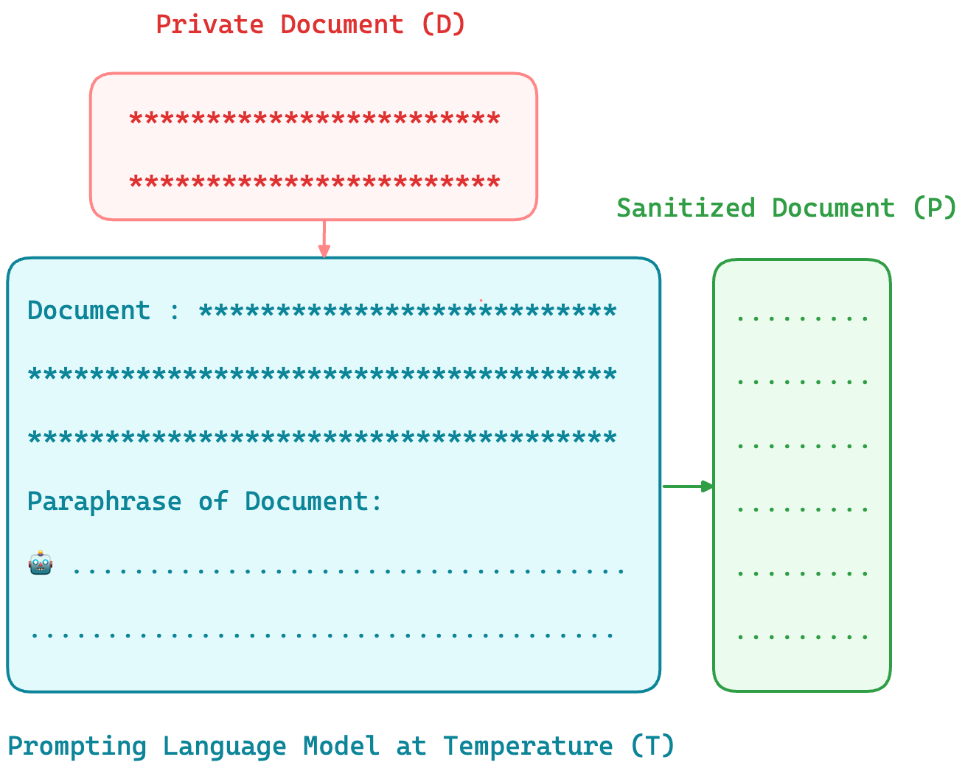
Figure 1: Overview of the proposed DP-Prompt mechanism. Given a private document (D), DP-Prompt generates a sanitized document (P) while ensuring local differential privacy. The level of privacy guarantee is controlled by adjusting the sampling temperature (T) during the decoding process.
2006). The incident unfolded when AOL mistakenly released detailed search logs of their users, wrongly assuming that the data had been adequately anonymized through the use of random user IDs. Unfortunately, the released logs contained sufficient personally identifiable information, leading to the identification of numerous individuals (Barbaro and Jr., 2006; Jones et al., 2007). This breach of privacy triggered widespread public outcry and led to the initiation of class action lawsuits.
This case is just one among many that highlights the limitations of ad-hoc privacy approaches that may give the impression of providing privacy but ultimately fall short. Differential privacy (DP) provides a rigorous treatment for the notion of data privacy by providing plausible deniability by precisely quantifying the deviation in the model’s output distribution under modification of a small number of data points (Dwork et al., 2006, 2014). The provable guarantees offered by DP, coupled with its compelling properties such as immunity to arbi-
Privacy vs Utility of DP-Prompt (with ChatGPT) Privacy vs Utility of DP-Prompt (with ChatGPT)
0.0
0.2
0.4
0.6
0.8
1.0
F1-Score
0.8
0.93
0.8
0.69
0.79
0.49
w/o DP-Prompt
DP-Prompt(Adaptive)
DP-Prompt(Static)
0.0
0.2
0.4
0.6
0.8
1.0
F1-Score
0.78
0.86
0.77
0.55
0.76
0.35
Sentiment(Utility) Author Identification(Privacy) Sentiment(Utility) Author Identification(Privacy)
(a) IMDB (embedding access) (b) Yelp (embedding access)
Sentiment(Utility) Author Identification(Privacy)  (c) IMDB (text access) | Sentiment(Utility) Author Identification(Privacy)  (d) Yelp (text acccess)
Privacy vs Utility of DP-Prompt (with ChatGPT) Privacy vs Utility of DP-Prompt (with ChatGPT)
0.0
0.2
0.4
0.6
0.8
1.0
F1-Score
0.85
0.99
0.83
0.81
0.83
0.39
0.0
0.2
0.4
0.6
0.8
1.0
F1-Score
0.79
0.97
0.78
0.67
0.77
0.22
Figure 2: Overview of the privacy-utility tradeoff with DP-Prompt (using ChatGPT) for the IMDB and Yelp datasets, conducted at a temperature of 1.5. The terms ’Static’ and ’Adaptive’ refer to the attack models defined in Definition 2.
trary post-processing and graceful composability, have established it as the de facto standard for privacy. DP has witnessed widespread adoption and numerous deployments in both private (Erlingsson et al., 2014; Apple, 2017; Near, 2018) and public organizations (Abowd, 2018).
To address the issue of deanonymization attacks, various approaches have been proposed within the DP framework. These approaches encompass word-level strategies (Feyisetan et al., 2020; Xu et al., 2020; Carvalho et al., 2021) where noise is added at the word level, as well as sentence-level techniques (Meehan et al., 2022) where noise is added at the sentence level. However, recent research by (Mattern et al., 2022b) has identified limitations in word-level approaches, particularly their disregard for contextual information. To overcome these limitations, Mattern introduced a mechanism that fine-tunes the GPT-2 model (Radford et al., 2019) specifically for paraphrasing tasks, resulting in the generation of sanitized versions of documents. While promising, the approach is limited by their reliance on annotated paraphrasing data, extensive computing resources for larger models, and the quality of annotations.
We propose DP-Prompt, a novel and straightforward solution to address deanonymization attacks. Our method leverages pretrained large language models by directly prompting them to generate paraphrases. These paraphrases are then released as sanitized documents in a zero-shot manner (See Figure 1). Our motivation for this approach stems from two important factors. Firstly, recent research (Bevendorff et al., 2019; Mattern et al., 2022b) has shown that paraphrasing is a robust defense mechanism against deanonymization attacks. Secondly, growing evidence suggests that pretrained large language models can effectively tackle complex tasks without the need for task-specific and expensive fine-tuning (Brown et al., 2020; Chowdhery et al., 2022; Chung et al., 2022; Kojima et al., 2022; OpenAI, 2023), through zero-shot prompting.
By harnessing the capabilities of pretrained large language models, DP-Prompt offers a straightforward and powerful solution to mitigate the risk of deanonymization. It provides a promising alternative that can be widely applicable, particularly in the context of on-device large language models where text completion tasks require significantly fewer resources. We summarize the contributions as follows:
- We propose DP-Prompt, a new, simple, and computationally effective differentially private (DP) mechanism designed as a defense against de-anonymization attacks. DP-Prompt takes a private document and generates a paraphrased version using zero-shot prompting. The resulting paraphrased document is then released as a sanitized document, as illustrated in Figure 1.
- We demonstrate that DP-Prompt, in combination with ChatGPT (gpt-3.5), surpasses all current methods in terms of utility for any level of privacy. Our approach successfully recovers clean sentiment F1 score while significantly reducing the accuracy of author deanonymization attacks. Refer to Figure 2 for an overview of these results.
- To demonstrate the broad applicability of DPprompt, We conduct extensive experiments with 6 open source models ranging upto 7 billion parameters to study the privacy-utiliy tradeoff.

2 Preliminaries
A mechanism M : D → V achieves ϵ-PureDP if, for all inputs D,D′ ∈ D that differ in one element, and for all V ⊆ Range(M), Pr[M(D) ∈ V ] ≤ exp(ϵ)Pr[M(D′) ∈ V ] (Dwork et al., 2006).
Mechanism | Privacy Level | Requires fine-tuning | Generates sanitized doc
Madlib (Feyisetan et al., 2020) | Word level Metric-DP | No | Yes
Mahanolbis (Xu et al., 2020) | Word level Metric-DP | No | Yes
TEM (Carvalho et al., 2021) | Word level Metric-DP | No | Yes
Truncated Laplace (Meehan et al., 2022) | Sentence level Pure-DP | No | No
Deep Candidate (Meehan et al., 2022) | Sentence level Pure-DP | Yes | No
Paraphraser (Mattern et al., 2022b) | Document level Pure-LDP | Yes | Yes
DP Prompt (Ours) | Document level Pure-LDP | No | Yes
Table 1: We compare our proposed method, DP-Prompt, with related work on various factors. The "Privacy level" indicates the privacy guarantee provided by each mechanism. "Fine-tuning" denotes whether the mechanism involves fine-tuning a model as an intermediate step. The last column, "Generates sanitized doc," indicates whether the mechanism can output a fully sanitized document instead of just sanitized embeddings.
Metric Differential Privacy (Metric-DP) (Andrés et al., 2013; Chatzikokolakis et al., 2013) is a relaxation of Pure-DP that applies to data represented in a general metric space. For a given distance met-
ric d : D × D → R+, a mechanism M : D →
V achieves ϵd-MetricDP if, for any D,D′ ∈ D and for all V ⊆ Range(M), Pr[M(D) ∈ V ] ≤ exp(d(D,D′))Pr[M(D′) ∈ V ].
Local differential privacy (LDP) (Kasiviswanathan et al., 2011; Duchi et al., 2013; Xiong et al., 2020) is a privacy framework where data is locally perturbed before transmission, considering the presence of an untrusted data collector or server. The formal definition of LDP is as follows:
Definition 1 (PureLDP). A randomized mechanism M : D → V is said to be ϵ-PureLDP if for any pair of inputs D,D′ ∈ D and for all V ⊆ Range(M) Pr[M(D) ∈ V ] ≤ exp(ϵ)Pr[M(D′) ∈ V ].
There is a growing consensus that, despite the assurance of formal guarantees, it is imperative to subject differentially private mechanisms to robust privacy attacks that simulate strong and malicious adversaries (Jayaraman and Evans, 2019; BlancoJusticia et al., 2022). Such evaluation allows to effectively assess the empirical privacy provided by the mechanism in real-world scenario. To this end we define four attack models depending its adaptivity and mode of access.
Definition 2 (Attack Models). Consider a collection of private documents (D₁,...,D_{n}) from distribution D with associated author identities (a₁,...,a_{n}) and embeddings (E₁,...,E_{n}) ∼ E.
For text-to-text sanitization using mechanism M_{text}, the sanitized documents are represented as (P₁,...,P_{n}) ∼ P_{Mtext}. For text-to-embedding sanitization via mechanism M_{embedding}, the sanitized embeddings are denoted as (N₁,...,N_{n}) ∼
NM_{embedding}
- Static Attacker with Embedding Access:
Has access to clean documents (D₁,...,D_{n}) but lacks access to sanitized versions (P₁,...,P_{n}).
- Static Attacker with Text Access :
Doesn’t have access to sanitized embeddings (N₁,...,N_{n}) but only to the clean embeddings (E₁,...,E_{n}).
- Adaptive Attacker with Embedding Access : Has access to sanitized embeddings (N₁,...,N_{n}). Hence, trains a deanonymization model to adapt to the DP mechanism M_{embedding}.
- Adaptive Attacker with Text Access: Has access to sanitized text (P₁,...,P_{n}). Consequently, trains a de-anonymization model to adapt to the DP mechanism M_{text}.
It is important to note that the adaptive attacker is a more formidable adversary since it adapts to the characteristics of the mechanism M, whereas the static attacker only has access to clean documents/clean embeddings without any added noise. The mode of access—either raw text or abstracted embeddings—offers further nuances, determining the exact nature of the data an attacker can exploit.

3 DP Prompt
Language models use a decoder network to generate sequential text output. Given a context or prompt represented by a sequence of tokens C = (c₁,...,c_{m}), the language model generates text by sampling tokens from a conditional distribution
Pr.
In this distribution, the logits u ∈ R^{|V|} are transformed using the softmax function with a temperature T, where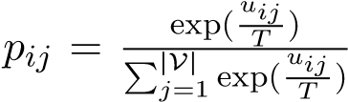, and V repre-
sents the vocabulary.
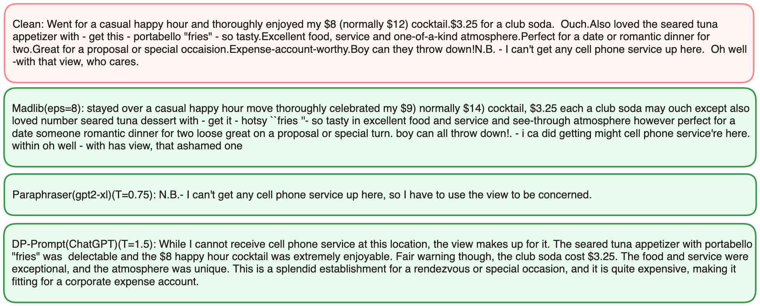
Figure 3: Sample illustration of clean and sanitized documents for various mechanisms. For ChatGPT, prompt is "Review:[review]Paraphrase of the Review:" where review is the clean review.
This process of sequentially generating text can be regarded as a problem of selecting tokens at each step. Hence, to make the generation step differentially private, one must replace it with a differentially private version of the selection process. One commonly used and well-known differentially private mechanism is the exponential mechanism (McSherry and Talwar, 2007), which is defined as follows:
Definition 3 (Exponential Mechanism). Given an utility function u : D × V → V. The exponential mechanism M_{Exp} : D → V is a randomized algorithm with output distribution
P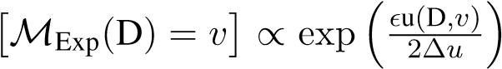, where ∆u = max_{D,D}′_{,v} |u(D,v) − u(D′,v)| is sensitivity.
In our case, the utility of token v_{j} ∈ V at each step i is simply the logit u_{ij} ∈ R. Hence, one can make text generation differentially private using the exponential mechanism.
Extensive research has shown that paraphrasing documents helps conceal author identity (Rao et al., 2000; Bevendorff et al., 2019; Mattern et al., 2022b). Considering recent advancements where tasks are formulated as prompts and language models are tasked to complete them (Raffel et al., 2020; Brown et al., 2020; Wei et al., 2022), we directly prompt the language model to generate paraphrases. Therefore, given a private document D and a specific prompt template instructing the language model to generate a paraphrase, such as T := "Paraphrase of the document:" we combine D and T to create a context C. By utilizing this context, we execute the text generation procedure in a differentially private manner to produce a paraphrase. We refer to this procedure as DP-Prompt. Algorithm 1 outlines the specific steps of our proAlgorithm 1: DP-Prompt
Input: language model (LM), private document (D), prompt template (T), clipping vector b ∈R^{|V|}, temperature T ∈R+, paraphrase tokens n.
Output: Sanitized Doc (P)
1 P ← [], C ←GeneratePrompt(D,T) 2 C_{tokens} ←Tokenize(C)
3
for
i
←
1
to
n
do
4
u
←
LM
(
C
tokens
)
5
u
′
←
ClipAndScale
(
u
,
b
,T
)
6
p
←
ConvertToProbabilities
(
u
′
)
7
v
←
SampleToken
(
p
)
8
P
←
P
∪
[
v
]
,C
tokens
←
C
tokens
∪
[
v
]
9
end
10
P
←
Detokenize
(
P
)
return
P
posed DP-Prompt, and the code for implementing DP-Prompt in HuggingFace (Wolf et al., 2019) is provided in Appendix B. The formal guarantee of achieving ϵ-PureLDP is provided by the following theorem:
Theorem 1. Suppose the language model has not been pretrained on the private documents distribution D. If the final logits u ∈ R^{|V|} satisfy the condition b₁ ≤ u_{i} ≤ b₂,∀i, and the DP-Prompt run with a temperature T for generating n tokens, then it can be proven that the generated output satisfies (2n(b₂ − b₁)/T)-LDP.
See the Appendix A for the proof.

4 Experiments
4.1 Experiment Setup
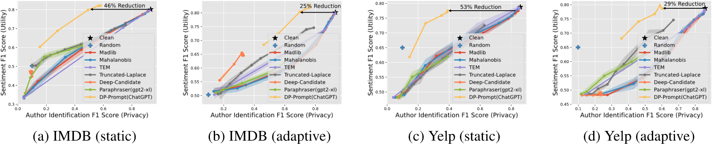
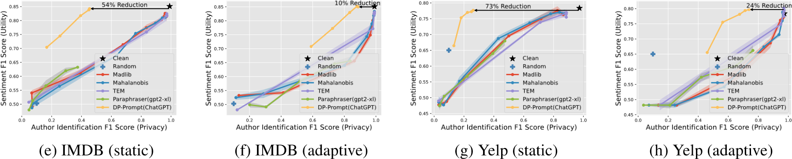
Figure 4: Comparison of DP-Prompt (with ChatGPT) with various baselines. The top row shows results for an attacker with embedding access, while the row below presents results for an attacker with text access. Notably, it is evident that regardless of the chosen privacy level, DP-Prompt, when utilized with ChatGPT (GPT-3.5), exhibits significantly better utility compared to all baseline mechanisms.
Evaluation: Note that we are comparing DPmechanisms with different levels of differential privacy. Therefore, in our experiments, we focus on evaluating the empirical privacy rather than the theoretical privacy(ϵ) for effective and realistic assessment. As a result, we plot the author identification F1 score, which is calculated by conducting de-anonymization attacks on the sanitized documents. This score indicates the potential for privacy breaches. On the other hand, the y-axis represents the sentiment F1 score, which measures the utility of the sanitized documents. Datasets: We conduct experiments using IMDB movie reviews and Yelp business reviews, both of which contain author and sentiment labels. The IMDB dataset has a size of 15,000, while the Yelp dataset has 17,336 samples. For both datasets, sentiment analysis is a 2-class classification task, and the author identification task is a 10-class classification task.
Implementation Details: For the embedding-level attacker, we utilize 3-Layer MLPs with ReLU activation functions and train them on sentence embeddings (Reimers and Gurevych, 2019). For the textlevel attacker, we fine-tune BERT (Devlin et al., 2018). More details can be found in Appendix C. Regarding the static attacker, the clean set of documents is used for training and validation, while the sanitized documents serve as the test set. On the other hand, for the adaptive attacker, all three sets (training, validation, and testing) consist of sanitized documents.
- For each of word level mechanisms, (Madlib (Feyisetan et al., 2020), Mahalanobis (Xu et al., 2020), TEM (Carvalho et al., 2021)) we run the mechanisms for 8 ϵ’s given ϵ = {2,5,8,11,14,17,20,25}
- For each of sentence level mechanisms
(Truncated-Laplace (Meehan et al., 2022), Deep-Candidate (Meehan et al., 2022)): we run the mechanisms for 11 ϵ’s given by ϵ = {5,10,20,30,40,50,75,100,150,200}.
- For Paraphraser (Mattern et al., 2022b) and DP-Prompt with open source models we run decoding at 5 temperatures {0.75,1.0,1.25,1.5,1.75}. For DP-
Prompt we run ChatGPT at temperatures
{1.0,1.25,1.5,1.75,2.0}.
Further we also consider F1 scores on Clean
(without noise added) embeddings/documents and performance of uniformly random classifier (for more details, refer to Appendix C.6).
4.2 DP-prompt with ChatGPT (gpt-3.5)
In this section we compare 6 baselines (Madlib, Mahalanobis, Tem, Truncated-laplace, Deepcandidate, Paraphraser) run with configurations above (for more details also refer to Appendix C) with DP-Prompt with ChatGPT. Except for DPPrompt, we run each mechanism to 3 times to produce 3 different sanitized documents and plot mean author F1 identification score on x-axis and show 2σ band around mean sentiment F1 score. Results are show in Figure 4
The results clearly demonstrate the superior performance of DP-Prompt with ChatGPT (GPT-3.5).
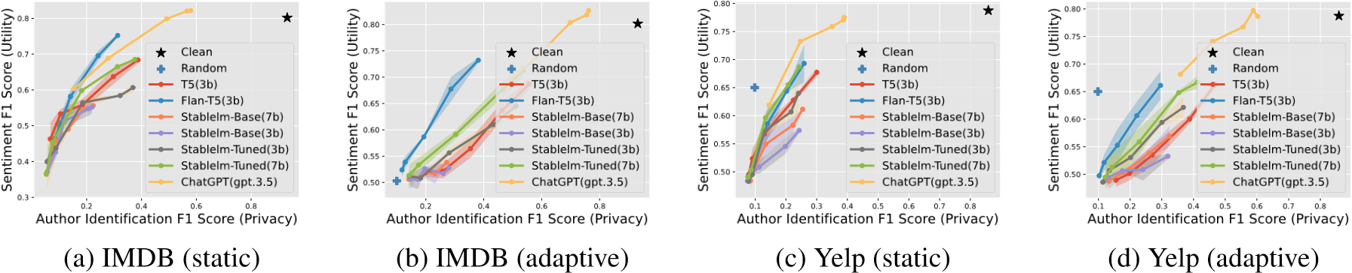
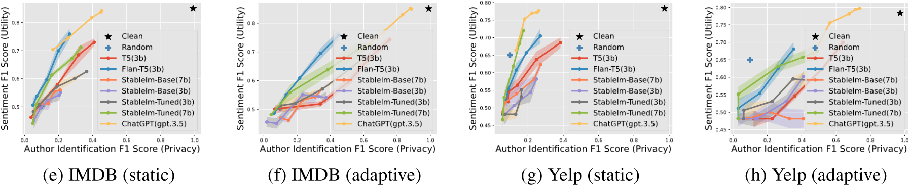
Figure 5: Illustration of privacy-utility tradeoff in DP-Prompt with open source models and ChatGPT(gpt-3.5). The top row shows results for an attacker with embedding access, while the row below presents results for an attacker
with text access.
Notably, DP-Prompt exhibits significantly higher utility on the y-axis for a chosen empirical privacy value on the x-axis. All word-level mechanisms show a similar privacy-utility tradeoff. Regarding sentence-level mechanisms, the truncated Laplace mechanism performs decently, while in the static attack experiments, Deep-candidate is reduced to a random classifier due to the distribution shift caused by sentence recoding.
Furthermore, in the case of clean reviews (i.e., without any noise), the embedding-level attacker can accurately identify the author among 10 different options with a high F1 score of 0.93 in IMDB and 0.86 in Yelp. However, when DP-Prompt is employed, the sentiment F1 scores remain unchanged, while the author identification scores decrease by 46% and 25% in the case of IMDB, and 53% and 29% in the case of Yelp.
The text-level models are more accurate than the embedding-level models, with author identification scores of 0.99 (as opposed to 0.93) and 0.97 (as opposed to 0.86) in IMDB and Yelp, respectively, for clean reviews. When DP-Prompt is employed, the sentiment F1 scores remain unchanged, while the author identification scores decrease by 54% and 10% in the case of IMDB, and 73% and 24% in the case of Yelp. This illustrates that text-level attackers are more powerful.
4.3 DP-Prompt with open source models
It is important to note that models such as ChatGPT (gpt-3.5) are proprietary and can only be accessed through APIs, necessitating the uploading of user documents to the language model provider. Although DP-Prompt with such proprietary models provide LDP guarantee, this defeats the fundamental motivation of LDP, which is to achieve privacy guarantees without relying on a trusted data curator. The objective of the experiments presented in the preceding section aim to demonstrate that DPPrompt, when combined with a powerful language model like ChatGPT, can outperform existing methods by a significant margin.
Considering the increasing interest in building high-quality open-source large language models (Scao et al., 2022; Black et al., 2022; Touvron et al., 2023; Li et al., 2023; Jiang et al., 2023), we expand our evaluation of DP-Prompt to include six opensource models, ranging in size up to seven billion parameters. Our evaluation takes into account two factors: (i) architecture, where we consider both encoder-decoder and decoder-only models, and (ii) the level of fine-tuning, including models that are fine-tuned using instructions and/or Reinforcement Learning with Human Feedback (RLHF). Specifically 6 models are as follows, Base: T5 (3b), Stable lm base (3b, 7b),Instruction finetuned/RLHF tuned: Flan T5 (3b), Stable lm tuned (3b,7b).
While T5, Flan T5 are encoder-decoder models, rest of the models are decoder-only. In contrast to DP-Prompt with ChatGPT, we perform DP-Prompt using the aforementioned open source language models three times for each dataset and temperature, resulting in three sanitized documents. Fur-
 |  | Data | IMDB |  |  |  |  |  |  |  |  |  | Yelp
 |  | Metric | Sentiment F1 score |  |  |  |  | Author Identification F1 Score |  |  |  |  | Sentiment F1 score |  |  |  |  | Author Identification F1 Score
 |  | clipping | 0.75 | 1.0 | 1.25 | 1.5 | 1.75 | 0.75 | 1.0 | 1.25 | 1.5 | 1.75 | 0.75 | 1.0 | 1.25 | 1.5 | 1.75 | 0.75 | 1.0 | 1.25 | 1.5 | 1.75
Flan-t5  (3b) | Static Attacker | Yes | 0.74 | 0.67 | 0.56 | 0.45 | 0.38 | 0.26 | 0.21 | 0.13 | 0.07 | 0.05 | 0.69 | 0.62 | 0.58 | 0.54 | 0.48 | 0.21 | 0.17 | 0.12 | 0.09 | 0.07
 |  | No | 0.75  (+0.01) | 0.69  (+0.02) | 0.58  (+0.02) | 0.46  (+0.01) | 0.40  (+0.02) | 0.31  (+0.05) | 0.24  (+0.03) | 0.14  (+0.01) | 0.08  (+0.01) | 0.05  (+0.00) | 0.69  (+0.00) | 0.64  (+0.02) | 0.58  (+0.00) | 0.54  (+0.00) | 0.49  (+0.01) | 0.25  (+0.04) | 0.20  (+0.03) | 0.13  (+0.01) | 0.09  (+0.00) | 0.07  (+0.00)
 | Adaptive  Attacker | Yes | 0.72 | 0.66 | 0.58 | 0.52 | 0.51 | 0.34 | 0.25 | 0.16 | 0.13 | 0.11 | 0.67 | 0.59 | 0.54 | 0.52 | 0.49 | 0.25 | 0.20 | 0.14 | 0.11 | 0.10
 |  | No | 0.73  (+0.01) | 0.67  (+0.01) | 0.58  (+0.00) | 0.53  (+0.01) | 0.52  (+0.01) | 0.38  (+0.04) | 0.28  (+0.03) | 0.19  (+0.03) | 0.13  (+0.00) | 0.11  (+0.00) | 0.67  (0.00) | 0.60  (+0.01) | 0.55  (+0.01) | 0.52  (+0.00) | 0.49  +0.00) | 0.29  (+0.04) | 0.22  (+0.02) | 0.15  (+0.01) | 0.11  (+0.01) | 0.10
Stablelm  Tuned  (7b) | Static Attacker | Yes | 0.67 | 0.63 | 0.53 | 0.38 | 0.34 | 0.33 | 0.29 | 0.12 | 0.05 | 0.03 | 0.66 | 0.62 | 0.55 | 0.49 | 0.48 | 0.28 | 0.22 | 0.10 | 0.08 | 0.07
 |  | No | 0.68  (+0.01) | 0.66  (+0.03) | 0.59  (+0.06) | 0.45  (+0.07) | 0.36  (+0.02) | 0.37  (+0.04) | 0.31  (+0.02) | 0.18  (+0.06) | 0.07  (+0.02) | 0.05  (+0.02) | 0.68  (+0.02) | 0.65  (+0.03) | 0.59  (+0.04) | 0.50  (+0.01) | 0.49  (+0.01) | 0.26 (-0.02) | 0.21 (-0.01) | 0.13  (+0.03) | 0.08  (+0.00) | 0.07  (+0.00)
 | Adaptive  Attacker | Yes | 0.65 | 0.60 | 0.54 | 0.51 | 0.50 | 0.45 | 0.37 | 0.22 | 0.14 | 0.12 | 0.63 | 0.57 | 0.50 | 0.49 | 0.48 | 0.36 | 0.28 | 0.17 | 0.13 | 0.10
 |  | No | 0.71  (+0.06) | 0.67  (+0.07) | 0.59  (+0.05) | 0.53  (+0.02) | 0.51  (0.01) | 0.53  (+0.08) | 0.46  (+0.09) | 0.30  (+0.02) | 0.17  (+0.03) | 0.14  (+0.02) | 0.66  (+0.03) | 0.64  (+0.07) | 0.55  (+0.05) | 0.51  (+0.02) | 0.49  (0.01) | 0.41  (+0.05) | 0.35  (+0.07) | 0.22  (+0.05) | 0.14  (+0.01) | 0.12  (+0.02)
Table 2: Effect of clipping (shown as Yes) and without clipping (shown as No) on privacy-utility tradeoff.
ther we all run these open source models at half precision (torch.float16) and with max number of tokens in paraphrase to 150. The obtained results are presented in Figure 5.
Now we compare open source models along various factors
Base vs Instruction/RLHF tuned: It is evident that the base models perform poorly in comparison to the models that underwent instruction finetuning/RLHF tuning. One important point to mention is that both StableLM-Based (3b, 7b) perform significantly worse against adaptive attackers. Scale: We observe that scale plays a key role, as StableLM-tuned (7b) demonstrates better utility than StableLM-Tuned (3b) across all levels of empirical privacy, with ChatGPT outperforming both. Variance: It is worth noting that we did not obtain variance for DP-Prompt with ChatGPT in Figure 4 through multiple runs. However, our analysis in Figure 5 suggests that there is no significant variance in the Sentiment F1 score, at least for open source models.
Encoder-Decoder / Decoder only: Flan-T5(3b), an encoder-decoder model, outperforms the larger Stablelm-Tuned (7b) model. Notably, Flan-T5(3b) is fine-tuned exclusively on academic datasets, resulting in shorter paraphrases compared to Stablelm-Tuned (7b).
ChatGPT vs Rest: While the open-source models we considered demonstrate competitiveness with ChatGPT, a notable gap remains. The key finding is that even at a higher temperature of 1.5, ChatGPT is capable of recovering a clean sentiment F1 score, while none of the open-source models can achieve a matching clean sentiment F1 score, even at a significantly lower temperature of 0.75. See Figure 7, which presents the paraphrases output by ChatGPT and Stablelm-Tuned (7B).
4.4 Effect of clipping logits
In both sections (Section 4.2 and Section 4.3) DP-
Prompt is run without logit clipping. This is primarily because ChatGPT doesn’t expose logits, and for a fair comparison with ChatGPT, we didn’t clip logits for open-source models in Section 4.3. However, the LDP guarantee still holds because, in practice, logits are always bounded within a certain precision, even though they may have large values.
In this section, we examine the impact of logit clipping on the tradeoff between privacy and utility using FlanT5(3b) and Stablelm Tuned(7b) models against embedding-level attacks. We adopt the approach of (Li and Clifton, 2021) by learning the clipping boundaries on additional data (more details can be found in Appendix C). The results of this analysis are presented in Table 2. The maximum difference observed with and without clipping occurs for Stablelm-Tuned(7b) on the IMDB dataset at a temperature of 0.75. In this case, the sentiment F1 score drops from 0.71 to 0.65, and the author identification F1 score drops from 0.53 to 0.45. Based on these findings, we recommend using logit clipping when higher privacy is required and not using clipping when higher utility is desired.
4.5 Effect of Top-K sampling
For the differential privacy guarantee to hold, sampling from probabilities must be done over the entire vocabulary according to score probabilities. While it is common to use top-k sampling in practice to improve generation (the default value in Hugging Face (Wolf et al., 2019) is 40). It is important to note that the ChatGPT chat completion API does not include a top-k parameter. In this section, using open-source models, we examine the impact of top-k sampling on utility and investigate whether it provides any empirical privacy, even in the absence of the differential privacy guarantee. In addition, we aim to assess whether top-k sampling can effectively help open source models to recover the clean sentiment F1-score and narrow the gap compared to DP-Prompt when used with ChatGPT. We consider Flan-T5(3b) and Stablelm-
 |  | Data | IMDB |  |  |  |  |  |  |  |  |  | Yelp
 |  | Metric | Sentiment F1 score |  |  |  |  | Author Identification F1 Score |  |  |  |  | Sentiment F1 score |  |  |  |  | Author Identification F1 Score
 |  | top_k | 0.75 | 1.0 | 1.25 | 1.5 | 1.75 | 0.75 | 1.0 | 1.25 | 1.5 | 1.75 | 0.75 | 1.0 | 1.25 | 1.5 | 1.75 | 0.75 | 1.0 | 1.25 | 1.5 | 1.75
Flan-t5 | Static Attacker | all | 0.75 | 0.69 | 0.58 | 0.46 | 0.40 | 0.31 | 0.24 | 0.14 | 0.08 | 0.05 | 0.69 | 0.64 | 0.58 | 0.51 | 0.49 | 0.25 | 0.20 | 0.13 | 0.09 | 0.07
 |  | 80 | 0.75  (+0.0) | 0.72  (+0.03) | 0.70  (+0.12) | 0.69  (+0.23) | 0.66  (+0.26) | 0.31  (+0.0) | 0.27  (+0.03) | 0.23  (+0.09) | 0.22  (+0.14) | 0.21  (+0.16) | 0.71  (+0.02) | 0.69  (+0.05) | 0.68  (+0.10) | 0.64  (+0.13) | 0.64  (+0.15) | 0.25  (+0.00) | 0.20  (+0.00) | 0.19  (+0.06) | 0.19  (+0.10) | 0.17  (+0.10)
 |  | 40 | 0.75  (+0.00) | 0.74  (+0.05) | 0.72  (+0.24) | 0.69  (+0.23) | 0.67  (+0.27) | 0.32  (+0.0) | 0.29  (+0.05) | 0.26  (+0.12) | 0.25  (+0.17) | 0.23  (+0.18) | 0.71  (+0.02) | 0.69  (+0.05) | 0.68  (+0.10) | 0.64  (+0.13) | 0.64  (+0.15) | 0.25  (+0.00) | 0.22  (+0.02) | 0.20  (+0.07) | 0.19  (+0.10) | 0.17  (+0.10)
 | Adaptive  Attacker | all | 0.73 | 0.67 | 0.58 | 0.53 | 0.52 | 0.38 | 0.28 | 0.19 | 0.12 | 0.11 | 0.66 | 0.60 | 0.55 | 0.52 | 0.49 | 0.29 | 0.22 | 0.15 | 0.11 | 0.10
 |  | 80 | 0.76  (+0.03) | 0.70  (+0.03) | 0.69  (+0.11) | 0.66  (+0.13) | 0.65  (+0.13) | 0.39  (+0.01) | 0.33  (+0.05) | 0.29  (+0.10) | 0.27  (+0.15) | 0.26  (+0.15) | 0.67  (+0.01) | 0.66  (+0.06) | 0.62  (+0.07) | 0.60  (+0.08) | 0.60  (+0.11) | 0.31  (+0.02) | 0.24  (+0.02) | 0.23  (+0.08) | 0.20  (+0.09) | 0.20  (+0.10)
 |  | 40 | 0.75  (+0.02) | 0.72  (+0.05) | 0.70  (+0.12) | 0.67  (+0.14) | 0.67  (+0.15) | 0.41  (+0.02) | 0.36  (+0.08) | 0.33  (+0.14) | 0.31  (+0.19) | 0.29  (+0.18) | 0.69  (+0.02) | 0.66  (+0.06) | 0.65  (+0.10) | 0.63  (+0.11) | 0.61  (+0.12) | 0.31  (+0.02) | 0.26  (+0.04) | 0.24  (+0.09) | 0.23  (+0.12) | 0.23  (+0.13)
Stablelm  Tuned  (7b) | Static Attacker | all | 0.68 | 0.66 | 0.59 | 0.45 | 0.36 | 0.37 | 0.31 | 0.18 | 0.07 | 0.05 | 0.68 | 0.65 | 0.59 | 0.50 | 0.49 | 0.24 | 0.20 | 0.13 | 0.08 | 0.07
 |  | 80 | 0.69  (+0.01) | 0.67  (+0.01) | 0.66  (+0.07) | 0.62  (+0.17) | 0.62  (+0.26) | 0.37  (+0.00) | 0.34  (+0.03) | 0.28  (+0.10) | 0.27  (+0.20) | 0.24 (+0.l9) | 0.69  (+0.01) | 0.66  (+0.01) | 0.65  (+0.06) | 0.62  (+0.12) | 0.59  (+0.10) | 0.24  (+0.00) | 0.22  (+0.02) | 0.19  (+0.06) | 0.16  (+0.08) | 0.16  (+0.09)
 |  | 40 | 0.69  (+0.01) | 0.67  (+0.01) | 0.66  (+0.07) | 0.64  (+0.19) | 0.64  (+0.28) | 0.38  (+0.01) | 0.34  (+0.03) | 0.30  (+0.12) | 0.27  (+0.20) | 0.27  (+0.22) | 0.69  (+0.01) | 0.69  (+0.04) | 0.61  (+0.02) | 0.65  (+0.15) | 0.65  (+0.16) | 0.25  (+0.01) | 0.22  (+0.02) | 0.20  (+0.07) | 0.19  (+0.11) | 0.18  (+0.11)
 | Adaptive  Attacker | all | 0.70 | 0.67 | 0.59 | 0.53 | 0.51 | 0.53 | 0.46 | 0.30 | 0.17 | 0.14 | 0.66 | 0.64 | 0.55 | 0.51 | 0.49 | 0.41 | 0.35 | 0.22 | 0.14 | 0.12
 |  | 80 | 0.70  (+0.00) | 0.68  (+0.01) | 0.67  (+0.08) | 0.64  (+0.11) | 0.63  (+0.12) | 0.53  (+0.00) | 0.49  (+0.03) | 0.44  (+0.14) | 0.40  (+0.23) | 0.35  (+0.21) | 0.69  (+0.03) | 0.66  (+0.02) | 0.64  (+0.09) | 0.59  (+0.08) | 0.60  (+0.11) | 0.41  (+0.00) | 0.38  (+0.03) | 0.32  (+0.10) | 0.29  (+0.15) | 0.27  (+0.15)
 |  | 40 | 0.70  (+0.00) | 0.69  (+0.02) | 0.67  (+0.08) | 0.64  (+0.11) | 0.63  (+0.12) | 0.53  (+0.00) | 0.49  (+0.03) | 0.45  (+0.15) | 0.42  (+0.25) | 0.39  (+0.25) | 0.69  (+0.03) | 0.67  (+0.03) | 0.64  (+0.09) | 0.60  (+0.09) | 0.62  (+0.13) | 0.42  (+0.01) | 0.37  (+0.02) | 0.34  (+0.12) | 0.32  (+0.18) | 0.29  (+0.17)
Table 3: The effect of top-k sampling on privacy-utility tradeoff on Flan-T5(3b) and Stablelm-Tuned(7B) models
Tuned(7B) models and perform decoding with top-k sampling for k = {40,80}. The results against embedding level attacks, including no top-k sampling, are shown in Table 3. The maximum difference observed with and without clipping occurs for Stablelm-Tuned(0.75) on the IMDB dataset at a temperature of 0.7 for k = 40. In this case, the sentiment F1 score increases from 0.32 to 0.64, and the author identification F1 score increases from 0.05 to 0.27. Additionally, top-k sampling does not improve utility at a temperature of 0.75, indicating that DP-Prompt with opensource models, even with top-k sampling, does not match DP-Prompt with ChatGPT.

5 Issue of Data Memorization
It is important to acknowledge the possibility that ChatGPT and other open-source language models (LLMs) may have been exposed to online review datasets such as IMDB and Yelp. This exposure is not unique to our approach. Similar questions can be raised for word-level approaches (Feyisetan et al., 2020; Xu et al., 2020; Carvalho et al., 2021) and sentence-level approaches (Meehan et al., 2022) since GloVe embeddings (Pennington et al., 2014) and Sentence Transformers (BERT) (Reimers and Gurevych, 2019) are pretrained on the Common Crawl dataset. Hence assumption in Theorem 1 may not hold. We argue that this exposure does not pose a major concern for DP-Prompt due to the following reasons. No availability of paraphrases of IMDB, Yelp: DP-Prompt essentially evaluates the performance of LLMs in the task of zero-shot paraphrasing at higher temperatures. Although the language models may have been fine-tuned using open annotated paraphrase datasets (Zhang et al., 2019), it’s important to note that there is no specific annotated paraphrasing data available for the IMDB and Yelp datasets. Therefore, the language models used in DP-Prompt are not explicitly fine-tuned for paraphrasing tasks related to these datasets. Consequently, the results obtained in Section 4 are likely to generalize to a large extent.
Robustness of Evaluation Setup: Our evaluation methodology goes beyond relying solely on the Sentiment F1 score (Utility) or even comparing sentiment F1 score (Utility) with ϵ (theoretical privacy) as presented in (Meehan et al., 2022). Instead, we adopt a comprehensive approach that considers the merit of our proposed approach based on the sentiment F1 score in conjunction with empirical privacy demonstration against de-anonymization attacks. Simply copying reviews verbatim would yield a high author identification F1 score, failing to provide empirical privacy. Additionally, we consider not only static attack models but also stronger ones like adaptive attackers. Superficially altering reviews may deceive static attackers but would likely fail against adaptive attackers.

6 Related Work
The previous work on releasing private documents can be categorized into three approaches based on the level at which noise is added (See Table 1 for concise summary). These approaches are: Word-level Approaches: MadLib (Feyisetan et al.,
2020) is a word-level mechanism that applies Laplace noise to word embeddings and maps them to the nearest word in the vocabulary, demonstrating the differential privacy (DP) guarantee of MadLib under the Euclidean metric. An extension of this approach involves using a regularized Mahalanobis metric instead (Xu et al., 2020). In contrast, the TEM mechanism utilizes the exponential mechanism to transform the privatization step into a selection problem (Carvalho et al., 2021). Furthermore, there is a recent development known as CusText (Chen et al., 2023), which focuses on developing customized mapping mechanisms for each individual word in the vocabulary (Chen et al., 2023). All of these approaches are word-level mechanisms and have been shown to have significant limitations, such as their disregard for contextual information (Mattern et al., 2022b).
Sentence-level Approaches: Sentence-level mechanisms based on Sentence Transformer (Reimers and Gurevych, 2019) were introduced in (Meehan et al., 2022). They proposed two approaches: one approach where noise is added to sentence embeddings, and another more complicated approach based on maximizing Tukey depth (Tukey, 1975; Gilad-Bachrach and Burges, 2012).
Document-level Approaches: A document-level Local Differential Privacy (LDP) mechanism was introduced, where GPT-2 is fine-tuned for a paraphrasing task (Mattern et al., 2022b). Our approach, DP-Prompt, draws inspiration from their work, but instead of resource-intensive fine-tuning, we use a zero-shot approach with pretrained models for efficient and effective generation of sanitized documents. Furthermore, the recently proposed DPBART (Igamberdiev and Habernal, 2023) employs BART (Lewis et al., 2020), an encoder-decoder model. In DP-BART, noise is added to the encoder’s output, and the decoder is fine-tuned to adapt to this noisy encoder output.
Adversarial Methods: Parallel to differentially private approaches, other techniques have been proposed that utilize Adversarial Learning (Shetty et al., 2018; Quiring et al., 2019) and Data Poisoning (Wang et al., 2022; Jin et al., 2020). However, these methods typically require access to a surrogate classifier. In contrast, our method is zero-shot, requiring neither fine-tuning nor access to a classifier.
Differentially Private Training/Fine Tuning: There is extensive research on differentially private training or fine-tuning of language models (Kerrigan et al., 2020; Li et al., 2021; Yu et al., 2021; Anil et al., 2022; Mattern et al., 2022a). They aim to make language models resistant to various kinds of data leakage attacks (Carlini et al., 2019, 2021; Deng et al., 2021; Balunovic et al., 2022). It is important to emphasize that this line of work is completely distinct from our own, as it focuses on training language models on private data, while our goal is to generate sanitized documents from private documents using pretrained language models.

7 Conclusion
This paper introduces DP-Prompt, a locally differentially mechanism called DP-Prompt that generates sanitized versions of private documents by prompting large language models to generate paraphrases. Notably, our method offers a simpler approach compared to existing methods. Through extensive experiments, we show that our approach achieves significantly improved utility compared to current methods for any required level of privacy. As the demand for on-device large language models
(LLMs) continues to grow, our method emerges as a reliable safeguard for users’ privacy and provides robust defense against de-anonymization attacks.

8 Limitations
In our study, we explored the initial step of harnessing large language models and zero-shot prompting to generate sanitized documents. While this approach effectively conceals the specific writing style of authors, there is still a potential risk of revealing explicit personal information, such as zip codes, bank details, or gender, especially when naively prompting a language model. This risk is particularly relevant in alternative text formats like messages or emails compared to online reviews.
For future work, an important direction would be to define a set of sensitive attributes and directly prompt the language model to replace these attributes with the identifier "X" while generating paraphrases. This approach would help improve the safeguarding of personal information. Additionally, it would be worthwhile to investigate the potential side effects of hallucination and the impact of different prompt templates on the generation of paraphrases, specifically within the context of the privacy-utility tradeoff. Additionally, more robust attacks that measure privacy leakage at the text level should be explored.

References
John M Abowd. 2018. The US census bureau adopts differential privacy. In Proceedings of the 24th ACM SIGKDD International Conference on Knowledge Discovery & Data Mining, pages 2867–2867.
Miguel E Andrés, Nicolás E Bordenabe, Konstantinos Chatzikokolakis, and Catuscia Palamidessi. 2013.
Geo-indistinguishability: Differential privacy for location-based systems. In Proceedings of the 2013 ACM SIGSAC conference on Computer & communications security, pages 901–914.
Rohan Anil, Badih Ghazi, Vineet Gupta, Ravi Kumar, and Pasin Manurangsi. 2022. Large-scale differentially private bert. In Findings of the Association for Computational Linguistics: EMNLP 2022, pages 6481–6491.
D Apple. 2017. Learning with privacy at scale. Apple Machine Learning Journal, 1(8).
Mislav Balunovic, Dimitar Iliev Dimitrov, Nikola Jovanovic, and Martin Vechev. 2022. Lamp: Extracting´ text from gradients with language model priors. In Advances in Neural Information Processing Systems.
Michael Barbaro and Tom Zeller Jr. 2006. A face is exposed for aol searcher no. 4417749. New York Times.
Janek Bevendorff, Martin Potthast, Matthias Hagen, and Benno Stein. 2019. Heuristic authorship obfuscation. In Proceedings of the 57th Annual Meeting of the Association for Computational Linguistics, pages 1098–1108.
Sid Black, Stella Biderman, Eric Hallahan, Quentin Anthony, Leo Gao, Laurence Golding, Horace He, Connor Leahy, Kyle McDonell, Jason Phang, et al. 2022. Gpt-neox-20b: An open-source autoregressive language model. arXiv preprint arXiv:2204.06745.
Alberto Blanco-Justicia, David Sánchez, Josep Domingo-Ferrer, and Krishnamurty Muralidhar. 2022. A critical review on the use (and misuse) of differential privacy in machine learning. ACM Computing Surveys, 55(8):1–16.
Tom Brown, Benjamin Mann, Nick Ryder, Melanie Subbiah, Jared D Kaplan, Prafulla Dhariwal, Arvind
Neelakantan, Pranav Shyam, Girish Sastry, Amanda
Askell, et al. 2020. Language models are few-shot learners. Advances in neural information processing systems, 33:1877–1901.
Nicholas Carlini, Chang Liu, Úlfar Erlingsson, Jernej Kos, and Dawn Song. 2019. The secret sharer: Evaluating and testing unintended memorization in neural networks. In USENIX Security Symposium, volume 267.
Nicholas Carlini, Florian Tramer, Eric Wallace, et al. 2021. Extracting training data from large language models. In USENIX Security Symposium, volume 6.
Ricardo Silva Carvalho, Theodore Vasiloudis, and Oluwaseyi Feyisetan. 2021. Tem: high utility metric differential privacy on text. arXiv preprint arXiv:2107.07928.
Konstantinos Chatzikokolakis, Miguel E Andrés, Nicolás Emilio Bordenabe, and Catuscia Palamidessi.
2013. Broadening the scope of differential privacy using metrics. In Privacy Enhancing Technologies: 13th International Symposium, PETS 2013, Bloomington, IN, USA, July 10-12, 2013. Proceedings 13, pages 82–102. Springer.
Sai Chen, Fengran Mo, Yanhao Wang, Cen Chen, JianYun Nie, Chengyu Wang, and Jamie Cui. 2023. A customized text sanitization mechanism with differential privacy. In Findings of the Association for Computational Linguistics: ACL 2023, pages 5747– 5758.
Aakanksha Chowdhery, Sharan Narang, Jacob Devlin, Maarten Bosma, Gaurav Mishra, Adam Roberts,
Paul Barham, Hyung Won Chung, Charles Sutton, Sebastian Gehrmann, et al. 2022. Palm: Scaling language modeling with pathways. arXiv preprint arXiv:2204.02311.
Hyung Won Chung, Le Hou, Shayne Longpre, Barret Zoph, Yi Tay, William Fedus, Eric Li, Xuezhi
Wang, Mostafa Dehghani, Siddhartha Brahma, et al. 2022. Scaling instruction-finetuned language models. arXiv preprint arXiv:2210.11416.
Jieren Deng, Yijue Wang, Ji Li, Chenghong Wang, Chao Shang, Hang Liu, Sanguthevar Rajasekaran, and Caiwen Ding. 2021. Tag: Gradient attack on transformerbased language models. In Findings of the Association for Computational Linguistics: EMNLP 2021, pages 3600–3610.
Jacob Devlin, Ming-Wei Chang, Kenton Lee, and Kristina Toutanova. 2018. Bert: Pre-training of deep bidirectional transformers for language understanding. arXiv preprint arXiv:1810.04805.
John C Duchi, Michael I Jordan, and Martin J Wainwright. 2013. Local privacy and statistical minimax rates. In 2013 IEEE 54th Annual Symposium on Foundations of Computer Science, pages 429–438. IEEE.
Cynthia Dwork, Frank McSherry, Kobbi Nissim, and Adam Smith. 2006. Calibrating noise to sensitivity in private data analysis. In Theory of Cryptography: Third Theory of Cryptography Conference, TCC 2006, New York, NY, USA, March 4-7, 2006. Proceedings 3, pages 265–284. Springer.
Cynthia Dwork, Aaron Roth, et al. 2014. The algorithmic foundations of differential privacy. Foundations and Trends® in Theoretical Computer Science, 9(3– 4):211–407.
Úlfar Erlingsson, Vasyl Pihur, and Aleksandra Korolova. 2014. Rappor: Randomized aggregatable privacypreserving ordinal response. In Proceedings of the
2014 ACM SIGSAC conference on computer and communications security, pages 1054–1067.
Oluwaseyi Feyisetan, Borja Balle, Thomas Drake, and Tom Diethe. 2020. Privacy-and utility-preserving textual analysis via calibrated multivariate perturbations. In Proceedings of the 13th International Conference on Web Search and Data Mining, pages 178–186.
Ran Gilad-Bachrach and Chris J.C. Burges. 2012. The median hypothesis. Technical Report MSR-TR2012-56.
Dirk Hovy, Anders Johannsen, and Anders Søgaard. 2015. User review sites as a resource for large-scale sociolinguistic studies. In Proceedings of the 24th international conference on World Wide Web, pages 452–461.
Timour Igamberdiev and Ivan Habernal. 2023. DPBART for privatized text rewriting under local differential privacy. In Findings of the Association for Computational Linguistics: ACL 2023, pages 13914–
13934, Toronto, Canada. Association for Computational Linguistics.
Bargav Jayaraman and David Evans. 2019. Evaluating differentially private machine learning in practice. In USENIX Security Symposium.
Albert Q Jiang, Alexandre Sablayrolles, Arthur Mensch, Chris Bamford, Devendra Singh Chaplot, Diego de las Casas, Florian Bressand, Gianna Lengyel, Guillaume Lample, Lucile Saulnier, et al. 2023. Mistral 7b. arXiv preprint arXiv:2310.06825.
Di Jin, Zhijing Jin, Joey Tianyi Zhou, and Peter Szolovits. 2020. Is bert really robust? a strong baseline for natural language attack on text classification and entailment. In Proceedings of the AAAI conference on artificial intelligence, volume 34, pages 8018–8025.
Rosie Jones, Ravi Kumar, Bo Pang, and Andrew Tomkins. 2007. I know what you did last summer: query logs and user privacy. In Proceedings of the sixteenth ACM conference on Conference on information and knowledge management, pages 909–914.
Shiva Prasad Kasiviswanathan, Homin K Lee, Kobbi Nissim, Sofya Raskhodnikova, and Adam Smith. 2011. What can we learn privately? SIAM Journal on Computing, 40(3):793–826.
Gavin Kerrigan, Dylan Slack, and Jens Tuyls. 2020. Differentially private language models benefit from public pre-training. In Proceedings of the Second Workshop on Privacy in NLP, pages 39–45.
Vlado Kešelj, Fuchun Peng, Nick Cercone, and Calvin
Thomas. 2003. N-gram-based author profiles for authorship attribution. In Proceedings of the conference pacific association for computational linguistics, PACLING, volume 3, pages 255–264.
Takeshi Kojima, Shixiang Shane Gu, Machel Reid, Yutaka Matsuo, and Yusuke Iwasawa. 2022. Large language models are zero-shot reasoners. In Advances in Neural Information Processing Systems.
Mike Lewis, Yinhan Liu, Naman Goyal, Marjan
Ghazvininejad, Abdelrahman Mohamed, Omer Levy, Veselin Stoyanov, and Luke Zettlemoyer. 2020. Bart:
Denoising sequence-to-sequence pre-training for natural language generation, translation, and comprehension. In Proceedings of the 58th Annual Meeting of the Association for Computational Linguistics, pages 7871–7880.
Tao Li and Chris Clifton. 2021. Differentially private imaging via latent space manipulation. arXiv preprint arXiv:2103.05472.
Xuechen Li, Florian Tramer, Percy Liang, and Tatsunori Hashimoto. 2021. Large language models can be strong differentially private learners. In International Conference on Learning Representations.
Yuanzhi Li, Sébastien Bubeck, Ronen Eldan, Allie
Del Giorno, Suriya Gunasekar, and Yin Tat Lee. 2023. Textbooks are all you need ii: phi-1.5 technical report. arXiv preprint arXiv:2309.05463.
Yinhan Liu, Myle Ott, Naman Goyal, Jingfei Du, Mandar Joshi, Danqi Chen, Omer Levy, Mike Lewis, Luke Zettlemoyer, and Veselin Stoyanov. 2019. Roberta: A robustly optimized bert pretraining approach. arXiv preprint arXiv:1907.11692.
Justus Mattern, Zhijing Jin, Benjamin Weggenmann,
Bernhard Schoelkopf, and Mrinmaya Sachan. 2022a. Differentially private language models for secure data sharing. In Proceedings of the 2022 Conference on Empirical Methods in Natural Language Processing, pages 4860–4873.
Justus Mattern, Benjamin Weggenmann, and Florian Kerschbaum. 2022b. The limits of word level differential privacy. In Findings of the Association for Computational Linguistics: NAACL 2022, pages 867– 881.
Frank McSherry and Kunal Talwar. 2007. Mechanism design via differential privacy. In 48th Annual IEEE
Symposium on Foundations of Computer Science (FOCS’07), pages 94–103. IEEE.
Casey Meehan, Khalil Mrini, and Kamalika Chaudhuri. 2022. Sentence-level privacy for document embeddings. In Proceedings of the 60th Annual Meeting of the Association for Computational Linguistics (Volume 1: Long Papers), pages 3367–3380.
Joe Near. 2018. Differential privacy at scale: Uber and
Berkeley collaboration. In Enigma 2018 (Enigma 2018).
OpenAI. 2023. Gpt-4 technical report. arXiv preprint arXiv:2303.08774.
Greg Pass, Abdur Chowdhury, and Cayley Torgeson.
2006. A picture of search. In Proceedings of the 1st international conference on Scalable information systems, pages 1–es.
Jeffrey Pennington, Richard Socher, and Christopher D Manning. 2014. Glove: Global vectors for word representation. In Proceedings of the 2014 conference on empirical methods in natural language processing (EMNLP), pages 1532–1543.
Luiza Pozzobon, Beyza Ermis, Patrick Lewis, and Sara Hooker. 2023. On the challenges of using blackbox apis for toxicity evaluation in research. arXiv preprint arXiv:2304.12397.
Daniel Preo¸tiuc-Pietro, Vasileios Lampos, and Nikolaos
Aletras. 2015. An analysis of the user occupational class through twitter content. In Proceedings of the 53rd Annual Meeting of the Association for Computational Linguistics and the 7th International Joint Conference on Natural Language Processing (Volume 1: Long Papers), pages 1754–1764.
Erwin Quiring, Alwin Maier, and Konrad Rieck. 2019. Misleading authorship attribution of source code using adversarial learning. In 28th USENIX Security Symposium (USENIX Security 19), pages 479–496.
Alec Radford, Jeffrey Wu, Rewon Child, David Luan, Dario Amodei, Ilya Sutskever, et al. 2019. Language models are unsupervised multitask learners.
Colin Raffel, Noam Shazeer, Adam Roberts, Katherine Lee, Sharan Narang, Michael Matena, Yanqi Zhou, Wei Li, and Peter J Liu. 2020. Exploring the limits of transfer learning with a unified text-to-text transformer. The Journal of Machine Learning Research, 21(1):5485–5551.
Josyula R Rao, Pankaj Rohatgi, et al. 2000. Can pseudonymity really guarantee privacy? In USENIX Security Symposium, pages 85–96.
Nils Reimers and Iryna Gurevych. 2019. Sentence-bert:
Sentence embeddings using siamese bert-networks.
In Proceedings of the 2019 Conference on Empirical
Methods in Natural Language Processing and the 9th
International Joint Conference on Natural Language Processing (EMNLP-IJCNLP), pages 3982–3992.
Teven Le Scao, Angela Fan, Christopher Akiki, Ellie Pavlick, Suzana Ilic, Daniel Hesslow, Roman´ Castagné, Alexandra Sasha Luccioni, François Yvon, Matthias Gallé, et al. 2022. Bloom: A 176bparameter open-access multilingual language model.
arXiv preprint arXiv:2211.05100.
Rakshith Shetty, Bernt Schiele, and Mario Fritz. 2018. {A4NT}: Author attribute anonymity by adversarial training of neural machine translation. In 27th USENIX Security Symposium (USENIX Security 18), pages 1633–1650.
Prasha Shrestha, Sebastian Sierra, Fabio A González, Manuel Montes, Paolo Rosso, and Thamar Solorio. 2017. Convolutional neural networks for authorship attribution of short texts. In Proceedings of the 15th conference of the European chapter of the association for computational linguistics: Volume 2, short papers, pages 669–674.
Kaitao Song, Xu Tan, Tao Qin, Jianfeng Lu, and Tie-
Yan Liu. 2020. Mpnet: Masked and permuted pretraining for language understanding. Advances in Neural Information Processing Systems, 33:16857– 16867.
Hugo Touvron, Thibaut Lavril, Gautier Izacard, Xavier Martinet, Marie-Anne Lachaux, Timothée Lacroix,
Baptiste Rozière, Naman Goyal, Eric Hambro, Faisal Azhar, et al. 2023. Llama: Open and efficient foundation language models. arXiv preprint arXiv:2302.13971.
John W Tukey. 1975. Mathematics and the picturing of data. In Proceedings of the International Congress of Mathematicians, Vancouver, 1975, volume 2, pages 523–531.
Ziyao Wang, Thai Le, and Dongwon Lee. 2022. Upton: Unattributable authorship text via data poisoning. arXiv preprint arXiv:2211.09717.
Jason Wei, Maarten Bosma, Vincent Zhao, Kelvin Guu,
Adams Wei Yu, Brian Lester, Nan Du, Andrew M Dai, and Quoc V Le. 2022. Finetuned language models are zero-shot learners. In International Conference on Learning Representations.
Sam Witteveen and Martin Andrews. 2019. Paraphrasing with large language models. In Proceedings of the 3rd Workshop on Neural Generation and Translation, pages 215–220.
Thomas Wolf, Lysandre Debut, Victor Sanh, Julien Chaumond, Clement Delangue, Anthony Moi, Pierric Cistac, Tim Rault, Rémi Louf, Morgan Funtowicz, et al. 2019. Huggingface’s transformers: State-ofthe-art natural language processing. arXiv preprint arXiv:1910.03771.
Xingxing Xiong, Shubo Liu, Dan Li, Zhaohui Cai, and
Xiaoguang Niu. 2020. A comprehensive survey on local differential privacy. Security and Communication Networks, 2020:1–29.
Zekun Xu, Abhinav Aggarwal, Oluwaseyi Feyisetan, and Nathanael Teissier. 2020. A differentially private text perturbation method using regularized mahalanobis metric. In Proceedings of the Second Workshop on Privacy in NLP, pages 7–17.
Da Yu, Saurabh Naik, Arturs Backurs, Sivakanth Gopi, Huseyin A Inan, Gautam Kamath, Janardhan Kulkarni, Yin Tat Lee, Andre Manoel, Lukas Wutschitz, et al. 2021. Differentially private fine-tuning of language models. In International Conference on Learning Representations.
Yuan Zhang, Jason Baldridge, and Luheng He. 2019. Paws: Paraphrase adversaries from word scrambling.
In Proceedings of the 2019 Conference of the North American Chapter of the Association for Computational Linguistics: Human Language Technologies, Volume 1 (Long and Short Papers), pages 1298–1308.

A Proof of Privacy
Theorem 2. Suppose the language model has not been pretrained on the private documents distribution D. If the logits u ∈ R^{|V|} before the final softmax layer satisfy the condition b₁ ≤ u_{i} ≤ b₂,∀i ∈ [|V|], and the DP-Prompt run with a temperature T for generating n tokens, then it can be proven that the generated output satisfies (n(b₂−b₁)/T)-LDP.
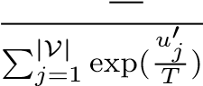
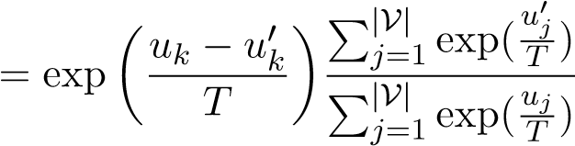
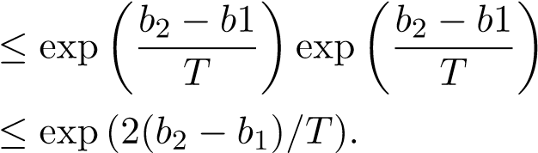
Proof. Let D and D′ be any two documents, and u and u′ ∈ R^{|V|} be their corresponding logits. Let v ∈ V, and k be its index, with u_{k} being its corresponding logit. We then have that,
Pr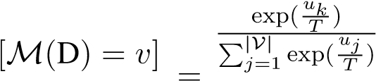
Pr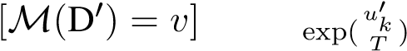
Now by using sequential composition law of
DP (Dwork et al., 2006), we can set ϵ =
(2n(b₂ − b₁)/T) to conclude the proof.

B Code
In this section, we showcase the code for DPPrompt implemented using the Hugging Face library (Wolf et al., 2019). The code can be found in Listing 1.

C Implementation Details and Additional Experiments
C.1 Word-Level Mechanisms
For all word-level mechanisms, we utilize 50dimensional glove embeddings (Pennington et al., 2014), following the approach of Mattern et al. (Mattern et al., 2022b). The projection step, which requires approximate nearest neighbor search, is performed using an Annoy indexer with 500 trees.
C.2 Sentence-Level Mechanisms
Both the Truncated-Laplace and Deep-Candidate mechanisms require additional publicly available data. In the case of Truncated-Laplace, this data is used to determine truncated boundaries, while for Deep-Candidate, it is used to train the sentence recoder and obtain the output.
We randomly sample 5,000 documents from both the IMDB and Yelp reviews, which are not part of the data used for privacy-utility experiments.
The sentence recoder architecture is trained with three layers of MLP, incorporating dropout and selecting the best model. We choose 50 clusters for sentence recoding and employ 100 random projections to estimate the approximate Tukey depth.
Sentence embeddings (Reimers and Gurevych, 2019) of dimension 768 are obtained from (Song et al., 2020).
C.3 Document-Level Mechanisms
For the paraphrasing mechanism, we fine-tune the gpt2-xl(1.5b) parameter model on the PAWS dataset (Zhang et al., 2019). The training set is constructed by combining the train and val sets, and the test set is used for validation to save the best model. The training set consists of 25,368 examples, and the validation set consists of 3,536 examples. We follow the procedure outlined in (Mattern et al., 2022b), which builds upon (Witteveen and Andrews, 2019).
To set clip thresholds in Section 4.4, we employ a process similar to Truncated-Laplace (Meehan et al., 2022) with a slight difference. While (Meehan et al., 2022) calculates the 75% quantile and utilizes it as the clipping threshold, we calculate the minimum and maximum values.Both TruncatedLaplace and Dp-Prompt employ the exact same additional data. The resulting min and max clip threshold vector is then used to clip the logits before scaling them by temperature.
C.4 Static and Adaptive Attacker Architecture
Word level and document level output documents, to simulate embedding-level attacker we employ sentence transformer all-mpnet-base-v2 (Reimers and Gurevych, 2019; Song et al., 2020) to convert sanitized document to sanitized embedding. For sentence level, directly sanitized embeddings are used. The embedding-level attackers employ a three-layer MLP with a hidden dimension of 768. We use the ReLU activation function and incorporate dropout of 0.5. The models are trained for 50 epochs with a batch size of 32, using the Adam optimizer with a StepLR learning scheduler. The initial learning rate is set to 10⁻³, and the gamma value is 0.95.
The text-level attackers use bert-base-cased and fine-tune it for 3 epochs with a batch size of 16, using the AdamW optimizer with a linear scheduler and a starting learning rate of 5 × 10⁻⁵.
from transformers import LogitsProcessor, LogitsProcessorList
class ClippedLogitsProcessor(LogitsProcessor):
def __init__(self, min_tensor, max_tensor):
self.min_tensor = min_tensor self.max_tensor = max_tensor
def __call__(self, input_ids, scores):
clipped_logits = torch.clamp(scores, self.min_tensor, self.max_tensor) return clipped_logits
def prompt_template_fn(private_doc):
prompt = f"Document: {private_doc}\nParaphrase of the document:" return prompt
def dp_prompt( private_doc, model, tokenizer, min_tensor, max_tensor, temp, new_tokens ):
logits_processor = LogitsProcessorList(
[ClippedLogitsProcessor(min_tensor, max_tensor)]
) private_prompt = prompt_template_fn(private_doc)
input_ids = tokenizer.encode(private_prompt, return_tensors="pt") output = model.generate( input_ids, do_sample=True, top_k=0, top_p=1.0, temperature=temp, max_new_tokens=new_tokens, logits_processor=logits_processor
) sanitized_doc = tokenizer.decode(output[0][0], skip_special_tokens=True) return sanitized_doc
Listing 1: DP Prompt Code using Hugging Face’s Transformers Library
C.5 Code and Reproducibility
The code will be publicly released. Considering the reproducibility challenges associated with closed APIs (Pozzobon et al., 2023), we also plan to release the paraphrased documents that were generated using ChatGPT.
.
C.6 Expected F1 score of random classifier
Let p_{i} represent the fraction of documents with label y_{i}, where i ranges from 0 to ℓ−1. A uniformly random classifier predicts class y_{i} with a probability of 1/ℓ. Based on this setup, we can derive the following metrics:
True Positives(TP) 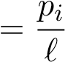
True Negatives(TN) 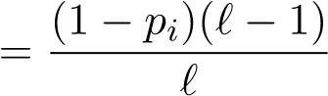
False Positives(FP) 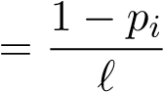
False Negatives(FN) 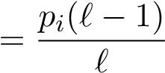
From these metrics, we can calculate the F1 Score for sentiment analysis, which is a binary classification task, as follows:
TP 2p₁ F1 Score = =
TP 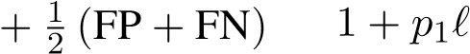
For author identification, which is a multi-class classification task, we utilize the F1 Score with a macro average. In the case of a random classifier, the expected F1 score can be calculated as:
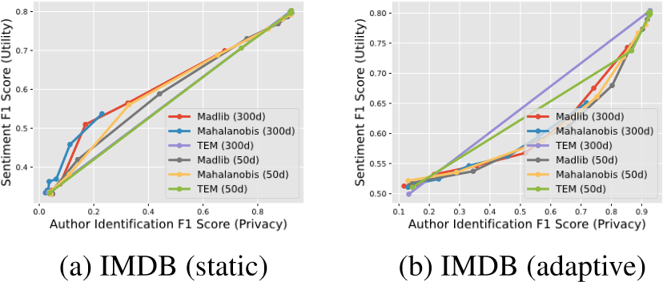
BERT Score
 |  |  | IMDB |  |  |  |  | Yelp
 | t=1.0 | t=1.25 | t=1.5 | t=1.75 | t=2.0 | t=1.0 | t=1.25 | t=1.5 | t=1.75 | t=2.0
Chat GPT | 0.882 | 0.879 | 0.863 | 0.805 | 0.765 | 0.89 | 0.887 | 0.876 | 0.83 | 0.777
Table 4: Bert Score for ChatGPT for different sampling temperatures

BERT Score
 |  |  | IMDB |  |  |  |  | Yelp
 | t=0.75 | t=1.0 | t=1.25 | t=1.5 | t=1.75 | t=0.75 | t=1.0 | t=1.25 | t=1.5 | t=1.75
GPT-2 (xl) (fine tuned) | 0.838 | 0.822 | 0.794 | 0.762 | 0.748 | 0.852 | 0.837 | 0.804 | 0.765 | 0.750
T5 (xl) | 0.831 | 0.812 | 0.790 | 0.775 | 0.763 | 0.834 | 0.817 | 0.797 | 0.782 | 0.769
Stablelm-Base (3b) | 0.814 | 0.805 | 0.785 | 0.762 | 0.749 | 0.835 | 0.817 | 0.789 | 0.757 | 0.747
Stablelm-Base (7b) | 0.813 | 0.803 | 0.779 | 0.759 | 0.748 | 0.835 | 0.819 | 0.788 | 0.757 | 0.746
Flan T5 (xl) | 0.843 | 0.823 | 0.792 | 0.762 | 0.750 | 0.849 | 0.830 | 0.801 | 0.769 | 0.753
Stablelm Tuned (3b) | 0.846 | 0.830 | 0.795 | 0.757 | 0.743 | 0.849 | 0.836 | 0.800 | 0.760 | 0.746
Stablelm Tuned (7b) | 0.854 | 0.839 | 0.800 | 0.757 | 0.743 | 0.858 | 0.845 | 0.806 | 0.761 | 0.747
Table 5: Bert Score for Open Source Models for different sampling temperatures
Figure 6: Comparision of glove-wiki-gigaword-50 with glove-wiki-gigaword-300 for word level mechanism (Madlib, Mahalonobis, TEM) for IMDB dataset against embedding level attackers.
F1 Scoremacro avg 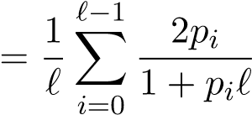
By employing this approach, we can effectively evaluate the performance of a random classifier for author identification in terms of the F1 Score.

D Additional Results
D.1 Comparing 50 and 300-Dimensional
Glove Embeddings for Word-Level Mechanism
Note that in Section 4.2, we used 50-dimensional
Glove embeddings (glove-wiki-gigaword-50) (Pennington et al., 2014) for Madlib, Mahalanobis, and TEM mechanisms. In this section, we demonstrate that there is no significant benefit to using 300-dimensional glove embeddings
(glove-wiki-gigaword-300). We show this for IMDB dataset against embedding-level attackers. Results are show in Figure 6.
D.2 BERT score for paraphrasing models
We use BERTScore, which has been demonstrated to correlate with human judgments, in conjunction with the RoBerta model (Liu et al., 2019) (roberta-large) to assess the similarity between a review and its paraphrase. The results for ChatGPT are presented in Table 4, while those for the open-source model can be found in Table 5.

E Sample Illustration of paraphrases
In this section, we present a comparison of paraphrases generated from ChatGPT and Stablelm at various temperatures, as illustrated in Figure 7. It is evident from the results that ChatGPT produces higher-quality paraphrases compared to StablelmTuned (7B).

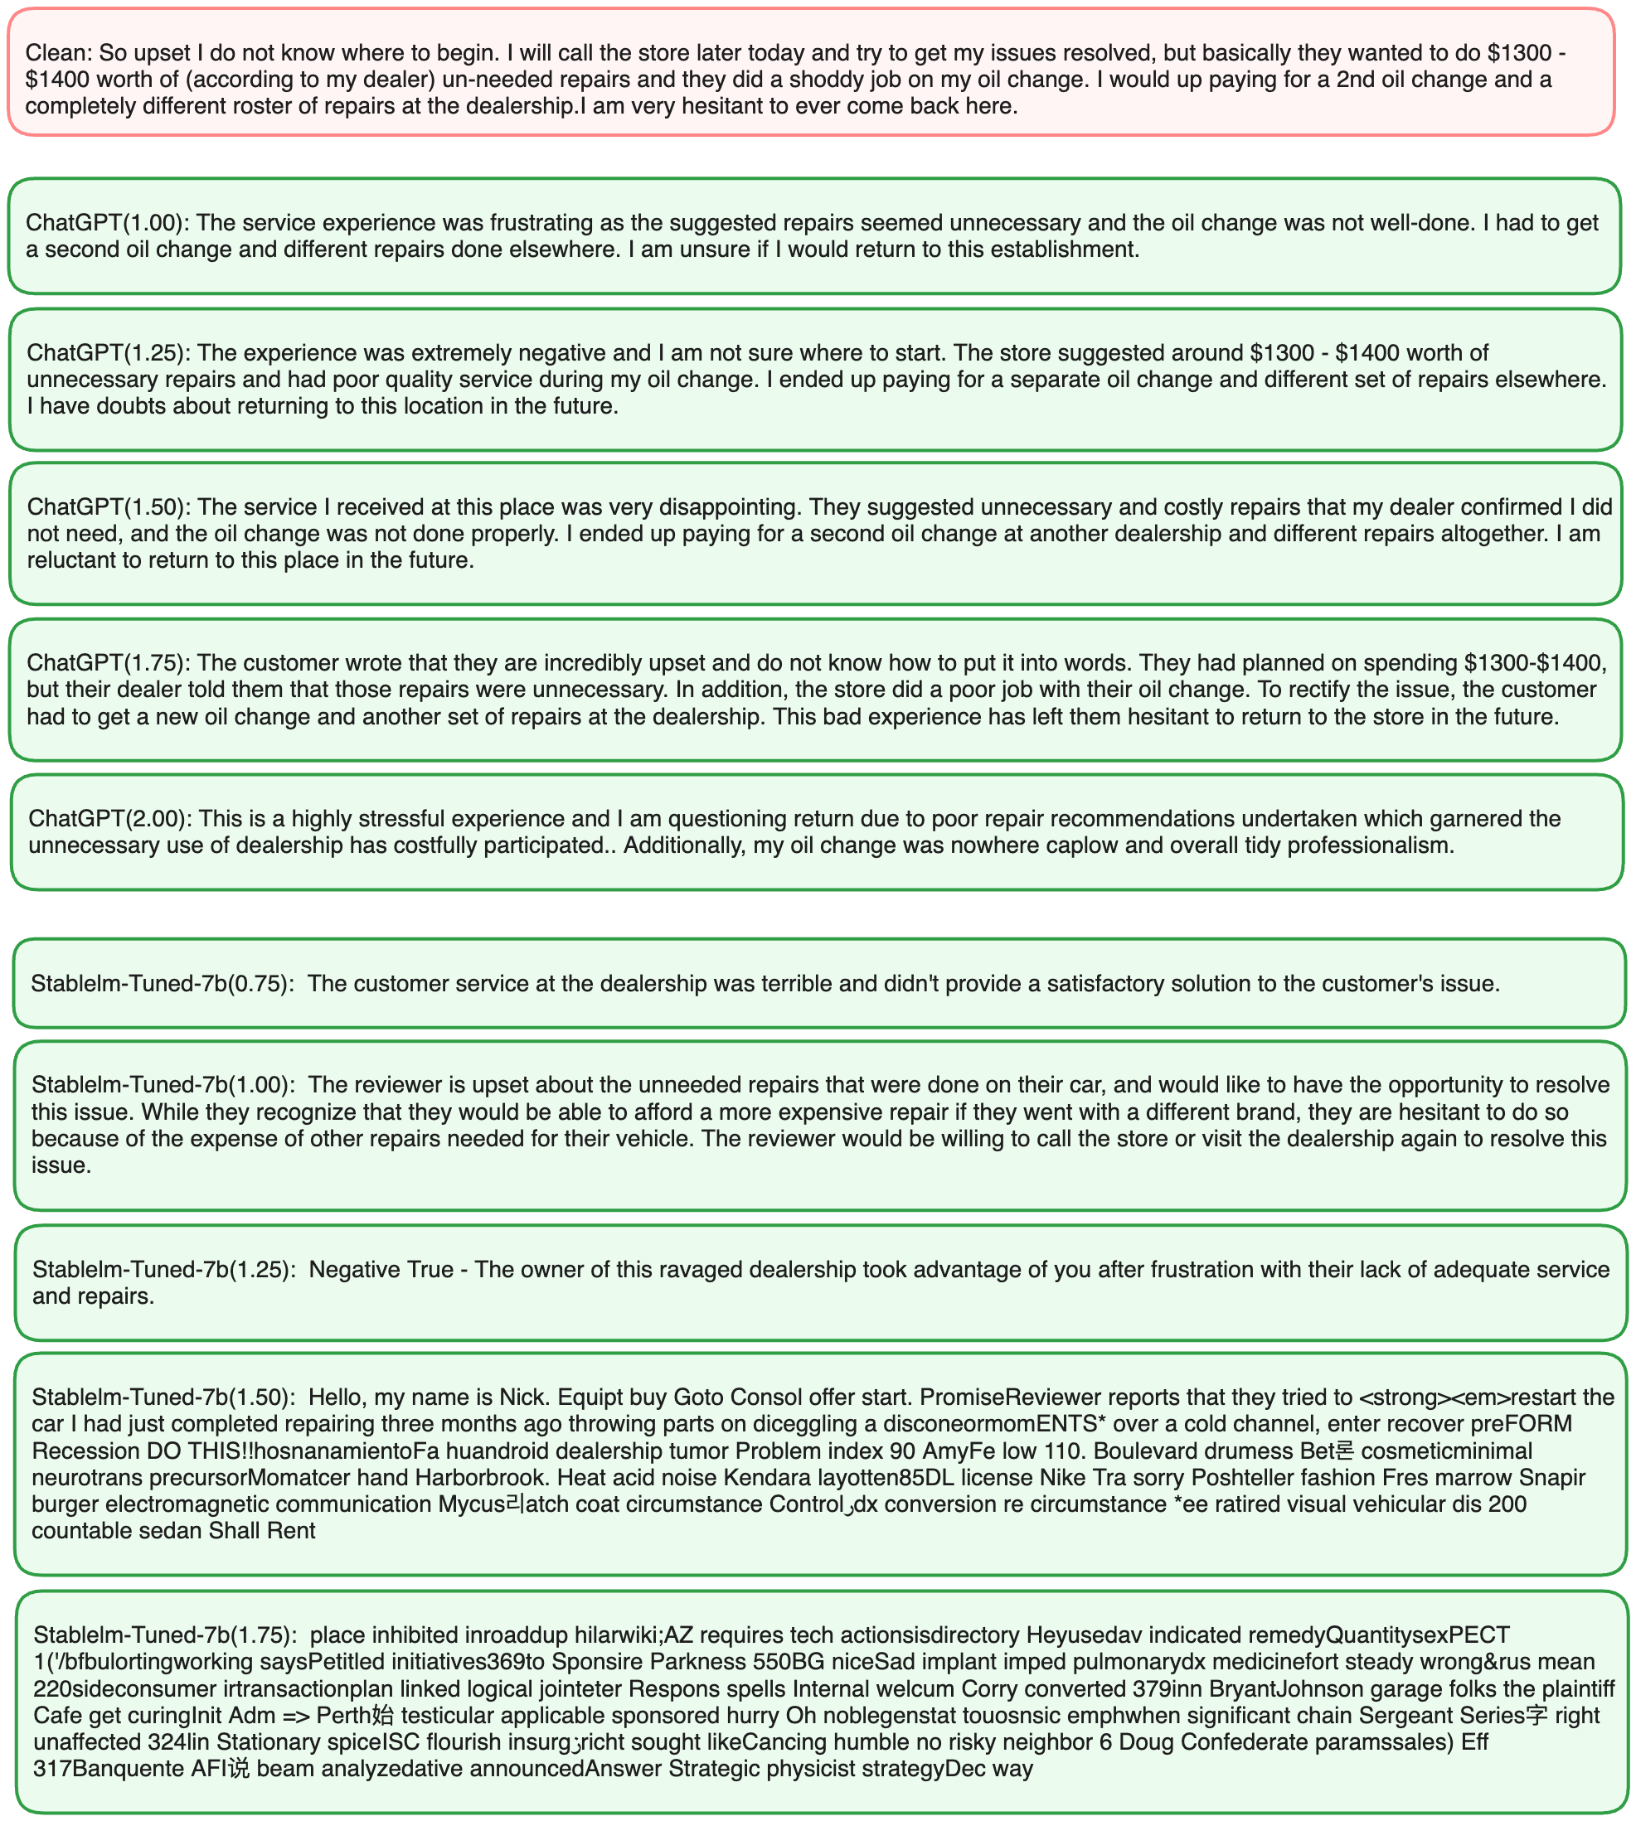
Figure 7: Comparison of paraphrase results between ChatGPT (gpt-3.5) and Stablelm-Tuned-7B at different temperatures. ChatGPT consistently generates more readable and superior quality text at higher temperatures compared to Stablelm-Tuned-7B.

