University of Michigan  School of Information
Database Application Design

Assignment 2 – Procure A Hosted PHP / MySQL Service

Due Date: Monday September 22, 9PM

Assignment

In this assignment you are to get a hosted PHP/MySQL service. You can use any service as long as it has a real, public domain name and URL. You can use:

- UM School of Information People Server
- A free hosting site like byethost.com
- A paid hosting site of any kind

If you already have a hosting site – you can make a folder like 'si664' and turn in all the assignments with the URL that includes the folder – so you can do all the assignment without disturbing the rest of your site like:

http://www.dr-chuck.com/si664hw/howdy.php

You will upload the following PHP into a file called howdy.php (putting your own name in)

<h1>Hello from Dr. Chuck's HTML Page</h1>
<p>
<?php
echo "Hi there.\n";
$answer = 6 * 7;
echo "The answer is $answer, what was the question again?\n";
?>
</p>
<p>Yes another paragraph.</p>

You will need to hand in the URL of your web site as follows:

- http://www.dr-chuck.com/si664hw/howdy.php
- http://csevumich.byethost18.com/howdy.php
- http://csev.people.si.umich.edu/howdy.php

We don't care where your PHP is running – just that it has a URL and that it is yours to modify.

Hand In

Once your web site is working you can automatically grade it using the auto-grading tool under the "Course Content" area I the course site in CTools.

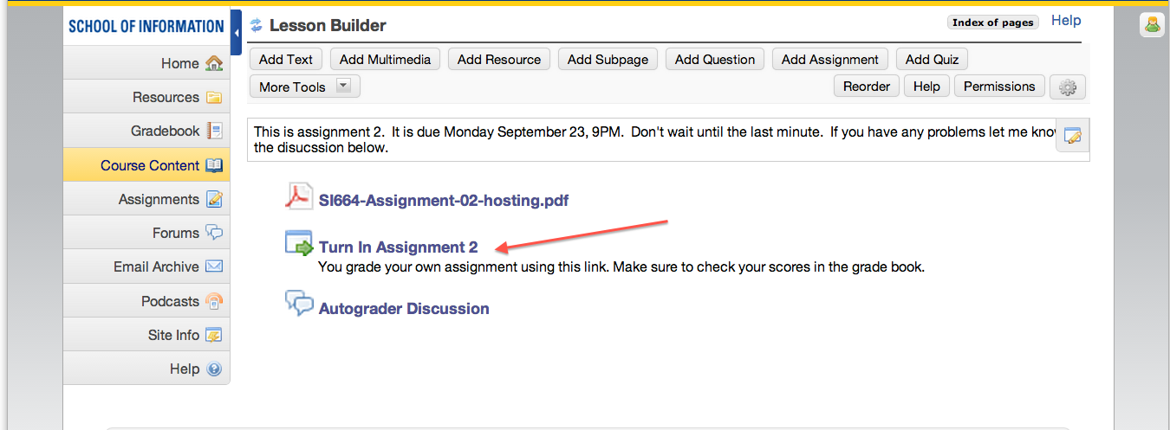

The autograder will instantly grade your assignment and send the grade to CTools. You should make sure to submit your assignment to the autograder before the deadline and make sure that the grade is properly reflected in CTools.

The autograder is new software and so if you have any problems make sure to contact Dr. Chuck or the GSI immediately. If you have problems – make sure to take screen shots or print out what the screen says.

