University of Michigan  School of Information
Database Applications

Assignment 3 – A Guessing Game and HTTP GET Parameters

Due Date: Thursday September 25, 2014

Overview

In this assignment you will write a guessing game in PHP that takes GET parameters and plays the game. You can play with an example implementation at:

http://www.php-intro.com/assn/guess/guess.php?guess=1234

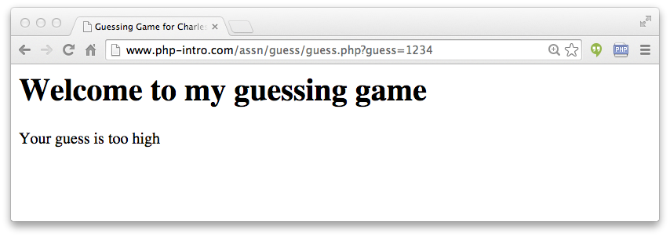
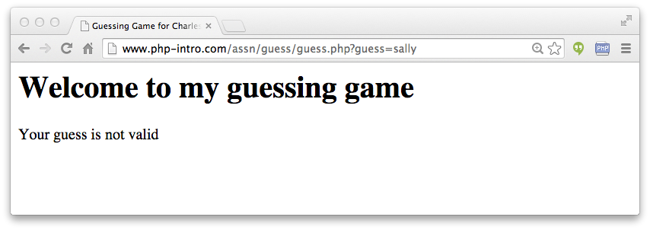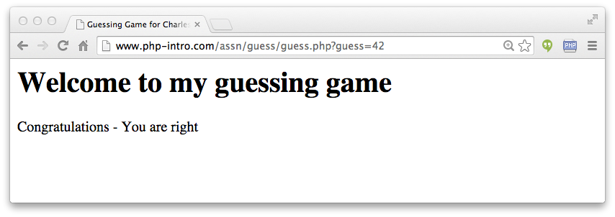

You can play with the game to get the exact wording for each of the messages.

Specifications

Since this code will be graded using the auto grader in CTools, your output must be very precise. You need to match the wording on the screen in the sample application precisely. The auto grader will run the following tests on your application:

- It will look at the contents of the <title> tag and insist your name within CTools (i.e. Charles Severance) is part of the title of the page. If your name is not in the title, all of the tests will be run but no grade will be sent.

- It will call your program with no parameters at all and your program should say, "Missing guess parameter".

- It will call your code with a non-numeric value and your code should say, "Your guess is not valid".

- It will call your code with a low guess and your code should say, "Your guess is too low".

- It will call your code with a too high guess and your code should say, "Your guess is too high".

- It will call your code with the right value (42) and your code should say, "Congratulations - You are right".

The output of the auto grader for a successful run will look as follows:

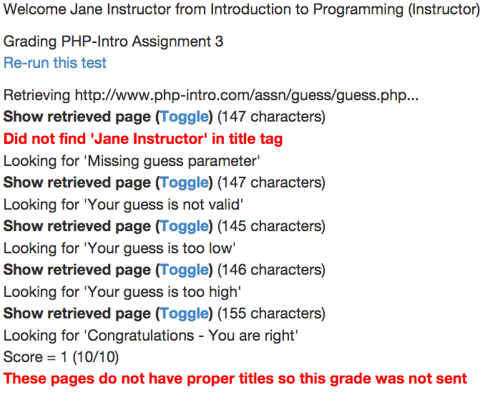

This run does not properly match the user's name in the title field of the page so you get the one error message and the grade is not sent back to CTools.

