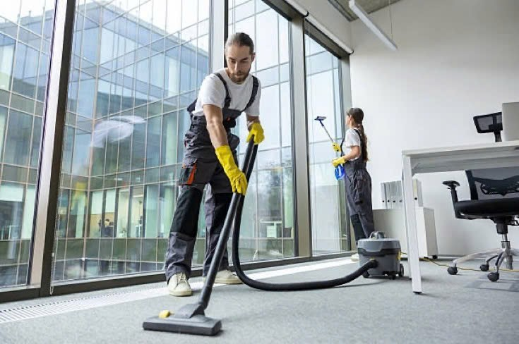

S: In the room
M: 2 cleaner , wearing grey uniform, pair of gloves
A: man use vacuum to clean the floor, woman is using tools to wipe the glass windows
R: Table chair.
T: they are busy

