Đại học Đà Nẵng
TRƯỜNG ĐẠI HỌC SƯ PHẠM KỸ THUẬT



BÁO CÁO
LẬP TRÌNH C#

Tên đề tài:
WEBSITE BÁN ĐIỆN THOẠI

Sinh viên thực hiện : Cái Quốc Đạt Lớp: 18T1
Mã sinh viên : 1811505310106
GVHD : Lê Thị Bích Tra

Đà Nẵng, tháng 06/2021
MỤC LỤC
CHƯƠNG 1. Link github 2
CHƯƠNG 2. Thực hiện yêu cầu cho trang Admin 2
2.1. Sử dụng template Admin mẫu, hiệu chỉnh lại cho phù hợp, và sử dụng các class css, bootstrap cho các chức năng bên dưới. (1 đ) 2
2.2. Thực hiện chức năng Kiểm tra đăng nhập (1đ) 2
2.3. Hiển thị danh sách UserAccount 2
2.3.1. Phân trang danh sách tài khoản người dùng (5 user/trang) và chức năng tìm kiếm (1đ) 2
2.3.2. Xóa 1 người dùng có Status là Blocked (1đ) 2
2.4. Hiển thị danh sách sản phẩm 2
2.4.1. Sắp xếp theo Số lượng tăng dần, Đơn giá giảm dần, dưới dạng bảng có các cột (1đ) 2
2.4.2. Click vào link Xem chi tiết (ở cột Thao tác) sẽ chuyển đến trang xem được chi tiết của sản phẩm (1đ) 2
2.5. Thiết kế form, thực hiện chức năng thêm 1 sản phẩm: 2
CHƯƠNG 3. Thực hiện yêu cầu cho trang USER 3
3.1. Download 1 template bán hàng bất kỳ, hiệu chỉnh lại cho phù hợp với dữ liệu của bảng Sản phẩm 3
3.2. Đổ dữ liệu của bảng sản phẩm vào trang chủ 3

Link github
Link GitHub tại đây: https://github.com/caiquocdat/CuoiKiCShap

Thực hiện yêu cầu cho trang Admin

Sử dụng template Admin mẫu, hiệu chỉnh lại cho phù hợp, và sử dụng các class css, bootstrap cho các chức năng bên dưới. (1 đ)
- _Layout.cshtml:
@{
Layout = null;
}

<!DOCTYPE html>

<html lang="en">
<head>
<meta charset="utf-8">
<meta name="viewport" content="width=device-width, initial-scale=1.0">
<meta name="description" content="">
<meta name="author" content="ThemeBucket">
<link rel="shortcut icon" href="~/Assets/admin/images/favicon.png">
<title>@ViewBag.Title - Quản Trị</title>
<!--Core CSS -->
<link href="~/Assets/admin/bs3/css/bootstrap.min.css" rel="stylesheet">
<link href="~/Assets/admin/js/jquery-ui/jquery-ui-1.10.1.custom.min.css" rel="stylesheet">
<link href="~/Assets/admin/css/bootstrap-reset.css" rel="stylesheet">
<link href="~/Assets/admin/font-awesome/css/font-awesome.css" rel="stylesheet">
<link href="~/Assets/admin/js/jvector-map/jquery-jvectormap-1.2.2.css" rel="stylesheet">
<link href="~/Assets/admin/css/clndr.css" rel="stylesheet">
<!--clock css-->
<link href="~/Assets/admin/js/css3clock/css/style.css" rel="stylesheet">
<!--Morris Chart CSS -->
<link rel="stylesheet" href="~/Assets/admin/js/morris-chart/morris.css">
<!-- Custom styles for this template -->
<link href="~/Assets/admin/css/style.css" rel="stylesheet">
<link href="~/Assets/admin/css/style-responsive.css" rel="stylesheet" />
<!-- Just for debugging purposes. Don't actually copy this line! -->
<!--[if lt IE 9]>
<script src="js/ie8-responsive-file-warning.js"></script><![endif]-->
<!-- HTML5 shim and Respond.js IE8 support of HTML5 elements and media queries -->
<!--[if lt IE 9]>
<script src="https://oss.maxcdn.com/libs/html5shiv/3.7.0/html5shiv.js"></script>
<script src="https://oss.maxcdn.com/libs/respond.js/1.3.0/respond.min.js"></script>
<![endif]-->
</head>
<body>
<section id="container">
<!--header start-->
<header class="header fixed-top clearfix">
<!--logo start-->
<div class="brand">
<a href="index.html" class="logo">
<img src="~/Assets/admin/images/logo.png" alt="">
</a>
<div class="sidebar-toggle-box">
<div class="fa fa-bars"></div>
</div>
</div>
<!--logo end-->
<div class="nav notify-row" id="top_menu">
<!-- notification start -->
<ul class="nav top-menu">
<!-- settings start -->
<li class="dropdown">
<a data-toggle="dropdown" class="dropdown-toggle" href="#">
<i class="fa fa-tasks"></i>
<span class="badge bg-success">8</span>
</a>
<ul class="dropdown-menu extended tasks-bar">
<li>
<p class="">You have 8 pending tasks</p>
</li>
<li>
<a href="#">
<div class="task-info clearfix">
<div class="desc pull-left">
<h5>Target Sell</h5>
<p>25% , Deadline 12 June’13</p>
</div>
<span class="notification-pie-chart pull-right" data-percent="45">
<span class="percent"></span>
</span>
</div>
</a>
</li>
<li>
<a href="#">
<div class="task-info clearfix">
<div class="desc pull-left">
<h5>Product Delivery</h5>
<p>45% , Deadline 12 June’13</p>
</div>
<span class="notification-pie-chart pull-right" data-percent="78">
<span class="percent"></span>
</span>
</div>
</a>
</li>
<li>
<a href="#">
<div class="task-info clearfix">
<div class="desc pull-left">
<h5>Payment collection</h5>
<p>87% , Deadline 12 June’13</p>
</div>
<span class="notification-pie-chart pull-right" data-percent="60">
<span class="percent"></span>
</span>
</div>
</a>
</li>
<li>
<a href="#">
<div class="task-info clearfix">
<div class="desc pull-left">
<h5>Target Sell</h5>
<p>33% , Deadline 12 June’13</p>
</div>
<span class="notification-pie-chart pull-right" data-percent="90">
<span class="percent"></span>
</span>
</div>
</a>
</li>
<li class="external">
<a href="#">See All Tasks</a>
</li>
</ul>
</li>
<!-- settings end -->
<!-- inbox dropdown start-->
<li id="header_inbox_bar" class="dropdown">
<a data-toggle="dropdown" class="dropdown-toggle" href="#">
<i class="fa fa-envelope-o"></i>
<span class="badge bg-important">4</span>
</a>
<ul class="dropdown-menu extended inbox">
<li>
<p class="red">You have 4 Mails</p>
</li>
<li>
<a href="#">
<span class="photo"><img alt="avatar" src="~/Assets/admin/images/avatar-mini.jpg"></span>
<span class="subject">
<span class="from">Jonathan Smith</span>
<span class="time">Just now</span>
</span>
<span class="message">
Hello, this is an example msg.
</span>
</a>
</li>
<li>
<a href="#">
<span class="photo"><img alt="avatar" src="~/Assets/admin/images/avatar-mini-2.jpg"></span>
<span class="subject">
<span class="from">Jane Doe</span>
<span class="time">2 min ago</span>
</span>
<span class="message">
Nice admin template
</span>
</a>
</li>
<li>
<a href="#">
<span class="photo"><img alt="avatar" src="~/Assets/admin/images/avatar-mini-3.jpg"></span>
<span class="subject">
<span class="from">Tasi sam</span>
<span class="time">2 days ago</span>
</span>
<span class="message">
This is an example msg.
</span>
</a>
</li>
<li>
<a href="#">
<span class="photo"><img alt="avatar" src="~/Assets/admin/images/avatar-mini.jpg"></span>
<span class="subject">
<span class="from">Mr. Perfect</span>
<span class="time">2 hour ago</span>
</span>
<span class="message">
Hi there, its a test
</span>
</a>
</li>
<li>
<a href="#">See all messages</a>
</li>
</ul>
</li>
<!-- inbox dropdown end -->
<!-- notification dropdown start-->
<li id="header_notification_bar" class="dropdown">
<a data-toggle="dropdown" class="dropdown-toggle" href="#">
<i class="fa fa-bell-o"></i>
<span class="badge bg-warning">3</span>
</a>
<ul class="dropdown-menu extended notification">
<li>
<p>Notifications</p>
</li>
<li>
<div class="alert alert-info clearfix">
<span class="alert-icon"><i class="fa fa-bolt"></i></span>
<div class="noti-info">
<a href="#"> Server #1 overloaded.</a>
</div>
</div>
</li>
<li>
<div class="alert alert-danger clearfix">
<span class="alert-icon"><i class="fa fa-bolt"></i></span>
<div class="noti-info">
<a href="#"> Server #2 overloaded.</a>
</div>
</div>
</li>
<li>
<div class="alert alert-success clearfix">
<span class="alert-icon"><i class="fa fa-bolt"></i></span>
<div class="noti-info">
<a href="#"> Server #3 overloaded.</a>
</div>
</div>
</li>
</ul>
</li>
<!-- notification dropdown end -->
</ul>
<!-- notification end -->
</div>
<div class="top-nav clearfix">
<!--search & user info start-->
<ul class="nav pull-right top-menu">
<li>
<p>Hello @ViewBag.adName</p>
</li>
<!-- user login dropdown start-->
<li class="dropdown">
<a data-toggle="dropdown" class="dropdown-toggle" href="#">
<img alt="" src="images/avatar1_small.jpg">
<span class="username">

</span>
<b class="caret"></b>
</a>
<ul class="dropdown-menu extended logout">

<li><a href="@Url.Action("Logout", "Home")"><i class="fa fa-key"></i> Đăng Xuất</a></li>
</ul>
</li>
<!-- user login dropdown end -->
<li>
<div class="toggle-right-box">
<div class="fa fa-bars"></div>
</div>
</li>
</ul>
<!--search & user info end-->
</div>
</header>
<!--header end-->
<!--sidebar start-->
<aside>
<div id="sidebar" class="nav-collapse">
<!-- sidebar menu start-->
<div class="leftside-navigation">
<ul class="sidebar-menu" id="nav-accordion">
@*<li>
<a class="active" href="/admin/home/index">
<i class="fa fa-dashboard"></i>
<span>Báo Cáo Thống Kê</span>
</a>
</li>*@
<li class="sub-menu">
<a href="/admin/user/index">
<i class="fa fa-user"></i>
<span>Quản Lý Tài Khoản</span>
</a>
</li>
<li class="sub-menu">
<a href="/admin/product/index">
<i class="fa fa-mobile-phone"></i>
<span>Quản Lý Sản Phẩm</span>
</a>
</li>
<li class="sub-menu">
<a href="/admin/category/index">
<i class="fa fa-laptop"></i>
<span>Quản Lý Loại Sản Phẩm</span>
</a>
</li>
@*<li class="sub-menu">
<a href="#" id="parent_hd">
<i class="fa fa-book"></i>
<span>Quản Lý Hóa Đơn</span>
</a>
<ul class="sub" id="child_hd">
<li><a href="/admin/Bill/unapproved">Hóa Đơn Chưa Duyệt</a></li>
<li><a href="/admin/Bill/index">Hóa Đơn Đã Duyệt</a></li>
</ul>
</li>*@
</ul>
</div>
<!-- sidebar menu end-->
</div>
</aside>
<!--sidebar end-->
<!--main content start-->
<section id="main-content">
<section class="wrapper">
<!--mini statistics start-->
<!--mini statistics end-->
<div class="row">
<div class="col-md-12">
<!--earning graph start-->
<section class="panel">
<header class="panel-heading">
<label style="color:red"><b>@RenderSection("header", required: true)</b></label>
</header>
<div class="panel-body col-12">
@if(TempData["AlertMessage"] != null)
{
<div id="AlertBox" class="alert @TempData["AlertType"] hide">
@TempData["AlertMessage"]
</div>
}

@RenderBody()
</div>
</section>
<!--earning graph end-->
</div>

</div>

</section>
</section>
<!--main content end-->
<!--right sidebar start-->
<div class="right-sidebar">
<div class="search-row">
<input type="text" placeholder="Search" class="form-control">
</div>
<div class="right-stat-bar">
<ul class="right-side-accordion">
<li class="widget-collapsible">
<a href="#" class="head widget-head red-bg active clearfix">
<span class="pull-left">work progress (5)</span>
<span class="pull-right widget-collapse"><i class="ico-minus"></i></span>
</a>
<ul class="widget-container">
<li>
<div class="prog-row side-mini-stat clearfix">
<div class="side-graph-info">
<h4>Target sell</h4>
<p>
25%, Deadline 12 june 13
</p>
</div>
<div class="side-mini-graph">
<div class="target-sell">
</div>
</div>
</div>
<div class="prog-row side-mini-stat">
<div class="side-graph-info">
<h4>product delivery</h4>
<p>
55%, Deadline 12 june 13
</p>
</div>
<div class="side-mini-graph">
<div class="p-delivery">
<div class="sparkline" data-type="bar" data-resize="true" data-height="30" data-width="90%" data-bar-color="#39b7ab" data-bar-width="5" data-data="[200,135,667,333,526,996,564,123,890,564,455]">
</div>
</div>
</div>
</div>
<div class="prog-row side-mini-stat">
<div class="side-graph-info payment-info">
<h4>payment collection</h4>
<p>
25%, Deadline 12 june 13
</p>
</div>
<div class="side-mini-graph">
<div class="p-collection">
<span class="pc-epie-chart" data-percent="45">
<span class="percent"></span>
</span>
</div>
</div>
</div>
<div class="prog-row side-mini-stat">
<div class="side-graph-info">
<h4>delivery pending</h4>
<p>
44%, Deadline 12 june 13
</p>
</div>
<div class="side-mini-graph">
<div class="d-pending">
</div>
</div>
</div>
<div class="prog-row side-mini-stat">
<div class="col-md-12">
<h4>total progress</h4>
<p>
50%, Deadline 12 june 13
</p>
<div class="progress progress-xs mtop10">
<div style="width: 50%" aria-valuemax="100" aria-valuemin="0" aria-valuenow="20" role="progressbar" class="progress-bar progress-bar-info">
<span class="sr-only">50% Complete</span>
</div>
</div>
</div>
</div>
</li>
</ul>
</li>
<li class="widget-collapsible">
<a href="#" class="head widget-head terques-bg active clearfix">
<span class="pull-left">contact online (5)</span>
<span class="pull-right widget-collapse"><i class="ico-minus"></i></span>
</a>
<ul class="widget-container">
<li>
<div class="prog-row">
<div class="user-thumb">
<a href="#"><img src="images/avatar1_small.jpg" alt=""></a>
</div>
<div class="user-details">
<h4><a href="#">Jonathan Smith</a></h4>
<p>
Work for fun
</p>
</div>
<div class="user-status text-danger">
<i class="fa fa-comments-o"></i>
</div>
</div>
<div class="prog-row">
<div class="user-thumb">
<a href="#"><img src="images/avatar1.jpg" alt=""></a>
</div>
<div class="user-details">
<h4><a href="#">Anjelina Joe</a></h4>
<p>
Available
</p>
</div>
<div class="user-status text-success">
<i class="fa fa-comments-o"></i>
</div>
</div>
<div class="prog-row">
<div class="user-thumb">
<a href="#"><img src="images/chat-avatar2.jpg" alt=""></a>
</div>
<div class="user-details">
<h4><a href="#">John Doe</a></h4>
<p>
Away from Desk
</p>
</div>
<div class="user-status text-warning">
<i class="fa fa-comments-o"></i>
</div>
</div>
<div class="prog-row">
<div class="user-thumb">
<a href="#"><img src="images/avatar1_small.jpg" alt=""></a>
</div>
<div class="user-details">
<h4><a href="#">Mark Henry</a></h4>
<p>
working
</p>
</div>
<div class="user-status text-info">
<i class="fa fa-comments-o"></i>
</div>
</div>
<div class="prog-row">
<div class="user-thumb">
<a href="#"><img src="images/avatar1.jpg" alt=""></a>
</div>
<div class="user-details">
<h4><a href="#">Shila Jones</a></h4>
<p>
Work for fun
</p>
</div>
<div class="user-status text-danger">
<i class="fa fa-comments-o"></i>
</div>
</div>
<p class="text-center">
<a href="#" class="view-btn">View all Contacts</a>
</p>
</li>
</ul>
</li>
<li class="widget-collapsible">
<a href="#" class="head widget-head purple-bg active">
<span class="pull-left"> recent activity (3)</span>
<span class="pull-right widget-collapse"><i class="ico-minus"></i></span>
</a>
<ul class="widget-container">
<li>
<div class="prog-row">
<div class="user-thumb rsn-activity">
<i class="fa fa-clock-o"></i>
</div>
<div class="rsn-details ">
<p class="text-muted">
just now
</p>
<p>
<a href="#">Jim Doe </a>Purchased new equipments for zonal office setup
</p>
</div>
</div>
<div class="prog-row">
<div class="user-thumb rsn-activity">
<i class="fa fa-clock-o"></i>
</div>
<div class="rsn-details ">
<p class="text-muted">
2 min ago
</p>
<p>
<a href="#">Jane Doe </a>Purchased new equipments for zonal office setup
</p>
</div>
</div>
<div class="prog-row">
<div class="user-thumb rsn-activity">
<i class="fa fa-clock-o"></i>
</div>
<div class="rsn-details ">
<p class="text-muted">
1 day ago
</p>
<p>
<a href="#">Jim Doe </a>Purchased new equipments for zonal office setup
</p>
</div>
</div>
</li>
</ul>
</li>
<li class="widget-collapsible">
<a href="#" class="head widget-head yellow-bg active">
<span class="pull-left"> shipment status</span>
<span class="pull-right widget-collapse"><i class="ico-minus"></i></span>
</a>
<ul class="widget-container">
<li>
<div class="col-md-12">
<div class="prog-row">
<p>
Full sleeve baby wear (SL: 17665)
</p>
<div class="progress progress-xs mtop10">
<div class="progress-bar progress-bar-success" role="progressbar" aria-valuenow="20" aria-valuemin="0" aria-valuemax="100" style="width: 40%">
<span class="sr-only">40% Complete</span>
</div>
</div>
</div>
<div class="prog-row">
<p>
Full sleeve baby wear (SL: 17665)
</p>
<div class="progress progress-xs mtop10">
<div class="progress-bar progress-bar-info" role="progressbar" aria-valuenow="20" aria-valuemin="0" aria-valuemax="100" style="width: 70%">
<span class="sr-only">70% Completed</span>
</div>
</div>
</div>
</div>
</li>
</ul>
</li>
</ul>
</div>
</div>
<!--right sidebar end-->
</section>
<!-- Placed js at the end of the document so the pages load faster -->
<!--Core js-->
<script src="~/Assets/admin/js/jquery.js"></script>
<script src="~/Assets/admin/js/jquery-ui/jquery-ui-1.10.1.custom.min.js"></script>
<script src="~/Assets/admin/bs3/js/bootstrap.min.js"></script>
<script src="~/Assets/admin/js/jquery.dcjqaccordion.2.7.js"></script>
<script src="~/Assets/admin/js/jquery.scrollTo.min.js"></script>
<script src="~/Assets/admin/js/jQuery-slimScroll-1.3.0/jquery.slimscroll.js"></script>
<script src="~/Assets/admin/js/jquery.nicescroll.js"></script>
<!--[if lte IE 8]><script language="javascript" type="text/javascript" src="js/flot-chart/excanvas.min.js"></script><![endif]-->
<script src="~/Assets/admin/js/skycons/skycons.js"></script>
<script src="~/Assets/admin/js/jquery.scrollTo/jquery.scrollTo.js"></script>
<script src="//cdnjs.cloudflare.com/ajax/libs/jquery-easing/1.3/jquery.easing.min.js"></script>
<script src="~/Assets/admin/js/calendar/clndr.js"></script>
<script src="http://cdnjs.cloudflare.com/ajax/libs/underscore.js/1.5.2/underscore-min.js"></script>
<script src="~/Assets/admin/js/calendar/moment-2.2.1.js"></script>
<script src="~/Assets/admin/js/evnt.calendar.init.js"></script>
<script src="~/Assets/admin/js/jvector-map/jquery-jvectormap-1.2.2.min.js"></script>
<script src="~/Assets/admin/js/jvector-map/jquery-jvectormap-us-lcc-en.js"></script>
<script src="~/Assets/admin/js/gauge/gauge.js"></script>
<!--clock init-->
<script src="~/Assets/admin/js/css3clock/js/css3clock.js"></script>
<!--Easy Pie Chart-->
<script src="~/Assets/admin/js/easypiechart/jquery.easypiechart.js"></script>
<!--Sparkline Chart-->
<script src="~/Assets/admin/js/sparkline/jquery.sparkline.js"></script>
<!--Morris Chart-->
<script src="~/Assets/admin/js/morris-chart/morris.js"></script>
<script src="~/Assets/admin/js/morris-chart/raphael-min.js"></script>
<!--jQuery Flot Chart-->
<script src="~/Assets/admin/js/flot-chart/jquery.flot.js"></script>
<script src="~/Assets/admin/js/flot-chart/jquery.flot.tooltip.min.js"></script>
<script src="~/Assets/admin/js/flot-chart/jquery.flot.resize.js"></script>
<script src="~/Assets/admin/js/flot-chart/jquery.flot.pie.resize.js"></script>
<script src="~/Assets/admin/js/flot-chart/jquery.flot.animator.min.js"></script>
<script src="~/Assets/admin/js/flot-chart/jquery.flot.growraf.js"></script>
<script src="~/Assets/admin/js/dashboard.js"></script>
<script src="~/Assets/admin/js/jquery.customSelect.min.js"></script>
<!--common script init for all pages-->
<script src="~/Assets/admin/js/scripts.js"></script>
<!--script for this page-->
<script src="~/Scripts/jquery.unobtrusive-ajax.min.js"></script>
<script>
$("#child_hd").hide();
$("#parent_hd").click(() => {
$("#child_hd").toggle("500");
})

$("#AlertBox").removeClass("hide");
$("#AlertBox").delay(4000).slideUp(500);
</script>
</body>
</html>
- HomeController.cs
using Model.Dao;
using OnlineShop.Common;
using System;
using System.Collections.Generic;
using System.Linq;
using System.Web;
using System.Web.Mvc;

namespace OnlineShop.Areas.Admin.Controllers
{
public class HomeController : BaseController
{
// GET: Admin/Home
public ActionResult Index()
{
var session = (UserLogin)Session[CommonConstants.USER_SESSION];
ViewBag.adName = session.UserName;
return View();
}
public ActionResult Logout()
{
return RedirectToAction("Index", "Login");
}
}

}
- Code css:
/*anchor*/
a {
color: #32323A;
}

a:hover {
color: #222227;
}

/*panel*/
.panel {
border: none;
box-shadow: none;
}

.panel-heading {
border-color:#eff2f7 ;
font-size: 13px;
font-weight: 400;
background: #fafafa;
text-transform: uppercase;
padding: 15px;
}

.panel-title {
color: #32323A;
font-size: 14px;
font-weight: 400;
margin-bottom: 0;
margin-top: 0;
font-family: 'Open Sans', sans-serif;
}

.panel-primary .tools a {
color: #fff;
}

/*label*/

.label {
padding: 0.5em 0.8em;
}

.label-default {
background-color: #a1a1a1;
}

.label-primary {
background-color: #59ace2;
}

.label-success {
background-color: #A9D86E;
}

.label-info {
background-color: #8175c7;
}

.label-warning {
background-color: #FCB322;
}

.label-danger {
background-color: #FF6C60;
}

.label-inverse {
background-color: #344860;
}

/*text color*/

.text-danger {
color: #FF6C60;
}

.text-muted {
color: #a1a1a1;
}

.text-primary {
color: #59ace2;
}

.text-warning {
color: #FCB322;
}

.text-success {
color: #A9D86E;
}

.text-info {
color: #8175c7;
}

/*modal*/

.modal-content {
box-shadow: none;
border: none;
}

.modal-header {
background: #FAFAFA;
color: #333;
border-radius: 5px 5px 0 0;
-webkit-border-radius: 5px 5px 0 0;
/*border-bottom: none;*/
}

.modal-header .close {
margin-top: 0;
}

/*text input*/

.form-control {
border: 1px solid #e2e2e4;
box-shadow: none;
color: #c2c2c2;
}

.form-control:focus, #focusedInput {
border: 1px solid #00A8B3;
box-shadow: none;
}

.form-horizontal .control-label {
font-weight: 300;
font-size: 14px;
}

input, textarea, select, button {
outline: none !important;
}

/*list*/

ul {
padding-left: 0;
}

/*button*/

.btn-default {
background-color: #c7cbd6;
border-color: #c7cbd6;
color: #fff;
}

.btn-default:hover, .btn-default:focus, .btn-default:active, .btn-default.active, .open .dropdown-toggle.btn-default {
background-color: #b0b5b9;
border-color: #b0b5b9;
color: #fff;
}

.btn-primary {
background-color: #1fb5ad;
border-color: #1fb5ad;
color: #FFFFFF;
}

.btn-primary:hover, .btn-primary:focus, .btn-primary:active, .btn-primary.active, .open .dropdown-toggle.btn-primary {
background-color: #1ca59e;
border-color: #1ca59e;
color: #FFFFFF;
}

.btn-success {
background-color: #95b75d;
border-color: #95b75d;
color: #FFFFFF;
}

.btn-success:hover, .btn-success:focus, .btn-success:active, .btn-success.active, .open .dropdown-toggle.btn-success {
background-color: #88a755;
border-color: #88a755;
color: #FFFFFF;
}

.btn-info {
background-color: #2eb4ad;
border-color: #2eb4ad;
color: #FFFFFF;
}

.btn-info:hover, .btn-info:focus, .btn-info:active, .btn-info.active, .open .dropdown-toggle.btn-info {
background-color: #53bee6;
border-color: #53BEE6;
color: #FFFFFF;
}

.btn-warning {
background-color: #f3c022;
border-color: #f3c022;
color: #FFFFFF;
}

.btn-warning:hover, .btn-warning:focus, .btn-warning:active, .btn-warning.active, .open .dropdown-toggle.btn-warning {
background-color: #e4ba00;
border-color: #e4ba00;
color: #FFFFFF;
}

.btn-danger {
background-color: #fa8564;
border-color: #fa8564;
color: #FFFFFF;
}

.btn-danger:hover, .btn-danger:focus, .btn-danger:active, .btn-danger.active, .open .dropdown-toggle.btn-danger {
background-color: #ec6459;
border-color: #ec6459;
color: #FFFFFF;
}

.btn-white {
box-shadow: none !important;
}

/*Rounded Button*/

.btn-round {
border-radius: 30px;
-webkit-border-radius: 30px;
}

/*dropdown shadow*/

.btn-group.open .dropdown-toggle, .btn-white.active, .btn:active, .btn.active {
box-shadow: none;
}

/*dropdown select bg*/
.dropdown-menu > li > a:hover, .dropdown-menu > li > a:focus {
background-color: #474752;
color: #FFFFFF;
text-decoration: none;
}

/*split dropdown btn*/

.btn-white {
background-clip: padding-box;
background-color: #FFFFFF;
border-color: rgba(150, 160, 180, 0.3);
box-shadow: 0 -1px 1px rgba(0, 0, 0, 0.05) inset;
}

/*breadcrumbs*/

.breadcrumb {
background-color: #fff;
}

/*tab*/

.nav-tabs > li > a {
margin-right: 1px;
}

/*collapse*/

.panel-default > .panel-heading {
background-color: #FFFFFF;
border-color: #DDDDDD;
color: #797979;
}

/*nav inverse*/

.navbar-inverse {
background-color: #32323A;
border-color: #32323A;
}

.navbar-inverse .navbar-nav > .active > a, .navbar-inverse .navbar-nav > .active > a:hover, .navbar-inverse .navbar-nav > .active > a:focus,
.navbar-inverse .navbar-nav > .open > a, .navbar-inverse .navbar-nav > .open > a:focus{
background-color: #474752;
}

.navbar-inverse .navbar-nav > li a:hover {
color: #fff;
}

.navbar-inverse .navbar-nav > li > ul > li a:hover {
color: #fff;
}

.navbar-inverse .navbar-brand {
color: #FFFFFF;
}

.navbar-inverse .navbar-nav > li > a {
color: #fff;
}

.navbar-inverse .navbar-nav > .dropdown > a .caret {
border-bottom-color: #fff;
border-top-color: #fff;
}

.navbar-inverse .navbar-nav .open .dropdown-menu > li > a {
color: #000;
}
.navbar-inverse .navbar-nav .open .dropdown-menu > li > a:hover {
color: #fff;
}

/*nav justified*/

.nav-justified {
width: auto !important;
}

.nav-justified li:last-child > a:hover, .nav-justified li.active:last-child > a {
border-radius: 0 4px 0 0 !important;
-webkit-border-radius: 0 4px 0 0 !important;
}

/*list group*/

.list-group-item.active, .list-group-item.active:hover, .list-group-item.active:focus {
background-color: #00A8B3;
border-color: #00A8B3;
color: #FFFFFF;
z-index: 2;
}

.list-group-item-heading {
font-weight: 300;
}

/*progress*/

.progress {
box-shadow: none;
background: #f0f2f7;
}

/*alert*/

.alert-success, .alert-danger, .alert-info, .alert-warning {
border: none;
}

/*table*/

.table thead > tr > th, .table tbody > tr > th, .table tfoot > tr > th, .table thead > tr > td, .table tbody > tr > td, .table tfoot > tr > td {
padding: 10px;
}

/*pagination*/

.pagination > li > a, .pagination > li > span {
background-color: #EFF2F7;
border: 1px solid #EFF2F7;
float: left;
line-height: 1.42857;
margin-left: 1px;
padding: 6px 12px;
position: relative;
text-decoration: none;
}

.pagination > li > a:hover, .pagination > li > span:hover, .pagination > li > a:focus, .pagination > li > span:focus, .pagination > li.active > a, .pagination > li.active > a:hover {
background-color: #2eb4ad;
border-color: #2eb4ad;
color: #fff;
}

/*--*/

.has-success .form-control:focus, .has-error .form-control:focus, .has-warning .form-control:focus {
box-shadow: none;
}

.panel-group .panel + .panel {
margin-top: 1px;
}

.progress {
border-radius: 50px;
-webkit-border-radius: 50px;
}

.progress-bar {
box-shadow: none;
}

/*well*/
.well {
box-shadow: none;
}
- Kết quả:
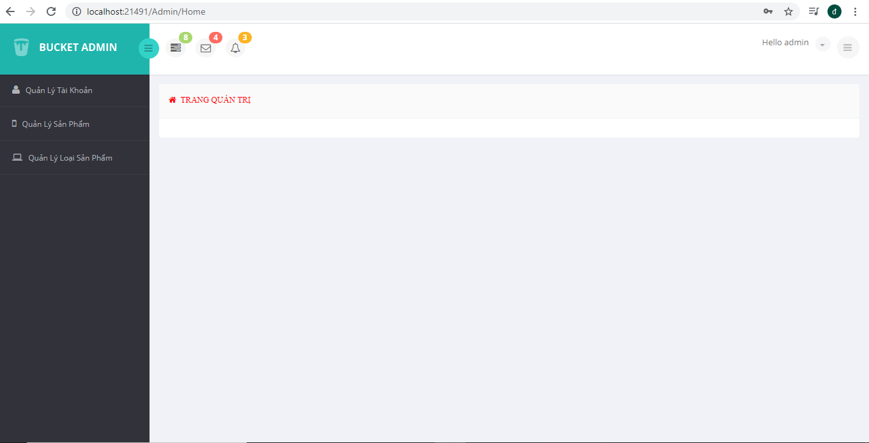

Thực hiện chức năng Kiểm tra đăng nhập (1đ)
- Index.cshtml:
@model OnlineShop.Areas.Admin.Models.LoginModel
@{
Layout = null;
}
<!DOCTYPE html>
<html lang="en">
<head>
<meta charset="utf-8">
<script src="https://ajax.googleapis.com/ajax/libs/jquery/3.5.1/jquery.min.js"></script>
<meta name="viewport" content="width=device-width, initial-scale=1.0">
<meta name="description" content="">
<meta name="author" content="ThemeBucket">
<link rel="shortcut icon" href="~/Assets/admin/images/favicon.png">

<title>Login</title>

<!--Core CSS -->
<link href="~/Assets/admin/bs3/css/bootstrap.min.css" rel="stylesheet">
<link href="~/Assets/admin/css/bootstrap-reset.css" rel="stylesheet">
<link href="~/Assets/admin/font-awesome/css/font-awesome.css" rel="stylesheet" />

<!-- Custom styles for this template -->
<link href="~/Assets/admin/css/style.css" rel="stylesheet">
<link href="~/Assets/admin/css/style-responsive.css" rel="stylesheet" />

<!-- Just for debugging purposes. Don't actually copy this line! -->
<!--[if lt IE 9]>
<script src="js/ie8-responsive-file-warning.js"></script><![endif]-->
<!-- HTML5 shim and Respond.js IE8 support of HTML5 elements and media queries -->
<!--[if lt IE 9]>
<script src="https://oss.maxcdn.com/libs/html5shiv/3.7.0/html5shiv.js"></script>
<script src="https://oss.maxcdn.com/libs/respond.js/1.3.0/respond.min.js"></script>
<![endif]-->
</head>

<body class="login-body">
<div class="container">

<div class="form-signin" action="index.html">
<p id="msg" style="color: red;"></p>
<h2 class="form-signin-heading">sign in now</h2>

<div class="login-wrap">
@using (Html.BeginForm("Login", "Login", FormMethod.Post))
{
<div class="user-login-info">
@Html.TextBoxFor(model => model.Username, new { @class = "form-control", @autofocus = "autofocus", })
@Html.PasswordFor(model => model.Password, new { @class = "form-control", })
</div>
<label class="checkbox">
@Html.CheckBoxFor(model => model.RememberMe)
Remember me
<span class="pull-right">
<a data-toggle="modal" href="#myModal"> Forgot Password?</a>

</span>
</label>
<button class="btn btn-lg btn-login btn-block" type="submit">Sign in</button>
<div style="padding: 5px;line-height:3px;list-style-type:none;" class="text-danger">
@Html.ValidationSummary(false, "", new { @class = "text-danger" })
</div>
}
<div class="registration">
Don't have an account yet?
<a class="" href="registration.html">
Create an account
</a>
</div>

</div>

<!-- Modal -->
<div aria-hidden="true" aria-labelledby="myModalLabel" role="dialog" tabindex="-1" id="myModal" class="modal fade">
<div class="modal-dialog">
<div class="modal-content">
<div class="modal-header">
<button type="button" class="close" data-dismiss="modal" aria-hidden="true">&times;</button>
<h4 class="modal-title">Forgot Password ?</h4>
</div>
<div class="modal-body">
<p>Enter your e-mail address below to reset your password.</p>
<input type="text" name="email" placeholder="Email" autocomplete="off" class="form-control placeholder-no-fix">

</div>
<div class="modal-footer">
<button data-dismiss="modal" class="btn btn-default" type="button">Cancel</button>
<button class="btn btn-success" type="button">Submit</button>
</div>
</div>
</div>
</div>
<!-- modal -->

</div>

</div>

<!-- Placed js at the end of the document so the pages load faster -->
<!--Core js-->
<script src="~/Assets/admin/js/jquery.js"></script>
<script src="~/Assets/admin/bs3/js/bootstrap.min.js"></script>

</body>
- Code css:
/*anchor*/
a {
color: #32323A;
}

a:hover {
color: #222227;
}

/*panel*/
.panel {
border: none;
box-shadow: none;
}

.panel-heading {
border-color:#eff2f7 ;
font-size: 13px;
font-weight: 400;
background: #fafafa;
text-transform: uppercase;
padding: 15px;
}

.panel-title {
color: #32323A;
font-size: 14px;
font-weight: 400;
margin-bottom: 0;
margin-top: 0;
font-family: 'Open Sans', sans-serif;
}

.panel-primary .tools a {
color: #fff;
}

/*label*/

.label {
padding: 0.5em 0.8em;
}

.label-default {
background-color: #a1a1a1;
}

.label-primary {
background-color: #59ace2;
}

.label-success {
background-color: #A9D86E;
}

.label-info {
background-color: #8175c7;
}

.label-warning {
background-color: #FCB322;
}

.label-danger {
background-color: #FF6C60;
}

.label-inverse {
background-color: #344860;
}

/*text color*/

.text-danger {
color: #FF6C60;
}

.text-muted {
color: #a1a1a1;
}

.text-primary {
color: #59ace2;
}

.text-warning {
color: #FCB322;
}

.text-success {
color: #A9D86E;
}

.text-info {
color: #8175c7;
}

/*modal*/

.modal-content {
box-shadow: none;
border: none;
}

.modal-header {
background: #FAFAFA;
color: #333;
border-radius: 5px 5px 0 0;
-webkit-border-radius: 5px 5px 0 0;
/*border-bottom: none;*/
}

.modal-header .close {
margin-top: 0;
}

/*text input*/

.form-control {
border: 1px solid #e2e2e4;
box-shadow: none;
color: #c2c2c2;
}

.form-control:focus, #focusedInput {
border: 1px solid #00A8B3;
box-shadow: none;
}

.form-horizontal .control-label {
font-weight: 300;
font-size: 14px;
}

input, textarea, select, button {
outline: none !important;
}

/*list*/

ul {
padding-left: 0;
}

/*button*/

.btn-default {
background-color: #c7cbd6;
border-color: #c7cbd6;
color: #fff;
}

.btn-default:hover, .btn-default:focus, .btn-default:active, .btn-default.active, .open .dropdown-toggle.btn-default {
background-color: #b0b5b9;
border-color: #b0b5b9;
color: #fff;
}

.btn-primary {
background-color: #1fb5ad;
border-color: #1fb5ad;
color: #FFFFFF;
}

.btn-primary:hover, .btn-primary:focus, .btn-primary:active, .btn-primary.active, .open .dropdown-toggle.btn-primary {
background-color: #1ca59e;
border-color: #1ca59e;
color: #FFFFFF;
}

.btn-success {
background-color: #95b75d;
border-color: #95b75d;
color: #FFFFFF;
}

.btn-success:hover, .btn-success:focus, .btn-success:active, .btn-success.active, .open .dropdown-toggle.btn-success {
background-color: #88a755;
border-color: #88a755;
color: #FFFFFF;
}

.btn-info {
background-color: #2eb4ad;
border-color: #2eb4ad;
color: #FFFFFF;
}

.btn-info:hover, .btn-info:focus, .btn-info:active, .btn-info.active, .open .dropdown-toggle.btn-info {
background-color: #53bee6;
border-color: #53BEE6;
color: #FFFFFF;
}

.btn-warning {
background-color: #f3c022;
border-color: #f3c022;
color: #FFFFFF;
}

.btn-warning:hover, .btn-warning:focus, .btn-warning:active, .btn-warning.active, .open .dropdown-toggle.btn-warning {
background-color: #e4ba00;
border-color: #e4ba00;
color: #FFFFFF;
}

.btn-danger {
background-color: #fa8564;
border-color: #fa8564;
color: #FFFFFF;
}

.btn-danger:hover, .btn-danger:focus, .btn-danger:active, .btn-danger.active, .open .dropdown-toggle.btn-danger {
background-color: #ec6459;
border-color: #ec6459;
color: #FFFFFF;
}

.btn-white {
box-shadow: none !important;
}

/*Rounded Button*/

.btn-round {
border-radius: 30px;
-webkit-border-radius: 30px;
}

/*dropdown shadow*/

.btn-group.open .dropdown-toggle, .btn-white.active, .btn:active, .btn.active {
box-shadow: none;
}

/*dropdown select bg*/
.dropdown-menu > li > a:hover, .dropdown-menu > li > a:focus {
background-color: #474752;
color: #FFFFFF;
text-decoration: none;
}

/*split dropdown btn*/

.btn-white {
background-clip: padding-box;
background-color: #FFFFFF;
border-color: rgba(150, 160, 180, 0.3);
box-shadow: 0 -1px 1px rgba(0, 0, 0, 0.05) inset;
}

/*breadcrumbs*/

.breadcrumb {
background-color: #fff;
}

/*tab*/

.nav-tabs > li > a {
margin-right: 1px;
}

/*collapse*/

.panel-default > .panel-heading {
background-color: #FFFFFF;
border-color: #DDDDDD;
color: #797979;
}

/*nav inverse*/

.navbar-inverse {
background-color: #32323A;
border-color: #32323A;
}

.navbar-inverse .navbar-nav > .active > a, .navbar-inverse .navbar-nav > .active > a:hover, .navbar-inverse .navbar-nav > .active > a:focus,
.navbar-inverse .navbar-nav > .open > a, .navbar-inverse .navbar-nav > .open > a:focus{
background-color: #474752;
}

.navbar-inverse .navbar-nav > li a:hover {
color: #fff;
}

.navbar-inverse .navbar-nav > li > ul > li a:hover {
color: #fff;
}

.navbar-inverse .navbar-brand {
color: #FFFFFF;
}

.navbar-inverse .navbar-nav > li > a {
color: #fff;
}

.navbar-inverse .navbar-nav > .dropdown > a .caret {
border-bottom-color: #fff;
border-top-color: #fff;
}

.navbar-inverse .navbar-nav .open .dropdown-menu > li > a {
color: #000;
}
.navbar-inverse .navbar-nav .open .dropdown-menu > li > a:hover {
color: #fff;
}

/*nav justified*/

.nav-justified {
width: auto !important;
}

.nav-justified li:last-child > a:hover, .nav-justified li.active:last-child > a {
border-radius: 0 4px 0 0 !important;
-webkit-border-radius: 0 4px 0 0 !important;
}

/*list group*/

.list-group-item.active, .list-group-item.active:hover, .list-group-item.active:focus {
background-color: #00A8B3;
border-color: #00A8B3;
color: #FFFFFF;
z-index: 2;
}

.list-group-item-heading {
font-weight: 300;
}

/*progress*/

.progress {
box-shadow: none;
background: #f0f2f7;
}

/*alert*/

.alert-success, .alert-danger, .alert-info, .alert-warning {
border: none;
}

/*table*/

.table thead > tr > th, .table tbody > tr > th, .table tfoot > tr > th, .table thead > tr > td, .table tbody > tr > td, .table tfoot > tr > td {
padding: 10px;
}

/*pagination*/

.pagination > li > a, .pagination > li > span {
background-color: #EFF2F7;
border: 1px solid #EFF2F7;
float: left;
line-height: 1.42857;
margin-left: 1px;
padding: 6px 12px;
position: relative;
text-decoration: none;
}

.pagination > li > a:hover, .pagination > li > span:hover, .pagination > li > a:focus, .pagination > li > span:focus, .pagination > li.active > a, .pagination > li.active > a:hover {
background-color: #2eb4ad;
border-color: #2eb4ad;
color: #fff;
}

/*--*/

.has-success .form-control:focus, .has-error .form-control:focus, .has-warning .form-control:focus {
box-shadow: none;
}

.panel-group .panel + .panel {
margin-top: 1px;
}

.progress {
border-radius: 50px;
-webkit-border-radius: 50px;
}

.progress-bar {
box-shadow: none;
}

/*well*/
.well {
box-shadow: none;
}
- UserAccountDao.cs:
using System;
using System.Collections.Generic;
using System.Linq;
using System.Text;
using System.Threading.Tasks;
using PagedList;
using Model.Model;

namespace Model.Dao
{
public class UserAccountDao
{
CaiQuocDat db = null;
public UserAccountDao()
{
db = new CaiQuocDat();
}

public long Insert(UserAccount entity)
{
db.UserAccounts.Add(entity);
db.SaveChanges();
return entity.ID;
}

public bool Update(UserAccount entity)
{
try
{
var user = db.UserAccounts.Find(entity.ID);
user.Password = entity.Password;
user.Account = entity.Account;
user.Status = entity.Status;
db.SaveChanges();
return true;
} catch (Exception ex)
{
return false;
}
}

public UserAccount ViewDetail(int id)
{
return db.UserAccounts.Find(id);
}

public UserAccount getById(string username)
{
return db.UserAccounts.SingleOrDefault(x=> x.UserName == username);
}

public bool Login(string username, string password)
{

var result = db.UserAccounts.Count(x => x.UserName == username && x.Password == password && x.Status==true&&x.Account==true);
if(result > 0 )
{
return true;
} else
{
return false;
}
}
public bool LoginUser(string username, string password)
{

var result = db.UserAccounts.Count(x => x.UserName == username && x.Password == password && x.Status == true && x.Account == false); ;
if (result > 0)
{
return true;
}
else
{
return false;
}
}
public bool Delete(int id)
{
try
{
var user = db.UserAccounts.Find(id);
db.UserAccounts.Remove(user);
db.SaveChanges();
return true;
} catch(Exception ex)
{
return false;
}
}

public bool DeleteBlockedAccount()
{
try
{
IQueryable<UserAccount> users = db.UserAccounts.Where(x => x.Status == false);
db.UserAccounts.RemoveRange(users);
db.SaveChanges();
return true;
}
catch (Exception ex)
{
return false;
}
}
public int BlockedAccountCount()
{
try
{
var userBlocked = db.UserAccounts.Where(x => x.Status == false);
return userBlocked.Count();
}
catch (Exception ex)
{
return 0;
}
}
public IEnumerable<UserAccount> ListAllPaging(string searchString, int page, int pageSize)
{
IQueryable<UserAccount> model = db.UserAccounts;
if(!string.IsNullOrEmpty(searchString))
{
model = model.Where(x => x.UserName.Contains(searchString));
}
return model.OrderByDescending(x => x.ID).ToPagedList(page, pageSize);
}
}
}
- LoginController.cs:
using Model.Dao;
using OnlineShop.Areas.Admin.Models;
using OnlineShop.Common;
using System;
using System.Collections.Generic;
using System.Linq;
using System.Web;
using System.Web.Mvc;

namespace OnlineShop.Areas.Admin.Controllers
{
public class LoginController : Controller
{
// GET: Admin/Login
public ActionResult Index()
{
return View();
}

public ActionResult Login(LoginModel model)

{
if (ModelState.IsValid)
{
var dao = new UserAccountDao();
var result = false;
var resultUser = false;
if (model.Username == "" || model.Password == "" || model.Username == null || model.Password == null)
{
ModelState.AddModelError("", "Cần Nhập đủ thông tin đăng nhập!");
}
else
{
result = dao.Login(model.Username, Encryptor.MD5Hash(model.Password));
resultUser = dao.LoginUser(model.Username, Encryptor.MD5Hash(model.Password));
if (result)
{

var user = dao.getById(model.Username);
var userSession = new UserLogin();

userSession.UserName = user.UserName;
userSession.UserID = user.ID;
Session.Add(CommonConstants.USER_SESSION, userSession);
return RedirectToAction("Index", "Home");
}
else
{
if (resultUser)
{
var user = dao.getById(model.Username);
var userSession = new UserLogin();
userSession.UserName = user.UserName;
userSession.UserID = user.ID;
Session.Add(CommonConstants.USER_SESSION, userSession);
return RedirectToRoute(new { action="Index",controller="Home",area="Customer"});
}

else
{
if (model.Username == "" || model.Password == "" || model.Username == null || model.Password == null)
{
ModelState.AddModelError("", "Cần Nhập đủ thông tin đăng nhập!");
}
else
{
ModelState.AddModelError("", "Đăng nhập không hợp lệ");

}

}
}

}
}
return View("Index");
}

}

}
- Kết quả:
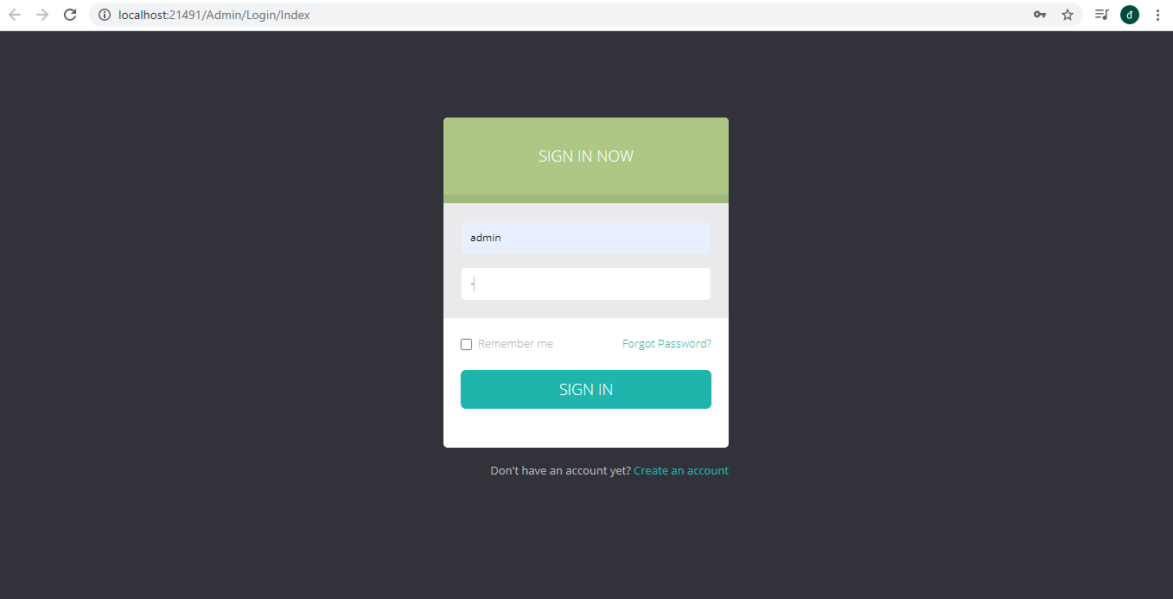
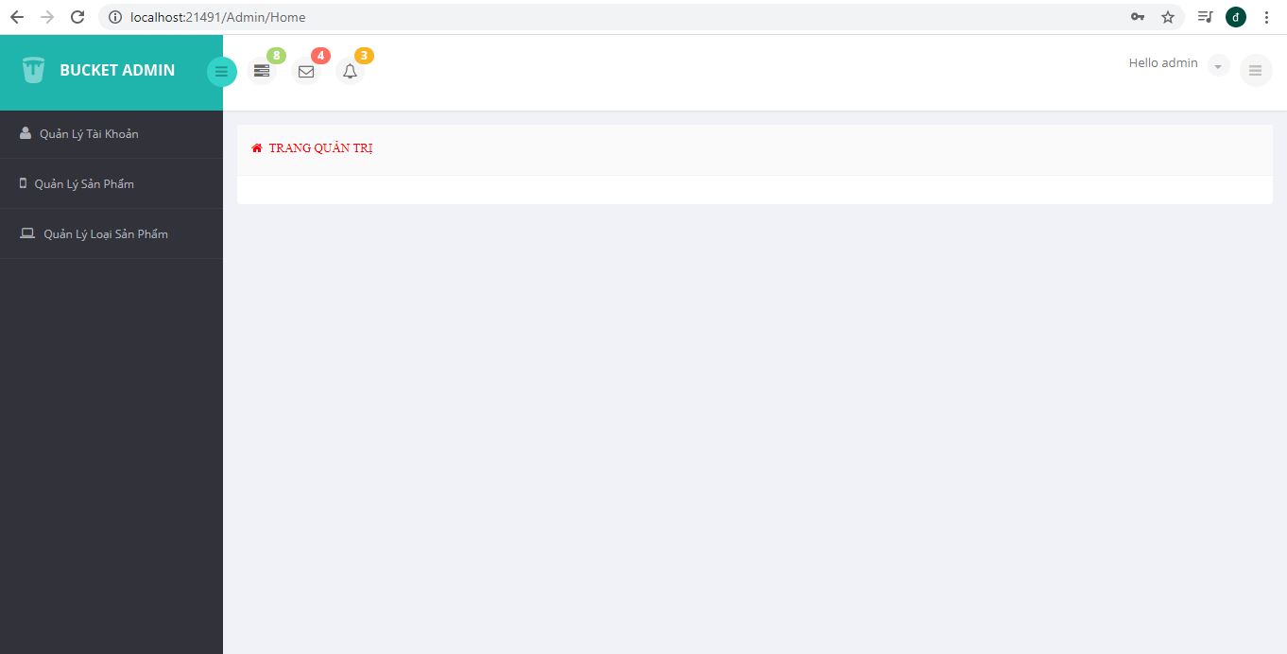

Hiển thị danh sách UserAccount

Phân trang danh sách tài khoản người dùng (5 user/trang) và chức năng tìm kiếm (1đ)
  - Code phân trang và tìm kiếm trong UserAccountDao.cs:
public IEnumerable<UserAccount> ListAllPaging(string searchString, int page, int pageSize)
{
IQueryable<UserAccount> model = db.UserAccounts;
if(!string.IsNullOrEmpty(searchString))
{
model = model.Where(x => x.UserName.Contains(searchString));
}
return model.OrderByDescending(x => x.ID).ToPagedList(page, pageSize);
}
public UserAccount ViewDetail(int id)
{
return db.UserAccounts.Find(id);
}

public UserAccount getById(string username)
{
return db.UserAccounts.SingleOrDefault(x=> x.UserName == username);
}
  - Code phân trang và tìm kiếm UserController.cs:
public ActionResult Index(string searchString, int page = 1, int pageSize = 5)
{
var session = (UserLogin)Session[CommonConstants.USER_SESSION];
ViewBag.adName = session.UserName;

var dao = new UserAccountDao();
ViewBag.BlockedAccountCount = dao.BlockedAccountCount();

var model = dao.ListAllPaging(searchString, page, pageSize);
ViewBag.search = searchString;
return View(model);
}

  - Code phân trang và tìm kiếm trong Index.cshtml:
@Html.PagedListPager(Model, page => Url.Action("Index", new { page, @searchString = ViewBag.search }))
<div class="">
<div class="col-md-6">
<input class="form-control" id="myInput" type="text" placeholder="Search.." name="searchString" value="@ViewBag.search">
</div>
<div class="col-md-2">
<button type="submit" class="btn btn-info" style="background:#2eb4ad;border-color: #2eb4ad">Tìm Kiếm</button>
</div>
</div>
  - Kết quả:
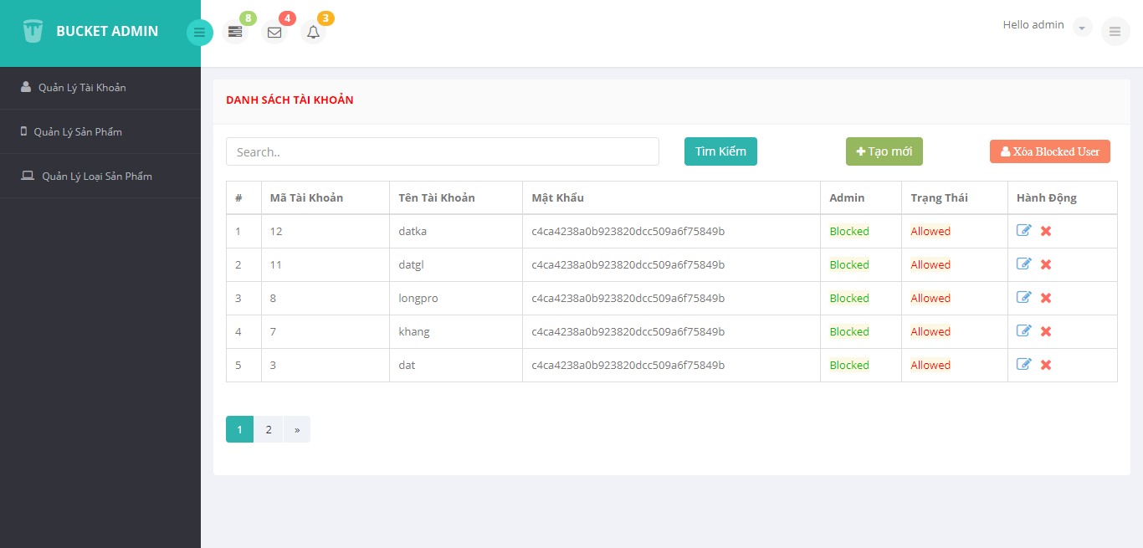

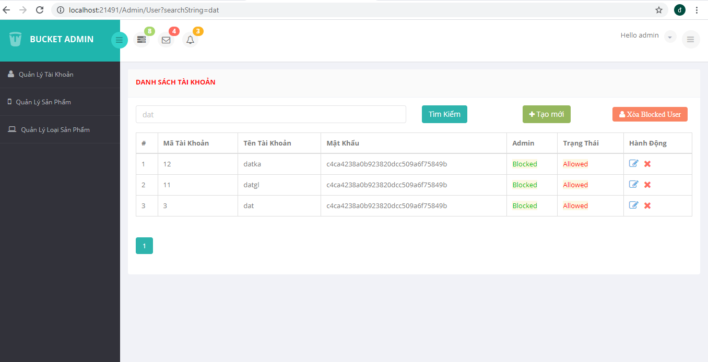

Xóa 1 người dùng có Status là Blocked (1đ)
  - Code xóa người dùng block ở UserAccountDao.cs
public bool DeleteBlockedAccount()
{
try
{
IQueryable<UserAccount> users = db.UserAccounts.Where(x => x.Status == false);
db.UserAccounts.RemoveRange(users);
db.SaveChanges();
return true;
}
catch (Exception ex)
{
return false;
}
}
public int BlockedAccountCount()
{
try
{
var userBlocked = db.UserAccounts.Where(x => x.Status == false);
return userBlocked.Count();
}
catch (Exception ex)
{
return 0;
}
}
  - Code xóa người dùng block ở UserController.cs:
public ActionResult DeleteBlockedAccount()
{
var dao = new UserAccountDao();
dao.DeleteBlockedAccount();
ModelState.AddModelError("", "Xóa thành công");
return RedirectToAction("Index");
}
  - Code xóa người dùng block ở Index.cshtml:
<div class="col-md-2" style="margin-top:3px;">

@Ajax.ActionLink(" Xóa Blocked User", "DeleteBlockedAccount", new { id = "Dlt_Blocked" }, new AjaxOptions
{
Confirm = "Bạn có muốn xóa tất cả tài khoản Blocked không? ",
OnComplete = "$('.row_False').remove()",
HttpMethod = "Delete"
}, new { @class = "fa fa-user text-light btn btn-danger", @style = "font-size: 14px;" })

</div>
  - Kết quả:
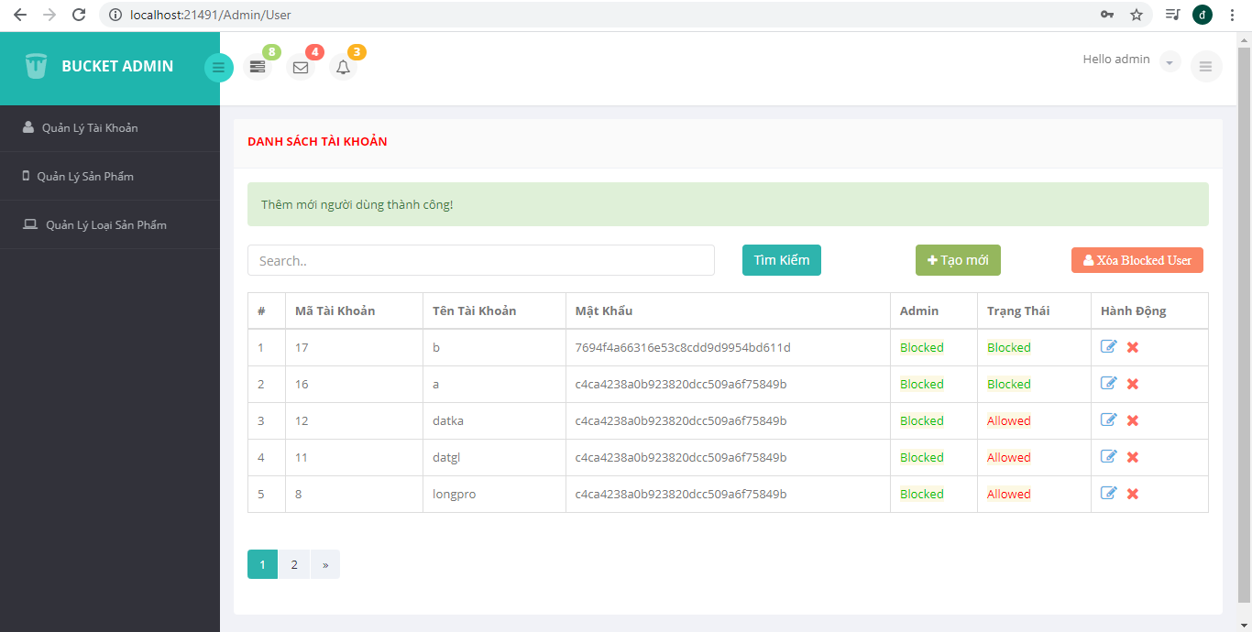
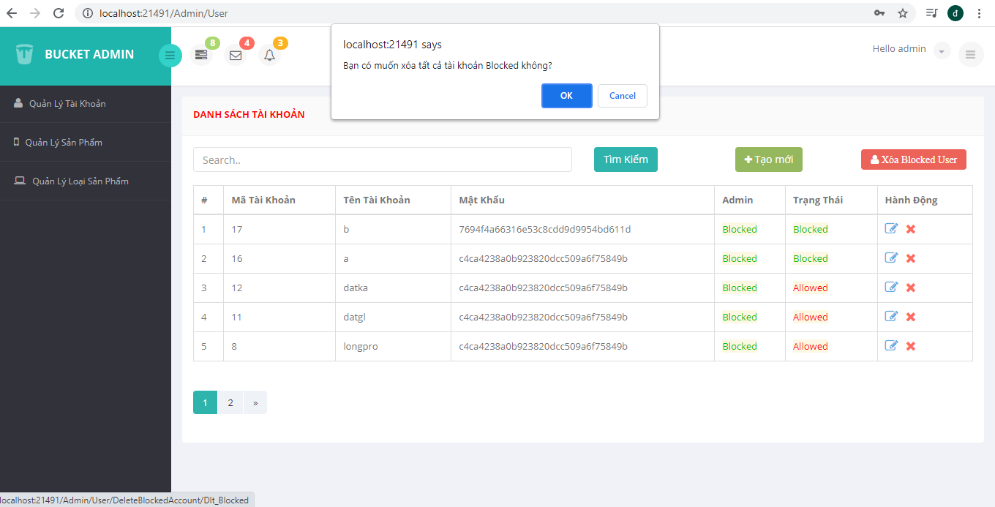
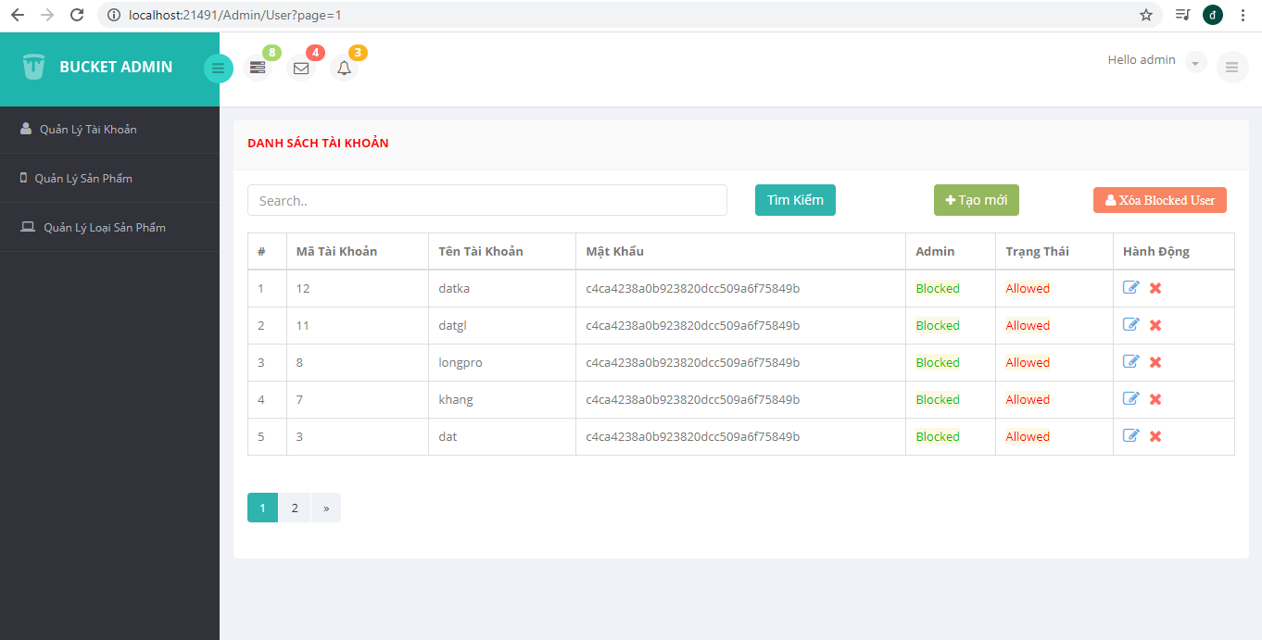

Hiển thị danh sách sản phẩm

Sắp xếp theo Số lượng tăng dần, Đơn giá giảm dần, dưới dạng bảng có các cột (1đ)
  - ProductController.cs:
using Model.Dao;
using OnlineShop.Common;
using System;
using System.Collections.Generic;
using System.Linq;
using System.Web;
using System.Web.Mvc;
using PagedList;
using Model.Model;
using System.IO;
using System.Drawing;
using System.Drawing.Drawing2D;

namespace OnlineShop.Areas.Admin.Controllers
{
public class ProductController : BaseController
{
// GET: Admin/User
public ActionResult Index(string searchString, int page = 1, int pageSize = 5)
{
var session = (UserLogin)Session[CommonConstants.USER_SESSION];
ViewBag.adName = session.UserName;

if(DateTime.Now.Month.ToString().Length == 1 )
{
ViewBag.monthURLImage = "0" + DateTime.Now.Month.ToString();
} else
{
ViewBag.monthURLImage = DateTime.Now.Month.ToString();
}
ViewBag.yearURLImage = DateTime.Now.Year.ToString();

var dao = new ProductDao();
var model = dao.ListAllPaging(searchString, page, pageSize);
ViewBag.search = searchString;
return View(model);
}

[HttpGet]
public ActionResult Create()
{
SetViewBag();
return View();
}

public ActionResult Edit(int id)
{
var entity = new ProductDao().ViewDetail(id);
SetViewBag();
return View(entity);
}

[HttpPost]
public ActionResult Create(Product entity, FormCollection fc)
{

if (ModelState.IsValid)
{
var dao = new ProductDao();
if (
entity.Name == ""
|| entity.Image == ""
|| entity.Description == ""
|| entity.Name == null
|| entity.Quantity == null
|| entity.Price == null
|| entity.Description == null
|| entity.CategoryID == null
)
{
SetAlert("Vui lòng nhập đầy đủ thông tin!", "warning");
return RedirectToAction("Create", "Product");
}
string size = fc["size"];
int sizeResize = 200;
if (!string.IsNullOrEmpty(size))
{
int.TryParse(size, out sizeResize);
}

List<string> fileNames = new List<string>();
try
{
// Duyệt qua các file được gởi lên phía client
foreach (string fileName in Request.Files)
{
//Lấy ra file trong list các file gởi lên
HttpPostedFileBase file = Request.Files[fileName];
//Save file content goes here
if (file != null && file.ContentLength > 0)
{
//Định nghĩa đường dẫn lưu file trên server
//ở đây mình lưu tại đường dẫn yourdomain.com/Uploads/
var originalDirectory = new DirectoryInfo(string.Format("{0}Uploads\\products\\", Server.MapPath(@"\")));
//Lưu trữ hình ảnh theo từng tháng trong năm
string pathString = System.IO.Path.Combine(originalDirectory.ToString(), DateTime.Now.ToString("yyyy-MM"));
bool isExists = System.IO.Directory.Exists(pathString);
if (!isExists) System.IO.Directory.CreateDirectory(pathString);
var path = string.Format("{0}\\{1}", pathString, file.FileName);
string newFileName = file.FileName;
//lấy đường dẫn lưu file sau khi kiểm tra tên file trên server có tồn tại hay không
var newPath = GetNewPathForDupes(path, ref newFileName);
string serverPath = string.Format("/{0}/{1}/{2}", "Uploads", DateTime.Now.ToString("yyyy-MM"), newFileName);
//Lưu hình ảnh Resize từ file sử dụng file.InputStream
SaveResizeImage(Image.FromStream(file.InputStream), sizeResize, newPath);
fileNames.Add("LocalPath: " + newPath + "<br/>ServerPath: " + serverPath);

TempData["Image"] = fileNames;
entity.Image = newFileName;
long id = dao.Insert(entity);
if (id > 0)
{
SetAlert("Thêm mới sản phẩm thành công!", "success");
return RedirectToAction("Index", "Product");
}
else
{
SetAlert("Thêm mới sản phẩm không thành công!", "error");
}
}
}
}
catch (Exception ex)
{
TempData["e"] = ex.Message;
}

}
return View("Index");
}
// GET: /File/
[HttpPost]
public ActionResult Upload(FormCollection fc)
{
string size = fc["size"];
int sizeResize = 200;
if (!string.IsNullOrEmpty(size))
{
int.TryParse(size, out sizeResize);
}

List<string> fileNames = new List<string>();
try
{
// Duyệt qua các file được gởi lên phía client
foreach (string fileName in Request.Files)
{
//Lấy ra file trong list các file gởi lên
HttpPostedFileBase file = Request.Files[fileName];
//Save file content goes here
if (file != null && file.ContentLength > 0)
{
//Định nghĩa đường dẫn lưu file trên server
//ở đây mình lưu tại đường dẫn yourdomain.com/Uploads/
var originalDirectory = new DirectoryInfo(string.Format("{0}Uploads\\", Server.MapPath(@"\")));
//Lưu trữ hình ảnh theo từng tháng trong năm
string pathString = System.IO.Path.Combine(originalDirectory.ToString(), DateTime.Now.ToString("yyyy-MM"));
bool isExists = System.IO.Directory.Exists(pathString);
if (!isExists) System.IO.Directory.CreateDirectory(pathString);
var path = string.Format("{0}\\{1}", pathString, file.FileName);
string newFileName = file.FileName;
//lấy đường dẫn lưu file sau khi kiểm tra tên file trên server có tồn tại hay không
var newPath = GetNewPathForDupes(path, ref newFileName);
string serverPath = string.Format("/{0}/{1}/{2}", "Uploads", DateTime.Now.ToString("yyyy-MM"), newFileName);
//Lưu hình ảnh Resize từ file sử dụng file.InputStream
SaveResizeImage(Image.FromStream(file.InputStream), sizeResize, newPath);
fileNames.Add("LocalPath: " + newPath + "<br/>ServerPath: " + serverPath);
}
}
}
catch (Exception ex)
{
TempData["e"] = ex.Message;
}
var dao = new ProductDao();
TempData["Image"] = fileNames;
return RedirectToAction("Index", "Home");

}
//Hàm resize hình ảnh
public bool SaveResizeImage(Image img, int width, string path)
{
try
{
// lấy chiều rộng và chiều cao ban đầu của ảnh
int originalW = img.Width;
int originalH = img.Height;
// lấy chiều rộng và chiều cao mới tương ứng với chiều rộng truyền vào của ảnh (nó sẽ giúp ảnh của chúng ta sau khi resize vần giứ được độ cân đối của tấm ảnh
int resizedW = width;
int resizedH = (originalH * resizedW) / originalW;
Bitmap b = new Bitmap(resizedW, resizedH);
Graphics g = Graphics.FromImage((Image)b);
g.InterpolationMode = InterpolationMode.Bicubic; // Specify here
g.DrawImage(img, 0, 0, resizedW, resizedH);
g.Dispose();
b.Save(path);
return true;
}
catch (Exception e)
{
return false;
}
}
private string GetNewPathForDupes(string path, ref string fn)
{
string directory = Path.GetDirectoryName(path);
string filename = Path.GetFileNameWithoutExtension(path);
string extension = Path.GetExtension(path);
int counter = 1;
string newFullPath = path;
string new_file_name = filename + extension;
while (System.IO.File.Exists(newFullPath))
{
string newFilename = string.Format("{0}({1}){2}", filename, counter, extension);
new_file_name = newFilename;
newFullPath = Path.Combine(directory, newFilename);
counter++;
};
fn = new_file_name;
return newFullPath;
}
[HttpPost]
public ActionResult Edit(Product entity)
{

if (ModelState.IsValid)
{
var dao = new ProductDao();

if (
entity.Name == ""
|| entity.Image == ""
|| entity.Description == ""
|| entity.Name == null
|| entity.Quantity == null
|| entity.Price == null
|| entity.Description == null
|| entity.CategoryID == null
)
{
SetAlert("Vui lòng nhập đầy đủ thông tin!", "warning");
return RedirectToAction("Edit", "Product");
}
var result = dao.Update(entity);
if (result)
{
SetAlert("Cập nhật thành công!", "success");
return RedirectToAction("Index", "Product");
}
else
{
SetAlert("Cập nhật không thành công!", "error");
ModelState.AddModelError("", "Cập nhật không thành công");
}
}
return View("Index");
}

[HttpDelete]
public ActionResult Delete(int id)
{
var dao = new ProductDao();
if (dao.Delete(id))
{
ModelState.AddModelError("", "Xóa thành công");
}
return RedirectToAction("Index");
}

public void SetViewBag(long? selectedid=null)
{
var dao = new CategoryDao();
ViewBag.CategoryID = new SelectList(dao.ListAll(), "ID", "Name", selectedid);
}
}
}
- ProductDao.cs:
using System;
using System.Collections.Generic;
using System.Linq;
using System.Text;
using System.Threading.Tasks;
using PagedList;
using Model.Model;

namespace Model.Dao
{
public class ProductDao
{
CaiQuocDat db = null;
public ProductDao()
{
db = new CaiQuocDat();
}

public long Insert(Product entity)
{
db.Products.Add(entity);
db.SaveChanges();
return entity.ID;
}
public void updateImage(Product entity, string fileName)
{
var Product = db.Products.Find(entity.ID);
Product.Image = fileName;
db.SaveChanges();
}

public bool Update(Product entity)
{
try
{
var Product = db.Products.Find(entity.ID);
Product.Name = entity.Name;
Product.Quantity = entity.Quantity;
Product.Price = entity.Price;
Product.Description = entity.Description;
Product.Status = entity.Status;
Product.CategoryID = entity.CategoryID;
db.SaveChanges();
return true;
}
catch (Exception ex)
{
return false;
}
}

public Product ViewDetail(int id)
{
return db.Products.Find(id);
}

public bool Delete(int id)
{
try
{
var Product = db.Products.Find(id);
db.Products.Remove(Product);
db.SaveChanges();
return true;
}
catch (Exception ex)
{
return false;
}
}

public IEnumerable<Product> ListAllPaging(string searchString, int page, int pageSize)
{
IQueryable<Product> model = db.Products;

if (!string.IsNullOrEmpty(searchString))
{
model = model.Where(x => x.Name.Contains(searchString));
}
return model.OrderBy(x => x.Quantity).OrderByDescending(x => x.Price).ToPagedList(page, pageSize);
}

}
}
- Index.cshtml:
@model PagedList.IPagedList<Model.Model.Product>
@using PagedList.Mvc;
@{
ViewBag.Title = "Quản Lý Sản Phẩm";
Layout = "~/Areas/Admin/Views/Shared/_Layout.cshtml";
}

@section header{
Danh Sách Sản Phẩm
}
<div class="row">
@using (Html.BeginForm("Index", "Product", FormMethod.Get))
{

<div class="">
<div class="col-md-6">
<input class="form-control" id="myInput" type="text" placeholder="Search.." name="searchString" value="@ViewBag.search">
</div>
<div class="col-md-2">
<button type="submit" class="btn btn-info">Tìm Kiếm</button>
</div>
</div>

}

<div class="col-md-2" >
<a href="/Admin/Product/create">
<button type="button" class="btn btn-success"><i class="fa fa-plus text-light" style="font-size: 13px;"></i> Tạo mới</button>
</a>
</div>
</div>
<br />
<div>
<table class="table table-bordered col-12">
<thead>
<tr>
<th>#</th>
<th>Mã Sản Phẩm</th>
<th>Tên Sản Phẩm</th>
<th>Đơn Giá</th>
<th>Số Lượng</th>
<th>Hình Ảnh</th>
<th>Trạng Thái</th>
<th>Mã Danh Mục</th>
<th>Hành Động</th>
</tr>
</thead>
<tbody>
@{ var i = 0;}
@foreach (var item in Model)
{
<tr id="row_@item.ID">
<td>
@{
i = i + 1;
<span>@i</span>

}

</td>
<td>@item.ID</td>
<td>@item.Name</td>
<td>@item.Price</td>
<td>@item.Quantity</td>
<td>
<img src="~/Uploads/products/@ViewBag.yearURLImage-@ViewBag.monthURLImage/@item.Image" style="height: 130px; width: 90px; margin: 0 auto;"/>
</td>
<td>
@if (@item.Status == false)
{
<span class="text-danger alert-warning" style="font-weight: bolder;">Hết Hàng</span>
}
else
{
<span class="text-success alert-warning" style="font-weight: bolder;">Còn Hàng</span>
}
</td>
<td>@item.CategoryID</td>
<td>
<a href="/Admin/Product/Edit/@item.ID">
<i class="fa fa-edit text-primary" style="font-size: 18px;"></i>
</a>&nbsp;
@*Cần add thư viện unobtrusive ajax*@
@Ajax.ActionLink(" ", "Delete", new { id = @item.ID}, new AjaxOptions
{
Confirm = "Bạn có muốn xóa danh mục "+ @item.Name.Trim() +" không?",
OnComplete = "$('#row_" + @item.ID + "').remove()",
HttpMethod = "Delete"
}, new { @class = "fa fa-times text-danger", @style="font-size: 18px;" })
</td>
</tr>
}

</tbody>
</table>
@Html.PagedListPager(Model, page => Url.Action("Index", new { page, @searchString = ViewBag.search }))
</div>
- Kết quả:
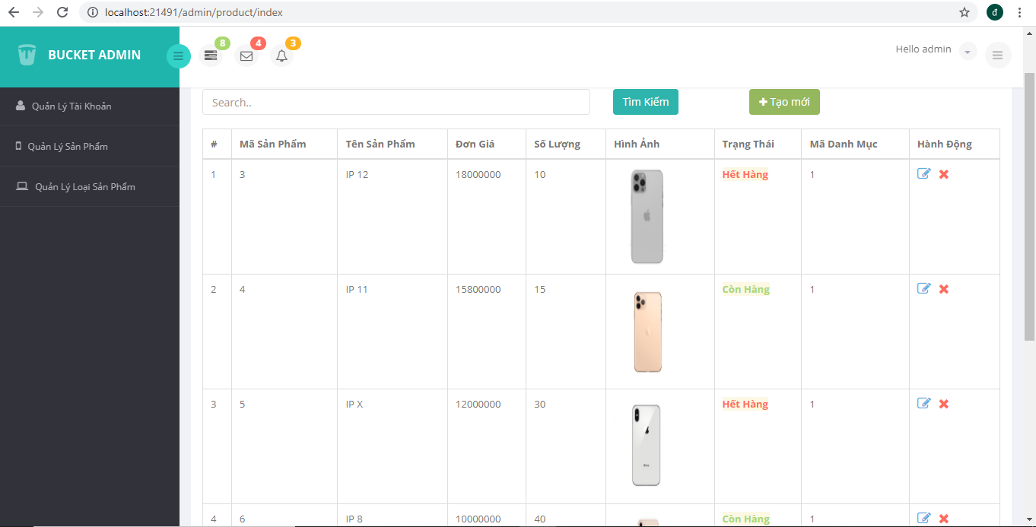

Click vào link Xem chi tiết (ở cột Thao tác) sẽ chuyển đến trang xem được chi tiết của sản phẩm (1đ)

Thiết kế form, thực hiện chức năng thêm 1 sản phẩm:
Form gồm có các Label kèm các Textbox: ID, Tên sản phẩm, đơn giá, số lượng và Loại Sản phẩm (dropdownlist: đổ dữ liệu của bảng Loại sản phẩm vào). (2đ)
Yêu cầu thực hiện:
    - Sử dụng Strongly typed Html Helper cho các thẻ trên form.
    - Validation dữ liệu trên form (dùng DataAnnotation)

- Create.cshtml:
@model Model.Model.Product

@{
ViewBag.Title = "Create";
Layout = "~/Areas/Admin/Views/Shared/_Layout.cshtml";
}

@section header{
Thêm Mới Sản Phẩm
}
<div class="row">
<div class="col-lg-12">
<div class="panel panel-default">
<div class="panel-heading">
Vui Lòng Nhập Thông Tin Sản Phẩm
</div>
<div class="panel-body">
<div class="row">
<div class="col-lg-9">
@using (Html.BeginForm("Create", "Product", FormMethod.Post, new { @enctype = "multipart/form-data", }))
{
@Html.AntiForgeryToken()

<div class="form-horizontal">
@Html.ValidationSummary(true, "", new { @class = "text-danger" })
<div class="form-group">
@Html.LabelFor(model => model.Name, htmlAttributes: new { @class = "control-label col-md-2" })
<div class="col-md-10">
@Html.TextBoxFor(model => model.Name, new { @class = "form-control" })
@Html.ValidationMessageFor(model => model.Name, "", new { @class = "text-danger" })
</div>
</div>

<div class="form-group">
@Html.LabelFor(model => model.Quantity, htmlAttributes: new { @class = "control-label col-md-2" })
<div class="col-md-10">
@Html.TextBoxFor(model => model.Quantity, new { @class = "form-control", @type = "number" })
@Html.ValidationMessageFor(model => model.Quantity, "", new { @class = "text-danger" })
</div>
</div>

<div class="form-group">
@Html.LabelFor(model => model.Price, htmlAttributes: new { @class = "control-label col-md-2" })
<div class="col-md-10">
@Html.TextBoxFor(model => model.Price, new { @class = "form-control", @type = "number" })
@Html.ValidationMessageFor(model => model.Price, "", new { @class = "text-danger" })
</div>
</div>

<div class="form-group">
@Html.LabelFor(model => model.Image, htmlAttributes: new { @class = "control-label col-md-2" })
<div class="col-md-10">
@Html.TextBoxFor(model => model.Image, new { @class = "form-control", @type = "file" })
@Html.ValidationMessageFor(model => model.Image, "", new { @class = "text-danger" })
</div>
</div>

<div class="form-group">
@Html.LabelFor(model => model.Description, htmlAttributes: new { @class = "control-label col-md-2" })
<div class="col-md-10">
@Html.TextBoxFor(model => model.Description, new { @class = "form-control" })
@Html.ValidationMessageFor(model => model.Description, "", new { @class = "text-danger" })
</div>
</div>

<div class="form-group">
@Html.LabelFor(model => model.CategoryID, htmlAttributes: new { @class = "control-label col-md-2" })
<div class="col-md-10">
@Html.DropDownListFor(model => model.CategoryID, (IEnumerable<SelectListItem>)ViewBag.CategoryID, "--Chọn loại sản phẩm--", new { @class = "form-control", @required = "required" })
@Html.ValidationMessageFor(model => model.CategoryID, "", new { @class = "text-danger" })
</div>
</div>

<div class="form-group">
@Html.LabelFor(model => model.Status, htmlAttributes: new { @class = "control-label col-md-2" })
<div class="col-md-10">
<div class="checkbox">
@Html.CheckBoxFor(model => model.Status)
@Html.ValidationMessageFor(model => model.Status, "", new { @class = "text-danger" })
</div>
</div>
</div>

<div class="form-group">
<div class="col-md-offset-2 col-md-10">
<input type="submit" value="Thêm Mới" class="btn btn-success" onclick="Submit()" />
</div>
</div>
</div>
}
</div>
</div>
</div>
</div>
</div>
</div>

<div>
@Html.ActionLink("<<< Quay Lại", "Index", null, new { style = "color: #00CC00;" })
</div>
- Kết quả:
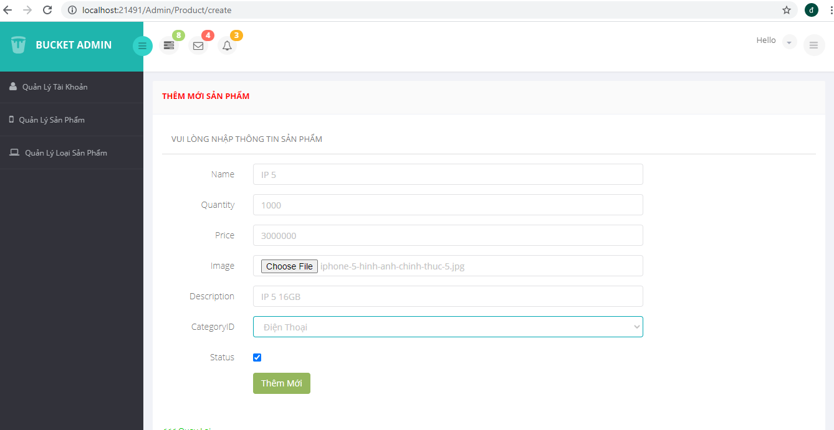

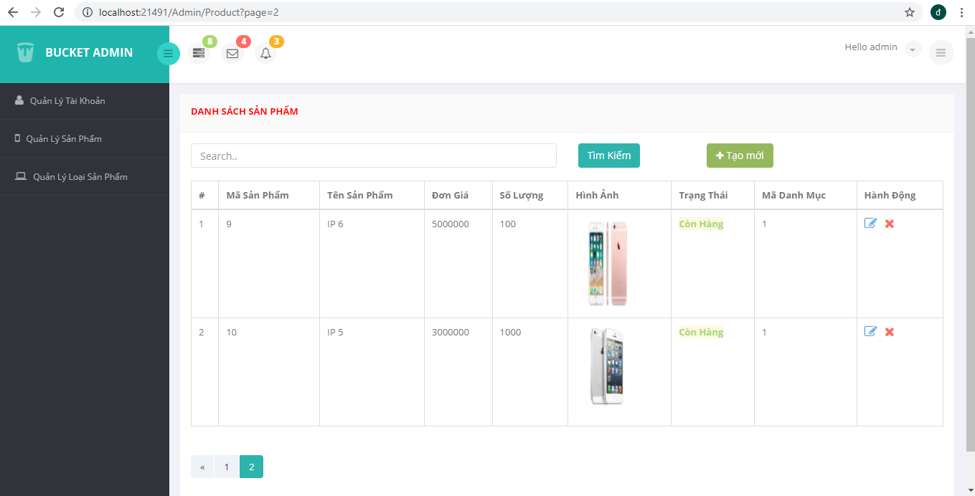

Thực hiện yêu cầu cho trang USER

Download 1 template bán hàng bất kỳ, hiệu chỉnh lại cho phù hợp với dữ liệu của bảng Sản phẩm
- _Layout_cshtml

@{
Layout = null;
}
<!DOCTYPE html>
<html lang="en">
<head>
<meta charset="utf-8">
<title>@ViewBag.Title - Sản Phẩm</title>
<meta name="viewport" content="width=device-width, initial-scale=1">
<link rel="stylesheet" href="https://maxcdn.bootstrapcdn.com/bootstrap/4.5.2/css/bootstrap.min.css">
<link rel="stylesheet" href="https://cdnjs.cloudflare.com/ajax/libs/font-awesome/4.7.0/css/font-awesome.min.css">
<script src="https://ajax.googleapis.com/ajax/libs/jquery/3.5.1/jquery.min.js"></script>
<script src="https://cdnjs.cloudflare.com/ajax/libs/popper.js/1.16.0/umd/popper.min.js"></script>
<script src="https://maxcdn.bootstrapcdn.com/bootstrap/4.5.2/js/bootstrap.min.js"></script>
<style>
.fakeimg {
height: 200px;
background: #aaa;
}
</style>
</head>
<body>

<div class="jumbotron text-center" style="margin-bottom:0;background:#f2f84e">
<h1 style="color:#1e5ffb">SHOP ĐIỆN THOẠI ĐẠT YẾN</h1>
</div>

<nav class="navbar navbar-expand-sm bg-dark navbar-dark">

<div class="top-nav clearfix" style="margin-left:auto;margin-right:100px;margin-top:15px;color:white">
<!--search & user info start-->
<ul class="nav pull-right top-menu">
<li>
<p>Hello @ViewBag.adName</p>
</li>
<!-- user login dropdown start-->
<li class="dropdown" style="width:50px">
<a data-toggle="dropdown" class="dropdown-toggle" href="#">
<img alt="" src="images/avatar1_small.jpg">
<span class="username">

</span>
<b class="caret"></b>
</a>
<ul class="dropdown-menu extended logout">

<li><a href="@Url.Action("Logout", "Home",new { area="Admin"})"><i class="fa fa-key" ></i> Đăng Xuất</a></li>
</ul>
</li>
<!-- user login dropdown end -->
<li>
<div class="toggle-right-box">
<div class="fa fa-bars"></div>
</div>
</li>
</ul>
<!--search & user info end-->
</div>
</nav>

<div class="container" style="margin-top:30px">
<div class="row">
<div class="col-sm-3" style="background:#efebeb">
<ul class="nav nav-pills flex-column">
<li class="nav-item">
<a class="nav-link active" style="background:#1e5ffb;color:#f2f84e" href="#">LOẠI SẢN PHẨM</a>
</li>
@foreach (var item in ViewBag.ListCategory)
{
<li class="nav-item">
<a class="nav-link" style="color:#1e5ffb" href="#">@item.Name</a>
</li>
}
</ul>
<hr class="d-sm-none">
</div>

<div class="col-sm-9" style="padding-bottom:50px;">
<h2>Danh Sách Sản Phẩm</h2>
<div class="row">
@RenderBody()
</div>
</div>
</div>
</div>

</body>
</html>
- Index.cshtml:
@model PagedList.IPagedList<Model.Model.Product>
@using PagedList.Mvc;
@{
ViewBag.Title = "Index";
Layout = "~/Areas/Customer/Views/Shared/_Layout.cshtml";
}

@foreach (var item in Model)
{
<div class="card col-sm-5" style="margin-left:10px;margin-bottom:10px;">
<div class="card-body">
<h4 class="card-title">@item.Name</h4>
<p class="card-text"><img src="~/Uploads/products/@ViewBag.yearURLImage-@ViewBag.monthURLImage/@item.Image" class="col-sm-12" style="height: 200px; margin: 0 auto;" /></p>
<p class="card-text">@item.Description</p>
<p class="card-text">Giá: @item.Price VNĐ</p>
<p class="card-text">Số Lượng: @item.Quantity</p>
<p class="card-text">
@if (@item.Status == false)
{
<span class="text-danger alert-warning" style="font-weight: bolder;">Hết Hàng</span>
}
else
{
<span class="text-success alert-warning" style="font-weight: bolder;">Còn Hàng</span>
}
</p>
<a href="#" class="card-link">Xem chi tiết</a>
<a href="#" class="card-link"><i class="fa fa-shopping-cart"></i></a>
</div>
</div>
}

- Kết quả:
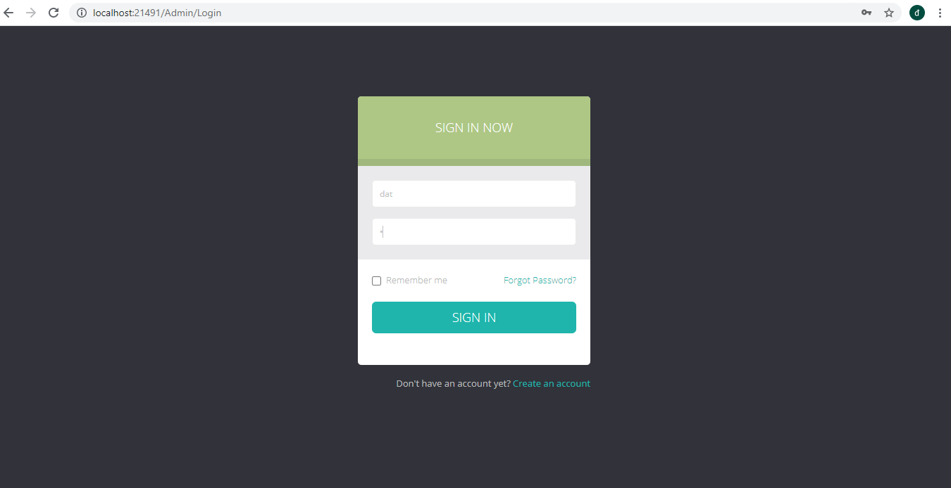
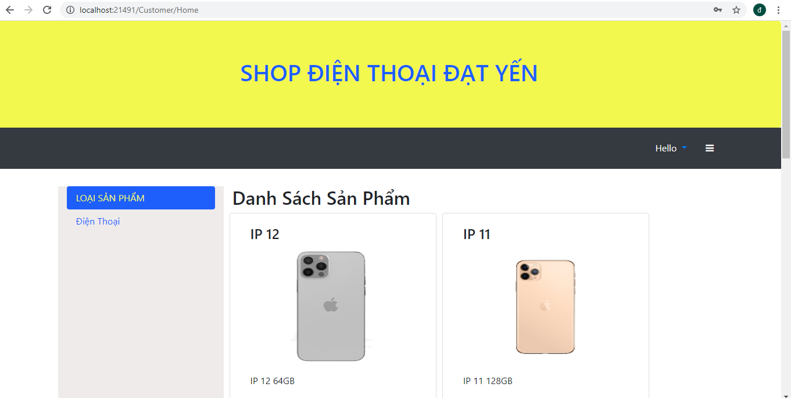

Đổ dữ liệu của bảng sản phẩm vào trang chủ
- HomeController.cs:
using Model.Dao;
using System;
using System.Collections.Generic;
using System.Linq;
using System.Web;
using System.Web.Mvc;

namespace OnlineShop.Areas.Customer.Controllers
{
public class HomeController : Controller
{
// GET: Customer/Home
public ActionResult Index(string searchString = "", int page = 1, int pageSize = 10)
{
var dao = new ProductDao();
var categoryDao = new CategoryDao();
var model = dao.ListAllPaging(searchString, page, pageSize);

if (DateTime.Now.Month.ToString().Length == 1)
{
ViewBag.monthURLImage = "0" + DateTime.Now.Month.ToString();
}
else
{
ViewBag.monthURLImage = DateTime.Now.Month.ToString();
}
ViewBag.yearURLImage = DateTime.Now.Year.ToString();

ViewBag.ListCategory = categoryDao.ListAll();
return View(model);
}
}
}
- Kết quả:
