Experiments
During the implementation phase of the project, experiments were conducted to identify the capabilities and limitations of the Embark framework, which informed the app’s design and implementation. Tautologically speaking, features can’t be implemented if they can’t be implemented. Additionally, realising a design which is theoretically possible, but prohibitively difficult to implement is suboptimal from a project management standpoint.

Below are the series of experiments conducted.

The experiments were logged using in-code comments and a worklog tab on Ethl’s site, to keep everything in one place.

The included images demonstrate the app under construction and do not represent the final product.

Experiment 1: Funding user accounts and contracts
Date: 02/04/17
Motivation:
For the app to work, users need to be able to send ether to contracts. The design at this stage involves ether being sent from loaners to contracts. The ether is stored in-contract until the lender terminates it or a predefined amount of time has passed. Borrowers can choose to accept a loan as long as it exists on the blockchain. At this point, the loan needs to send the lenders ether to the borrower. This experiment was conducted to confirm that this is possible.

Experiment 1.1: Sending ether from one user account to another
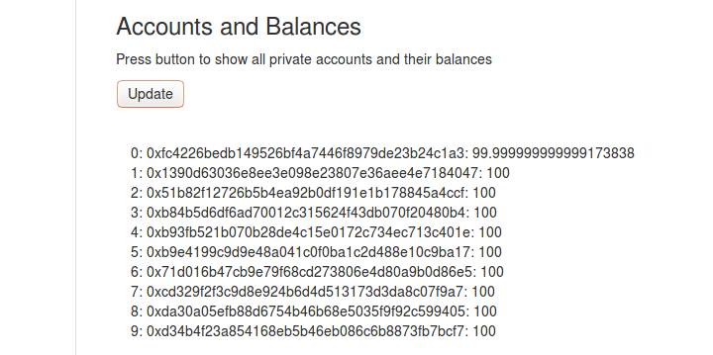
Figure 1: View accounts and balances from front-end

Method and Results:

First the list of user accounts autogenerated by ethereum-testrpc’s blockchain simulator. 10 accounts are created with 100 ether each on a private testnet blockchain, running locally. Embark has been configured to use this. The contracts deployed on this chain are automatically available in JS through EmbarkJS.

HTML5 and input forms for ether transfer can be seen in the image below:

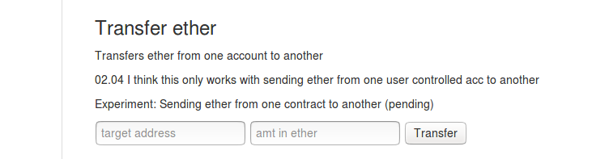
Figure 2: Transfer ether from front-end

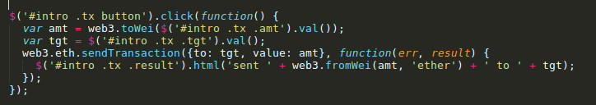
Figure 3: jQuery button handler for transfer ether
Users input the amount of ether they want to transfer, along with the target address for the transaction. The target address can be either a user-controlled account or a contract. The aim is for this functionality to be implemented behind the scenes as part of the loan creation process in the final design.

A transaction is sent using the web3 API {to: tgt, value: amt}. A callback function is included which is invoked asynchronously, once the transaction has been mined.

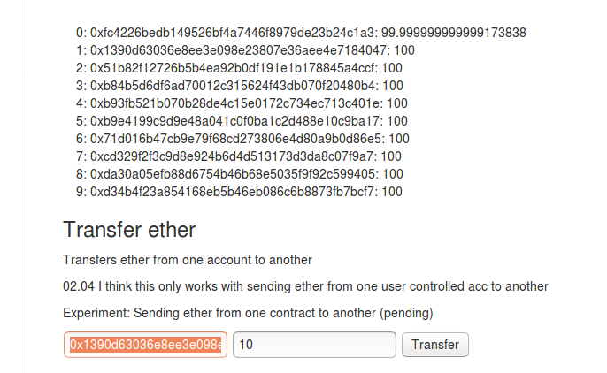
Figure 4: Transferring ether from accounts[0] to accounts[1]

10 ether is being sent from accounts[0] to accounts[1].

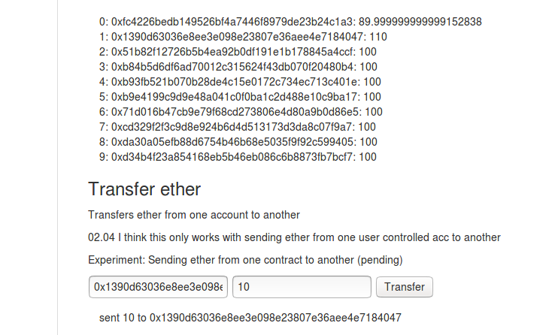
Figure 5: Transfer successful

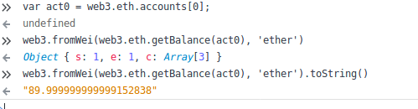
Figure 6: Confirmation via JS console in Firefox Developer Tools
Ether is transferred from a user’s default account. In this case it is accounts[0] from web3.eth.getAccounts().

A further experiment was conducted to confirm that ether can be sent from other accounts.

An extra text input with corresponding JS code was added to specify a sender address. A more ergonomic design will be implemented for the final product.

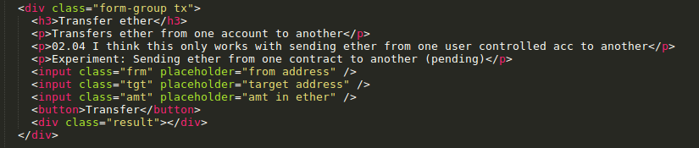
Figure 7: New text-input for from address added

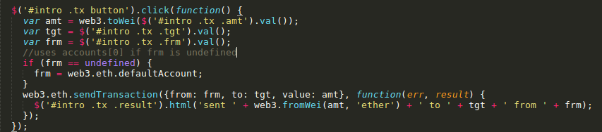
Figure 8: JS Handler for transfer ether

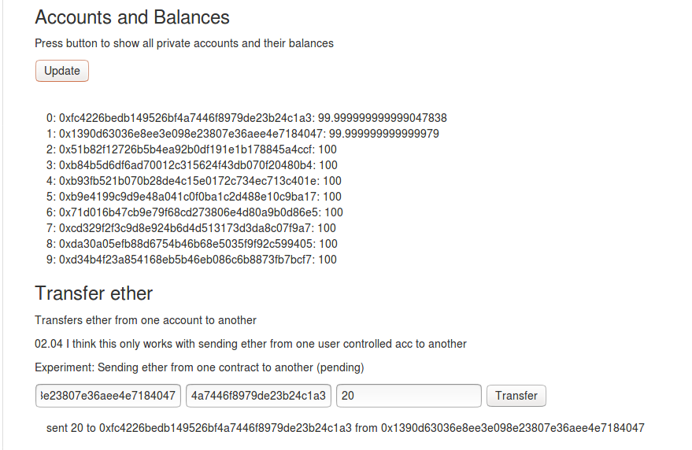
Figure 9: Successful transfer from accounts[1] to accounts[0]

First, a further 10 ether was accidentally sent from accounts[0] to accounts[1]. Next, 20 ether was sent from acccounts[1] to accounts[0]. This demonstrates the experiment’s success.

Note that accounts[1] has lost a very small amount of ether in the transaction. This amount is the amount in gas provided by the sender (accounts[1]). This is specified (optionally) in the web3.eth.sendTransaction(transactionObject [, callback]) method as the value: parameter of the transactionObject JSON. If no value is specified, a default amount of gas is provided by the sender and is deducted from their account. The gas is received by the miner.

On the private testnet deployed via ethereumjs-testrpc [ref] [github] it appears that this gas is not being mined by a miner (under default settings). This could be attributed to the fact that it is simulating a network node, as opposed to actually running one. As a result, the spent gas is lost from circulation.

Experiment 1.2: Funding contracts from user controlled accounts
Motivation:
Ether must be sent from user accounts to loan contracts on upon creation/instantiation. This experiment was conducted to confirm that this could be implemented.
Method and Results:
A new loan was created via the ‘Add Loan’ front-end functionality. This creates a new Loan object which has an associated value. The address of this Loan is automatically added to the array stored by LoanDB. This is the amount in ether that the lender is offering. It is deducted in this implementation from accounts[0].
Address of the newly added loan and it’s associated amount are accessible by the front-end, as illustrated by the figures below.

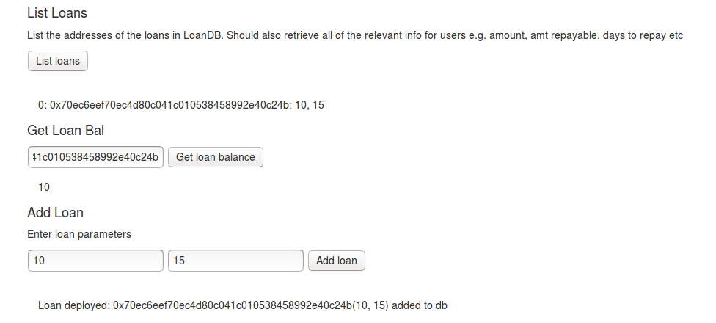
Figure 10: Get all db loans, get loan balance, add loan on front-end

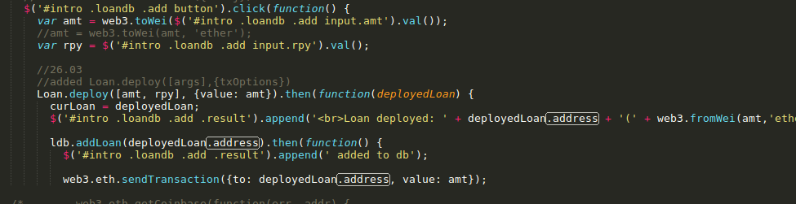
Figure 11: JS code for adding loans
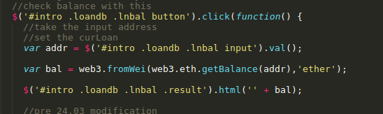
Figure 12: JS code for retrieving balance of loan contract

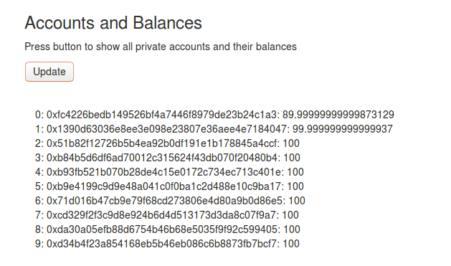
Figure 13: Accounts[0] has been depleted by 10 ether correspondingly

The web3.eth.sendTransaction funds the contract from the defaultAccount (accounts[0]) unless specified via an additional from: parameter. For any transaction from a user controlled account, user must possess the associated private key, or the transaction will not be verified.
The Loan contract inherits from Mortal. Mortal is a contract which has a field to store a contract’s owner and a method kill() which selfdestructs the contract, removing it from the blockchain, providing that the method was invoked by the owner of the contract. Once a contract is removed from the blockchain, the contract’s balance is returned to the owner, along with any unused gas.
The figures below demonstrate this functionality.
In its current form, loans are removed from the database and the blockchain via referencing its index in the LoanDB. There was only one loan in the database so the index is 0.
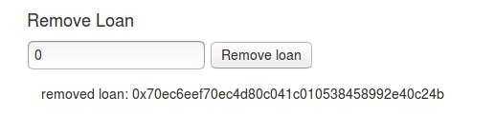
Figure 14: Remove Loan front-end
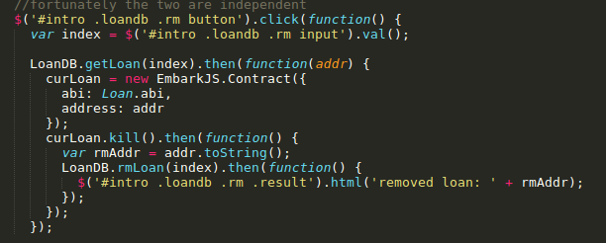
Figure 15: JS code for Remove Loan
kill() is called on the loan (curLoan) and the entry is removed from the database.
The figure below shows the function which removes loans from the LoanDB blockchain contract. The LoanDB contract is a wrapper for an array which stores the addresses of deployed Loans. The rmLoan function has been structured in such a way that avoids array traversal and re-ordering where possible. Contract computations require gas. The Ethereum platform in its current form also requires that all nodes on the network execute every transactions code, as part of the verification process. To save on gas (which has been implemented partly to make developers code in a computationally efficient manner), the method doesn’t maintain the original order of the array, when an element is deleted. Instead, the final item in the array is stored in the free space. Finally the array length is decremented.
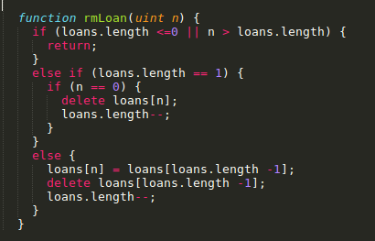
Figure 16: rmLoan function of LoanDB.sol (blockchain contract code)

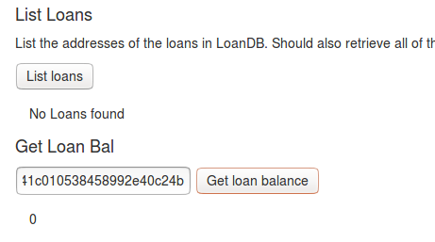
Figure 17: Experiment success: no loans found

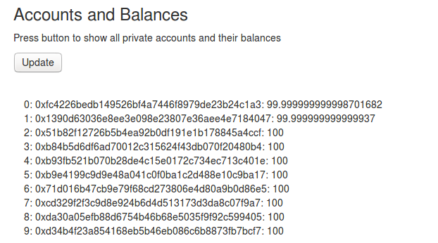
Figure 18: 10 ether has been restored to accounts[0]

Experiment 1.3: Funding user controlled accounts from contracts
Date: 02/04/17
Motivation:
The Loan’s balance must be transferred to the borrower, once accepted. This experiment attempts to implement this functionality.
Method and Results:
In Solidity, addresses have global variables and methods [ref][units and global variables]. A new function will be added to the Loan contract that acts as a wrapper for address.send(uint 256 amount).
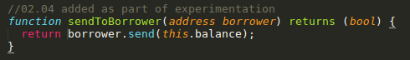
Figure 19: sendToBorrower function of Loan.sol

This implementation follows the recommended withdrawal pattern for Dapps. It is not encouraged for contracts to automatically push funds to recipients, because contracts have to pay the gas fee for the transaction. If the contract runs out of gas (which is initially supplied by the deployer of the contract), it sits on the blockchain uselessly until its selfdestruct method is called. This pattern ensures that the caller of the function is the sender of the transaction. In other words, whoever invokes this function will pay the gas fee.
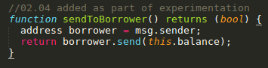
Figure 20: An alternative implementation of the above method

In the alternative implementation above, the loan will only send its balance to the sender of the transaction which includes this function call. This is almost identical to the first example, except no information needs to be supplied by the borrower, as the address retreival functionality is baked in. In other words, the contract knows to which address to send its balance automatically.
By setting a curAcct JS variable automatically or manually via the front-end and passing this value in every contract interaction requiring gas (as the from: parameter), it is possible to simulate the effects of interactions from multiple users. By default, all sendTransactions are sent from web3.eth.defaultAccount which is accounts[0] in the array automatically generated by ethereumjs-testrpc. This feature had to be implemented to test these types of cases e.g. have the borrower pay the gas for withdrawal (default behaviour thus far would have accounts[0] pay for the transaction here).

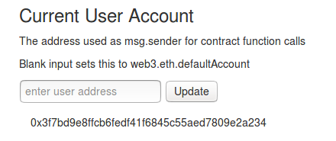
Figure 21: Front-end setter for curAcct

In the final implementation, this will likely be changed to a login form, requiring the user to input a passcode.
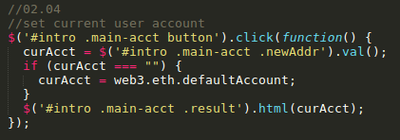
Figure 22: JS to set curAcct

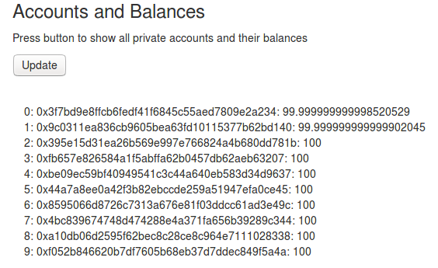
Figure 23: Initial balances before the experiment has been conducted

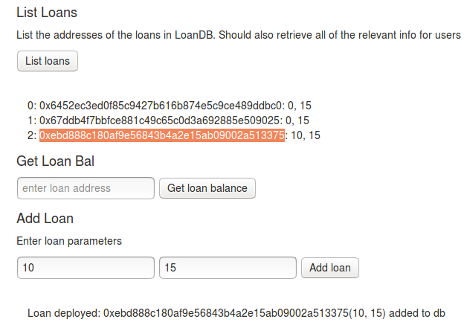
Figure 24: Loan with 10 ether in balance added
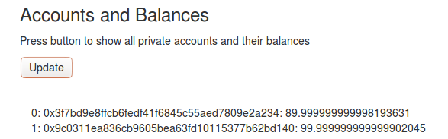
Figure 25: 10 ether depleted from accounts[0]
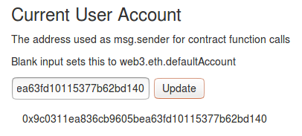
Figure 26: User account changed to simulate borrower interaction

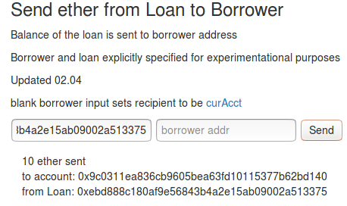
Figure 27: Entering Loan address with no borrower address sends the balance to the curAcct set in the previous figure

The figures confirm that the sending of ether from contract to user controlled account is possible. Much of the exposed functionality is unncessary from the perspective of the user. The final design should reflect this and make this machinery work behind-the-scenes.
Figure 28: Balances confirm that 10 ether has been withdrawn to address[1]
[consider]
Security-related features are vital and have not yet been implemented. Their absence was illuminated via the above experimentation. It should not be possible for users to perform transactions from other users’ accounts. Ethereum does have in-built functionality in the form of shared key cryptography. The corresponding private key must be entered to autheticate transactions being sent from a user controlled account. The simulator used for development supplies 10 accounts by default, which are all unlocked.
[check tags as in DISS]

Experiment 2: Setting the borrower and transferring loan funds
Date: 05/04/17
Motivation:
This following series of experiments were conducted to confirm the feasibility of a user taking an available loan and having the loan’s funds automatically transferred to their account.
A field borrower was added to Loan.sol to store the borrower’s address. It was envisioned that such a field would be required regardless, but at the time of writing, it had not yet been implemented. This is due to the piecewise development process (as documented in this appendix).
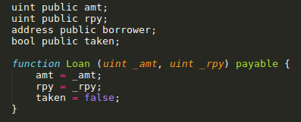
Figure 29: borrower and taken flag fields added to Loan.sol

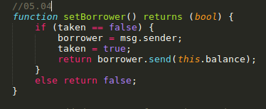
Figure 30: setBorrower function added to Loan.sol

A taken flag was added, which can only be altered once, via a new function setBorrower. The purpose of this was to prevent the borrower field from being overwritten by malicious users. The flag can be set once and only once, when the borrower is set. The invoker of setBorrower has their address stored in the borrower field. The loan’s funds are transferred to the borrower simultaneously.
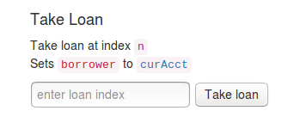
Figure 31: Front-end forms added for loan taking functionality

Much of the handler body takes the form of chained JS promises.
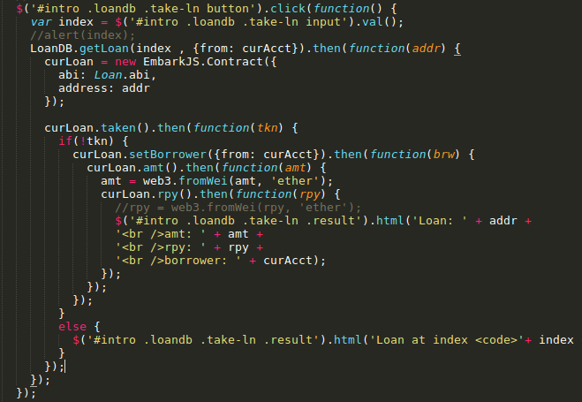
Figure 32: Corresponding jQuery handler for take loan HTML form
Functionality was tested by creating a loan then borrowing from another account.
Figure 33: Initial account balances
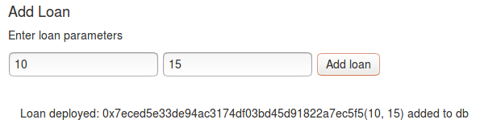
Figure 34: Loan deployed from accounts[0]

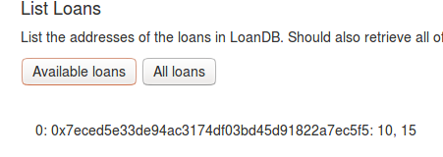
Figure 35: Confirmation of loan deployment. 10 ether offered

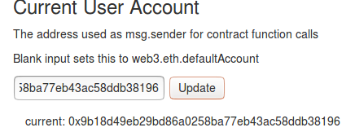
Figure 36: Switch to accounts[1] in preparation to take loan

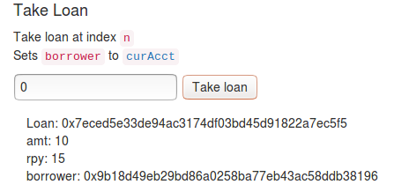
Figure 37: accounts[1] takes loan

Figure 38: Funds have been transferred

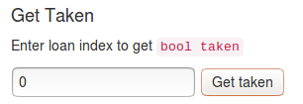
Figure 40: Form returns bool taken of Loan.sol
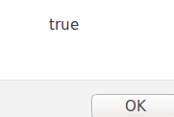
Figure 39: Returns true

