Lock的使用

jdk1.5中新增了ReentrantLock类，可以用来实现同步互斥，还支持嗅探锁定、多路分支通知等功能。Lock是一个接口，ReentrantLock实现了这个接口。
一、ReentrantLock类的使用
1、尝试ReentrantLock
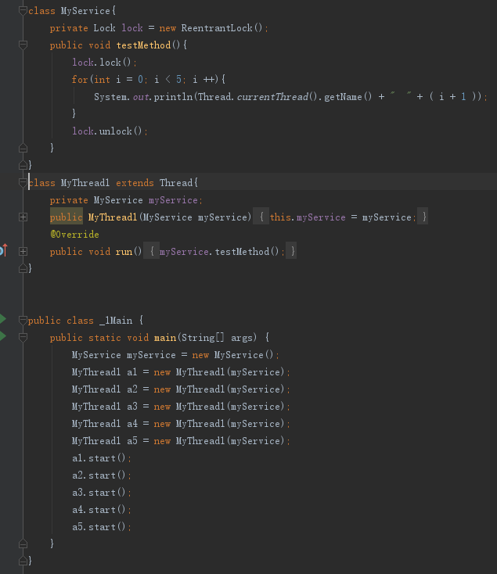
使用lock和unlock设置锁。

2、使用condition类配合ReentrantLock可以做到选择性通知，即唤醒指定的线程。注意，调用await方法必须先获得此condition所对应的lock的锁，即能调用了lock方法。
class MyService2{
private Lock lock = new ReentrantLock();
private Condition condition = lock.newCondition();
public void await(){
try{
lock.lock(); //必须先获得此锁
System.out.println("wait - A");
condition.await(); //此锁的此condition wait
System.out.println("wait - B");
} catch (InterruptedException e) {
e.printStackTrace();
} finally {
lock.unlock(); //finally unlock
}
}
public void signal(){
try{
lock.lock();
System.out.println("signal - " + System.currentTimeMillis());
condition.signal(); //解锁此Contional
} finally {
lock.unlock();
}
}
}
class MyThread4 extends Thread{
private MyService2 myService2;
public MyThread4(MyService2 myService2) {
this.myService2 = myService2;
}
@Override
public void run() {
super.run();
myService2.await();
}
}
public class _3Main {
public static void main(String[] args) {
MyService2 myService2 = new MyService2();
MyThread4 myThread4 = new MyThread4(myService2);
myThread4.start();
try {
Thread.sleep(2000);
} catch (InterruptedException e) {
e.printStackTrace();
}
myService2.signal(); //2秒后调用唤醒方法
}
}

wait() = condition.await()
wait(long timeout) = condition.await(long time , TimeUnit unit) //多久，单位
notify() = condition.signal()
notifyAll() = condition.signalAll()

3、使用多个Condition实现通知部分线程
使用ReentrantLock对象可以唤醒指定种类的线程以达到控制部分线程的目的。
class MyService3{
private Lock lock = new ReentrantLock();
public Condition conditionA = lock.newCondition(); //有两个condition对象
public Condition conditionB = lock.newCondition();
public void awaitA(){
try {
lock.lock();
System.out.println(Thread.currentThread().getName() + "await A " + System.currentTimeMillis());
conditionA.await();
System.out.println(Thread.currentThread().getName() + " end await A " + System.currentTimeMillis());
} catch (InterruptedException e) {
e.printStackTrace();
} finally {
lock.unlock();
}
}
public void awaitB(){
try {
lock.lock();
System.out.println(Thread.currentThread().getName() + "await B " + System.currentTimeMillis());
conditionB.await();
System.out.println(Thread.currentThread().getName() + " end await B " + System.currentTimeMillis());
} catch (InterruptedException e) {
e.printStackTrace();
} finally {
lock.unlock();
}
}
public void signalAll_A(){
try {
lock.lock();
System.out.println(Thread.currentThread().getName() + "signalAll A " + System.currentTimeMillis());
conditionA.signalAll();
} finally {
lock.unlock();
}
}
public void signalAll_B(){
try {
lock.lock();
System.out.println(Thread.currentThread().getName() + "signalAll B " + System.currentTimeMillis());
conditionB.signalAll();
} finally {
lock.unlock();
}
}
}
class MyThread5 extends Thread{
private MyService3 myService3;
public MyThread5(MyService3 myService3) {
this.myService3 = myService3;
}
@Override
public void run() {
myService3.awaitA();
}
}
class MyThread6 extends Thread{
private MyService3 myService3;
public MyThread6(MyService3 myService3) {
this.myService3 = myService3;
}
@Override
public void run() {
myService3.awaitB();
}
}
public class _4Main {
public static void main(String[] args) {
MyService3 myService3 = new MyService3();
MyThread5 myThread5 = new MyThread5(myService3);
myThread5.start();
MyThread6 myThread6 = new MyThread6(myService3);
myThread6.start();
try {
Thread.sleep(3000);
} catch (InterruptedException e) {
e.printStackTrace();
}
myService3.signalAll_A(); //只唤醒A
}
}

4、使用Lock实现一对一交替打印
class MyService4 {
private Lock lock = new ReentrantLock();
public Condition condition = lock.newCondition();
private boolean hasValue = false; //标志此时需要set还是get
public void set() {
try {
lock.lock(); //加锁
if (hasValue == true) {
condition.await(); //等待
}
System.out.println("※");
hasValue = true;
condition.signal(); //唤醒
} catch (InterruptedException e) {
e.printStackTrace();
} finally {
lock.unlock(); //解锁
}
}
public void get(){
try {
lock.lock();
if (hasValue == false){
condition.await();
}
System.out.println("●");
hasValue = false;
condition.signal();
} catch (InterruptedException e) {
e.printStackTrace();
} finally {
lock.unlock();
}
}
}
class MyThread7 extends Thread{
private MyService4 myService4;
public MyThread7(MyService4 myService4) {
this.myService4 = myService4;
}
@Override
public void run() {
while (true)
myService4.get();
}
}
class MyThread8 extends Thread{
private MyService4 myService4;
public MyThread8(MyService4 myService4) {
this.myService4 = myService4;
}
@Override
public void run() {
while (true)
myService4.set();
}
}
public class _5Main {
public static void main(String[] args) {
MyService4 myService4 = new MyService4();
MyThread7 myThread7 = new MyThread7(myService4);
myThread7.start();
try {
Thread.sleep(1000);
} catch (InterruptedException e) {
e.printStackTrace();
}
MyThread8 myThread8 = new MyThread8(myService4);
myThread8.start();
}
}

5、公平锁和非公平锁
锁Lock分为公平锁和非公平锁，公平锁表示线程获得锁的顺序是按照线程加锁的顺序来分配的，而非公平锁即随机获得锁。
如果是公平锁，则先打印出来线程会从小到达排列（先start的线程先获得锁），否则为非公平锁时，线程为无序获得锁。
class MyService5 {
private ReentrantLock lock;
public MyService5(boolean isFair) {
this.lock = new ReentrantLock(isFair);
}
public void serviceMethod() {
try {
lock.lock();
System.out.println(Thread.currentThread().getName() + "获得锁");
} finally {
lock.unlock();
}
}
}
public class _6Main {
public static void main(String[] args) {
final MyService5 service5 = new MyService5(false); //公平锁 / 非公平锁
Runnable runnable = new Runnable() {
@Override
public void run() {
System.out.println("线程：" + Thread.currentThread().getName() + "运行了");
service5.serviceMethod();
}
};
Thread[] threads = new Thread[10];
for (int i = 0; i < 10; i++) {
threads[i] = new Thread(runnable);
threads[i].start();
}
}
}

6、其他API
（1）getHoldCount() 查询当前线程保持此锁的个数，即此对象lock被调用lock()的次数。
（2）getQueueLength() 返回正等待该锁释放的线程数（估计值，不保证正确，有可能在返回时线程数目又增减）
（3）getWaitQueueLength(Condition condition) 获取等待condition.await()的线程数目
（4）hasQueuedThread(Thread thread) 查询thread是否在等待此lock解锁
hasQueuedThreads() 查询是否有线程正在等待此lock解锁
（5）hasWaiters(Condition condition) 查询是否有线程正在等待此condition唤醒
（6）isFair() 判断该锁是不是公平锁（默认为非公平锁）
（7）isHeldByCurrentThread() 是否当前线程持有该锁
（8）isLocked() 当前锁是否由任意线程持有着
（9）tryLock() 该锁未被另一个线程保持的情况下才获取锁

7、使用condition实现顺序执行
package 第四章_Lock的使用._1使用ReentrantLock类;
import java.util.concurrent.locks.Condition;
import java.util.concurrent.locks.ReentrantLock;
/**
* create by cairuojin on 2019/01/07
*/
class run {
volatile private static int nextPrintWho = 1; //用此值判断线程是否该执行
private static ReentrantLock lock = new ReentrantLock(); //锁
final private static Condition conditionA = lock.newCondition(); //三个条件
final private static Condition conditionB = lock.newCondition();
final private static Condition conditionC = lock.newCondition();
public static void main(String[] args) {
Thread threadA = new Thread() { //三个线程分别加锁打印3个值（保证123能连续打印）
@Override
public void run() {
try {
lock.lock();
while (nextPrintWho != 1) { //判断该线程是否该执行
conditionA.await();
}
for (int i = 0; i < 3; i++) {
System.out.println("ThreadA" + (i + 1));
}
nextPrintWho = 2;
conditionB.signalAll(); //唤醒下一个任务（不保证下个任务能抢占到CPU，所以需要nextPrintWho判断是否该继续）
} catch (InterruptedException e) {
e.printStackTrace();
} finally {
lock.unlock();
}
}
};
Thread threadB = new Thread() {
@Override
public void run() {
try {
lock.lock();
while (nextPrintWho != 2) {
conditionB.await();
}
for (int i = 0; i < 3; i++) {
System.out.println("ThreadB" + (i + 1));
}
nextPrintWho = 3;
conditionC.signalAll();
} catch (InterruptedException e) {
e.printStackTrace();
} finally {
lock.unlock();
}
}
};
Thread threadC = new Thread() {
@Override
public void run() {
try {
lock.lock();
while (nextPrintWho != 3) {
conditionC.await();
}
for (int i = 0; i < 3; i++) {
System.out.println("ThreadC" + (i + 1));
}
nextPrintWho = 1;
conditionA.signalAll();
} catch (InterruptedException e) {
e.printStackTrace();
} finally {
lock.unlock();
}
}
};
Thread[] aThreads = new Thread[5];
Thread[] bThreads = new Thread[5];
Thread[] cThreads = new Thread[5];
for (int i = 0; i < 5; i++) {
aThreads[i] = new Thread(threadA);
bThreads[i] = new Thread(threadB);
cThreads[i] = new Thread(threadC);
aThreads[i].start();
bThreads[i].start();
cThreads[i].start();
}
}
}
public class _8Main {
}

8、使用ReentrantReadWriteLock类 读写锁
表示有两个锁，一个是读操作锁（共享锁），另一个是写操作锁（排他锁）。读锁之间不互斥，写锁之间互斥，读锁和写锁互斥。 所以当线程要进行写操作的时候，要先等待读锁释放，获取写锁才能进行写操作。多个线程可以同时进行读操作。

读读不互斥：
启用多个线程，同时调用read()，可以发现可以获取多个读锁，彼此共享。
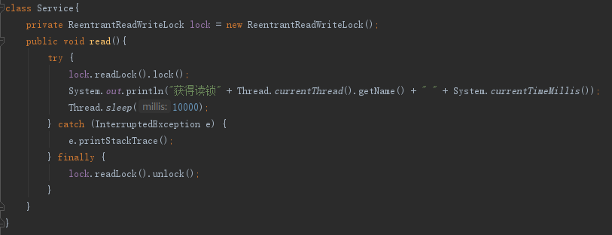

写写互斥：
启动多个线程同时调用write()，可以发现线程是同步执行lock方法中的内容，说明写锁彼此互斥。
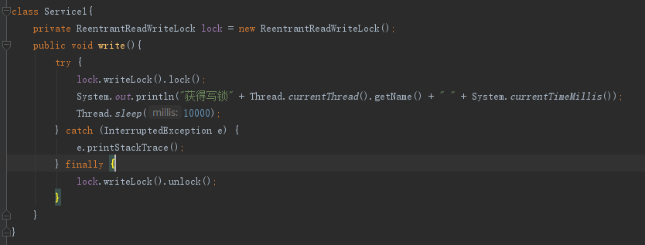

读写互斥：
同理读写是互斥的，同步执行。
