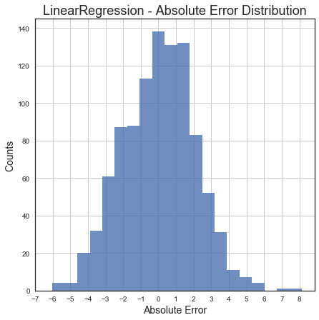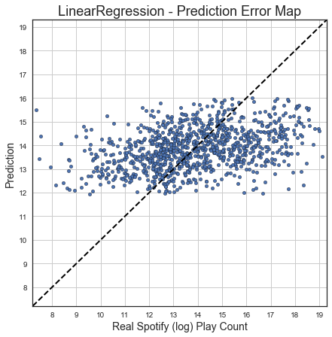C:\Users\think\AppData\Local\Microsoft\Windows\INetCache\Content.Word\lr_performance_stat.png