# Caitlan Nichols June 02 2024

## Assignment: Module 1.2 - GitHub Repository Setup

### GitHub Repository Screenshot

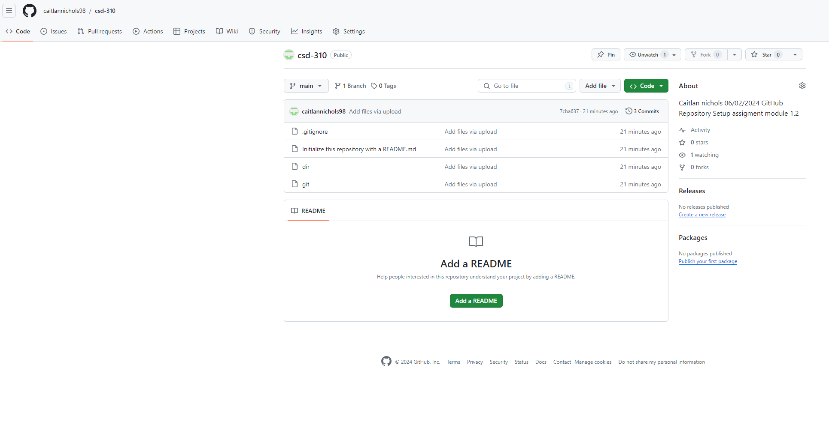

### Local Directory Screenshot

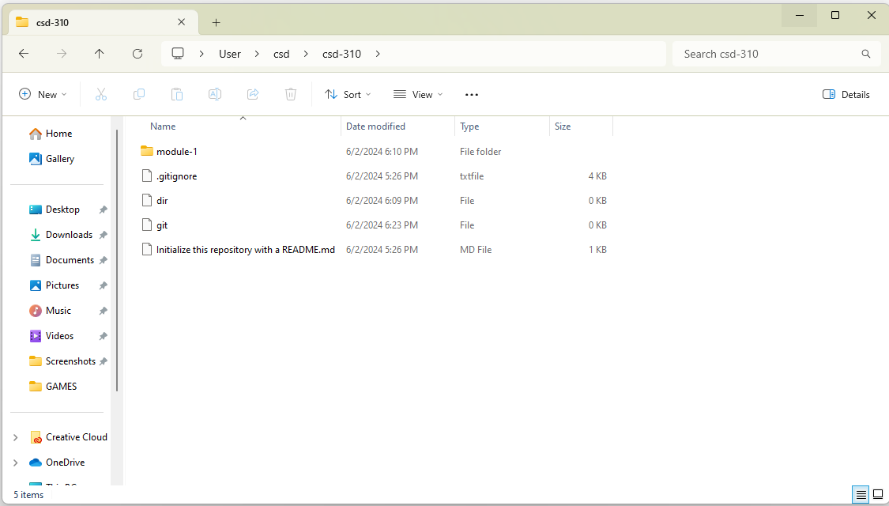

### Module-1 Directory Screenshot

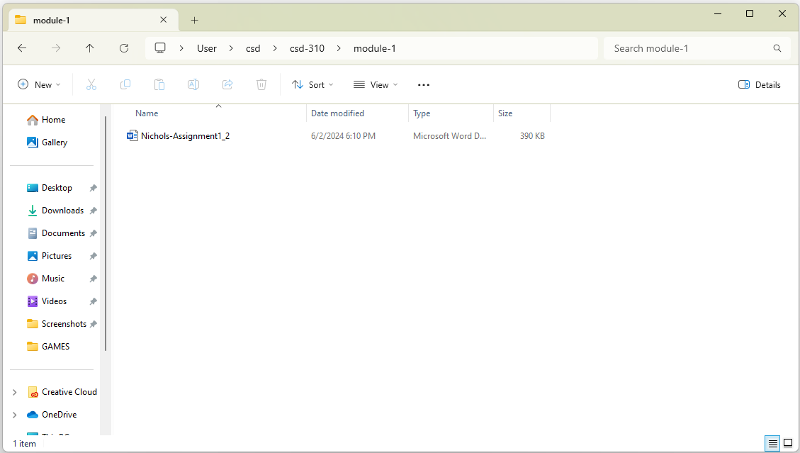

### GitHub Repository Link

https://github.com/caitlannichols98/csd-310