**Charlie Team**

Alexander Zayas

Botiwa Konan

Caitlan Nichols

Scott Cacal

7.13.2024

Module 10.1

**Milestone 2**

**Revised ERD**

* Employees
  + EmployeeID (PK)
  + Name
  + Position
  + EmploymentType (Full-Time, Part-Time)
  + HireDate
* Clients
  + ClientID (PK)
  + Name
  + ContactInfo
  + JoinDate
  + Status (Active, Inactive)
* Assets
  + AssetID (PK)
  + ClientID (FK)
  + AssetType (e.g., Cash, Investments, Real Estate)
  + Value
  + ValuationDate
* Transactions
  + TransactionID (PK)
  + ClientID (FK)
  + TransactionDate
  + Amount
  + Description
  + TransactionType (Credit, Debit)
* Billing
  + BillingID (PK)
  + ClientID (FK)
  + BillingDate
  + Amount
  + BillingMethod (Fixed Fee, Percentage of Assets)

**Relationship**

* Client - Transaction: One-to-Many
  + Each client can have multiple transactions.
* Client - Asset: One-to-Many
  + Each client can have multiple assets.
* Client – Billing: Many-to-Many
  + Many clients provide accounting info to many billing information
* Employee - Client (through Appointment): Many-to-Many
  + Many employees work with many clients.

**Revised ERD Diagram**

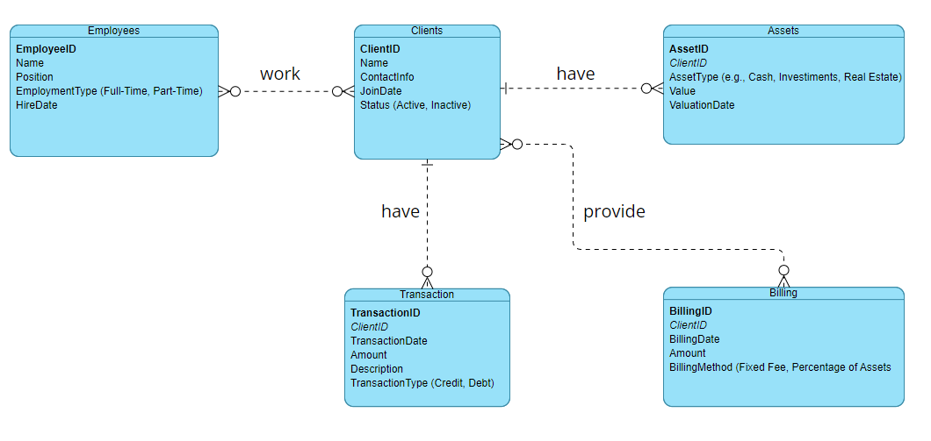

*ERD using Visual Paradigm*

**Data**

Below is a screenshot of the data displayed when running the python script.

*Script Output*