MileStone # 3

Charlie Group

July 17th, 2024

**Report Output**

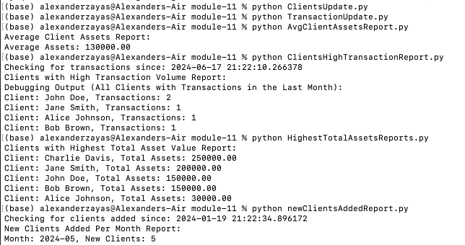

**Report Descriptions**

1. **Average Client Assets Report:** This script calculates the average amount of assets for the entire client list.
2. **Clients with Highest Total Asset Value Report:** This script identifies clients with the highest total asset value.
3. **Clients with High Transaction Volume Report:** This script needs to identify clients with more than ten transactions in the past month.
4. **New Clients Added Per Month Report:** This script needs to count the number of clients added each month for the past six months.

**Database**

