**Charlie Team**

Alexander Zayas

Botiwa Konan

Caitlan Nichols

Scott Cacal

7.13.2024

Module 9.1

**Milestone 1**

**Case Study**

Our team has chosen to work with the Willson Financial case Study

**Business Rules**

1. Company Registration and Compliance
   1. Willson Financial is registered with the SEC.
   2. A compliance manager ensures that the company follows SEC regulations.
2. Employees
   1. Jake and Ned Willson are the primary financial advisors.
   2. Phoenix Two Star handles office duties, including client appointments and office supplies.
   3. June Santos is the part-time compliance manager.
3. Clients and Client Management
   1. Clients are individuals or entities receiving financial management and advising services.
   2. Clients have assets that need to be tracked.
   3. Clients may have multiple transactions each month.
4. Billing and Transactions
   1. The company needs to track the number of transactions for each client.
   2. Billing structures need to be evaluated based on client activity and assets.
5. Reporting and Analysis
   1. Track the number of new clients added monthly.
   2. Calculate the average assets per client.
   3. Identify clients with many transactions (more than 10 per month).

Assumptions

Clients can have multiple types of assets.

Transactions are tracked monthly per account

The business operates on a monthly reporting cycle.

Client(s) transaction data is stored and managed electronically.

Asset amounts are reported in USD.

**Initial ERD**

* Employees
  + EmployeeID (PK)
  + Name
  + Position
  + EmploymentType (Full-Time, Part-Time)
  + HireDate
  + Certification (CFA, MBA, etc.)
  + Experience
* Clients
  + ClientID (PK)
  + Name
  + ContactInfo
  + JoinDate
* Assets
  + AssetID (PK)
  + ClientID (FK)
  + AssetType (e.g., Cash, Investments, Real Estate)
  + Value
* Transactions
  + TransactionID (PK)
  + ClientID (FK)
  + TransactionDate
  + Amount
  + Description
* Billing
  + BillingID (PK)
  + ClientID (FK)
  + BillingDate
  + Amount
  + BillingMethod (Fixed Fee, Percentage of Assets)

**Relationship**

* Client - Transaction: One-to-Many
  + Each client can have multiple transactions.
* Client - Asset: One-to-Many
  + Each client can have multiple assets.
* Client – Billing: Many-to-Many
  + Many clients provide accounting info to many billing information
* Employee - Client (through Appointment): Many-to-Many
  + Many employees work with many clients.

**Initial ERD Diagram**

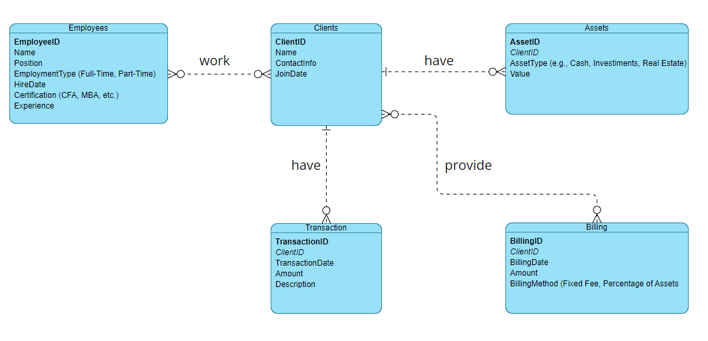

*ERD using Visual Paradigm*