Caitlan Nichols
06 February 2025
Module 5.2 - Assignment: Value Stream Mapping (VSM)

I will map a game development workflow that I plan to do for over the span of one development cycle (about 2 weeks). This workflow includes designing, coding, testing, and refining a game feature.

Step 1: Visualizing Using a Value Stream Map (I used CSP for the creation of this, hope it shows properly)
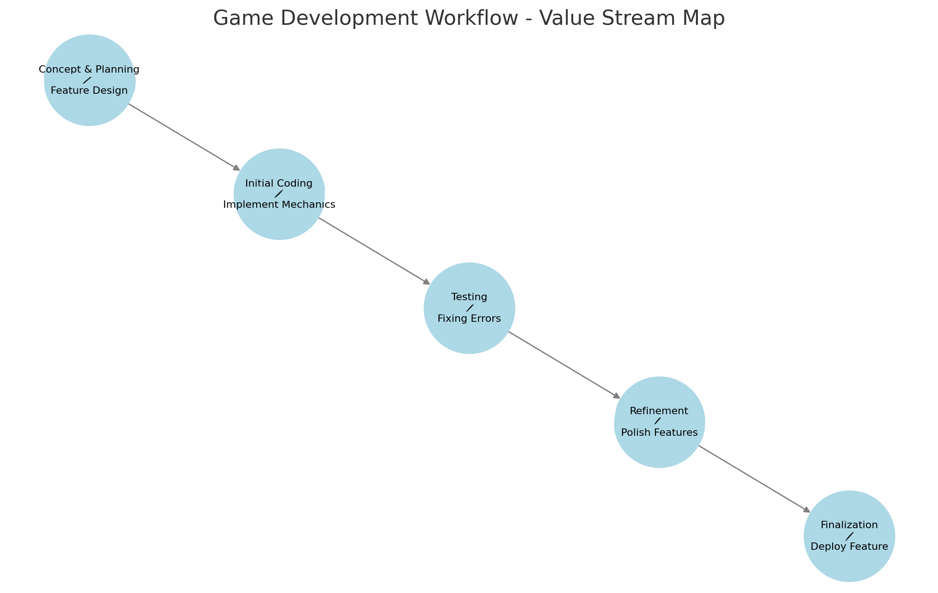

Step 2: Analyzing Lean Metrics

Estimated Average Flow Time per Stage
- Concept & Planning → 6 Hours
- Initial Coding → 12 Hours
- Testing → 10 Hours
- Refinement → 8 Hours
- Finalization → 4 Hours
Estimated Total Cycle Time = 40 Hours (~1 Week, assuming 5-6 hours per day)

Step 3: Optimizing the Processes

Eliminating Waste
- Reduce time spent on planning by preparing templates and reusing design patterns.
- Implement automated testing to reduce debugging efforts.
- Use code linting tools to catch errors earlier, minimizing time in the Testing phase.

Workflow Orchestration
- Shift some debugging tasks to the Refinement stage to parallelize work.
- Introduce version control branching strategies to prevent slowdowns in feature implementation.

Governance Models
- Implement a checklist system to ensure all steps are followed before moving to the next stage.
- Introduce a time-tracking system to measure time spent on each phase for further optimization.
References
Nichols C, 2025, OpenAI. (2025). ChatGPT (40 mimi). https://chat.openai.com/chat
Nichols C, 2025, Our textbook
Nichols C, 2025, 3 Easy Steps for Using VSM in Everyday Life https://www.connectall.com/blog/3-easy-steps-for-using-vsm-in-everyday-life/

