Caitlyn Chau

Professor Karra

CS 151 – 2

March 2, 2020

Screenshots

Screen 1: Sign up

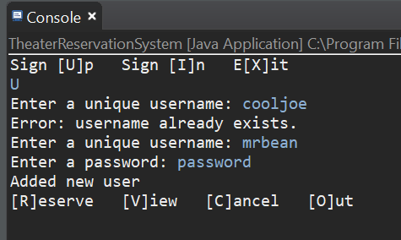

Screen 2: Sign in with an invalid user id

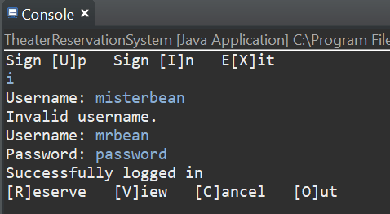

Screen 3: Sign in with an invalid password

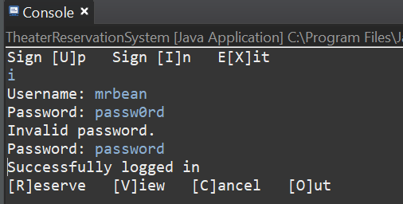

Screen 4: Sign in with a valid credential

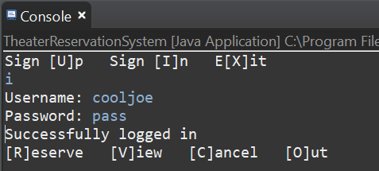

Screen 5: Start a reservation session. Reserve 10 seats across different sections for a given show, say Show A. (at least one seat from each section) (Do not end the reservation section yet.)

Screen 5: Try to Reserve one more seat of Show A that will cause an error because the seat is not available.

Screen 6: Reserve 5 seats for another show, say Show B, on a discount night (group discount is not applied on a discount night), and end this reservation session.

Screen 7: Start another reservation session. Reserve 5 more seats of Show A.

Screen 8: In the same session, cancel 2 seats from Show A and 1 seat from Show B and end the reservation session.

Screen 9: View the reservations by date.

Screen 10: View the entire reservations.

Screen 11: Sign out. Show the receipt for the transaction.

Screen 12: Sign up another user, sign in the user and reserve 2~3 seats, view the reservation, and sign out the user.

Screen 13: Exit the program. Show the content of reservation.txt