

Database Design
Experiment Report

Student Name： 卢xx，蔡xx，翁xx，张xx
Student Number： xxxxxxxxxxxx，xxxxxxxxxxxx，
xxxxxxxxxxxx，xxxxxxxxxxxx
Class: 计创，计创，计创，计科2班
Teacher: 汪秀敏

Design Document
Part 1: Overview
- Overview
This is a hospital database management system using Browser / Server model written in Python and Vue which is supposed to run on hospital center server and provide management services to computers at all conners of the hospital. The system fulfills following functions:
- Personnel Management, including patients, doctors, nurses and helping staffs.
- Medical Program and Property Management, including examination, rehabilitation, surgery programs and medicines, rooms, departments.
- Medical Record Management, including patient medical records, doctor advice, prescriptions, surgeries, appointments and so on.
There are two ways to access our system: the first is by accessing 178.128.106.95:5173 through a web browser, and the other is by directly running the executable (exe) file provided by us. Two methods share the same database, which is deployed on our server.
- Project File Organization
front-end
├── README.md
├── electron
│ └── main.ts
├── index.html
├── node_modules
├── package website.json
├── package-lock.json
├── package.json
├── public
│ └── vite.svg
├── src
│ ├── App.vue
│ ├── assets
│ ├── components
│ ├── composables
│ ├── main.ts
│ ├── router
│ ├── stores
│ ├── style.css
│ ├── types
│ ├── utils
│ ├── views
│ └── vite-env.d.ts
├── tsconfig.json
├── tsconfig.node.json
└── vite.config.ts

back-end/
├── CreateTable.py
├── SQLWrapper.py
├── adminForm.py
├── adminGetData.py
├── adminPutData.py
├── adminTableColumn.py
├── api.py
├── checker.py
├── common.py
├── nurseGetData.py
└── test
├── __init__.py
├── fields.py
├── static_back_end.py
└── tuples.py

docs/
└── table.md

Part 2: Design Principle
- System Architecture
Our management system is divided into front-end and back-end as shown in Figure 1. The front-end is responsible for providing readable and comprehensive information with user-friendly UI to browsers by sending requests to the back-end for data. And the back-end is responsible for fetching desired data from database and responding to requests from the front-end. In our project, flask library is used to establish this request-reply framework and MySQL is used as the DBMS to query, insert, update and delete information.
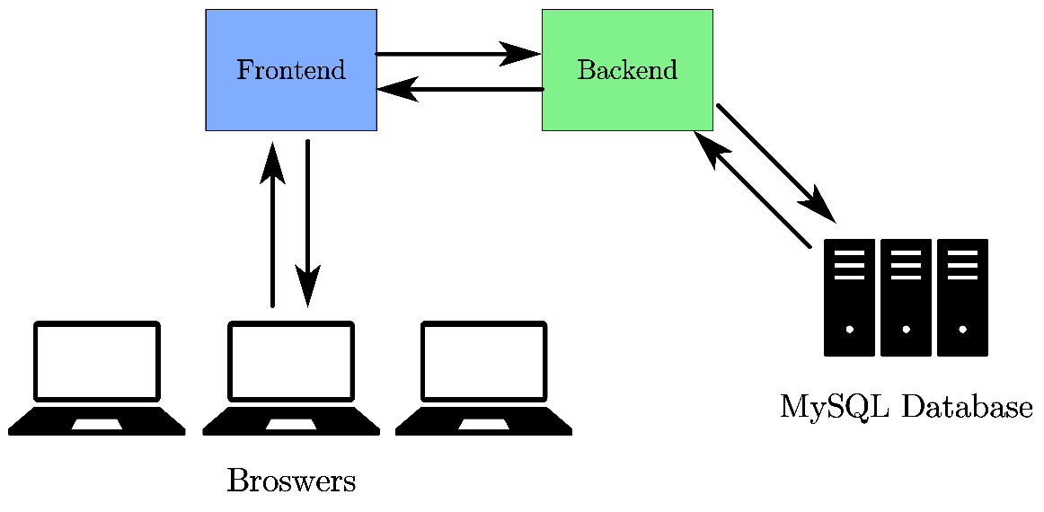
Figure 1: System Architecture

- Message Passing
Our system is a message-passing system. When the front-end needs to display information or users have done some operations to insert, update, delete information from database, it sends a GET or POST HTTP request to the back-end with appropriate parameters or forms. When the back-end successfully receives the requests, it routes requests to registered functions. The desired function runs and parses the incoming data (parameters and forms). Next it queries the database with incoming data and SQL statement by a database connection which is set up when the system starts up.

- Database Design
In our project, MySQL, a relational database is used to store information. According to the requirements, the information needed consists of following parts:
- User id and their password for login.
- Personal information of patients and hospital employees (doctor, nurse, helping staff). For example, patient’s birthday, phone number, address, blood type, allergen, etc. Doctor’s department. Employee’s supervisor, room that they works, etc.
- Medical record information. For example, doctor advice, prescription given in a consultation; appointments, examinations, rehabilitations or surgeries made, hospitalization information, prescription details including medicine needed, charge information, etc.
- Hospital property information. For example, rooms in the hospital, medicine stored in pharmacies and examination, surgery, rehabilitation program that the hospital supports, etc.
- The relation information between all above information. For example, the participants in a surgeries, patient and doctor information involved in a consultation, etc.

In our project, after registration, a unique id with length of 10 characters will be given to login the system, which starts with “p” (patient), “d” (doctor), “n” (nurse), “h” (helping staff) and 9 digits. Specially, administrators cannot be publicly registered and assigned an ID of 10 characters consisting of leading “a” and 9 digits. Then we can build up relationship between entities using foreign key references.

After decomposition, the above information can be stored in following tables and fields. Detailed table creation statements, constrains can be found in a separate file createTable.sql. Here we briefly introduce the information stored in each table.
- user: contains user’s information for login, such as username, password, role, etc.
- employee: contains common information of doctors, nurses, and helping staffs (employees), such as name, phone, address, etc.
- patient: contains patients’ information, such as name, phone, etc.
- doctor: contains doctors’ special information, such as their departments.
- nurse: contains nurses’ special information, such as the rooms they work in.
- helping_staff: used to determine whether an employee is helping staff.
- room: record all rooms and their information, such as room ID, type, etc.
- consultation: record consultation requested by patients and its detailed information such as time, doctor’s ID, charge information.
- prescription: record the prescriptions gave by the doctors related to a consultation and its detailed information.
- medicine: record all medicine available in the hospital and their information such as manufacturer, cost, etc.
- prescription_medicine: record the relationship between a prescription and its medicine used. It contains the information of quantity, dosage, etc.

- examination: record the examination conducted or is to conduct, including the information of consultation ID, examination time, result time, etc.
- examination_doctor: record the doctor related to an examination.
- examination_helping_staff: record the helping staff related to an examination.
- examination_nurse: record the nurse related to an examination
- rehabilitation: record the rehabilitation item conducted or is to conduct. Including the information of its corresponding consultation, name, time, etc.
- rehabilitation_doctor: record the doctor related to a rehabilitation item.
- rehabilitation_helping_staff: record the helping staff related to a rehabilitation item.
- rehabilitation_nurse: record the nurse related to a rehabilitation item.
- surgeries: contain all surgery programs that the hospital supports and their name, cost, etc.
- surgery: record the surgery item conducted or is to conduct. Including information of the participating doctor, patient, time, etc.
- surgery_related_record: record the detail of a surgery.
- surgery_doctor: record the doctors participated in a surgery.
- surgery_nurse: record the nurses participated in a surgery.
- surgery_helping_staff: record the helping staff participated in a surgery.
- hospitalizations: contain all hospitalization programs that the hospital supports and their information.
- hospitalization: record the hospitalization item conducted or is to conduct, including information such as patient ID, check-in time, discharge time, etc.
- hospitalization_record: record the relationship between hospitalization item and consultation.
- charge: record the charge paid by the patient and information such as payment method, cost, etc.
Here are all the table schema.
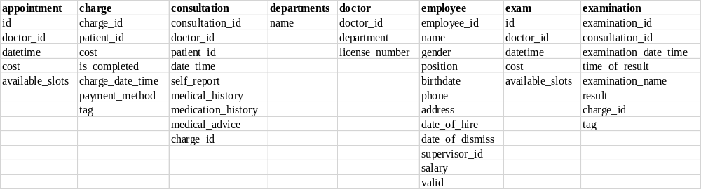
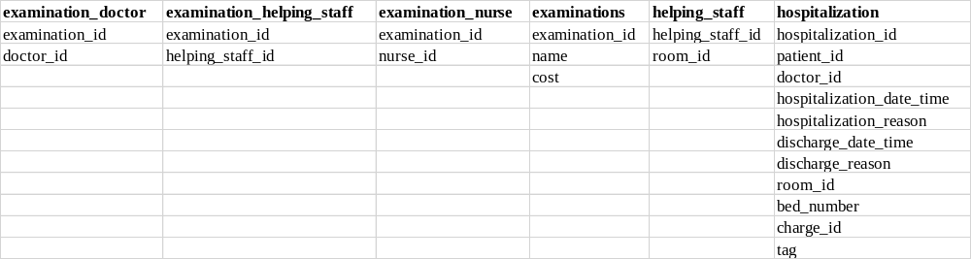
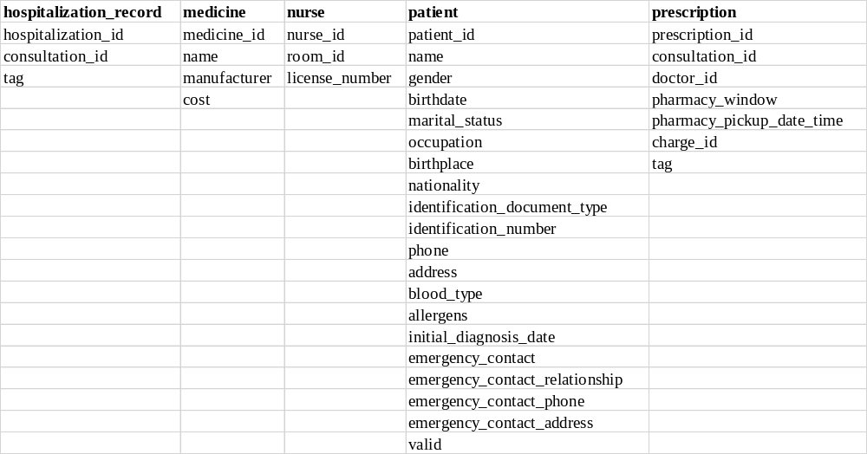
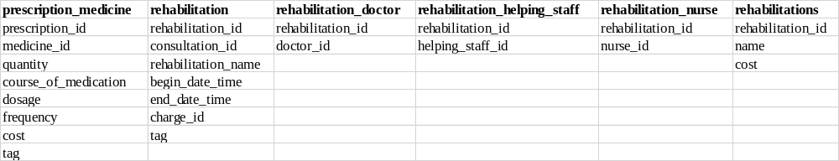
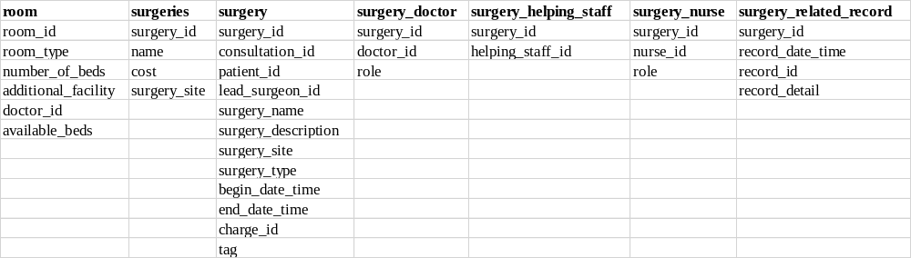

- Atomic Operation
Many operations on the database are supposed to be atomic, where transactions are used to avoid inconsistency when system crashes or concurrent threads executes. Following are some of the operations of our system to be considered atomic and how we handle them.

- On registration, a user record should be inserted into all of “user” and “patient” (“employee”, “doctor”, etc.) tables or none of them to guarantee that they can login into the system and their information is available. Therefore, we need to open a transaction to fetch existing IDs, generate new ID, insert information into all related tables and commit at the end.
- On user deletion, the information should also be deleted from multiple tables and the deletion should be performed only after no one is using those information. Therefore, a transaction should be opened and includes the deletion from multiple tables and commit at last.
- Consultation record is a complex part in our hospital database management system. Doctor will add some prescriptions, examinations, rehabilitation, surgeries into database. If doctor decide to cancel the consultation record, the related data will be deleted from database. But if doctor add some examination records and the system broke down in any reason, the newly added data will stay in database, which will destroy atomicity. To deal with this problem, we add an attribute “tag” into related table. Only when the consultation record is confirmed by the doctor the related records’ tag will be set as 1. If the system broke down, the record will be deleted form database when the system starts, by searching the related record with tag 0. By this way we successfully ensure atomicity in our hospital database management system.

- Frontend architecture
Tools we use:
Vite

The front-end toolchain that we use is Vite. Vite is used to provide a fast and efficient development environment for web development. We choose Vite as the toolchain for following three main-reason.
- Hot Module Replacement (HMR). Vite supports hot module replacement, which indicates that we can see the instant updates to our code in the browser without the need to refresh the page manually. This greatly improves the development experience and reduced the development time.
- Tight integration with Vue. Vite is specifically designed to work seamless with the Vue.js framework. It can understand the structure of a Vue project and optimize the build process. This allows us to establish intermedia version of our applications fast and smoothly.
- Out-of-the-box support for TypeScript. Vite has the perfect support for TypeScript. We abandon JavaScript in our development. TypeScript brings static typing and compile-time check to the project, which can help us catch potential bugs early in the development process.

Vue.js

The framework that we use in front-end is Vue.js. Vue.js is a progressive JavaScript framework that is used for building web user interfaces. The version of Vue that we use in the project is Vue3. We choose Vue.js as our front-end framework for the following reasons.
- Strong Chinese Community Ecosystem. Vue has a vibrant and thriving community in China. Almost all problems can be solved by searching on the Chinese internet.
- Well-documented. The document of Vue is the best document that I have ever read. The guide and tutorial show almost all the core features of Vue by hands-on teaching.
- Reactive design. The biggest advantage of Vue is its reactivity design. Vue’s reactivity design allows change in data to automatically reflect in the user interface without manual updates. This greatly reduce our workload since we do not need to track the flow of the data in the front-end. Especially in this project, almost all the state of elements in the web page will change with the data in database. With the help of reactive design, we do not need to track the flow of data in the development. The framework will accomplish this task excellently.

Element Plus

Element Plus is a Vue3 based component library. It provides an enormous number of components that can be reused easily. As a hospital database management system, users need to insert data into the database system. Most of the data has special constraints, such as the foreign key constraint and the value constraints. Users also need to insert some particular value into the database system, such date and time. We want to provide users with good user experience by informing them which data are available and which data are unavailable when they are filling the form. We also want to perform some simple data validation in front-end, so that we can prevent unnecessary requests which may lead to security issue.
Element Plus helps us achieve our goal. Using the elements provided by Element Plus is similar to building with blocks. After putting the block together by HTML and create an association between user input and objects by TypeScript, we can achieve the mentioned above.
What’s more, the components provided by Element Plus have consistent design style, icons, texts and positions of element. This allows us to focus on developing the functions of the system instead of some boring work, such us typesetting. Also, the components of Element Plus is simple and intuitive. This allows the users of our hospital database system can quickly understand how to use the system.

Electron
We build an application using the Electron framework that can run on the Windows environment. Electron is used to built cross-platform desktop apps with JavaScript, HTML, and CSS. The code that can run in a browser can be easily ported to run in the sandbox environment provided by Electron. By using this framework, we provide users with a more stable way to access the hospital manage system. This aligns well with the working environment of hospital staff using the hospital management system.

Other tools
We also use other tools or package in the front-end development process, but we cannot illustrate all of them. We will briefly list them and their role in our system here.
- Pinia: Pinia is used as a state store in our system. We use Pinia to store the variables that is necessary when the system is running, such user ID, user identity (patient, doctor, etc.).
- Vue-router: Vue-router is a package that is used to build a single page application. With the help of Vue-router, we can minimize the unnecessary page refreshes. This can not only improve the user experience, but also let the back-end of the system focus on providing API and managing the database.
  - Day.js: Day.js is used to manipulate and format date and time. Since the user can use our application in every corner of the Earth, it is necessary to ensure the value of date and time is always correct. We use Day.js to achieve this goal.
- Axios: Axios is a JavaScript package that is widely used to send request to backend. It provides the promise-style interaction, allowing us to deal with the asynchronous programming with a synchronous approach, significantly enhance the development experience.

Front-end working principle
Following picture shows the working principle of the front-end. All the document object model (DOM) nodes are included in components. Vue acts as the render in the rendering process. After the nodes have been inserted into the DOM tree, Vue will call relative functions to get data from the database, and the data will be rendered on the webpage. Vue will listens for the data change. Whenever Vue detects the change of data, it will update the DOM tree and retendered it. There are many reasons for data changes, including but not limited to changes in the database content, user interactions with the page, and the passage of time. Vue will automatically apply the change to corresponding DOM node. When a component is removed from the web page, Vue will also all relative functions. Some pages will call send feedback in this function to maintain the integrity of the data in the database.
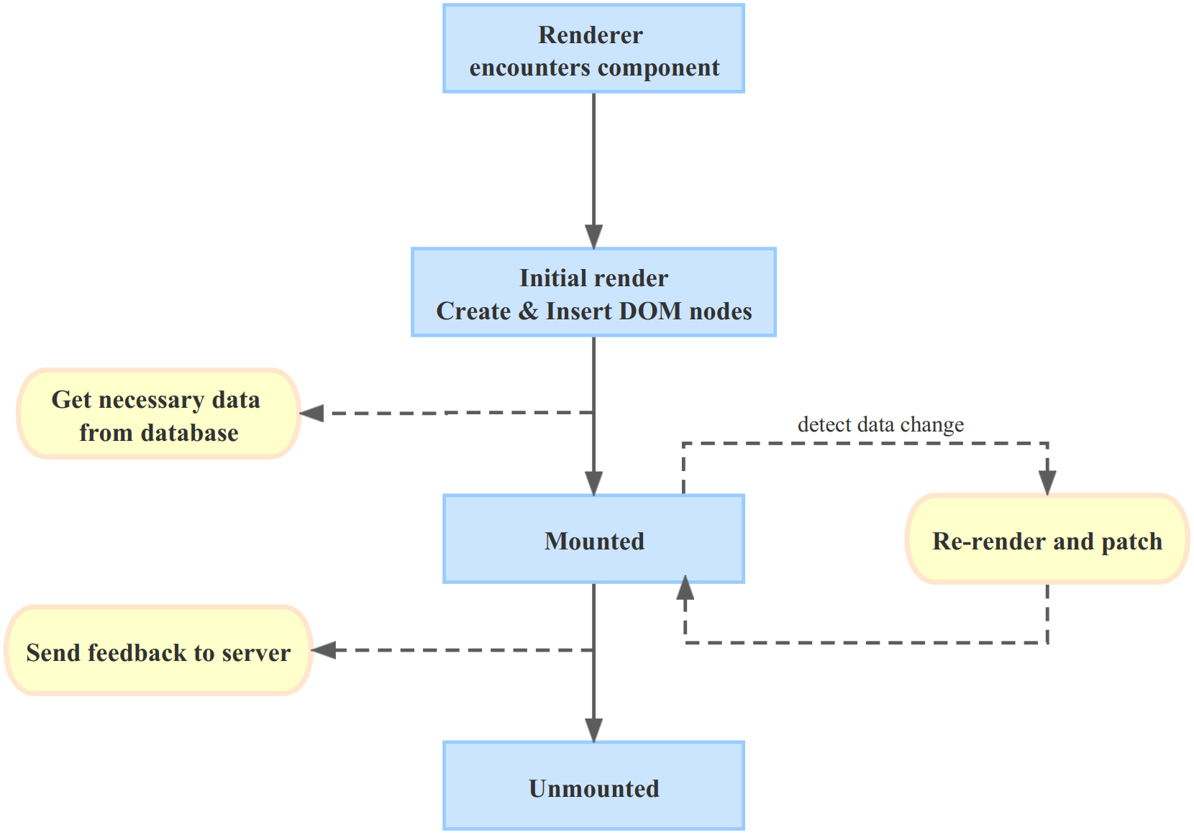
Highlight of the front-end
Exquisite Forms
All the forms that are used in the system are meticulously designed. We select different kind of components for different kind of input. These components help users to input the valid value with valid format efficiently.
- Input: Input is the most basic component that is used in the form. Users can input any value in the input.
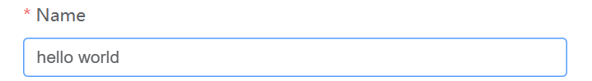
- Single select: The basic single select allows users to select a value from the options. The options are fixed during the development process. Some single selects also allow user to enter a value that do not exist in the options, which is shown as bellow. Here, user input “fool” in the select, and it is accepted as a valid input.
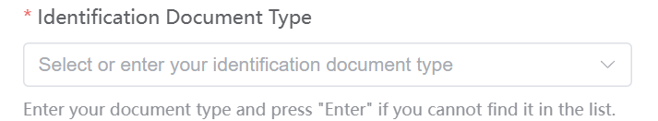
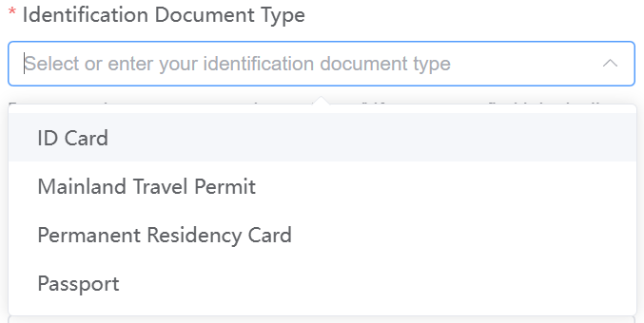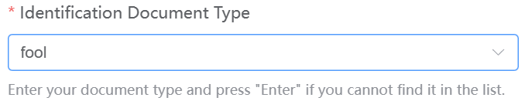
- Multiple select: Multiple select allows users to select multiple value at the same time. Its behavior is quite similar to the single select, except that it allows multiple selection.
- Date Picker/Date Time Picker: In the system, users need to input date and time frequently. For example, a patient can find a consultation quickly if he or she can specify the date that the consultation happen. We provide two components that allow users to input information related to time. The first is date picker (on the left) and the second one is date time picker (on the right). They are quite similar to each other. We can see that some data are disabled, which means that the system prevents users from submitting incorrect data at the source. The combination of these two pickers and Day.js is really powerful.
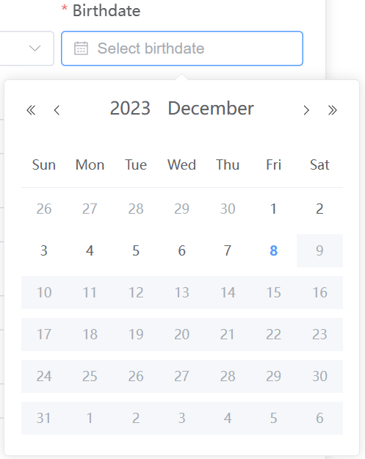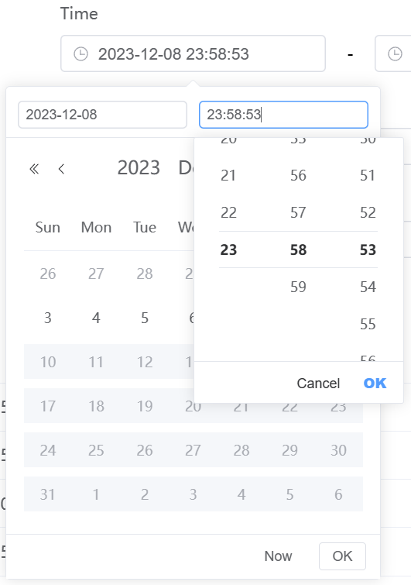
- Select with remote search: It take us a lot of effort to implement this component. This component can replace the input in some places. It also allows users to input value, but the value that will be filled in the form finally can only be the options of the selector. The most amazing point is that the options is dynamic, which means that the values of the options change according to the user's input. If user want to input a string whose length is long, he or she may only need to input the first few characters, then the string will appear as one of the options. What’s more, this component also prevents the user from inputting invalid value in the form fundamentally. Almost all the detail implementation of this component is achieved by ourselves. It is widely used in our system and it greatly improve the user experience. Following figure shows the component’s effect. We can see that user can get the full names of medicine which match the user’s input. we also list the ID of the item in this component if necessary to prevent potential errors.
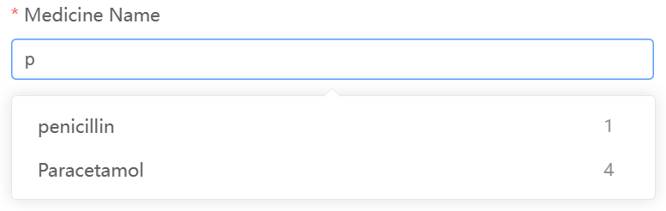
User-friendly promotes
We strive to provide users with ability to know whether the information they have entered in the form is correct or not before submitting it. We use textual feedback with vibrant color, showing them the correct method to fill the corresponding form element.
Following picture shows what will happen if users miss providing the required input or provide inconsistent input (e.g. password). The necessary inputs are labeled with *, which is understandable to almost everyone. In the following figure, we can see that user remove the input in the “Initial Diagnosis Date” field and them remove the input. The system detects this action and notify users that he or she must select a data. We can also see that system will inform user that they enter different passwords in two input field, allowing user to correct their input immediately. The value of the form will not be passed to the back-end before the form passes the validation check of the front-end, this not only improve the security of the system, but also improve the user experience, since the data transmission time between the client and server may be lengthy.
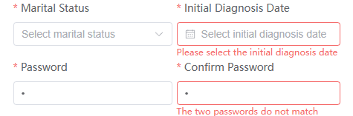
We also use the select with remote search to provide user-friendly promote. We have already illustrated this component above in detail. This component provides users an input method that is similar. This component provides behavior similar to a browser search bar but offers richer information, helping users access their choices more quickly.
Clear interface
In our system, we list all the information in a clear and tidy way. Almost all information in the system is list in the tabular form. When users searching information, the rough information of an item is listed in the table. The detail information of the item can be obtained by the “show detail” button, which is usually appears near the ID of an object, depending on whether the operator has relevant permissions.
Ubiquitous animations.
The animations are in anywhere. We cast animations as important roles in our system, since they can not only improve users’ experience, but also give users information about the information of the components. When a component is in the process of being loaded, it is covered by a mask to prevent user interaction. Additionally, the components will provide graphic feedback to user. For example, a rotating loading icon and a dynamic blur effect inform the user that the data in table is not ready. When a button is disabled, its color will change. The shape of the cursor will also change if user move the cursor to disabled button. These design details are present throughout the system.
Dark mode
We care all people eyes. Almost the color of all components will change in dark mode, providing user a less glaring page. Following pictures show the different of pages in different modes.
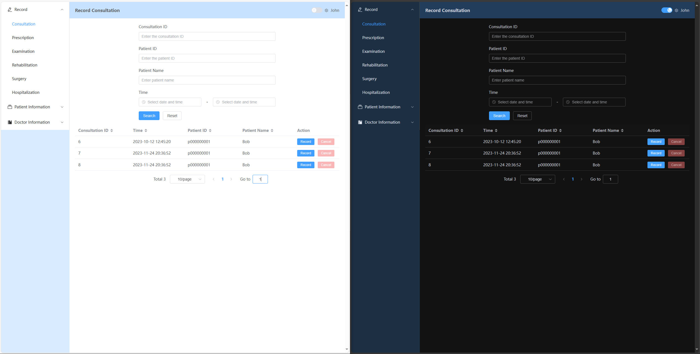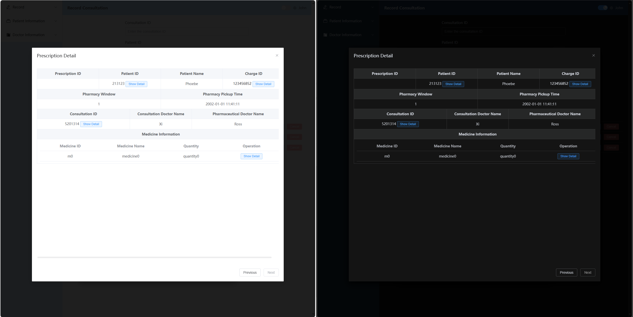

- User Interface
Our project utilized Vite, Vue.js, etc. to develop front-end user interface, which is compatible with Electron client application and browsers. The framework extends its capability to provide a well-readable, user-friendly, well-functioning and neat user interface.

Part 3: Implementation
- Database Query Scheme
We use mysql library in python to set up the connection to the database. The database can be located on the same machine or a remote machine that provides public access. By using mysql.connector.connect() method with database location, user and password, a connection object is set up.
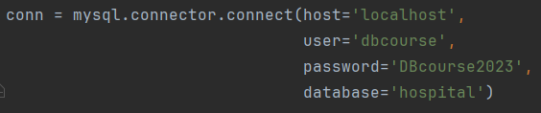
Figure 2: Setting up database connection (local machine)

Next, a cursor object can be obtained by calling cursor() method in the connection, which is used to execute SQL commands and fetch data from the database if a SELECT statement is executed. For transactions, it is the connection object that handles the commit and rollback by commit() and rollback() methods of it and all changes to database is guaranteed to be visible to all cursors objects that belongs to this connection. In our project, the connection is set up at system start and only once. And here is an example of using transaction.
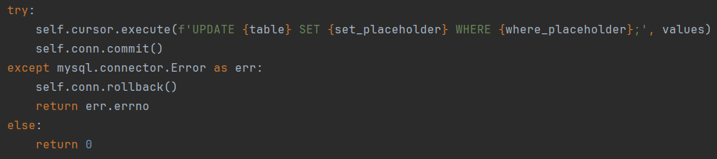
Figure 3: Transaction example

For INSERT, DELETE, UPDATE statements, changes are effective only after an explicit commit() method is called.
- Generating SQL Statements
Writing raw SQL statements to operate the database is a laborious and error-prone job. Therefore, we wrote a SQLWrapper class to generate SQL statements basically by concatenate sigma, table names, conditions and other parts together, which helps avoid syntax errors and let our team focus on data retrieval scheme. Our SQLWrapper accept a database connection object to initiate, and store query information by query() method (collecting table and sigma information), where() or like() method (collecting conditions), run() method (setting limit, join algorithm and error handling). Finally, if the data is available, get() method can be used to get the result list. On the other hand, execute_raw() method is provided to execute raw SQL statements that are too complicated to concatenate by SQLWrapper. And insert(), update() methods are provided for executing INSERT, UPDATE statements with options. The SQLWrapper is implemented by storing information in the object when the methods are called. Method query() store the tables and fields to be requested. Method where() and like() store the AND conditions and OR conditions separately. And method run store LIMIT condition and join algorithm used, concatenating different parts of SQL statements, and fetch data from MySQL database through the connection and cursor.fetchall() method. run() method provides error handling functions. If the statement is executed successfully, it returns 0, otherwise it returns a database error code to indicate the kind of errors. The fetched results are also stored within the object and can be obtained by calling get() method later on.
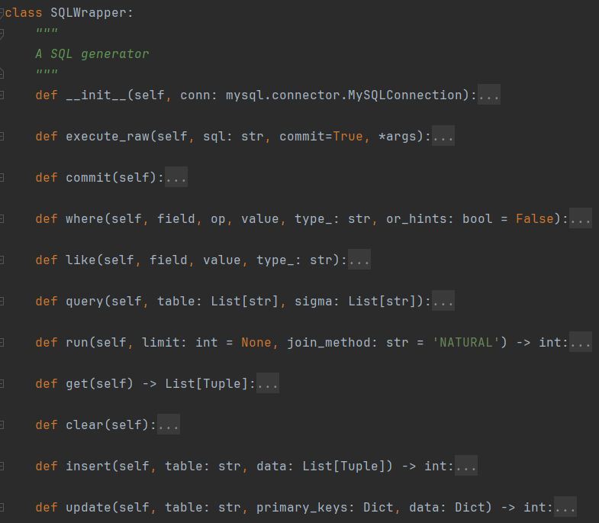
Figure 4: SQLWrapper methods

Figure 5 is an example of using our SQLWrapper.
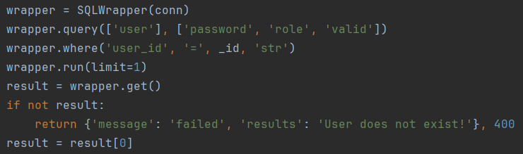
Figure 5: SQLWrapper example in login()

- Some API Implementation Examples
In our hospital database management system, each function has it’s API to implement the logic in the back end. There are totally 118 API. Some of them implement in similar logic. Here we select several representative ones for illustration.

- Patient-schedule-appointment
When the patient wants to make a appointment for consultation, he can search for the available appointment and schedule a consultation. We implement this function in patient-schedule-appointment API. Firstly we make an insertion into charge table in the database and get newly generated charge_id:
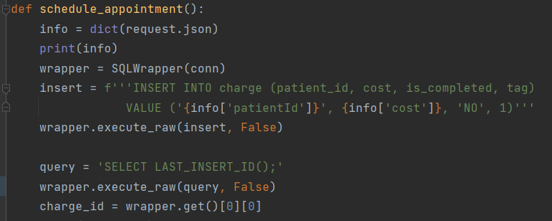
Then we need to make a insertion into consultation table and get newly generated consultation_id:
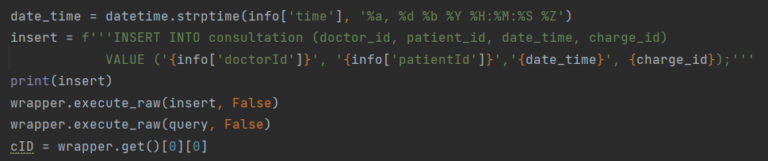
Finally, we cannot forget to update the appointment information, reduce the available slots by one, and return the consultation_id to front-end:
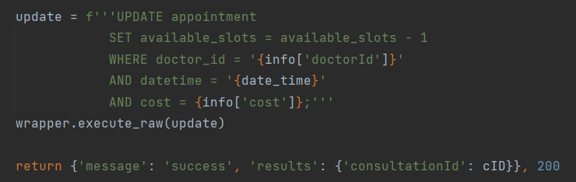

- get-patient-consultation
In hospital database management system, there are lots of function to get the data from database then show the information in the browser. We take get-patine-consultation API for example. In this API, we need to get patient’s consultation information including time, department, doctor name. Firstly we need to get some requirement from the front-end and convert them into proper format for further operation:
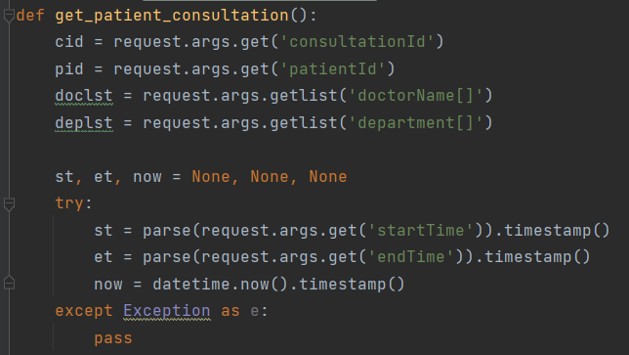
Then we connect to database and use wrapper to generate SQL according to the requirement to fetch the consultation information:
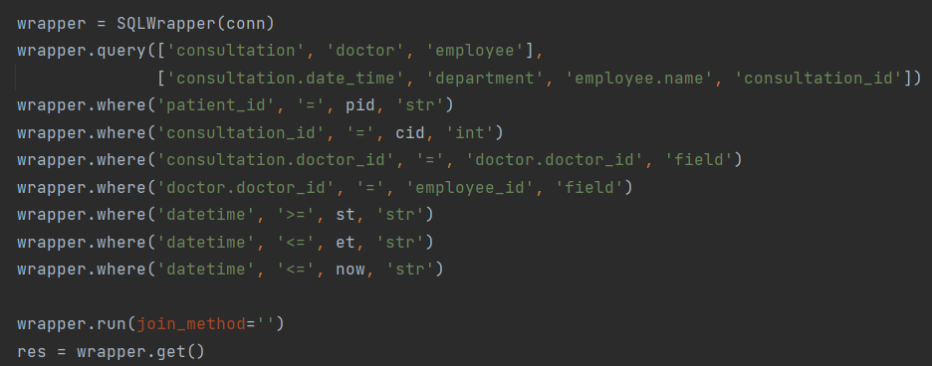
Finally we get the data and convert them into proper format. Return the information to the front-end to present in the browser:
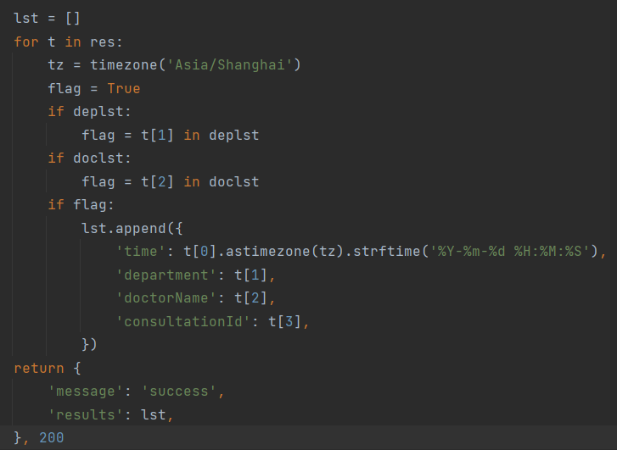
- get-consultation-detailed
After get patient’s consultation rough information, there is a API for the users to see detailed information related to the consultation. In this API, we need to query more data from database:
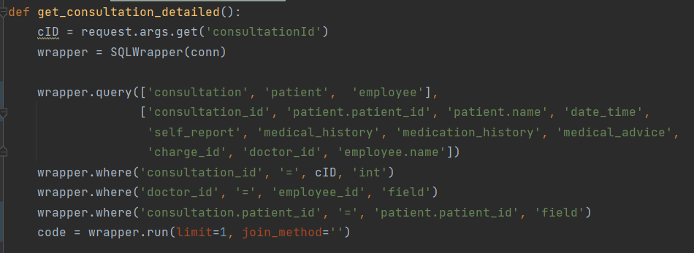
Then put the data in a dictionary, waiting for sending to front-end:
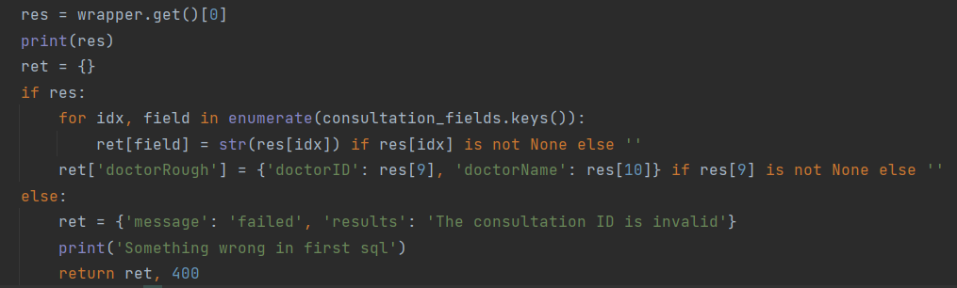

The most complex part is to query all the data related to the consultation for prescription, examination, rehabilitation, surgery table in the database. We implement this process by a long SQL command using UNION operation:
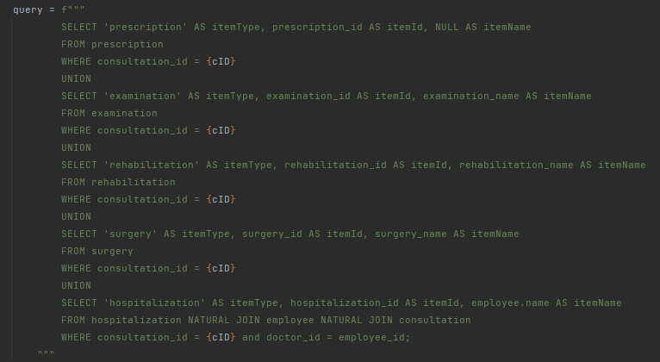
Finally after fetching the data form database, we can deal with them and convert them into proper format. Return them to front-end for presentation.
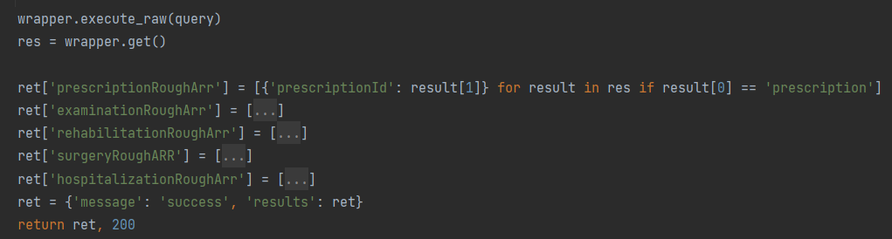
- Patient-cancel-consultation
After patient make an appointment for a consultation, he can cancel the consultation if he change his mind. Some other function like cancel-prescription, cancel-examination is similar. In this API, we need to properly update the data in the database. Firstly we need to query the charge_id, doctor_id and date_time related to the consultation for further operation:
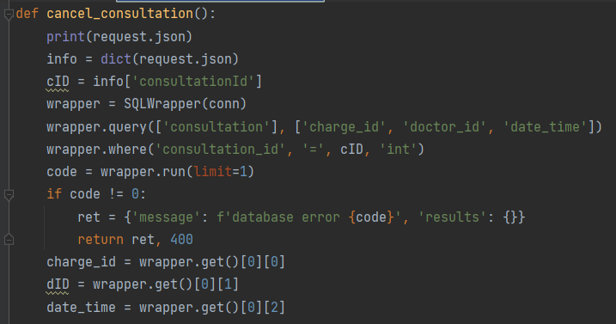
Then we need to delete the consultation data, charge date from database. And cannot forget to update the available slots in appointment table:
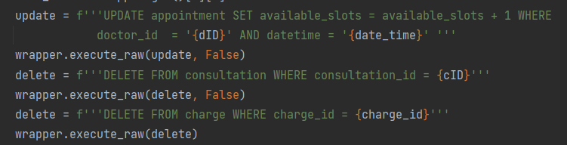
- Appointment-examination-is-time-available
When doctor need to arrange an examination, rehabilitation or surgery for the patient, the system should tell him which time is available. We take Appointment-examination-is-time-available API for illustration. Firstly, we will query the examination record scheduled on that date according to the given examination_name, time. And select the time which appear more than 10 times.
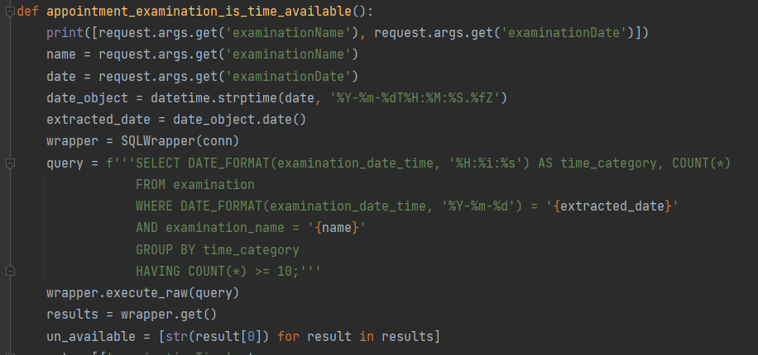

Since the schedule time is divided by hours, we can judge that the time not in the query result is available, then return the information to front-end:
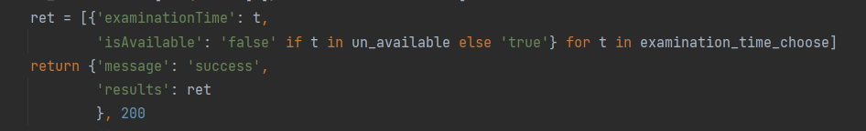
- get-surgery-name-arr
When doctor arrange a examination, rehabilitation, surgery for the patient, he need to input the corresponding name. For their convenience, we provide a function to get the possible name according to their current input. Now we take get-surgery-name-arr API for example. Firstly, we get the query information like surgery_site, current user’s input from front-end:
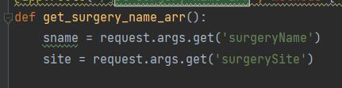
Then we can use LIKE command to query the possible surgery names and return them to front-end:
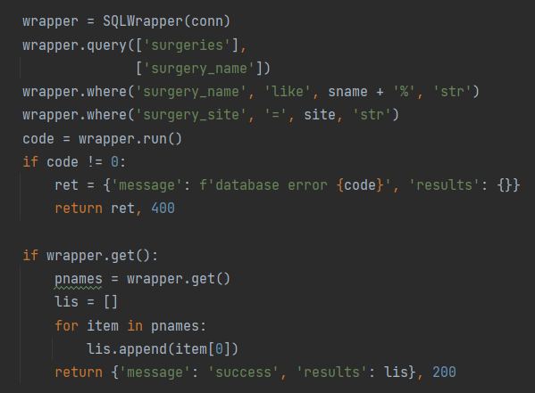

- Appointment-surgery-pre-schedule
After doctor select the surgery name and other information, he will confirm the surgery. At this time there will be a function to insert the information into database. In this API, firstly we get the information form front-end and query patient_id for further operation:
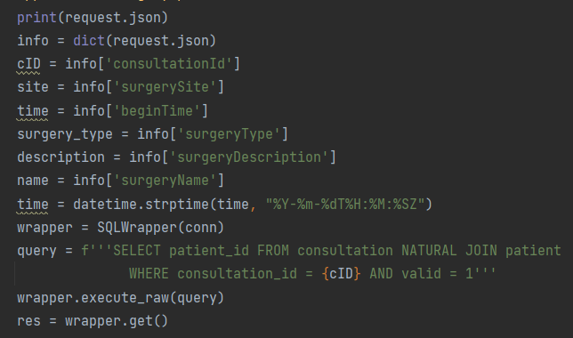
Then we can insert the data into charge table in database and get newly generated charge_id:
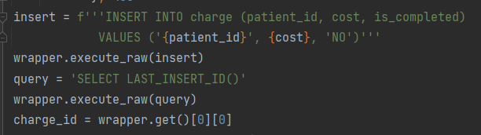
Finally we insert the data into surgery table and get newly generated surgery_id. Return the surgery_id to front-end:
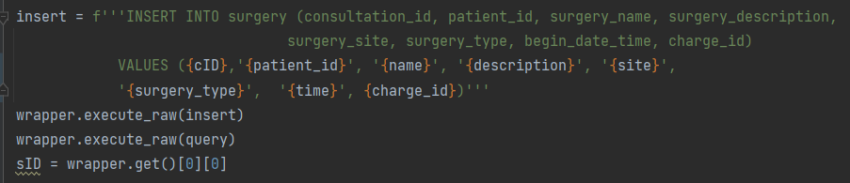

Part 4. Conclusion
In this database design project, we design and develop a hospital database management system. The system use browser/server model written in Python and Vue. It can run on hospital centre sever and provide management services to computers at all conners of the hospital. The system can satisfy all the common requirements in daily application scenarios.
Our management system is divided into front-end and back-end. In front-end, it provide the users with a user-friendly UI in browser, thought which the users can see the information they want to know or do some operation in the system. Then front-end will send the request to back-end, which will connect to database and fetching desired data or do some operation like insertion.
In our project, we implement lots of functions like user login, registration. We provide three different interfaces for different users, including employee interface, patient interface and administrator interface. Different kinds of users will enter corresponding interface after they login.
To make our development process more efficient, we implement a SQLWrapper class to generate some SQL statements. Then when we implement our 118 API, we can use SQL wrapper to generate some SQL. The generated SQL statements can help use avoid syntax errors and let our team focus on data retrieval scheme.
There are totally 118 API in our system, each API need a function to implement in the back-end. In each API, we need to write several SQL statements to fetch the data or do some operation such as insertion. With the unity and cooperation of our team, we have successfully implemented these 118 API, providing the users with a fantastic hospital database management system.
In the design and development of this hospital database management system, not only have we practised our programming skills, but also we have a deeper understanding of the characteristic of database. What’s more, we have also honed our teamwork skills, which will benefit us in for a lifetime.

