1. The following sections fit prediction charts, including predicted and true values, to ridge regression, lasso regression, and decision tree regression models using the final optimal parameter results of the grid search after model fitting.

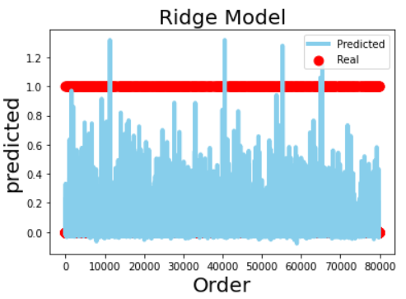

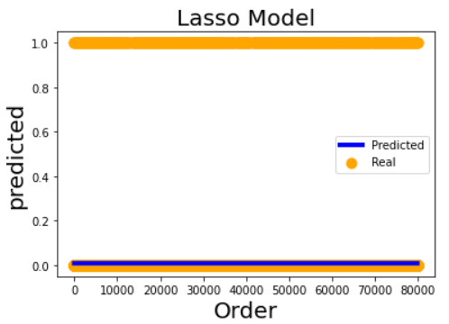

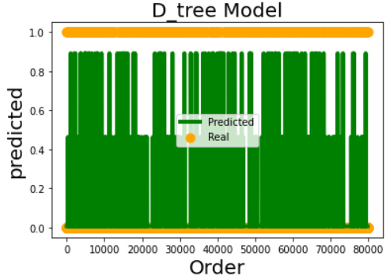

I fit the regression machine model using GridSearchCV(model, parameters, cv=2) and bifold cross-validation for the lasso, decision tree, and ridge regression models with parameter modification enhancements, where the alternative parameters for lasso are [0.02,0.03,0.04, 2,3]. The alternative arguments for ridge are [0.1,1,2,3] and for D_tree are [1,2,3,4,5], resulting in Lasso of GS.best_params_ = {'alpha': 0.02}, lasso's optimal argument is 0.02, ridge.best_ params_ = {'alpha': 1}, optimal parameter for ridge is 3, and D_tree.best_params_ = {'max_depth': 2} optimal parameter for the decision tree i.e., the maximum depth value is 4.

In the ridge model the alpha parameter was adjusted (alpha=1.0), where the mean absolute error, mean square error, median absolute error, explained variance variables, and r2 scores were 0.020457761899748905, 0.006820602176344477, 0.007167360833442235, 0.24872797109751654, 0.248672327878816.

For the Lasso model with parameter alpha parameter adjustment (alpha = 0.02), the mean absolute error, mean square error, median absolute error, explained variance variables, and r2 scores during Lasso training were 0.01745491571981748, 0.009078576206856249. 0.008447703202356332, 0.0, -5.6204909432588934e-05.

Adjusting the max_depth parameter for the D_tree model (max_depth=2), the mean absolute error, mean square error, median absolute error, explained variance variables, and r2 scores during the training of D_tree were 0.01524479139942859, 0.008149597545657477. 0.006427753808224003, 0.10232244423022518, 0.10227601692714505.