## **Final Assignment 01**

#### **Task**

Your work will be assessed on:

1. how accurately your model classifies on a test set
2. how well your model generalizes
3. the organization and documentation of your Jupyter Notebooks
4. communication of your work in class reflections and final presentations
5. model improvement over the semester
6. -10 points if you use a random_seed of 74 in your train/test data split

#### **Solution**

I used many of model including DecisionTreeRegressor，ridge regression， lasso regression， Linear Regression，XGBRegression，SVC，Logistic_regress， RandomForestClassifier to confirm which one of them could be better optimal。,I found that lasso model's mean_squared_error performance was pretty well with 0.017777346206774767，Ridge model's mean absolute error was distinguished with 0.009291881988991271.

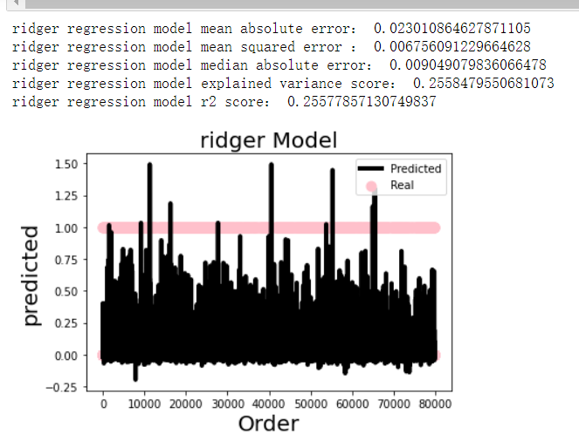 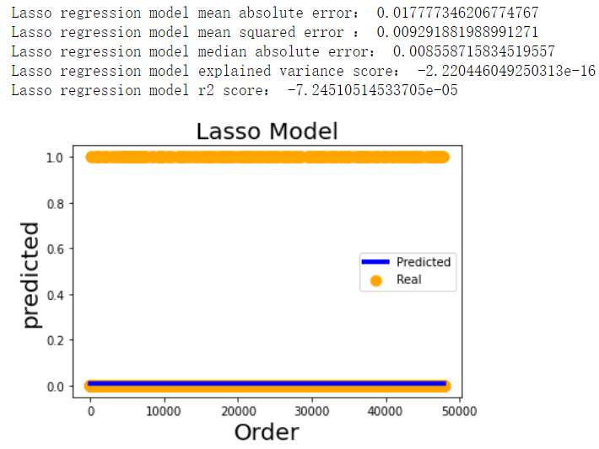

#### **Improvement**

Then, I decide to take the classified model in order to figure out if the classified model can better fit the model and get the optimal result after the process of fitting and predicting. After doing research from the website google as well as baidu, I intend to utilize the classified model pertaining SVC, Logistic_regress ，RandomForest in copying with fitting the original data as well as predicting classified result ,and, I maked use of the criteria of precision score, accuracy score, recall score, f1 score so as to check the models’ efficiency .And ,from observing the final result , I noticed that Logistic regression model got the higher precision score with 0.9855363096282556 , higher accuracy score with 0.9855363096282556 , higher recall score： 0.9855363096282556 , the results is as follows:

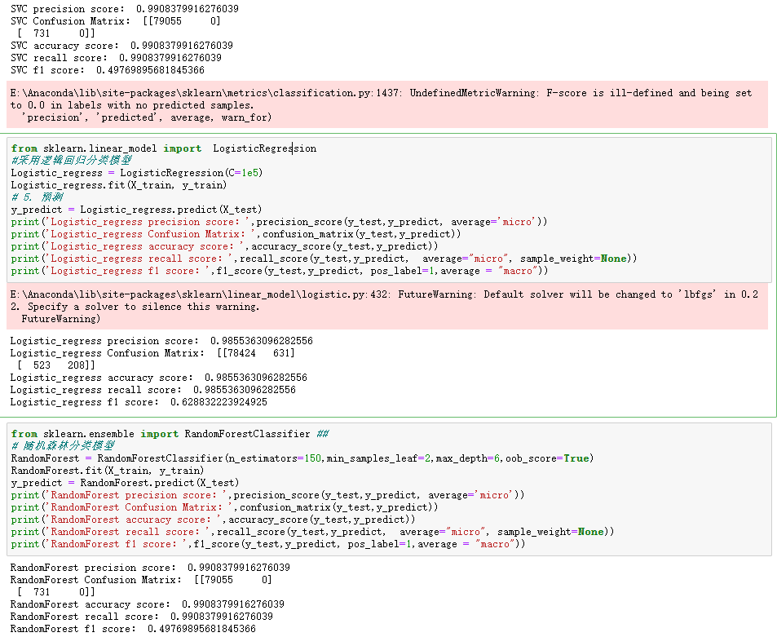

Nonetheless, this kind of result cannot be better than it of regressions, thus I returned to seize the regression model for better excavating the total data.

#### **Modification**

To select the best alpha value of ridge and lasso regression model, I found the API GridSearchCV would be the most suitable tool on progress of deciding the most optimal parameters. What’s more, I set a series of parameters of the lasso model including [0.02,0.03,0.04, 2,3], and the best parameter is 0.02 .

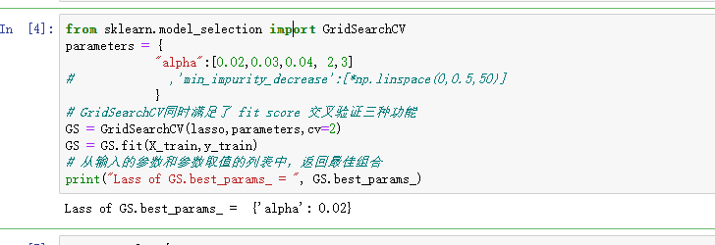

I set a series of parameters of ridge regression model including [0.1,1,2,3], and the best parameter is 1 .

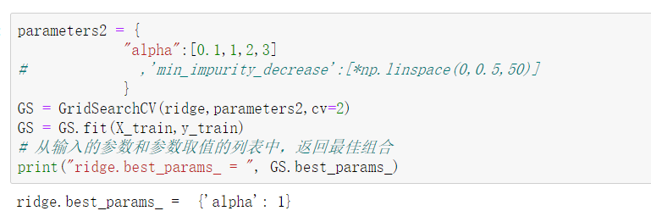

I set a series of parameters of the DecisionTree model including “max_depth:[1,2,3,4,5],” and the best parameter is 4 .

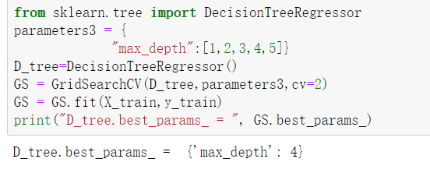

Then I took the optimal parameters of those regressions to explore the regression analysis , the final results ares as follows:

