1. The following sections show graphs of the results of the four major classification models, including predicted and true values.

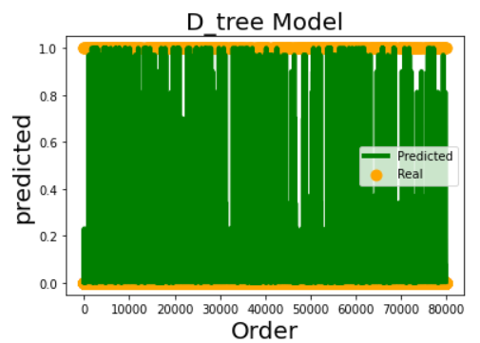

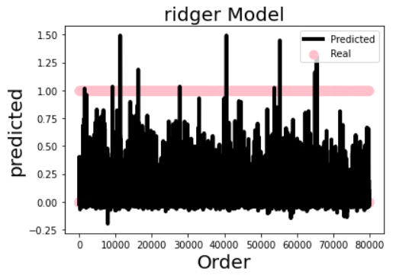

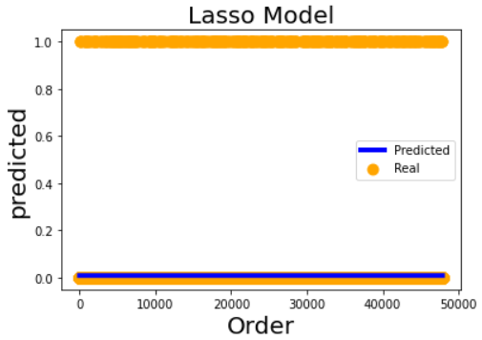

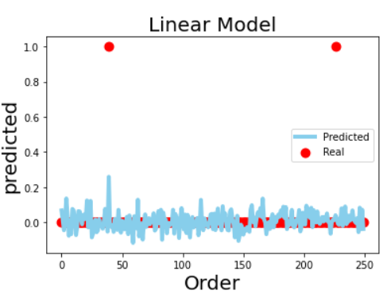

I used sklearn.DecisionTreeRegressor for fitting the regression machine model, sklearn.linear_model. Regression was performed to fit the data to the regression model.

where the mean absolute error, the mean square error, the median absolute error, the explained variance variables, and the r2 score during the training of DecisionTreeRegressor are 0.013787117431068446, 0.007889561597191622, 0.004125190565868532, 0.13094246436246726, 0.13092043845729573.

During Ridge's training, the mean absolute error, mean square error, median absolute error, explained variance variables, and r2 scores were 0.023010864627871105, 0.006756091229664628, 0.009049079836066478, 0.2558479550681073, 0.25577857130749837.

In Lasso's training process, the mean absolute error, mean square error, median absolute error, explained variance variables, and the results of the r2 score were 0.017777346206774767, 0.009291881988991271, 0.008558715834519557, -2.220446049250313e-16, -7.24510514533705e-05.

In the training process of LinearRegression_model, the mean absolute error, mean square error, median absolute error, explained variance variables, and r2 scores were 0.04538344827934254, 0.008250988788484646, 0.031754963975227285,-0.0396801499142716,-0.039691127581231056

The following are examples of the use of the term "-0.09566902495700291, -0.09615498621210516".

This indicates that lower errors represent more accurate classification results for the model. However, if you continue to use linear regression for both training and test set prediction performance begins to suffer. It appears that the predictive model with linear regression has poorer performance.