1. The following sections show graphs of the results of the three major improved classification models, including predicted and real values.

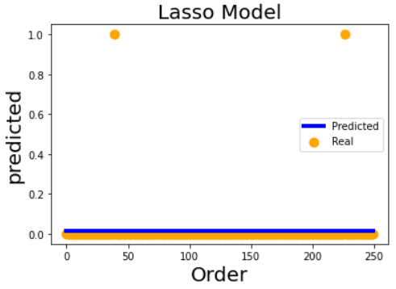

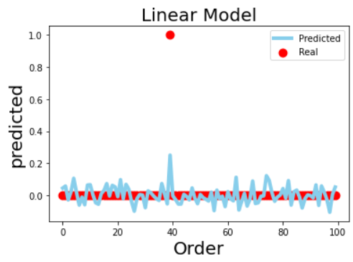

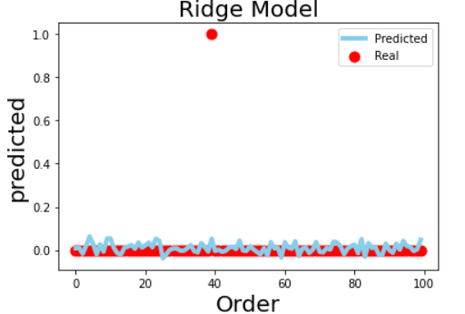

I fit the regression machine model using a parametric boost of the lasso, linear, and ridge regression models.

The alpha parameter was adjusted in the lasso model (alpha=2.0), where the mean absolute error, mean square error, median absolute error, explained variance variables, and r2 scores were 0.023744000000000005, 0.008000000000000002, 0.016, 0.0, -0.008064516129032917 during lasso training. 0.4860729121610042, -4.440892098500626e-16, -7.042100236276383e-11, where the median error was boosted.

The number of training sets was increased to 80% for the linear model, and the mean absolute error, mean square error, median absolute error, explained variance variables, and r2 scores for the linear training process were 0.046559340106311596, 0.00806712445534741, 0.03204373053295611, and 0.19212982665038836. 0.18513894390430197.

Adjusting the ridge model for alpha parameters (alpha=2.0), the mean absolute error, mean square error, median absolute error, and explained variance variables during ridge training resulted in r2 scores of 0.02792540888822014, 0.00953257915393784, 0.014678394615021725, 0.03713752073201526, 0.037113216773955404, 0.5001175250527342, and 0.25330028293883333. 0.48578338025620155, -0.01398728611317357, -0.013987365254694684, where the mean-squared error values were boosted to reduce the mean-squared error.