## **Final Assignment of Kmeans**

#### **Task**

Your work will be assessed on:

* data processing and transformation
* choosing the right number of clusters for the problem
* the organization and documentation of your GitHub repository
* communication of your work in class reflections and final presentations
* model improvement over the semester

### Include with submission:

* I used the “food_enforcement_US_bacteria.json '' dataset containing classification 、center_classification_date reason for recalls. The json file cannot be utilized directly ,thus ,I determine to alter the dataset form into a csv file through API to_csv and fully save the whole data into csv .
* What’s more , I am eager to take many of features of the original data including "event_id", "classification", "center_classification_date", "report_date", "recall_initiation_date","recall_number","city", "distribution_pattern", "recalling_firm", "state", "reason_for_recall" , "initial_firm_notification", "status", "product_description", "code_info" , "address_1", "complete_address" in order to better heed the efficiency of kmeans process .
* In addition, I have to clearn the non standard data pertaining to NaN data which cannot be utilized in the analysis , thus I decide to invoke the API dropna(axis=0) so as to better clear the non standard data existing among the whole dataset .
* For more, The feature class I or class II cannot be fit by the Kmeans API，There is no other choice ， I must change all of them into 0 、1 and 2 in order to get the final result of the cluster.
* After observing the feature of the reason of recall , I notice that this kind of feature is still cannot be used directly , so, using API TfidfVectorizer can absolutely help me turn the character into the numeral features which can be calculated by API kmeans Algorithm.
* Before I conducted the kmeans cluster experiment , I set the parameter n_clusters equal to 3 because I notice that there are 3 kinds of classes refering to class I 、 class II 、 and Nan class. Then ,I have a trail on the feature of "reason_for_recall" .
* From the kmeans fitting model picture , we can konw that the kmeans model still cannot perfectly fit the whole data ,and the kmeans model just exhibits the direct line , thus the kmeans model is absolutely the normal model during the fitting period and process of cluster cases. The kmeans cluster model efficient is as follows :

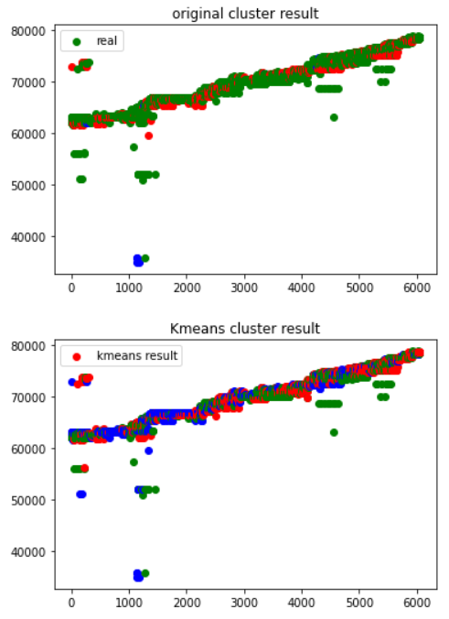

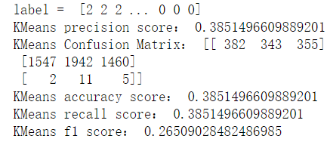

From the result in figure, we can get the conclusion that the kmeans model exhibits the not high precision accuracy and recall, thus kmeans fitting model could not be the optimal model with the feature of reason_for_recall .

Then， I concatenate the features of "center_classification_date", "report_date" with features of recall so as to observe the kmeans efficiency. And the cluster of kmeans is as follows :

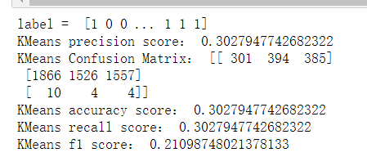

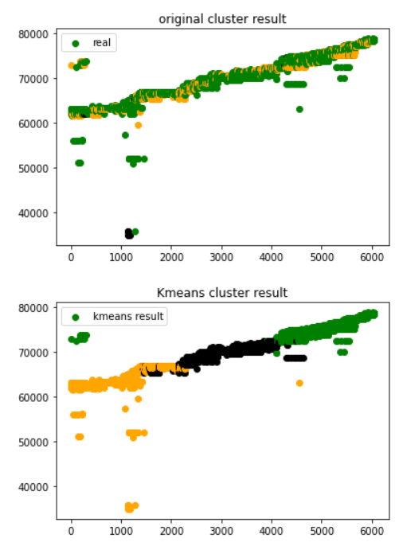

From result in figure, we can get the conclusion that the kmeans model exhibits the lower precision accuracy and recall, thus kmeans fitting model couldnot be the optimal model with the combination feature of center_classification_date", "report_date" with feature of reason of recall .

Then， I concatenate the features of " distribution_pattern" with the feature of reason of recall so as to observe the kmeans efficiency. And the cluster of kmeans is as follows :

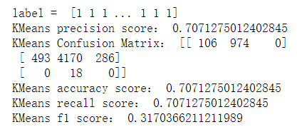

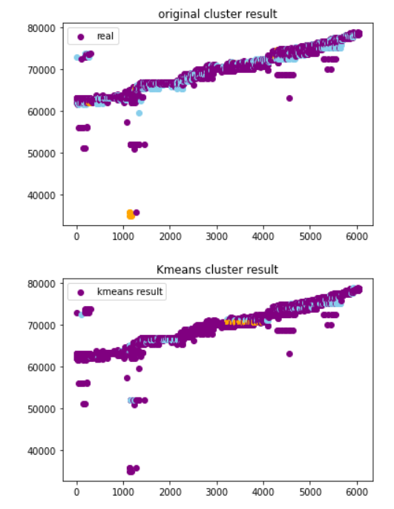

From the result in figure, we can get the conclusion that the kmeans model exhibits the highest precision accuracy and recall, thus kmeans fitting model couldnot be the optimal model with the combination feature of distribution_pattern '' with feature of reason of recall.

I still take other features in exploring final kmeans cluster result ，the result figure is as follows：

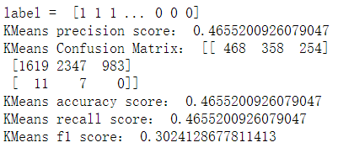

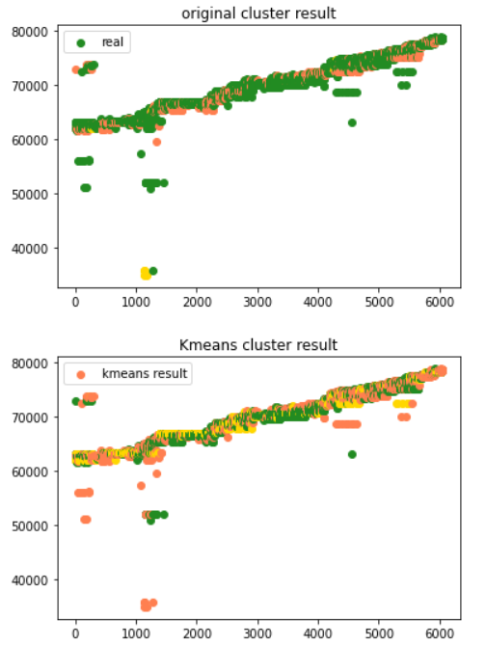

At last，I concatenate the features of " distribution product_description with feature of reason of recall so as to observe the kmeans efficiency. And the cluster of kmeans is as follows :

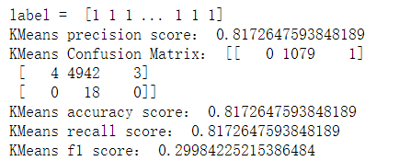

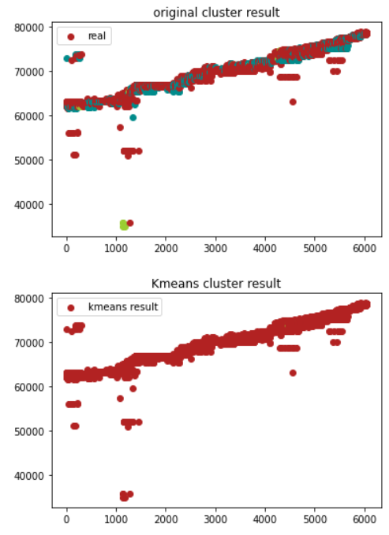

#### **In conclusion**

#### From the result in figure, we can get the conclusion that the kmeans model exhibits the most optimal and highest precision accuracy and recall, thus kmeans fitting model could be the optimal model with the combination feature of “ product_description " with feature of reason of recall.