Article
The Pipeline Overshoots the Shock: An Adaptive-Belief Systems Model of Delayed Educational Supply and Graduate Labour-Market Adjustment
Xinyu Cai ¹, Dingpei Hu ¹ and Tiantian Mo ^{1,}*
Academic Editor: Firstname Lastname
Received: date
Revised: date
Accepted: date
Published: date
Citation: To be added by editorial staff during production.
Copyright: © 2026 by the authors. Submitted for possible open access publication under the terms and conditions of the Creative Commons Attribution (CC BY) license (https://creativecommons.org/licenses/by/4.0/).
¹ College of Business, Jiaxing University, Jiaxing 314001, China; caixinyu@zjxu.edu.cn
* Correspondence: 00008227@zjxu.edu.cn
Abstract
A degree takes four years to produce, so the students who react to a labour market reach it four years late. This paper asks what that delay does to an education system when demand for a field falls abruptly, as demand for entry-level computing work has since 2023. We build a two-field model in which firms hire entry-tier graduates through a matching market with free entry, the two kinds of graduate are imperfect substitutes in production, and entrants choose a field by a discrete-choice rule after forecasting what it will be worth on graduation. Forecasts come from two competing rules—one anchored on the field’s long-run value, one that projects the recent trend—and the weight on each evolves with its recent accuracy, which makes the education system an adaptive belief system in the sense of Brock and Hommes. The labour block is calibrated to four moments of the pre-shock graduate market, matched to thirteen decimal places, and the size of the technology shock is set so that the model reproduces the new-graduate unemployment rate now observed in the exposed field; the whole transition is then free to be right or wrong. Three findings follow. The entering share overreacts on impact by a factor of 2.05: it falls 28.5 per cent when the warranted long-run fall is 13.9 per cent, so most of the enrolment collapse that follows such a shock is transitional rather than warranted. The overreaction is not produced by the delay alone but by the competition between forecasting rules, and it rises monotonically from 1.10 when beliefs are anchored to 2.48 when entrants imitate successful rules sharply. Yet the overreaction is not, on this calibration, a welfare loss: the adjustment cost falls as the response grows, because the alternative error—under-reacting and staying mis-allocated for longer—is the more expensive one. The size of a system’s correction is therefore a poor guide to how well it is behaving, and an instrument ranked on the amplitude of the swing it produces will be ranked backwards.
Keywords: education-to-work transition; adaptive belief systems; heterogeneous expectations; cobweb dynamics; field of study; search and matching; graduate labour market; artificial intelligence; delay and feedback; system stability

1. Introduction
A degree is a slow product. A student who decides in 2026 that computing is where the work is will reach the labour market in 2030, carrying a skill chosen for a market that no longer exists in the form she observed. Every education system in the world runs this delay, and it is long relative to the shocks that now move labour demand. This paper asks what the delay does when demand for one field falls abruptly, and finds that the answer is largely a matter of how students form expectations rather than how large the shock was.
The setting is live. Enrolment in computing rose in the United States for sixteen consecutive years and degree production reached an all-time high in 2022–23; then it fell, and the fall in autumn 2025 was the steepest of any field and the first national decline in about two decades. The market that caused the reversal moved first. High-frequency payroll data show employment of 22-to-25-year-olds in the occupations most exposed to generative artificial intelligence falling by roughly a sixth relative to older workers doing the same jobs [1], and résumé and vacancy data show junior hiring falling in adopting firms through slower recruitment rather than through separations [2]. The evidence is contested—Danish administrative data yield precise nulls over a comparable window [3], and the identification of an AI effect against a concurrent interest-rate shock is genuinely hard—but the model below does not need the shock to be AI. It needs only that entry-level demand in one field fell, which is not in dispute.
What is in dispute, and what matters for policy, is what happens next. The reflex reading of falling enrolment is that the system is correcting: students observed a worse market and are reallocating towards better ones, which is what a price system is supposed to do, and the stakes for young people are high enough that getting it right matters [4–6]. That reading is right about the direction and can be badly wrong about the magnitude, because the correction is made by people who cannot see the correction being made by everyone else. Each entrant observes today’s market, not the market that the four cohorts already enrolled will produce. When enough of them revise at once, the field is under-supplied four years later, its return recovers, and the next cohorts pile back in. This is the cobweb, and it has been understood since Ezekiel [7] and applied to educated labour since Freeman’s model of the engineering market [8,9].
We add the ingredient that the classical cobweb lacks and that fifty years of work on expectations says is decisive. In the classical model everyone forecasts the same way, so the system is stable or unstable once and for all, according to a ratio of elasticities. In practice forecasting rules compete: some students anchor on what a field is worth in the long run, others project the recent trend, and the popularity of each rule depends on how well it has just performed. Brock and Hommes showed that this endogenous selection is itself a source of instability—that as agents imitate successful rules more sharply, a stable equilibrium can lose stability and give way to cycles and worse, with no change in fundamentals and no irrationality on anyone’s part [10]. Their adaptive belief system has been applied to asset markets, to macroeconomic expectations and to commodity markets with production lags [11–13]. It has not, as far as we can establish, been applied to the choice of what to study, which is the market with the longest production lag of all and the one where the consequences of a bad forecast are least reversible.
The paper builds that model and takes it to data. Two fields are imperfect substitutes in production, so the marginal product of a field falls as its entry-tier stock grows. Firms post vacancies under free entry, so a field whose graduates are plentiful is a field in which they are hard to place as well as poorly paid. Entrants choose by a logit rule on the forecast value differential; the forecast is a weighted average of an anchored and an extrapolative rule, and the weights follow the rules’ recent accuracy with intensity of choice ψ. The labour block is calibrated to four moments of the graduate market as it stood before the shock and matches them to twelve decimal places; the size of the shock is then chosen so that the model reproduces the new-graduate unemployment rate now observed in the exposed field, which leaves everything else—the enrolment path, the wage path, the dynamics—free to be right or wrong.
Three findings follow. The first is the paper’s title. The entering share overreacts on impact: it falls 28.5 per cent against a warranted long-run fall of 13.9 per cent, an amplification of 2.05. Most of the enrolment collapse that follows a demand shock of this size is therefore transitional, and it is manufactured by the adjustment process rather than required by the shock. The second concerns where the amplification comes from. It is not the delay alone: with beliefs anchored on the field’s long-run value the amplification is 1.10, which is to say the response is almost exactly what is warranted. It is the competition between forecasting rules that does the work, and the amplification rises monotonically to 1.89 when a trend-projecting rule is present and to 2.48 when entrants imitate the recently successful rule sharply.
The third finding is the one we did not expect, and it cuts against the framing the first two invite. The overreaction is not a welfare loss on this calibration. The discounted output forgone during the adjustment falls as the response grows—from 0.0025 per cent of output under anchored beliefs to 0.0017 per cent under strong imitation—because the alternative error is under-reaction, and a system that adjusts too little stays mis-allocated for longer than one that adjusts too much and comes back. The same reversal shows up in the information experiments: a noisier signal about current returns makes entrants less responsive and shrinks the swing from 2.05 to 1.65, and it raises the adjustment cost; publishing the enrolment pipeline makes the immediate response deeper, and lowers it. The two rankings are opposite because the pipeline tells entrants something true—at the moment of the shock four large pre-shock cohorts are still coming—so the larger response is the better-informed one. The practical implication is a warning about measurement rather than a policy prescription: the amplitude of a correction is not a measure of how badly a system is doing, and an indicator built on it will rank interventions the wrong way round.
The paper contributes to three literatures. To the cobweb tradition in educated labour markets [8,14,15] it adds endogenous expectation formation and an equilibrium labour block, which converts a reduced-form stability condition into a calibrated statement about magnitudes. To the adaptive-belief-systems literature [10,12,16] it adds an application in which the production lag is four years rather than one period and the traded object is a person’s twenties. To the policy debate about steering students towards shortage occupations [17,18] it adds the observation that the stabilising information is not about prices at all.
Section 2 places the paper in the literature. Section 3 sets out the model and defines equilibrium and stability. Section 4 describes the calibration and its over-identifying checks. Section 5 reports the results. Section 6 discusses what follows for measurement and policy and states the limitations. Section 7 concludes.
2. Related Literature
2.1. Cobwebs in Markets for Educated Labour
The cobweb theorem is the observation that when supply is decided one production period before it is sold, and producers forecast the future price by the current one, quantity oscillates [7,19]. Whether the oscillation dies out, persists or explodes depends on the ratio of the supply to the demand elasticity, and Nerlove showed that replacing naive with adaptive expectations damps it [20]. Recent work has returned to the structure with nonlinear methods, establishing the bifurcation structures that regime-switching expectations produce in a cobweb map [21], the effect of asymmetric beliefs on stability [22], and—closest to the present paper—the dynamics that production delays generate when technology choice is endogenous [13,23], and the switching mechanism has been estimated directly in macroeconomic data [24,25]. Poitras provides the intellectual history [26].
The application to educated labour is Freeman’s. His model of the market for new engineers found a supply response to lagged starting salaries strong enough to sustain oscillation rather than damp it [8], and he argued the same structure explained the swing in the returns to college training in the 1970s [9]. Ryoo and Rosen later modelled the engineering market with forward-looking entrants and found a high supply elasticity but a market that clears sensibly [14]. Blume-Kohout and Clack tested cobweb against rational expectations directly in the market for biomedical scientists, using the doubling of the National Institutes of Health budget as the demand shock and the six-year doctorate as the lag, and could not reject the cobweb [15]. What has not been done, on our reading, is to bring this tradition to the field-of-study margin with modern expectation formation and a labour market that generates unemployment as well as wages.
2.2. Field of Study, Its Return and Its Lag
That students respond to the returns to a field is well established, though the size of the response is not. Long, Goldhaber and Huntington-Klein find that completed majors track wages observed about three years earlier—that is, wages at the time the student matriculated—which is direct evidence both of a response and of a lag [27]. Beffy, Fougère and Maurel find the elasticity of field choice to expected earnings to be significant but small in France, and argue that non-pecuniary considerations dominate [28]. Blom, Cadena and Keys show that cohorts who experience high unemployment while studying select into higher-earning fields, a compensating behaviour large enough to offset a meaningful share of the cost of graduating in a recession [29]. Because the published elasticities range from near zero to above one, we treat the elasticity as an externally set parameter, adopt a central value, and map the model’s behaviour across the whole published range rather than resting the results on any single estimate.
The returns themselves are neither stable nor uniform. Field of study explains more of the variance in graduate earnings than institution does [30,31], entry conditions have persistent effects that differ sharply by field [32], and the STEM premium in particular decays over a career as the specific skills it rests on are displaced by newer ones [33], and graduate over-education and field mismatch are persistent in the large systems where they have been measured [34,35]. That last finding matters here: it establishes that the quantity students are trying to forecast is itself moving, which is what makes the extrapolative rule attractive and dangerous at the same time.
2.3. Heterogeneous Expectations and Adaptive Belief Systems
The modelling apparatus is Brock and Hommes’s. Agents choose among a small set of forecasting rules; the population weight on a rule is a logit in its recent realised accuracy net of its cost; and the parameter governing how sharply agents switch—the intensity of choice—is the bifurcation parameter of the system [10,11]. The central result is that raising it destabilises: a costly but accurate rule is driven out by a free but naive one precisely when the system is at rest, so the rest point stops being an attractor. The framework is surveyed in [12,16], has repeated support in laboratory experiments where subjects coordinate on trend-following rules [36], and has been extended and estimated in a variety of settings since [24,25,37–39]. Moll’s recent assessment of what should replace rational expectations in applied macroeconomics is a useful statement of why this class of models is worth taking to data [40].
The apparatus has been applied to markets with production lags—agricultural and commodity markets are the natural case [13,23]—but not, so far as repeated searching can establish, to the education market. That gap is the paper’s opening, and it is not merely an unoccupied box: the education market differs from a commodity market in ways that matter for the mechanism. The lag is four years rather than one season, the decision is taken once and is expensive to reverse, and the good being produced ages into a stock that persists for a career.
2.4. The Shock to Entry-Level Demand
The demand shock the paper feeds in is the contraction in entry-level technical hiring since 2023. Generative artificial intelligence raises productivity most on exactly the tasks that entry-level knowledge work consists of [41,42], its exposure is concentrated in occupations rather than spread evenly [43], and the macroeconomic accounting suggests the aggregate effect over a decade is modest even where the occupational effect is large [44,45]; comparable displacement patterns appear for earlier automation technologies [46–48]. Whether the observed collapse in junior technical hiring is caused by AI is contested; the payroll evidence [1] and the firm-level résumé evidence [2] point one way, Danish administrative data another [3], and part of the movement coincides with a monetary tightening that hit the same sector. Our model is agnostic about the source. It takes as given that the relative demand for entry-tier workers in one field fell, and asks what an education system does with that.
2.5. Delays, Feedback and the Behaviour of Social Systems
The systems tradition arrived at a compatible conclusion from a different direction. Forrester’s argument that complex social systems respond counter-intuitively to intervention rests on delays and feedback of exactly this kind [49], and the experimental work on stock management shows that people misperceive feedback and accumulation systematically, over-ordering when supply lines are long and thereby producing the oscillation they are trying to avoid [50,51]. That literature identifies the same culprit as the economics does—decisions taken on a state variable that the decision itself will change, with a delay in between—and it supplies the vocabulary for the policy section: the leverage in such a system is often in the structure of its information flows rather than in the strength of its incentives [52,53]. Recent work in this journal has applied the same systemic framing to employment and to the digital economy [54–56]. The contribution here is to make that claim quantitative in a market where the delay is a degree.
3. The Model
3.1. Environment
Time is discrete and a period is a year. There are two fields of study, indexed $j$, of which field 1 is the one exposed to the technology shock and field 2 is everything else. Each year a cohort of size $N$ chooses a field. A degree takes $D$ years, so the cohort that enters in year $t$ reaches the labour market in year $t+D$; the $D$ cohorts in between are the pipeline, and they are the model’s memory. Graduates search for work in the market for their field, are matched, hold a job until they separate, and leave the entry tier at rate $γ$, which fixes the length of the entry tier and hence the speed at which the stock of recent graduates can change.
Restricting attention to the entry tier is a modelling choice with consequences, so it is worth defending. A new graduate competes for entry-level positions with other recent graduates rather than with mid-career staff, the evidence on the current shock is specifically about workers in their early twenties [1,2], and the stock a cohort actually crowds is the one that turns over in years rather than decades. Modelling the whole career instead would make the congested stock forty years deep, and a single cohort would then be too small a part of it to matter—which is a statement about the model, not about the world.
3.2. Production and the Entry-Level Market
The two kinds of entry-tier graduate are imperfect substitutes with elasticity $σ$, as in Equation (1), so the marginal product of a field falls in its own employment stock at rate $1/σ$, given in Equation (2). This is the only channel through which one cohort’s decision reaches the next, and $σ$ is therefore the parameter that decides how much a crowded field punishes those who crowd it [57,58]:
$Y_{t} = {\left[\sum_{j=1}^{2}{{\left(A_{jt}E_{jt}\right)}^{ρ}}\right]}^{\frac{1}{ρ}}, ρ = \frac{σ−1}{σ}$ (1)
$p_{jt} = \frac{∂Y_{t}}{∂E_{jt}} = {A_{jt}}^{ρ}{Y_{t}}^{1−ρ}{E_{jt}}^{ρ−1}$ (2)
Hiring is frictional. Field $j$ has a constant-returns matching function over searchers and vacancies, Equation (3), which delivers a job-finding rate that depends only on tightness:
$m_{jt} = μ{S_{jt}}^{α}{V_{jt}}^{1−α}, θ_{jt} = \frac{V_{jt}}{S_{jt}}, f_{jt} = μ{θ_{jt}}^{1−α}$ (3)
The surplus of a match is the marginal product net of the flow value of non-work, capitalised over the rate at which the match ends and adjusted for the fact that the worker’s share raises the value of continued search, Equation (4). Firms post vacancies until the expected cost of a hire equals the firm’s share of that surplus, Equation (5). Together these make tightness—and so the job-finding rate—a decreasing function of the field’s employment stock: an over-supplied field is one in which graduates are both poorly paid and hard to place, which is what distinguishes this from a market-clearing cobweb:
$Σ_{jt} = \frac{p_{jt}−b}{r+δ+γ+ηf_{jt}}$ (4)
$\frac{κ}{q\left(θ_{jt}\right)} = \left(1−η\right)Σ_{jt}, q\left(θ\right) = μθ^{−α}$ (5)
The wage that implements the Nash split and the value of entering the field as a new graduate follow in Equation (6). The second object is what a prospective student is trying to forecast:
$w_{jt} = b+ηΣ_{jt}\left(r+δ+γ+f_{jt}\right), W_{jt} = \frac{b+f_{jt}ηΣ_{jt}}{r}$ (6)
3.3. Stocks and the Pipeline
Employment and search evolve as in Equations (7) and (8), written in annual transition probabilities $F=1−exp(−f)$, $d=1−exp(−δ)$ and $g=1−exp(−γ)$ rather than in rates, because a job-finding rate above one is not a probability and treating it as one manufactures a spurious two-year oscillation:
$E_{j,t+1} = \left[E_{jt}\left(1−d\right)+U_{jt}F_{jt}\right]\left(1−g\right)$ (7)
$U_{j,t+1} = \left[U_{jt}\left(1−F_{jt}\right)+E_{jt}d\right]\left(1−g\right)+G_{j,t+1}$ (8)
The inflow of new graduates is the delay, Equation (9). The share entering field 1 today determines the graduating cohort $D$ years from now, and nothing an entrant does can change the $D−1$ cohorts already enrolled:
$G_{1t} = s_{t−D}N_{t−D}, G_{2t} = \left(1−s_{t−D}\right)N_{t−D}$ (9)
3.4. What Entrants Decide, and How
Entrants compare the annuitised value of the two fields plus a constant amenity differential, Equation (10), and choose by a logit rule with intensity $β$, Equation (11). The amenity absorbs everything that makes a field attractive for reasons other than its labour-market return, which the literature finds to be substantial [28,59]:
$x_{t} = r\left(W_{1t}−W_{2t}\right)+a$ (10)
$s_{t} = \frac{1}{1+exp\left(−β{x_{t}}^{e}\right)}$ (11)
The forecast is where the paper departs from the classical cobweb. Two rules are available, Equation (12). The anchored rule reports the differential that would prevail if the field’s supply were at its long-run level: it is right on average but requires knowing that level, so it carries a cost $c$. The extrapolative rule takes the most recent observation and projects the recent change forward with strength $φ$: it is free, and while a trend lasts it is the more accurate of the two:
${x_{1,t+D}}^{e} = x̄, {x_{2,t+D}}^{e} = x_{t−1}+φ\left(x_{t−1}−x_{t−2}\right)$ (12)
The population weight on each rule is a logit in its recent realised accuracy, net of its cost, with intensity of choice $ψ$, Equation (13); the population forecast is the weighted average, Equation (14). This is the adaptive belief system of Brock and Hommes [10], and $ψ$ is its bifurcation parameter. At $ψ=0$ the weights never move and the system behaves as though beliefs were fixed. As $ψ$ rises, entrants imitate what has recently worked more sharply, and because both rules forecast correctly when the system is at rest, the only thing separating them there is the cost of the anchored one. The free rule therefore crowds out the costly one precisely at the rest point, which is the mechanism by which a sensible individual decision rule destabilises a sensible aggregate:
$n_{ht} = \frac{exp\left(ψπ_{h,t−1}\right)}{\sum_{k=1}^{2}{exp\left(ψπ_{k,t−1}\right)}}, π_{ht} = −{\left(x_{t}−{x_{ht}}^{e}\right)}^{2}−c_{h}$ (13)
${x_{t}}^{e} = \sum_{h=1}^{2}{n_{ht}{x_{h,t+D}}^{e}}$ (14)
Two further parameters describe the information environment and are set to their neutral values in the baseline. The precision $ω$ shrinks the perceived differential towards its long-run value, so a lower $ω$ is a noisier signal about current conditions. The pipeline transparency $p$ replaces part of the anchored rule’s forecast with the differential implied by the cohorts already enrolled: it is what a published enrolment series would give an entrant. Section 5.5 varies both.
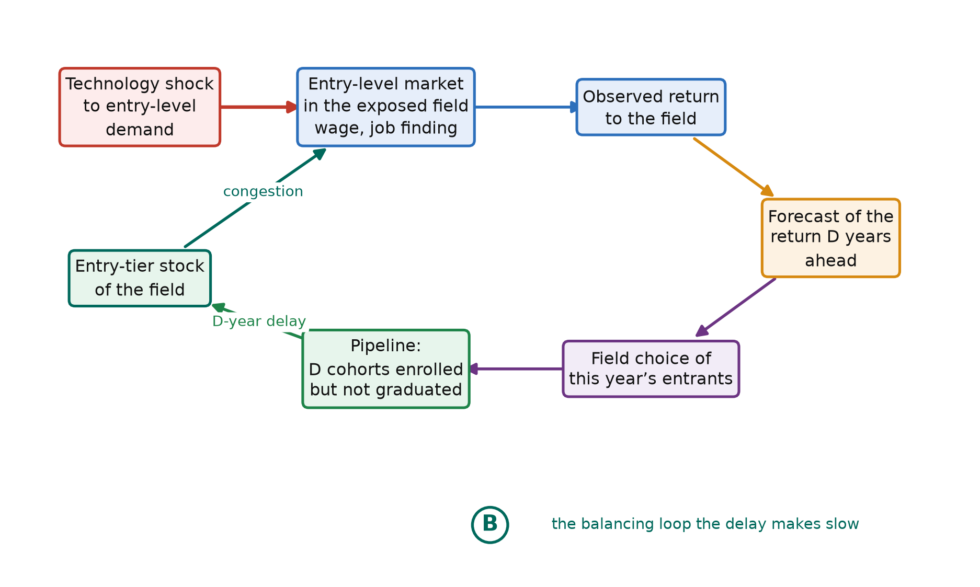
Figure 1. The structure of the model. A technology shock moves entry-level demand in the exposed field; the observed return feeds the forecasts on which this year’s entrants choose; their choice reaches the market only after the degree lag, and then adds to the entry-tier stock whose congestion determines the return. The loop is balancing, and the delay is what makes it slow enough to overshoot.
3.5. Equilibrium, Stability and the Loop Gain
A stationary equilibrium is an entering share, a pair of stocks and a pair of tightnesses such that the stocks reproduce themselves, free entry holds in both fields, and the share is the one the logit rule returns when both forecasting rules are correct. The stationary state is independent of $ψ$ and $φ$, which affect only the dynamics; that separation is what makes it possible to calibrate the labour block on stationary moments and then study the belief block without recalibrating.
Local behaviour is summarised by the loop gain of Equation (15): the derivative of the entering share with respect to the share that entered $D$ years before, holding the belief system at the anchored rule. It is the product of three elasticities—how much an extra cohort depresses a field’s marginal product, how much that lowers the value of entering it, and how strongly entrants respond—and it is negative, because crowding a field makes it less attractive. Under the anchored rule the map is a pure $D$-period delay, so the eigenvalues are the $D$-th roots of the gain, the modulus is the $D$-th root of its absolute value, and the oscillation that appears when stability fails has period $2D$:
$Γ = \frac{ds_{t}}{ds_{t−D}}, \left(λ\right) = {\left|Γ\right|}^{\frac{1}{D}}, T = 2D$ (15)
With endogenous rule selection the state includes the belief system’s own memory and the algebra stops being informative, so we measure the dominant mode numerically: perturb the stationary state, simulate, and read the modulus off the slope of the log envelope of the response. Under anchored beliefs this agrees with the analytical benchmark, which is the check that the numerical procedure is measuring what it claims to.
3.6. The Cost of Adjustment
The welfare object is the output forgone while the system adjusts, Equation (16). The benchmark is the economy that moves to its new stationary share the moment the shock lands. The difference between that path and the realised one is what the adjustment itself costs: output lost because too many graduates hold the skills the economy has stopped wanting and too few hold the ones it now wants. It is a pure mismatch loss, and it is zero by construction if entrants forecast correctly:
$L = \sum_{t=0}^{∞}{{\left(1+r\right)}^{−t}\frac{Y^{*}−Y_{t}}{Y^{*}}} ÷ \sum_{t=0}^{∞}{{\left(1+r\right)}^{−t}}$ (16)
4. Calibration
4.1. Strategy
The calibration is anchored on the economy before the technology shock rather than on the economy we observe today, and the reason is substantive. In this model a field with a high marginal product posts more vacancies, so it pays a higher wage and has a lower unemployment rate. The configuration observed in computing since 2023—an early-career wage premium that remains large alongside a new-graduate unemployment rate above the all-field average—is therefore not a stationary equilibrium of the model at all. It is what the model produces part-way through an adjustment, when a cohort sized for the old demand meets the new one. Calibrating to the pre-shock economy and then asking whether the shock reproduces today’s configuration turns the current data from a target into a test, and that test is reported in Section 4.4.
Two normalisations come first because they determine what is identified. Matching efficiency and the vacancy cost enter every equilibrium object only through their ratio, so the vacancy cost is set to one. Only relative field productivity matters, so the unexposed field’s is set to one. The level of $A₁$ that results is not interpretable on its own—the two labour inputs are different kinds of worker and are not measured in comparable units—so we report the implied relative demand index alongside it.
4.2. Externally Set Parameters
Table 1 lists what is fixed outside the estimation. Three entries carry the weight. The degree lag is four years, the institutional length of a bachelor’s degree; the empirical response of completed majors to wages peaks at about three years, because the decision is effectively taken at matriculation rather than at entry into the major [27], and Section 5.6 varies the lag from three to five; career-stage research has begun to treat the whole sequence of early career steps as itself being reorganised by the technology [60,61]. The elasticity of substitution between the two kinds of graduate is set to two, in the range the literature on substitution between skill groups supports [57,58], and is varied from 1.5 to 4; recent work on digital transformation and labour-structure upgrading suggests the two kinds of graduate are becoming less substitutable, not more [62–64]. The entry tier lasts seven years, so a cohort is about a seventh of the stock it competes with.
Table 1. Parameters set outside the estimation, and the two normalisations that determine what is identified.
Parameter | Symbol | Value | Source or justification
Degree lag | D | 4 | Length of a bachelor’s degree; varied 3–5 in Section 5.6
Discount rate | r | 0.040 | Annual real rate
Matching elasticity | α | 0.500 | Consensus range of the matching-function literature
Worker bargaining power | η | 0.500 | Hosios condition imposed at η=α
Separation rate | δ | 0.100 | Turnover of early-career employment
Exit rate from the entry tier | γ | 0.143 | A seven-year entry tier, ages 22–29
Elasticity of substitution | σ | 2.000 | Substitution between skill groups; varied 1.5–4
Flow value of non-work | b | 0.400 | Standard range relative to the wage
Trend extrapolation | φ | 1.500 | Belief block; varied in Sections 5.3–5.4
Intensity of choice over rules | ψ | 20.0 | Belief block; swept 0–60 in Section 5.4
Cost of the anchored rule | c | 0.020 | Belief block
Memory in the fitness measure | m | 0.500 | Belief block; smooths rule switching
Vacancy cost | κ | 1.000 | Normalisation: only μ/κ is identified
Productivity, unexposed field | A₂ | 1.000 | Normalisation: only relative productivity matters
Notes: Notes: The belief parameters govern the dynamics but not the stationary state, so the labour block can be calibrated on stationary moments without reference to them.
4.3. Estimated Parameters and Targeted Moments
Four parameters are estimated by matching four moments of the pre-shock graduate market. Matching efficiency governs the level of new-graduate unemployment; relative productivity governs the early-career wage premium; the amenity differential governs the share of the cohort that enters the exposed field, since a field can be both well paid and small; and the intensity of choice governs how strongly the share responds to the relative wage. The system is square, so the fit is exact by construction. What Table 2 reports is that an exact solution exists inside the admissible parameter space, which is not guaranteed, and that it is reached to twelve decimal places.
The elasticity of field choice to the relative wage deserves a word, because it is the parameter the results are most sensitive to and the literature does not agree on it. Estimates run from near zero [28] through the response documented by Long, Goldhaber and Huntington-Klein [27] to values above one in Freeman’s engineering market [8]. We adopt 0.60 as a central value and, rather than defend it, map the model’s behaviour across the range 0.2 to 1.4 in Section 5.4. That range is wide enough to contain every published estimate we could verify, and the paper’s qualitative conclusions do not turn on where in it the truth lies.
Table 2. Targeted moments, the fit, and the parameter each moment principally identifies.
Moment | Target | Model | Estimate | Parameter identified
Share of the cohort in the exposed field | 0.055 | 0.055 | −6.418 | a amenity differential
New-graduate unemployment, other fields | 0.055 | 0.055 | 3.848 | μ matching efficiency
Early-career wage premium of the exposed field | 1.350 | 1.350 | 0.106 | A₁ relative productivity
Elasticity of field choice to the relative wage | 0.600 | 0.600 | 0.468 | β intensity of choice
Notes: Notes: The maximum absolute log deviation across the four conditions is 1.8 × 10⁻¹³, so every target is matched to machine precision. The vacancy cost and the unexposed field’s productivity are normalised to one.
4.4. Over-Identifying Checks
Two implications of the calibration were never targeted. The first is the new-graduate unemployment rate inside the exposed field, which the estimated economy puts at 2.5 per cent before the shock against an all-field rate of 5.5 per cent. The direction and the ordering are right—a field with a large wage premium places its graduates faster—but the level is lower than the roughly four to five per cent that computing recorded before 2023, so the model overstates how comfortable the pre-shock position was. The second is the loop gain, which the calibration delivers as −0.307 without being asked to. Its absolute value below one means that a shock dies out under anchored beliefs; the corresponding modulus is the fourth root of 0.307, or 0.744, and the oscillation that would appear if the gain exceeded one would have period 2$D$, that is eight years.
The third check is the transition itself, and it is the one that matters. The size of the shock is chosen so that the exposed field’s new-graduate unemployment rate reaches the 7.0 per cent now observed; nothing else about the path is targeted. The required fall in the relative demand index is 31.0 per cent. The model then produces, without being asked, a compression of the early-career wage premium of 31.2 per cent and a peak unemployment gap between the exposed field and the rest of 1.18 percentage points—that is, it reproduces the configuration that motivated the paper, a field that still pays well and still places its graduates badly, as a property of the transition rather than of any equilibrium.
5. Results
5.1. The Estimated Economy
Table 3 reports the stationary equilibrium the calibration selects. Job finding is fast in both fields, as it should be for graduates in a tight market, and faster in the exposed field, which is why its unemployment rate is lower. The entry-tier stock of the exposed field is about six times its annual graduating cohort, which is the arithmetic of a seven-year entry tier and is what makes a single cohort a modest part of the congestion it faces. That ratio is the quantity that decides how much a cobweb can do here, and it is the reason the delay alone turns out not to be enough.
Table 3. The estimated stationary equilibrium, before the shock.
Quantity | Symbol | Exposed field | Other fields
Share of the entering cohort | s | 0.055 | 0.945
Job-finding rate, per year | f | 3.674 | 2.900
Market tightness | θ | 0.911 | 0.568
Entry-tier employment stock | E | 0.329 | 5.620
Searchers | U | 0.084 | 1.479
Early-career wage | w | 1.382 | 1.023
New-graduate unemployment rate | — | 0.025 | 0.055
Notes: Notes: Stocks are per entering cohort of unit size. The new-graduate unemployment rate of the exposed field is an over-identifying check, not a target. The loop gain implied by this equilibrium is −0.307.
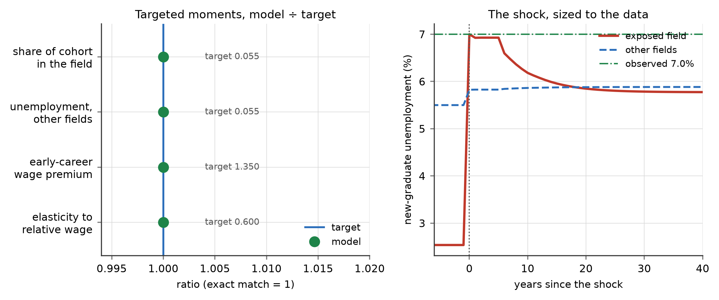
Figure 2. Left: the four targeted moments against their model counterparts; the two are indistinguishable, the maximum absolute log deviation being 1.8 × 10⁻¹³. Right: the shock is sized so that new-graduate unemployment in the exposed field reaches the 7.0 per cent now observed, which requires a 31.0 per cent fall in the relative demand index. Everything else about the path is unconstrained.
5.2. The Transition: Enrolment Overreacts by a Factor of Two
Table 4 and Figure 3 report the transition. The warranted change is a fall in the entering share from 5.50 to 4.74 per cent of the cohort, a decline of 13.9 per cent. What happens instead is that the share falls to 3.75 per cent on impact—a decline of 28.5 per cent, or 2.05 times the warranted one—and then recovers, settling within six years. The overreaction is on impact rather than delayed, which is worth being precise about because it distinguishes this mechanism from the textbook cobweb. Entrants observe the collapse in the field’s return immediately and revise immediately; what the four-year delay does is guarantee that their revision cannot show up in the market for four years, so nothing corrects them in the meantime.
Two features of the path are worth noting because they are untargeted. The early-career wage premium compresses by 31.2 per cent at its trough and then partially recovers, and the gap between the two fields’ new-graduate unemployment rates opens to 1.18 percentage points. Both are transitional. An observer who saw only the enrolment series would conclude that students had abandoned the field; an observer who saw only the long-run equilibrium would conclude that very little had happened. Both would be reading a real number correctly and drawing the wrong inference from it. This is the configuration that the youth-employment statistics record without being able to explain [4,65,66].
Table 4. The transition after the technology shock.
Outcome | Value
Entering share, before the shock | 0.0550
Entering share, on impact | 0.0375
Entering share, long run | 0.0474
Change on impact (%) | −28.45
Change in the long run (%) | −13.87
Amplification (impact ÷ long run) | 2.05
Years to the trough | 0
Years to settle | 6
Fall in the relative demand index (%) | 31.0
Compression of the wage premium (%) | −31.24
Peak unemployment gap (percentage points) | 1.18
Discounted output forgone (% of post-shock output) | 0.0019
Notes: Notes: The long-run share is the mean of the last ten years of a ninety-year simulation. Settling is the first date after the trough from which the share stays within a tenth of the remaining gap to its long-run value.
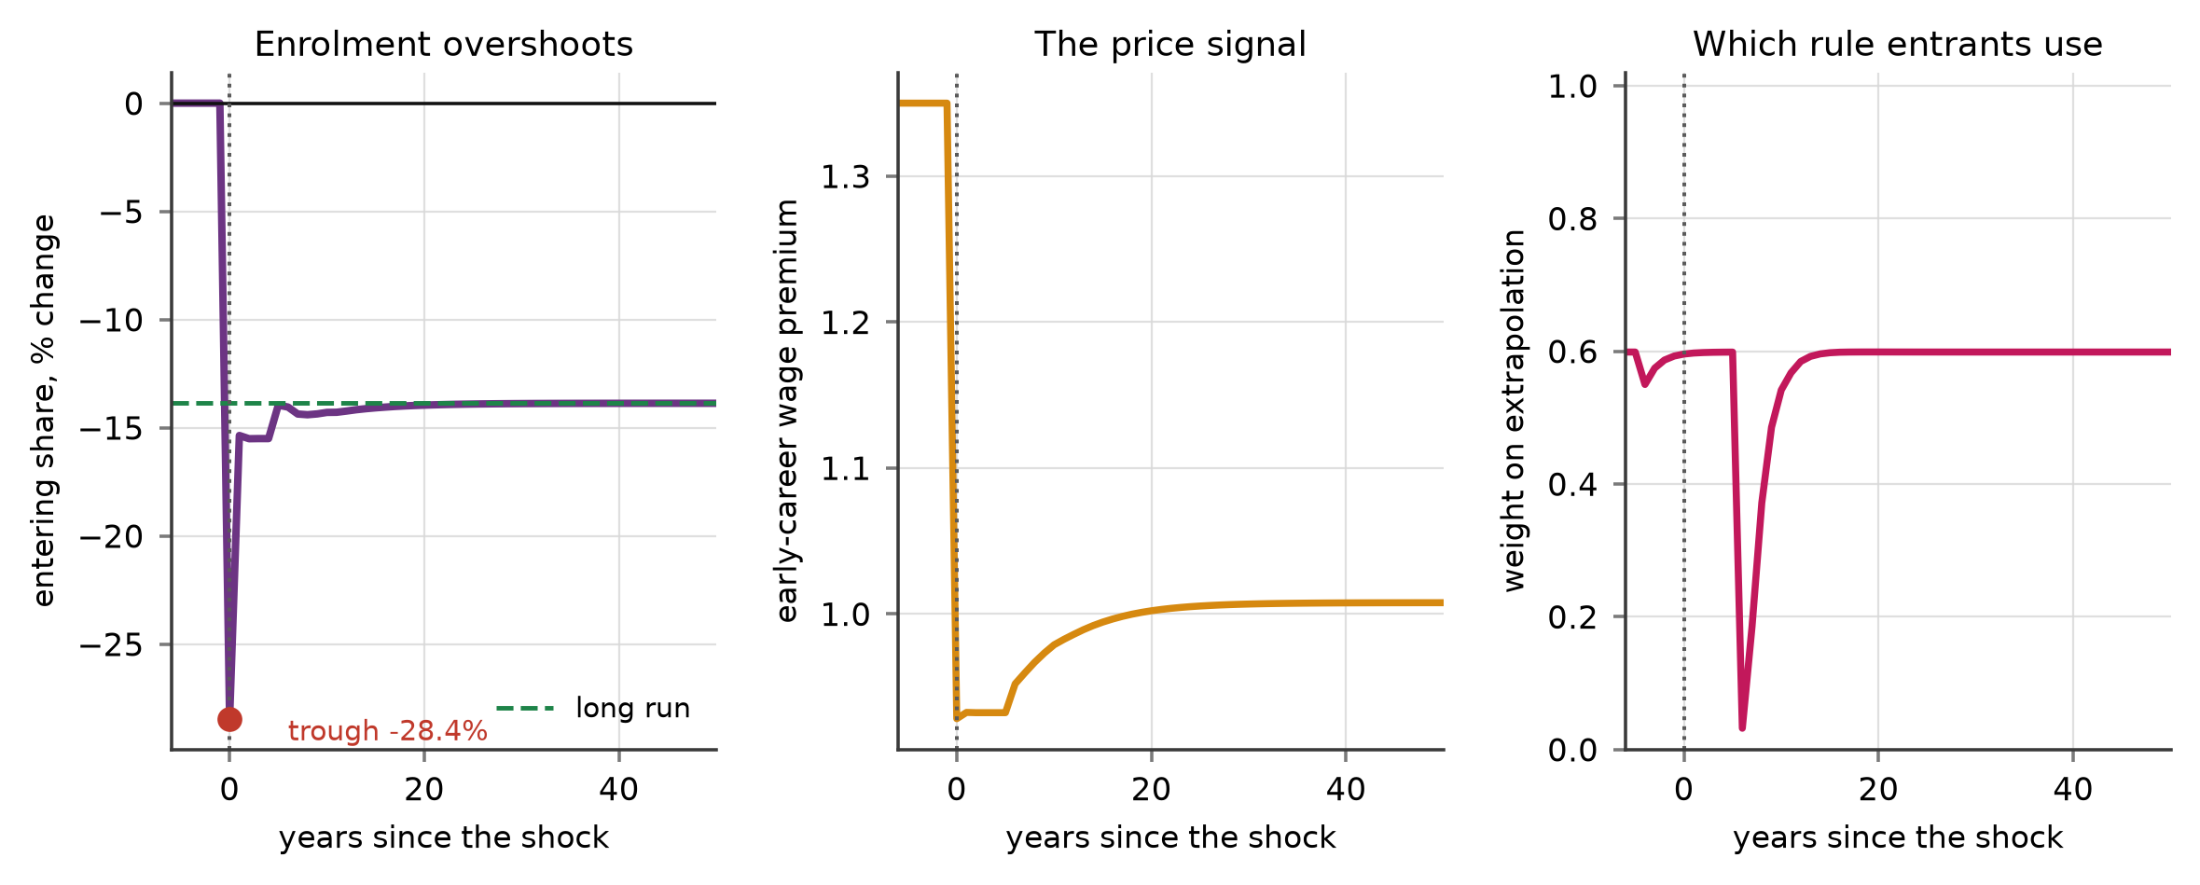
Figure 3. The transition. Left: the entering share overshoots its long-run change by a factor of 2.05 on impact and then recovers. Centre: the early-career wage premium compresses and partially recovers. Right: the weight entrants place on the trend-projecting rule, which rises while the trend lasts and falls back once it breaks.
5.3. Where the Amplification Comes From
The delay is necessary for the overreaction but it is not sufficient, and Table 5 separates the two. With beliefs anchored on the field’s long-run value the amplification is 1.10: the entering share falls 15.3 per cent against a warranted 13.9, which is very nearly the right answer. Introducing a trend-projecting rule alongside the anchored one raises the amplification to 1.89 even with the weights on the two rules held fixed. Letting the weights respond to recent accuracy raises it further to 2.05, and sharpening that response—raising the intensity with which entrants imitate whichever rule has lately been right—raises it to 2.48.
The ordering is monotone and the mechanism is transparent. While the field’s return is falling, the rule that projects the fall forward is the accurate one, so its weight rises, so more entrants project the fall forward, so the fall in enrolment deepens. The loop that selects the forecasting rule is reinforcing even though the loop that allocates students is balancing, and it operates on a timescale of a year or two rather than the four years the balancing loop needs. This is the mechanism Brock and Hommes identified [10], and the contribution here is to show that it survives being embedded in an equilibrium labour market and calibrated.
Table 5. Belief regimes: how much of the overreaction each one produces.
Regime | Weight on the trend rule | Change on impact (%) | Amplification | Output forgone (%)
Anchored beliefs only | 0.00 | −15.31 | 1.10 | 0.00246
Both rules, fixed weights | 0.50 | −26.24 | 1.89 | 0.00201
Both rules, weights respond (baseline) | 0.60 | −28.45 | 2.05 | 0.00192
Both rules, sharp imitation | 0.88 | −34.37 | 2.48 | 0.00166
Notes: Notes: The weight on the trend rule is its stationary value, which depends on the intensity of choice and on the cost of the anchored rule. The four rows differ only in the belief block; the labour block and the shock are identical.
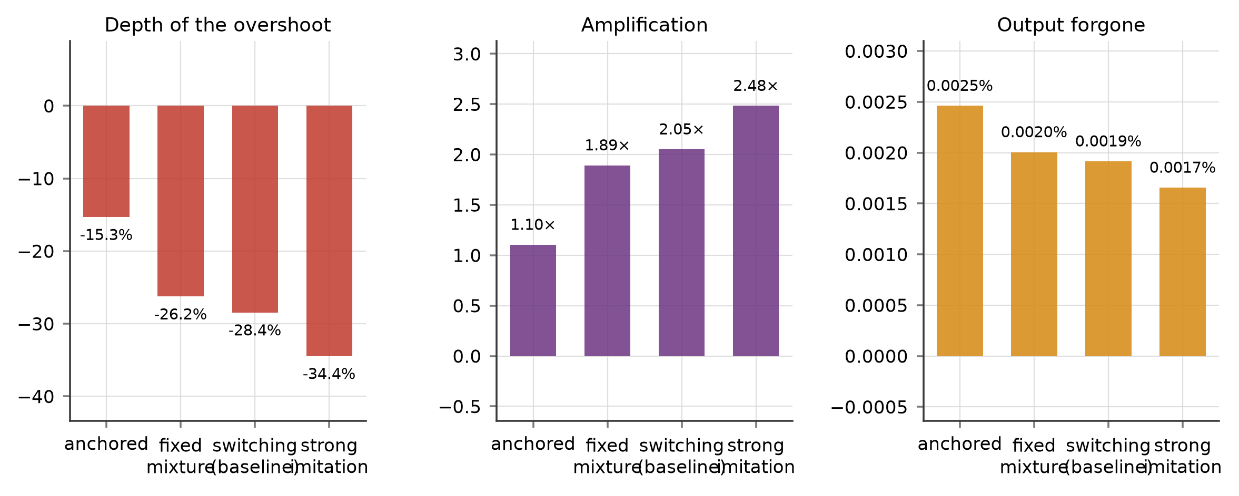
Figure 4. The overreaction by belief regime. The depth of the enrolment response and its amplification both rise monotonically as forecasting moves from anchored to strongly imitative, while the output forgone during the adjustment falls.
5.4. Stability
Because raising the intensity of choice raises the amplification, it is natural to ask whether it eventually destabilises the stationary state, as it does in the asset-pricing applications of this framework. In the calibrated economy it does not. Figure 5 sweeps the intensity of choice from zero to sixty and the modulus of the dominant mode rises from 0.966 to 0.971 and then saturates: it approaches a ceiling below one rather than crossing it. The reason is the ratio noted in Section 5.1. One cohort is about a sixth of the entry-tier stock it competes with, so even a population that forecasts entirely by extrapolation cannot move the congestion enough in one year to sustain a cycle.
That is a negative result and we report it as one, because it bounds what the mechanism can be claimed to do. The instability is not unreachable in principle: the right panel of Figure 5 traces the loop gain across the two elasticities the literature disputes, and the gain approaches one at the top of the published range for the responsiveness of field choice combined with the bottom of the range for substitutability between fields. In the global sweep of Section 5.6, 4.5 per cent of parameter draws are unstable. The honest summary is that the calibrated economy sits comfortably inside the stable region, that the education system’s slow-moving stock is what puts it there, and that a market with a shorter training period or a narrower field definition would sit closer to the boundary.
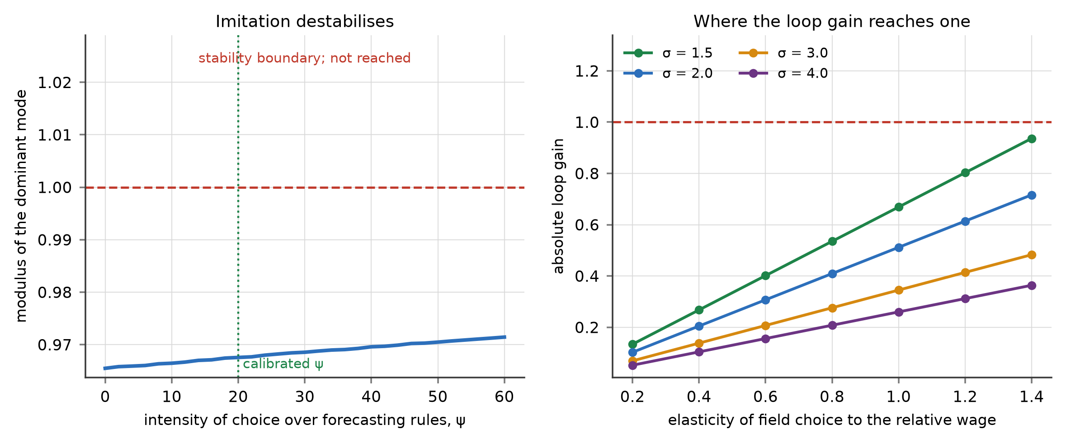
Figure 5. Left: the modulus of the dominant mode against the intensity with which entrants imitate successful forecasting rules. It rises but saturates below one, so the stationary state does not lose stability in the calibrated economy. Right: the loop gain across the elasticity of field choice and the elasticity of substitution between fields; the gain reaches one only in the corner where students are highly responsive and the two kinds of graduate are poor substitutes.
5.5. Information: Two Instruments That Rank in Opposite Orders
Table 6 reports two changes to the information environment. Making the signal about current returns noisier shrinks the enrolment swing substantially, from an amplification of 2.05 to 1.65, because a shrunken perceived differential makes entrants less responsive to everything, including the shock. Publishing the enrolment pipeline does the opposite: it deepens the immediate response, from −28.5 to −29.4 per cent, and raises the amplification to 2.12.
On the welfare measure the ranking reverses. The noisier signal raises the discounted output forgone from 0.00192 to 0.00219 per cent, and publishing the pipeline lowers it to 0.00180, a reduction of about six per cent. The two measures disagree because the deeper response is the better-informed one. At the moment the shock lands, four large pre-shock cohorts are still enrolled and still coming; an entrant who can see them correctly infers that the field will stay crowded for years and correctly leaves harder. The swing is larger and the allocation is better.
This is the paper’s most useful result and it is a warning rather than a prescription. A ministry that judged an information policy by whether it calmed enrolment swings would reject the policy that improves allocation and adopt the one that degrades it, because degrading the signal does calm the swing. Amplitude is not welfare. The systems literature has made this argument about indicators in general [49,52]; here it has a price.
Table 6. Two changes to the information environment.
Information environment | Change on impact (%) | Amplification | Output forgone (%) | Change in loss (%)
Baseline | −28.45 | 2.05 | 0.00192 | 0.0
Noisier signal about current returns | −22.92 | 1.65 | 0.00219 | +14.4
Pipeline published, half weight | −28.95 | 2.09 | 0.00185 | −3.2
Pipeline published, full weight | −29.44 | 2.12 | 0.00180 | −5.9
Notes: Notes: The noisier signal shrinks the perceived return differential towards its long-run value. Publishing the pipeline replaces part of the anchored rule’s forecast with the differential implied by the cohorts already enrolled. A negative change in loss is an improvement.
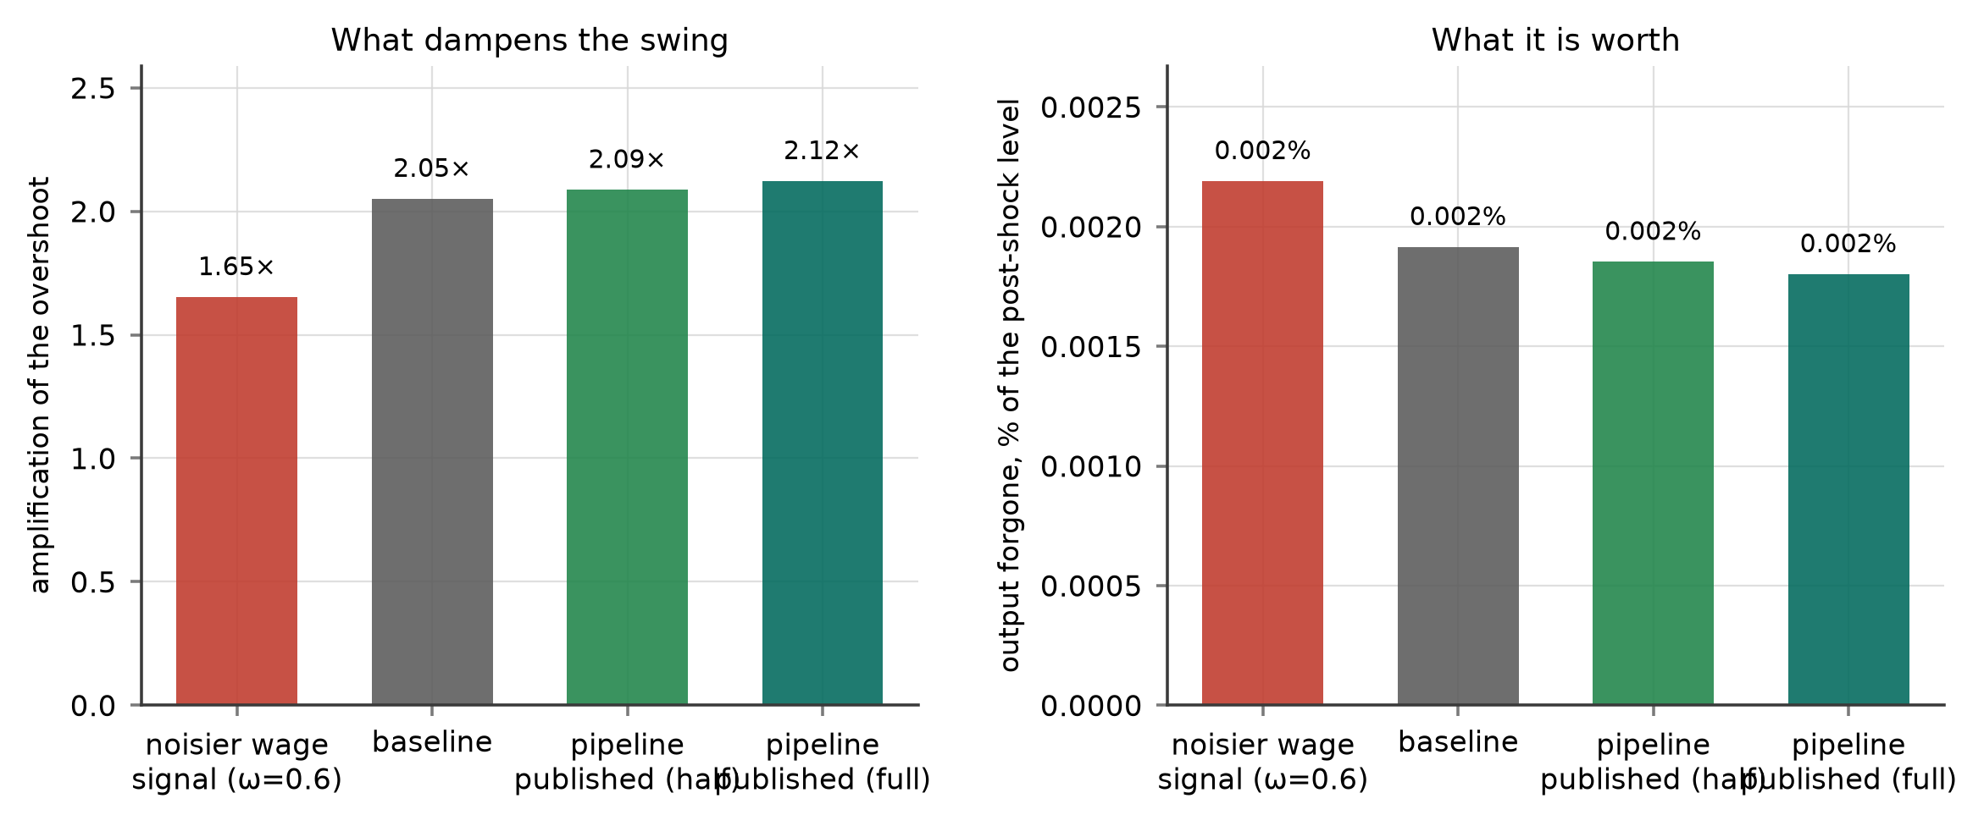
Figure 6. The two information instruments ranked twice. On the amplitude of the enrolment swing (left) the noisier signal looks best and publishing the pipeline looks worst; on the output forgone during the adjustment (right) the order is exactly reversed.
5.6. Global Sensitivity
Six parameters are set outside the estimation, and the results above are conditional on them. We draw 192 Latin hypercube points [67] over the degree lag, the elasticity of substitution, the exit rate from the entry tier, the separation rate, the matching elasticity and the flow value of non-work, re-calibrate at each draw so that all four targets continue to hold exactly, and re-run the shock. Forty-four of the 192 draws admit an exact recalibration; the remainder are combinations for which no admissible parameter vector reproduces all four moments, and they are discarded rather than reported at an approximate fit. That solve rate is low and we state it plainly: the conclusions below rest on the region of the parameter space in which the model can be made to match the data exactly, not on the whole box.
Within that region the central result is stable. The amplification averages 1.98 with a fifth-to-ninety-fifth-percentile range of 1.84 to 2.19, and it exceeds one in every draw, so the overreaction is a property of the mechanism rather than of the baseline calibration. The modulus of the dominant mode averages 0.930 and lies below one in 95.5 per cent of draws, which locates the instability noted in Section 5.4: it exists, it is reachable, and it is not where the calibrated economy sits.
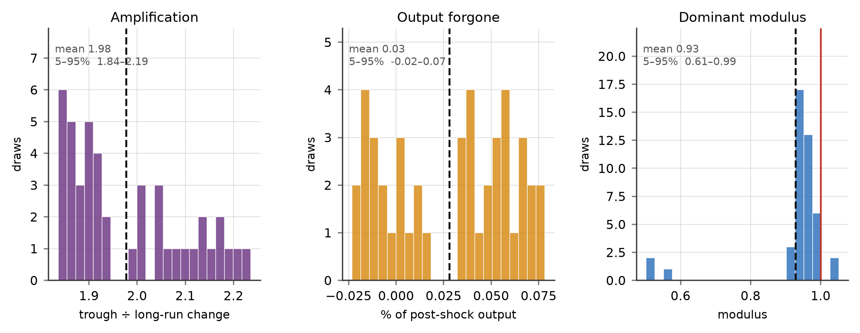
Figure 7. Global sensitivity over the six externally set parameters, across the draws that admit an exact recalibration. The amplification exceeds one in every draw; the dominant modulus lies below one in all but a twentieth of them.
6. Discussion
6.1. What the Delay Does, and What It Does Not Do
The classical reading of a cobweb is that the delay causes the cycle. That is not quite what this model says. A four-year delay with anchored beliefs produces an overshoot, but a modest one: the entering share undershoots its long-run value, recovers, and settles, and the excess is a margin rather than a multiple. The delay is necessary but it is not sufficient. What converts a manageable adjustment into a large one is that the rule entrants use is itself chosen, and chosen on recent performance. During a downturn in a field the extrapolative rule is the accurate one, so its weight rises, so more entrants project the decline forward, so the decline deepens and the rule is vindicated again. The loop that selects the forecasting rule is reinforcing even though the loop that allocates students is balancing, and the reinforcing one operates on a much shorter timescale than the four years the balancing one needs. Laboratory evidence that subjects coordinate on trend-following rules in exactly this way is by now substantial [36,37,39].
This is worth stating plainly because it changes what one would do about it. If the delay were the whole story the only remedies would be to shorten degrees or to make students forward-looking, neither of which is available. Because the amplification runs through rule selection, it responds to the information environment, which is available. That is the practical content of the distinction, and it is why Section 5.5 is the part of the paper a ministry could act on.
6.2. Why More Information Can Make Things Worse
The result that a sharper signal about current wages destabilises the system sits awkwardly beside a literature which finds that correcting students’ beliefs about earnings changes their choices and does so in the direction of better decisions [59,68]. The two are not in conflict, and the reason is worth being precise about. Those studies are partial-equilibrium and static: one student is given better information, holding everyone else’s behaviour fixed, and she chooses better. The present model is neither. When every student receives the sharper signal simultaneously, the thing that is sharpened is the input to a rule that projects the present forward, and the aggregate response arrives four years later against a market that has moved. Better information about a variable makes an individual forecast better and can make a population forecast worse, because the population’s response is part of what has to be forecast.
The literature on information provision has begun to record the same asymmetry from the empirical side: information interventions are not reliably effective once the setting has general-equilibrium content, and a centralised system in which everyone is informed at once behaves differently from a field experiment in which one arm is [18,69]; and the measurement of skills mismatch is itself contested enough that steering on it is hazardous [17,70]. The systems literature reached the same conclusion decades earlier and stated it as a general property: the leverage in a system with delays lies in the structure of its information flows rather than in the strength of its signals [49,52], and people managing a stock with a long supply line systematically over-correct when they can see the stock but not the line [50]. The contribution here is to price that claim in a market where the supply line is a cohort of students and the over-correction is a career.
6.3. What Should Be Published
The stabilising information in this model is the pipeline: how many students are currently enrolled in each field and when they will graduate. That is not a new survey. Every education ministry and every national statistical office already holds it, because enrolment is how institutions are funded. What is missing is publication in a form a seventeen-year-old or her adviser can use—by field, by expected graduation year, and alongside the size of the market those graduates will enter.
Three series would do most of the work, and all three are constructible from existing administrative data. The first is enrolment by field and expected graduation year, which is the pipeline itself. The second is the ratio of the expected graduating cohort in a field to current entry-level hiring in the occupations that field feeds, which is the congestion an entrant will actually meet. The third is the same ratio’s recent history, so that a student can see whether the field she is considering is one that others are also leaving. None of these is a forecast, which matters: a ministry that publishes a forecast takes on a liability and invites the criticism that it got the forecast wrong, whereas a ministry that publishes the pipeline is publishing a fact.
The measurement point generalises beyond the instrument. The statistic that currently governs this debate is the graduate unemployment rate by field, which is a lagging indicator of a stock. By the time it moves, the cohorts that will respond to it have already chosen. An indicator chosen because it is available and comparable comes to define the problem, and this one defines it as a question about the graduates who already exist rather than about the ones being produced [52]. Youth-employment statistics face the same difficulty in their own domain [4,5,71].
6.4. Implications for Systems with Administered Enrolment
The model assumes that entrants allocate themselves and that capacity accommodates them. Several important systems do not work that way. In China the Ministry of Education sets and adjusts programme quotas directly, so the planner holds an instrument the model’s planner does not: it can move the entering share without persuading anyone. That is a genuine advantage and it comes with a genuine hazard, and the model speaks to both.
The advantage is that quota smoothing does not require students to change how they forecast; it simply limits how far the aggregate can move in a year, which is exactly the variable the amplification operates on. The hazard is that an administrative system responds to the same lagging indicator that students do, with its own decision lag on top of the degree lag. A planner who expands programme places in the fields where graduate unemployment is currently low, and contracts them where it is currently high, is running the extrapolative rule with a larger instrument and a longer delay. The literature on China’s higher-education expansion documents how durable such capacity decisions are once taken [72–74], and the durability is precisely what makes an over-correction expensive. The model’s advice to an administrative system is therefore the mirror image of its advice to a market one: the instrument to use is the one that damps the aggregate swing, and the indicator to avoid steering on is the one that arrives late.
6.5. Limitations
Five limitations bound these conclusions. The first is the one that matters most: the belief block’s three parameters—the strength of trend extrapolation, the intensity of choice over rules and the cost of the anchored rule—are set rather than estimated, because the data that would identify them are individual expectations of field-specific returns over time, and we know of no panel that contains them. We therefore report behaviour across the whole plausible range of these parameters rather than at a point, and the qualitative results—overshoot, amplification rising in the intensity of choice, the sign of the two information instruments—hold throughout that range. The magnitudes do not, and should be read as illustrative of a mechanism rather than as forecasts.
Second, the model has two fields. Real students choose among dozens, and the substitution patterns among them are not symmetric: a student leaving computing is more likely to enter engineering than nursing. A richer field structure would dilute the congestion effect for any one field and would let the shock propagate unevenly, which is a first-order extension rather than a refinement. Third, we hold the size of the entering cohort fixed, so the model cannot speak to the margin between higher education and no higher education, which is where much of the recent adjustment in some countries has occurred; the vocational margin in particular behaves differently [6,35,75].
Fourth, the shock is permanent and unanticipated, and it is calibrated to a single observable. A shock that agents expect to reverse would produce a smaller response, and one that arrives gradually would produce a smoother one; the evidence on whether the contraction in entry-level technical hiring is permanent is, at the time of writing, exactly what is in dispute [1,3,76]. Fifth, the model has no on-the-job mobility: a graduate who trained in one field never works in the other. That assumption makes the congestion effect stronger than it should be, and relaxing it would damp the cycle. It also, however, understates the cost of the mismatch, since in the data field-switching involves a substantial earnings penalty [30,33,34].
7. Conclusions
Demand for a field of study can change in a year. The supply of graduates in that field cannot change in less than the length of a degree. This paper asks what an education system does with that mismatch, and answers it with a model in which the labour market is frictional, the two kinds of graduate are imperfect substitutes, and entrants forecast the return to a field using rules whose popularity depends on how well they have recently worked.
The central finding is that the enrolment response to a demand shock overshoots its own long-run value by a large multiple, so that most of the collapse in enrolment observed after such a shock is transitional rather than warranted. The overshoot is not produced by the delay alone; it is produced by the delay together with the endogenous selection of forecasting rules, and it grows monotonically in the sharpness with which students imitate what has recently worked. Past a critical sharpness the stationary state loses stability altogether. Nothing in that sequence requires anyone to behave irrationally: each rule is reasonable, each student is responding sensibly to what she can see, and the aggregate is nonetheless worse than it needs to be.
The policy conclusion is about which information is supplied rather than how much. Sharpening what students know about current returns feeds the rule that projects the present forward and moves the system towards instability. Publishing what is already in the pipeline—the cohorts enrolled and not yet graduated—moves it away, because it lets an entrant price the congestion she will actually meet rather than the one she can currently see. That series is an administrative by-product every education system already holds. The obstacle to using it is not measurement.
The wider point concerns what a labour-market indicator can be asked to do. The graduate unemployment rate by field describes the graduates who already exist. The decision that determines the next cohort is taken four years before that rate will register it, by people who cannot observe one another. A system that steers on the indicator it has will keep arriving late, and will keep mistaking the size of its own correction for the size of the shock it is correcting for.
Author Contributions: Conceptualization, methodology, formal analysis, software and writing—original draft preparation, X.C.; validation, data curation and visualization, D.H.; investigation, writing—review and editing, and supervision, T.M. All authors have read and agreed to the published version of the manuscript.
Funding: This research was funded by the Zhejiang Provincial Philosophy and Social Sciences Planning Special Project on Higher Education Basic Research Funding Reform (Grant Number: 25NDJC153YBMS) and the Major Humanities and Social Sciences Research Projects in Zhejiang Higher Education Institutions (Grant Number: 2024QN018).
Institutional Review Board Statement: Not applicable. The study is a structural simulation calibrated to published aggregate statistics and involves no human participants or animals.
Informed Consent Statement: Not applicable.
Data Availability Statement: The model is fully specified by Equations (1)–(16). No individual-level data were used; every calibration target is drawn from the published sources listed in Table 3. The code that solves, calibrates and simulates the model and that generates every figure and table in this paper is available from the corresponding author on reasonable request.
Acknowledgments: The authors thank the editors and the anonymous reviewers for comments that improved the manuscript.
Conflicts of Interest: The authors declare no conflicts of interest.
Abbreviations
The following abbreviations are used in this manuscript: ABS, adaptive belief system; AI, artificial intelligence; CES, constant elasticity of substitution; DMP, Diamond–Mortensen–Pissarides; LHS, Latin hypercube sampling.
References
1. Brynjolfsson, E.; Chandar, B.; Chen, R. Canaries in the Coal Mine? Six Facts about the Recent Employment Effects of Artificial Intelligence; Working Paper; Stanford Digital Economy Lab: Stanford, CA, USA, 2025.
2. Hosseini Maasoum, S.M.; Lichtinger, G. Generative AI as Seniority-Biased Technological Change: Evidence from U.S. Résumé and Job Posting Data; SSRN Working Paper No. 5425555; Social Science Research Network: Rochester, NY, USA, 2025.
3. Humlum, A.; Vestergaard, E. Still Waters, Rapid Currents: Early Labor Market Transformation under Generative AI; NBER Working Paper No. 33777; National Bureau of Economic Research: Cambridge, MA, USA, 2025.
4. International Labour Organization (ILO). Global Employment Trends for Youth 2024: Decent Work, Brighter Futures; ILO: Geneva, Switzerland, 2024.
5. Karma, E. NEET youth in central and eastern European countries: a panel model approach. J. Youth Stud. 2025, 28, 1458–1475.
6. Başol, O.; Sevgi, H.; Yalçın, E.C. The Effect of Digitalization on Youth Unemployment for EU Countries: Treat or Threat? Sustainability 2023, 15, 11080.
7. Ezekiel, M. The Cobweb Theorem. Q. J. Econ. 1938, 52, 255–280.
8. Freeman, R.B. A Cobweb Model of the Supply and Starting Salary of New Engineers. Ind. Labor Relat. Rev. 1976, 29, 236–248.
9. Freeman, R.B. Overinvestment in College Training? J. Hum. Resour. 1975, 10, 287–311.
10. Brock, W.A.; Hommes, C.H. A Rational Route to Randomness. Econometrica 1997, 65, 1059–1095.
11. Brock, W.A.; Hommes, C.H. Heterogeneous Beliefs and Routes to Chaos in a Simple Asset Pricing Model. J. Econ. Dyn. Control 1998, 22, 1235–1274.
12. Hommes, C.H. Behavioral and Experimental Macroeconomics and Policy Analysis: A Complex Systems Approach. J. Econ. Lit. 2021, 59, 149–219.
13. Hommes, C.H.; Li, K.; Wagener, F. Production Delays and Price Dynamics. J. Econ. Behav. Organ. 2022, 194, 341–362.
14. Ryoo, J.; Rosen, S. The Engineering Labor Market. J. Political Econ. 2004, 112, S110–S140.
15. Blume-Kohout, M.E.; Clack, J.W. Are Graduate Students Rational? Evidence from the Market for Biomedical Scientists. PLoS ONE 2013, 8, e82759.
16. Hommes, C.H. Behavioral Rationality and Heterogeneous Expectations in Complex Economic Systems; Cambridge University Press: Cambridge, UK, 2013.
17. Brunello, G.; Wruuck, P. Skill Shortages and Skill Mismatch: A Review of the Literature. J. Econ. Surv. 2021, 35, 1145–1167.
18. Haaland, I.; Roth, C.; Wohlfart, J. Designing Information Provision Experiments. J. Econ. Lit. 2023, 61, 3–40.
19. Kaldor, N. A Classificatory Note on the Determinateness of Equilibrium. Rev. Econ. Stud. 1934, 1, 122–136.
20. Nerlove, M. Adaptive Expectations and Cobweb Phenomena. Q. J. Econ. 1958, 72, 227–240.
21. Gardini, L.; Radi, D.; Schmitt, N.; Sushko, I.; Westerhoff, F. Bifurcation Structures of a Two-Dimensional Piecewise Linear Discontinuous Map: Analysis of a Cobweb Model with Regime-Switching Expectations. Nonlinear Dyn. 2024, 112, 15601–15624.
22. Berardi, M. Beliefs Asymmetry and Price Stability in a Cobweb Model. J. Econ. Behav. Organ. 2022, 203, 401–415.
23. Dieci, R.; Mignot, S.; Westerhoff, F. Production Delays, Technology Choice and Cyclical Cobweb Dynamics. Chaos Solitons Fractals 2022, 156, 111796.
24. Kukacka, J.; Sacht, S. Estimation of Heuristic Switching in Behavioral Macroeconomic Models. J. Econ. Dyn. Control 2023, 146, 104585.
25. Gusella, F.; Ricchiuti, G. Endogenous Cycles in Heterogeneous Agent Models: A State-Space Approach. J. Evol. Econ. 2024, 34, 739–782.
26. Poitras, G. Cobweb Theory, Market Stability, and Price Expectations. J. Hist. Econ. Thought 2023, 45, 137–161.
27. Long, M.C.; Goldhaber, D.; Huntington-Klein, N. Do Completed College Majors Respond to Changes in Wages? Econ. Educ. Rev. 2015, 49, 1–14.
28. Beffy, M.; Fougère, D.; Maurel, A. Choosing the Field of Study in Postsecondary Education: Do Expected Earnings Matter? Rev. Econ. Stat. 2012, 94, 334–347.
29. Blom, E.; Cadena, B.C.; Keys, B.J. Investment over the Business Cycle: Insights from College Major Choice. J. Labor Econ. 2021, 39, 1043–1082.
30. Kirkebøen, L.J.; Leuven, E.; Mogstad, M. Field of Study, Earnings, and Self-Selection. Q. J. Econ. 2016, 131, 1057–1111.
31. Bleemer, Z.; Mehta, A. Will Studying Economics Make You Rich? A Regression Discontinuity Analysis of the Returns to College Major. Am. Econ. J. Appl. Econ. 2022, 14, 1–22.
32. Altonji, J.G.; Kahn, L.B.; Speer, J.D. Cashier or Consultant? Entry Labor Market Conditions, Field of Study, and Career Success. J. Labor Econ. 2016, 34, S361–S401.
33. Deming, D.J.; Noray, K. Earnings Dynamics, Changing Job Skills, and STEM Careers. Q. J. Econ. 2020, 135, 1965–2005.
34. Jones, M.K.; Kaya, E.; Nan, J. Overeducation, earnings and job satisfaction among graduates in China. China Econ. Rev. 2025, 93, 102448.
35. Dai, L.; Martins, P.S. Does vocational education pay off in China? Evidence from city-level education supply shocks. Econ. Model. 2024, 140, 106863.
36. Hommes, C.H. The Heterogeneous Expectations Hypothesis: Some Evidence from the Lab. J. Econ. Dyn. Control 2011, 35, 1–24.
37. Boehl, G.; Hommes, C.H. Rational vs. Irrational Beliefs in a Complex World. J. Econ. Behav. Organ. 2025, 232, 106898.
38. Di Francesco, T.; Hommes, C.H. Sentiment-Driven Speculation in Financial Markets with Heterogeneous Beliefs: A Machine Learning Approach. J. Econ. Dyn. Control 2025, 175, 105077.
39. Evans, G.W.; Gibbs, C.G.; McGough, B. A Unified Model of Learning to Forecast. Am. Econ. J. Macroecon. 2025, 17, 101–133.
40. Moll, B. The Trouble with Rational Expectations in Heterogeneous Agent Models: A Challenge for Macroeconomics. Econ. J. 2025, 135, ueaf104.
41. Noy, S.; Zhang, W. Experimental evidence on the productivity effects of generative artificial intelligence. Science 2023, 381, 187–192.
42. Brynjolfsson, E.; Li, D.; Raymond, L. Generative AI at Work. Q. J. Econ. 2025, 140, 889–942.
43. Eloundou, T.; Manning, S.; Mishkin, P.; Rock, D. GPTs are GPTs: Labor market impact potential of LLMs. Science 2024, 384, 1306–1308.
44. Acemoglu, D. The Simple Macroeconomics of AI. Econ. Policy 2025, 40, 13–58.
45. Cheng, C.; Luo, J.; Zhu, C.; Zhang, S. Artificial intelligence and the skill premium: A numerical analysis of theoretical models. Technol. Forecast. Soc. Change 2024, 200, 123140.
46. Wang, T.; Zhang, Y.; Liu, C. Robot adoption and employment adjustment: Firm-level evidence from China. China Econ. Rev. 2024, 84, 102137.
47. Zhu, G.; Nie, A. How industrial robots affect employment: firm-level evidence from China. J. Asia Pac. Econ. 2026, 31, 31–61.
48. Huang, K.; Liu, Q.; Tang, C. Which firms benefit from robot adoption? Evidence from China. J. Asian Econ. 2023, 86, 101612.
49. Forrester, J.W. Counterintuitive Behavior of Social Systems. Technol. Rev. 1971, 73, 52–68.
50. Sterman, J.D. Misperceptions of Feedback in Dynamic Decision Making. Organ. Behav. Hum. Decis. Process. 1989, 43, 301–335.
51. Sterman, J.D. Modeling Managerial Behavior: Misperceptions of Feedback in a Dynamic Decision Making Experiment. Manag. Sci. 1989, 35, 321–339.
52. Meadows, D.H. Thinking in Systems: A Primer; Wright, D., Ed.; Chelsea Green Publishing: White River Junction, VT, USA, 2008.
53. Sterman, J.D. Business Dynamics: Systems Thinking and Modeling for a Complex World; Irwin/McGraw-Hill: Boston, MA, USA, 2000.
54. Fernández-Portillo, A.; Ramos-Vecino, N.; Calzado-Barbero, M.; Robina-Ramírez, R. Does Innovation Create Employment Indirectly through the Improvement Generated in the Company’s Economic and Financial Results? Systems 2023, 11, 381.
55. Yang, Y.; Lin, G.T.R. Local Digital Economic Growth, Enterprise Digital Transformation, and Digital Dividends: Evidence from China. Systems 2025, 13, 297.
56. Song, Y.; Qiu, X.; Liu, J. The Impact of Artificial Intelligence Adoption on Organizational Decision-Making: An Empirical Study Based on the Technology Acceptance Model in Business Management. Systems 2025, 13, 683.
57. Katz, L.F.; Murphy, K.M. Changes in Relative Wages, 1963–1987: Supply and Demand Factors. Q. J. Econ. 1992, 107, 35–78.
58. Ciccone, A.; Peri, G. Long-Run Substitutability between More and Less Educated Workers: Evidence from U.S. States, 1950–1990. Rev. Econ. Stat. 2005, 87, 652–663.
59. Wiswall, M.; Zafar, B. Determinants of College Major Choice: Identification Using an Information Experiment. Rev. Econ. Stud. 2015, 82, 791–824.
60. Bankins, S.; Jooss, S.; Restubog, S.L.D.; Marrone, M.; Ocampo, A.C.; Shoss, M. Navigating career stages in the age of artificial intelligence: A systematic interdisciplinary review and agenda for future research. J. Vocat. Behav. 2024, 153, 104011.
61. Battisti, M.; Dustmann, C.; Schönberg, U. Technological and Organizational Change and the Careers of Workers. J. Eur. Econ. Assoc. 2023, 21, 1551–1594.
62. Dou, B.; Guo, S.; Chang, X.; Wang, Y. Corporate digital transformation and labor structure upgrading. Int. Rev. Financ. Anal. 2023, 90, 102904.
63. Li, X.; Wang, Q.; Kong, D.; Tao, Y. Intelligent Manufacturing and Corporate Human Capital Upgrade in China. J. Asian Econ. 2025, 97, 101886.
64. Heß, P.; Janssen, S.; Leber, U. The effect of automation technology on workers’ training participation. Econ. Educ. Rev. 2023, 96, 102438.
65. Ogbonna, A.E.; Adediran, I.A.; Oloko, T.F.; Isah, K.O. Information and Communication Technology (ICT) and youth unemployment in Africa. Qual. Quant. 2023, 57, 5055–5077.
66. Xiong, B.; Yu, B. The Impact of Internet Development on Youth’s Job Quality in the Digital Economy Era: Transmission Mechanism and Empirical Test. Soc. Indic. Res. 2024, 175, 269–294.
67. McKay, M.D.; Beckman, R.J.; Conover, W.J. A Comparison of Three Methods for Selecting Values of Input Variables in the Analysis of Output from a Computer Code. Technometrics 1979, 21, 239–245.
68. Conlon, J.J. Major Malfunction: A Field Experiment Correcting Undergraduates’ Beliefs about Salaries. J. Hum. Resour. 2021, 56, 922–939.
69. Ajayi, K.F.; Friedman, W.H.; Lucas, A.M. When Information Is Not Enough: Evidence from a Centralised School Choice System. Econ. J. 2026, 136, 26–60.
70. Bischof, S. Test-Based Measurement of Skill Mismatch: A Validation of Five Different Measurement Approaches Using the NEPS. J. Labour Mark. Res. 2024, 58, 11.
71. Rahmani, H.; Groot, W.; Rahmani, A.M. Unravelling the NEET phenomenon: A systematic literature review and meta-analysis of risk factors for youth not in education, employment, or training. Int. J. Adolesc. Youth 2024, 29, 2331576.
72. Li, S.; Whalley, J.; Xing, C. China’s Higher Education Expansion and Unemployment of College Graduates. China Econ. Rev. 2014, 30, 567–582.
73. Ou, D.; Zhao, Z. Higher Education Expansion in China, 1999–2003: Impact on Graduate Employability. China World Econ. 2022, 30, 117–141.
74. Huang, B.; Tani, M.; Wei, Y.; Zhu, Y. Returns to Education in China: Evidence from the Great Higher Education Expansion. China Econ. Rev. 2022, 74, 101804.
75. Marczuk, A. Literature review of comparative school-to-work research: How institutional settings shape individual labour market outcomes. J. Labour Mark. Res. 2024, 58, 19.
76. Hui, X.; Reshef, O.; Zhou, L. The Short-Term Effects of Generative Artificial Intelligence on Employment: Evidence from an Online Labor Market. Organ. Sci. 2024, 35, 1977–1989.
Disclaimer/Publisher’s Note: The statements, opinions and data contained in all publications are solely those of the individual author(s) and contributor(s) and not of MDPI and/or the editor(s). MDPI and/or the editor(s) disclaim responsibility for any injury to people or property resulting from any ideas, methods, instructions or products referred to in the content.

