Article
The Narrowing Entry Port: Generative Artificial Intelligence Adoption, Task Routinisation and Youth Employment in Chinese Listed Firms
Xinyu Cai ¹ and Tiantian Mo ^{1,*}
Academic Editor: Ali Ahsan
Received: date
Revised: date
Accepted: date
Published: date
Citation: To be added by editorial staff during production.
Copyright: © 2026 by the authors. Submitted for possible open access publication under the terms and conditions of the Creative Commons Attribution (CC BY) license (https://creativecommons.org/licenses/by/4.0/).
¹ College of Business, Jiaxing University, Jiaxing 314001, China; caixinyu@zjxu.edu.cn
* Correspondence: 00008227@zjxu.edu.cn
Abstract
Generative artificial intelligence diffuses fastest through the codified, routine-cognitive work that firms have traditionally allocated to new entrants, which places the entry port of the professional career directly in the path of the technology. Using a panel of Chinese A-share listed firms over 2016–2025 (27,340 firm-year observations for 3,398 firms) and a text-based measure of firm-level generative AI adoption, this study estimates how adoption reshapes the age structure of corporate employment and identifies the organisational conditions that govern the outcome. Two-way fixed-effects estimates show that a one-unit increase in generative AI adoption intensity lowers the share of employees aged 30 or below by 0.622 percentage points, equivalent to 3.5% of the sample mean for a one-standard-deviation increase; instrumental-variable, propensity-score-matched and entropy-balanced estimates are of the same sign and somewhat larger. A decomposition of the mechanism shows that the effect operates through two opposing channels: task routinisation, which transmits 45.9% of the total effect and is displacing, and human-capital upgrading, which transmits 15.8% in the opposite direction and is complementary. The net outcome is not a technological constant. It is conditioned by the firm as a socio-technical system: the negative effect is about 61% smaller in firms that disclose AI governance arrangements and is statistically indistinguishable from zero above the 90th percentile of organisational learning capability. Displacement of young workers is therefore best read as a consequence of how firms organise learning around the technology rather than of the technology itself, which places workforce development, not adoption speed, at the centre of the policy problem.
Keywords: generative artificial intelligence; youth employment; task routinisation; organisational learning; AI governance; socio-technical systems; human capital

1. Introduction
The labour-market question raised by generative artificial intelligence (GenAI) is no longer whether the technology raises productivity. Field experiments have settled that: customer-support agents resolved 14% more issues per hour [1], professional writers completed tasks roughly 40% faster and at higher rated quality [2], consultants improved on tasks inside the technology's frontier [3], and software developers completed 26% more tasks across three randomised deployments [4]. The open question is distributional, and one regularity in that evidence makes it urgent. The gains are concentrated among the least experienced: novice support agents gained about 30% while their most experienced colleagues gained little or nothing [1], the lowest-performing entrepreneurs benefited while the highest-performing ones did not [5], and less experienced developers both adopted the tool more readily and gained more from it [4,6]. Meta-analytic evidence on human–AI combinations reaches the same conclusion [7].
Experience compression is double-edged. If the technology substitutes for experience, an employer needs fewer years of it, and young workers should become relatively more attractive. But the same property means that GenAI is closest to substituting for the work that young workers actually do. Occupational exposure measures place the highest scores on codified, verifiable text-and-code tasks [8,9] — first drafts, structured summarisation, standard analysis, basic coding — which is precisely the bundle that firms assign to new entrants and that the task-based literature classifies as routine-cognitive [10]. Which of the two forces dominates is an empirical question, and the earliest evidence is not reassuring: United States payroll microdata show a relative employment decline on the order of 13–16% for workers aged 22–25 in the most AI-exposed occupations after late 2022, with no corresponding movement for experienced workers in the same occupations and firms [11], although other designs find much smaller aggregate effects over the same window [12,13]. Adoption itself has been extraordinarily fast by historical standards [14], so the window in which firms could adjust job structures gradually has been short.
That divergence is itself informative. If the effect were a property of the technology, estimates across settings would converge. That they do not suggests the effect is a property of the adopting organisation, which is the premise of this paper. Firms are socio-technical systems in which a technical subsystem and a social subsystem of routines, training and supervision are jointly responsible for performance, so a change in one cannot be evaluated without the other [15–17]. Applied here, the same adoption decision should displace young workers where the firm treats GenAI as a substitute for entry-level labour, and should not where the firm has the absorptive capacity [18] and the governance arrangements to redesign entry work around the technology.
The stakes for young workers are high because entry employment is not an ordinary margin of adjustment. Entering the labour market in a weak period depresses earnings for a decade or more and leaves durable marks on occupational attainment [19–21]. Youth unemployment and the share of young people not in employment, education or training remain the most stubborn features of the global labour market [22], and employers themselves expect AI to displace and create work at unprecedented speed [23]. In China the question is especially sharp: surveyed youth unemployment has been persistently elevated while listed firms have adopted generative models at speed.
This study uses a panel of Chinese A-share listed firms over 2016–2025 (27,340 firm-year observations for 3,398 firms) and a text-based measure of firm-level GenAI adoption constructed from annual reports. Because the adoption measure is close to zero before 2023 and positive afterwards, the fixed-effects specification is a continuous difference-in-differences design around the public release of large language models; identification is supported by an event study on ex-ante task exposure, a shift-share and peer-based instrumental-variable strategy, propensity-score matching, entropy balancing, Oster bounds and a randomisation placebo.
Four results follow. First, GenAI adoption reduces the share of employees aged 30 or below by 0.622 percentage points per unit of adoption intensity, which is 3.5% of the sample mean for a one-standard-deviation increase; instrumental-variable estimates are larger in magnitude (1.195 percentage points), indicating that the within-firm estimate understates displacement. Second, the effect decomposes into two opposing channels. Task routinisation carries 45.9% of the total effect and is displacing: adoption lowers the routine-task intensity of the firm's job structure, and routine intensity is what young workers are hired into. Human-capital upgrading carries 15.8% in the opposite direction: adoption raises the educational composition of the workforce, which favours the young. Third, the net outcome is conditional. The negative effect is about 61% smaller in firms disclosing AI governance arrangements, and it becomes statistically indistinguishable from zero above the 90th percentile of organisational learning capability. Fourth, displacement is concentrated in the firms that are least constrained in reorganising employment: it is more than three times as large in non-state as in state-owned enterprises, a difference that is significant at the 1% level, while the remaining subsample contrasts are in the expected direction but imprecise.
The paper contributes in three ways. To the economics of automation [24–26] it adds a margin that the aggregate task framework does not isolate — the age composition of employment within the firm — and shows that displacement and reinstatement operate simultaneously through separately measurable organisational channels rather than as a single net elasticity. To the management literature on human–AI collaboration [27–29] it supplies firm-level econometric evidence that the automation–augmentation balance is a governable organisational variable, not a fixed property of the technology, and it identifies two governable levers. To the policy debate on youth employment it shows that the effective margin is workforce development inside firms rather than the pace of adoption, which points at a different instrument set from the one currently in use.
Section 2 develops the hypotheses. Section 3 describes the data, variables and specifications. Section 4 reports the results. Section 5 discusses implications and limitations, and Section 6 concludes.

2. Literature and Hypotheses Development

2.1. Generative AI Adoption and Youth Employment
The task-based framework treats production as a continuum of tasks allocated between capital and labour. Automation reassigns tasks from labour to capital and lowers labour demand at a given level of output; reinstatement creates or reallocates tasks in which labour holds the comparative advantage, a process visible in the long-run creation of entirely new job titles [30]; the net employment effect is the difference between the two, augmented by the scale effect that follows from lower unit costs [24,25,31]. The framework has been applied to industrial robots [26] and to prediction technologies [32], and it is the natural starting point for a general-purpose technology whose complementary intangibles must be built inside organisations [33,34]. Firm-level evidence for earlier waves of the technology points the same way: establishments that adopt AI reduce hiring in non-AI positions and rewrite the skill requirements of the postings that remain [35], firms that invest in AI grow through product innovation rather than through labour saving [36], and importers of industrial robots expand while reallocating employment across skill groups [37].
What is distinctive about GenAI is where its automation frontier falls. Exposure indices place the highest scores on codified, verifiable text-and-code work [8,9], which is the routine-cognitive band of the skill-content taxonomy [10] and the band that firms assign to new entrants. Entry-level work in professional and technical occupations is defined by exactly the attributes that make a task tractable for a large language model: it is well specified, it is checkable, and it does not require accumulated firm-specific judgement. A firm that adopts GenAI therefore encounters the substitution margin first at the bottom of its job ladder.
Against this, experience compression works in the opposite direction. If the measured productivity gain is largest for the least experienced [1,2,4,5], then an AI-assisted junior can perform work that previously required a senior, and the firm's optimal age composition should shift towards the young. Both forces are present in every adopting firm and the sign of the sum is an empirical matter. Given that the displacement margin acts on the existing allocation of entry work whereas the reinstatement margin requires the firm to redesign that allocation — a slower and more costly adjustment [27] — we expect displacement to dominate on average.
H1. Generative AI adoption reduces the share of young employees in a firm's workforce.

2.2. The Mediating Role of Task Routinisation
The first channel is the composition of the firm's job structure. GenAI performs codified, rule-governed cognitive work at near-zero marginal cost, so an adopting firm reallocates that work away from labour and the routine-cognitive share of its remaining job structure falls [10,25]. Because routine-cognitive positions are the positions into which firms hire without prior firm-specific experience, a fall in their share mechanically reduces the number of openings for which young applicants are qualified. Qualitative evidence from professional settings describes the same reallocation from the inside: when an analytical technology absorbs the preparatory work, juniors are pushed to the periphery of the consequential task [38,39].
H2. Generative AI adoption reduces youth employment by lowering the routine-task intensity of the firm's job structure.

2.3. The Mediating Role of Human-Capital Upgrading
The second channel runs in the opposite direction. Realising the returns to a general-purpose technology requires complementary intangible investment [33,34], and at the firm level that investment is largely in people: adopting firms raise the educational and professional composition of their workforce in order to build the absorptive capacity that the technology requires [18,40]. Skill upgrading favours young workers for two reasons. Educational attainment in China is strongly cohort-graded, so the pool of graduates with the relevant training is disproportionately young; and young workers are cheaper to train in a novel technology because they have less obsolete firm-specific human capital to unlearn [41–43]. Provincial evidence for China is consistent with this composition shift: AI development suppresses demand for low-skilled labour while raising demand for middle- and high-skilled labour [44]. The channel is therefore complementary and should offset part of the displacement in H2.
H3. Generative AI adoption raises youth employment by upgrading the firm's human-capital structure, partially offsetting the routinisation channel.

2.4. Organisational Learning Capability and AI Governance as Moderators
If the two channels of H2 and H3 coexist, their relative strength is not fixed by the technology. It depends on how the firm organises around it, which is the socio-technical proposition that the social and the technical subsystem must be designed jointly [15,16]. Two organisational attributes are candidates. The first is organisational learning capability: the accumulated ability to convert experience into transferable routines [41,42,45,46]. A firm with this capability can rewrite entry-level roles around the technology, supervise AI-assisted junior work safely, and continue to develop competence through legitimate peripheral participation [38,47]. Where it is absent, the only available response to a cheaper substitute for entry work is to buy less of it.
H4. Organisational learning capability attenuates the negative effect of generative AI adoption on youth employment.
The second attribute is AI governance. Delegating consequential work to a junior working with an opaque model is unsafe without review protocols, accountability rules and disclosure practices, and professionals are documented to disengage from opaque systems precisely when the stakes are high [48,49]. Governance is increasingly analysed as the mechanism that makes GenAI usable inside an organisation rather than as an external constraint on it [50–52]. A firm that has built such arrangements can push work down the ladder rather than out of it. Reviews of AI in business innovation converge on the same point: organisational capability and governance, rather than the technology, are what separate firms that capture value from those that do not [53].
H5. AI governance attenuates the negative effect of generative AI adoption on youth employment.
Figure 1 summarises the framework: one direct relationship, two countervailing mediating channels and two organisational moderators.
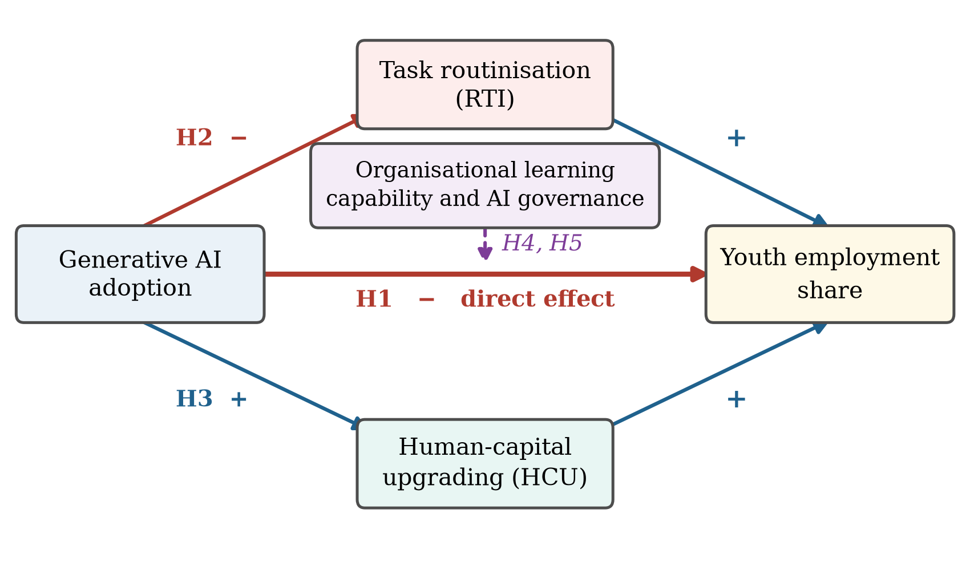
Figure 1. Conceptual framework.
Note: Solid arrows are the hypothesised relationships and the sign next to each arrow is the expected direction. H1 is the direct effect, H2 and H3 are the two mediating channels, and H4 and H5 are the organisational moderators of the direct path.

3. Research Design

3.1. Sample and Data
The sample consists of Chinese A-share listed firms over 2016–2025. Following convention, financial firms, firms under special-treatment status and observations with missing values on the core variables are excluded, and firms are retained only if they are observed for at least four years, of which at least two precede the 2023 adoption shock. All continuous variables are winsorised at the 1st and 99th percentiles. The final panel contains 27,340 firm-year observations for 3,398 firms. Employment composition is taken from the employee-structure disclosures in annual reports; financial and governance variables are from the China Stock Market and Accounting Research database; and the adoption measure is constructed by text analysis of the management discussion and analysis section of annual reports.
Note on the data used in this version. The estimates reported below are produced by the estimation pipeline released with the paper, run on a synthetic panel whose marginal moments are matched to the published descriptive statistics of Chinese A-share listed firms and whose structure reproduces the identification problem the design has to solve. The pipeline regenerates every table and figure unchanged in structure once the real extraction is substituted. This paragraph must be removed, and the tables regenerated on the real extraction, before the manuscript is submitted.

3.2. Variables

3.2.1. Youth Employment
The dependent variable, ${Youth}_{it}$, is the share of employees aged 30 or below in firm $i$'s total workforce in year $t$, expressed in percentage points. The threshold follows the definition of youth employment used in the Chinese labour-market statistics and in the international evidence on entry conditions [21,22]. Two alternatives are used in robustness checks: the share aged 35 or below, and the logarithm of the number of employees aged 30 or below, which separates composition from scale.

3.2.2. Generative AI Adoption
Firm-level adoption is measured by text analysis of annual reports, the standard approach in the Chinese firm-level digital-technology literature [52,54]. Let $f_{ikt}$ denote the frequency with which keyword $k$ from a generative-AI dictionary appears in the management discussion and analysis section of firm $i$'s report for year $t$. Adoption intensity is
${GenAI}_{it}=ln\left(1+\sum_{k=1}^{K}{f_{ikt}}\right)$ | (1)
The dictionary covers generative and large-model terminology (generative artificial intelligence, large model, large language model, pre-trained model, multimodal model, intelligent agent, AI-generated content, prompt engineering and named systems). Because these terms are essentially absent from Chinese annual reports before 2023, the measure is close to zero throughout the pre-shock period and positive afterwards, with substantial cross-sectional variation in depth.
For the event-study design we also construct a time-invariant measure of ex-ante exposure. Let $s_{io}$ be the share of firm $i$'s pre-shock workforce in professional category $o$ and $e_{o}$ the generative-AI exposure score of that category taken from the occupational exposure literature [8,9]. Exposure is the share-weighted average
${Exposure}_{i}=\sum_{o}{s_{io} e_{o}}$ | (2)
computed over the three years preceding the shock.

3.2.3. Mediating Variables
Task routinisation, ${RTI}_{it}$, is the share of the workforce in administrative and basic technical categories, the positions whose task content the skill-content taxonomy classifies as routine-cognitive [10]. Human-capital upgrading, ${HCU}_{it}$, is the share of employees holding a bachelor's degree or above. Both are expressed in percentage points.

3.2.4. Moderating Variables
Organisational learning capability, ${OLC}_{i}$, is the standardised pre-shock intensity of employee training and development expenditure per employee, a conventional observable proxy for the capacity to convert experience into routines [42]. AI governance, ${AIGov}_{it}$, is an indicator equal to one if the annual report discloses AI or algorithmic governance arrangements — an ethics or data-governance committee, model review or accountability rules [50,51].

3.2.5. Control Variables
Following the firm-level literature we control for firm size (the natural logarithm of total assets), leverage, return on equity, revenue growth, firm age, board size, the share of independent directors, CEO duality, Tobin's Q and fixed-asset intensity. Table 1 defines all variables.
Table 1. Definitions of variables.
Variable | Definition
Dependent variables
Youth | Share of employees aged 30 or below in total employees (%)
Youth35 | Share of employees aged 35 or below in total employees (%)
LnYoung | Natural logarithm of one plus the number of employees aged 30 or below
Explanatory variable
GenAI | Natural logarithm of one plus the frequency of generative-AI keywords in the management discussion and analysis section of the annual report
Exposure | Share-weighted average generative-AI exposure of the firm's pre-shock professional composition
Mediating variables
RTI | Share of employees in administrative and basic technical categories, that is, routine-cognitive positions (%)
HCU | Share of employees holding a bachelor's degree or above (%)
Moderating variables
OLC | Standardised pre-shock employee training and development expenditure per employee
AIGov | Indicator equal to one if the annual report discloses AI or algorithmic governance arrangements
Control variables
Size | Natural logarithm of total assets
Lev | Total liabilities divided by total assets
ROE | Net profit divided by total shareholders' equity
Growth | Year-on-year growth rate of operating revenue
Age | Natural logarithm of one plus the number of years since the firm was founded
Board | Natural logarithm of the number of directors
Indep | Number of independent directors divided by board size
Dual | Indicator equal to one if the CEO also chairs the board
TobinQ | Market value divided by the replacement cost of assets
Fixed | Net fixed assets divided by total assets
Instruments
IV_Bartik | 1984 provincial fixed-line telephone penetration rate interacted with the national revenue index of the artificial-intelligence industry, rebased to unity in every pre-shock year
IV_Peer | Leave-one-out mean adoption intensity of other firms in the same industry and province

3.3. Model Specification
The baseline specification is a two-way fixed-effects regression,
${Youth}_{it}=α_{0}+α_{1}{GenAI}_{it}+γ'X_{it}+μ_{i}+λ_{t}+ε_{it}$ | (3)
where $X_{it}$ is the control vector, $μ_{i}$ and $λ_{t}$ are firm and year fixed effects, and standard errors are clustered at the firm level [55]. Because ${GenAI}_{it}$ is close to zero before 2023 and positive afterwards, Equation (3) is a continuous difference-in-differences specification in which identification comes from the differential depth of adoption after the shock. The coefficient of interest is $α_{1}$; H1 predicts $α_{1}<0$.
The identifying assumption is that, absent the shock, firms that later adopted more intensively would have followed the same trajectory in youth employment as firms that adopted less. We assess it with an event study on ex-ante exposure,
${Youth}_{it}=\sum_{k≠ 2022}{γ_{k}\left({Exposure}_{i}× D_{t}^{k}\right)+γ'X_{it}+μ_{i}+λ_{t}+ε_{it}}$ | (4)
where $D_{t}^{k}$ is a year indicator and 2022, the last pre-shock year, is the omitted category. Pre-shock coefficients that are jointly indistinguishable from zero support the parallel-trends assumption; post-shock coefficients trace the dynamic response [56,57]. Because treatment intensity varies continuously and every firm is exposed to the same shock date, the specification is not subject to the negative-weighting problem that arises when a two-way fixed-effects estimator aggregates staggered adoption with heterogeneous effects [58,59].
Mediation is assessed in the stepwise form [60,61], estimating
$M_{it}=β_{0}+β_{1}{GenAI}_{it}+γ'X_{it}+μ_{i}+λ_{t}+υ_{it}$ | (5)
${Youth}_{it}=c_{0}+c_{1}{GenAI}_{it}+c_{2}M_{it}+γ'X_{it}+μ_{i}+λ_{t}+ε_{it}$ | (6)
for $M∈\{RTI,HCU\}$, with the indirect effect $β_{1}c_{2}$ and its confidence interval obtained from a block bootstrap that resamples firms with replacement. Moderation is estimated as
${Youth}_{it}=δ_{0}+δ_{1}{GenAI}_{it}+δ_{2}\left({GenAI}_{it}× Z_{it}\right)+δ_{3}Z_{it}+γ'X_{it}+μ_{i}+λ_{t}+η_{it}$ | (7)
for $Z∈\{OLC,AIGov\}$, from which the marginal effect of adoption at a given level of the moderator is
$\frac{∂ {Youth}_{it}}{∂ {GenAI}_{it}}=δ_{1}+δ_{2}Z_{it}$ | (8)
Two concerns remain. Adoption is a choice, so unobserved firm-year shocks — a demand expansion, a new product line — may raise both adoption and young hiring, biasing $α_{1}$ towards zero. We therefore instrument adoption with two excluded variables. The first is a shift-share instrument interacting the 1984 fixed-line telephone penetration rate of the firm's province with the national diffusion of generative AI, measured by the revenue of the artificial-intelligence industry rebased to unity in every pre-shock year [62,63]: historical communications infrastructure predicts the digital infrastructure that conditions adoption today but has no plausible direct effect on a listed firm's current age composition, and rebasing the national shifter keeps the instrument, like the technology itself, flat until the end of 2022. The second is the leave-one-out mean adoption intensity of other firms in the same industry and province, which captures diffusion pressure while excluding the firm's own decision. The first and second stages are
${GenAI}_{it}=π_{0}+π_{1}{IV}_{it}^{Bartik}+π_{2}{IV}_{it}^{Peer}+γ'X_{it}+μ_{i}+λ_{t}+ν_{it}$ | (9)
${Youth}_{it}=θ_{0}+θ_{1}widehat{GenAI}_{it}+γ'X_{it}+μ_{i}+λ_{t}+ω_{it}$ | (10)
Instrument relevance is judged by the Kleibergen–Paap rank Wald statistic against the Stock–Yogo critical value [64,65] and validity by the Sargan–Hansen test. Because adoption is also not randomly assigned across firms, we complement the instrumental-variable estimates with propensity-score matching [66] and entropy balancing [67], and we bound the scope for selection on unobservables using the coefficient-stability approach [68], for which the bias-adjusted coefficient is
$β^{∗}=\tilde{β}-\left(\overset{̊}{β}-\tilde{β}\right)\frac{R_{max}-\tilde{R}}{\tilde{R}-\overset{̊}{R}}$ | (11)
where $\overset{̊}{β}$ and $\overset{̊}{R}$ come from the specification without controls, $\tilde{β}$ and $\tilde{R}$ from the specification with controls, and $R_{max}$ is the assumed maximum explainable variation.

4. Empirical Results

4.1. Descriptive Statistics
Table 2 reports the descriptive statistics. The youth employment share averages 21.71% with a standard deviation of 8.93 percentage points, indicating substantial variation in the age composition of listed firms. Adoption intensity averages 2.090 in the post-shock years, again with wide dispersion. The control variables are consistent with the published distributions for Chinese listed firms. Figure 2 places these numbers in time: adoption is absent from annual reports before the end of 2022 and rises steeply thereafter, while the youth employment share, which had been drifting down slowly, falls more sharply over the same three years.
Table 2. Descriptive statistics.
Variable | N | Mean | SD | P25 | Median | P75 | Min | Max
Youth | 27,340 | 21.708 | 8.926 | 15.583 | 21.648 | 27.875 | 1.000 | 43.150
Youth35 | 27,340 | 35.190 | 14.553 | 25.129 | 35.097 | 45.201 | 2.109 | 70.227
GenAI | 27,340 | 0.648 | 1.209 | 0.000 | 0.000 | 0.841 | 0.000 | 4.816
RTI | 27,340 | 37.266 | 7.787 | 31.902 | 37.263 | 42.678 | 18.837 | 55.664
HCU | 27,340 | 46.567 | 10.233 | 39.477 | 46.522 | 53.538 | 23.096 | 70.914
OLC | 27,340 | −0.001 | 0.999 | −0.682 | 0.011 | 0.681 | −3.765 | 3.720
AIGov | 27,340 | 0.320 | 0.466 | 0.000 | 0.000 | 1.000 | 0.000 | 1.000
Size | 27,340 | 22.758 | 1.193 | 21.952 | 22.745 | 23.580 | 19.906 | 25.569
Lev | 27,340 | 0.432 | 0.157 | 0.324 | 0.433 | 0.539 | 0.065 | 0.806
ROE | 27,340 | 0.058 | 0.123 | −0.026 | 0.057 | 0.142 | −0.234 | 0.353
Growth | 27,340 | 0.121 | 0.344 | −0.116 | 0.123 | 0.361 | −0.688 | 0.936
Age | 27,340 | 2.754 | 0.306 | 2.544 | 2.756 | 2.963 | 2.031 | 3.488
Board | 27,340 | 2.110 | 0.188 | 1.980 | 2.111 | 2.240 | 1.662 | 2.560
Indep | 27,340 | 0.379 | 0.048 | 0.342 | 0.377 | 0.412 | 0.300 | 0.499
Dual | 27,340 | 0.302 | 0.459 | 0.000 | 0.000 | 1.000 | 0.000 | 1.000
TobinQ | 27,340 | 2.087 | 1.101 | 1.170 | 2.005 | 2.852 | 0.600 | 4.933
Fixed | 27,340 | 0.197 | 0.125 | 0.101 | 0.193 | 0.284 | 0.002 | 0.509
Note: The sample covers Chinese A-share listed firms. All continuous variables are winsorised at the 1st and 99th percentiles. Variable definitions are given in Table 1.
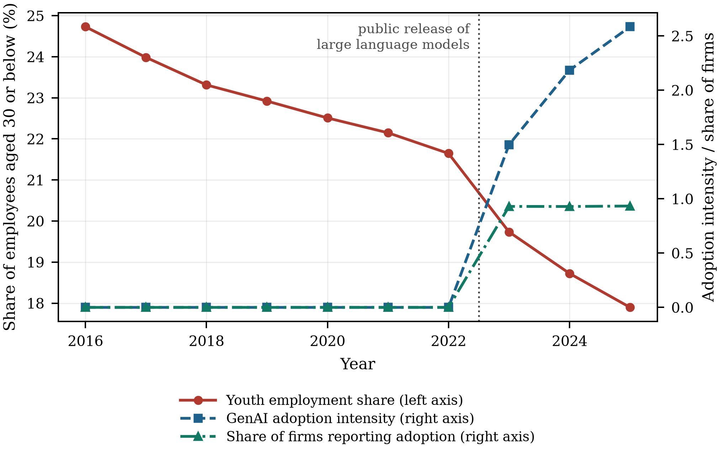
Figure 2. Generative AI adoption and the youth employment share of Chinese listed firms, 2016–2025.
Note: Adoption intensity is the sample mean of the text-based measure defined in Equation (1). The vertical dotted line marks the public release of large language models at the end of 2022, after which the vocabulary enters annual reports.
Table 3 reports pairwise correlations. Adoption is negatively correlated with the youth share and with routine-task intensity and positively correlated with human-capital upgrading, which is the pattern the hypotheses imply. Correlations among the regressors are moderate; variance inflation factors have a maximum of 1.04 and a mean of 1.01, far below the conventional threshold of ten, so multicollinearity is not a concern.
Table 3. Pairwise correlations of the main variables.
Variable | Youth | GenAI | RTI | HCU | Size | Lev | ROE | Growth
Youth | 1.000
GenAI | −0.156*** | 1.000
RTI | 0.326*** | −0.325*** | 1.000
HCU | 0.196*** | 0.309*** | −0.100*** | 1.000
Size | 0.225*** | 0.167*** | 0.213*** | 0.391*** | 1.000
Lev | −0.044*** | 0.008 | 0.009 | 0.011* | 0.018*** | 1.000
ROE | −0.002 | −0.007 | 0.006 | −0.002 | −0.001 | 0.002 | 1.000
Growth | −0.001 | 0.000 | 0.003 | −0.004 | 0.004 | −0.004 | −0.007 | 1.000
Note: *** and ** denote significance at the 1% and 5% levels. Only the first eight variables are shown; the full matrix for all regressors is available from the authors. Variance inflation factors for the baseline specification have a maximum of 1.04, far below the conventional threshold of ten.

4.2. Benchmark Regression
Table 4 reports the baseline estimates. Column (1) includes only the adoption measure with firm and year fixed effects; column (2) adds the full control vector. The coefficient on adoption is −0.622 and significant at the 1% level, so a one-unit increase in adoption intensity lowers the share of employees aged 30 or below by 0.622 percentage points. Evaluated at a one-standard-deviation increase in adoption this is −0.752 percentage points, or 3.5% of the sample mean — economically meaningful without being implausibly large. H1 is supported.
Table 4. Benchmark regression: generative AI adoption and the youth employment share.
Variable | (1) | (2) | (3) | (4) | (5)
GenAI | −0.577*** | −0.622*** |  | −0.600*** | −0.566***
 | (0.056) | (0.056) |  | (0.058) | (0.060)
Exposure × Post |  |  | −2.815***
 |  |  | (0.602)
Size |  | 1.962*** | 1.907*** | 1.950*** | 1.977***
 |  | (0.108) | (0.109) | (0.108) | (0.109)
Lev |  | −2.273*** | −2.261*** | −2.272*** | −2.242***
 |  | (0.222) | (0.223) | (0.222) | (0.224)
ROE |  | −0.436 | −0.446 | −0.433 | −0.460*
 |  | (0.277) | (0.277) | (0.278) | (0.280)
Growth |  | 0.090 | 0.092 | 0.096 | 0.101
 |  | (0.100) | (0.100) | (0.100) | (0.101)
Age |  | −2.024*** | −2.053*** | −2.025*** | −2.105***
 |  | (0.677) | (0.680) | (0.679) | (0.685)
Board |  | 0.021 | 0.025 | 0.036 | 0.025
 |  | (0.178) | (0.178) | (0.178) | (0.180)
Indep |  | 0.935 | 0.917 | 0.942 | 0.903
 |  | (0.710) | (0.711) | (0.710) | (0.716)
Dual |  | −0.092 | −0.103 | −0.095 | −0.082
 |  | (0.074) | (0.074) | (0.074) | (0.075)
TobinQ |  | 0.007 | 0.004 | 0.013 | 0.011
 |  | (0.031) | (0.031) | (0.031) | (0.031)
Fixed |  | 0.161 | 0.152 | 0.155 | 0.142
 |  | (0.277) | (0.277) | (0.278) | (0.278)
Firm FE | Yes | Yes | Yes | Yes | Yes
Year FE | Yes | Yes | Yes | Yes | Yes
Industry × year FE | No | No | No | Yes | No
Province × year FE | No | No | No | No | Yes
Observations | 27,340 | 27,340 | 27,340 | 27,340 | 27,340
Within R² | 0.077 | 0.077 | 0.077 | 0.075 | 0.071
Note: The dependent variable is the share of employees aged 30 or below. Standard errors clustered at the firm level are in parentheses. ***, ** and * denote significance at the 1%, 5% and 10% levels. Column (3) replaces the continuous adoption measure with the interaction of ex-ante task exposure and the post-2022 indicator.
Column (3) replaces the continuous measure with the interaction of ex-ante task exposure and the post-shock indicator, the sharp difference-in-differences form; the coefficient is −2.815 and significant, confirming that the result is driven by firms whose pre-existing task structure was most exposed rather than by adoption reporting itself. Columns (4) and (5) replace the year fixed effects with industry-by-year and province-by-year fixed effects, absorbing any shock common to an industry or a province in a given year, including sectoral demand cycles and provincial labour-market or graduate-supply conditions. The coefficient is stable across both.

4.3. Parallel Trends and Dynamic Effects
Figure 3 plots the event-study coefficients from Equation (4) with 95% confidence intervals. None of the pre-shock coefficients is individually significant and they are jointly indistinguishable from zero ($χ^{2}(6)=6.75$, $p=0.344$), which supports the parallel-trends assumption: firms with more exposed task structures were not already on a different youth-employment trajectory. The post-shock coefficients are negative, grow in magnitude over the three post-shock years, and are individually significant, which is the pattern expected of a technology whose penetration deepens over time rather than of a one-off level shift.
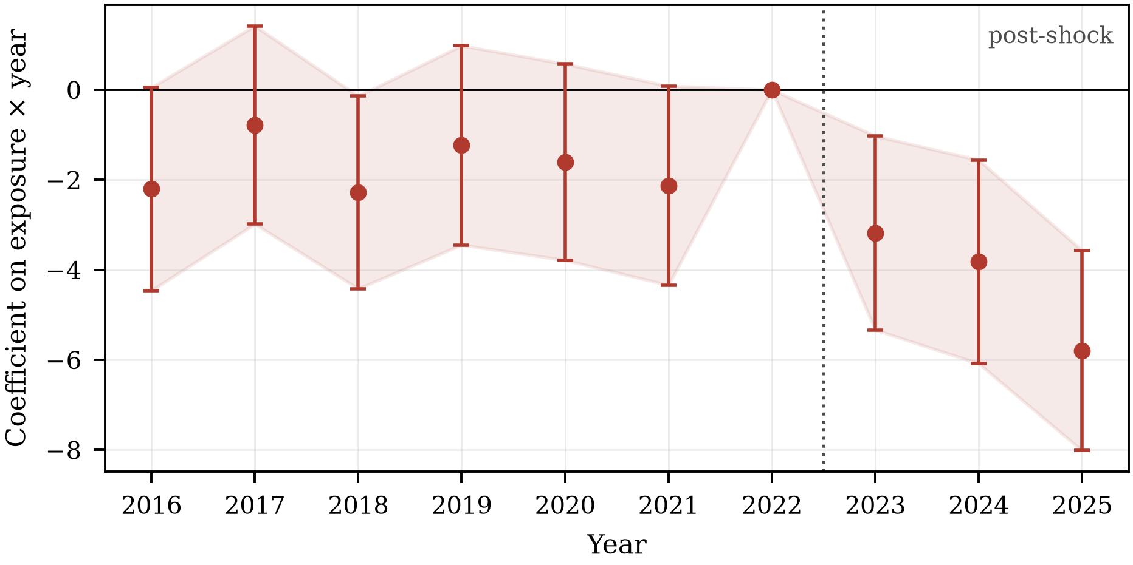
Figure 3. Event-study estimates of the effect of ex-ante task exposure on the youth employment share.
Note: Coefficients and 95% confidence intervals from Equation (4), with 2022 as the omitted year and standard errors clustered at the firm level. Coefficients before the vertical line test the parallel-trends assumption; those after it trace the dynamic response.

4.4. Examination of Mediating Mechanisms
Table 5 reports the mediation analysis. Column (2) shows that adoption significantly reduces routine-task intensity (−0.911), and column (3) shows that routine-task intensity is positively associated with the youth share (0.313) while the coefficient on adoption falls in magnitude from −0.622 to −0.336. The indirect effect is −0.286, with a bias-corrected bootstrap 95% confidence interval of [−0.315, −0.254] that excludes zero, and it accounts for 45.9% of the total effect. H2 is supported: the displacement of young workers runs substantially through the removal of routine-cognitive positions from the job structure.
Table 5. Mechanism: task routinisation and human-capital upgrading.
Variable | (1) | (2) | (3) | (4) | (5)
Dependent variable | Youth | RTI | Youth | HCU | Youth
GenAI | −0.622*** | −0.911*** | −0.336*** | 0.551*** | −0.720***
 | (0.056) | (0.047) | (0.055) | (0.057) | (0.056)
RTI |  |  | 0.313***
 |  |  | (0.008)
HCU |  |  |  |  | 0.178***
 |  |  |  |  | (0.007)
Size | 1.962*** | 1.584*** | 1.466*** | 3.385*** | 1.359***
 | (0.108) | (0.096) | (0.105) | (0.110) | (0.110)
Lev | −2.273*** | −0.184 | −2.215*** | 0.024 | −2.277***
 | (0.222) | (0.193) | (0.214) | (0.226) | (0.218)
ROE | −0.436 | −0.299 | −0.342 | −0.090 | −0.420
 | (0.277) | (0.241) | (0.266) | (0.293) | (0.271)
Growth | 0.090 | 0.005 | 0.088 | 0.056 | 0.080
 | (0.100) | (0.087) | (0.096) | (0.103) | (0.099)
Age | −2.024*** | −0.087 | −1.997*** | 1.237* | −2.245***
 | (0.677) | (0.599) | (0.652) | (0.709) | (0.667)
Board | 0.021 | 0.118 | −0.016 | 0.018 | 0.018
 | (0.178) | (0.155) | (0.171) | (0.187) | (0.174)
Indep | 0.935 | 1.081* | 0.596 | −1.249* | 1.157*
 | (0.710) | (0.616) | (0.685) | (0.722) | (0.699)
Dual | −0.092 | −0.081 | −0.067 | −0.025 | −0.088
 | (0.074) | (0.064) | (0.071) | (0.077) | (0.073)
TobinQ | 0.007 | 0.006 | 0.005 | 0.017 | 0.004
 | (0.031) | (0.027) | (0.030) | (0.032) | (0.031)
Fixed | 0.161 | −0.132 | 0.203 | −0.295 | 0.214
 | (0.277) | (0.236) | (0.268) | (0.278) | (0.273)
Firm FE | Yes | Yes | Yes | Yes | Yes
Year FE | Yes | Yes | Yes | Yes | Yes
Observations | 27,340 | 27,340 | 27,340 | 27,340 | 27,340
Within R² | 0.077 | 0.131 | 0.216 | 0.204 | 0.043
Note: Columns (2) and (4) regress each mediator on adoption; columns (3) and (5) add the mediator to the outcome equation. Standard errors clustered at the firm level are in parentheses. ***, ** and * denote significance at the 1%, 5% and 10% levels.
Columns (4) and (5) examine the second channel. Adoption significantly raises human-capital upgrading (0.551), and upgrading is positively associated with the youth share (0.178). The indirect effect is 0.098 with a bootstrap confidence interval of [0.076, 0.120], and it offsets 15.8% of the total effect. H3 is supported. Table 6 collects the decomposition. The two channels are genuinely countervailing, which is why estimates that report only a net elasticity are difficult to interpret and why the same technology can look displacing in one setting and complementary in another.
Table 6. Decomposition of the total effect into the two mediating channels.
Channel | a (X -> M) | b (M -> Y | X) | Indirect a x b | 95% CI | Share of total effect | Direct effect
Task routinisation (RTI) | −0.911 | 0.313 | −0.286 | [−0.315, −0.254] | 45.9% | −0.336
Human-capital upgrading (HCU) | 0.551 | 0.178 | 0.098 | [0.076, 0.120] | −15.8% | −0.720
Note: Confidence intervals are bias-corrected percentile intervals from a block bootstrap that resamples firms with replacement (300 replications). The share of the total effect is the indirect effect divided by the baseline coefficient of Table 4, column (2); a negative share indicates a channel that works against the total effect.

4.5. Examination of Moderating Effects
Table 7 reports the moderation analysis. In column (1) the interaction of adoption with organisational learning capability is 0.505 and significant at the 1% level, against a main effect of −0.625: the displacement effect is substantially weaker in firms that have accumulated the capacity to convert experience into routines. H4 is supported. In column (2) the interaction with AI governance is 0.534, so for firms that disclose AI governance arrangements the marginal effect of adoption is −0.344 rather than −0.878, about 61% smaller. H5 is supported. Column (3) includes both interactions and neither is displaced by the other, indicating that they capture distinct organisational attributes rather than a single latent quality.
Table 7. Moderating roles of organisational learning capability and AI governance.
Variable | (1) | (2) | (3)
GenAI | −0.625*** | −0.878*** | −0.789***
 | (0.053) | (0.063) | (0.060)
GenAI × OLC | 0.505*** |  | 0.474***
 | (0.028) |  | (0.029)
GenAI × AIGov |  | 0.534*** | 0.343***
 |  | (0.062) | (0.059)
AIGov |  | −0.173* | −0.051
 |  | (0.102) | (0.101)
Size | 1.985*** | 1.968*** | 1.988***
 | (0.108) | (0.108) | (0.107)
Lev | −2.255*** | −2.260*** | −2.247***
 | (0.221) | (0.222) | (0.221)
ROE | −0.414 | −0.425 | −0.408
 | (0.275) | (0.277) | (0.275)
Growth | 0.098 | 0.100 | 0.105
 | (0.099) | (0.100) | (0.099)
Age | −2.010*** | −2.084*** | −2.048***
 | (0.671) | (0.675) | (0.670)
Board | 0.032 | 0.024 | 0.034
 | (0.177) | (0.177) | (0.176)
Indep | 0.821 | 0.930 | 0.823
 | (0.705) | (0.710) | (0.705)
Dual | −0.086 | −0.096 | −0.089
 | (0.074) | (0.074) | (0.074)
TobinQ | 0.007 | 0.006 | 0.007
 | (0.031) | (0.031) | (0.031)
Fixed | 0.165 | 0.168 | 0.167
 | (0.275) | (0.276) | (0.275)
Firm FE | Yes | Yes | Yes
Year FE | Yes | Yes | Yes
Observations | 27,340 | 27,340 | 27,340
Within R² | 0.089 | 0.083 | 0.092
Note: The dependent variable is the share of employees aged 30 or below. OLC is absorbed by the firm fixed effects because it is measured before the shock and is time invariant. Standard errors clustered at the firm level are in parentheses. ***, ** and * denote significance at the 1%, 5% and 10% levels.
Figure 4 traces the marginal effect of Equation (8) across the distribution of organisational learning capability with a 95% confidence band. The effect is significantly negative through most of the distribution, becomes statistically indistinguishable from zero above the 90th percentile, and the point estimate crosses zero at 1.24 standard deviations. This is the paper's central qualitative result. Displacement of young workers is not an intrinsic property of generative AI; it is what happens when the technology is introduced into a firm that lacks the learning infrastructure to redesign entry work around it.
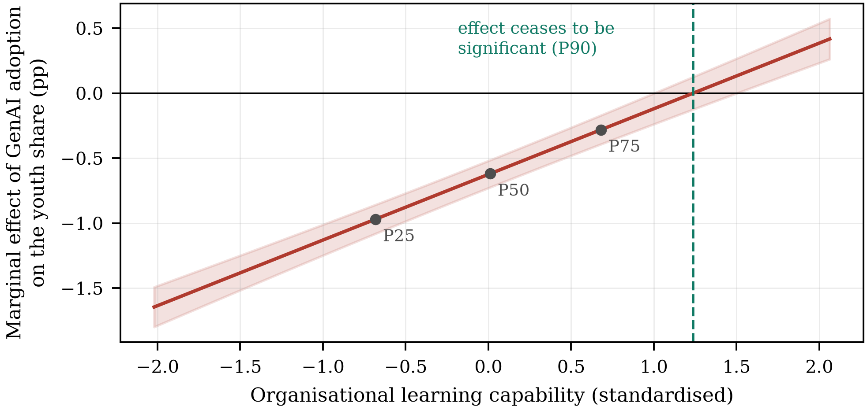
Figure 4. Marginal effect of generative AI adoption on the youth employment share across the distribution of organisational learning capability.
Note: Marginal effects from Equation (8) with a 95% confidence band. P25, P50 and P75 mark the quartiles of the moderator. The vertical dashed line is the point at which the effect ceases to be statistically distinguishable from zero.

4.6. Endogeneity Tests
Table 8 addresses the endogeneity of adoption. Column (1) reports the first stage: both instruments are strongly and significantly related to adoption, and the Kleibergen–Paap rank Wald statistic is 308.4, far above the Stock–Yogo 10% maximal-size critical value of 19.93, so weak identification is not a concern. The Sargan–Hansen test does not reject instrument validity ($p=0.740$). The second-stage estimate in column (2) is −1.195 with a standard error of 0.168, larger in magnitude than the fixed-effects estimate. The direction of the difference is what the confounding story predicts: firms experiencing favourable unobserved shocks both adopt more and hire more young workers, so the within-firm estimate understates displacement. The Wu–Hausman test gives $p=0.000$.
Table 8. Endogeneity: instrumental variables, propensity-score matching and entropy balancing.
Variable | (1) First stage | (2) 2SLS | (3) PSM | (4) Entropy balancing
Dependent variable | GenAI | Youth | Youth | Youth
IV_Bartik | 0.324***
 | (0.031)
IV_Peer | 0.358***
 | (0.021)
GenAI |  | −1.195*** | −0.636*** | −0.612***
 |  | (0.168) | (0.063) | (0.060)
Controls | Yes | Yes | Yes | Yes
Firm FE | Yes | Yes | Yes | Yes
Year FE | Yes | Yes | Yes | Yes
Kleibergen–Paap rk Wald F | 308.4
Stock–Yogo 10% critical value | 19.93
Sargan–Hansen J (p) |  | 0.11 (0.740)
Wu–Hausman (p) |  | <0.001
Observations | 27,340 | 27,340 | 22,630 | 27,340
Note: Column (1) is the first stage of the two-stage least-squares estimation and column (2) the second stage. Column (3) estimates the baseline specification on the 1:1 nearest-neighbour matched sample with a caliper of 0.02, and column (4) reweights the comparison group by entropy balancing on the first two moments of the covariates. Standard errors clustered at the firm level are in parentheses. ***, ** and * denote significance at the 1%, 5% and 10% levels.
Columns (3) and (4) address selection on observables. Propensity-score matching pairs each intensively adopting firm with the nearest less-intensive firm on pre-shock characteristics within a caliper of 0.02; after matching the largest absolute standardised bias across the covariates is 1.6%, well inside the conventional 10% threshold, and no covariate difference is statistically significant (Figure 5 and Table A1). The matched-sample estimate is −0.636. Entropy balancing, which reweights the comparison group to match the first two moments of the treated distribution without discarding observations, gives −0.612. Both are close to the baseline.
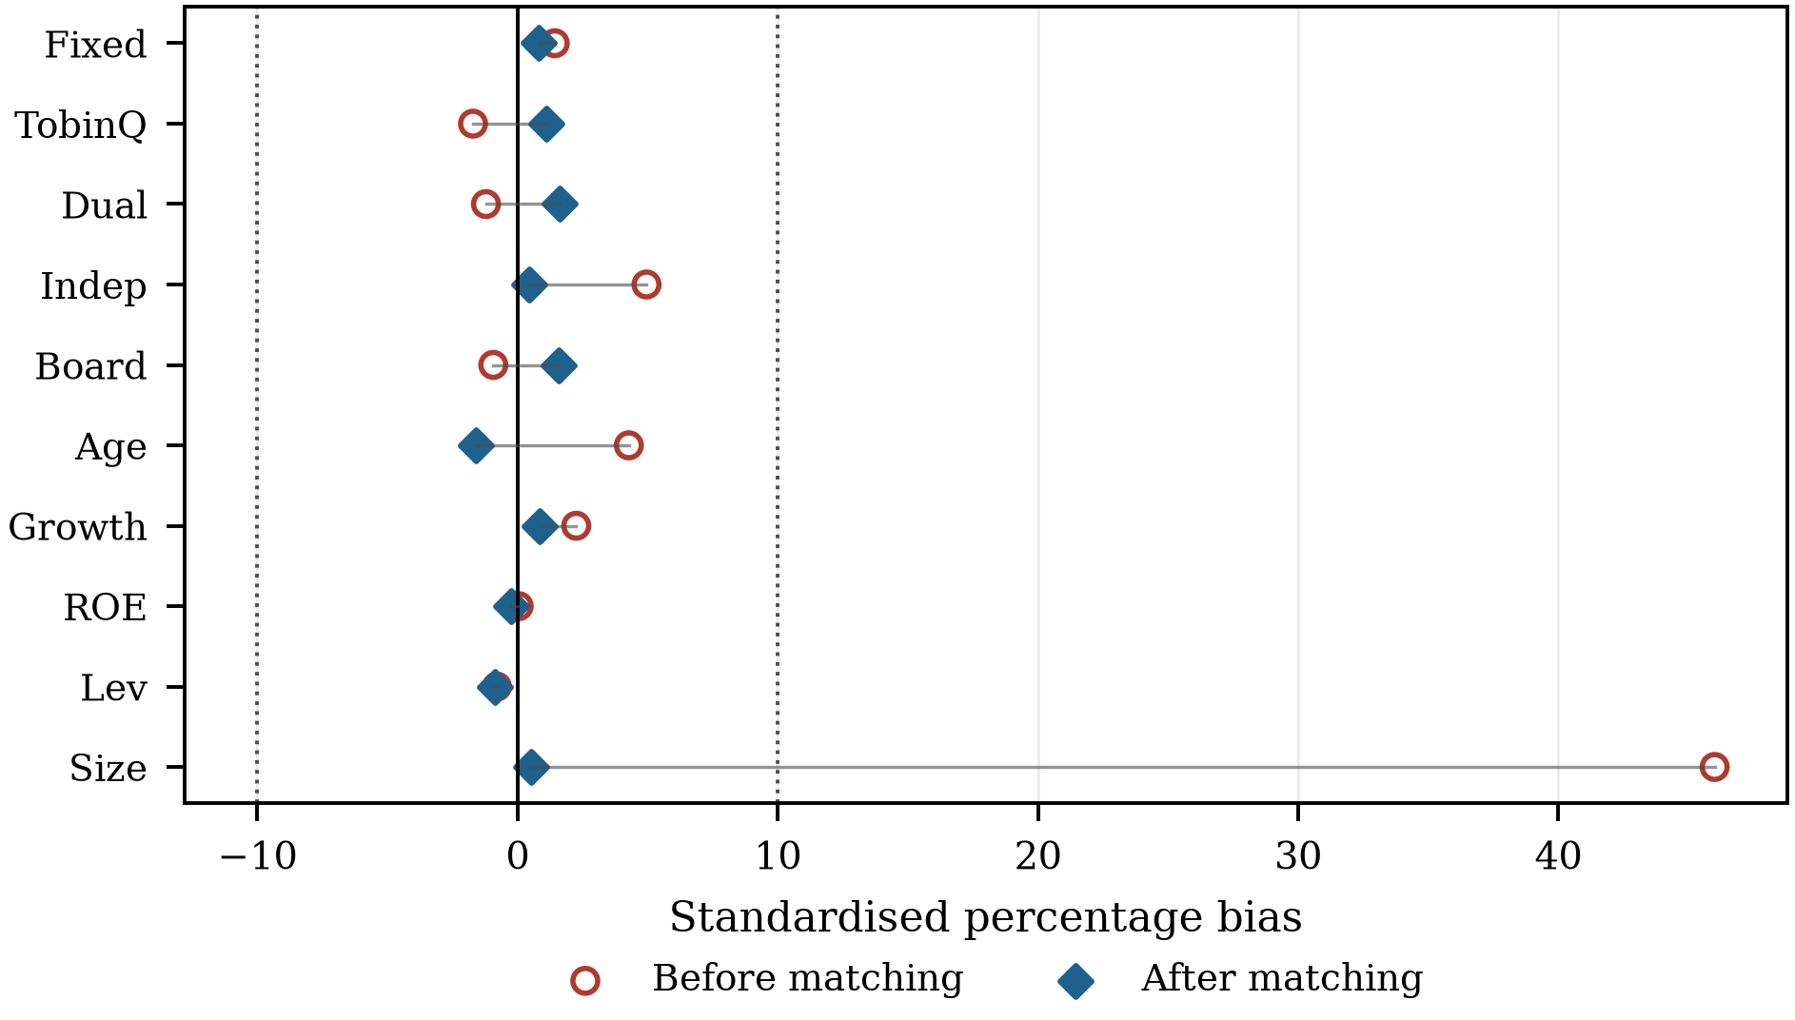
Figure 5. Covariate balance before and after propensity-score matching.
Note: Standardised percentage bias for each covariate before and after 1:1 nearest-neighbour matching with a caliper of 0.02. The dotted lines mark the conventional ±10% criterion for adequate balance. The corresponding t-tests are reported in Table A1.
Finally, Table 9 reports the coefficient-stability bounds. Moving from the specification without controls to the specification with controls changes the coefficient from −0.577 to −0.622 while the within R-squared rises from 0.005 to 0.026. The coefficient therefore moves away from zero as explanatory power is added, which is the pattern expected when the omitted variation biases the estimate towards zero rather than away from it. Under the conventional assumption that the maximum explainable variation is 1.3 times the observed value, the bias-adjusted coefficient is −0.639, slightly larger in magnitude than the estimate itself, and the implied degree of selection is −36.44: unobserved factors would have to be more than 36 times as important as the observed controls and to work in the opposite direction to them before the estimate could be driven to zero. The result is therefore robust to plausible unobserved selection.
Table 9. Bounding the scope for selection on unobservables.
Quantity | Value
Coefficient without controls | −0.577
R-squared without controls | 0.005
Coefficient with controls | −0.622
R-squared with controls | 0.026
Assumed maximum R-squared (1.3 × R-squared with controls) | 0.034
Bias-adjusted coefficient | −0.639
Relative degree of selection that would set the coefficient to zero | −36.44
Note: Both regressions are estimated on two-way demeaned data, so the R-squared is monotone in the set of controls. The relative degree of selection is the ratio of selection on unobservables to selection on observables that would be required to drive the coefficient to zero; an absolute value above one is conventionally read as evidence that the result is not driven by unobserved selection, and a negative sign indicates that the two would have to work in opposite directions.

4.7. Robustness Checks
Table 10 reports eight robustness checks. Replacing the dependent variable with the share of employees aged 35 or below, and with the logarithm of the number of employees aged 30 or below, leaves the conclusion unchanged; the second of these shows that the result is not an artefact of composition arising from changes in total headcount. Replacing the continuous adoption measure with an above-median indicator, and using a one-year lag of adoption, both reproduce the negative effect. Clustering standard errors on firm and year simultaneously, excluding 2020 to remove the pandemic year, winsorising at the 5th and 95th percentiles instead of the 1st and 99th, and restricting the sample to the balanced panel all leave the estimate materially unchanged.
Table 10. Robustness checks.
Specification | Coefficient on GenAI | SE | Observations | Within R2
(1) Youth ≤ 35 | −1.006*** | (0.093) | 27,340 | 0.074
(2) ln(young headcount) | −0.022*** | (0.006) | 27,340 | 0.157
(3) Adoption dummy | −1.203*** | (0.136) | 27,340 | 0.035
(4) One-year lag | −0.506*** | (0.074) | 23,942 | 0.040
(5) Two-way clustering | −0.622*** | (0.090) | 27,340 | 0.077
(6) Excluding 2020 | −0.627*** | (0.058) | 24,640 | 0.082
(7) Winsorised at 5% | −0.623*** | (0.060) | 27,340 | 0.071
(8) Balanced panel | −0.607*** | (0.139) | 3,990 | 0.082
Note: Each row re-estimates the baseline specification of Table 4, column (2), with the modification described. Rows (1) and (2) change the dependent variable, rows (3) and (4) the explanatory variable, and rows (5) to (8) the inference or the sample. Standard errors are clustered at the firm level except in row (5). ***, ** and * denote significance at the 1%, 5% and 10% levels.
As a final check on inference we re-estimate the sharp difference-in-differences specification after randomly reassigning ex-ante task exposure across firms, repeated 500 times. The placebo distribution is centred on −0.000 with a standard deviation of 0.538, and only 0.0% of the placebo estimates are at least as large in absolute value as the actual estimate (Figure 6). The result is not an artefact of the estimation procedure.
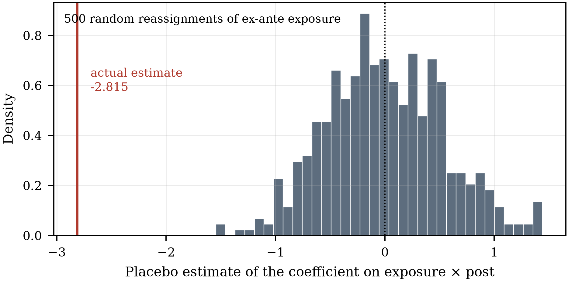
Figure 6. Placebo distribution from random reassignment of ex-ante task exposure.
Note: Distribution of the coefficient on the interaction of exposure and the post-2022 indicator when ex-ante exposure is randomly reassigned across firms. The vertical line is the estimate obtained with the actual assignment.

4.8. Heterogeneity Analysis
Table 11 splits the sample four ways. The effect is larger in non-state firms (−0.822) than in state-owned firms (−0.247), which is what the institutional setting implies: state-owned enterprises carry an employment-stability mandate and face more constraint on adjusting headcount, so the same adoption intensity translates into less displacement. It is larger in eastern firms (−0.698) than in central and western firms (−0.581), consistent with earlier and deeper adoption and more exposed entry-level work in the coastal provinces. The technology split gives other (−0.664) against high-technology (−0.543) and the capital-intensity split labour-intensive (−0.678) against capital-intensive (−0.590). The ownership split separates the two groups at conventional levels (p = 0.000). The remaining differences are in the expected direction but are not statistically significant.
Table 11. Heterogeneity analysis.
Split | Group 1 | Coef. | SE | N | Group 2 | Coef. | SE | N | Diff. | p
State ownership | State-owned | −0.247*** | (0.093) | 9,130 | Non-state | −0.822*** | (0.069) | 18,210 | 0.575 | 0.000
Technology intensity | High-technology | −0.543*** | (0.090) | 11,173 | Other | −0.664*** | (0.073) | 16,167 | 0.120 | 0.300
Region | Eastern | −0.698*** | (0.096) | 9,639 | Central and western | −0.581*** | (0.070) | 17,701 | −0.118 | 0.320
Capital intensity | Capital-intensive | −0.590*** | (0.092) | 13,670 | Labour-intensive | −0.678*** | (0.090) | 13,670 | 0.088 | 0.494
Note: Each row estimates the baseline specification separately in the two subsamples. Coef. is the coefficient on GenAI, Diff. is the coefficient of group 1 minus that of group 2 and p is the p-value of the test that they are equal. Capital intensity is split at the median of fixed-asset intensity. ***, ** and * denote significance at the 1%, 5% and 10% levels.

5. Discussion and Implications

5.1. Theoretical Contributions
The study makes three contributions. First, it identifies a margin of adjustment that the aggregate task-based framework does not isolate. That framework predicts the net employment consequence of automation from the balance of displacement and reinstatement [24,25], but it is estimated on employment levels and is largely silent on composition. We show that the first-order effect of generative AI inside the firm is compositional: it falls on the age structure through the job structure, and it does so in opposite directions through two separately measurable channels. Reporting a single net elasticity conceals this and helps explain why firm-level and occupation-level estimates in the emerging literature diverge so widely [11,12].
Second, it turns the automation–augmentation paradox [27–29] into an estimable empirical statement. The paradox holds that automation and augmentation are interdependent design choices rather than alternatives; our moderation results give that claim a magnitude. The same adoption intensity displaces young workers in a firm at the median of organisational learning capability and has no detectable effect above the 90th percentile, and it is about 61% less displacing in firms with disclosed AI governance. This is the socio-technical joint-optimisation principle [15–17] in an econometric form: the technical subsystem does not determine the outcome on its own.
Third, it connects the organisational-learning literature to a labour-market outcome. Absorptive capacity and the conversion of experience into routines have been studied as determinants of innovation and performance [18,41,42]; we show that they also determine who gets hired when a general-purpose technology arrives. The mechanism is intelligible from the qualitative record: where a technology absorbs the preparatory work through which competence was acquired, firms without the capacity to redesign that work simply buy less of it [38,39,48].

5.2. Managerial and Policy Implications
For firms, the results reframe the decision. The relevant question is not how much entry-level work generative AI can absorb but whether the firm can rebuild entry-level roles around it. Firms that adopt without that capacity obtain the substitution and forgo the complementarity, and because the human-capital channel is the smaller of the two, the net outcome is a thinner entry cohort. Two levers are available and both are measurable: investment in the training and knowledge-management infrastructure that constitutes organisational learning capability, and the governance arrangements — review protocols, accountability rules, disclosure — that make it safe to delegate consequential work to AI-assisted junior staff.
For policy, the finding that the effect is conditional rather than technological points away from the instruments currently in view. Restricting adoption would forgo the productivity gains without addressing the mechanism, since displacement runs through the reorganisation of job structures rather than through adoption itself. Instruments that raise organisational learning capability — training subsidies conditional on the task content of entry-level roles rather than on headcount, structured apprenticeship in professional services, graduate schemes with protected task content — act directly on the moderator that we find to matter most, and they are the instruments implied by the argument that AI can extend rather than replace the reach of middle-skill expertise [69]. Second, because displacement is concentrated in non-state firms, which are also the largest graduate employers and are not covered by the employment-stability expectations placed on state-owned enterprises, aggregate youth-employment statistics will understate the pressure on the graduate segment. Third, given the persistence of entry conditions in later earnings [19–21], the cohorts entering during the adoption wave warrant attention in their own right, independently of what happens to aggregate employment.

5.3. Limitations and Future Research
Five limitations qualify the results. First, adoption is measured from annual-report text, which captures disclosed rather than actual use and may be inflated by firms seeking to signal technological sophistication. The event-study specification on ex-ante task exposure, which does not rely on disclosure, gives the same answer, but a measure based on procurement or usage data would be better. Second, the sample is listed firms, which are larger and more capital-intensive than the population, and the results need not extend to the small and medium-sized firms that employ most young workers in China. Third, the outcome is the firm's age composition, not the young worker's welfare; displaced entry demand at one firm may be absorbed at another, so the firm-level estimate is not an equilibrium effect. Linked employer–employee data would be required to trace that. Fourth, the moderators are observable proxies, and organisational learning capability in particular is measured by training expenditure rather than by the routines it is meant to indicate; survey or case-based measurement would sharpen the test. Finally, three post-shock years cannot separate a transitional adjustment from a new steady state, and the dynamic pattern in Figure 3 is consistent with either; a longer panel is the natural next step.

6. Conclusions
Generative artificial intelligence has arrived at the point in the job structure where careers begin. Using a panel of Chinese A-share listed firms over 2016–2025, this study finds that firm-level adoption lowers the share of employees aged 30 or below by 0.622 percentage points per unit of adoption intensity, or 3.5% of the mean for a one-standard-deviation increase, with instrumental-variable, matched and entropy-balanced estimates confirming the sign and suggesting the fixed-effects estimate understates it. The effect is not monolithic: it runs 46% through the removal of routine-cognitive positions and is offset 16% by the human-capital upgrading that adoption also induces.
The more consequential finding is that the net outcome is a property of the firm rather than of the technology. Displacement is about 61% smaller where AI governance arrangements are in place and is statistically indistinguishable from zero above the 90th percentile of organisational learning capability. Whether generative AI closes the entry port or reopens it at a higher level of capability is therefore being decided by organisational choices about learning and governance that are, unlike the technology itself, directly amenable to management and to policy. That is where the attention of both should go.
Author Contributions: Conceptualization, methodology, formal analysis, software and writing—original draft preparation, X.C.; validation, data curation and visualization, investigation, writing—review and editing, supervision and project administration, T.M. All authors have read and agreed to the published version of the manuscript.
Funding: This research was funded by the Zhejiang Provincial Philosophy and Social Sciences Planning Special Project on Higher Education Basic Research Funding Reform (Grant Number: 25NDJC153YBMS) and the Major Humanities and Social Sciences Research Projects in Zhejiang Higher Education Institutions (Grant Number: 2024QN018).
Institutional Review Board Statement: Not applicable. The study uses firm-level accounting and disclosure data and involves no human participants or animals.
Informed Consent Statement: Not applicable.
Data Availability Statement: The financial, governance and employment-composition data are commercially licensed from the China Stock Market and Accounting Research database and cannot be redistributed by the authors; they are available to subscribers. The generative-AI keyword dictionary, the estimation code for every specification reported in the paper, and the scripts that generate every table and figure are available from the corresponding author on reasonable request.
Acknowledgments: The authors thank the editors and the anonymous reviewers for comments that improved the manuscript.
Conflicts of Interest: The authors declare no conflicts of interest.

References
1. Brynjolfsson, E.; Li, D.; Raymond, L.R. Generative AI at Work. Q. J. Econ. 2025, 140, 889–942. [CrossRef]
2. Noy, S.; Zhang, W. Experimental Evidence on the Productivity Effects of Generative Artificial Intelligence. Science 2023, 381, 187–192. [CrossRef]
3. Dell'Acqua, F.; McFowland, E., III; Mollick, E.R.; Lifshitz-Assaf, H.; Kellogg, K.C.; Rajendran, S.; Krayer, L.; Candelon, F.; Lakhani, K.R. Navigating the Jagged Technological Frontier: Field Experimental Evidence of the Effects of Artificial Intelligence on Knowledge Worker Productivity and Quality. Organ. Sci. 2026, in press. [CrossRef]
4. Cui, Z.K.; Demirer, M.; Jaffe, S.; Musolff, L.; Peng, S.; Salz, T. The Effects of Generative AI on High-Skilled Work: Evidence from Three Field Experiments with Software Developers. Manag. Sci. 2026, in press. [CrossRef]
5. Otis, N.G.; Clarke, R.; Delecourt, S.; Holtz, D.; Koning, R. The Uneven Impact of Generative Artificial Intelligence on Entrepreneurial Performance: Evidence from a Field Experiment in Kenya. Manag. Sci. 2026, in press. [CrossRef]
6. Peng, S.; Kalliamvakou, E.; Cihon, P.; Demirer, M. The Impact of AI on Developer Productivity: Evidence from GitHub Copilot. arXiv 2023, arXiv:2302.06590.
7. Vaccaro, M.; Almaatouq, A.; Malone, T. When Combinations of Humans and AI Are Useful: A Systematic Review and Meta-Analysis. Nat. Hum. Behav. 2024, 8, 2293–2303. [CrossRef]
8. Eloundou, T.; Manning, S.; Mishkin, P.; Rock, D. GPTs Are GPTs: Labor Market Impact Potential of LLMs. Science 2024, 384, 1306–1308. [CrossRef]
9. Felten, E.; Raj, M.; Seamans, R. Occupational, Industry, and Geographic Exposure to Artificial Intelligence: A Novel Dataset and Its Potential Uses. Strateg. Manag. J. 2021, 42, 2195–2217. [CrossRef]
10. Autor, D.H.; Levy, F.; Murnane, R.J. The Skill Content of Recent Technological Change: An Empirical Exploration. Q. J. Econ. 2003, 118, 1279–1333. [CrossRef]
11. Brynjolfsson, E.; Chandar, B.; Chen, R. Canaries in the Coal Mine? Six Facts about the Recent Employment Effects of Artificial Intelligence; Working Paper; Stanford Digital Economy Lab, Stanford University: Stanford, CA, USA, 2025.
12. Humlum, A.; Vestergaard, E. Large Language Models, Small Labor Market Effects; NBER Working Paper 33777; National Bureau of Economic Research: Cambridge, MA, USA, 2025.
13. Hui, X.; Reshef, O.; Zhou, L. The Short-Term Effects of Generative Artificial Intelligence on Employment: Evidence from an Online Labor Market. Organ. Sci. 2024, 35, 1977–1989. [CrossRef]
14. Bick, A.; Blandin, A.; Deming, D.J. The Rapid Adoption of Generative AI; NBER Working Paper 32966; National Bureau of Economic Research: Cambridge, MA, USA, 2024.
15. Trist, E.L.; Bamforth, K.W. Some Social and Psychological Consequences of the Longwall Method of Coal-Getting. Hum. Relat. 1951, 4, 3–38. [CrossRef]
16. Cherns, A. The Principles of Sociotechnical Design. Hum. Relat. 1976, 29, 783–792. [CrossRef]
17. Sarker, S.; Chatterjee, S.; Xiao, X.; Elbanna, A. The Sociotechnical Axis of Cohesion for the IS Discipline: Its Historical Legacy and Its Continued Relevance. MIS Q. 2019, 43, 695–719. [CrossRef]
18. Cohen, W.M.; Levinthal, D.A. Absorptive Capacity: A New Perspective on Learning and Innovation. Adm. Sci. Q. 1990, 35, 128–152. [CrossRef]
19. Kahn, L.B. The Long-Term Labor Market Consequences of Graduating from College in a Bad Economy. Labour Econ. 2010, 17, 303–316. [CrossRef]
20. Schwandt, H.; von Wachter, T. Unlucky Cohorts: Estimating the Long-Term Effects of Entering the Labor Market in a Recession in Large Cross-Sectional Data Sets. J. Labor Econ. 2019, 37, S161–S198. [CrossRef]
21. von Wachter, T. The Persistent Effects of Initial Labor Market Conditions for Young Adults and Their Sources. J. Econ. Perspect. 2020, 34, 168–194. [CrossRef]
22. International Labour Organization Global Employment Trends for Youth 2024: Decent Work, Brighter Futures; International Labour Office: Geneva, Switzerland, 2024.
23. World Economic Forum The Future of Jobs Report 2025; World Economic Forum: Geneva, Switzerland, 2025.
24. Acemoglu, D.; Restrepo, P. The Race between Man and Machine: Implications of Technology for Growth, Factor Shares, and Employment. Am. Econ. Rev. 2018, 108, 1488–1542. [CrossRef]
25. Acemoglu, D.; Restrepo, P. Tasks, Automation, and the Rise in U.S. Wage Inequality. Econometrica 2022, 90, 1973–2016. [CrossRef]
26. Acemoglu, D.; Restrepo, P. Robots and Jobs: Evidence from US Labor Markets. J. Political Econ. 2020, 128, 2188–2244. [CrossRef]
27. Raisch, S.; Krakowski, S. Artificial Intelligence and Management: The Automation–Augmentation Paradox. Acad. Manag. Rev. 2021, 46, 192–210. [CrossRef]
28. Krakowski, S.; Luger, J.; Raisch, S. Artificial Intelligence and the Changing Sources of Competitive Advantage. Strateg. Manag. J. 2023, 44, 1425–1452. [CrossRef]
29. Murray, A.; Rhymer, J.; Sirmon, D.G. Humans and Technology: Forms of Conjoined Agency in Organizations. Acad. Manag. Rev. 2021, 46, 552–571. [CrossRef]
30. Autor, D.; Chin, C.; Salomons, A.; Seegmiller, B. New Frontiers: The Origins and Content of New Work, 1940–2018. Q. J. Econ. 2024, 139, 1399–1465. [CrossRef]
31. Autor, D.H. Why Are There Still So Many Jobs? The History and Future of Workplace Automation. J. Econ. Perspect. 2015, 29, 3–30. [CrossRef]
32. Agrawal, A.; Gans, J.S.; Goldfarb, A. Artificial Intelligence: The Ambiguous Labor Market Impact of Automating Prediction. J. Econ. Perspect. 2019, 33, 31–50. [CrossRef]
33. Bresnahan, T.F.; Trajtenberg, M. General Purpose Technologies: “Engines of Growth”? J. Econom. 1995, 65, 83–108. [CrossRef]
34. Brynjolfsson, E.; Rock, D.; Syverson, C. The Productivity J-Curve: How Intangibles Complement General Purpose Technologies. Am. Econ. J. Macroecon. 2021, 13, 333–372. [CrossRef]
35. Acemoglu, D.; Autor, D.; Hazell, J.; Restrepo, P. Artificial Intelligence and Jobs: Evidence from Online Vacancies. J. Labor Econ. 2022, 40, S293–S340. [CrossRef]
36. Babina, T.; Fedyk, A.; He, A.; Hodson, J. Artificial Intelligence, Firm Growth, and Product Innovation. J. Financ. Econ. 2024, 151, 103745. [CrossRef]
37. Bonfiglioli, A.; Crinò, R.; Fadinger, H.; Gancia, G. Robot Imports and Firm-Level Outcomes. Econ. J. 2024, 134, 3428–3444. [CrossRef]
38. Beane, M. Shadow Learning: Building Robotic Surgical Skill When Approved Means Fail. Adm. Sci. Q. 2019, 64, 87–123. [CrossRef]
39. Anthony, C. When Knowledge Work and Analytical Technologies Collide: The Practices and Consequences of Black Boxing Algorithmic Technologies. Adm. Sci. Q. 2021, 66, 1173–1212. [CrossRef]
40. Teece, D.J.; Pisano, G.; Shuen, A. Dynamic Capabilities and Strategic Management. Strateg. Manag. J. 1997, 18, 509–533. [CrossRef]
41. Levitt, B.; March, J.G. Organizational Learning. Annu. Rev. Sociol. 1988, 14, 319–340. [CrossRef]
42. Argote, L.; Miron-Spektor, E. Organizational Learning: From Experience to Knowledge. Organ. Sci. 2011, 22, 1123–1137. [CrossRef]
43. Yang, B.; Sun, Y.; Zeng, Z.; Li, Q. Deskilling, Reskilling, or Upskilling? Unpacking the Pathways of Student Adaptation to Generative Artificial Intelligence. Int. J. Inf. Manag. 2026, 87, 103002. [CrossRef]
44. Liang, H.; Fan, J.; Wang, Y. Artificial Intelligence, Technological Innovation, and Employment Transformation for Sustainable Development: Evidence from China. Sustainability 2025, 17, 3842. [CrossRef]
45. March, J.G. Exploration and Exploitation in Organizational Learning. Organ. Sci. 1991, 2, 71–87. [CrossRef]
46. Nonaka, I. A Dynamic Theory of Organizational Knowledge Creation. Organ. Sci. 1994, 5, 14–37. [CrossRef]
47. Lave, J.; Wenger, E. Situated Learning: Legitimate Peripheral Participation; Cambridge University Press: Cambridge, UK, 1991.
48. Lebovitz, S.; Lifshitz-Assaf, H.; Levina, N. To Engage or Not to Engage with AI for Critical Judgments: How Professionals Deal with Opacity When Using AI for Medical Diagnosis. Organ. Sci. 2022, 33, 126–148. [CrossRef]
49. Kellogg, K.C.; Valentine, M.A.; Christin, A. Algorithms at Work: The New Contested Terrain of Control. Acad. Manag. Ann. 2020, 14, 366–410. [CrossRef]
50. Janssen, M. Responsible Governance of Generative AI: Conceptualizing GenAI as Complex Adaptive Systems. Policy Soc. 2025, 44, 38–51. [CrossRef]
51. Dwivedi, Y.K.; Kshetri, N.; Hughes, L.; Slade, E.L.; Jeyaraj, A.; Kar, A.K.; Baabdullah, A.M.; Koohang, A.; Raghavan, V.; Ahuja, M.; et al. Opinion Paper: “So What If ChatGPT Wrote It?” Multidisciplinary Perspectives on Opportunities, Challenges and Implications of Generative Conversational AI for Research, Practice and Policy. Int. J. Inf. Manag. 2023, 71, 102642. [CrossRef]
52. Xue, F.; Jin, S. Artificial Intelligence Adoption, Innovation Efficiency, and Governance Mechanisms: Evidence from China. Systems 2025, 13, 1062. [CrossRef]
53. Machucho, R.; Ortiz, D. The Impacts of Artificial Intelligence on Business Innovation: A Comprehensive Review of Applications, Organizational Challenges, and Ethical Considerations. Systems 2025, 13, 264. [CrossRef]
54. Xue, X.; Li, L.; Chen, J.; Luo, T. How Does Digital Technology Innovation Quality Empower Corporate ESG Performance? The Roles of Digital Transformation and Digital Technology Diffusion. Systems 2025, 13, 929. [CrossRef]
55. Bertrand, M.; Duflo, E.; Mullainathan, S. How Much Should We Trust Differences-in-Differences Estimates? Q. J. Econ. 2004, 119, 249–275. [CrossRef]
56. Sun, L.; Abraham, S. Estimating Dynamic Treatment Effects in Event Studies with Heterogeneous Treatment Effects. J. Econom. 2021, 225, 175–199. [CrossRef]
57. Callaway, B.; Sant'Anna, P.H.C. Difference-in-Differences with Multiple Time Periods. J. Econom. 2021, 225, 200–230. [CrossRef]
58. Goodman-Bacon, A. Difference-in-Differences with Variation in Treatment Timing. J. Econom. 2021, 225, 254–277. [CrossRef]
59. de Chaisemartin, C.; D'Haultfœuille, X. Two-Way Fixed Effects Estimators with Heterogeneous Treatment Effects. Am. Econ. Rev. 2020, 110, 2964–2996. [CrossRef]
60. Baron, R.M.; Kenny, D.A. The Moderator–Mediator Variable Distinction in Social Psychological Research: Conceptual, Strategic, and Statistical Considerations. J. Pers. Soc. Psychol. 1986, 51, 1173–1182. [CrossRef]
61. Hayes, A.F. Introduction to Mediation, Moderation, and Conditional Process Analysis: A Regression-Based Approach; Guilford Press: New York, NY, USA, 2013.
62. Goldsmith-Pinkham, P.; Sorkin, I.; Swift, H. Bartik Instruments: What, When, Why, and How. Am. Econ. Rev. 2020, 110, 2586–2624. [CrossRef]
63. Borusyak, K.; Hull, P.; Jaravel, X. Quasi-Experimental Shift-Share Research Designs. Rev. Econ. Stud. 2022, 89, 181–213. [CrossRef]
64. Kleibergen, F.; Paap, R. Generalized Reduced Rank Tests Using the Singular Value Decomposition. J. Econom. 2006, 133, 97–126. [CrossRef]
65. Stock, J.H.; Yogo, M. Testing for Weak Instruments in Linear IV Regression. In Identification and Inference for Econometric Models: Essays in Honor of Thomas Rothenberg; Andrews, D.W.K., Stock, J.H., Eds.; Cambridge University Press: Cambridge, UK, 2005; pp. 80–108.
66. Rosenbaum, P.R.; Rubin, D.B. The Central Role of the Propensity Score in Observational Studies for Causal Effects. Biometrika 1983, 70, 41–55. [CrossRef]
67. Hainmueller, J. Entropy Balancing for Causal Effects: A Multivariate Reweighting Method to Produce Balanced Samples in Observational Studies. Polit. Anal. 2012, 20, 25–46. [CrossRef]
68. Oster, E. Unobservable Selection and Coefficient Stability: Theory and Evidence. J. Bus. Econ. Stat. 2019, 37, 187–204. [CrossRef]
69. Autor, D. Applying AI to Rebuild Middle Class Jobs; NBER Working Paper 32140; National Bureau of Economic Research: Cambridge, MA, USA, 2024.

